Security Framework
One security framework for the firm. Identity, custody, trust boundaries, and the agent as a principal.

The Security Framework
Artifact 2 of 5. The security architecture for an AI-native corporation — a firm whose engineering workforce includes an AI agent that writes the code, holds an identity, and can reach production. ChatHealthy.ai is the reference implementation. The architecture is not.

0. Markers and evidence
Two kinds of sentence are mixed here on purpose and both are marked, following the convention the Enterprise Architecture (architecture/TargetArchitecture/1_ChatHealthyEnterpriseArchitecture.docx) sets.
mark | meaning
[R] | Reference. Transfers unchanged to any AI-native company in any domain.
[I] | Instance. True of ChatHealthy because of what it sells, its size, or what it bought. Replaceable without touching an [R].

A reader who wants only the transferable architecture can read the [R] sentences end to end. The [I] sentences are the worked example that proves each [R] was affordable, and — in section 13 — that it was not always achieved.
On evidence. Every factual claim in this document names what establishes it. Four things count: behaviour (what executable code does), data (a record, a database, or a live platform query), requirement (an approved requirement in the backlog), and intent (a design document labelled as intent). Comments, docstrings, variable names, log wording and bug descriptions establish nothing — they are claims someone made once and nothing checks them, and the firm's own defect records carry corrections that prove it. Where a claim is unverified, it says so rather than sounding measured.
A buyer should read section 13 first. It is not an appendix. A firm that publishes only what holds is asking to be believed; a firm that publishes what does not hold, by name, with the evidence type beside it, is offering something checkable.

1. What this document decides, and what it defers

1.1 Decides
- The identity model: who and what may authenticate, under what credential, and
where the record of that lives.
- Certificate issuance, custody, lifetime and revocation, and who may retrieve
private key material.
- The session: what it is, what signs it, what re-stamps it, what verifies it —
and the three distinct questions a hop must answer.
- Every trust boundary the system has, what crosses each in both directions, and
the obligation on the caller as well as the callee.
- Least privilege: how a grant is made, recorded, reviewed and withdrawn.
- The agent as a principal — what it may do alone, what needs a human
authorisation given at the moment it acts, and what enforces the boundary.
- What a model vendor may and may not receive.
- What the architecture contributes to a compliance case, as evidence rather
than as claims.

1.2 Defers
to | subject
Enterprise Architecture — architecture/TargetArchitecture/1_ChatHealthyEnterpriseArchitecture.docx | Every boundary's placement. Where this document and the parent disagree about a boundary, the parent is authoritative. The shared vocabulary is the parent's.
DevOps Governance Framework — architecture/TargetArchitecture/3_DevOpsGovernanceFramework.docx | What an actor may change and what record that leaves: the four acts, the rule registry, the gates. This document owns what an actor may reach.
Data Pipeline Framework — architecture/TargetArchitecture/4_DataPipelineFramework.docx | What a pipeline computes, and the run model. This document owns the grants that separate its planes.
Live Application Architecture — architecture/TargetArchitecture/5_LiveApplicationArchitecture.docx | What a product capability shows and how a user's web request is served.

One amendment to that division, because the live grants cut across it. Reachability determines changeability wherever the credential store is reachable. A grant on a vault holding every identity's certificate is not a "reach" grant with a "change" consequence — it is both, and the finding belongs here. §8.4.

1.3 What binds this document
EPIC-002-F-003 Manage ChatHealthy's 0 Trust security is the owning feature. Also binding: EPIC-002-F-004-S-001 (the universal gate), EPIC-008-F-013 (conversation archive), EPIC-008-F-012 (commit, promote, build, deploy), EPIC-008-F-004 and EPIC-008-F-014 (PKI), and engineering_rules.json, principally Rule-065.
This document authors no requirement. Where a control is needed and no requirement asks for it, the gap is stated and escalated in section 14. Three approved requirement sets contradict each other on certificate lifetime, registry location and subject naming; that conflict is stated in §5.5 and is the operator's to resolve. A control an agent invents is indistinguishable, a week later, from one the firm specified — every gate checks that what the requirements ask for is present, and nothing checks for what they never asked for.

2. The thesis: three principles — [R]
Every governance framework assumes a separation between the thing governed and the record that governs it. A change board is not the engineer. A control catalogue is not the application. That separation is what makes a record evidence rather than assertion.
An AI-native firm does not have it. The agent writes the code. It writes the record the code is judged against. It writes the gate that does the judging. And it writes the check the gate runs. On any given day the record certifies itself.
Three principles follow, and a firm needs all three, because the agent writes all three kinds of thing. Each carries a conformance check in section 12.

S-1 — A constraint the constrained party can lift is not a constraint
A control on an actor must also forbid that actor from removing the control, and must forbid every second-hop route to the same granted privilege — including the route through re-granting, and the route through borrowing another principal's credential. A permission list alone is a suggestion. A permission list plus a condition that includes itself is a boundary.
This is not a statement about trust. It is a statement about what the word "control" can mean when authorship and subjecthood are the same party.

S-2 — A declaration is evidence only where an independent reading can contradict it
A record written by the actor it constrains is not evidence. It becomes evidence the moment a second reading of the same fact is taken from the system that holds the fact rather than from the record, such that the two are comparable and a disagreement is a finding. The record does not have to be trusted; it has to be falsifiable.
[I] This one is not the architecture's invention. The operator arrived at it once, for one domain, and the sentence is the general answer:
*"the entitlement report must come 100% from Entra, Mongo, and the vault. Not from the
deployment architecture… **This is the only way we can face an auditor and tell
them we are actually zero trust.*"

S-3 — A control is only as strong as its check, and a check written from a description reports a pass it has not earned
S-1 asks whether the constrained party can lift the constraint. S-2 asks whether an independent reading can falsify the declaration. Neither asks whether the check detects the thing the principle forbids.
A false green is worse than an absent gate. An absent gate is visible — a registry says a rule carries no enforcement and a reader knows to look. A green check answers the question, stops the next reader looking, and keeps answering after the mechanism it was written against has been replaced.
The sharpest question in the set, and it is cheap:
**Exhibit a live true positive. A check that has never gone red against a real
violation is unproven, whatever it reports.**
[I] Three demonstrations, all found by running that question against this firm's own checks:
- A conformance check reading "no module outside the facade imports a vendor SDK" reports green while the principle is violated in eight places, because the live bypass is Agent(...) construction and not an SDK import. The check was written from a bug description of a mechanism that no longer exists.
- A check this document itself proposed — "no runtime module passes `verify=False`" — reports green over ssl.CERT_NONE on the deploy's own verification path (§13, R-33).
- 03_devops ran the question across its enforcement log: Rule-065-ENF-008 has returned green across 569 runs and has never once gone red. On that evidence it is a hypothesis, not a control.
The three together. S-1 governs controls, S-2 governs records, S-3 governs the checks that enforce both. A firm with an agent in its workforce needs all three, because the agent writes controls, records and checks — and S-3 is what catches the case where it wrote all three consistently and all three are wrong together.
One name, two documents. These three appear in the Enterprise Architecture's governance register as G-6 (S-1), G-2 (S-2) and G-5 (S-3), where they sit beside the product principles a model-mediated firm also needs. That register is the canonical numbering and the parent owns it; the security framework is where the three are derived and where their conformance checks live. A reader should treat `S-n` and the parent's `G-n` as one principle under two indexes, never as two. Where the parent's statement of a check is stronger than this document's, this document adopts it and says so — §12.1 is such a case.

3. The identity model

3.1 One registry, four classes — [R]
Every actor that authenticates against any surface — a person, a service, a container, a scheduled job, an AI agent — has exactly one canonical identity, the same string on every surface at which it authenticates, declared in a single authoritative registry. Nothing authenticates under an identity absent from that registry. Each entry enumerates every surface the identity may authenticate at, and no identity holds privileges beyond what its declared function requires.
Binding: EPIC-002-F-003-S-008-REQ-B-001 through -REQ-B-005, approved.
class | authenticates by | lifetime | brought into existence by
Person | OAuth 2.0 at an identity provider; OIDC claims carry authorisation | indefinite | a person
Agent | its own X.509 certificate; a directory service principal | indefinite | a person, and only a person
Service | an X.509 certificate held in the vault, readable only by the identities the running host is entitled to fetch | as long as the component exists | deploy, on human authorisation
Job | an X.509 certificate whose validity ends no later than the job. -REQ-B-004 requires a short-lived identity to self-mint one; nothing in the codebase mints anything — R-36 | ends no later than the job | the job

Why one identity and not one per surface. An identity with two credentials has two attack surfaces and one audit trail, and the audit trail covers the surface you were watching.
A new identity is never created ad hoc. Every proposed identity is authored by the agent and approved by a human before it enters the registry and before it receives a certificate (-REQ-B-003). This is the sharpest single rule in the architecture: an agent that can create an identity can create the identity that has no governance on it, and no later control reaches that.
When one component needs two disjoint grant sets — the collision between one-identity-per-component and least privilege — the component is two components. A boundary inside a process that the identity model cannot express is a boundary the architecture has not drawn. The security reasoning, as distinct from the parent's: a merged identity makes the audit record name the component rather than the function; two credentials in one process means a defect in either function reaches both grant sets, so the separation buys nothing. Splitting is the only one of the three that makes the boundary real at runtime. The Enterprise Architecture §4 rules on this; the deciding case is on the operator's list.
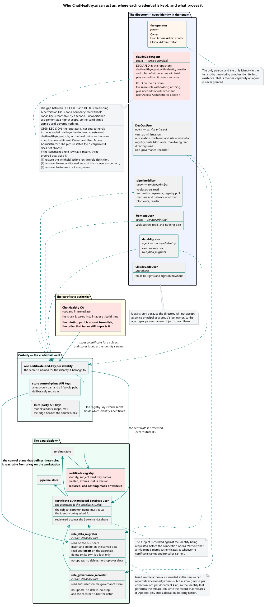
Every authenticating actor resolves to one entry in one registry; the certificate is the credential, and the vault is where a credential becomes an identity.

3.2 The certificate is the credential — [R]
A ChatHealthy-issued X.509 certificate, and nothing else, proves a non-human actor is who it says it is. The database holds no certificate; it holds the subject Distinguished Name as the account name and trusts the authority that signed it. The connection carries no password because there is nothing to carry — the credential is the material presented in the handshake.
Two logins reach a collection, and they are two different services with two different credentials. First the vault, to obtain the certificate. Then the store, authenticated with that certificate over mutual TLS, where the subject DN matches an external-authentication user and the server applies that user's role. The certificate is fetched in order to make a connection and is not held as configuration — a process reuses an established client only where the vault's own tag on that identity's secret marks the cluster reusable, and every fresh process, and every cluster marked otherwise, fetches again. (Evidence: behaviour — `ChatHealthyLib/src/chathealthy_lib/mongo_utilities.py`, `_fetch_identity_cert` at :645, `_is_cacheable` at :768 and `getConnection` at :777.)
Four consequences, all load-bearing.
The vault credential is named after the identity it fetches, and there is no second argument. frontendUser's certificate is reachable only with frontendUser's vault credential; a host therefore holds exactly the vault credentials for the identities it is entitled to act as, and a host that is not entitled has no key and fails closed. The design refuses the second parameter on purpose — the vault identity is not free to differ from the store identity, and a parameter that must always equal another parameter is a parameter that will eventually not. There is deliberately no fallback: if the certificate cannot be obtained the call raises, because a fallback to a shared credential is what makes the whole model decorative. (Evidence: behaviour, same two functions.) This is what a single ambient platform credential cost: one credential served every identity, so the workstation's could read the front end's certificate and the front end's could read the pipeline's.
Withdrawal is therefore immediate and central, at two independent points. Remove the identity's vault entitlement and no host can obtain the certificate at all, from its next fetch, everywhere at once. Drop the external-authentication user and the store stops accepting the certificate even where the key is already held — which is the stronger of the two, because it reaches a leaked key and a live client. Neither depends on a certificate expiring, on a revocation list, or on a channel back from the authenticating party to the firm's notion of revocation.
The vault protects the cabinet, not the door. Whoever reads a certificate's private key from the vault is that identity, on every surface, from anywhere, until the subject is withdrawn from the store or the certificate is replaced. The database has never heard of the vault and cannot ask how the presenter came by the key. Vault scoping is therefore a primary control, not housekeeping: one secret per identity, granted per secret and never per vault. §8.4 is what happens when that is not held.
The presented certificate must name the identity requested. A component asking the vault for identity A's material and receiving identity B's would authenticate perfectly as the wrong principal — the vault would have behaved correctly and the caller would be in the wrong place. The connection utility therefore parses the fetched certificate, reads its Common Name, and refuses unless subject_CN == identity. (Evidence: behaviour.) Note what this control is and is not: it is a real control against a vault misconfiguration and it is code the agent maintains, so under S-1 it does not constrain the agent.
[I] The seven identities. One person; claudeCodeAgent; DevOpsUser; frontendUser; pipelineEditor; PipelineToFrontEndPublicDataMigrator; and ClaudeCodeUser, which exists only because the directory will not accept a service principal as a group's last owner. frontendUser is the shape the target wants: one grant, exactly what the function needs. claudeCodeAgent is the shape that needs a section of its own, and the firm's position on its breadth is stated with the live grants in §8.4.
[I] The registry is a key inside the deployment record rather than a file of its own. That is why a commit changing an identity can be gated by the same mechanism that gates a deployment change — a real benefit — and why an identity change and a deployment change are indistinguishable to every downstream reader — a real cost. The Enterprise Architecture §5.1 names it as one artifact carrying two concerns.

4. Trust boundaries
A boundary is where one party stops being able to vouch for the other. At each, this framework states two obligations, because stating only the callee's is the mistake that produced most of section 13: a callee that checks nothing is a defect, and a caller that presents nothing is equally one.

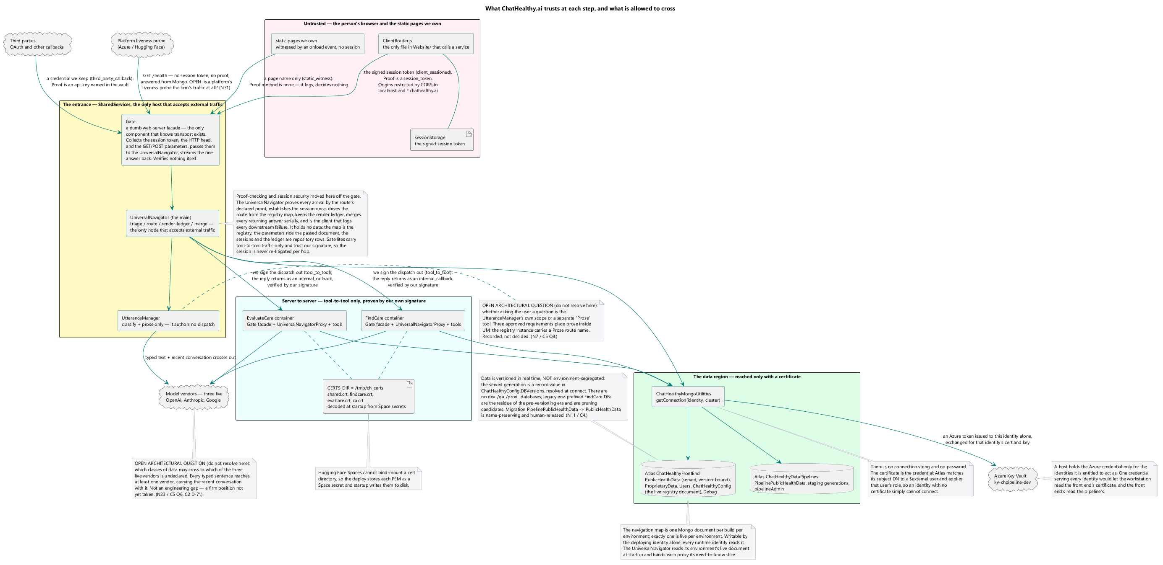
Every arrow crossing a zone edge is labelled with the credential presented, not the protocol. Three arrows are marked as defective: the agent's direct path to the platform, the component-to-component call that disables peer verification, and the deploy's own read-back.

4.1 The boundary table — [R] rows, [I] examples
# | boundary | caller's obligation | callee's obligation
B1 | Browser → the firm | Present the session token minted for this page session. Carry the User State as payload, never as credential. | Verify the signature against the key the callee selected for the origin it expected; act on the result; expose no second entrance.
B2 | Component → component | Present the caller's own certificate; complete mutual TLS 1.2+ before any payload is exchanged; verify the peer's chain. | Authenticate the client from the certificate, never from the payload. An incomplete handshake is a fatal error.
B3 | Component → database | Fetch only its own certificate; verify CN == identity; connect X.509. | Validate against the firm's CA, map the subject DN to a user, apply that user's role and nothing wider.
B4 | Component → vault | Authenticate as the platform identity the secret is scoped to. | Return only the one secret that identity is entitled to; log the retrieval; grant no principal vault-wide read on a vault holding others' credentials.
B5 | Deploy → target | Carry a human authorisation naming what is deployed. | Report which build it carries, over an authenticated connection, so the deploy verifies rather than asserts.
B6 | Agent → any remote platform | Hold a human authorisation given at the moment of the act, recorded, naming the act. | No enforcement exists on this path. R-1.
B7 | The firm → a model vendor | Send the minimum the task requires; no credential; nothing the task does not need. | Nothing can be required of a vendor by architecture — only by contract. §9.
B8 | The firm → its hosting platform | Present mutual TLS. | Terminate mutual TLS. [I] The platform does not, and a bug is registered rather than the requirement weakened.
B9 | Workstation → everything | Hold no secret on disk; read every secret from the vault at the moment of use. | The workstation is not a firm asset. The agent is an ordinary user there.
B10 | Internet → the edge | Nothing may present a static shared secret as a credential. | Apply the edge controls to every request. A path exempted from them is a boundary and is declared as one.

Binding: EPIC-002-F-003-S-003-REQ-B-008 (mutual TLS on every cross-service and external system-to-system call; a failed handshake is fatal; where a substrate cannot host it, a bug is registered against it).

4.2 One entrance — [R]
Every request that reaches a firm server arrives at the Gate, and no other route answers. Not one entrance per component, not one per page, not a REST surface per resource. Two properties follow and they are the reason: everything that must happen on every call happens in one place and cannot be forgotten by a route that did not know about it; and because there is exactly one entrance, every other component can refuse anything that did not come through it.
The firm registers the address. The sender decides the method. That single distinction is what makes one entrance achievable for traffic of every origin, and it is one axis of a larger set — it separates the firm's own client from everyone else, and the five call types below name each way a call arrives:
class | shape | why
traffic the firm's own client originates | POST to the Gate | it is the firm's own traffic and the firm decides its shape
traffic the firm does not originate — an identity provider's redirect, a third party's webhook, a platform's liveness probe | arrives at a URI the Gate owns; the Gate collects the facts of the request and dispatches it to the tool that handles it; the method is whatever the sender sends | the firm registers the address and the sender decides how to deliver to it, so a method requirement on inbound traffic would make compliance depend on a third party's choice

The entrance is two components, not one. The Gate is transport and nothing else: it collects the session token if there is one, the HTTP head if there is one, and the parameters if there are any, passes them to the UniversalNavigator, and streams the answer back. It verifies nothing and owns no route of its own, and one generic Gate module serves every container, so the three per-service app.py files collapse into one. The verification the dispositions below describe is the UniversalNavigator's, performed mechanically against the proof the route declares in the registry — route known, proof named, verify or refuse — not logic each service's app.py carries. This strengthens §4.2's point that everything which must happen on every call happens in one place: the one place is the Navigator behind the Gate, driven by the registry, and no route can forget a check the registry declares for it.
Inbound traffic is a closed set of five call types, all mapped, each a route carrying a call type, a proof method, and its timeout facts. The origin distinction above is the axis along which they divide; it does not exhaust them.
- tool_to_tool — one tool calling another. Proof none at the type level; the call is authorised by the acyclic may_call graph (§7.2), not by a credential on the wire.
- client_sessioned — a client we served index.html and established a session with. Proof session_token: the full signed token with its per-hop nonce.
- third_party_callback — an external party calling us back on its own initiative, carrying a credential we keep as we keep OAuth's. Proof api_key, named by a vault credential name and never a value.
- static_witness — the onload witness of a static page we own. Proof none: the route accepts a page name, logs, and decides nothing. It is the exact shape of B10 — a path exempted from the credential checks, declared as the boundary it is.
- internal_callback — a tool that finished working calling back into the SharedServices UniversalNavigator. Proof our_signature: we signed the dispatch out and verify the signature coming back, named by a vault signing-key name.
Two of the five are inbound classes the boundary table (§4.1) does not carry — static_witness and internal_callback — and every proof names a credential, never a value: a value in a credential name or a signing-key name is a violation, which is §3.2's rule applied to routes.
The main UniversalNavigator lives in SharedServices and is the only node that accepts external traffic. There is a Gate per container, but only the main Navigator takes external client traffic, which sharpens one entrance into one entrance that faces outward. A satellite server carries only tool-to-tool traffic, relayed both ways by a UniversalNavigatorProxy that holds no session, no render ledger, no merge and no external call, and that refuses work on stale metadata — a proxy that cannot be brought current is an exception. A satellite's answer returns to the main as an internal_callback, proven by our signature over the dispatch we minted. Every throw ends in a UniversalNavigator or a UniversalNavigatorProxy; a tool in the middle re-raises and never swallows. The navigators are the client to every server and service they call, and the client logs the failures of what it calls: every dispatch that dies, callback that never comes, timeout and merge conflict is instrumented with timings, at a severity matching impact, to the repository the component logs every fact to. That is audit generation, and §11's AU-2/AU-3/AU-12 row carries it.
Page completeness is the render ledger's to manage, and its security edge is that every failure mode fails closed. The render ledger the Navigator owns, and the render, callback and external-call timeouts the registry carries per route, are Live Application Architecture's mechanism (§1.2); what belongs here is what those facts do under failure. The Navigator determines which page an incoming request constructs, records that page's required members as ledger expectations at dispatch, and closes each only on that member's completion callback — an internal_callback proven by our_signature, so an expectation is discharged by a signed report over a dispatch the Navigator minted and never by an unproven arrival that claims to be done. A completeness budget races those callbacks: a page not reconciled in time raises on the timeout — a governance timeout is fatal, a user-facing one answers anyway with the layman explanation the registry declares (on_timeout) rather than hanging or returning a stack. A parameter or state conflict while merging the returning documents raises (on_conflict), the merge being serial precisely so a conflict is caught rather than silently resolved last-writer-wins; and a required member that dies or never calls back raises (on_missing_required). Each of the three — timeout, conflict, missing required — is instrumented with timings at a severity matching impact, to the same repository §11's AU-2/AU-3/AU-12 row already carries for every dispatch that dies and callback that never comes. This is §8.3's a timeout rejects on the render path.
Nothing is exempt. A route outside the Gate is non-compliant whatever its method and whoever calls it.
Binding: EPIC-002-F-004-S-001-REQ-B-001.

4.2.1 What the Gate can observe — [R]
The table above is written by origin, and origin is the one thing that is not on the wire. A request carries a method, a URI, headers and a body. It does not carry who caused it. A Gate that had to know an intention could enforce nothing, so the rule has to be expressible in what arrives.
It is. The address carries the origin. The firm registers exactly one op address for its own client, and registers a distinct address with each third party it expects to hear from. Which address was hit is therefore the firm's own declaration of what class of traffic may arrive there, made in advance, and the method rule follows from it:
what arrives | disposition | why
POST to the op address | collect and pass; the Navigator verifies the session_token the route declares, then dispatches | the firm's own traffic in the shape the firm requires
GET to the op address | refused | that address serves only traffic the firm originates, and the firm requires POST of it. A firm-originated GET is not a lesser compliance — it is the one shape this address does not accept
any method to a registered callback address | collect and pass; the Navigator verifies the signed state the callback route declares, then dispatches | the sender chose the method and the firm cannot choose it for them
any other URI | 404 | no other route answers
a bare domain name | redirect to the Gate | the one convenience, and it lands on the Gate rather than beside it

So the enforceable statement of the rule is: a GET that the Gate serves is a callback from a third party, and nothing else. There is no internal GET. The Gate does not infer that from the caller's identity — it reads it off which of its own addresses was reached.
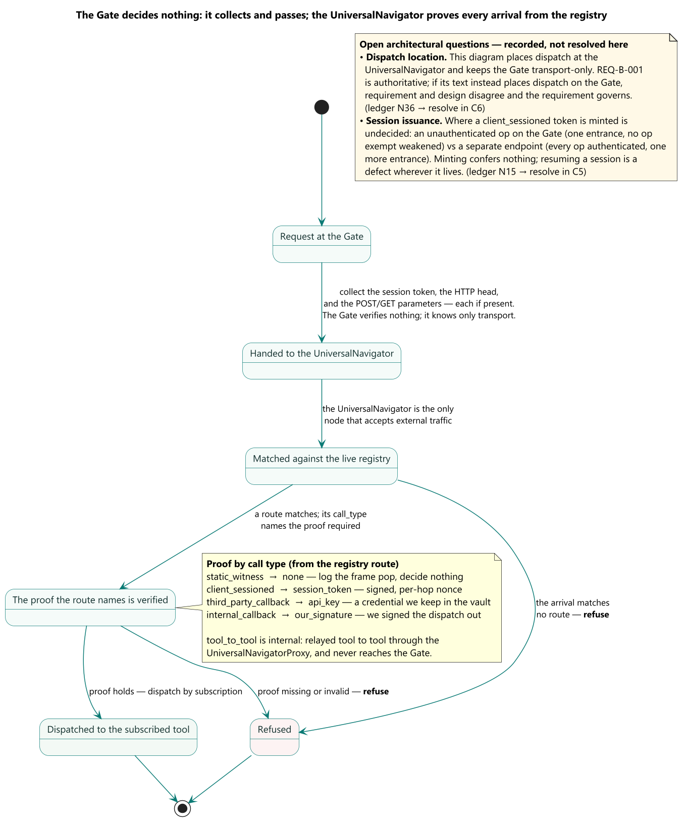
The Gate decides on the address first and the method second, because the address is the firm's own advance declaration of what may arrive there and the method is all the request itself contributes.

4.2.2 Where this is enforced — [R]
Both at runtime and at check-in, because they catch different failures and neither substitutes for the other.
At runtime, the Gate refuses. A GET to the op address is answered as a refusal, not served and not logged as an oddity. This is the only place the method rule can be enforced, because a method is a property of a live request and nothing at rest exhibits one.
At check-in, a scan refuses a route that answers outside the Gate. This is the only place the one-entrance rule can be enforced, because a component serving its own route is never asked by the Gate and so can never be refused by it. Runtime enforcement is structurally blind to exactly the violation that matters most: the request that never arrives at the Gate at all.
Stated as the pair they are:
enforcement | catches | cannot catch
the Gate, at runtime | a request arriving at the wrong address, or at the right address with the wrong method | a route that bypasses the Gate, since such a route is never consulted
a scan, at check-in | a route declared or served anywhere but the Gate | a wrong method, since no client runs at check-in

The check-in half is a gap, and an enforcement under Rule-065 is mandated to close it. The runtime half is the Gate's own dispatch and is in force. The scan is specified here, exists nowhere, and is the only enforcement that can catch the violation that matters most.
Rule-065 — no commit without explicit human authorization — is where it belongs, and it belongs there on the rule's own terms rather than by convenience. Rule-065 carries the whole commit gate: nine enforcements today, seven of them pre-commit scans over the committed files and two commit-msg authorisation gates, and its statement 6 already requires that every file committed is architecturally compliant. A route that answers outside the Gate is exactly that class of violation — a property of a file at rest, checkable with no client running — so the scan is a tenth enforcement of Rule-065 at pre-commit, and the requirement it enforces already exists in EPIC-002-F-004-S-001-REQ-B-001. (Evidence: `engineering_rules.json`, Rule-065 statements and its `enforcements` list.)
The JSON edit is the operator's and this document does not make it. Stating the mandate is not the same as hedging about whose it is: the gap is named, the rule that must carry it is named, the hook is named, and what remains is one edit by the party that owns the rule registry.

4.2.3 The callback in detail, and what remains outside — [R]
How an identity-provider callback routes, since it is the case a reader will test the rule against. The redirect arrives carrying a signed reference to a session: the state parameter is built as a payload, HMAC-signed, and verified on return with a constant-time comparison. The rule the Navigator applies against the registry is that every call carries the proof its route declares, and state is The machinery that collects the facts of an arbitrary request already exists and is already called with a token, the posted body and the headers. The callback handler is already a separate module — a tool in everything but registration, and that registration is a subscription in the one build-generated registry. Adding a route entry and the handling tool's subscription to it in the registry, which the build regenerates from source, is the whole of the work. (Evidence: behaviour.)
The routes that answer outside the Gate today are non-compliant paths, and §13 carries each as scheduled work with an owner or as an open question with one. There is no third category: a boundary carrying a list of carve-outs has carried two boundaries, and a reader follows the shorter list.

4.3 The caller's credential at B2, and where the verification posture is declared — [R]
A shared secret in a header is not a credential. It proves possession of a string. It proves nothing about who presents it, it cannot be scoped, it cannot be revoked for one holder without revoking it for all, and its disclosure is undetectable. Where a caller must be identified it presents a certificate; where it need not be, no secret is required and asking for one creates a credential to manage without creating a control.
A transport library may carry a transport. It may not carry a policy. Whether a peer's certificate chain is verified is a deployment fact about a specific boundary, and a deployment fact belongs in the record — never in a default argument on a base class that every component inherits. A single default in a shared base class is not one mistake's worth of risk; it is the contract new components are told to inherit from.
[I] What B2 establishes today, and what it does not. B8 records that the hosting platform does not terminate client certificates, so the certificate half of B2's caller obligation is not met on the hops the application actually makes. Something else is, and it is not nothing.
What is established. Three things, and they are more than a header check.
- A signature, verified against a key the verifier chose. Every request a peer serves carries a signed session token and the peer refuses without one. The door verifies an RSA PKCS1v15/SHA-256 signature over the token against the entrance's certificate — an environment value the deployment record binds to the host, which the process writes into its certificate directory at startup — and answers 401 both when no token is present and when the signature does not verify. It names the expected origin as a constant it holds rather than reading it off the token, which is the correct form of §6.4 and the one site in the codebase that takes it.
- The token carries no session. It carries an identifier; the session itself is a document in the store under that identifier. So a peer that needs any of the person's state goes to the database for it, and an invented identifier resolves to nothing.
- A write against a session that is not there is refused by name. The peer raises session_not_found when the update matches no document, rather than creating one.
(Evidence: behaviour — `Code/ConversationalUX/FindCareChat/backend/app.py:555` `require_gateway_signature` and its `verify(expected_origin=SHARED_SERVICES_ORIGIN)` at :584; `ChatHealthyLib/src/chathealthy_lib/authentication/session_token.py:142`; the store reads at `app.py:965` and `:989` and the `session_not_found` refusal at `:763`; the environment binding in `deployment_architecture.json` and the startup materialisation at `app.py:427`.)
What is not established. Three things, and they are what the boundary asked for:
- Which peer is on the connection. The signature is over the token and travels in the payload, so it is a bearer credential: anything holding the token presents it identically and no check can tell one presenter from another. That is the difference between authenticating a message and authenticating a channel, and B2's obligation is the second.
- That this hop is fresh. The signed payload covers the fixed half of the nonce, so one signature stays valid for the life of the session, and no expiry, freshness or replay check runs at verification. R-3.
- That every callee does any of it. One service computes the same verdict and never branches on it, so a token with a bad signature is answered with the full payload. R-20.
So B2's answer to *who is the caller* is a signed assertion that the token came from the entrance, plus a session that has to exist in the database for the request to get anywhere — carried by a credential any holder can present. That is weaker than the boundary requires and it is a real mechanism rather than an absence, which is why §6.3's warning is about a residue and not a void.

5. Certificate authority, lifetime and custody

5.1 The authority — [R]
The firm operates its own certificate authority. It holds a root signing certificate; that root signs every issued leaf; the root is reachable only by authorised identities. Every issued certificate is traceable to an identity, a network node and the server it belongs to, and is issued only to a requester whose own identity is verified and who holds an entitlement for the requested subject.
The requester generates its own keypair and submits a CSR. The authority returns the leaf and the chain and never returns a private key — because a key the authority could return is a key the authority once held.
Binding: EPIC-002-F-003-S-006-REQ-B-001, -REQ-B-002; EPIC-008-F-004-S-002-REQ-B-001.

5.2 Lifetime is not the control — [R]
A certificate's lifetime bounds a compromise. It does not withdraw one. The control that withdraws is §3.2's: the credential is fetched against an entitlement the running host holds, so pulling that entitlement stops every subsequent fetch, and dropping the store's external-authentication user stops the certificate being accepted at all, including one already leaked. Both act immediately and centrally, on every host at once, without reference to any expiry date. Lifetime is a backstop behind those two, and a firm that reaches for it first has chosen the slowest instrument it owns.
[I] The firm issues no short-term certificates, and that ordering is why. A short lifetime buys a bound on a window; the two withdrawals above close the window on demand, which is what an operator actually needs at the moment they need anything.
What the approved requirement asks, clause by clause. EPIC-002-F-003-S-006-REQ-B-004 is approved and binds, and it contains one permission that is easily read as a mandate:
clause | state
a long-lived identity receives a certificate when the identity is brought into existence | met by the deploy for identities that already hold one; no code can produce a new one — R-17
a short-lived identity self-mints a certificate when it comes into existence | unimplemented. Nothing in the codebase mints a certificate — R-36
validity ends no later than the identity ceases to exist | not contradicted; nothing drives it either
long-lived certificates expire on a schedule short enough that a compromise cannot outlive one management cycle, long enough that an unexpectedly long job does not lose its certificate mid-run | unimplemented in both halves. No management cycle is defined anywhere, and no rotation driver exists — R-36
"It is permissible to accomplish this by issuing short-term certificates valid for up to a week" — and where that is done, every certificate for a completed job is revoked and destroyed from every place it exists | a permission, not a mandate. The firm does not issue short-term certificates, which is fully compliant with this clause; the revocation-and-destruction obligation is conditional on exercising the permission and therefore does not arise

(Evidence: requirement, for what is asked; behaviour, for each state — there is no `CertificateBuilder`, no `not_valid_after` and no validity duration anywhere in the firm's Python. The one minting function on disk, `architecture/DevOpsBuildDeployAndEnvironmentManagement/cert_placement.py` `_mint_leaf_cert` at :323, imports a module that is absent from the repository, so it raises; and its only caller, `provision_long_lived_certs` at :394, is called from nowhere. Of that file only `bake_ca_chain_into_images` is imported by the deploy. It is a dead path and belongs deleted, not described.)
So two clauses of an approved requirement are gaps and are carried as R-36. Neither is closed by choosing a lifetime. The self-mint clause needs an issuer, which is R-17. The management-cycle clause needs the firm to say what a management cycle is, which is a decision and not code.

5.3 Custody — [R]
The private component of every certificate is readable only by the identity it was issued to, and every retrieval authenticates the caller as that identity first. Every secret is readable only by the party that requires it.
No secret sits on any disk. A component holds the vault's address and its own platform identity and nothing else, and reads the secret at the moment of use. A deployment carries locations, never secrets. Where a library must materialise a certificate to hand a file path to a driver, it writes to a process-scoped path with restrictive permissions and removes it when the process ends — a key file that outlives the process that needed it is a secret on a disk.
Deploy provisions every identity and writes its credential before any runtime call is made. No runtime path issues a certificate, creates an identity, or grants an entitlement.
Binding: EPIC-002-F-003-S-007-REQ-B-001, -REQ-B-002.

5.4 [I] The firm operates a trust chain without an issuer
Stated plainly because it is the kind of fact a buyer should not have to discover.
A commit on 2026-08-17 deleted the CA client library, the issuance runbook, the signing helpers, the bootstrap runbook and seven tests. The function that would mint a leaf certificate checks for that library and, finding it absent, raises aborted naming the missing file. The file is absent, and the function that would call it is called from nowhere, so the path is dead twice over. Root and intermediate PEMs remain readable from the vault and are baked into images.
So validating a chain works and issuing does not. The firm can verify a certificate it already holds and cannot produce a new one. Concretely: no identity created after that date can receive a certificate by any code path in the repository; -REQ-B-004's self-mint clause has no mechanism at all; and no rotation can run, there being neither a driver nor a declared cycle to run it on. (Evidence: behaviour — the guard, the absent file, and the absence of any caller.)
And the authority is not one in the S-1 sense either, independently of the deletion: the root signing key is a secret in the vault on which the agent holds unconditioned vault-wide administration (§8.4). An authority whose root key is readable by the party it authenticates cannot refuse that party anything.

5.5 The registry, and three requirement sets that disagree
Target. A registry maps each subject DN to the vault secret names where its public certificate and private key are stored separately, supports multiple certificates per DN for rotation, supports third-party certificates, and resolves deterministically. It holds pointers, never material. The database holds no secret; the database host is not a secret either — it is a public DNS name, and the certificate is the credential, which is why the connection string carries no password.
[I] The conflict. Three approved requirement sets describe one authority and do not agree. Two features carry the identical name.
question | EPIC-002-F-003-S-006 | EPIC-008-F-004 | EPIC-008-F-014
validity | ends no later than the identity; short-term job-scoped certificates permitted up to a week, not required | "exactly one (1) year" | 1 year, auto-renew at 30 days
registry | not stated | ChatHealthyConfig.CertificateRegistry | ProprietaryData.CertificateRegistry
subject naming | not stated | requester-supplied DN | <service>.<env>.chathealthy.internal
who may request | verified, entitled requesters only | "any IP address on the internet" | bootstrap, operator, renewal

A certificate cannot be both "exactly one year" and "ends when the identity does" for a nine-hour job, and a registry cannot be in two databases. The running system matches none of the three on naming, and the connection utility depends on the naming it actually uses, so adopting one requirement would break every database user. Two approved requirements contradict each other; this document does not choose between them..

6. The session

6.1 What a session is — [R]
A session is one person's continuous use of the application, bounded at one end by a session-boot call and at the other by expiry or logout. It is represented by exactly one User State object instantiated at session start. Every page load performs a session-boot call as its first network action.
The application is stateless on the server: state lives long-term in the user store and short-term in a session store. That matters to security rather than to scaling — session content is expected to hold PHI, financial detail and, eventually, credentials to external portals, so it is written where access can be granted and audited rather than held in a process nothing audits. No PHI is held as client state.
Binding: EPIC-002-F-003-S-005-REQ-B-001 through -REQ-B-006.

6.2 The envelope — [R]
part | what it is | who sets it | when it changes
GUID | the stable session identifier | the entrance, once | never, for the life of the session
NONCE | two timestamps: session creation (fixed) and last successful use (volatile) | the service that currently owns the interaction | on every successfully authenticated hop
signature | over the session's identifying content | the component that produced this instance | on every re-stamp
origin | the component that produced this instance | the same component | on every re-stamp

Three rules.
Manufacture is central; management is shared. Manufacture of the token and of the original nonce belongs entirely to the entrance. Management — parsing, verifying, advancing the nonce — is shared library code. A component may re-stamp; no component but the entrance may mint. An authority installed everywhere is no authority.
Only the owning service re-stamps. A nonce that did not change across a hop is a defect, not a stable value.
The signature covers content, not identity, and is re-made per hop. This settles a disagreement between two design documents that the Live Application Architecture referred here. A signature is not required to survive a hop because the envelope is re-signed at every hop — so there is exactly one signature in force at any moment, and a design in which one signature must survive multiple hops is incompatible with per-hop re-stamping and is rejected. Two consequences:
- The signature covers every field the next verifier will rely on — the GUID, both halves of the nonce, and the environment. A field the signature does not cover is a field an intermediary can rewrite, and there is no purpose in transmitting a field nobody can trust.
- The origin field is not signed and must not be, because it names the signer, and a signer's own claim about its identity is precisely what the verifier is trying to establish.

6.3 Three questions, not one — [R]
Conflating these is what produces the recurring argument about whether validation happens once or many times.
question | establishes | how often | answered by
Is the session live? | a person holds a live, unexpired session | once, at the entrance | the entrance
Who is the caller? | the peer's identity | every hop | the mutual TLS handshake, and nothing in the payload
Did this come through the entrance? | provenance | every inbound hop | each receiving component, against a constant it holds

The ruling: liveness is decided once and carried forward. Three independent computations of "is this session alive" are not defence in depth — they are three places that can disagree, and when they do, behaviour depends on which one ran. Provenance is a different question and every hop asks it. A component performing the provenance check is not performing the second half of session validation.
The sharp consequence: a valid session presented by a peer proves that some session is live. It does not prove the peer is entitled to act on it. That comes from B2 alone — so where B2 rests on a bearer credential, session validation is being asked to do work it cannot do. [I] Per §4.3, that is the current state of every hop this application makes: the token's signature establishes that the entrance produced it and that the session it names exists, and nothing on the hop establishes who presented it.
[R] One inbound class answers who is the caller differently. An internal_callback — a tool reporting completion to the SharedServices UniversalNavigator — proves itself by our_signature: the Navigator signed the dispatch out and verifies that signature coming back, over a payload we minted and hold the key for. That authenticates the channel rather than a message any holder can re-present, and is a materially stronger proof than the bearer token of §4.3. [I] The current code does not draw this distinction; the target does.

6.4 The trust anchor is named by the verifier — [R]
The public key against which a signature is checked is selected by the verifier, from the verifier's own configuration, keyed on the origin it expected. The verifier never reads the expected origin off the object it is verifying.
Stated as a first-class target because the failure survives review: a token that names its own trust anchor is self-certifying, and a forged token that names the forger's anchor verifies perfectly. Signature verification is not a property of a signature; it is a relation between a signature and a key the verifier chose.

6.5 Expiry, and human login — [R]
Two independent limits, both enforced server-side: an absolute limit measured from the nonce's creation stamp, and an idle limit measured from its last-used stamp. The server surfaces remaining lifetime on every response; the client refuses to issue a request once it has fallen below zero. The client-side refusal is a courtesy; the server-side check is the control.
Humans authenticate only by OAuth 2.0 at a supported identity provider, and are authorised by OIDC claims layered over that result; OAuth alone never makes an authorisation decision, and no code implements OIDC verification itself. The firm stores no password. A failed authentication keeps the person as a guest, tells them it failed, deletes no record, and does not disclose whether the identity is known — an account-enumeration defence, and it should be read as one. Every attempt and outcome is recorded in the security audit stream.
Binding: EPIC-002-F-003-S-004-REQ-B-001, -REQ-B-006, -REQ-B-007, -REQ-B-010.

7. Least privilege, and the review that makes it falsifiable

7.1 The standing rules — [R]
No identity holds a privilege beyond what its declared function requires. No party holds read access to a secret it does not need. Grants are made per secret and per collection, never per vault and never per database, because the blast radius of a grant is the level at which it is written.
Privilege is computed from the actions a right publishes — never from the right's name and never from a description written for it. A name goes stale on a rename; a description is an assertion; the action list is the fact. [I] The firm learned this concretely: a hardcoded list of privileged role names stopped flagging the agent's own role after that role was renamed.
A role definition is a declared artifact that is deployed, never a form that is edited. [I] A grant edit made by hand is destructive with no undo: a custom-role dialog saved carrying one action replaced a whole role, removed seven grants, and left a pipeline inoperable until twenty-one entries were re-entered by hand.

7.2 Single-writer is stronger than least privilege — [R]
Served data has exactly one writer, and that writer is an auditable job. Not a service, not a session, not a one-off script, not an agent.
Least privilege says nobody holds more than they need, which still permits a dozen principals each to legitimately need write. Single-writer says the data can only change through one path — and it is the durable answer to the failure mode an AI-native firm actually has, which is an agent with administrative rights destroying production data.
The strongest form is a grant that cannot do otherwise: give the release identity insert and create-index, and no update, no delete and no drop over any data anywhere. Then "a release never destroys what is serving users" stops being a property of the code and becomes a property of the credential. A prohibition expressed as a withheld grant is enforced by the store; the same prohibition expressed as a rule is enforced by whoever remembered to write it.
And the honest scope of that, under S-1: a no-delete grant makes destruction impossible for the identity it constrains, and impossible for the agent only if the agent cannot reach the control plane that defines the grant. §8.4, R-30.
The grant boundary is the database, not the cluster. One certificate subject can be a registered user on several clusters, granted differently on each. Cluster placement is routing; the role names databases. A framework that reasons in clusters will get this wrong. (Adopted from the Data Pipeline Framework §2.4a.)
The navigation registry is a single-writer record of the same shape. The whole front-application map is one Mongo document per build per environment, carrying an instance object — build, commit, env, live — that is its identity and state. The deploy appends a new live instance and retires the predecessor's live flag; that flag is the only field ever mutated on an existing document, and the history is otherwise append-only, with exactly one instance live per environment. The prohibitions are withheld grants and store invariants rather than rules someone remembered: a unique partial index on instance.env where live is true means the store itself refuses a second live per environment; the collection is writable by the deploying identity alone and every runtime identity only reads it; one canonical library function does validate-insert-retire in a single transaction, and a pre-commit scan rejects any other code that touches the collection; a $jsonSchema validator on the collection mirrors the registry schema; and the audit asserts the history invariant in its sweep. Generated from source at build, it cannot name a route or tool the build does not carry — the authorisation-adjacent record whose presence is itself the allowlist.
Least privilege has an internal face as well as the external boundaries of §4. Which tool may call which is the may_call graph the registry declares, and it is the allowlist for tool-to-tool traffic: a call absent from may_call is refused, and presence in the registry is the whole of the grant. The generator enforces referential integrity and refuses a registry whose call map contains a circle, so the internal call surface is a checked acyclic graph — least privilege expressed on the call graph and verified at build rather than asserted in prose.

7.3 The entitlement review — [R]
This is the firm's answer to how does a company with one human review the grants an agent made, and it is S-2 made operational.
A periodic report, delivered to a named recipient list on a controlled schedule, covering: scope (every protected asset, how entitlements are allocated on each, and which subscriptions the run could and could not enumerate); statistics, where every figure is measured from what the run found and a number the run did not measure is not stated; exceptions (rights held by principals absent from the approved register, grants whose principal no longer exists, resources carrying no description, grants already covered by another the same user holds); each user's full entitlements, stated as user → cluster → database → collection with the right stated once at the level it is granted; an explanation of every right named, stated from the actions the right carries and not from any description written for it; the group hierarchy, saying so where the directory could not be read rather than showing no groups; and vault-wide access — every principal that can reach every secret in a vault.
Binding: EPIC-002-F-003-S-009-REQ-B-001 through -REQ-B-010, approved.
Two design properties are architecture rather than implementation:
- The approved population is not held by the thing being audited. The register of who is supposed to hold rights is read from the published record on the origin branch, never from the working tree and never from a structure inside the reporting program — because holding it inline made the audit grade itself against its own answer key and print zero exceptions by construction.
- Unreadability is reported as unreadability, never as zero. A report that says "0 exceptions" because it could not look is worse than no report.
The review is complete only when a human has signed it off. The report being produced is not the control; a person reading it and saying so is.

8. The agent as a principal — [R]
The part with no precedent, and the heart of this document.

8.1 The standing position
[I] The operator's constitution of the agent, and its limit:
Claude Code has responsibility as ChatHealthy.ai's system administrator for all
ChatHealthy.ai components… On each substrate it administers, Claude Code acts
under its own identity or the identity of a human operator. The intent is to
allow devops to have the code bot do all hands-on work and humans to do no work
outside those related to necessary supervision.

This authority does not extend to its human user's workstation, of which Claude
Code is not the system administrator, but an ordinary user.
[R] Two things are settled by this and should not be re-litigated by anyone building on the blueprint.
The agent is a principal, not a tool operating under a human's account. An agent acting under a human's credential produces an audit trail that says a human did it, which is a false record. [I] The operator forced this explicitly: create an identical identity, grant it the same rights, log in as that identity, and stop obfuscating what the meaning of that identity is.
The boundary of its authority is the firm's assets, not the human's machine. On the workstation the agent is an ordinary user, and administrative rights there are granted for a named piece of work and withdrawn when it is done — bounded by an act the agent cannot perform.

8.2 What the agent may do alone
Anything whose effect is confined to the local working tree, and any read-only inspection of a system it holds rights to. Writing and editing files, running tests, building locally, reading the directory, reading the database, listing resources, running the entitlement report: no per-act authorisation.
The reasoning is that a local file change is not a deployment and is not an enforcement. Editing the manifest is not deploying it. Editing the rules file is not enforcing it. Editing the secrets file is not publishing secrets. Each becomes consequential only when a separately-gated act carries it somewhere — and gating the harmless step produces a stream of same-shaped prompts that trains the human to click through, which is a real loss of control rather than an inconvenience.

8.3 What requires a human authorisation at the moment of the act
act | state [I]
commit to the repository (the push that completes it is implicit) | gated
commit changing identity or role grants | gated, and weaker than the commit gate — R-4
promote a baseline between environments | gated
deploy to a non-local environment | gated
bring a new identity into existence | declared, not in force — R-11
any state-mutating call to a remote platform outside the sanctioned chain | nothing — R-1
waive any defined process | agent discipline only

Authorisation is an event, not a state. Given at the moment the act fires, naming the act, recorded. A standing approval, a policy document, a comment in a file, or an earlier "yes" to something similar is not an authorisation. The threat model is specific: an agent reads everything in its context and will reason from a general permission to a particular act. Only a live, per-act, human-produced signal cannot be derived.
The authorisation is produced by a human act the governed process cannot perform. This is the hardest sentence here to satisfy, and the firm's own design contains its conclusion:
*"The actor being constrained runs on the operator's workstation and can open a
browser, read the approval page, and post to any loopback endpoint it can see.
Anything that actor can perform is not evidence of a human."*
That sentence is stronger than the mechanism built from it. Any approval channel that originates on the machine the governed process runs on is forgeable by that process. Hardening a server-side check only moves which field must be forged; requiring the page's JavaScript to run only forces the forger to drive a real browser. There is no arrangement of a same-machine channel that yields evidence rather than a convention.
So the target is a channel the workstation cannot originate: the authorisation is requested by the workstation and answered somewhere the workstation cannot reach — a second device, or a service that delivers the request out of band and returns a signed answer. The signature, over the identity of the act, made by a key the workstation does not hold, is the evidence.
The record of the authorisation lives outside what it governs, and the stronger argument is the grant rather than the location. A gate that records its verdicts into a file inside the tree it polices asks the governed thing to hold its own evidence. Writing to a separate store stops a commit from rewriting it; a writer that holds insert and no update or delete stops the writer from rewriting it, which is the threat actually present.
The gate fails closed. A timeout rejects. A gating hook that dispatched no enforcement is a failure, not a pass — nothing was checked, so nothing can be certified compliant.
[I] What the operator's own gate log establishes, and what it does not. 03_devops ran S-3's question against a thousand invocations: a human really does read and really does say no on roughly seven per cent of commits, and silence became rejection 26 times. That is strong evidence the gate is a real control against accident, distraction and drift. It establishes nothing about unforgeability — the gate was exercised a thousand times by an operator and an agent that were both cooperating. Both halves are true and neither retires the other.

8.4 The live privilege picture — [I], and the lesson is [R]
The firm's position, first, because everything below is read against it. That claudeCodeAgent holds broad administrative privilege is an acknowledged risk the firm has taken deliberately, and its current mitigation is that the agent is closely supervised — a human reads while it works. The authority exists because the operating model is one human and one agent doing all the hands-on work, and the firm priced that. Nothing in this section is a discovery that the privilege is broad.
What this section establishes is narrower and is the part that was not known: the specific control built to bound that privilege is inoperative. So supervision is not the outer layer over a technical constraint — today it is the whole of it. That is the finding. And §8.4.1 is why it is tractable: the firm has already built the shape that replaces supervision with a constraint, on one control plane, and there it works.
The design below is right and should be adopted by any firm deploying an agent with administrative rights. Stating it before stating its failure, because the failure is not in the design.
The design. The agent's custom role grants everything Owner grants minus creating a managed identity, deleting one, and writing or deleting a role definition; identity creation is reserved to a named human. And the assignment of that role carries a condition forbidding the agent from assigning itself, or anyone, any of six roles: the three that carry identity creation directly, the two that can hand out arbitrary roles and so reach the first three in a second hop, and — the load-bearing entry — the agent's own role. The firm's own note states why:
*"Without it the holder deletes its own conditioned assignment and creates an
unconditioned replacement. The condition therefore constrains DELETE as well as
WRITE, so the assignment carrying it cannot be removed by the principal it
governs… It must be applied by an account that is not the agent."*
That is S-1 satisfied, in a substrate the agent cannot reconfigure from inside.
What the platform holds. Queried live (evidence: data — live platform):
- The custom role definition reads Actions:["*"], NotActions:[], DataActions:["*"]. It withholds nothing.
- The condition is applied, on the assignment, intact.
- The same principal separately holds unconditioned `Owner` at subscription scope, unconditioned Key Vault Administrator on the vault holding every identity's certificate, and — per a second verification — User Access Administrator at tenant root, unconditioned.
- The identity registry declares five roles for that principal and declares neither Owner nor User Access Administrator. The record understates the agent's privilege by exactly the two grants that make every other control conditional. (This is the sharpest S-2 instance the architecture produced.)
Why this matters more than a grant list. The control was applied correctly and then defeated twice, by two mechanisms that look unrelated to it in any portal: the role it conditions was widened to withhold nothing, and Azure RBAC is the union of a principal's assignments — a condition on assignment A does not constrain assignment B.
[R] The lesson: enumerate the union, then check the union. A principal's
effective privilege is the union of every assignment it holds. A constraint is
written against that union, verified against that union, and re-verified
whenever any assignment changes. **A conditioned grant standing beside an
unconditioned one is an unconditioned grant.**
Four consequences, each of which reaches into another artifact.
- The agent is every identity in the firm. The certificate is the credential;
every identity's certificate is a secret in that vault; the connection utility fetches the named secret and presents it. So the agent can be any identity at will, and the audit trail names whichever it chose. R-29.
- The CA is not an authority the agent is subject to (§5.4).
- **The append-only records are append-only for their writers, and for the agent
only while nobody has elevated it** — the roles that express them are control-plane objects on a plane where the agent's key rests read-only and is raised to write by the operator for named work (§8.4.1). R-30.
- Every local git gate is a file the governed party can delete. The hooks
directory is a workstation path, writable by the agent's own process, and not version-controlled, so no commit gate observes a change to it. The post-commit rollback is a real control against a bypass flag — the case it was built for — and not against deleting the hook. R-31.

8.4.1 One control plane is administered in time rather than held — [R] pattern, [I] instance
The pattern. An agent's authority over a control plane need not be a standing grant at all. It can be read-only as its resting state, elevated to write for one named piece of work while a human watches, and withdrawn when that work is done. The agent keeps everything it needs to diagnose — it can see every object, every grant, every user — and can change none of them until somebody makes it able to, which is a decision that leaves a trace by being made.
Why this passes S-1 where a condition on an assignment does not. The constrained party cannot perform the elevation. There is no second-hop route because the credential's own rights do not include granting rights to itself, so the enumeration S-1 asks for comes back empty by construction rather than by a condition somebody remembered to attach. And it needs no comparison against a union: the resting state is one state, not the sum of several.
It is not one of the sixteen controls §12.1 assessed, and it would make three passing rather than two, because an S-1 pass taken from a declaration is an S-1 pass nobody has checked. That is S-2 applying to S-1's own result, which is exactly what §12.1 says the check requires.
[I] The instance: the database control plane. The agent's programmatic key on the database control plane carries read-only project access and read-only data access as its standing state. Write authority over the project — the right that can create a custom role or rewrite a database user's grants — is granted by the operator for a specific piece of work, while the operator is watching, and withdrawn immediately afterwards. The key cannot grant itself that right; attempting it fails, which is what makes the arrangement a constraint rather than an honour system. (Evidence: intent — the operator's standing direction, which names the resting role pair, the named-work elevation and the immediate withdrawal. Not behaviour and not data: no code administers this, and the platform was not queried in this pass so the resting state is declared here and not independently read. Under S-2 that is a declaration with no independent reading, which is the same gap the entitlement report exists to close on the other plane.)
What the mechanism does not bound, so the claim is not read too widely. While an elevation is in force the key is a full write credential on that plane, held in plaintext on the workstation, reachable from a prompt, and nothing gates its use per action — a change made under an elevation leaves no authorisation record of its own. That is not hypothetical: with this key a custom role has been created and a database user's grants patched, with no approval and no record, and the resting-state discipline is the answer that was put in place afterwards. So the temporary grant bounds the window, not what happens inside it, and R-30's exposure is live for exactly as long as an elevation is.
The asymmetry this exposes. On the database control plane the agent has no standing write authority and cannot obtain any by itself. On the directory and cloud control plane it holds Owner at subscription scope and user-access administration at tenant root, both unconditioned and both standing. One plane is administered in time; the other is held outright. The two are the same kind of authority over the same firm.

8.5 The self-certification problem, and how many controls survive it
Applying S-1's check to every control in the firm gives two of sixteen passing (§12.1). Both survivors are facts about the world rather than artefacts: content-addressed identity, and state held on a server the workstation does not own.
The unification of the three principles, said once:
The checking party must be somewhere the checked party cannot reach.
A record the agent writes is not evidence about the system; an approval the
agent could post is not evidence about a human; a check the agent wrote from a
description is not evidence about the code. For approvals that means a second
device or an out-of-band signer. For declarations it means a reading taken from
the running thing. For checks it means a seeded violation that makes them go
red. They are one problem.
And a distinction worth keeping, because one is a decision and the other is a project: the off-machine authorisation channel is genuinely open — no design exists and the options must be chosen between. The platform constraint is not research; it is designed, documented, and unapplied.
A model may not authorise a change. A model may review, score, advise or refuse. The act of releasing is a person's, and a gate that accepts a model's sign-off in a person's place has removed the only control the asymmetry rests on.

9. What a model vendor may and may not receive — [R]
Every model call exports data to a third party permanently. This is the one boundary with no enforcement available after the request leaves, so the entire control is on what goes into it.
data class | may cross | basis
public reference data the firm redistributes | yes | already public
a person's free-text utterance | yes, for the task at hand | it is the input; the task cannot be performed otherwise
a person's contact details | only with consent, at the tier consented to | the consent framework
a transcript retained for the firm's purposes | only de-identified, unless verbatim retention was consented to | two-tier consent
a record of a person in distress | only de-identified, and never alongside a network identifier | §9.2
any credential, key, connection string or certificate | never | unconditional; there is no case in which this crosses
the operator/agent conversation archive | only after credential and secret removal | EPIC-008-F-013-S-001-REQ-B-005

The rules. A model call carries the minimum the task requires and nothing carried "in case it helps" — prompt padding is a data export. No credential appears in a prompt. The conversation archive is scrubbed before storage and re-scrubbed as knowledge of credentials grows, so a secret recorded before it was known is removed once it is known; where a credential is removed the archive records which, by naming the key of the key/value pair — the key is not the secret, and naming it is what makes the removal auditable.
Model choice is architectural, not per-call. Every call goes through one facade, so "which vendor sees this class of data" is a decision the architecture makes once and can change once.

9.1 The largest crossing: unconditional, two vendors, and the prior dialogue — [I]
The table above is about retention. The largest crossing this application makes is neither retention nor consent-gated, and a buyer should be told before asking:
- It is unconditional. There is no path by which a person uses the product's chat and their words do not reach a vendor. It is not consent-gated because it is the input to the task.
- Three vendors are live — OpenAI, Anthropic and Google — and any single chat request crosses to two of them. One sentence crosses to two distinct third parties.
- The prior dialogue crosses with it, on every user's web request. The classifier window is up to the last ten human utterances, so one request exports a conversation rather than a sentence, and something disclosed nine requests ago crosses again on every request after it.
The third sits in tension with "carries the minimum the task requires": the window size is a classification-quality decision that is also a data-export-volume decision, and nothing states who owns that trade.
[I] That trade is current state, and the target moves it onto a named component. The standalone classifier and its hand-maintained prompt and taxonomy retire: the UtteranceManager becomes the classifier, answering in one model call — a cached preamble plus every tool's registry-declared fragment in, the set of routes out — and it holds no parameters and no window policy of its own. The intelligence that scopes a pass — which fragments to present, page-first or broad, and how rigor escalates from a first mining pass to a refinement — lives in the UniversalNavigator's dispatch code. So the data-export window this section flags as unowned becomes a property of the Navigator's scoping code and the UtteranceManager preamble, and the question of who owns the trade lands on a named component rather than nowhere.

9.2 The distress case — [R]
A record created because a person was detected to be in distress is subject to the strictest handling in the system, not the loosest. It is de-identified before storage and never stored alongside a network identifier, because a health-relevant utterance plus an IP address is the most re-identifiable pair the application can hold. [I] The code does the reverse (R-10), and this is the one place where a security defect and a safety feature are the same code path.
[I] The safety feature named there is layered, not a single non-deterministic model call. On a never-before-seen utterance an LLM classifier still makes the first call, now pinned to temperature 0 — it had run at the model default, which flipped borderline emergencies, a real defect since fixed. Every lockout the lockout_tool imposes records the uppercased verbatim utterance into a UserLockOutUtterances collection with a count, so a later utterance of exactly those words is a deterministic repeat that never reaches the model. ChatHealthy staff review a monthly operational report of those utterances, ordered by frequency, and curate which learned phrases become trusted deterministic triggers. The net is the model for the unknown and a curated, crowd-sourced exact-match list for the known.

9.3 The archive's second redaction layer is itself a crossing — [R]
Archive redaction is two-layer: a deterministic pass built from known secret names, then a model call to catch what the first pass missed. The second layer sends not-yet-fully-redacted operator text to a vendor. That is a defensible design — the alternative is worse recall — and the ordering is correct, so the model never sees a credential the firm already knows about. It remains a crossing of B7 with the least clean payload in the system, and it belongs in the boundary register explicitly rather than buried inside "redaction".

10. Data protection — [R]
TLS 1.2 or above on every network path, no plaintext HTTP anywhere, and mutual TLS additionally on every path that is not browser-to-entrance.
No secret in any committed file, enforced at commit. A database connection-string literal is forbidden anywhere it appears, with no test-file exemption — because the certificate is the credential, and code that reaches a store without an identity is code whose authorisation is never tested.
No fake database in any test. Standing a mock, stub or in-memory double in place of a client, database or collection is forbidden for the same reason: a test that fakes the store tests everything except whether the identity was allowed in.
A served origin publishes a Content-Security-Policy, and a cross-frame receiver validates the sender's origin against a declared allowlist before reading the message. No channel between frames carries executable source. R-28.
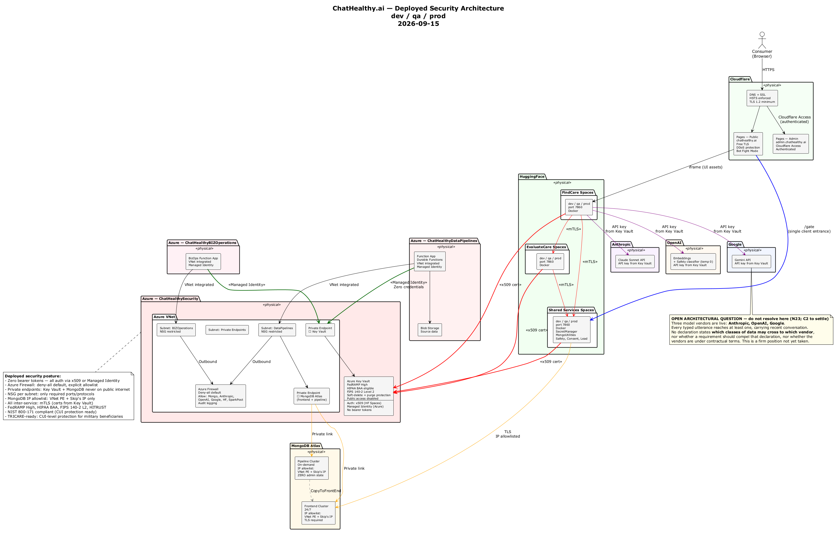
The deployed security architecture: where each credential is held, which boundary consumes it, and the three paths that carry no authentication today.
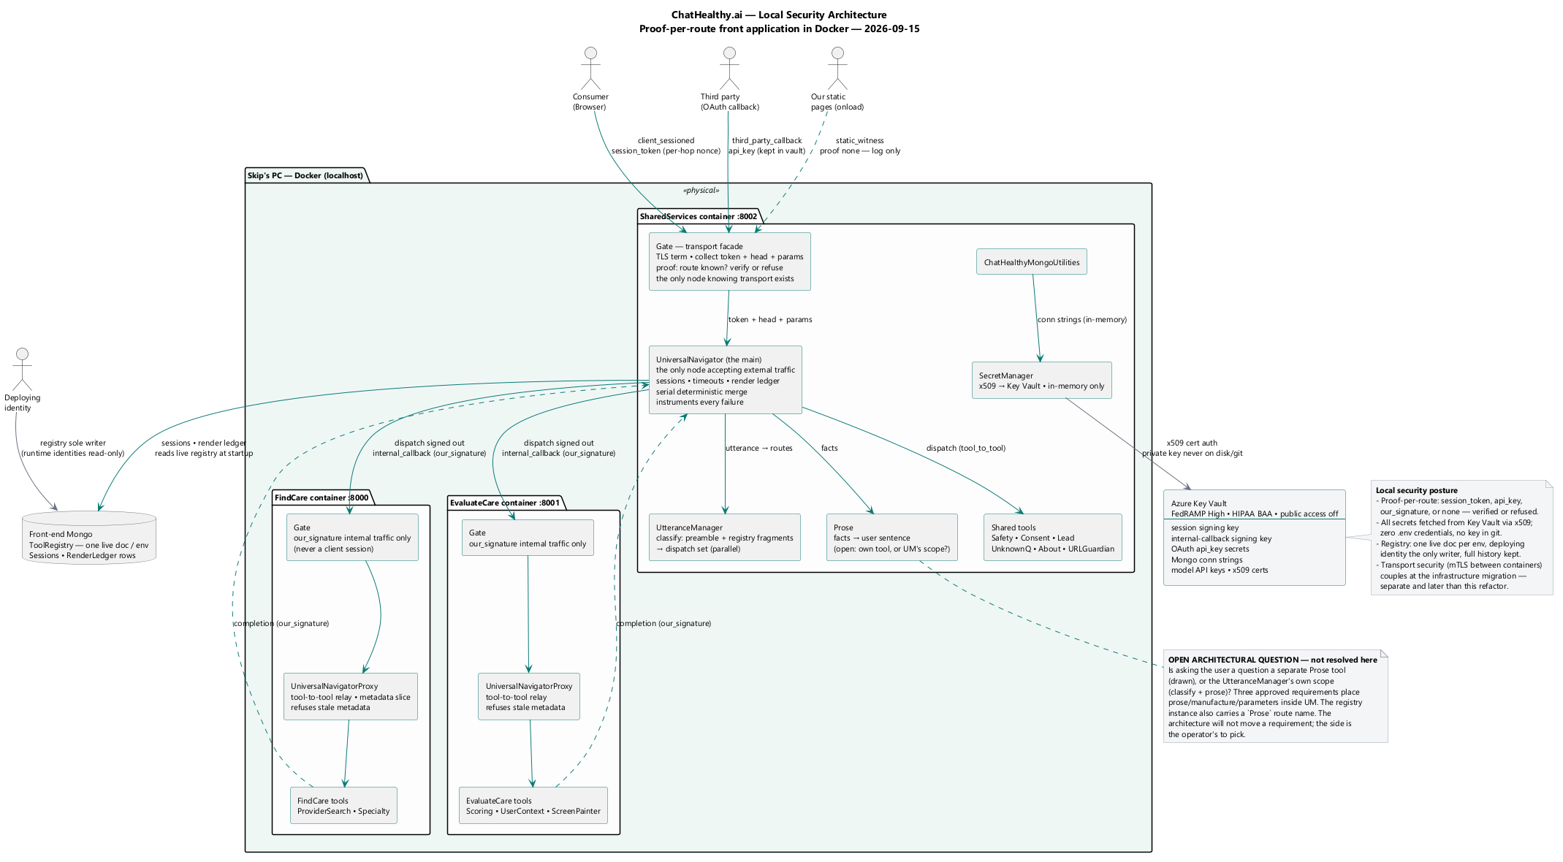
The same architecture in the local environment, where the agent's workstation is inside the boundary rather than outside it.

11. Compliance posture — [R]
The architecture contributes evidence, not claims. A control that produces an artifact an auditor can inspect is evidence; a control described in a document is a claim.
[I] The operator's recorded assessment is "we are so far away from NIST it is not even funny," against the stated obligation "I'm going to have to pass a NIST 800-53 audit." Nothing below softens that.
area | NIST 800-53 | HITRUST | evidence, and its state
identifier and credential management | IA-2, IA-5, IA-8 | 01.b, 01.q | The registry and the certificate registry, machine-readable and comparable to the platform. [I] The certificate registry has no reader or writer — R-18.
no shared secrets | IA-5 | 01.d | No password exists for a person (OAuth only) or a component (X.509 only). Provable by absence: there is no password store to audit.
least privilege | AC-6 | 01.c | The entitlement report's per-user, per-right enumeration, stated from actions carried rather than descriptions written.
access review | AC-2(7), AC-6(7) | 01.a | The periodic report plus recorded human sign-off, with the approved population read from the published record so the audit cannot grade itself. [I] Bounded by R-13.
session authenticity, replay | SC-23 | 10.h | The nonce advances per hop under signature. [I] Freshness is not checked at verification, so the replay claim is not yet supportable — R-3.
transmission confidentiality | SC-8, SC-13 | 09.m, 10.f | TLS everywhere; mutual TLS on every non-browser path, with a registered bug where the substrate cannot host it. [I] Undercut by R-14 and R-33.
boundary protection | SC-7 | 09.m | One Gate; every other URL 404s. Testable in a single assertion, and currently failing it. Three routes answer outside the Gate (R-26, R-34, R-35) and one service authenticates none of its own (R-20). The evidence a buyer should ask for is the assertion's output, not this row.
audit generation | AU-2, AU-3, AU-12 | 09.aa | The security audit stream for logins; the conversation archive for every utterance, verbatim, attributed, carrying both the time made and the time archived so latency is measurable. The UniversalNavigator and its proxies instrument every failure they see — a dispatch that dies, a callback that never comes, a timeout, a merge conflict — with timings and a severity matching impact, because the caller is the client that logs the failures of what it calls.
audit record protection | AU-9 | 09.ac | Capture is durable and acknowledged; forced loss is itself recorded. Authorisation records live outside the governed repository on a role with insert and no update or delete. [I] R-30. The navigation registry is single-writer and append-only — writable by the deploying identity alone, one live instance per environment enforced by a unique partial index — so what is live can be read back and contradicted.
non-repudiation | AU-10 | 09.ab | Partial. The archive attributes every utterance. Commits are not signed by a key the workstation cannot reach — R-7.
change authorisation | CM-3, CM-5 | 09.b | Real and enforced for commit, identity change, promote and deploy, with a bypass detector git cannot skip. [I] Not enforced for direct platform change — R-1.
baseline configuration | CM-2, CM-6 | 09.a | Not achieved. What runs cannot be reproduced from the record.
de-identification | — | HIPAA §164.514 | Not achieved. Specified, unbuilt — R-10.

What a buyer should be told without asking. Mutual TLS is required by approved requirement and is not achieved on the front-end substrate; the gap is carried as a defect, not waived. Deployment is not reproducible from the repository in either direction. The audit of the firm's own grants is produced by a principal inside its own population. And no approved requirement states what a model vendor may retain, train on, or log — the architecture can bound what is sent; only a contract bounds what is kept.

12. Conformance — the check a program could run
Each principle, and the check. Following S-3, each check names an effect and declares whether it has ever gone red.

12.1 S-1 — the check
Name the granted privilege the control withholds — as an action, not an intent — then perform three enumerations, all of which must come back empty. This form is the Enterprise Architecture G-6's, adopted here, and the reason it is the sharper form: it requires an enumeration rather than an assertion, which is why a document cannot satisfy it by being well written.
- **Every assignment, grant, role or policy conferring the withheld privilege on
the constrained party, at or above the scope where the constraint is written.** Permission systems are additive: a condition on one assignment constrains that assignment and nothing else.
- **Every control plane that can rewrite the constraint, and every credential
reaching one.** A grant that withholds delete is defeated by whoever can rewrite the grant.
- Every second-hop route — any privilege that can hand out the withheld
privilege, including the constrained party's own role, without which the holder deletes its conditioned assignment and creates an unconditioned replacement.
The enumeration is performed against the platform, not the repository, which makes S-1 a special case of S-2 and the sharpest one.
A control that fails any enumeration is documented as a convention — not upgraded in prose to a guarantee. Conventions are worth having: they stop accident, distraction and drift, and they produce a record. They are not evidence against a deliberate actor, and a governance claim asserts evidence.
[I] Result, applied to sixteen controls. Two pass: content-addressed approval binding (nobody can transplant an approval onto different content — mathematics), and the remote branch tip (the remote decides what the ref contains). The fourteen that fail are in section 13, each as a row.
Limitation, stated because S-3 applies to S-1's own check: it is a human procedure with no executable form. It cannot report a false green because it reports nothing on its own. It has never been wired to a hook, a build, or anything else.

12.2 S-2 — the check
For each fact the architecture asserts, name three things: the declaration, the independent reading, and the principal that performs the reading. The fact is evidence only when all three exist and the third is not the party the declaration constrains.
[I] Result, applied to seven security facts: six current, and one the target adds.
fact | declaration | independent reading | state
which principals hold which grants | the identity catalogue | the entitlement report, from the directory, the cloud and the vault | reading exists; performed by a principal inside its own population, authenticating with a client secret
which grants an identity holds in the database | the custom-role catalogue | nothing reads it back | none
which certificates exist, and when they expire | a required registry collection | no code reads or writes it | neither
which secrets a host holds | the target's secret declaration | specified, not built | none
which routes a service exposes unauthenticated | nothing declares them | nothing enumerates them | neither
which data classes reach which vendor | nothing declares them | nothing observes payloads | neither
which navigation registry is live per environment | the registry document's live instance flag | the store itself, read back under the unique partial index on instance.env where live is true | target: the reading is independent by construction — the deploying identity writes, every runtime identity reads, one live per environment the store enforces — but not yet built or exercised

Zero of the six current facts is fully independent. One has the right shape, and the seventh is a target whose independent reading the store's own index would supply. That fraction is the roadmap: independence of the reading is the whole game.

12.3 S-3 — the check
For each check, four questions:
- Name the mechanism the principle forbids, as behaviour, not as a spelling.
- Name what the check detects. If these differ, the gap is stated, not left
implicit.
- Exhibit at least one live true positive. A check that has never gone red
against a real violation is unproven, whatever it reports. Seed a known violation and confirm it fails; if it cannot be made to fail, it is not a check.
- Name what would silently change the answer — a refactor, a library swap, a
new spelling — and prefer a check that reads a declared value over one that enumerates spellings, because an enumeration is a race against the next one.
Two corollaries. A check derived from a bug description inherits the bug's staleness. And prefer a check that reads a declaration over one that pattern-matches source — that is S-2 one level down.
[I] Result of running question 3 on this firm's checks. A vendor-SDK check: never red, mechanism deleted. This document's own verify=False check: never red, and green over a live violation. Rule-065-ENF-008: green across 569 runs, never once red — on that evidence a hypothesis rather than a control.

12.4 Checks this framework asks the build to run
Named as effects, per S-3 question 1.
# | the build refuses if | never-red?
1 | any runtime module disables peer certificate verification by any means — a falsey verify however spelled, CERT_NONE, check_hostname = False, attribute assignment, or a non-default transport — and the shared library's cross-service call does not take its posture from the deployment record | unproven; seed a violation
2 | any cross-frame receiver reads a message without validating the sender's origin, or any channel carries executable source | unproven; seed a violation
3 | a served origin ships without a Content-Security-Policy excluding unsafe-eval | unproven
4 | a signature verification selects its key from the object being verified | unproven
5 | a principal's union of platform assignments confers a granted privilege the architecture withholds from it | not built; requires the live read of §12.2
6 | the navigation registry it generated names more than one live instance for any environment, or names a route or tool the build did not generate from source | not built; enforced at insert by the store's unique partial index
7 | the may_call graph the registry declares contains a cycle, or a subscription or may_call entry names a route or tool absent from the registry | not built; the generator enforces it

Clause two of check 1 is the durable half: an enumeration of spellings is a race; a value read from a record is not.

13. Non-compliance register
What the target says, where the code is not there, what would close it. Every row names its evidence type, and prose is not one. Ordered by consequence. Numbers are stable references used elsewhere in this document and are not renumbered.
# | target | divergence | evidence | closes it
R-28 | §10 — no cross-frame channel carries executable source; a receiver validates the sender's origin; a served origin publishes a CSP. | The wrapper's message listener performs no origin check, and one message type executes an attacker-supplied string as code in the wrapper's own origin — the origin holding the session token. The site publishes no CSP at all, so nothing blocks it. Any hosted frame, or content injected into one, obtains code execution and the session token from a single message. Needs no credential, no insider, no network position. | behaviour | Delete the exec path; check the origin against an allowlist; publish a CSP. Three independent fixes; all three should land.
R-29 | §3.2, §5.3 — one secret per identity, granted per secret; no principal holds vault-wide administration over a vault holding other identities' credentials. | The agent holds unconditioned vault-wide administration on the vault holding every identity's certificate. Since the certificate is the credential, the agent is every identity in the firm, and the audit trail names whichever it presents. The CA root key is in the same vault. | data (live platform) | Withdraw the vault-wide grant; grant per secret. One role assignment, and the highest-leverage change available.
R-11 | §3.1, §8.4 — a new identity requires a person's approval; a constraint cannot be lifted by the constrained party. | The custom role reads Actions:["*"] NotActions:[] DataActions:["*"] — it withholds nothing. The self-including condition is applied and intact and governs nothing, because unconditioned Owner sits beside it and platform RBAC unions a principal's assignments; plus tenant-root User Access Administrator. The registry declares neither of those two grants. | data (live platform) | Restore the role definition; remove the additive grants; then the condition means what it was designed to mean. Enumerate the union, then check the union.
R-22 | §8.3 — the authorisation is produced by a human act the governed process cannot perform. | The presence proof is a client-supplied string the server trusts; the real tests run in page JavaScript and arrive as a form field. The approval URL is written to the gated process's own stdout and the token is in the page body, on plain HTTP on loopback. This is the shared function behind commit, promote, deploy and data migration. | behaviour | Move the answer off the machine the governed process runs on. No same-machine hardening closes this — it only changes which field is forged.
R-1 | §4.1 B6 — a state-mutating call to a remote platform outside the sanctioned chain carries a human authorisation given at the moment. | No enforcement exists, at three independent levels: the rule carries an empty enforcement list, the tool-use hook is not registered, and the harness permission layer is disabled. A standing document instructs the agent to route such calls through a wrapper that is not on disk. | data + behaviour | An approved requirement stating what an agent may do to a remote system unsupervised. None exists. Meanwhile the document naming a non-existent control should not stand.
R-33 | §4.1 B5 — the deploy verifies rather than asserts, over an authenticated connection. | The deploy's read-back — the evidence path for the requirement making agreement "the only evidence the deploy succeeded" — runs over a TLS context with check_hostname = False and verify_mode = CERT_NONE. Anything answering on that address satisfies the read-back. Compounds the separate finding that the target reports a number baked into its own image. | behaviour | Verify the chain on the read-back. Also 03_devops's to carry.
R-30 | §7.2 — a prohibition expressed as a withheld grant is enforced by the store. | The append-only governance grant and the single-writer grant are control-plane objects, and the key that can replace either sits in plaintext on the workstation. Its resting state is read-only and it cannot elevate itself (§8.4.1), so the exposure is live only while the operator's elevation is in force — but inside that window nothing gates its use per action and a grant rewrite leaves no authorisation record, which has happened. So both grants are real controls against their writers, and against the agent they are controls for exactly as long as nobody has elevated it. Separately: the credential that verifies a grant is the same one that rewrites it under elevation, so no reading is available to a principal that cannot also write. | data + behaviour | An auditing credential that cannot be elevated. That unblocks the two unverifiable grant claims below and makes the resting state itself falsifiable.
R-31 | §8.3 — a gate that cannot be skipped is enforced by a party other than the workstation. | The git hooks directory is a workstation path, writable by the agent's own process, and not version-controlled, so no commit gate observes a change to it. The post-commit rollback is a real control against a bypass flag and not against deleting the hook. | behaviour | Server-side refusal: branch protection plus the hosted check.
R-2 | §6.4 — the verifier selects the trust anchor from its own configuration. | The expected origin is read off the token being verified, so the comparison can never fail. One site does it correctly, by bypassing the shared helper and passing a constant — that site is the pattern. | behaviour | Pass the verifier's own origin. One word. Then make the correct site the only pattern.
R-14 | §4.3 — the caller verifies the peer's chain; a library carries no policy. | Twenty runtime call sites disable peer verification, the worst being the shared library base class — the same call that forwards the session token to a peer, so the library ships one line removing transport authentication from every tool that inherits it. | behaviour | Verify the chain; take the posture from the record. See check 12.4/1.
R-10 | §9.2 — a distress record is de-identified before storage and never stored alongside a network identifier. | The consent and de-identification layer is specified and does not exist — no service, no module, no symbol. The verbatim utterance reaches a vendor through the classifier on every typed user's web request, and the lockout path stores the trigger message and conversation history beside the IP address. A second, worse implementation exists as dead code. | behaviour | Build the specified layer. Delete the dead service rather than fix it — leaving it invites someone to restore a second exposure.
R-20 | §4.2 — every route behind the entrance is authenticated. | One service authenticates none of its five routes; on one of them a verification verdict is computed and never branched on, so a token with a bad signature returns 200 with the full payload. An unauthenticated endpoint enumerates which secret names are set in the process environment. | behaviour | Branch on the verdict. Remove the secrets and debug endpoints.
R-3 | §6.2, §6.5 — the signature covers every field the verifier relies on; verification checks freshness. | The signed payload covers a subset: the moving half of the nonce, the environment and both timestamps are unsigned and an intermediary can rewrite them. No expiry, freshness or replay check runs at verification; the helpers that would do it exist and are never called. | behaviour | Sign the full nonce and the environment; check freshness. Until then the replay control is a claim.
R-4 | §8.3 — the record of an authorisation lives outside what it governs. | The gate on the most sensitive surface — identity and role-grant changes — writes no durable record at all, only a log file inside the repository it governs, and its audit-write failure is silent. | behaviour | Give it the commit gate's record. Both mechanisms already exist.
R-13 | §7.3, S-2 — the review is independent of what it audits. | The report authenticates with a client secret rather than a certificate, and that principal appears in its own population and is the one reading the directory and every subscription. | behaviour | A reader that is not the agent and not a principal in the population.
R-12 | §7.2 — served data has exactly one writer, and a destructive act carries an authorisation. | A standalone script connects to the serving cluster and drops the destination collection unconditionally before refilling it, with free-text environment arguments and no dry-run default. No approval, no record, no rule fires on execution. Committing a change to it is gated; running it is not. It is also undeclared in the record, so no gate can see it at all. | behaviour | Retire it, or route it through the chain's authorisation. Widest ungated destructive path found.
R-9 | §9 — model choice is architectural; every call goes through one facade. | Eight call sites construct their own model agent outside the facade. The defect record instead describes eleven vendor-SDK call sites: of the four that exist, one is unused, two are unreachable and one is the facade itself, and a scan of those patterns over those trees finds no live vendor-SDK bypass. A remediation aimed at the described mechanism touches four files, three of them dead, and leaves every live site untouched. | behaviour | Route the live sites through the facade.
R-17 | §5.1 — the firm operates its own certificate authority. | The minting library was deleted; the function that would call it checks for it and refuses cleanly, and is itself called from nowhere. Issuing does not work; validating does. | behaviour | Restore issuance, or amend the requirement.
R-36 | §5.2 — EPIC-002-F-003-S-006-REQ-B-004: a short-lived identity self-mints a certificate as it comes into existence; a long-lived certificate expires on a schedule short enough that a compromise cannot outlive one management cycle. | Two clauses of an approved requirement, unimplemented. Nothing self-mints — there is no CertificateBuilder, no not_valid_after and no validity duration anywhere in the firm's Python, and the one minting function on disk imports an absent module and has no caller. And no management cycle is defined anywhere, so the rotation clause has neither a driver nor an interval to drive to. Note what this is not: the requirement's short-term-certificate clause is a permission, and not exercising it is compliant — the gap is the two mandatory clauses, and neither is closed by choosing a lifetime. | requirement + behaviour | Self-mint needs an issuer, which is R-17. The cycle needs the firm to state what a management cycle is. Delete the dead minting path rather than leave it looking like a mechanism.
R-8 | §5.3 — no secret sits on any disk; a materialised key does not outlive its process. | The connection utility writes the decrypted certificate and private key to a process-scoped temp path and never deletes it; the permission call's failure is swallowed. Each file is a full credential. On long-lived hosts they accumulate. | behaviour | Remove on close or exit; do not swallow the permission failure.
R-23 | §4.3 — no boundary is crossed by presenting a static shared secret. | An enabled edge rule exempts any request to a data path carrying a named header equal to a shared secret from every edge control the firm has — WAF, rate limiting, bot management, zone lockdown, user-agent blocking. | data (manifest) | Authenticate that path by certificate, or scope the exemption to something the edge can verify. Being in the manifest is the system working; the mechanism is the defect.
R-6 | §6.5 — resuming a session requires proof of possession of the prior token. | Knowledge of a 32-character identifier is sufficient to obtain a freshly signed token; existence and expiry are the only checks. That identifier travels in request bodies across every hop. This is a defect in the resume path and is independent of where the route lives — it remains true after the route is routed through the Gate. | behaviour | Require the prior token, or a proof derived from it, on resume. Minting a new session needs no credential and should stay open.
R-21 | §4.1 B3 — network posture is declared; grants are scoped. | The pipeline cluster declares an allowlist of 0.0.0.0/0; the cluster that serves users declares no network posture at all. Separately, the deploy identity holds database-wide write reaching the certificate registry, and the agent holds read on every database. | data (manifest) | Declare the serving cluster; scope the deploy identity to the two collections it governs.
R-25 | §8.3 — the gate fails closed; a waiver requires an echoed token. | An environment variable, settable by the process being waived, downgrades a failed requirement to a warning on the gate governing the only writer of production data. The mechanism is careful — two variables required, wildcards rejected, every waiver emitted as a violation record — and it is still a waiver implemented in code, with no ask and no echoed token, which is the one direction the firm's own discipline forbids. | behaviour | Require the override to carry an authorisation recorded as an approval is. The machinery exists.
R-26 | §4.2 — every request arrives at the Gate and no other route answers. | The OAuth callback answers outside the Gate. It is a registered address the firm does not originate traffic to, which the requirement accommodates — the Gate owns the URI, collects the facts and dispatches, and the method is the sender's. The redirect carries an HMAC-signed session reference in state, the fact-collection machinery exists, and the handler is a separate module. Routing it is one entry in a dispatch map. | behaviour | Register the address on the Gate and add the dispatch entry. Carried by the Refactor Plan's Phase 5a.
R-35 | §4.2 — every request arrives at the Gate and no other route answers. | Session issuance answers outside the Gate. This one is a genuine either/or and only the operator picks: an unauthenticated op on the Gate weakens "no op is exempt", and a separate endpoint weakens "one entrance". It is firm-originated traffic, so the POST clause binds it either way. Note that the two halves differ — minting a new session needs no credential and confers nothing, while resuming one is R-6 and is a defect wherever the route lives. | behaviour | Both dispositions are compliant with a different clause and neither is available to this document.
R-34 | §4.2 — every request arrives at the Gate and no other route answers. | Health and liveness routes answer outside the Gate on three services. Where a platform probes liveness, that is not a client call and is not a compliance question about client traffic; where the firm's own client or chain calls a health route, it is a route outside the Gate like any other. The two cases are separate findings and not one. | behaviour | Register the address on the Gate for the firm-originated case. The platform-probe case needs the operator to say whether a platform's liveness contract is in scope at all.
R-7 | §8.5 — a bot's authority is proved by a signature over a key the workstation cannot reach. | No commit-signing identity exists; agent context is distinguished by environment markers the process can set. Non-repudiation for commits is not achieved. | behaviour | A signing identity held only in the vault, and a gate that checks the signature.
R-18 | §5.5 — a registry maps each subject to its key material's location. | The registry collection is required and no code reads or writes it; the facts live as tags on vault secrets. The firm cannot answer "which certificates are live" or "which expire this month" from any source. | behaviour | Build it, or amend the requirement.
R-27 | §5.3 — deploy provisions credentials and loses read. | The design record and the code state opposite positions on who mints during a deploy. The code's position is the coherent one; §5.3's "loses read after writing" was written against the design's model and cannot be true of a deploy that never writes. Compounded by R-17: neither party can mint today. | behaviour + intent | Settle which is target and correct the other.
R-15 | §8.5 — a model may not authorise a change. | A record states that a model signs off promotion into one environment while a human signs off production. Those are different categories of control wearing one word. | data | State which authorisations are human and which are machine, and record them as different kinds of fact.
R-16 / R-32 | §9 — the permitted-data-class set per vendor is declared and enforceable. | No approved requirement states what a vendor may retain, train on or log, and no record declares a permitted field set per vendor — so §9's table binds nobody and the conformance check cannot run. The Enterprise Architecture rules that its home is a key inside the deployment record. | requirement (absence) | The operator decides whether a requirement compels it. Contents are this document's; the home is the parent's.
R-5 | §8.4 — no second-hop route to a withheld granted privilege. | Attaching a system-assigned identity to a resource mints a principal as a side effect of the resource write, and no permission list or assignment condition reaches it. Documented by the firm rather than discovered by an auditor. | intent | A policy denying identity-on-resource-creation.
R-19 | §3.1 — one identity, one credential; database users are scoped to their cluster. | Password users are reported to exist alongside certificate identities, and one pipeline identity is reported to carry no cluster scope. Unverified. The only credential that could confirm this is the one that rewrites it under elevation — see R-30 — and this document does not use it. | unverified | Stated as unverified rather than asserted.

On the three Gate rows. R-26, R-34 and R-35 are routes outside the Gate. The Refactor Plan (architecture/TargetArchitecture/6_RefactorPlan.docx) carries the work at Phase 5a, which registers the addresses the firm does not originate traffic to and dispatches them through the Gate's fact-collection path. R-35 is not closed by that phase and cannot be: it is an operator decision, and the phase records it as blocked on one.

15. What transfers
For a reader deciding what to adopt.
section | transfers | ChatHealthy-specific inside it
§2 the three principles | whole — this is the section to read first | the three worked demonstrations of S-3
§3 identity model | whole | the seven identities
§4 trust boundaries | the rows and both obligations | the hosting platform's limit
§5 CA, lifetime, custody | whole | the deleted issuer; the requirement conflict
§6 the session | whole | nothing
§7 least privilege | whole | the role-edit incident
§8 the agent as principal | whole, and it is the part with no precedent | the live grants
§9 model vendors | the rows and the three rules | which vendors, and the ten-utterance window
§11 compliance | the evidence/claim distinction and the table's shape | the named frameworks
§12 conformance | whole | the results
§13 register | nothing — it is evidence | all of it

A different firm adopts §2 through §10 and §12 entire, and replaces §11's frameworks and §13. Nothing in §2 is about healthcare and nothing in §2 is about this company.
The one division worth the reader's attention: §2's three principles are what a firm needs when the agent writes the controls, the records and the checks. A firm that adopts only the identity model and the boundaries has built a security architecture. A firm that adopts §2 as well has built one that can be audited by someone who does not trust the party that wrote it — which, in an AI-native corporation, is the only kind worth having.

