Name: ---------
Date: 3/13/2020
15.07 Picture Lab Worksheet
Directions: Make note of your responses to the following questions as you work through the activities and exercise in the lesson.
Activity 5 Questions
Question | Yes | No
- Is the method getPixels2D in the Picture.java class? |  | No
- Is the method getPixels2D in the SimplePicture.java class? | Yes
- Will the following code compile?  DigitalPicture p = new DigitalPicture(); |  | No
- Assuming a no-argument constructor exists for SimplePicture, will the following code compile?  DigitalPicture p = new SimplePicture(); | Yes
- Assuming a no-argument constructor exists for Picture, will the following code compile?  DigitalPicture p = new Picture(); | Yes
- Assuming a no-argument constructor exists for Picture, will the following code compile?  SimplePicture p = new Picture(); | Yes
- Assuming a no-argument constructor exists for SimplePicture, will the following code compile?  Picture p = new SimplePicture(); |  | No

Activity 5 Exercise Results

- Describe your method for keepOnly red, blue, or green.
  - My method uses the same code as the ZeroBlue method, except that I changed the part that sets the blue value to 0 to changing red and green values to 0.
- For the negate method, paste your code related to calculating and setting the values for red, blue, and green.
public void negate() {
Pixel[][] pixels = this.getPixels2D();
for (Pixel[] rowArray : pixels)
{
for (Pixel pixelObj : rowArray)
{
pixelObj.setGreen(255 - pixelObj.getGreen());
pixelObj.setRed(255 - pixelObj.getRed());
pixelObj.setBlue(255 - pixelObj.getBlue());
}
}
}
- Paste a copy of the image that is the result of calling the grayscale.
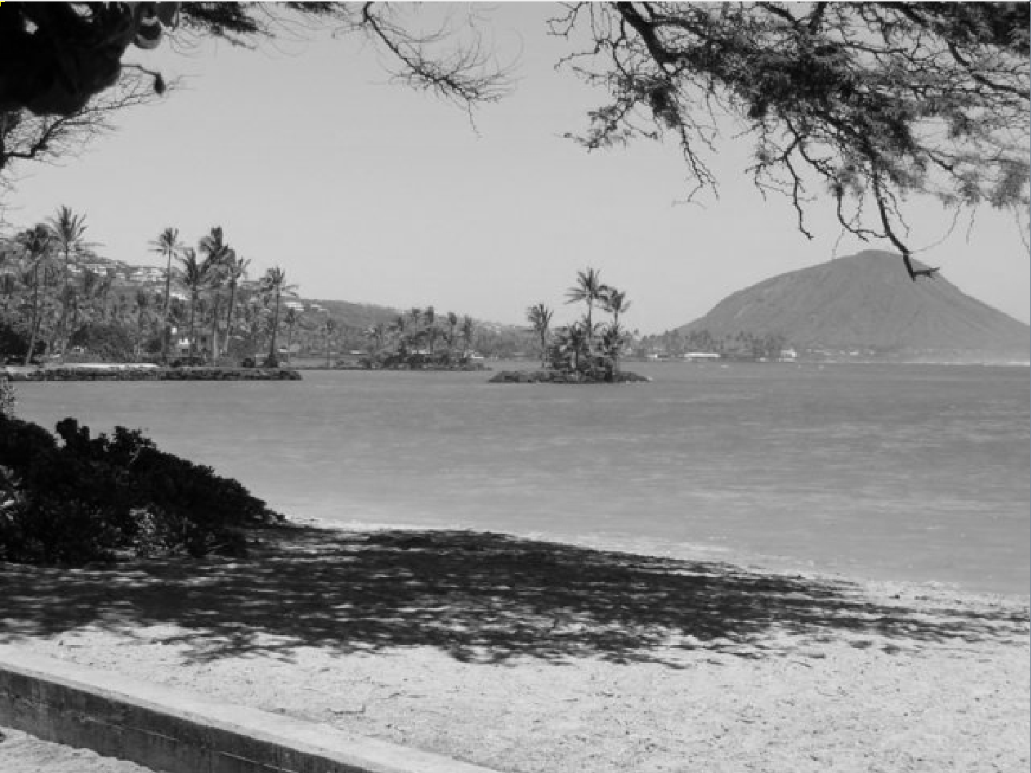
- For the method fixUnderwater, describe the algorithm you'd propose to accomplish the task.
  - For the fixUnderwater method, I would use an algorithm that filters out or reduces the blue values in the image in order to make the picture a little more clear, whilst boosting colors like red and green to make it easier to see. I would really just like to remove the cloudiness and improve the clarity of the image, so I would probably sharpen it aswell.
Activity 6 Exercise Results
- Paste the image that is the result of calling the method mirrorVerticalRightToLeft. 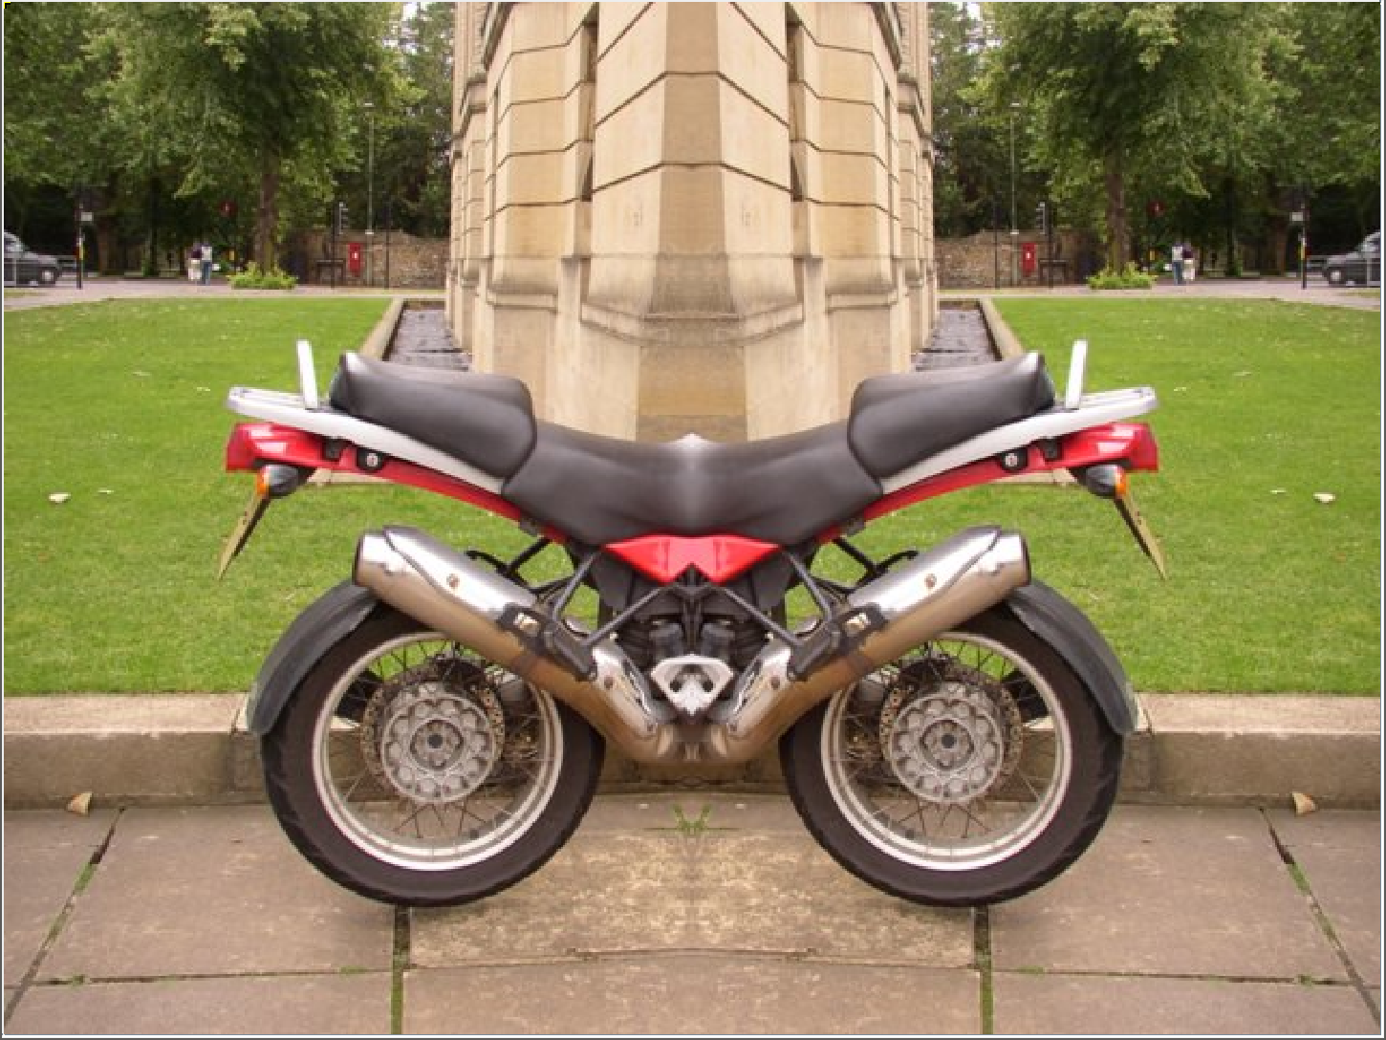

- Describe the algorithm for the method mirrorHorizontal works.
  - The algorithm for mirrorHorizontal works by getting the color of the pixels at the top of the image and reflecting them down to the bottom of the image using a 2D array. It just goes through every pixel until the halfway point and copies it down to the bottom.
- Paste the image that is the result of calling the method mirrorHorizontalBotToTop.
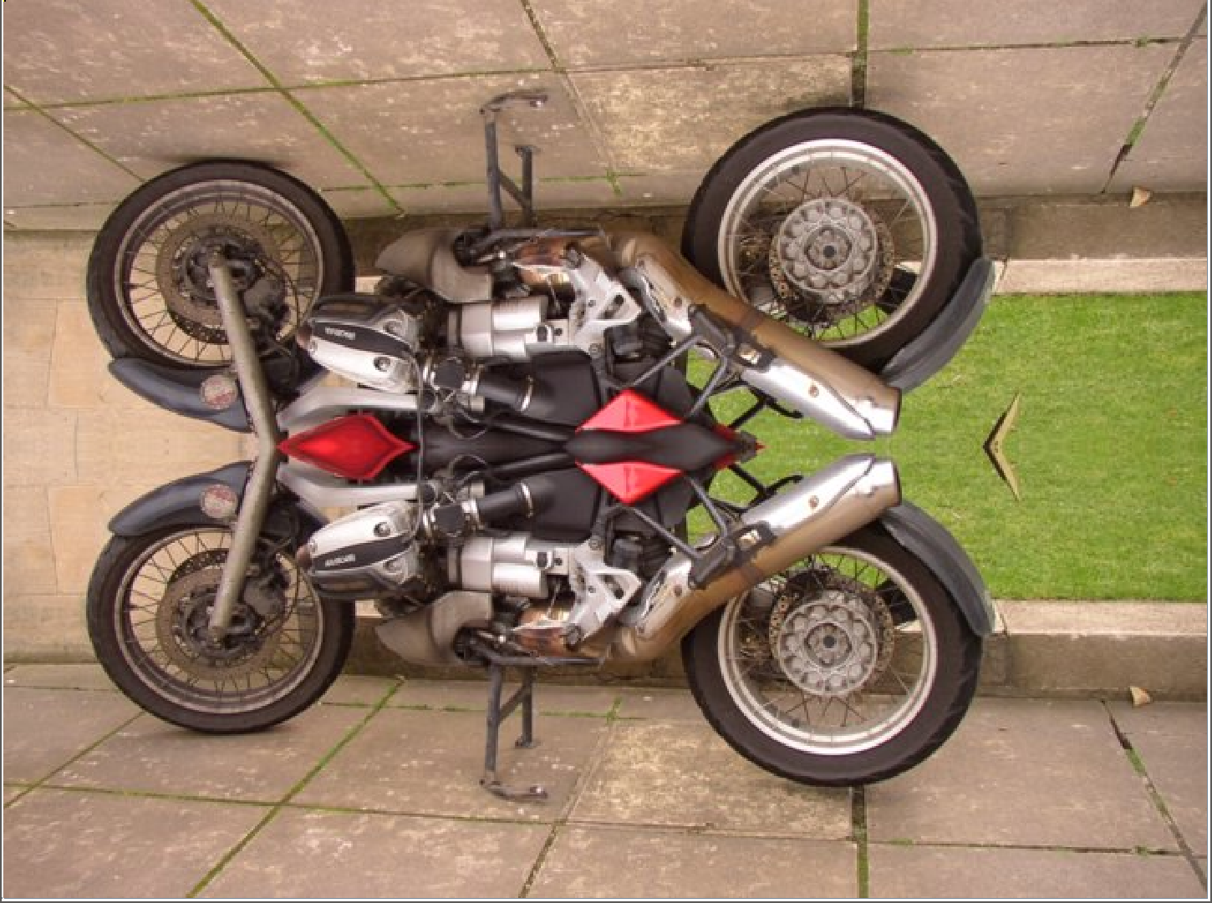

Activity 7 Questions
  - How many times would the body of this nested for loop execute? __90___
for(int row = 7; row < 17; row++)
for(int col = 6; col < 15; col++)
  - How many times would the body of this nested for loop execute? __90___
for(int row = 5; row <= 11; row++)
for(int col = 3; col <= 18; col++)

Activity 7 Exercise Results

- What value is displayed for count after the nested loop ends in the mirrorTemple method?
  - 1840 times
- Paste the image that is the result of calling the method mirrorArms.
  - 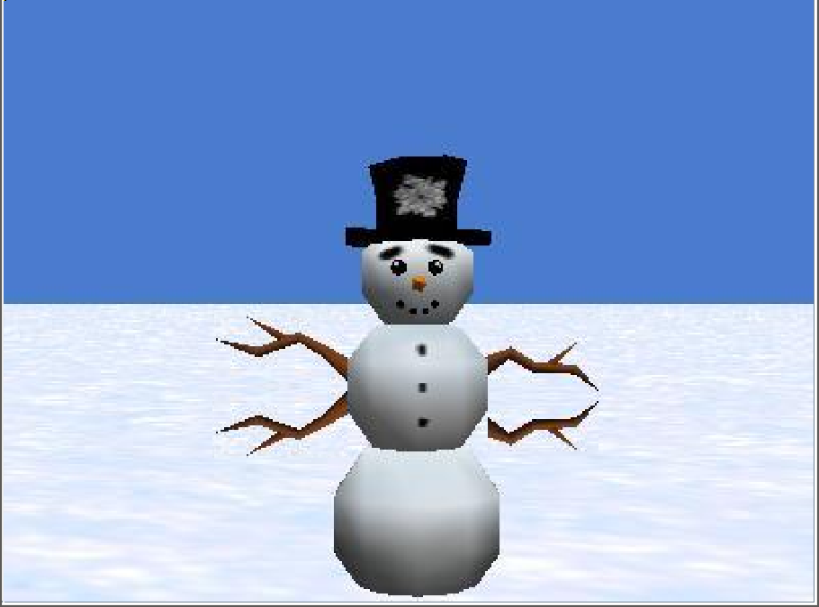
- Paste the image that is the result of calling the method mirrorGull.
