Name: ----- -----
Date: ----- ------
16.06 Picture Lab Worksheet
Directions: Make note of your responses to the following questions as you work through the activities and exercise in the lesson.

Activity 8 Exercise Results

- Paste the image that is the result of calling the second copy method that adds parameters to allow you to copy just part of the fromPic.
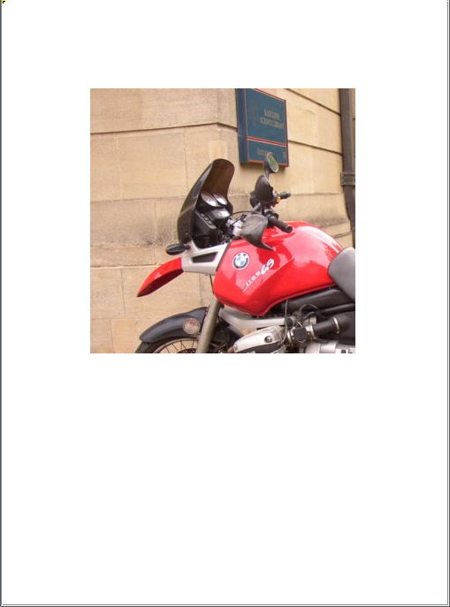
- Paste the image that is the result of calling the myCollage method.
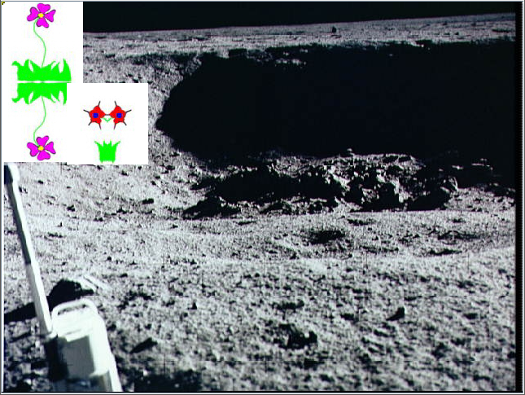

Activity 9 Exercise Results
- Paste the image that is the result of calling the edgeDetection2 method.
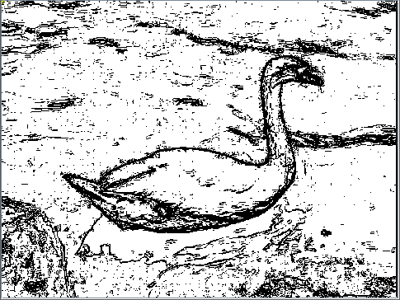
- Think about and propose another algorithm for edge detection.
- You could combine up / down edge detection with left / right detection to make a super fine detailed image. You could also use different colors like light grey, grey, and black to tell the confidence of the program that the ‘edge’ is actually an edge.

