Исправление SQL-уязвимостей DB_SEC_SITE

1. Поиск клиентов: ' OR 1=1 --
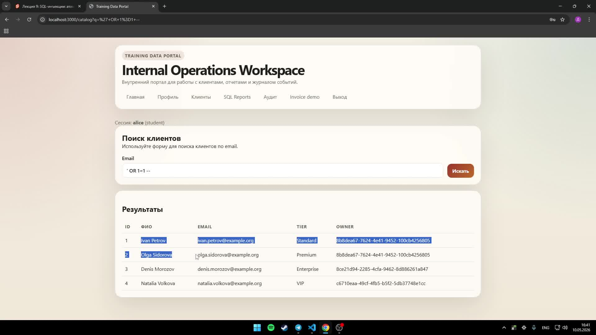
Исправление
export async function searchCustomers(search: string, userId: string) {
const normalized = search.trim();
if (!normalized) {
return { rows: [] };
}

const result = await pool.query(
`SELECT id, full_name, email, tier, owner_user_id
FROM training.customers
WHERE owner_user_id = $1
AND email ILIKE '%' || $2 || '%'
ORDER BY id`,
[userId, normalized]
);

2. Поиск клиентов: UNION SELECT
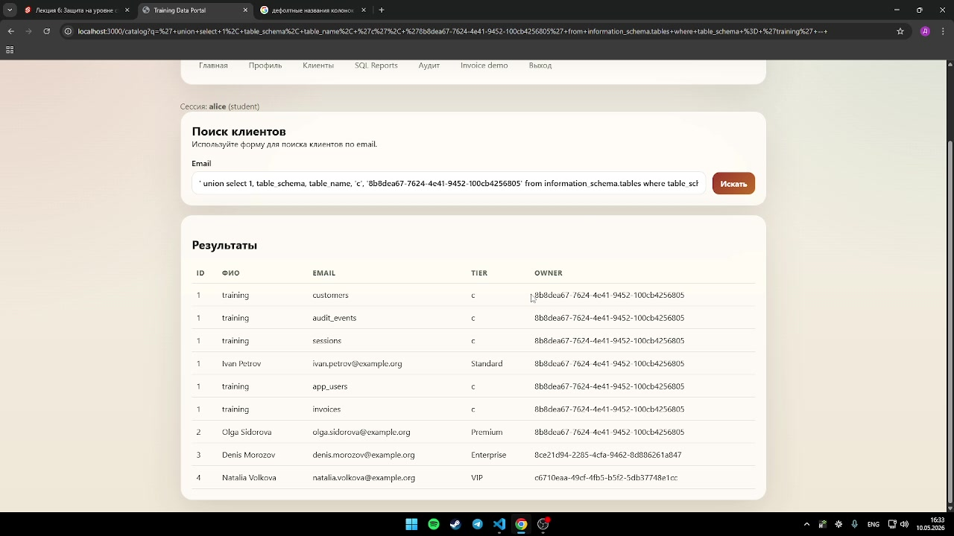
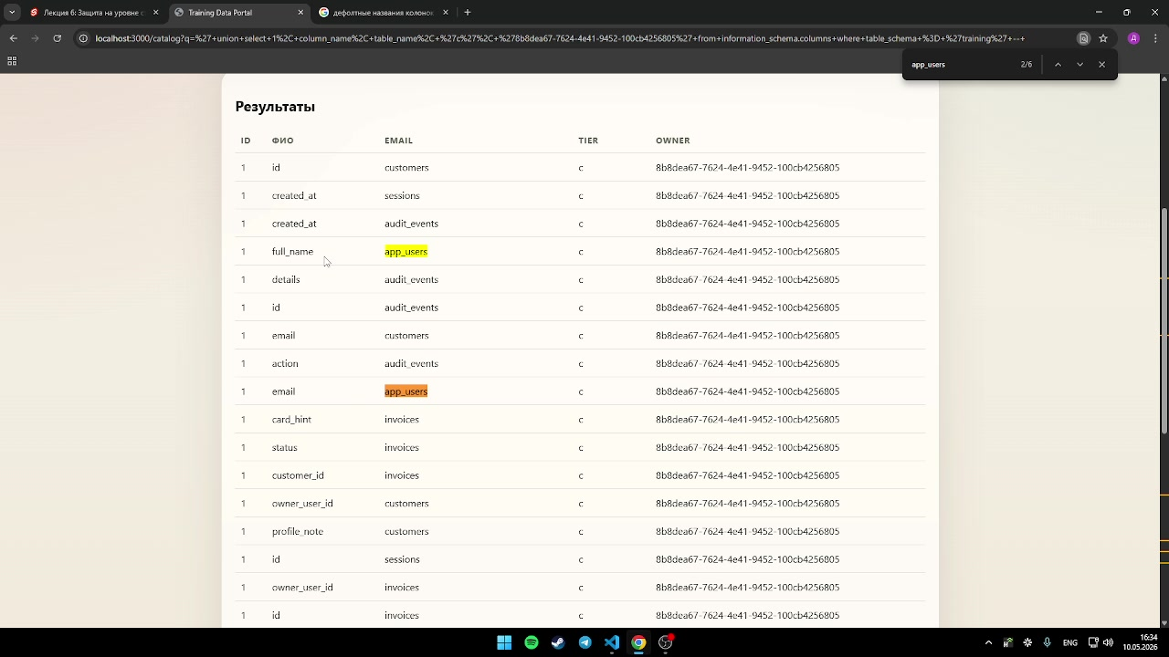
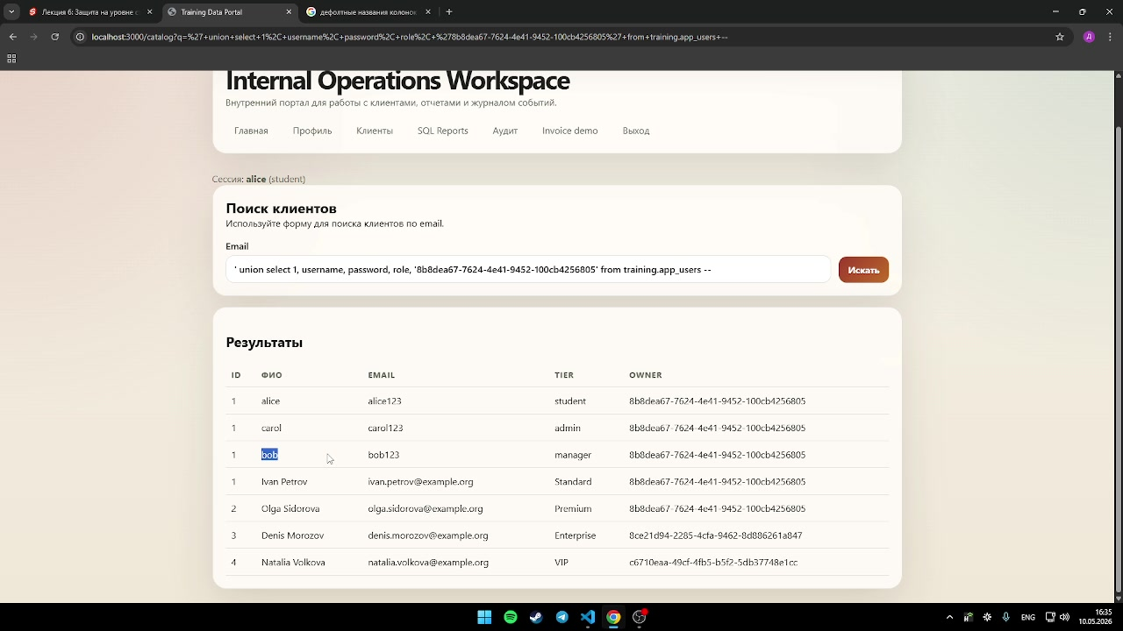
Исправление
CREATE ROLE catalog_reader LOGIN PASSWORD 'change_me_catalog_reader'
NOSUPERUSER NOCREATEDB NOCREATEROLE NOINHERIT;

GRANT USAGE ON SCHEMA training TO catalog_reader;

GRANT SELECT (id, owner_user_id, full_name, email, tier)
ON TABLE training.customers TO catalog_reader;

REVOKE ALL ON training.app_users FROM catalog_reader;
REVOKE ALL ON training.invoices FROM catalog_reader;
REVOKE ALL ON training.audit_events FROM catalog_reader;
REVOKE ALL ON training.sessions FROM catalog_reader;

3. SQL Reports: u.username = '' OR 1=1 --
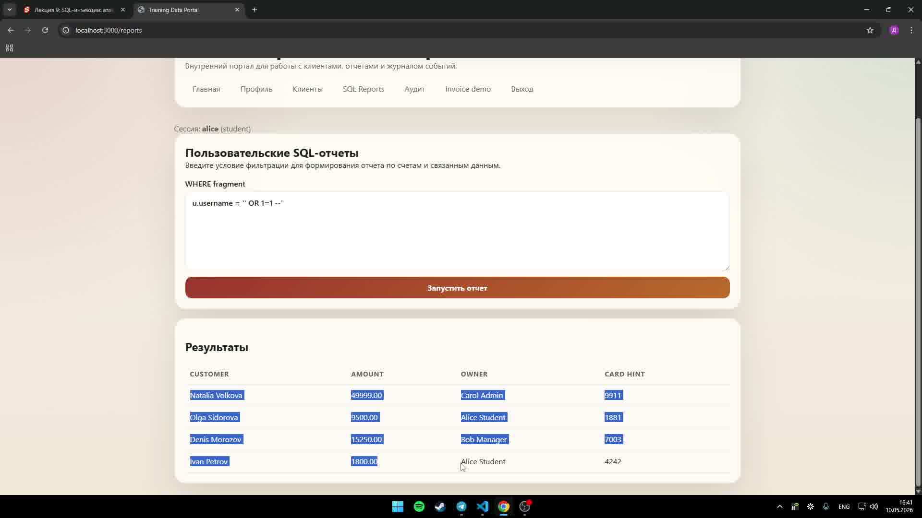
Исправление
export async function runUserReport(userId: string) {
const result = await pool.query(
`SELECT c.full_name AS customer_name,
i.amount,
u.full_name AS owner_name,
'****' AS card_hint
FROM training.invoices i
JOIN training.customers c ON c.id = i.customer_id
JOIN training.app_users u ON u.id = i.owner_user_id
WHERE i.owner_user_id = $1
ORDER BY i.id`,
[userId]
);

4. SQL Reports: u.username = 'carol'
u.username = 'carol'
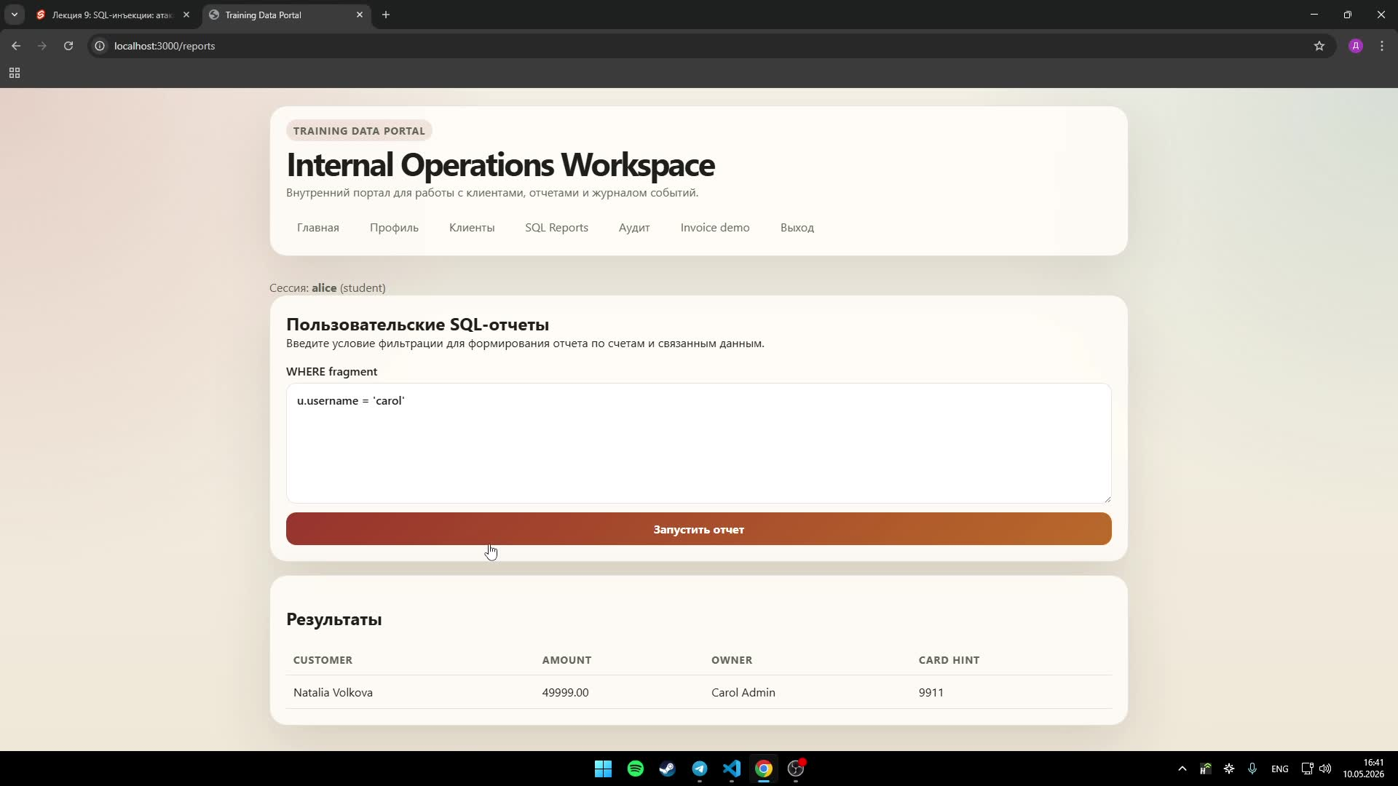
Исправление
const results = await runUserReport(locals.user.id);

export async function runUserReport(userId: string) {
const result = await pool.query(
`SELECT c.full_name AS customer_name,
i.amount,
u.full_name AS owner_name
FROM training.invoices i
JOIN training.customers c ON c.id = i.customer_id
JOIN training.app_users u ON u.id = i.owner_user_id
WHERE i.owner_user_id = $1
ORDER BY i.id`,
[userId]
);

return result.rows;
}

