|  |  |
| --- | --- |
| `  User Manual  Team Agile Solutions |  |

Team Agile Solutions

Business Information Systems Program

Saskatchewan Polytechnic

Moose Jaw, SK

June 23, 2017

Teresa Aho

Child and Family Co-ordinator

CNIB Saskatchewan

Regina, SK

Dear Teresa Aho,

The enclosed user manual outlines the basic information and instructions needed to operate the virtual reality game - Project ViREO. The purpose of the project is to use virtual reality technology to create a game that is accessible to visually impaired kids and will be played at the Saskatchewan CNIB summer camp. This project was authorized by Craig Nielsen and Gavin Osborne of Saskatchewan Polytechnic. It was completed with help from CNIB Saskatchewan.

Topics covered in the user manual include: system and hardware requirements, installation, game design, and gameplay overview. The manual is comprehensive in terms of setting up and playing the game. However, it does not cover the troubleshooting steps needed to resolve any number of potential issues.

Project ViREO was made possible because of the help of many, Team Agile Solutions would like to sincerely thank the following people: Craig Nielsen, Gavin Osborne, Greg Olson, Teresa Aho, and all the kids who participated in the CNIB Regina Family Fun Day.

For further information on the HTC Vive, including troubleshooting steps, please refer to Valve’s extensive documentation located @ <https://support.steampowered.com/kb_cat.php?id=111>.

Team Agile Solutions welcomes any questions, suggestions, or feedback and can be contacted @ [Vireo.Proj@gmail.com](mailto:Vireo.Proj@gmail.com).

Thank-you and Happy Gaming!

Team Agile Solutions

Amanda Braun, Josh Couse, Subin Jacob, Tim Trott

PROJECT ViREO

Virtual Reality for Everyone

Presented to Craig Nielsen and Gavin Osborne

Saskatchewan Polytechnic

Prepared by Team Agile Solutions

Amanda Braun, Josh Couse, Subin Jacob, and Tim Trott

Date of Submission: June 23, 2017

TABLE OF CONTENTS

LIST OF ILLUSTRATIONS iv

EXECUTIVE SUMMARY v

INTRODUCTION 6

SYSTEM AND HARDWARE REQUIREMENTS 7

INSTALLATION 9

GAME DESIGN 15

Accessibility 15

Simple Game Design 15

Visual Field 16

Colour Contrast 16

Audio 16

Testing 17

GAMEPLAY 17

WORKS CITED 21

# LIST OF ILLUSTRATIONS

Figure 1 User Manual Relationship Diagram 6

Figure 2 HTC Vive Required Hardware 8

Figure 3 Example of VR Setup 9

Figure 4 Adjust Base Station 11

Figure 5 Link Box to PC Connections 11

Figure 6 Link Box to Headset Connections 12

Figure 7 Launch Steam 13

Figure 8 Launch SteamVR 13

Figure 9 Vive Controller 13

Figure 10 SteamVR 14

Figure 11 SteamVR Room Setup 14

Figure 12 Project ViREO Game Executable Shortcut 15

Figure 13 Game Options Scene - Scale Enemies 17

Figure 14 Game Options Scene - Next Button 18

Figure 15 Game Options Scene - Paint Colour 18

Figure 16 Game Options Scene – Back and Next Buttons 19

Figure 17 Game Options Scene - Lever 19

Figure 18 Game Scene - Shoot Enemies 20

Figure 19 Game Scene - Score and Timer Display 20

# EXECUTIVE SUMMARY

Project ViREO (Virtual Reality for Everyone) is an HTC Vive Virtual Reality (VR) game designed for individuals with a visual impairment. The game will be available to play at the Saskatchewan CNIB summer camp. This user manual was created to document all the information and steps needed to setup and play the game.

Within the manual, instructions are presented in the following order:

1. Assembly (System and Hardware Requirements).
2. Setup (Installation).
3. Run the game (Game Design and Gameplay).

First, the System and Hardware Requirements are documented in a comprehensive list of the HTC Vive hardware components. The hardware is provided by SaskPolytech and no additional equipment is needed.

Second, the Installation process is covered in step-by-step instructions. When setting up the play area be sure toclear the area of all cords, obstacles, and tripping hazards. It is compulsory that when the VR is in use there must be an attendant monitoring the player at all times.

For the official HTC Vive documentation, refer to:

* Equipment and installation - <https://support.steampowered.com/steamvr/HTC_Vive/>.
* Troubleshooting - <https://support.steampowered.com/kb_cat.php?id=111>.

Third, game design elements are discussed. To enhance accessibility the game uses simple game design, contrasting colours, VR technology, audio descriptions, and feedback obtained through testing. Detailed gameplay instructions are included; the step-by-step instructions outline how to play and interact with the VR game environment.

# INTRODUCTION

The Project ViREO User Manual aims to prepare any user, without prior knowledge, to setup and play the Project ViREO virtual reality (VR) game. It is recommended that first-time users take the time to review the entire user manual. For an overview of the user manual or to jump to a section, refer to the table of contents. Topics are presented in the sequential order needed to successfully assemble, setup, and run the game.

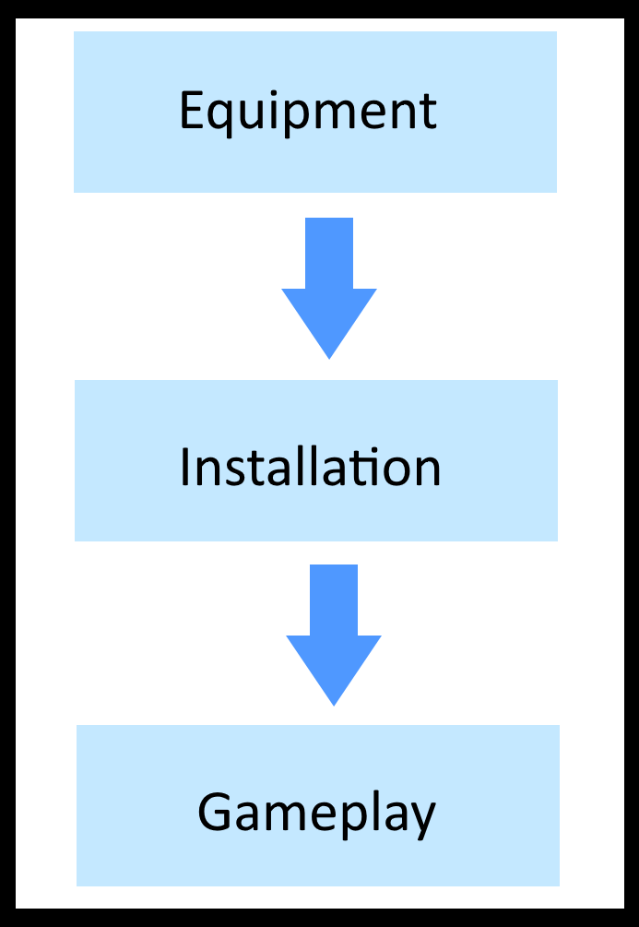

Figure 1 User Manual Relationship Diagram

First, the System and Hardware Requirements of the HTC Vive System are documented. This is a comprehensive list of all equipment needed for VR. Second, the Installation process is documented in step-by-step instructions. This manual assumes that the user is setting up for the first time and provides a thorough walkthrough. Third, game design elements are highlighted. Specifically, an overview of how the game is designed to be accessible to those with a visual impairment. Lastly, gameplay instructions are included. This covers how to interact with the VR game environment and detailed steps of the entire game.

# SYSTEM AND HARDWARE REQUIREMENTS

|  |  |
| --- | --- |
| Main Component | Accessories |
| Headset | * 3 in 1 cable (attached) * Audio cable (attached) * Headphones * Face cushions (1 attached and 1 alternate for narrow face) * Alcohol wipes for cleaning |
| Link Box | * Power adapter * HDMI cable * USB cable |
| Vive Controllers (2) | * Micro-USB cables (2) * Lanyards (2 attached) |
| Base Stations | * Power adapters (2) * Mounting kit (2 tripods) * Sync cable (optional) |
| VR-Ready Computer | Recommended System Requirements:   * OS: Windows 7 SP1, Windows 8.1, or Windows 10 * Processor: Intel® i5-4590 / AMD FX 8350 equivalent or greater * Memory: 4 GB RAM * Graphics: NVIDIA GeForce® GTX 970 / AMD Radeon™ R9 290 equivalent or greater * Tower (with power cable) * Monitor (with HDMI cable) * Mouse and keyboard * SteamVR installed and ready-to-use * Project ViREO game installed and ready-to-use |

Table 1 System and Hardware Requirements

The following illustration from the HTC Vive documentation shows a detailed image of the equipment. Please refer to the note for modifications (**\***).

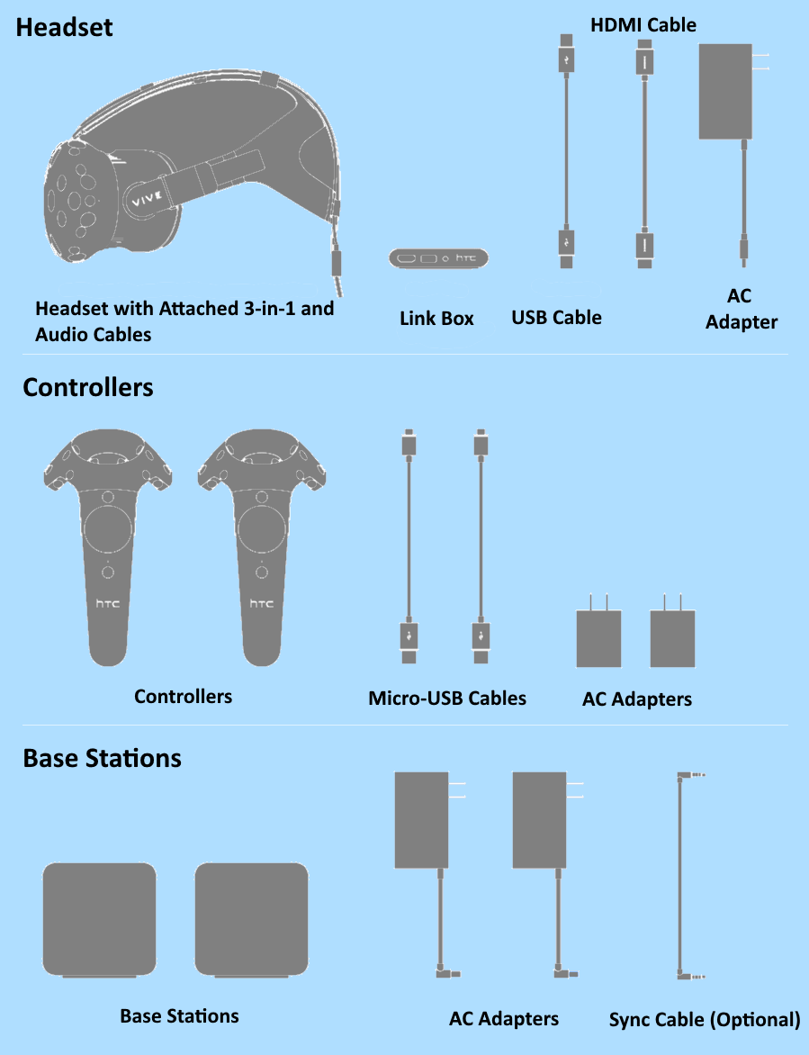

Figure 2 HTC Vive Required Hardware

(Valve Corporation)

**\***Not pictured: VR-ready computer, mounting kit (2 tripods), alcohol wipes, and headphones.

# INSTALLATION

**WARNING:** It is compulsory that when the VR is in use there **must be an attendant monitoring the player at all times**.

**WARNING:** When setting up the play area be sure to **clear the area of all cords, obstacles, and tripping hazards**.

The following steps will walkthrough setting up the HTC Vive VR system for play. For the detailed list of all the equipment needed for set up, refer to the previous section System and Hardware Requirements. Below is an example floorplan of the entire setup.

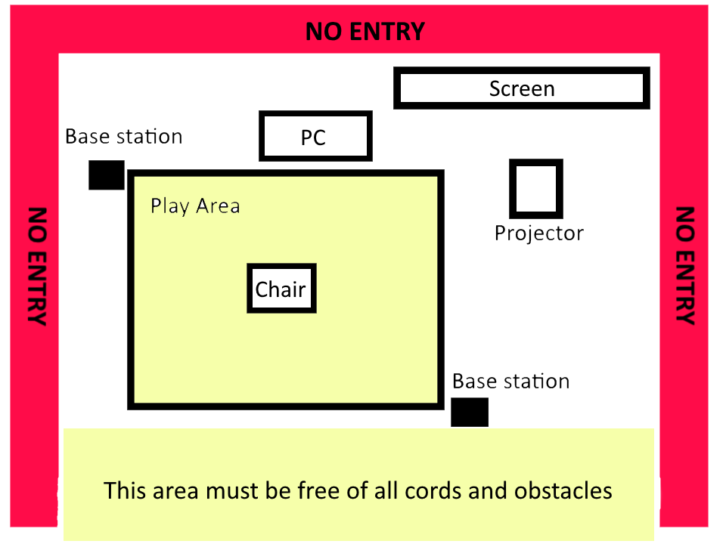

Figure 3 Example of VR Setup

The following instructions have been sourced from the HTC Vive Official Documentation (Valve Corporation).

1. **Pick a space.**
   * **WARNING:** The VR area should be **clear of all obstacles**. It is essential the path to the VR headset and surrounding area is clear of all cords and any other possible tripping hazards.
   * Room Scale VR needs at least 2m x 1.5m (6.5ft x 5ft). The maximum supported distance between base stations is 5m (16ft).
   * Make sure there is some room overhead, as some experiences may have the player reaching above their head.
2. **Pick a spot for the VR-ready PC.**
   * It is essential that the PC is off to the side, not in the play area, and can be connected to the projector (if using).
3. **(Optional) Pick a spot for the projector and screen.**
   * Place the projector on a stable surface facing towards the screen.
   * Connect the projector to the VR PC and a power source.
4. **Set up the VR-ready PC.**
   * Connect the PC tower to a power source, mouse, keyboard, and screen (either monitor or projector).
   * Turn on the PC, verify that the mouse, keyboard, and screen are working properly.
5. **Pick a spot for your base stations.**

Pick two corners of the room opposite of each other that have a good view of the chosen VR area.

* + The base stations don't have to be on the edges of the chosen play area, as long as they can see each other, and aren't more than 5 meters (16.5 feet) apart.
  + The play area doesn't have to be a perfect square.
  + The base stations will each need access to a power outlet.

1. **Set up base stations.**

Mount the base stations on the tripods. The base stations should be:

* + Above head height (ideally over 2m or 6.5 ft)
  + Angled down around 30-45°
  + Have an unobstructed view of each other

1. **Power and adjust base stations.**

Plug the base stations into an outlet with the provided power cords. Then check the front panel of each base and make sure one is in mode "**b**" and one is in mode "**c**":

* + If the base stations are not in the proper modes, press the mode button on the back of each base station to change modes.
  + It doesn't matter which base is in which mode
  + Look at the base stations LEDs and make sure they are **solid green**.

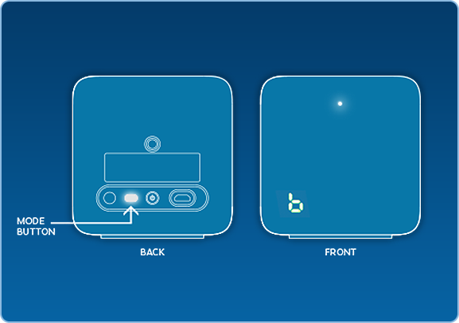

Figure 4 Adjust Base Station

(Valve Corporation)

1. **Install Link Box.**

Connect the Link Box to the computer using the side of the Link Box **without** orange ports.

* + Use the HDMI cable to connect the Link Box to the computer's graphics card. Use the USB cable to connect the Link Box to an available HDMI port on the PC.
  + Then plug the power cord into the Link Box, and plug it into a power outlet.
  + Once the Link box is connected to the PC, do not unplug it. Drivers will immediately start installing.

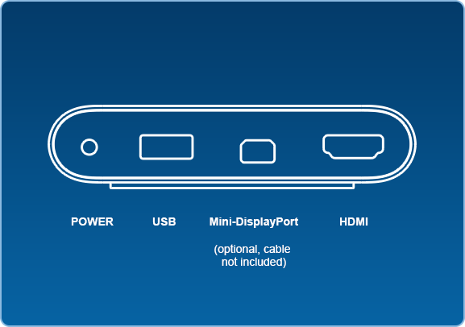

Figure 5 Link Box to PC Connections

(Valve Corporation)

1. **Install Headset.**

Connect the Headset to the Link Box using the side of the Link Box with the orange ports.

* + The end of the Headset's attached 3-in-1 tether has three orange tipped cords (USB, HDMI, and Power). Plug all three of these into the side of the Link Box with orange ports.
  + On the back of the Headset is an audio connection, plug the headphones into this jack.
  + Once the Headset is connected, do not unplug it - important drivers will immediately start installing.

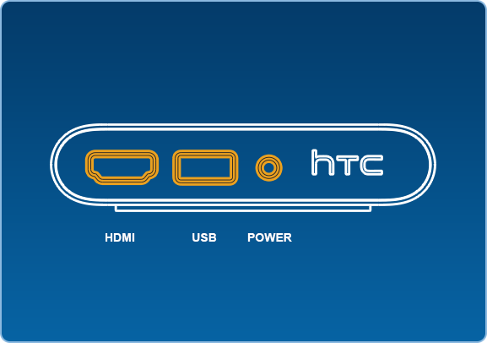

Figure 6 Link Box to Headset Connections

(Valve Corporation)

1. **Place Headset in center of play area.**
   * **WARNING:** The Headset has a cord that attaches to the Link Box. **This cord must be monitored during play so that it doesn’t become a tripping hazard.**
   * Place the Headset on a chair in the center of the play area. The chair will be used by players when playing the game.
2. **Launch SteamVR.**

Launch the Steam Desktop app.

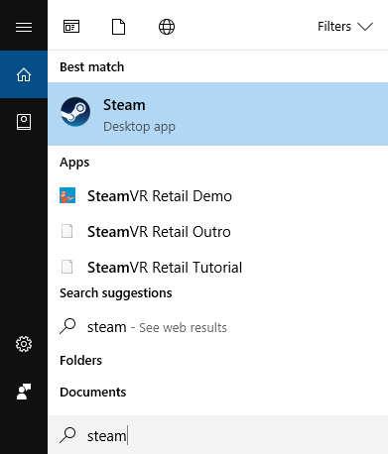

Figure 7 Launch Steam

Launch SteamVR from the Steam desktop app.



Figure 8 Launch SteamVR

1. **Turn on Controllers.**
   * Power on the Controllers by pressing the System Button (the button below the trackpad on each controller).
   * The controllers will automatically pair to the Headset when turned on for the first time.
   * When needed, the Controllers can be charged using the micro-USB cables.

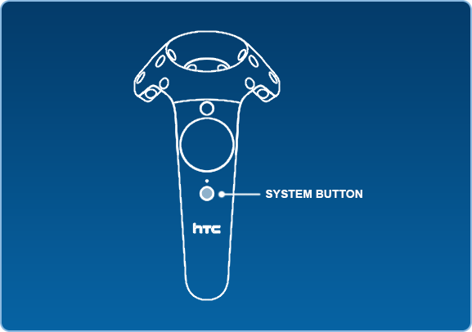

Figure 9 Vive Controller

(Valve Corporation)

1. **Room Setup and Tutorial.**

If properly connected, the SteamVR window will show all the components as green.

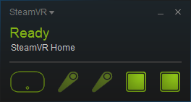

Figure 10 SteamVR

Run the room setup to calibrate the VR play area.

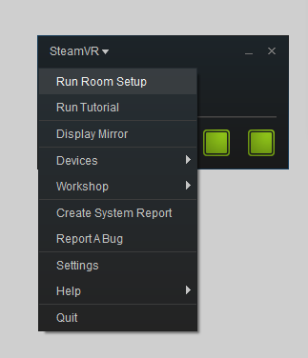

Figure 11 SteamVR Room Setup

* + Follow the instructions for Room Setup to set up the room. At the end of Room Setup it will launch into a tutorial to teach you about SteamVR, Chaperone, controllers, and the Dashboard.
  + You can run Room Setup and the Tutorial at any time by clicking on the SteamVR menu and selecting Run Room Setup or Run Tutorial.

1. **Ready to play.**
   * **WARNING:** Make sure that players are **always supervised** and the area is **clear of all cords, obstacles, and tripping** **hazards**.
   * Launch the ViREO.exe – Shortcut from the Desktop to start the game.

A close up of a sign

Description generated with high confidence

Figure 12 Project ViREO Game Executable Shortcut

# GAME DESIGN

## Accessibility

To create accessible content games designers should examine how users interact differently with technology. The focus of the Project ViREO game was to make it as accessible as possible to those with a visual impairment. This central idea determined all game design choices.

## Simple Game Design

The game concept is a simple paintball shooter. Players have various levels of exposure to video games and, therefore, varying degrees of experience. A simple concept ensures that the player can jump straight into the game and have no confusion on what they are meant to do to play. Typically, virtual reality games use two controllers. However, Project ViREO is designed to use only one. This reduces the elements that the player must focus on while playing. The team concentrated on having only a few elements on screen at a time. Only essential visual elements were included. It is important, when designing accessible games, that unnecessary visual clutter is avoided.

## Visual Field

The common way that individuals with vision loss play video games is to sit very close to the screen. This allows them to get enough visual information to play; be it their player’s current position, reading text, or viewing images. However, it is limiting because the player can only focus on one small part of the screen at a time. Being aware of how individuals with vision loss interact with screens prompted the decision to create this game for virtual reality. The virtual reality headset sits directly in front of the user’s eyes so it is within their field of vision. The headset also tracks the user’s head movements and responds accordingly. This technique for playing games allows for more comfortable gaming, making the games on this platform a lot more accessible.

## Colour Contrast

Contrasting colours are an important part of creating accessible visuals. Measuring the contrast between two colours can be done using the contrast ratio. The contrast ratio is the relation between the luminance of two colours. Colours that are too similar, have a low contrast ratio, will blend together and make images or text hard to interpret. A high contrast ratio indicates that it is easier to distinguish between the two colours. For example, black and white have the highest contrast ratio (21:1) and are easily distinguishable. As dictated by the World Wide Web Consortium, to meet accessibility standards the contrast ratio between text and its background must be at least 4.5:1 (W3C). Following this standard, the Project ViREO game uses bright, well-contrasted colours.

## Audio

As stated by Texas Tech University, audio descriptions allow access to important visual information. They recommend to verbally talk through all the steps in a straightforward manner (Texas Tech University). The Project ViREO game uses audio descriptions and instructions for all tutorials and game elements. In-game text was mostly avoided. There is an audio description for the text that does appear in the game.

## Testing

The Project ViREO game was tested at the CNIB Regina Family Fun Day. Kids with varying degrees of visual impairment played the game and were surveyed for their opinion. They reported that a slower pace, larger in-game characters, and audio cues would improve the game. Team Agile Solutions implemented changes to the game based on these opinions. A few kids with more acute visual impairments were unable to successfully interact with the game. However, a large majority of the kids were comfortable with virtual reality and could play the game. This shows that the game may be accessible to many, but not all, individuals with a visual impairment.

# GAMEPLAY

1. Upon starting the game will launch into the interactive options menu.
2. The audio cues will introduce the player to the game environment and controls.
3. Two options will be set in the options menu: the enemies size and the paintball colour
4. Two enemies will appear on the horizon in front of the player. The player can increase/decrease the size of these enemies by pressing the front trackpad on the Vive controller. In game, audio cues will walk the player through this step.

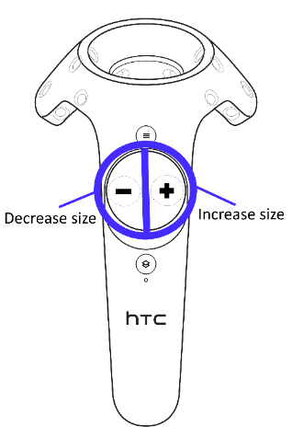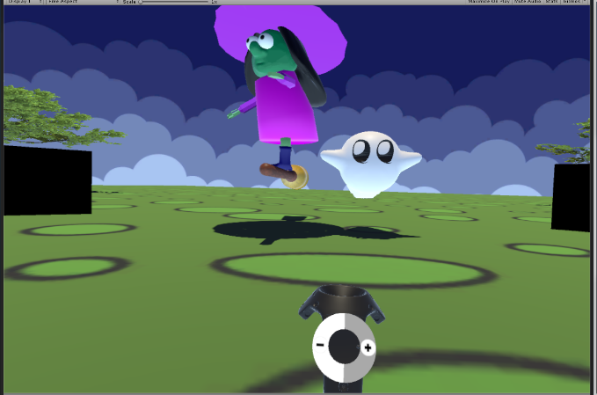

Figure 13 Game Options Scene - Scale Enemies

1. When the player is finished choosing a size, they will press the pink button found on their right to progress to the next step.

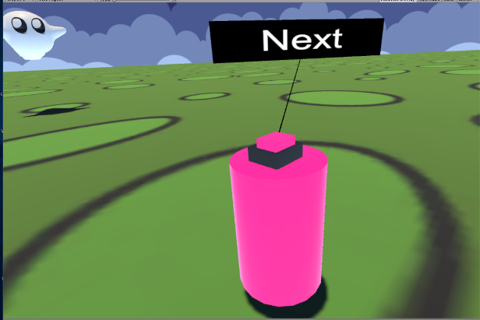

Figure 14 Game Options Scene - Next Button

1. A paintball splatter will appear on the ground in front the player. Using the trackpad on the Vive controller the player will cycle through all the available colours. In game, audio cues will walk the player through this step.

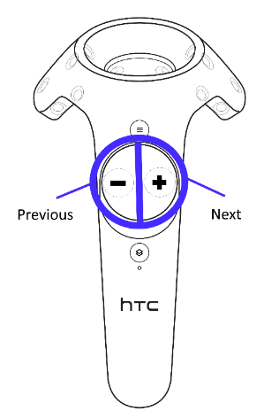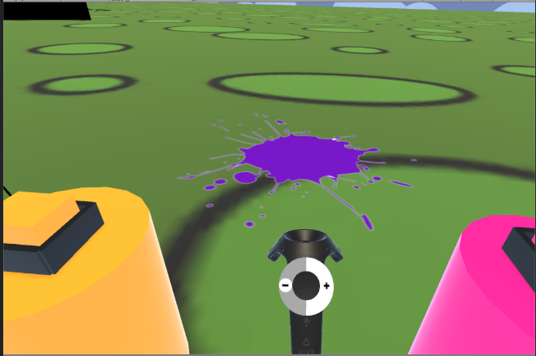

Figure 15 Game Options Scene - Paint Colour

1. When the player is finished choosing their paint colour, they will press the pink button found on their right to progress to the next step. To go back to a previous setting the player can press the orange button found on their left.

A close up of a device

Description generated with high confidence

Figure 16 Game Options Scene – Back and Next Buttons

1. A lever will appear in front of the player. When the player is ready, the lever can be pulled to start the game.

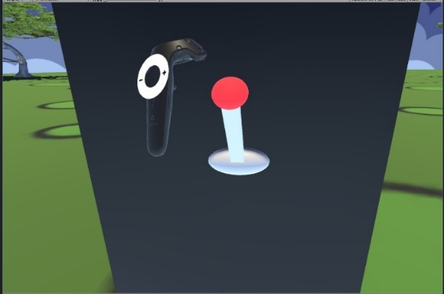

Figure 17 Game Options Scene - Lever

1. The game scene launches and the player is transported to the game area. An audio cue will introduce the player to the scene and the gameplay.
2. In the scene, enemies will appear around the player. They will have a paintball gun in their hand, controlled by the Vive controller. To shoot the enemies with paintballs press the trigger found on the underside of the Vive controller.

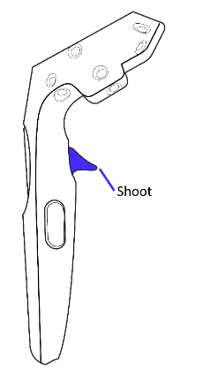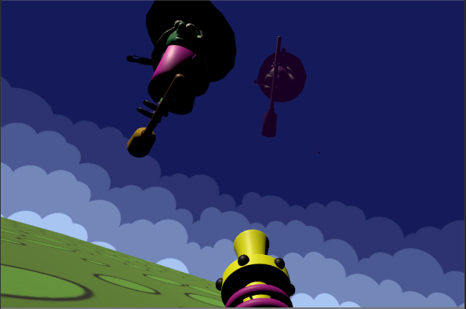

Figure 18 Game Scene - Shoot Enemies

1. The player will have two minutes to shoot as many enemies as possible. An audio cue will let the player know when the countdown timer will begin. The timer and player’s score will be displayed as large text in the sky in front of the player.

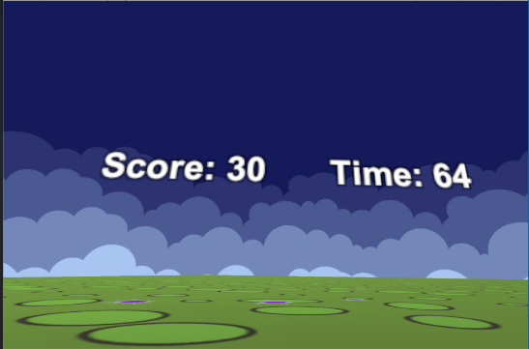

Figure 19 Game Scene - Score and Timer Display

1. As enemies are hit, they will disappear and new enemies will spawn.
2. When the time is up, an audio cue will alert the player. The enemies will disappear and the player’s final score will be displayed.
3. End of game.

# WORKS CITED

Texas Tech University. *Accessible Audio Descriptions*. n.d. http://www.ttu.edu/accessibility/AccessibleAudioDescriptions.php. 14 June 2017.

Valve Corporation. *HTC Vive Installation Guide*. n.d. https://support.steampowered.com/steamvr/HTC_Vive/. 14 June 2017.

W3C. *Techniques for WCAG 2.0*. 7 October 2016. https://www.w3.org/TR/2016/NOTE-WCAG20-TECHS-20161007/. 14 June 2017.