Assignment 2: Chess Games with Stockfish

# 1.1 Introduction

This document is made to show the results of the chess games played with Stockfish. It includes statistics, graphs and descriptions of the results.

# 2.1 General games

Here you can see some general info about the games played

## 2.1.1 Statistics

|  |  |  |  |  |
| --- | --- | --- | --- | --- |
|  | White wins | Black wins | Games Drawn | Total games |
| Amount of games | 704 | 296 | 1600 | 2600 |

## 2.1.2 Graphs

Here you can see a graph showing how many games were still going after x moves.

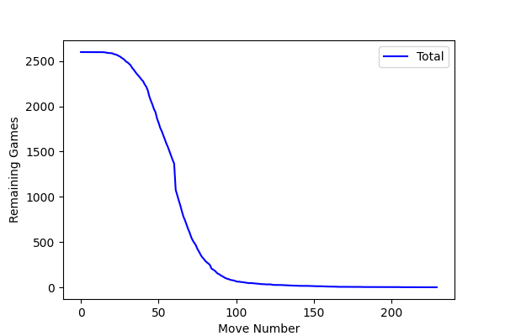

# 2.2 Games focused on Stockfish

Here you can see some general info about the games Stockfish played

## 2.2.1 Statistics

|  |  |  |  |
| --- | --- | --- | --- |
|  | Games Won | Games Lost | Games Drawn |
| Total | 992 | 8 | 1600 |
| As White | 698 | 2 | 601 |
| As Black | 294 | 6 | 999 |

## 2.2.2 Graphs

Here you can see a graph showing how many games were still going after x moves.

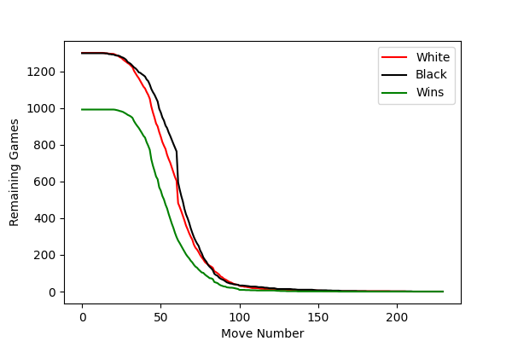

Needed another graph to show the losses since there were so few.

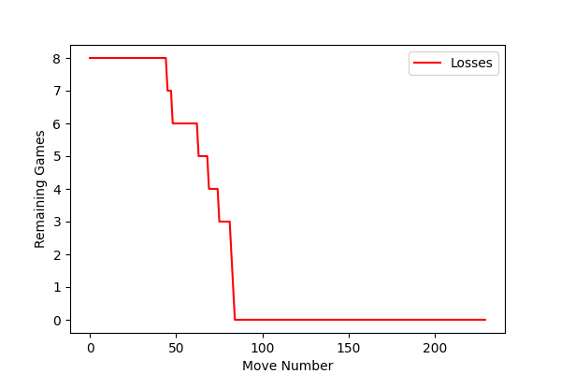

# 3.1 Mean and Standard Deviation for Stockfish

Here you can see the mean and standard deviation of the games played

## 3.1.1 statistics

|  |  |  |  |  |  |
| --- | --- | --- | --- | --- | --- |
|  | All games | Played as white | Played as black | Games won | Games lost |
| Mean | 60.33 | 58.78 | 61.88 | 55.08 | 68.62 |
| Standard Deviation | 19.59 | 19.78 | 19.27 | 16.67 | 15.48 |