# Students manual

The Automated Marking System (AMS) has been developed to provide you with the possibility of getting instant feedback. The system will compare **your** solutions / answers against **model** solutions / answers for a particular task. Please mind that due to the fact that in some cases there might be MORE THAN ONE correct solution of a task (in some cases it is possible to come up with multiple correct solutions of exactly the same problem), the AMS system may NOT award you marks correctly just because it will treat your very solution as erroneous. If you are positive that this is the case please contact your Tutor / Lecturer so that he / she would be able moderate the AMS marking and manually adjust your mark accordingly.

Accessing the AMS system requires a WEB browser (IE, Chrome and Mozilla were tested, Safari was NOT) and a computer connected to the local network. In the browser students will need to type in URL comprising of the AMS network name (for example, in Greenwich campus the AMS is available at http://scriptcheck.cms.gre.ac.uk/COMP1562 for COMP1562 students and http://scriptcheck.cms.gre.ac.uk/COMP1691 for COMP1691 students) or IP address like for example (assuming that the AMS system is located at 192.168.0.1 IP address) http://192.168.0.1/COMP1562 (you Tutors will provide you with all necessary details).

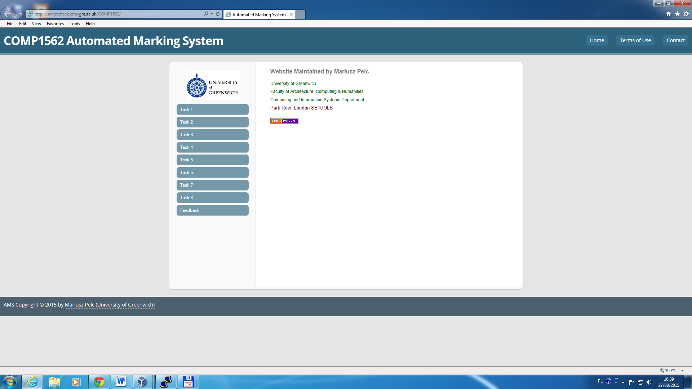

Fig.1.1. Main page for the AMS for COMP1562 students

Depending on the task that students are supposed to solve, they should could click the appropriate link on the left hand side of the website. Once this is done, a website containing all necessary elements to enter the solutions to the task will be displayed (these may be upload buttons, text fields, etc. – see Fig.1.2.)

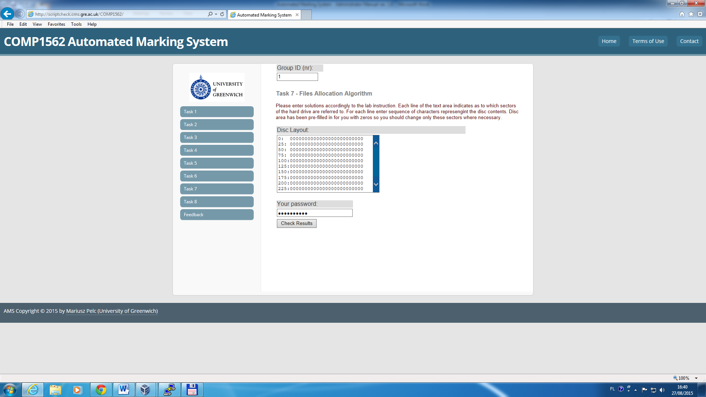

Fig.1.2. Website that should be used to solve Task 7

`

**NOTE:** All that students need to get their solution marked / checked is that they need to enter group ID (1-40) in the Group ID text field and group password in the “Your password” text field (ask your Tutor what your group password is). Following that the group should hit the “*Check Results*” button. Students MUST read very thoroughly WHAT they should do and HOW to enter the solution as the AMS expects a strictly defined input data. Deviating from the expected content of format regarding data results in loosing marks.

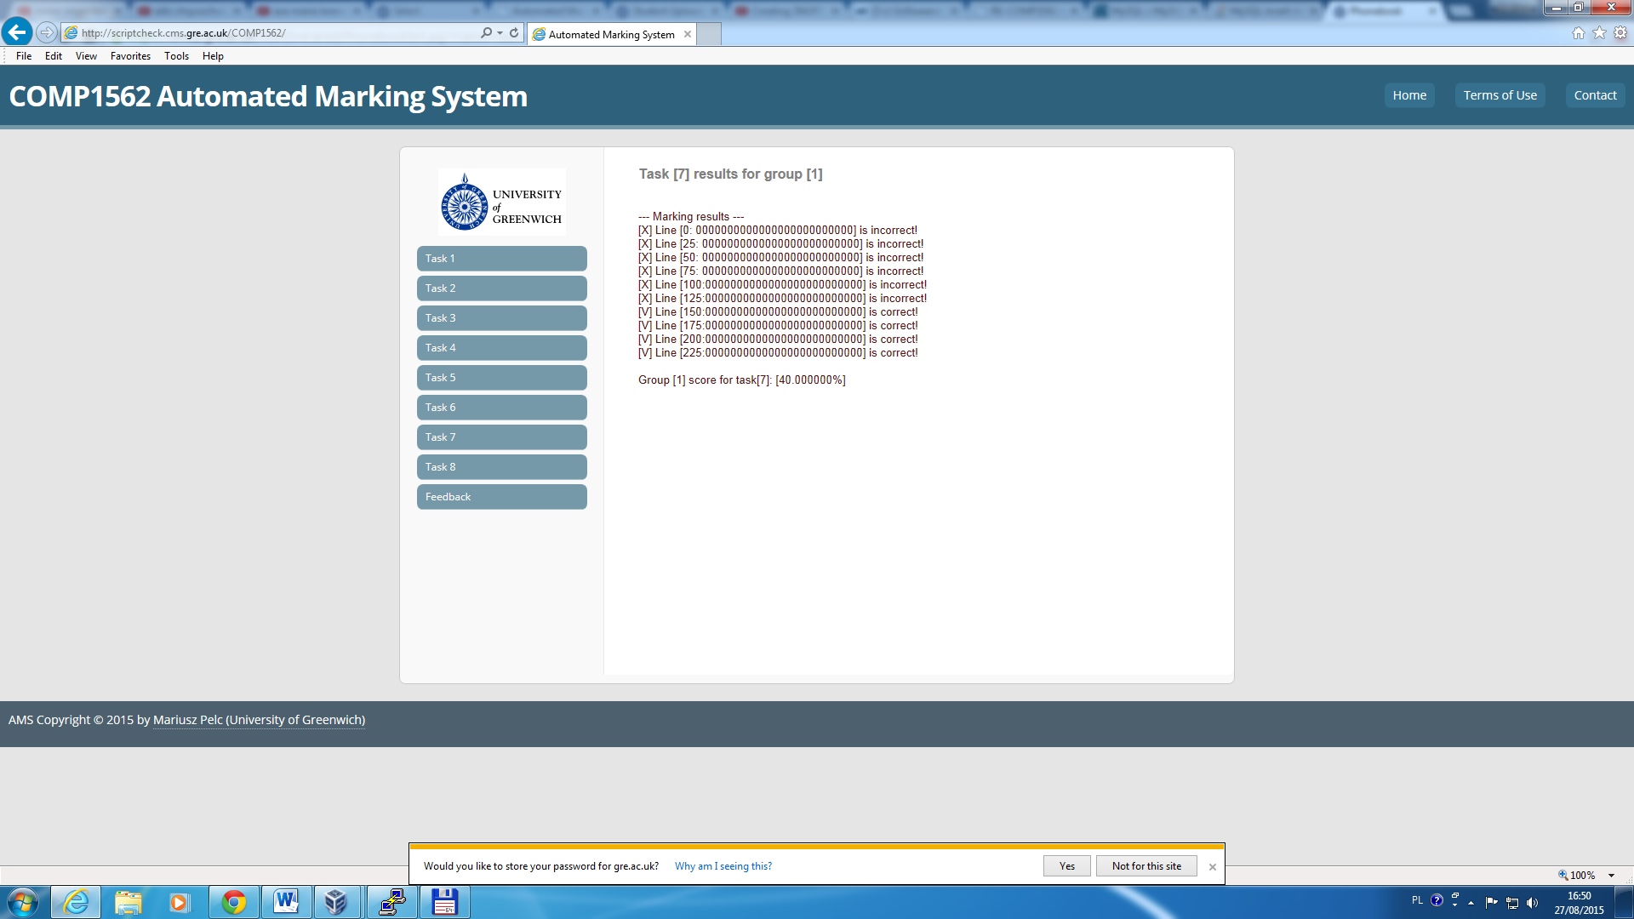

Fig.1.3. Example marking results

AMS will show marking results usually indicating WHICH solutions were correct, sometimes it may also show WHICH were incorrect. Usually getting 100% means that everything was correct, if the mark is lesser than that, there are some errors in the solutions OR in the format they were entered to the AMS system. In the Fig.1.4. one can see marking results for Task 1. If the task has NOT been previously marked, student will see what their current result is.

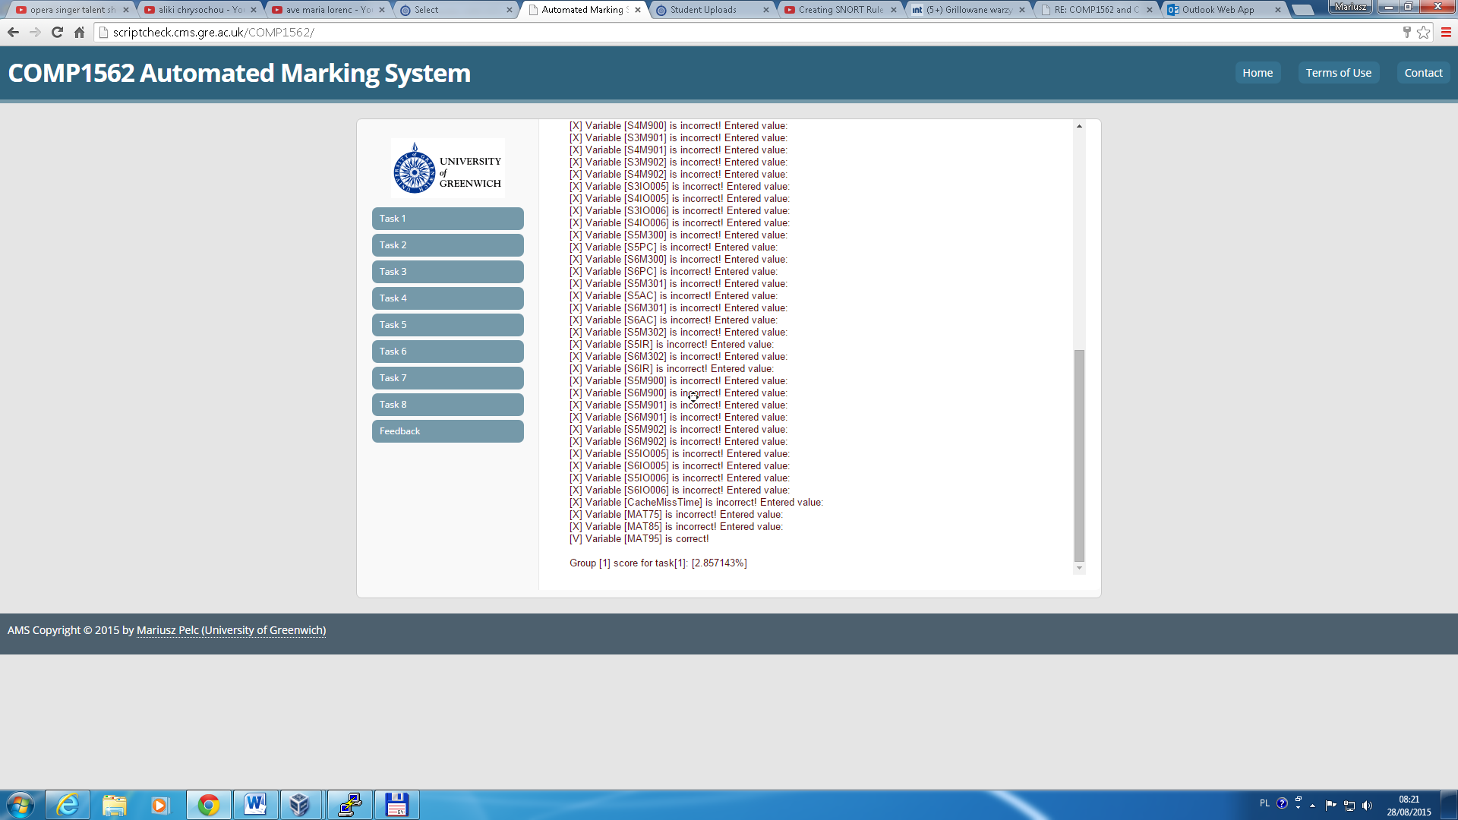

Fig.1.4. Marking results for Task 1.

`

**NOTE:** Students are allowed to check their solutions until the given Task submission deadline. Every time the task is being sent for marking with AMS it will show the current mark and will indicate what the previous mark was. Only solutions with HIGHER mark than the one stored in the feedback file (or database) will be saved. This allows students to gradually improve their work until the deadline. It allows also the group members to work to a level independently or share work between them and together work toward the best achievable group mark. Fig.1.5. and Fig.1.1. illustrate this process.

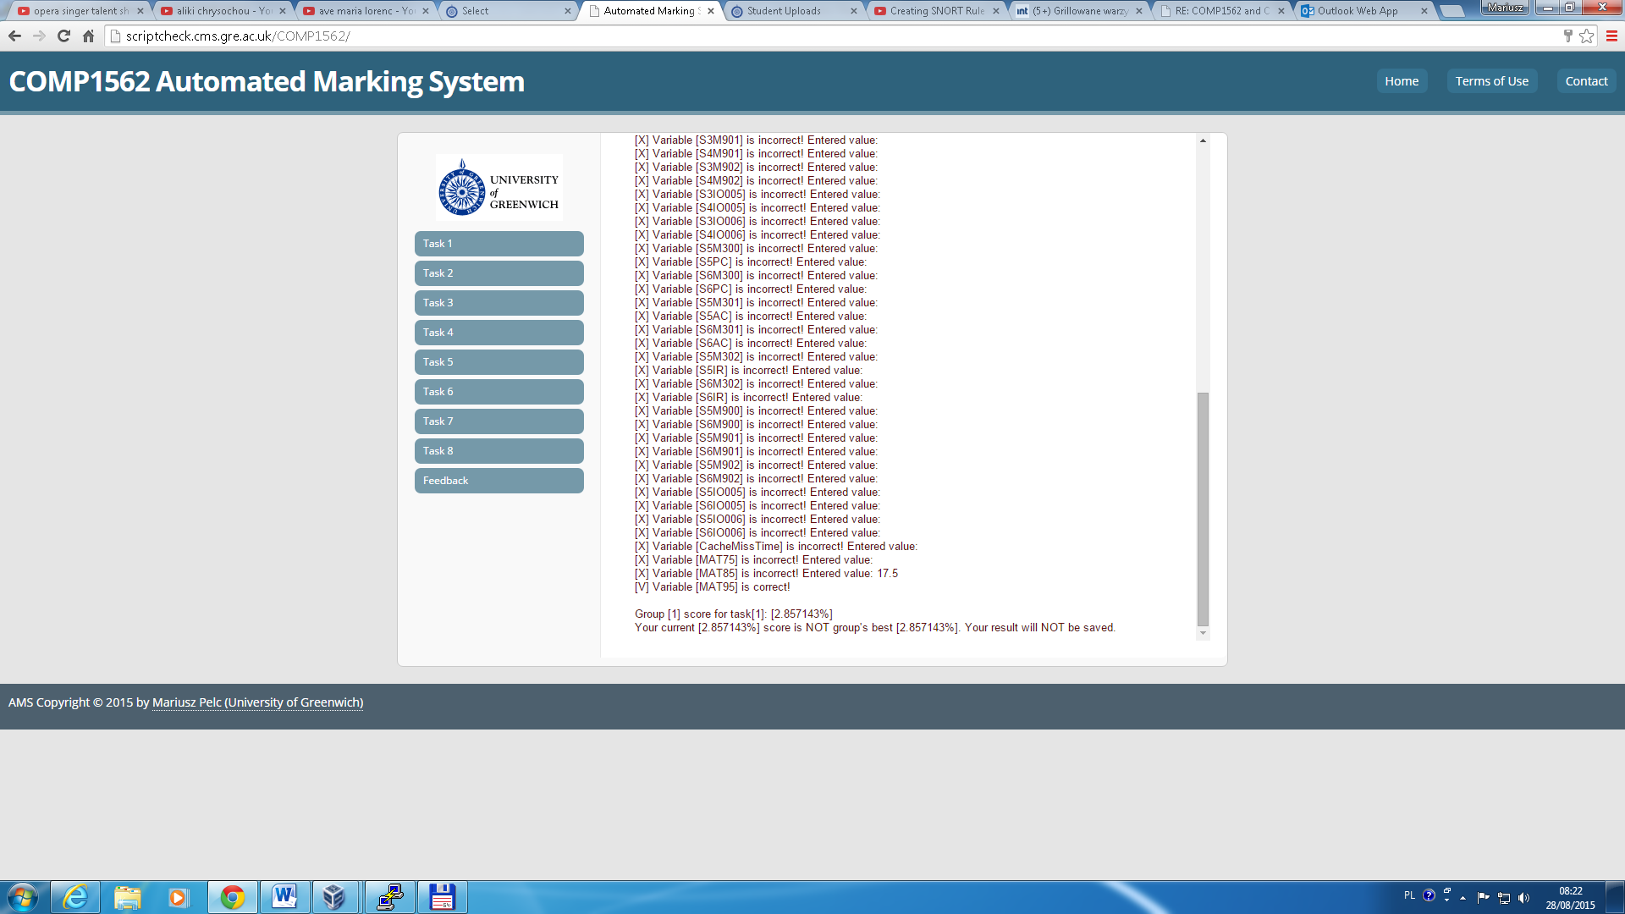

Fig.1.5. Marking results for solution that IS NOT better than the group’s best

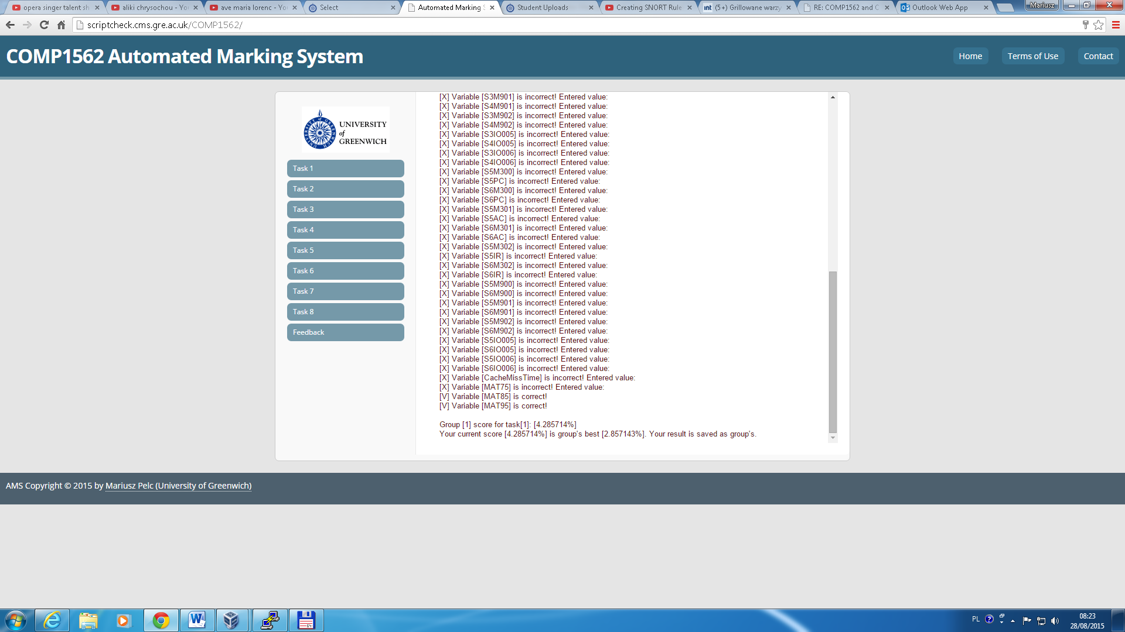

Fig.1.1. Marking results for solution that IS better than the group’s best

Students can see FULL feedback once the feedback is enabled by course administrator after a task submission deadline. To get full feedback students need to enter **Group ID**, **Task ID** (the task for which the students would like to see the feedback) and group’s **password**.

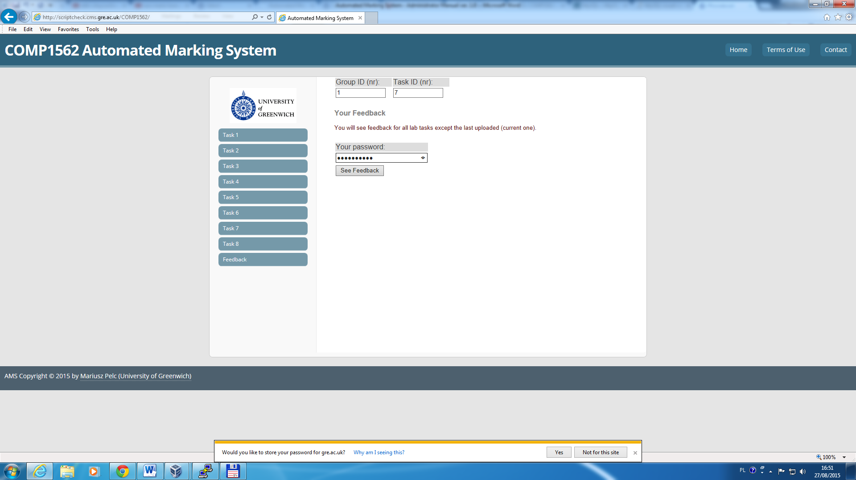

Fig.1.7. Checking feedback

Full feedback usually shows group’s solution compared to the expected (correct) solution as shown in Fig.1.8. (some information was blurred purposefully).

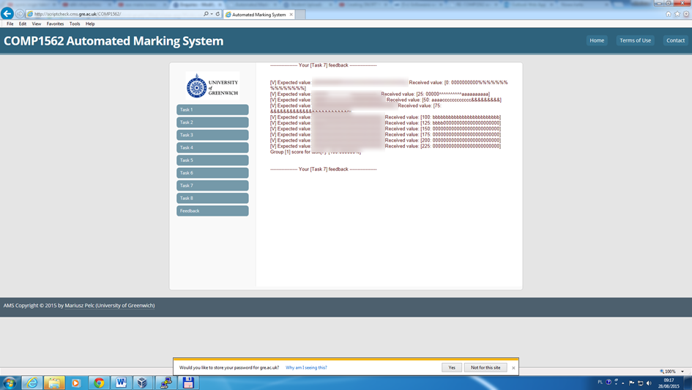

Fig.1.8. Full group’s feedback

If the feedback is NOT enabled by Tutors, students will see only BLANK PAGE, as shown in Fig.1.9.

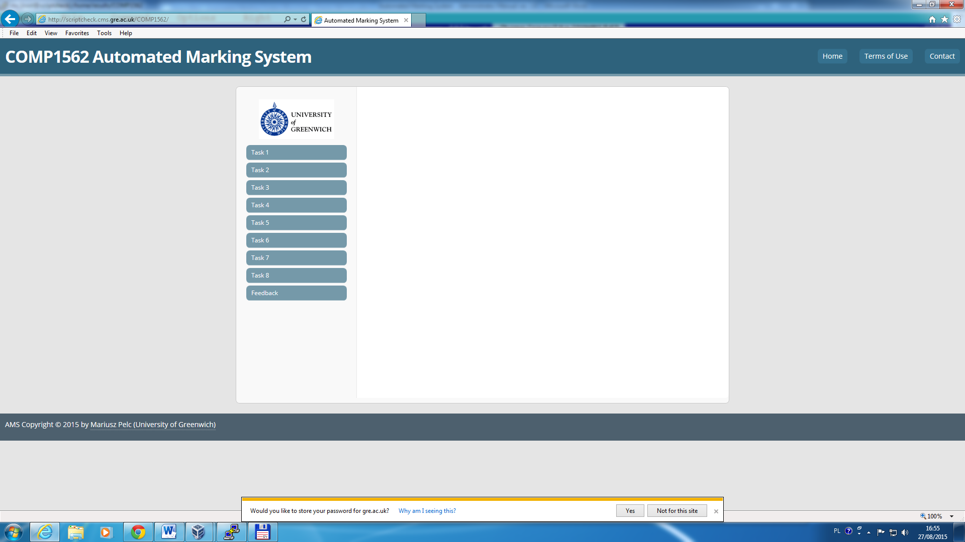

Fig.1.9. Group’s feedback not enabled for students – BLANK PAGE shown

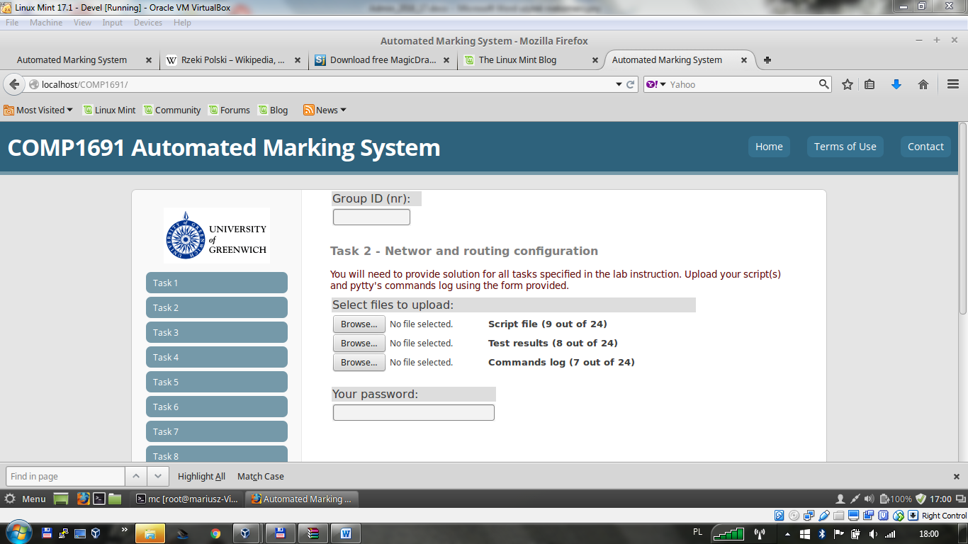

Fig.1.10. Example screenshot for COMP1691 course (marking Task 2).

For the COMP1691 course you should be aware that:

1. Wherever the AMS system requires a **script file / configuration file / solution file**, you are supposed to provide the file in the exact form you tested it in your test system. Please mind that script names SHOULD NOT contain neither, spaces nor any special characters (Linux in general doesn’t like filenames with spaces and some special characters may in an file / script name may cause some other problems).
2. Wherever the AMS system requests **test results**, you should copy-paste any test results (just highlight in putty program the command / test output) from the test system into a text file and then upload the file to AMS for marking). Again, please stick with file names that do not contain any spaces and special characters. For example, you will be testing your solution (script file) by providing specified test parameters specified in the lab instruction. These should produce strictly defined output. Such an output should be then copy-pasted from the test system into a fresh text file and uploaded to the AMS.
3. Wherever the AMS system requests you to upload **command log**, this means that you should create a file that contains list of ALL commands (except commands comprising solution of a task – these should be uploaded as script file / configuration file / solution file. NO MARKS will be awarded for these commands if they are uploaded into the wrong place (confusing the file containing all commands with the file that contains commands comprising solution of a task and uploading them using wrong links will result in 0 marks being awarded). Typically the command log should contain all commands you used in the exercise part (if such part is included into a given lab instruction).