The homepage
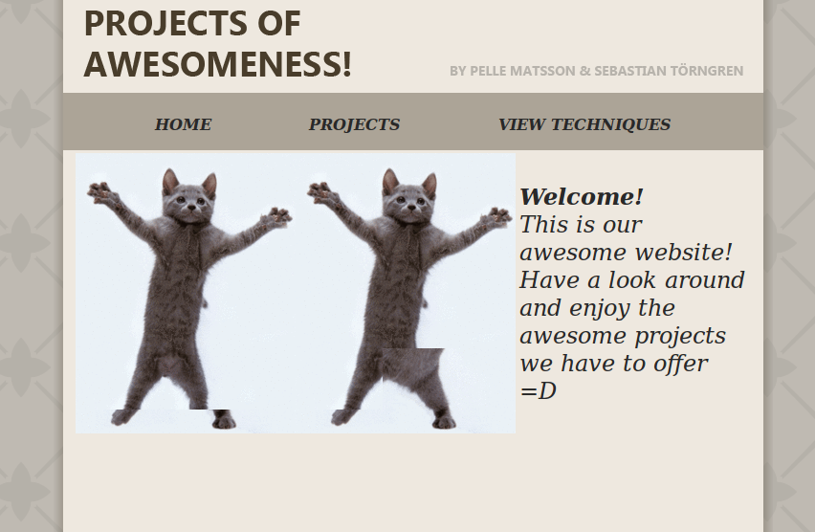
Below you can see a picture of the homepage. You can see the links to the different pages of the website; Home, Projects and View techniques.

Below you can see what happens when you enter the homepage. It is a print from the file awesome.py. First it imports Flask, then imports the data.py file.
When enter the homepage it will run the init() function from data.py and then show you the start.html file which extends the index.html.

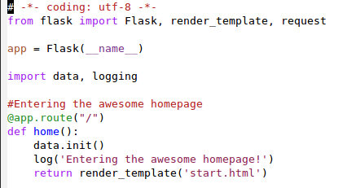
Projects
Here you see the projects page where you can search for projects.
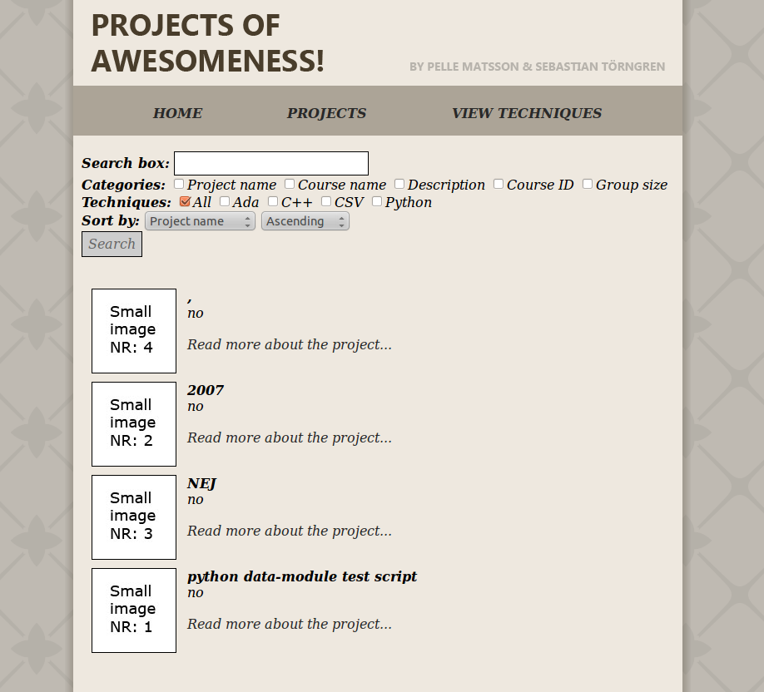

Below you can see what happens when you enter the projects page. First you got the main projects page and under that is what happens when you click on a project.
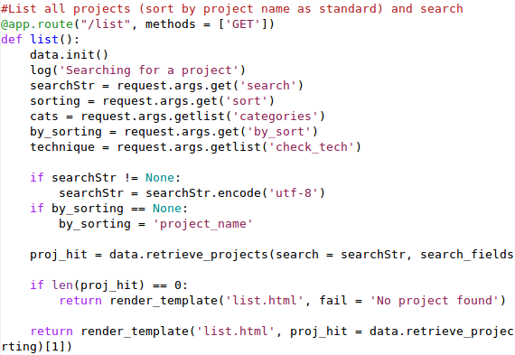
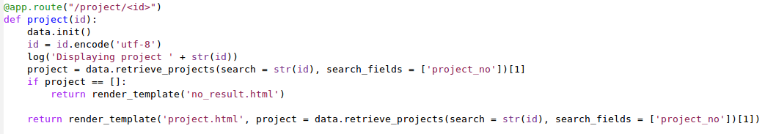

View techniques
Here is the View techniques page that lists all the techniques and all the projects that use them.
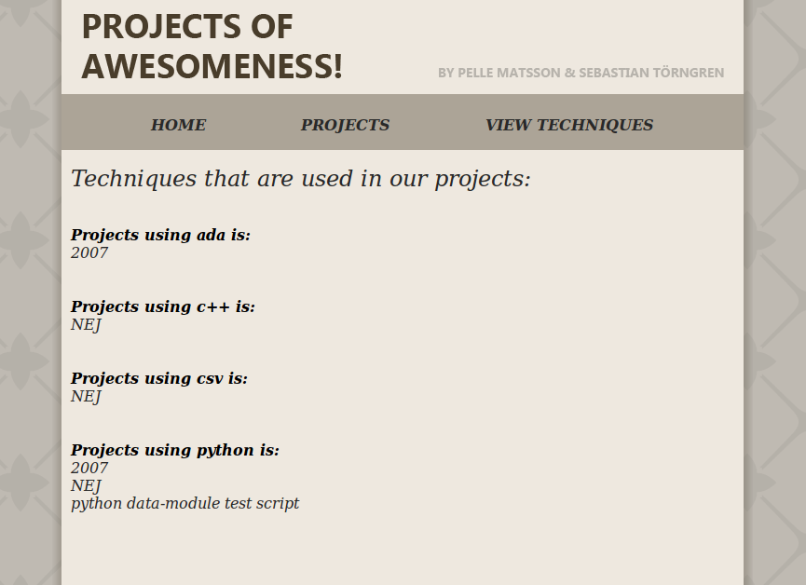
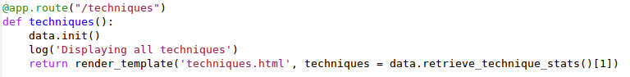
Below you can see what happens when you enter the view techniques page.

And if you click on any of the project the page will call the same function as the project page to display them.

The CSV file
If you want to change anything in the portfolio you will need to open the data.csv file and modify it's content.

Here is an exampel of a data.csv file, every line is a project.

