AEOLUS INDUCTION TASKS ROUND 2

TASK 1: AUTONOMOUS ARCHITECTURES

1. Evaluation of the 5 Build Options

For a club project, the most important thing is that the build actually works for the mission (use case). Right after that the compute, cost and weight matter a lot, because clubs have small budgets and simple airframes. Power comes last.)
Priorities used (in order): Use Case (30%) > Compute(20%) ~ Cost(20%) ~ Weight (20%) > Power (10%)

2. Analysing each build and rating them:
1. Stereo Camera + Jetson Orin Nano:
The camera gives raw images, so the Jetson has to do all the depth calculation itself. The Jetson is powerful enough for this, but it also means the Jetson is doing extra work, using more GPU power and adding weight and cost.
2. OAK-D Lite + Raspberry Pi 5:
The OAK-D Lite has its own small chip (Myriad) that calculates depth and can also run simple AI directly on the camera. This means the Raspberry Pi does not need to do heavy work, so a cheaper, lighter, low-power computer is enough. This I think might be ideal for clubs and student projects.
3. LIDAR d500 + Wide Camera + Raspberry Pi 5:
LIDAR gives accurate distance readings and works well in poor lighting, but combining LIDAR data with camera data needs more processing, and the Raspberry Pi does not have a dedicated chip for this. So it is not very ideal and also LiDAR is costly.
4. Stereo Camera + Raspberry Pi 5:
Same camera as Build 1, but paired with a Raspberry Pi instead of a Jetson. The Raspberry Pi does not have a GPU, so it struggles to calculate depth from stereo images in real time. This is the weakest build for actually completing the task, even though it is cheap and light.
5. RealSense D435i + Jetson Orin Nano:
The RealSense camera also has its own depth chip, like the OAK-D, so it saves the Jetson from doing depth calculations. This camera enables jetson to do its AI computing tasks with more efficiency also easing out the tracking and location tasks. This build is actually pretty good and poweful but also the heaviest, most power consuming, and most expensive.
It costs around 50k so for club projects, budget restrictions could be a problem.

Build | Use Case (30%) | Compute (20%) | Cost (20%) | Weight (20%) | Power (10%) | Weighted Score
1. Stereo + Jetson | 6 | 8 | 6 | 5 | 6 | 6.35
2. OAK-D + Raspberry Pi5 | 9 | 6 | 8 | 9 | 9 | 8.2
3. LIDAR + Raspberry Pi5 | 6 | 5 | 6 | 8 | 8 | 6.35
4. Stereo + Raspberry Pi5 | 3 | 2 | 10 | 9 | 10 | 5.75
5. RealSense + Jetson | 7 | 10 | 3 | 4 | 5 | 6.15

So, looking at this information as well, the Build 2 stands out to be the best build. This is the best choice for a college club because the camera itself handles the depth and AI work, so a cheap, light, low-power Raspberry Pi is good enough to finish the job. It gives the best balance of doing the task well, without needing a big budget, heavy hardware. Build 5 (RealSense + Jetson) would only be better if the club had extra funding and needed very advanced target detection.

3. Bonus: Camera Placement and Alternate build.

Camera placement:
The main thing is putting the camera facing forward, since thats the direction the drone is flying and where it needs to see obstacles first. On top of that, I would add a second camera or sensor pointing down, mainly to help the drone know how high it is and stay steady as without it, the drone can wobble, especially indoors where GPS wont help. I would not bother with side or rear cameras unless the drone is doing a lot of sharp turns in small spaces, since that adds extra weight and complexity, this problem statement mainly deals with locating of Odysseus so I don’t think we will be needing rear or side cams.
Alternate build:
I would stick with the Raspberry Pi 5 setup since its already light and cheap, but swap in a wider-angle version of the depth camera so it sees more to the sides while still facing forward. That way I get better coverage without adding more cams and conserve weight.

TASK 2: COMMUNICATION ARCHITECTURES

RC Transmitter & Receiver: The remote control in our hands (Transmitter) sends stick inputs over the air to the receiver mounted on the drone so you can fly it manually when needed. Its basically used to control the drone.
Telemetry Module: A two-way radio link that sends data like battery voltage, GPS position, height, and speed live to a ground station laptop running in the ground control stations. This is for the monitoring of the drone not flying it.
VTX / Video Transmitter: Takes the live camera video and broadcasts it back to ground screens or pilot goggles. This enables the pilot to see what the drone sees in real time.

Model Selection (Addressing Digital vs. Analog & PWM vs. PPM Mismatches)
- RC Receiver:
Selected Model: RadioMaster RP1 ExpressLRS (ELRS) 2.4GHz Receiver: I would go with ELRS over an old-style receiver because it's digital, gives very low latency, and sends telemetry (like
signal strength and receiver voltage) back to the transmitter over the same link. The protocol i will be using will be the CRSF protocol (Crossfire Protocol). This avoids the problems caused by the old school PWM (needs many wires and ports) and PPM (one wire, but no telemetry and a low channel limit) wire models. CRSF is a two way serial protocol using a single wire.
- Telemetry Module:
Selected Model: Holybro SiK Telemetry Radio V3 (915MHz or 433MHz). It is designed specifically for Pixhawk architectures as it uses MAVLink directly. . Uses transparent serial communication over standard port.
- VTX (Video Transmitter):
Selected Model: Rush Tank Solo 5.8GHz (Analog VTX) : For this particular task which is locating Odysseus I would rather pick Analog over Digital. Analog has low video and it degrades as the drone flies further but it gives a static warning before it cuts off the feed. Digital has more video quality but it cuts off the feed abrubtly which can be risky in a scenario where we cannot ourself see the drone. If we prioritise quality of the video then Digital, for safety it would be Analog.

Component | Selected Model | Operating Protocol | Range | Power Source
RC Receiver | Radiomaster RP3 ELRS | CRSF (2.4GHz) | 10km+ range | 5V Rail from Pixhawk TELEM2
Telemetry | Holybro SiK Radio V3 | MAVLink | 1km - 5km range | 5V Rail from Pixhawk TELEM1
VTX | Rush Tank Solo 800mW | Analog Video | 1-10km range depending on transmit power. | Direct battery voltage via PDB (VTX regulates its own 5V internally)

KiCAD Schematic Diagram:
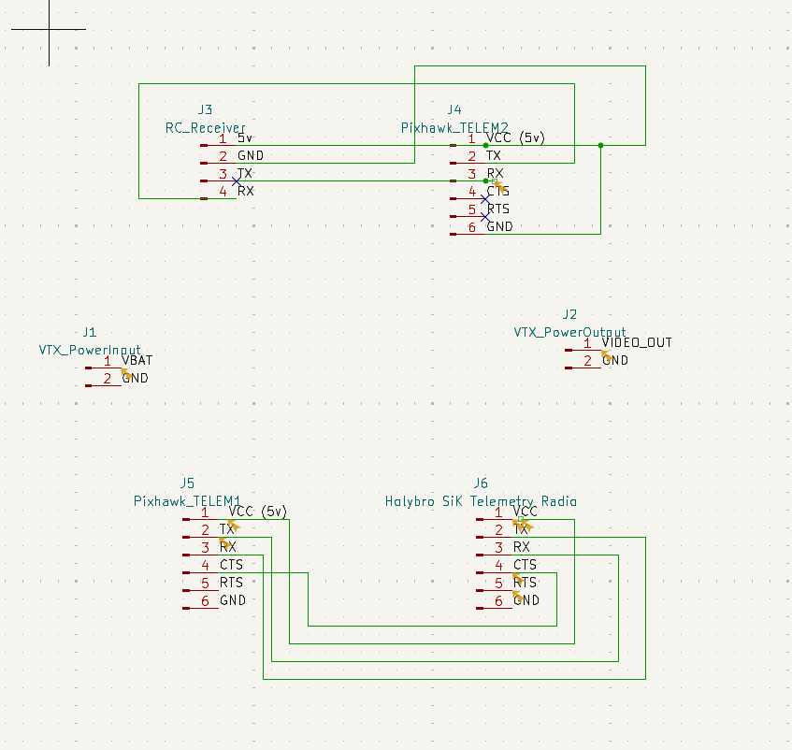

J1 (VTX_PowerInput) connects to the battery via the PDB, which supplies raw, unregulated battery voltage directly to the VTX. J2 (VTX_PowerOutput) connects to the FPV goggles or monitor to carry the video downlink. Both are external to the flight controller wiring shown in the KiCad diagram.

TASK 3: PROPULSION SYSTEMS:
To pick a battery and ESC, I first need a rough weight budget for the whole drone, since the max weight is fixed at 2.5kg.
  - Frame: Holybro S500 V2 (~440g)
  - 4x Motors (2216-920KV): ~65g each = 260g
  - 4x Propellers (1045): ~15g each = 60g
  - ESCs: ~120g (4 units, exact model chosen below)
  - Flight computer (Pixhawk 6C Mini + GPS): ~55g
  - RC receiver + Telemetry radio + VTX: ~50g
  - Companion computer + camera (OAK-D Lite + Raspberry Pi 5): ~110g
  - Wiring, mounts, misc hardware: ~100g
Total non-battery weight ≈ 1195g (about 1.2kg)
This leaves 2.5kg − 1.2kg = 1.3kg as the maximum weight the battery is allowed to be.
So, first we need to estimate the current draw:
Holybro doesnt publish a full thrust chart for this exact motor, so I used published bench test data for a very similar 920KV motor paired with a 10 inch propeller as a stand in, since its the closest real test data available:
At a strong throttle setting, this motor class pulls around 15A and produces about 820g of thrust on 3S power
Moving to 4S (which this build should use, since 920KV motors are commonly run on 4S with 1045 props) increases both thrust and current somewhat further.
Using this as a guide, a reasonable estimate for our build is:
Hover current: ~9A per motor (for hovering the drone need not use its full throttle, jus that the thrust should be equal to its weight)
Full throttle current: ~19A per motor
With 4 motors: Hover current ≈ 36A total, plus about 1A extra for the flight computer, camera etc
Estimated total current draw ≈ 37A
Now, we need to calculate the battery capacity for 12+ minutes:
Lithium ion batteries should not be drained below about 20% for safety and battery life, so only 80% of the rated capacity is usable in this calculation.
Formula:
Required capacity = (Current draw × Flight time) / Usable fraction
Plugging in our numbers (12 minutes = 0.2 hours):
Required capacity = (37A × 0.2h) / 0.8
= 7.4Ah /0.8
= 9.25Ah = 9250mAh
So the battery needs to be at least 9250mAh to hit 12 minutes of flight time.

Now, checking if the weight fits the budget:
Rounding up to a common commercial size: a 4S 10,000mAh battery.
Energy = Capacity x Voltage = 10Ah × 14.8V = 148Wh
Batteries in this class (Lithium ion smart batteries, like the type Holybro sells for the S500 series) typically weigh
around 850–900g for this capacity which is well within our 1.3kg battery weight budget.
Endurance check with this battery:
Usable capacity = 10,000mAh × 0.8 = 8,000mAh (8Ah)
Endurance = (8Ah / 37A) × 60 minutes ≈ 13 minutes
This clears the 12-minute requirement with a small safety margin.
Now, we gotto choose the ESC:
The ESC needs to handle the peak current, not just the hover current, with some safety margin so it doesnt
overheat during full-throttle missions
Estimated full-throttle current: ~19A per motor
Its genrally better pick an ESC rated at least 30 to 50% above the expected peak current draw, so its never like very close to the limit.
19A × 1.5 (safety margin) ≈ 28.5A, approximating it to around 30A per motor.
ESC Recommendation: 30A BLHeli32 ESC
Justification:
We are choosing this ESC because it comfortably covers the 19A max current draw with a good safety margin, so it wont overheat during full throttle missions. The stock Holybro S500 kit only includes 20A ESCs which are very close to the full throttle limit, choosing a 30A ESC eliminates the risk. The BLHeli32 is also having better Telemetry feedback like current, RPM, temperature etc, which pairs well with the Pixhawk flight computer for monitoring the drone health during flight.

Bonus: Alternative Motor with Better Thrust for Lower Power:
Using the same bench test reference data, the stock 2216-920KV motors likely produce somewhere around
800 to 950g of thrust each at full throttle on 4S with the 1045 prop meaning roughly 3.2 to 3.8kg of total thrust
across all four motors.
At our estimated all-up weight of about 2.05kg (1.2kg other components + 0.85kg battery), that gives a thrust
to weight ratio of only around 1.6:1 to 1.8:1. A minimum of 2:1 is usually recommended just to hover
comfortably. So our drone is a bit underpowered.
Since the propeller size is fixed at 10 inches (1045), the best way to fix the thrust margin without a full
Battery or ESC redesign is to swap in a more efficient motor of the same size class, rather than a bigger or
higher KV one.
The suggested motor can be iFlight XING2 2212, 920KV. We are using this motor because, reputed motor
brands like iFlight use better quality magnets and more accurate and precising winding than other general
motors which directly improve the thrust per watt effiency. A more efficient motor produces the same or more
thrust for lesser current, it does 2 things which are raising the thrust to weight ratio and also reduce the hover
current usage. This indeed can increase the 12 minute endurance period or allow us to switch our current
battery with a battery of a lower weight to hit the same target.

