# A Project Report On

**DRY CLEANING**

**BY**

**Prof.Ajinkya R.Abhang (Software Engineer)**

**Precident (Eagle’s Technomania)**

**Prof.Vishal D. Auti (Software Engineer)**

**Vice precident(Eagle’s Technomania)**

**Eagle’s Technomania**

**(Software Development )**

**ACKNOWLEDGEMENT**

It is our pleasure to be indebted to various people, who directly or indirectly contributed in the development of this work and who influenced our thinking, behaviour , and acts during the course of study.

We are thankful to Prof. . and Prof. .(Project Guide) for his support, cooperation, and motivation provided to me during the Study of project.

We also extend my sincere appreciation to Prof. who provided his valuable suggestions and precious time in accomplishing my project report.

We are also thankful to my friends, colleagues and all our instructors for helping in the project.

**Contents**

|  |  |  |  |  |  |
| --- | --- | --- | --- | --- | --- |
| **Sr.No.** | **Name** | | | **Page No.** | |
| 1. | **Introduction** | | | 6 | |
| 2. | **Problem Definition** | | | 7 | |
| 3. | **Need of the System** | | | 8 | |
| 4. | **Scope of the System**  4.1 Job Seeker  4.2 Employer(Company)  4.3 Site Admin | | | 9 | |
| 5. | **Requirement Analysis**  5.1Software Specifications  5.2 Hardware Specification | | | 10 | |
| 6. | **Feasibility Study**   * 1. Technical Feasibility   2. Operational Feasibility   3. Economical Feasibility | | | 11-13 | |
| 8. | | **Data Tables & Data Dictionary** | 14-16 | |
| 9. | | **Diagrams**  9.1 Class Diagram  9.2 Use-Case Diagram  9.3 Activity Diagram  9.4 Sequence Diagram  9.5 Data Flow Diagram (DFD)  9.6 ER Diagram | 17-25 | |
| 10. | | **Screenshots** | 26-38 | |
| 11. | | **System testing** | 39 | |
| 12. | | **Limitations** | 40 | |
| 13. | | **Future Enhancement** | 41 | |
| 14. | | **Bibliography** | 42 | |

**Introduction**

Dry_cleaning is web-based tool which manages and maintains all important information about Laundry Service. Using this software we can provide good service to customer.

This software is helpful for the users to placed order and make payment online.

This site can be accessed throughout the world with proper login provided. This system can be used to provide online laundry service to customers.

**Problem Definition**

Currently the laundry service is manual and there is no way of verifying the ownership of clothes. The process of tagging clothes of a customer is not fool proof. It is prone to error and clashes. The billing System is manual sometimes leading to mistake in calculation .Laundry firms currently use a manual system for the management and maintenance of critical information. The current system requires numerous paper forms, with data stores spread throughout the laundry management infrastructure. Often information (on forms) is incomplete or does not follow management standards. Records are often lost in transit during computation requiring a comprehensive auditing process to ensure that no vital information is lost. Multiple copies of the same information exist in the laundry firm data and may lead to inconsistencies in data in various data stores. A significant part of the operation of any laundry firm involves the acquisition, management and timely retrieval of great volumes of information. This information typically involves; customer personal information and clothing records history, user information, price of delivery and retrieval period, users scheduling as regards customers details and dealings in service rendered, also our products package waiting list. All of this information must be managed in an efficient and cost wise fashion so that the organization resources may be effectively utilized.

**Need of the System**

Laundry firm currently uses a manual system for the management and maintenance of critical information. The current system requires numerous paper forms, with data stores spread throughout the Laundry firm management infrastructure. Often information (on forms) is incomplete, or does not follow management standards. Forms are often lost in transit between departments requiring a comprehensive auditing process to ensure that no vital information is lost. This has lead to inconsistencies in various data due to large volume of contrasting customer details leading to mix-up of clothes in the laundry firm which The Pacific Journal of Science and Technology thus leads to delay in collecting the clothes back.

The proposed system seeks to simplify the users operation. The stages involved in the registration process must be reduced to nearest minimum if it is to be faster and more convenient. The crude way of registration using paper based processes of registration are time consuming and expensive. The customers are rest assured security and availability of their clothing as at when due, as information are protected using a specific Id. An increase in the number of customer will obviously mean more paper work and less efficiency of the existing system. Hence, many Laundry firms are finding the proposed system a better and more effective way of catering for the inconvenience and inefficiency of the existing system of registration. The proposed system for laundry firms plays a vital role in the transition and if effectively implemented, it should be able to: Reduce paper work and redundancy thereby improving productivity and lowering cost of printing and purchasing registration materials annually. It aids the administrative in data management of customers, by allowing the user to search for any customer with ease.

**Scope of the Proposed System**

The Laundry Management System is designed for any Laundry firm to replace their existing manual, paper based system. The new system is in form of an e-registration system to control the following; customer information, products, services, users, carts and receipt. These services are to be provided in an efficient, cost effective manner, with the goal of reducing the delay and resources currently required for such tasks as clothes details are bounded to a particular customer with a given id. Since the existing system makes use of tedious administrative tasks, lots paper work and time, in which full information cannot be gotten from busy customers. The goal of the laundry management system is to provide a computerized process that is stress free, reliable and quick through the use of asp.net computer programming language and SQL database application to the users and staffs in charge of the registration of customers and laundry management processes. HTML would be at the front-end and provide the graphical user interface that relates with the user, while the SQL database will be at the back-end to handle the data storage process.The objective of this work is to implement a management system that will streamline registration process, reduce administrative tasks and paper work so as to improve the registration cycle process flow.

**Requirement Analysis**

Requirement analysis produces in the specification of software operational characteristics:

It indicates software interface with other system element.

It establishes constraint that should accomplish.

* Requirement analysis provides information, function & behavior that can be translated into architectural interface & component level design.
* This translation is performed during construction of analysis model.
* It includes:
* It decides and adds all important function which is maintained in the requirements.
* It decides and adds important function which is not maintained in the requirements, but it is essential to build.

It defines all interfaces of the software to be developed

* **Software Requirements**

Operating System : Windows ,Linux or Further

Languages : Java, HTML

Front End : Java script.

Platform : Java

Web Servers : Glassfish Server

Backend : My SQL

* **Hardware Requirements**

Processor : Pentium III or Any Advanced Processor

RAM : 256 MB or More

Hard disk : 40 GB or more

**Feasibility Study**

Preliminary investigation examine project feasibility, the likelihood the system will be useful to the organization. The main objective of the feasibility study is to test the Technical, Operational and Economical feasibility for adding new modules and debugging old running system. All system is feasible if they are unlimited resources and infinite time. There are aspects in the feasibility study portion of the preliminary investigation:

* Technical Feasibility
* Operation Feasibility
* Economical Feasibility

**3.1. Technical Feasibility**

The technical issue usually raised during the feasibility stage of the investigation includes the following:

* Does the necessary technology exist to do what is suggested?
* Do the proposed equipment have the technical capacity to hold the data required to use the new system?
* Will the proposed system provide adequate response to inquiries, regardless of the number or location of users?
* Can the system be upgraded if developed?
* Are there technical guarantees of accuracy, reliability, ease of access and data security?

Earlier no system existed to cater to the needs of ‘Secure Infrastructure Implementation System’. The current system developed is technically feasible. It is a web based user interface for audit workflow at NIC-CSD. Thus it provides an easy access to the users. The database’s purpose is to create, establish and maintain a workflow among various entities in order to facilitate all concerned users in their various capacities or roles. Permission to the users would be granted based on the roles specified. Therefore, it provides the technical guarantee of accuracy, reliability and security. The software and hard requirements for the development of this project are not many and are already available in-house at NIC or are available as free as open source. The work for the project is done with the current equipment and existing software technology. Necessary bandwidth exists for providing a fast feedback to the users irrespective of the number of users using the system.

**3.2. Operational Feasibility**

Proposed projects are beneficial only if they can be turned out into information system. That will meet the organization’s operating requirements. Operational feasibility aspects of the project are to be taken as an important part of the project implementation. Some of the important issues raised are to test the operational feasibility of a project includes the following: -

* Is there sufficient support for the management from the users?
* Will the system be used and work properly if it is being developed and implemented?
* Will there be any resistance from the user that will undermine the possible application benefits?

This system is targeted to be in accordance with the above-mentioned issues. Beforehand, the management issues and user requirements have been taken into consideration. So there is no question of resistance from the users that can undermine the possible application benefits.

The well-planned design would ensure the optimal utilization of the computer resources and would help in the improvement of performance status.

**3.3. Economic Feasibility**

A system can be developed technically and that will be used if installed must still be a good investment for the organization. In the economical feasibility, the development cost in creating the system is evaluated against the ultimate benefit derived from the new systems. Financial benefits must equal or exceed the costs.

The system is economically feasible. It does not require any addition hardware or software. Since the interface for this system is developed using the existing resources and technologies available at NIC, There is nominal expenditure and economical feasibility for certain.

**Dry Cleaning: Data Dictionary**

**Database Name: PhotoCompetition**

***Table Name: Customer_Login***

|  |  |  |
| --- | --- | --- |
| **FieldName** | **DataType** | **Description** |
| customer_id | Varchar(10) | PrimaryKey |
| full_name | Varchar(100) | FullName |
| Email | Varchar(40) | Email |
| Password | Varchar(30) | Password |
| Mobile_No | Varchar(10) | MobileNo |

Indexes:

"customer_login_pkey" PRIMARY KEY, btree (customer_id)

Referenced by:

TABLE "pickup_request" CONSTRAINT "pickup_request_customer_id_fkey" FOREIGN KEY (customer_id) REFERENCES customer_login(customer_id) ON UPDATE CASCADE ON DELETE CASCADE

***Table Name: Customer_Payment***

|  |  |  |
| --- | --- | --- |
| **FieldName** | **DataType** | **Description** |
| payment_id | Varchar(10) | PrimaryKey |
| payment_amount | Double precision | PaymentAmount |
| payment_Status | Integer | Payment_Status |
| Pick_id | Varchar(10) | PickUP_Id |
| Payment_Date | Varchar(20) | PaymentDate |
| Payment_time | Varchar(20) | PaymentTime |

Indexes:

"payment_pkey" PRIMARY KEY, btree (payment_id)

Foreign-key constraints:

"payment_pickup_id_fkey" FOREIGN KEY (pickup_id) REFERENCES pickup_request(pickup_id) ON UPDATE CASCADE ON DELETE CASCADE

***Table Name: Pickup_Request***

|  |  |  |
| --- | --- | --- |
| **FieldName** | **DataType** | **Description** |
| pickup_id | Varchar(10) | PrimaryKey |
| full_name | Varchar(100) | FullName |
| Pincode | Varchar(6) | Pincode |
| pickup_time | Varchar(10) | PickupTime |
| pickup_date | Varchar(15) | PickupDate |
| Address | Varchar(150) | Address |
| saree_wash_qty | Integer | saree_was_qty |
| saree_iron_qty | Integer | saree_iron_qty |
| jeans_wash_qty | Integer | jeans_wash_qty |
| jeans_iron_qty | Integer | jeans_iron_qty |
| suit_wash_qty | Integer | Suit_wash_qty |
| suit_iron_qty | Integer | Suit_iron_qty |
| top_wash_qty | Integer | TopWashQty |
| top_iron_qty | Integer | TopIronQty |
| completed_status | Integer | CompletedStatus |
| customer_id | Varchar(10) | CustomerId |
| store_id | Varchar(10) | StoreId |

Indexes:

"pickup_request_pkey" PRIMARY KEY, btree (pickup_id)

Foreign-key constraints:

"pickup_request_customer_id_fkey" FOREIGN KEY (customer_id) REFERENCES customer_login(customer_id) ON UPDATE CASCADE ON DELETE CASCADE

"pickup_request_store_id_fkey" FOREIGN KEY (store_id) REFERENCES store_login(store_id) ON UPDATE CASCADE ON DELETE CASCADE

Referenced by:

TABLE "payment" CONSTRAINT "payment_pickup_id_fkey" FOREIGN KEY (pickup_id) REFERENCES pickup_request(pickup_id) ON UPDATE CASCADE ON DELETE CASCADE

***Table Name: Rate***

|  |  |  |
| --- | --- | --- |
| **FieldName** | **DataType** | **Description** |
| rate_id | Varchar(10) | PrimaryKey NOTNLL |
| saree_wash_qty | Double precision | saree_was_qty |
| saree_iron_qty | Double precision | saree_iron_qty |
| jeans_wash_qty | Double precision | jeans_wash_qty |
| jeans_iron_qty | Double precision | jeans_iron_qty |
| suit_wash_qty | Double precision | Suit_wash_qty |
| suit_iron_qty | Double precision | Suit_iron_qty |
| top_wash_qty | Double precision | TopWashQty |
| top_iron_qty | Double precision | TopIronQty |
| store_id | Varchar(10) | StoreID |

Indexes:

"rate_pkey" PRIMARY KEY, btree (rate_id)

Foreign-key constraints:

"rate_store_id_fkey" FOREIGN KEY (store_id) REFERENCES store_login(store_id) ON UPDATE CASCADE ON DELETE CASCADE

***Table Name: store_login***

|  |  |  |
| --- | --- | --- |
| **FieldName** | **DataType** | **Description** |
| store_id | Varchar(10) | PrimaryKey NotNuLL |
| store_name | Varchar(100) | StoreName |
| Email | Varchar(40) | Email |
| Password | Varchar(30) | Password |
| store_address | Varchar(200) | store_address |
| mobile_no | Varchar(10) | MobileNo |
| Pincode | Varchar(6) | Pincode |
| admin_approve_flag | Intger | admin_approve_flag |

Indexes:

"store_login_pkey" PRIMARY KEY, btree (store_id)

Referenced by:

TABLE "pickup_request" CONSTRAINT "pickup_request_store_id_fkey" FOREIGN KEY (store_id) REFERENCES store_login(store_id) ON UPDATE CASCADE ON DELETE CASCADE

TABLE "rate" CONSTRAINT "rate_store_id_fkey" FOREIGN KEY (store_id) REFERENCES store_login(store_id) ON UPDATE CASCADE ON DELETE CASCADE

**Diagrams**

**Class Diagram:**

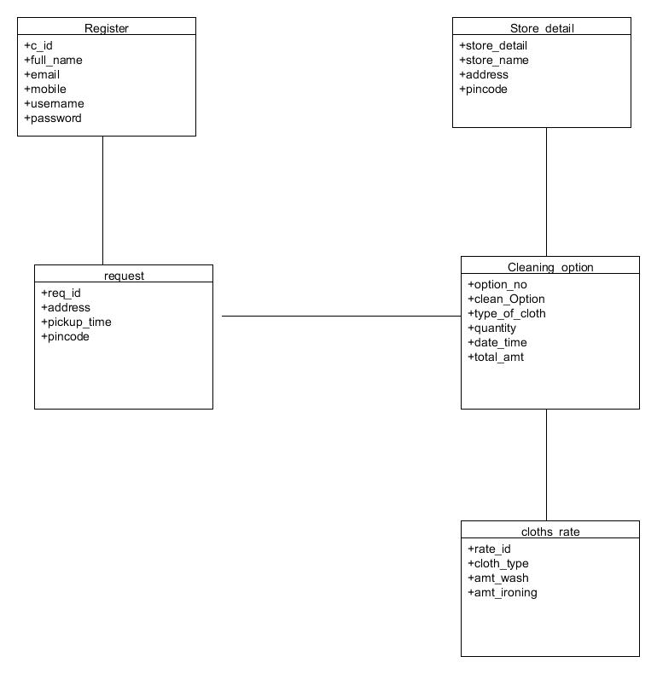

**Use-Case Diagram:**

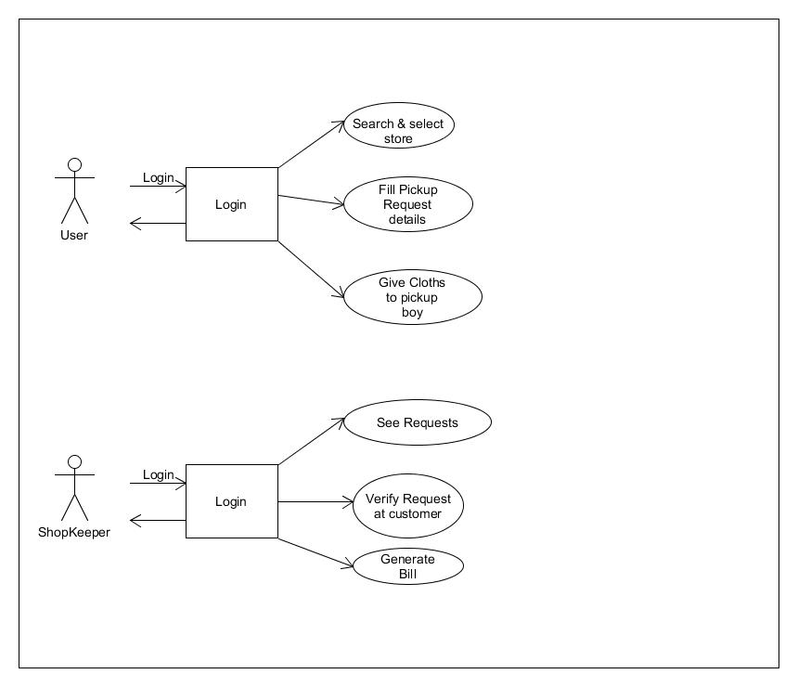

**Activity Diagram:**

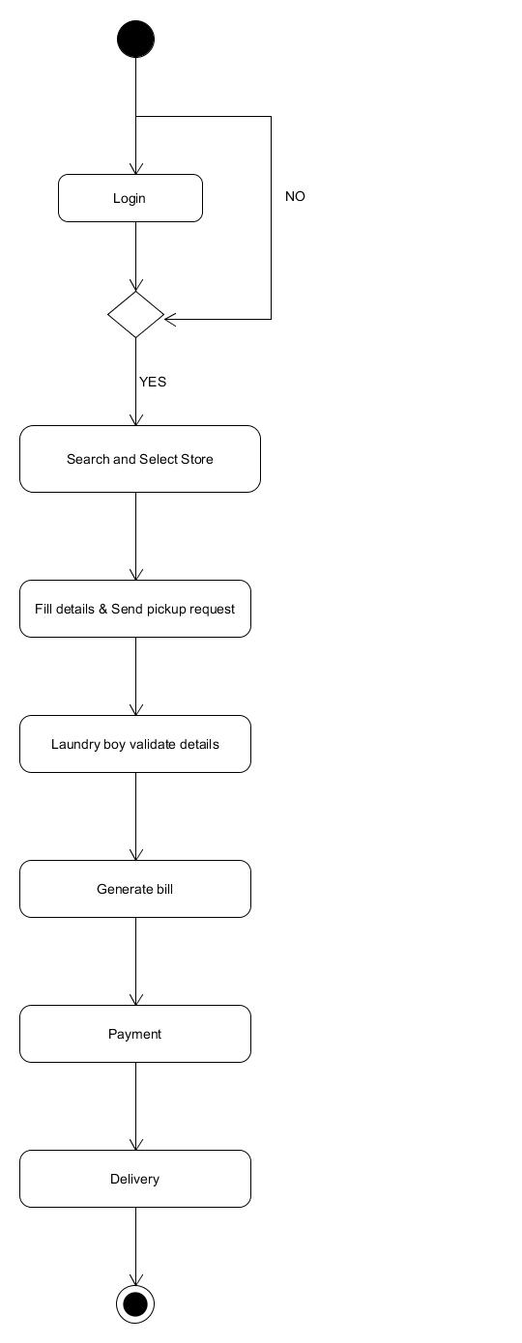

**Sequence Diagram:**

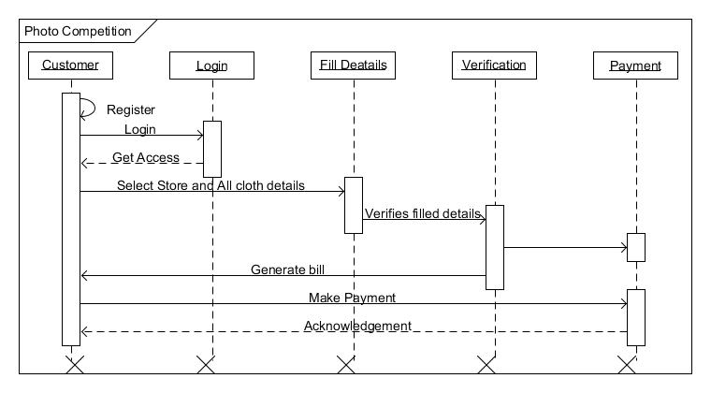

**Data Flow Diagram (DFD):**

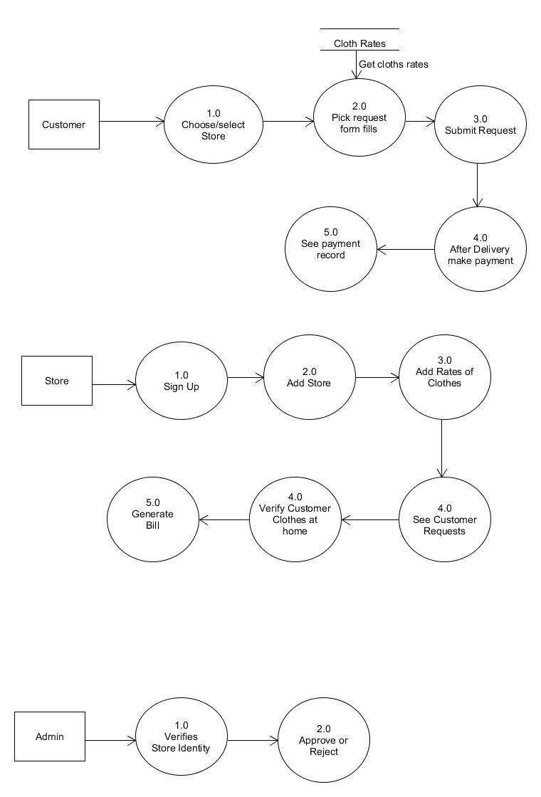

**Screenshots**



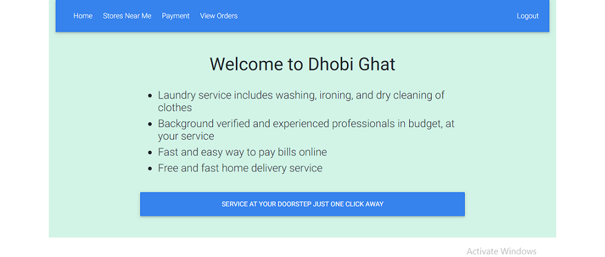

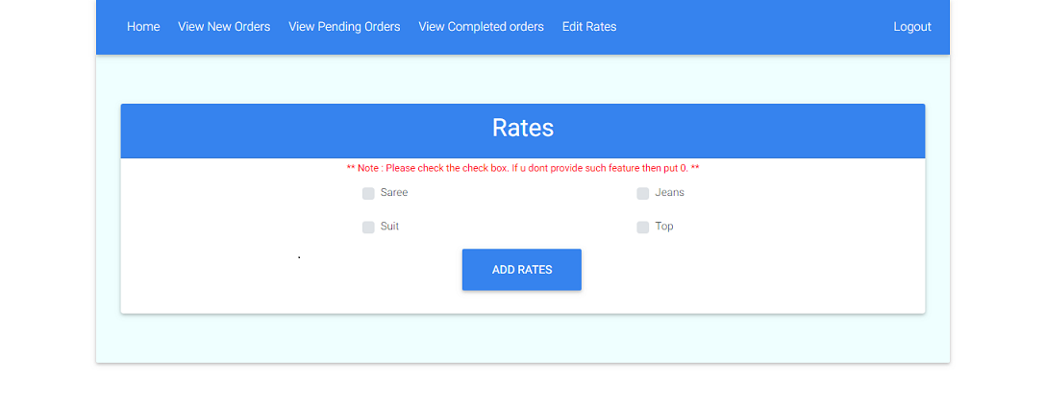

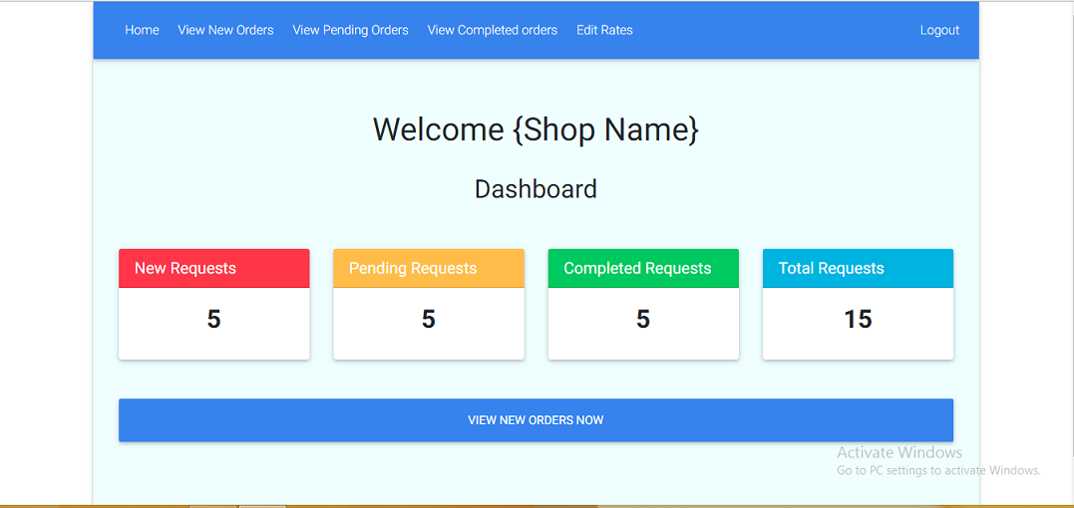

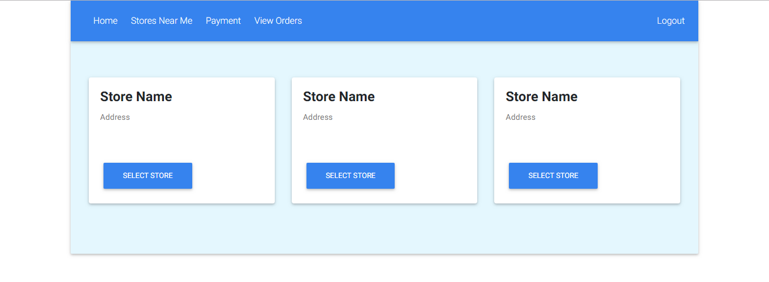

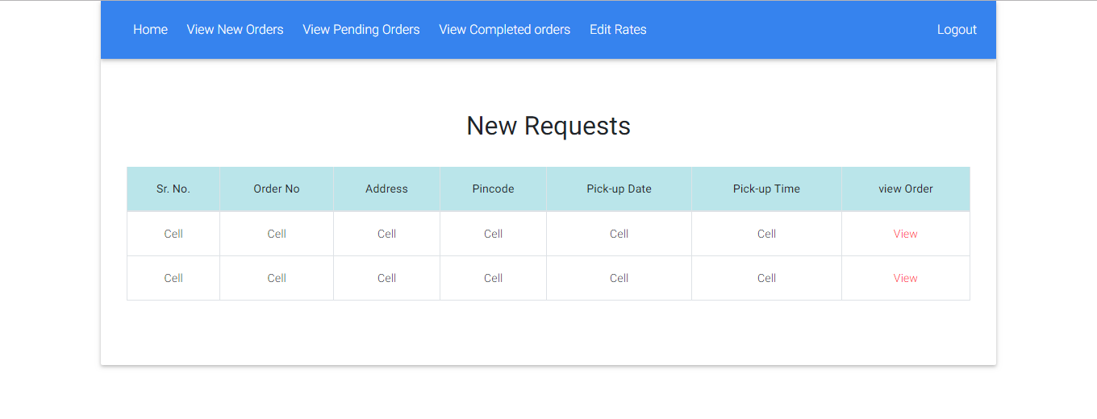

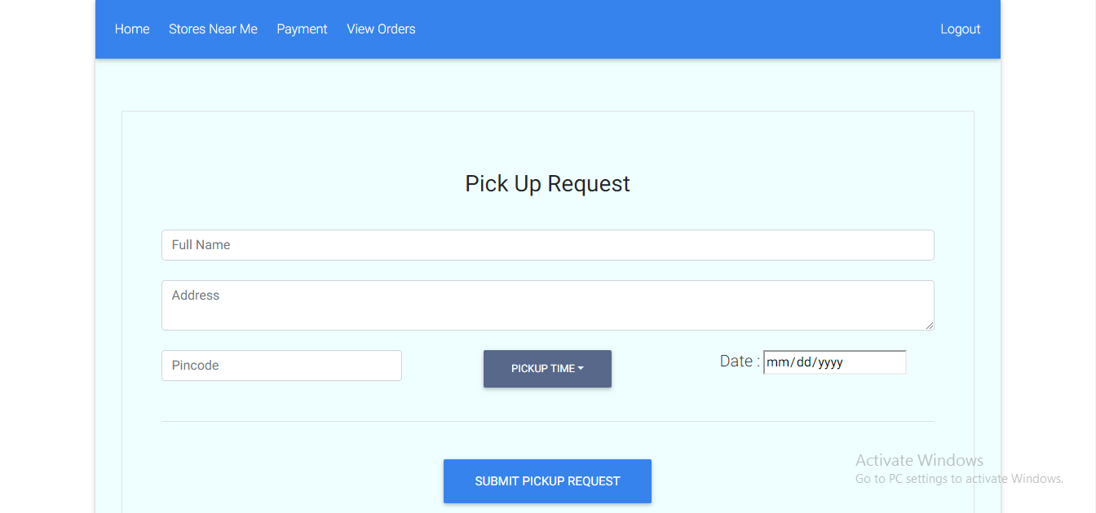

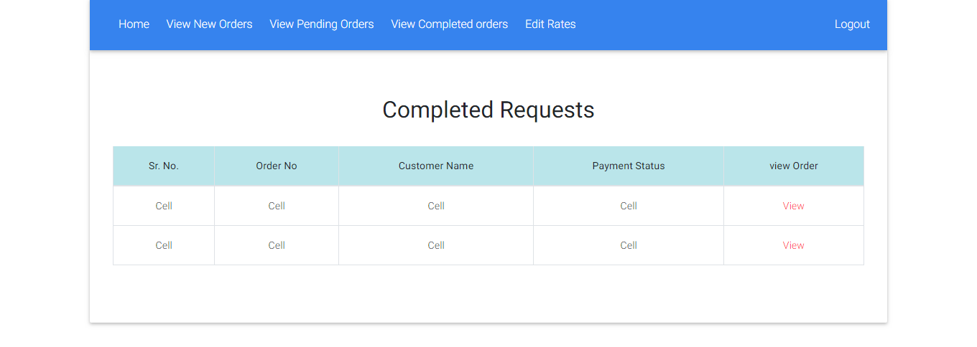

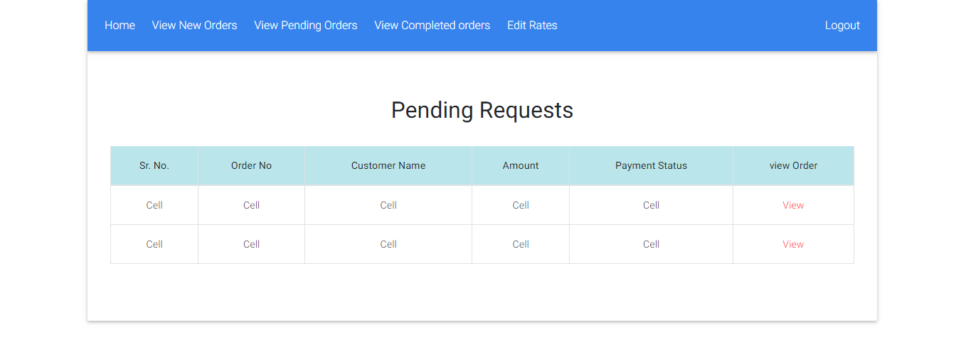

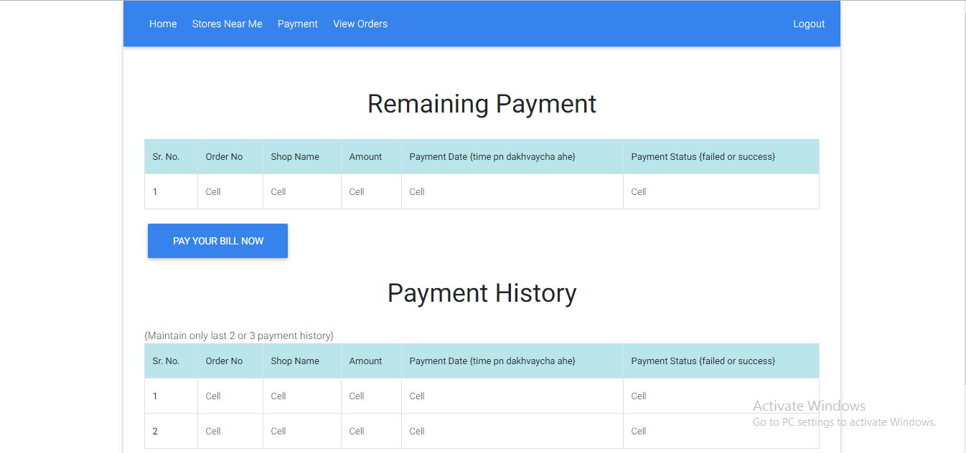

**System Testing**

* The system was tested with usual test routines with the intent of finding an error to detect bugs and to test the quality of the software.
* There are three main kinds of system testing:-
* **Alpha testing** was conducted at the developer side by the end users.
* **Beta testing** was carried out by the selected group of friendly customers, conducted at the end user side.
* **Acceptance testing** was performed by the customer himself to determine whether the system should be accepted or rejected.
* The system begins its first test by **unit testing** one & only one unit is tested as such.
* Testing procedures were carried following the **Bottom-up testing approach**. According to the Bottom-up approach each unit is tested as and when it developed. This units are combining into modules are also individually tested. And finally all the modules are integrated to form the entire system.
* **Integrated testing** is then performed on this developed system.
* An entire code is return in java. The system is object oriented. Thus the entire code is encapsulated into classes so it was easy to perform the testing procedure system was developed progressively taking one module at a time. Finally when all the modules were ready they were integrated to form the entire system.
* Finally when all the modules were integrated and the entire system was ready, I/Otesting ,performance testing and stress testing was carried out to test for all the conditions, exception handling capabilities, etc.
* **Input/output testing** was carried to check whether the system generated consistent files of the desired format. Also Input / Output testing helped to confirm whether the files were successfully uploaded at the server or downloaded from the server.

**Limitations**

* The size of the database increases day-by-day, increasing the load on the database back up and data maintenance activity.
* Training for simple computer operations is necessary for the users working on the system.
* Cyber-crimes are increasing day by day, so advance data security is needed to implement.

**Future Enhancement**

* This System being web-based and an undertaking of Cyber Security Division, needs to be thoroughly tested to find out any security gaps.
* Cyber-crimes are increasing day by day, so advance data security will be implemented in future.
* More searching options will be provided to the employer (company) in the future.

**Bibliography**

* Software Engineering
* HTML & Web Designing

**ONLINE REFERENCE:**