Mikhail Skobov  
CSEP 590 – Programming Systems  
Homework 1

**Problem 1:**

Note: it was unclear whether the period was part of the regular expression or was simply used to terminate the sentence. As such, both solutions are provided.

1. The strings accepted by the regular expression 10* are any strings that start with a 1 and have [0-infinity) 0 afterwards.  
   The strings accepted by the regular expression 10*. Are any strings that start with a 1 and have [0-infinity) 0 afterwards, and must be followed by any character

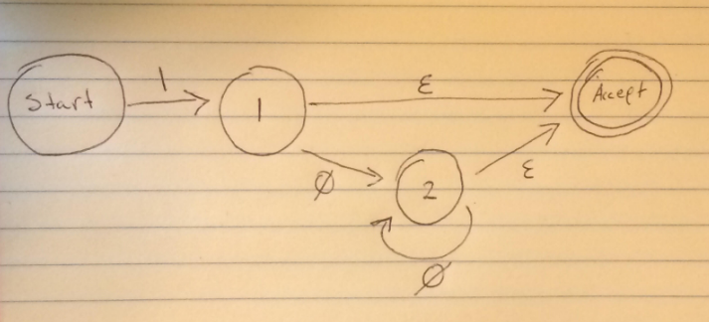

Note: This FA can apply to both solutions by changing the definition of E(psilon). For 10* E should imply any character, including the lack of one (the regular definition of E). For 10*. E should imply that a character exists and not include the lack of one (modified definition of E).

**Problem 2:**

a.

|  |  |  |  |  |
| --- | --- | --- | --- | --- |
| State | Input | Output | Stack (bottom-top) | Next |
| 1 | ([(x)])$ |  | 1 | S4 |
| 4 | [(x)])$ |  | 1 4 | S7 |
| 7 | (x)])$ |  | 1 4 7 | S4 |
| 4 | x)])$ |  | 1 4 7 4 | S3 |
| 3 | )])$ |  | 1 4 7 4 3 | R2 |
| 5 | )])$ | 2 | 1 4 7 4 5 | S6 |
| 6 | ])$ | 2 | 1 4 7 4 5 6 | R0 |
| 8 | ])$ | 2, 0 | 1 4 7 8 | S9 |
| 9 | )$ | 2, 0 | 1 4 7 8 9 | R1 |
| 5 | )$ | 2, 0, 1 | 1 4 5 | S6 |
| 6 | $ | 2, 0, 1 | 1 4 5 6 | R0 |
| 2 | $ | 2, 0, 1, 0 | 1 2 | ACC |

b.

|  |  |  |  |  |
| --- | --- | --- | --- | --- |
| State | Input | Output | Stack (bottom-top) | Next |
| 1 | ([x)] |  | 1 | S4 |
| 4 | [x)] |  | 1 4 | S7 |
| 7 | x)] |  | 1 4 7 | S3 |
| 3 | )] |  | 1 4 7 3 | R2 |
| 8 | )] | 2 | 1 4 7 8 | ERROR |

There is an error identified. The error occurs when the stack becomes 1 4 7 8. This is also the point in time where one would say that the parse table is attempting to reduce rule 1, but is unable to do so (since the only option for state 8 is S9 -> R1).