**Warm-up**: Discovery of the topic

**what is it about?** keywords & key information

**expected outcome**: use proper tenses when you speak & write

give a presentation of your background & future in **IT** & succeed the quiz

**LANGUAGE AT WORK**

|  |  |  |  |
| --- | --- | --- | --- |
| **Present tenses** | Present simple | Present continuous | Present perfect continuous |
|  | **I** code  **He** code  **She**  code  **It** code  You / we / they code | **I** code  **He** code  **She**  code  **It** code  You / we / they code | **I** code  **He** code  **She**  code  **It** code  You / we / they code |
| Auxiliaries ( - &?) | Do / Does | Be + ing | Have been + ing |
|  | simple present repeated action | present continuous now | present perfect continuous duration |

|  |  |  |  |
| --- | --- | --- | --- |
| **Past tenses** | Past simple | Past continuous | Present perfect simple |
|  | **I /** You / we / they code  **He / she / it**  code | **I /** You / we / they code  **He / she / it**  code | **I /** You / we / they code  **He / she / it**  code |
| **Auxiliaries ( - &?)** | **Did** | **Be + ing** | **Have + pp** |
|  | simple past completed action | past continuous interrupted action | past continuous interrupted action |

|  |  |  |  |
| --- | --- | --- | --- |
| **Future** **tenses** | Future simple |  | Conditional simple  if |
|  | **I /** You / we / they code  **He / she / it**  code |  | **I /** You / we / they code  **He / she / it**  code |
| **Auxiliaire ( - &?)** | **Will** |  | **Would** |
|  | https://www.englishpage.com/image/verbs/simplefuture.gif |  |  |

[**https://www.ego4u.com/en/business-english/grammar**](https://www.ego4u.com/en/business-english/grammar)

**Listen to the following story: Tech giants woo 15-year-old whizzkid**

First, read the comprehension questions below. Listen to the story with the class, answer as many questions as you can, using **keywords** only!!! (no need to write full sentences)

|  |  |
| --- | --- |
| **1.** | What are Facebook & Google in competition for? |
| **2.** | What is the name of the app designed by the teenager? |
| **3.** | How many times has the app been downloaded since October? |
| **4.** | What did Facebook invite Ben for? |
| **5.** | What about Google? |
| **6.** | What will the high-schoolers collaborate on? |
| **7.** | How many of them will participate in the event? |
| **8.** | Who will the high-schoolers listen to? |
| **9.** | Who is Michael Matias? |
| **10.** | What did he say about Ben's app? |

**Create a website with the Gallery block**

Today I (present) how to start with inserting a gallery block quite easily.

Most of the times, when I ([create) a website](https://www.en.sitew.com/) for a customer, I want it to be unique and attractive. Always attentive to my clients’ needs and requests, our team of developers recently (create) a brand new Gallery block to display photos on the website. They expect the numerous and powerful features of this new function (allow) our clients to customize their website.

To cut a long story short, if you want to add a wonderful photo gallery to a website, it (be) very easy. You just (have) to go to the website modification page and to drag and drop a gallery block to the website. Then we choose the gallery style in the blue panel on the left of the screen.

The slider below (offer) an elegant simple display of pictures.

* As you can see below, the arrow navigation (enable) the client to browse the images of the gallery, when you click on the side arrows.

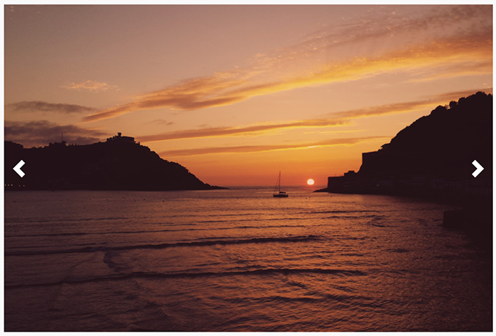

**Side arrow**

* The dot navigation (available for galleries of 5 pictures or less) (allow) you to browse the pictures by using dots located at the bottom of the block.

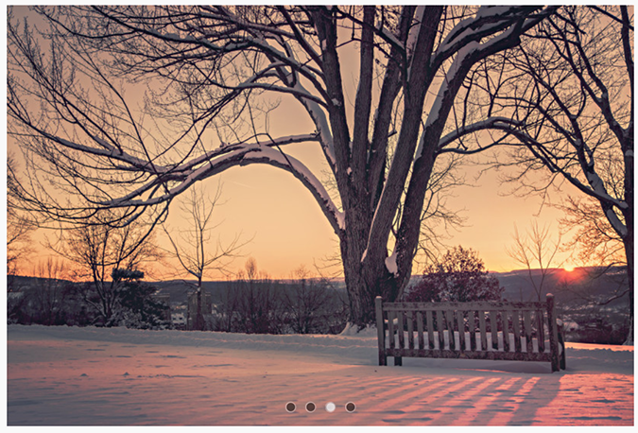

**Dot navigation**

* The client can choose between 2 different effects on image transition: either leftward slide or cross fade.
* As soon as I added the Autoplay option, the pics (display) automatically.
* With the “Full screen width” option, the image width will be adjusted to fit the visitor's browser. It is very useful for the homepage or to highlight specific images.

With the horizontal gallery I (be able to) customize the display of my clients’ photos.



**Preview gallery**

* For the last few months, I (use) a lot this gallery type to preview the selected picture and to enhance pictures

I know you (like) to master all the secrets of the Gallery block. You can start with this tutorial and use it according to your needs and make a website more attractive, while highlighting all images.

**Analyzing**: what is it about? keywords

**Vocabulary search**

|  |  |  |  |
| --- | --- | --- | --- |
| La barre de défilement |  | Afficher |  |
| Les besoins |  | Ajouter |  |
| Les caractéristiques |  | Glisser déposer |  |
| Un client |  | Mettre en valeur |  |
| Disponible |  | Naviguer |  |
| La page d’accueil |  | Permettre |  |
|  |  | Personnaliser |  |
| Selon |  | Proposer |  |

**Then find out about the tenses used in the document and complete the following tables!**

**expected outcome 1**: take the **quiz**!

**OPTIONAL OUTCOME:** Tell a story of your background & future in **IT**

Prepare a short text to tell your story (How you discovered IT…. What you expect from the training... and finally your plans after the training is over!