**Rocket Ball**

**Semester 1 Report**

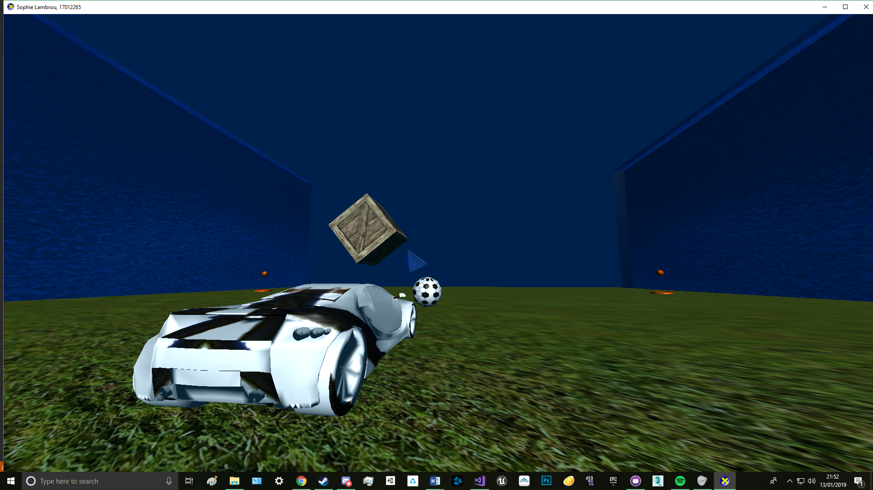

**Instructions**

You can use the WASD keys to drive the car around, to speed the car up you can hold the left shift (unless you’re reversing) as this will use your boost. You start off with a small boost at the start and from then on staying on a powerup will charge the boost, so the longer you stay on one the more boost you’ll have. The pickups and their bases will turn grey when you contact them, this way you know your boost is charging. To change between cameras, you can use numbers 1 – 4: the static camera is 1, top down camera is 2, third person is 3 and first person is 4. To switch between wireframe and solid mode you can use the up and down arrow keys.

**Features**

I have a fully textured cube that rotates and has been hard coded as well as a pyramid that rotates around the cube and is slightly transparent. There is a grid that has also been hardcoded and a grass texture has been applied. There is a ball in the centre of the pitch with an appropriate texture applied to it; this object as well as the car, pickups, pickup bases and walls have been loaded by an external file rather than hard coded, so this has been done through the mesh loader. The pickups hover up and down in the air and the texture changes when you come into contact with one. I have implemented ambient, diffuse and specular lighting as well as a day and night cycle. There are 4 cameras to choose from which are held in the camera class, for the first- and third-person camera the values are passed through the camera class and add an offset to the x, y and z position, these add to the car’s position, so the camera’s follow the car.

**Class Diagram**

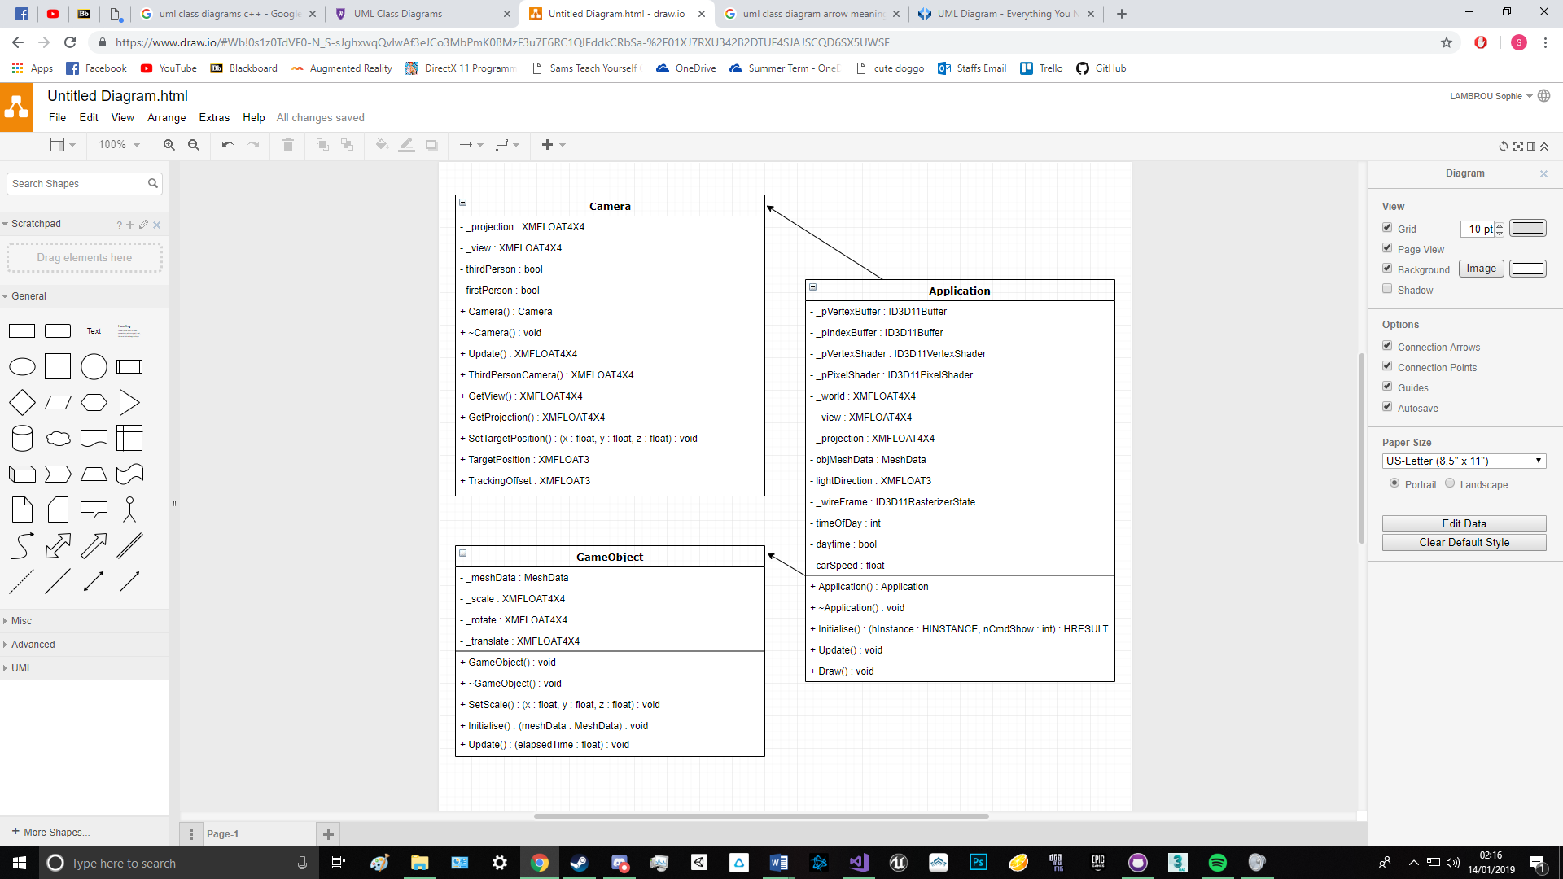

**Test Documentation**

|  |  |  |
| --- | --- | --- |
| Name | Problem | Solution |
| Grid | I had an issue with the main ground grid for a while, this was because I didn’t really understand completely how the indices worked with the vertices. | It was very simple once I understood it, it turned out instead of creating a new index I had re-used indices because some overlapped, so this had meant that the lines on the grid were all over the place. |
| Walls | It took a while to get the walls, this was because I was overcomplicating things as I tried to copy and then flip the grid that I had for the ground and then rescale and reposition. | It was much easier to take a cube from an obj loader and rescale that to fit appropriately. |
| Pickup Collisions | I wasn’t sure on how to approach driving over pickups to gain boost. I wanted to add a collider to the car and the pickup bases so that it would be easy to interact with them, and I could just apply the collider to future pickups/objects. | It ended up I got the positions for the pickups and the bases and set the boost to increase whenever the car was on one of those spaces. |
| Cameras | I did not know how to pass through the variable for the car’s position for the first- and third-person camera. When I did pass through the variables, I found the y value especially to be way lower than it should have been. | The strange values were due to the car being scaled down massively, as this was huge when I first imported it. The y value was at -700 so I added offsets to the camera class in order to place the camera so far away from the car and scaled them to match the car so they could follow its’ position. |

**References:**

<https://www.braynzarsoft.net/viewtutorial/q16390-9-transformations>

<https://www.brusheezy.com/textures/20185-seamless-green-grass-textures>

<https://stackoverflow.com/questions/41469631/directx-11-move-object-based-on-rotation>

<https://www.vecteezy.com/vector-art/110279-football-texture-vector>