York Pirates! Instruction Manual

Controls

|  |  |
| --- | --- |
| **Key** | **Control** |
| Up Arrow / W | Enable forward movement |
| Down Arrow / S | Stop forward movement |
| Left Arrow / A | Turn left |
| Right Arrow / D | Turn right |
| F | Interact with islands |
| Esc | Exit menus |
| LMB | Select button |

Gameplay

Sailing:

During sailing mode you can use your ship to move between islands. You can also randomly encounter enemy colleges’ ships if you sail around in their territory (the territory you are currently in is displayed at the top of the screen). If you sail to a college’s island you can challenge their boss ship. If you successfully defeat a college’s boss you will take over their territory and will no longer encounter hostile ships there. You will also be able to heal at that college’s island (for a cost).

Some islands house departments rather than colleges. These islands are neutral and so can always be used to repair or even apply unique upgrades to your ship.

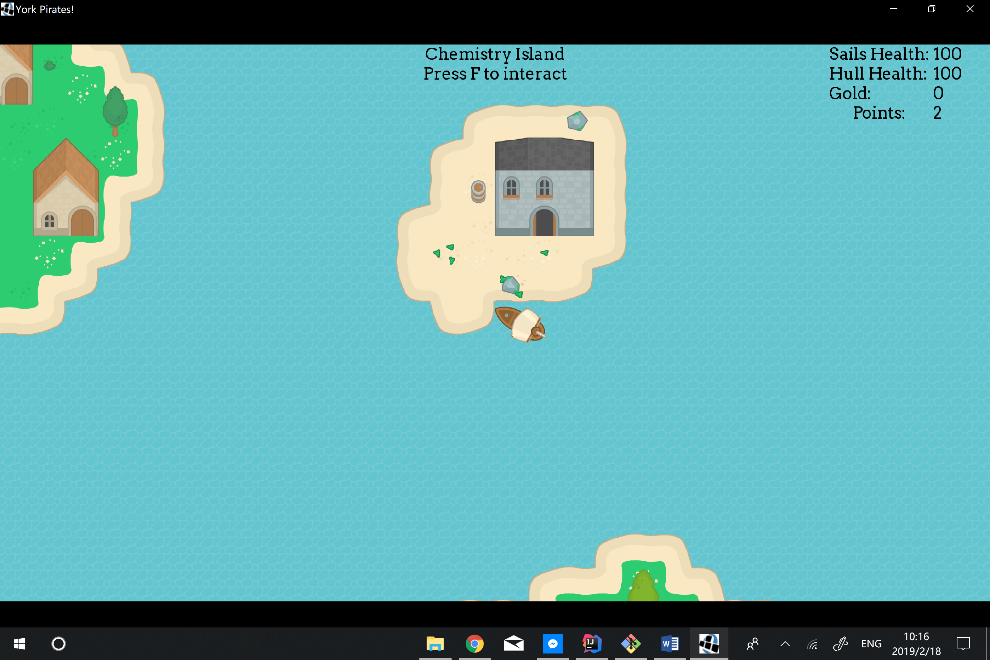

Combat:

During combat mode you are able to select attacks to use against the enemy ship in order to defeat them. You can also flee if you feel you are unable to defeat the enemy. Successfully defeating an enemy ship will reward you with some points and gold.

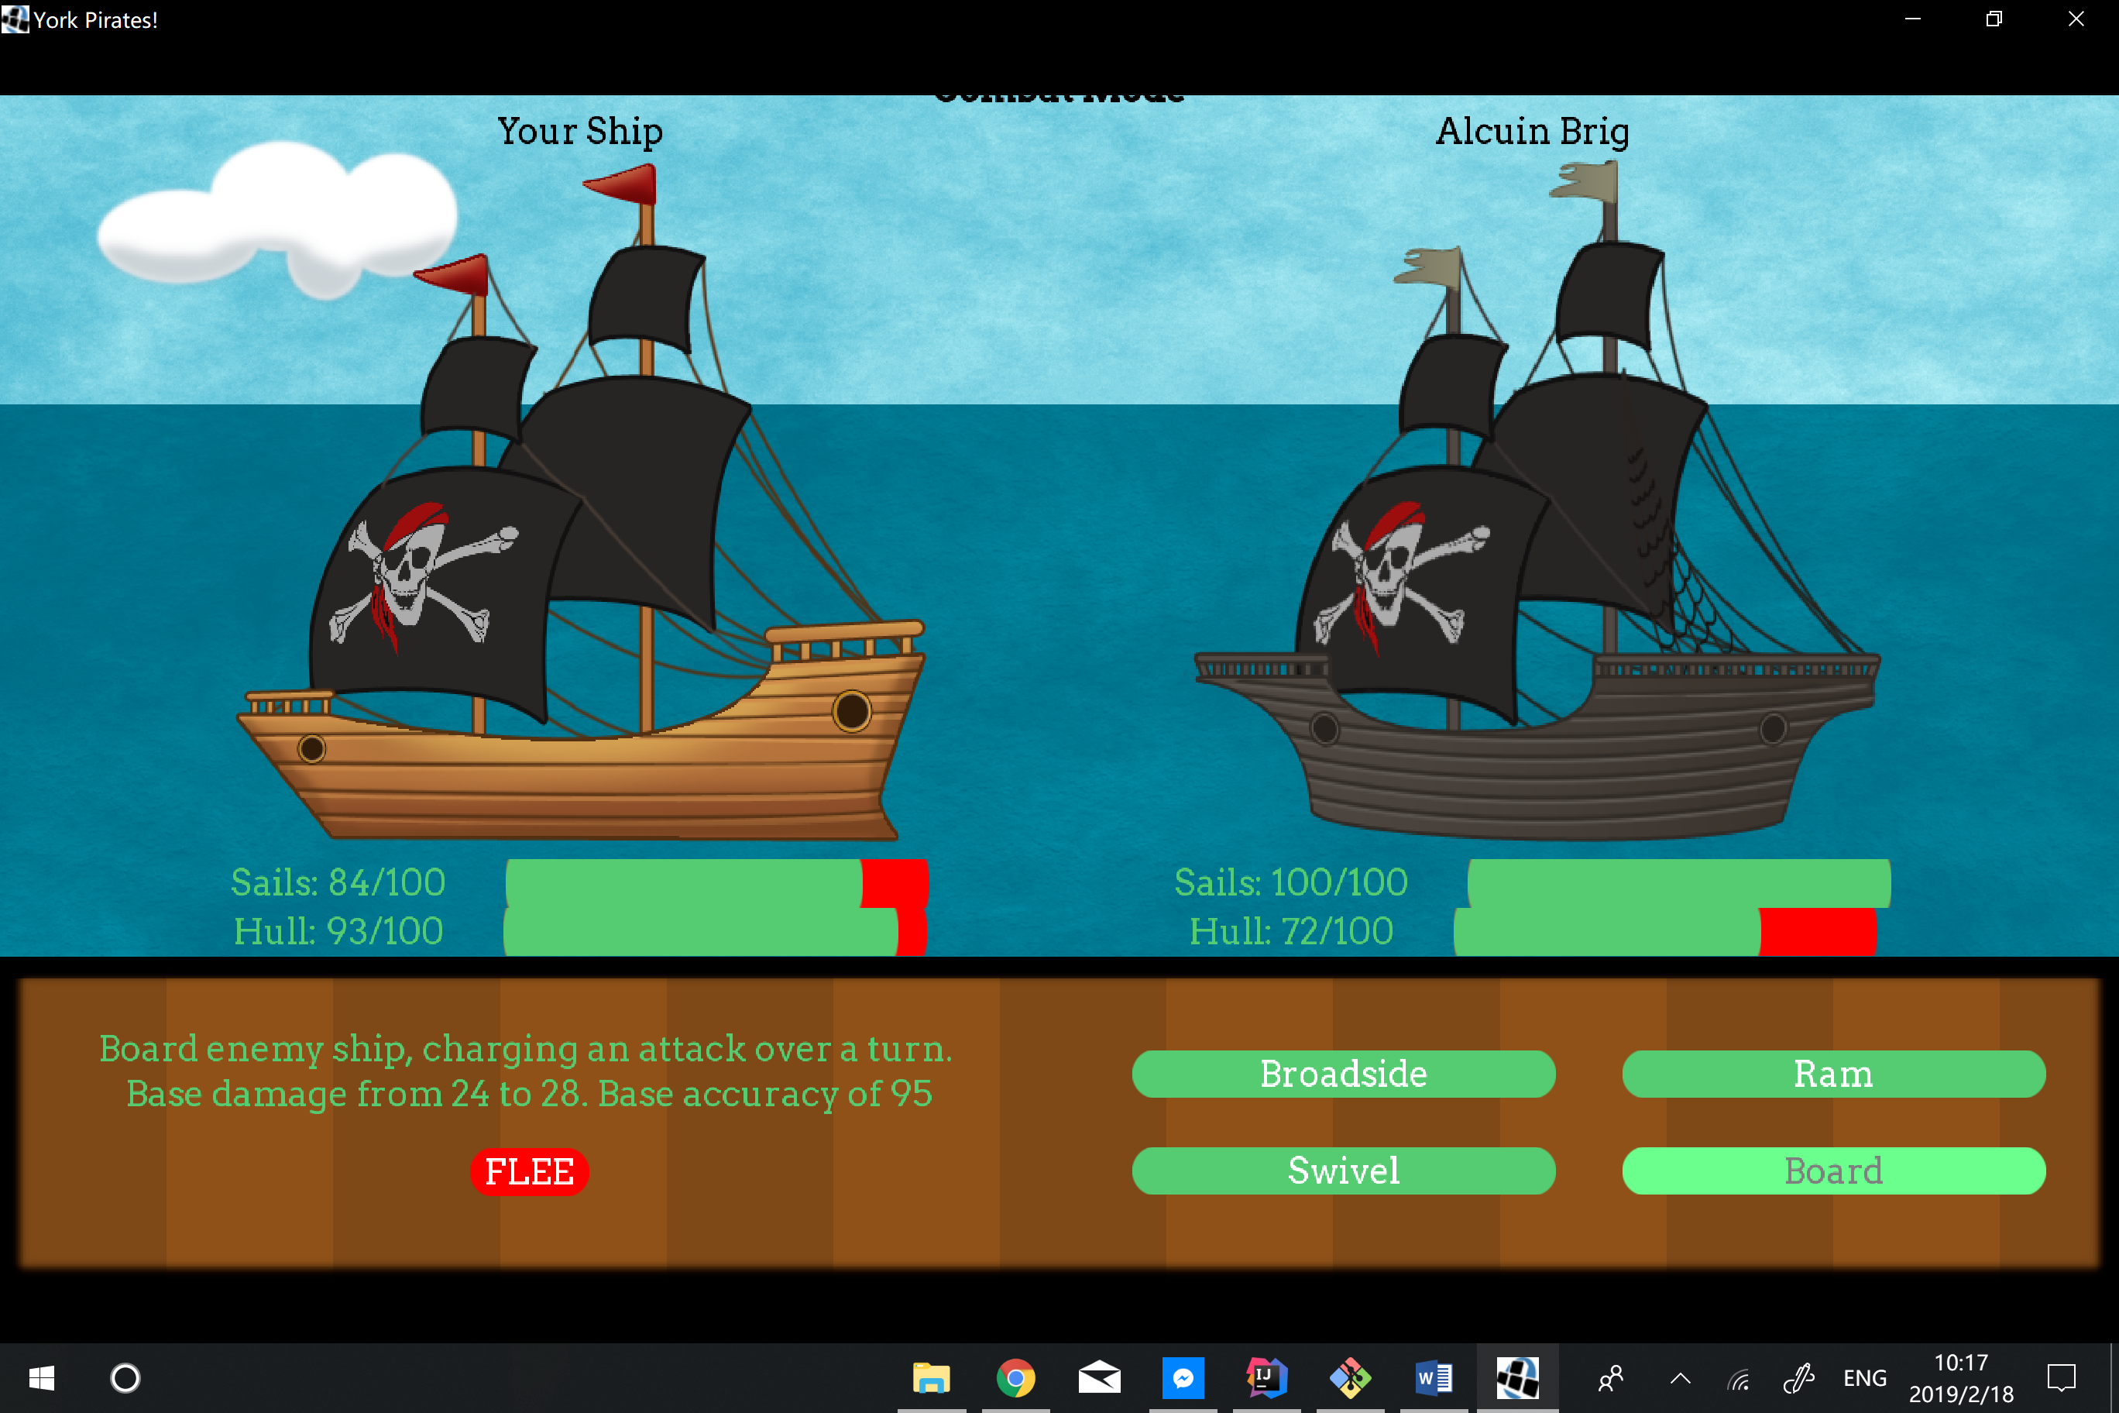

MiniGame:

You can enter the Mini Game in through ally college’s screen. Win the mini Game will give you 100 extra point. In the mini game, player is operating the pirate and has a simple goal to get out of the maze and avoid being caught by the ghosts. The control keys are the same as the main game.

