York Pirates! Instruction Manual

Controls

|  |  |
| --- | --- |
| **Key** | **Control** |
| Up Arrow / W | Enable forward movement |
| Down Arrow / S | Stop forward movement |
| Left Arrow / A | Turn left |
| Right Arrow / D | Turn right |
| F | Interact with islands |
| M | Open/Close the map |
| Esc | Open/Exit menus |
| LMB | Select button |

Gameplay!

Menu and Map:

You could open and close the menu and map at any time during the sailing mode.

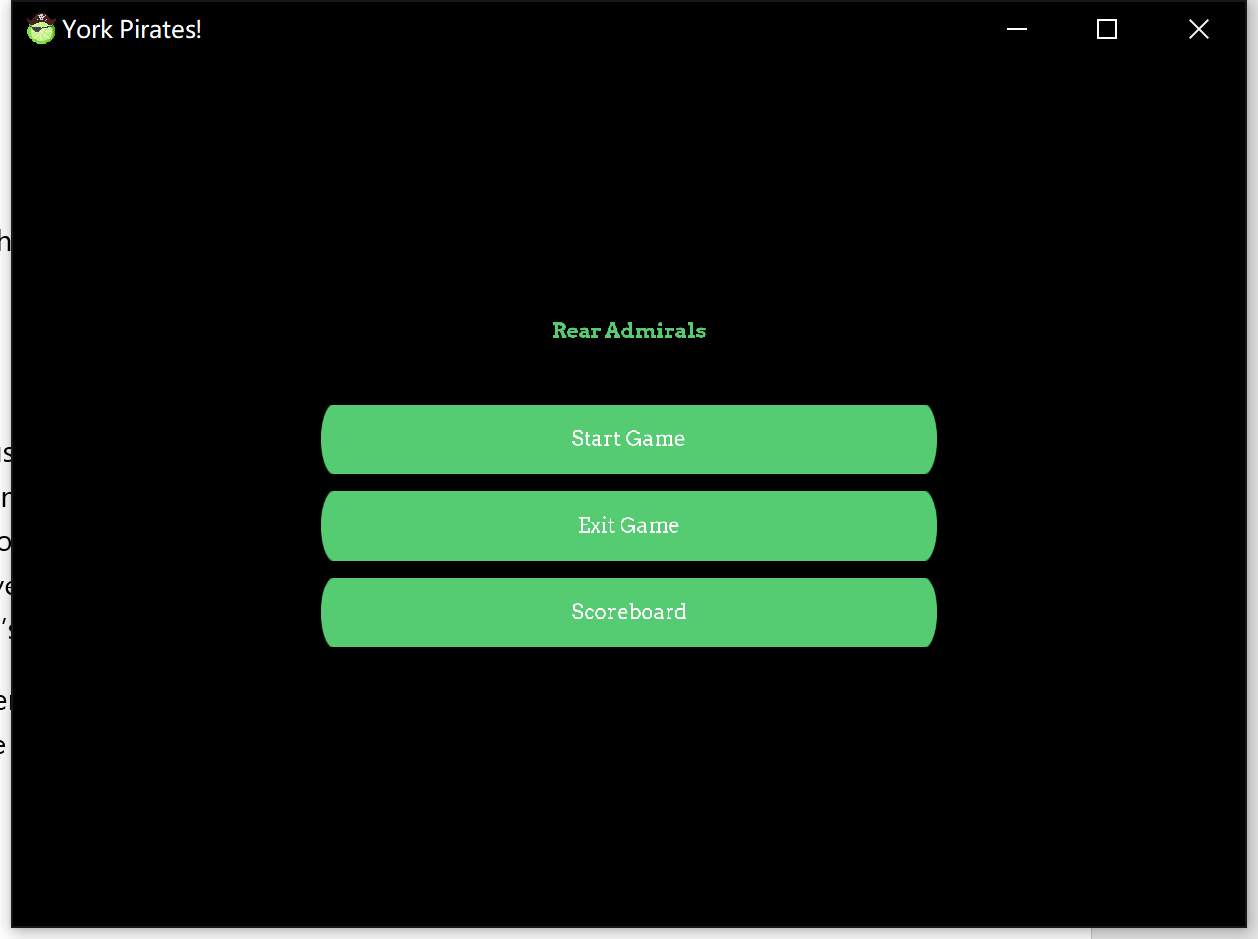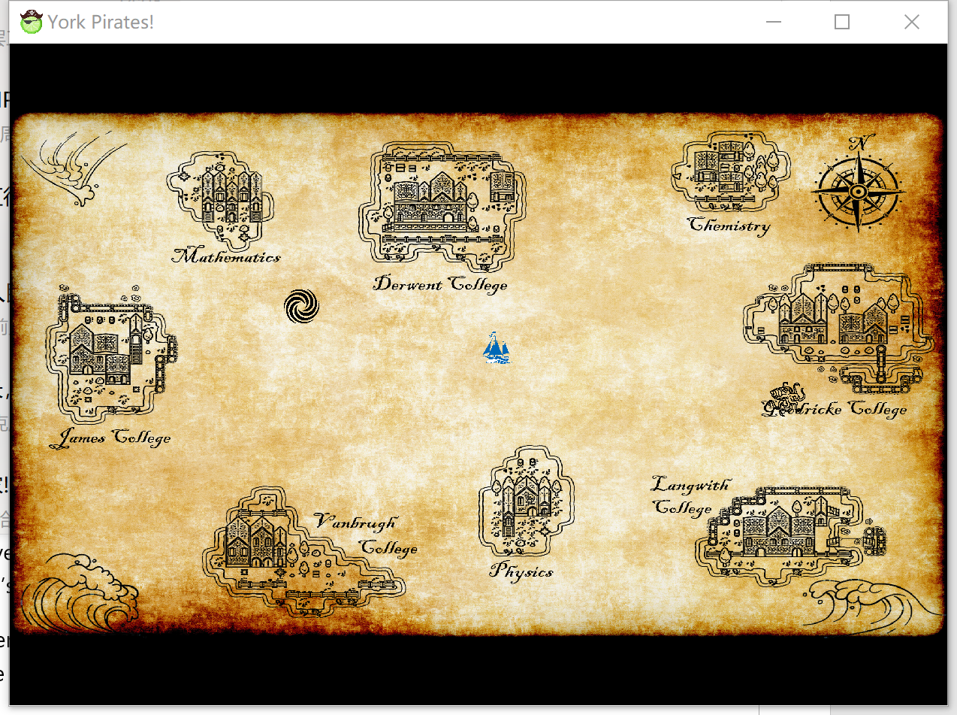

Sailing:

During sailing mode you can use your ship to move between islands. You can also randomly encounter enemy colleges’ ships if you sail around in their territory (the territory you are currently in is displayed at the top of the screen). If you sail to a college’s island you can challenge their boss ship. If you successfully defeat a college’s boss you will take over their territory and will no longer encounter hostile ships there. You will also be able to heal at that college’s island (for a cost).

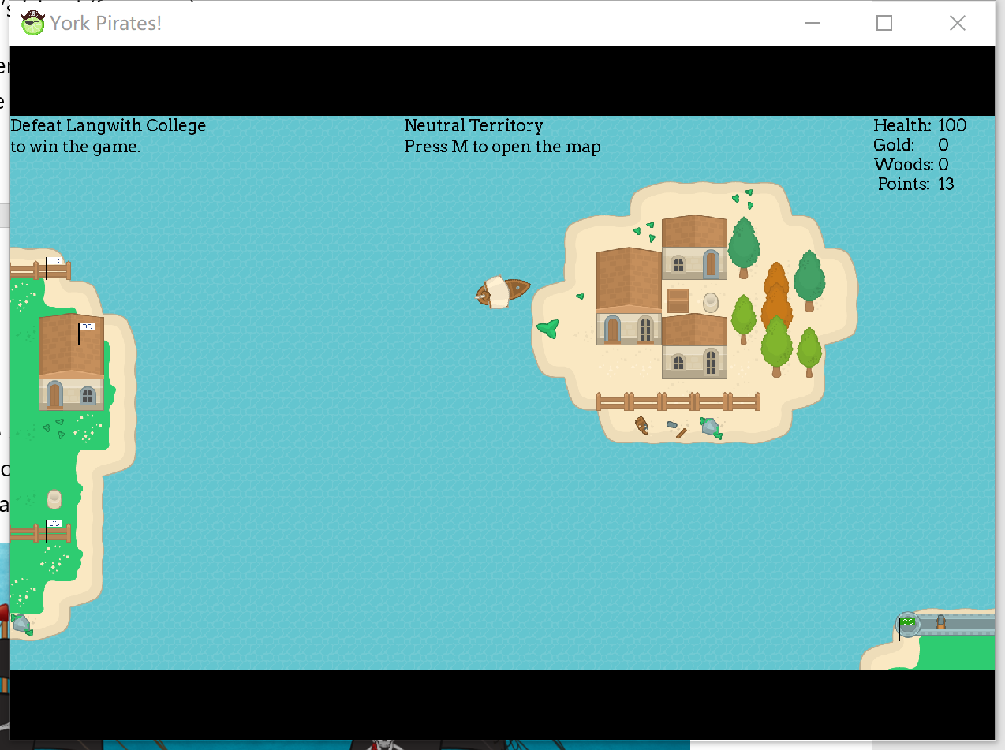Some islands house departments rather than colleges. These islands are neutral and so can always be used to repair or even apply unique upgrades to your ship.

Combat:

During combat mode you are able to select attacks to use against the enemy ship in order to defeat them. You can also flee if you feel you are unable to defeat the enemy. Successfully defeating an enemy ship will reward you with some points and gold.

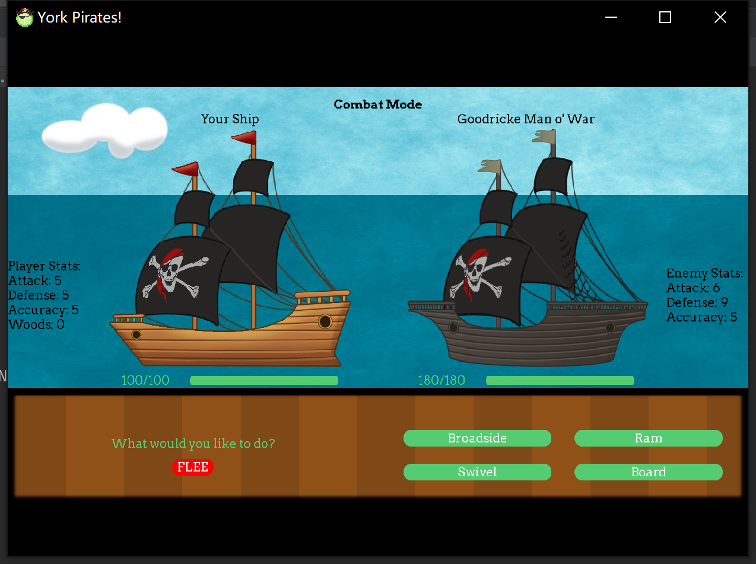

Sea Monster:

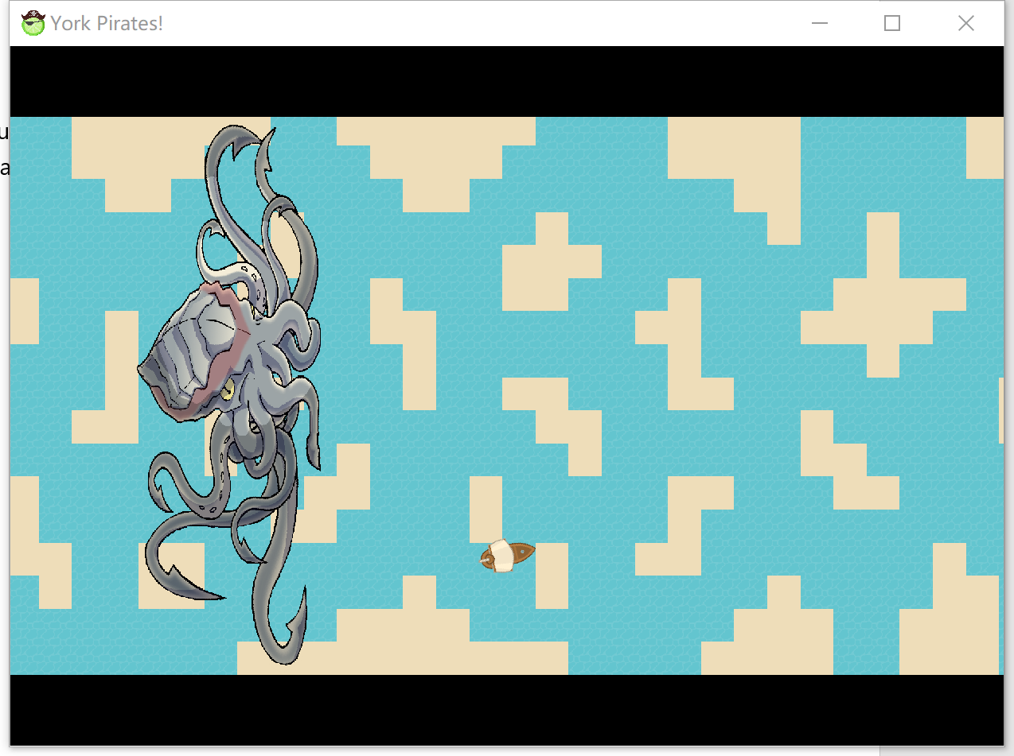You will play a mini game to run escape from the sea monster if you meet the monster on the lake. If you fail to escape, you will lose golds and wood pieces.

Whirlpool:

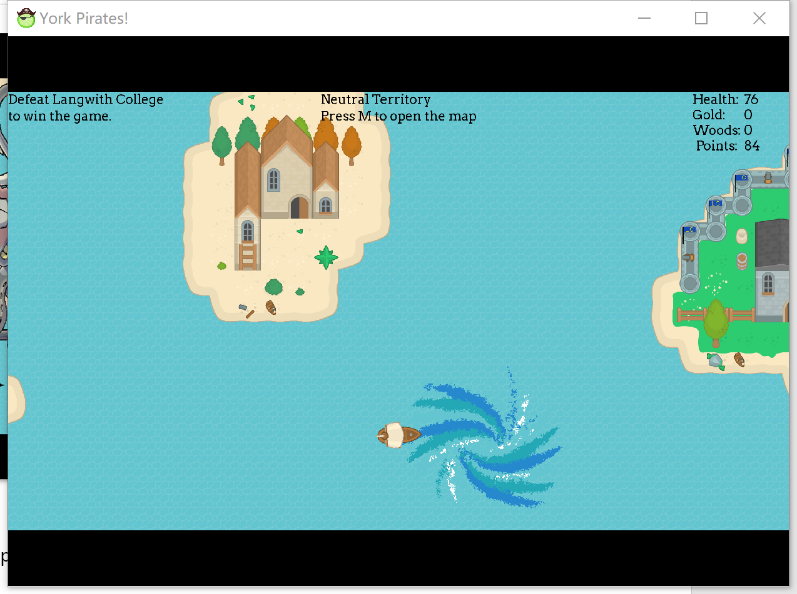You will lose health of your ship every second in the area of the whirlpool, and your speed will decrease unless you leave the area.

Other Feathers:

Mini game: play mini game in department and win golds!

Unlock new crew: Defeat colleges and unlock new crew to give you extra ability!

Scoreboard: See if you can get the lead!