Hits

1. How to find jar file in IDEA project in “External Libraries”:

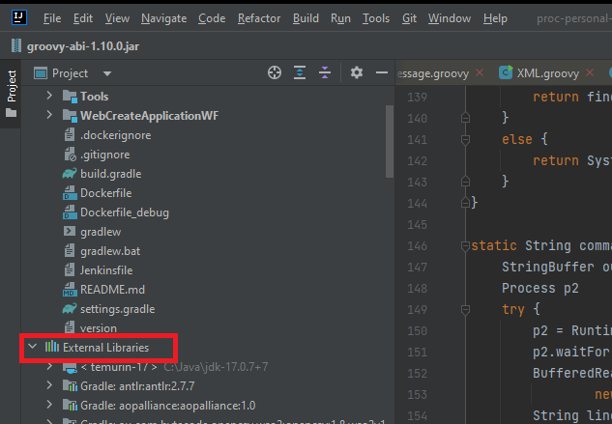

Changes jar library -> Open In -> Explore
After that copy jar file

