The Home Task can be done using Typescript or less preferable (try to avoid) Vanilla JS.

Check the UML representation of a set of classes that represent the inventory and various types of items. Methods and classes where you are providing an implementation are shown in bold.

The classes in italics represent abstract classes or interfaces. The concrete child classes must implement all methods from the abstract parent classes. **Item**, **Consumable**, and **Weapon** are the abstract classes.

The line from **Item** to **Comparable** indicates that Item must implement the **Comparable** interface. Similarly, the **ItemWeightComparator** class must implement the **ItemComparator** interface, which extends the **Comparator** interface. **ItemWeightComparator** compares items based on their weight.

**Specific Steps**

The **Item** class is the common ancestor to the various types of items that can exist in this fantasy game.

* All instances of **Item** are given a unique number *id*. These are to be assigned by the **Item** constructor. The first instance of an item is assigned an *id* of 0 (zero); the next is assigned 1, etc. Note that you have available a class variable that will help with the implementation of the constructor (and there is a static *reset*() method).
* *compareTo(other: Item)*: The **Item** class implements the **Comparable** interface. This requires adding the *compareTo(other: Item)* method to the class. The *compareTo(other:Item)* method takes in another instance of **Item** and compares it to the current instance. If the current instance’s value field is greater than other’s value field then the method should return a positive integer (convention is 1). If the current instance’s value field is less than other’s value field then the method should return a negative integer (convention is -1). If both items are equal, then compare the name field of the items lexicographically (meaning, compare each character in the strings based on its value, ignoring case. i.e. A == a), returning the appropriate value.
* *Item.toString():* for an **Item** with the name of “*ring*”, a value of 3000, and a *weight* of 0.013, the method must return a String in the following format (excluding the quotes):

”*ring − Value: 3000, Weight: 0.01*”

The **ItemWeightComparator** class implements the **ItemComparator** interface, meaning instances of it can be passed to methods requiring a comparator for objects of type Item.

* The *compare(first: Item, second: Item)* method of **ItemWeightComparator** should function similarly to the *compareTo(other: Item)* method of the **Item** class, but for the weight field of the **Items**. If the weights are equal, this method should call the *compareTo(other: Item)* method of the first Item and return the resulting value.

The **Weapon** class is an abstract implementation of **Item** and describes items that can deal damage and break from use. The implementation of this class is provided for you. All instances of **Weapon** have a base damage value *baseDamage* and a modifier to that value *damageModifier*. The sum of these two values determines the *effective damage* that this **Weapon** can do on a single use. In addition, **Weapons** have a base durability value *baseDurability*, and a modifier to that value *durabilityModifier*. The sum of these two values determines the *effective durability* of the **Weapon**. When this sum reaches zero or less, the effective durability is zero and the **Weapon** is considered to be *broken* and cannot be used.

We provide several implemented methods that include:

* *Weapon.getDamage()*: Returns the effective damage of the **Weapon**.
* *Weapon.getDurability()*: Returns the effective durability of the Weapon.
* *Weapon.toString():* for a **Weapon** with the *name* of “hammer”, a value of 300, a *weight* of 2.032, a *baseDamage* value of 30.4219, a *damageModifier* of 0.05, a *baseDurability* of 0.7893, and a *durabilityModifier* of 0.05, the method returns a String in the following format:

*”hammer − Value: 300, Weight : 2.03 , Damage : 30.47 , Durability : 83.93%”*

* *Weapon.use()*: This method returns a String describing what happens when a **Weapon** is used. For a **Weapon** with the name of “*hammer*”, and an *effective damage* of 30.4725, the method should return the following:

*”You use the hammer , dealing 30.47 points of damage.”*

* “Using” a **Weapon** lowers (subtracts) its effective durability by **Weapon.MODIFIER CHANGE RATE**. If the *effective durability* of the **Weapon** hits or drops below 0, the **Weapon** will ”break”. If the **Weapon** ”breaks”, the method should output the previous String, but additionally with a newline character and the additional text “*The hammer breaks.*”:

*”You use the hammer , dealing 34.05 points of damage . The hammer breaks.”*

* For a **Weapon** with the name of “hammer”, if it is “broken” (The *effective durability* is 0 or less), calling its *use*() method returns the following:

*”You can't use the hammer , it is broken.”*

In this case, there is no change to *durabilityModifier*.

The **Sword** class is a concrete implementation of **Weapon** that you must provide.

* All instances of the **Sword** class have the *name* “sword”.
* *Sword.polish()*: This method increases the instance’s *damageModifier* by adding **Weapon.MODIFIER_CHANGE_RATE** each time *polish*() is called, up to 25% of the *baseDamage* value. If the *base damage* of a sword were to be 100, then the maximum that the effective damage could be increased to would be 125.

The **Bow** class is a concrete implementation of **Weapon** that you must provide.

* All instances of the **Bow** class have the *name* “bow”.
* *Bow.polish():* This method increases the instance’s *durabilityModifier* by adding **Weapon.MODIFIER_CHANGE_RATE**. Any changes are capped such that *effective durability* is no larger than one (1).

The **Inventory** class is a container for items in this fantasy game. You need to add the following methods:

* *Inventory.sort()*: This sorts the items in the **Inventory** instance based on their *value*
* *Inventory.sort(comparator: ItemComparator)*: This sorts the items in the **Inventory** instance based on their *weight*.
* *Inventory*.toString: return string representation of the item list (.join(‘, ’))

The **Consumable** class describes those items that can be eaten by the player. **Consumables** can be marked as consumed, and can be spoiled. These properties are stored in the instance variables *consumed* and *spoiled*, respectively. A newly-created **Consumable** object should have its *consumed* field set to false.

* *Consumable.use():* If a **Consumable** is not *spoiled* and is not *consumed*, calling this simply returns the value from a call to *Consumable.eat().* For a **Consumable** with the *name* of “bread” that has already been consumed, this method returns the following:

*”There is nothing left of the bread to consume.”*

Assuming for this **Consumable** named “bread” that the value returned by a call to its *eat()* method is the following:

*”You eat the bread.”*

If this “bread” were to be *spoiled*, the method returns this String, appended with a newline and the text “You feel sick.”:

*”You eat the bread.*

*You feel sick.”*

Specific Instructions:

1. Start from creating **Item**, **Consumable**, and **Inventory** classes.

2. Create the **Sword**, **Bow** and **ItemWeightComparator** classes

Implementation details

1. both int/float types in the UML diagram represents “number” type in typescript;
2. **Item class**:

* *numberOfItems* is static getter property which returns “*counter*” (keep it outside of class declaration and increment every time class constructor is executed)
* *reset*() method should assign 0 to the “counter”
* *compareTo(other: Item) - see description above*

1. **Consumable class**:

* consumed is false when create new instance

1. **Inventory class:**

* items - Array<Item>
* *sort()* method is polymorphic and has 2 declarations: *sort() and sort(comparator: ItemComparator)*

1. ***Weapon class****:*

* don’t forget to use super in constructor (note that parent classes can require extra fileds, such as ‘*name*’)

1. **Pizza class:**

* *example of eat() method:*

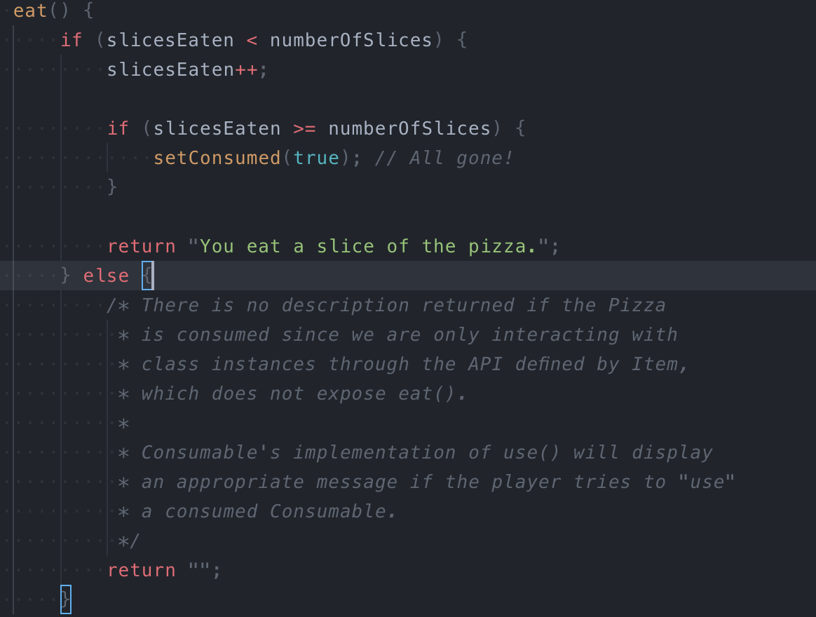

Evaluation criteria

2. Only some of the classes were not implemented.

3. Some classes were not implemented.

4. Some of the required methods are missing.

5. All tasks are implemented to a full extend.