Practical Task 1
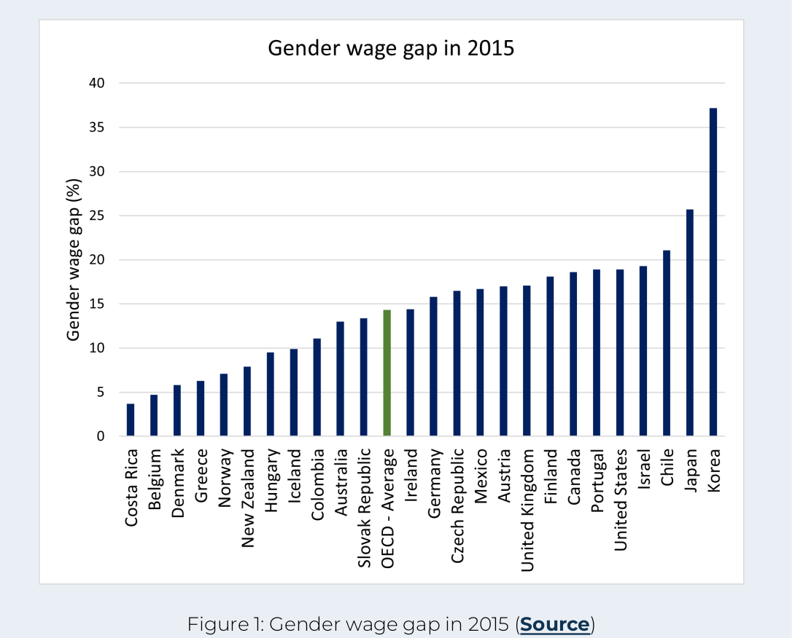
● Which three countries have the lowest gender wage gap?

Costa Rica, Belgium, Denmark

● Which three countries have the highest gender wage gap?

Korea, Japan, Chile

● Do some research on the country with the lowest gender wage gap and comment on why you think it succeeded in achieving a low gender wage gap in 2015 (max. 150 words).

Based on “The Global Gender Gap Report“ by World Economic Forum (https://www.weforum.org/publications/global-gender-gap-report-2015/), small wage gap in Costa Rica was due to a near doubling of women in ministerial positions (from 25% to 41%). It has also fully closed its gender gap on the Educational Attainment subindex, but ranks among the bottom three in the region on Health and Survival. Since 2006, it has improved in all subindexes except Health and Survival where it has slightly regressed.

But measuring wage gap like that is flawed. They usually put all men into one group and all women into other and then calculate average wage for both groups. Men usually do dangerous and risky jobs like: Miners, Construction workers, Soldiers, Police officers. While women tend to get no-risk jobs like: Waiters, Cleaners or Stay at home moms. Wifes of top earning men probably don‘t have day job. So of course it will look like that women get paid less than men on average.
But if you compare people with same education, same role and same amount of time spent in work, than you find out that women are paid more. Once you start think about it, you realise, that if man would get higher salary just because he is man, than no employer would want to hire him, because they could get same work done by woman and pay her less. Right? So why would any employer hire “more expensive employee“? Because employer expects more work to be done by them.

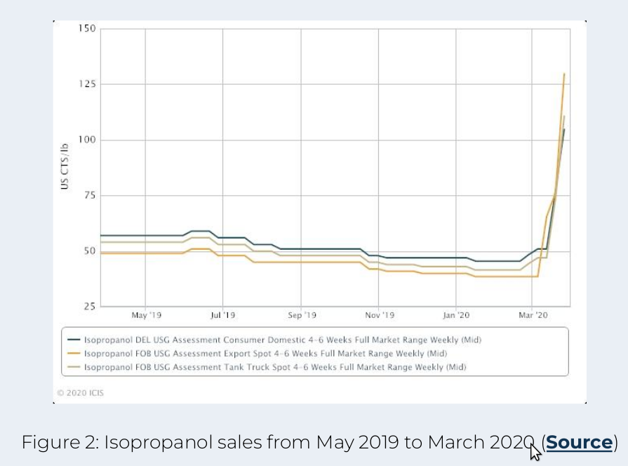
● Explain what is happening in the graph during March 2020 with regards to isopropanol sales (max. 100 words).

Sales of Isopropanol went 150% up.

● Describe a possible reason for the observation you made about isopropanol sales in March 2020 (max. 100 words). Hint: Isopropanol is the main ingredient in hand sanitiser.

March 2020 is infamous for oubreak of COVID-19. In UK, official Government advice was: „We have respiratory dissease roaming arround. You can get it if somebody coughs in your face. No need for masks, just wash your hands and sing a song. Twice. That will protect you.“ So people were washing their hands like ther is no tomorrow.

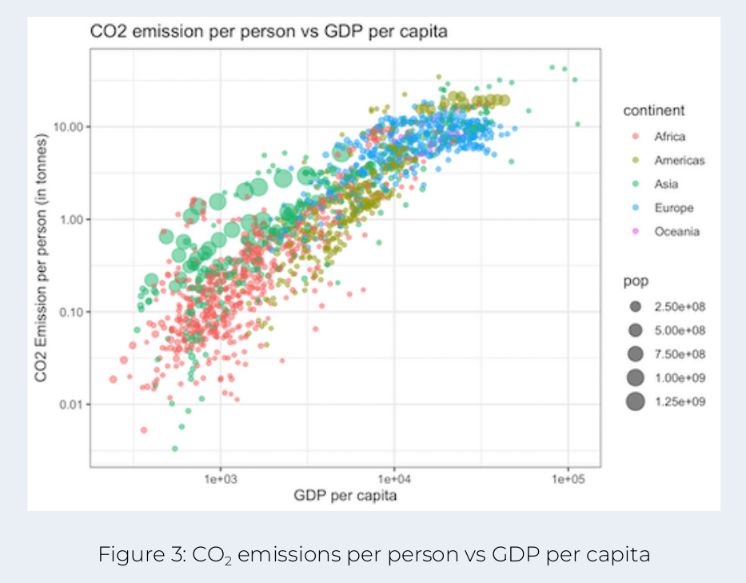
●Discuss the relationship between CO 2 emissions per person and GDP per capita for each continent listed in the figure legend (max. 350 words).

Africa: Low CO2 emissions and low GDP per capita.

Americas: It is divided into 2 groups. One with higher CO2 and higher GDP per capita and other with lower CO2 and lower GDP per capita.

Asia: Some countries have same CO2 emmisions but way lower GDP than in Europe

Europe: High GDP per capita and high CO2

Oceania is all over the graph, but mostly on same low levels as Africa is.

Conclusion: Breathing higher levels of CO2 has positive effect on persons productivity. :D

Practical Task 2
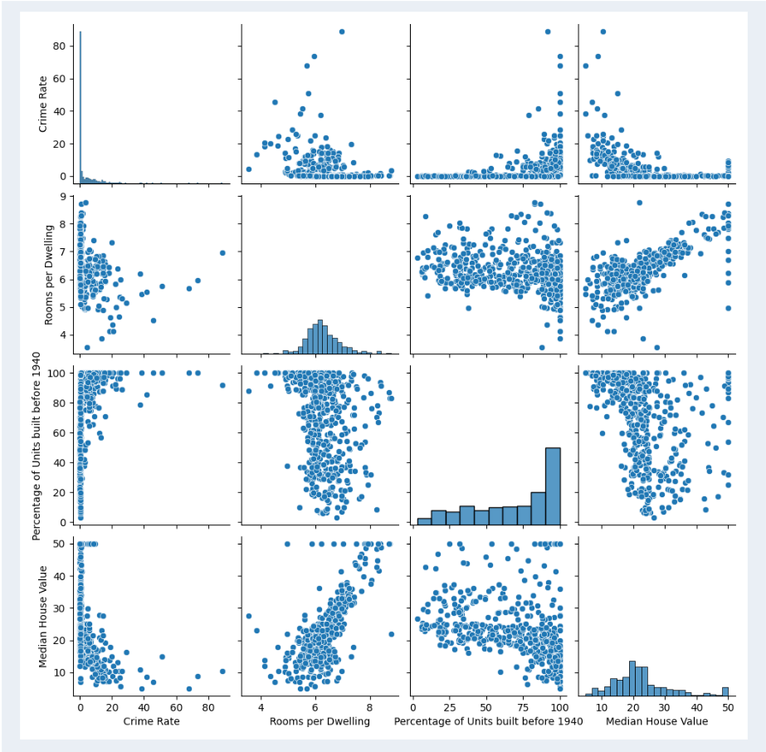
● Which graph best represents the population of Boston as a whole? Based on this graph, explain whether Boston has a high or low crime rate.
There are 4 indicators. Crime Rate, Rooms per Dwelling, Percentage of units built before 1940 and Median House Value. From those only Crime rate describes actions of population, while other 3 describe buildings.

Insufficient data to explain if Boston has high or low crime rate. To get those I would have to compare data from other cities. I can only tell that beware from people living in old cheap houses, which have 5-7 rooms. Also stay away from most expensive houses, probably Crime Lords live there. And they say: Crime doesn‘t pay…

Fun fact: In distopian universe of Judge Dredd, crime in Megacity One happened every second. Population of Megacity One is 800 mil. So 31,5 crimes per 800 residents in a year. London had 124,8 crimes per 1000 residents in 2022 (https://crimerate.co.uk/london). In other words, crime rate in London is 3,2x higher than in distopian Megacity One “The Most Dangerous City in the World“.

Based on data from https://www.city-data.com/crime/crime-Boston-Massachusetts.html Boston has higher crime rate than 83,4% of other USA cities. Which makes it really dangerous place to live. Public data only shows that crime rate in Boston is at 25 crimes per 1000 residents. But they didn‘t include small crime in their report like London does.

● What is the average number of rooms per dwelling in Boston?

I love your “Rooms per Dwelling / Rooms per Dwelling“ graph. Based on number of bars I guess there are houses with 6; 6.2; 6.4; 6.6… rooms. Anyway it looks like answer is 6.

● What is the correlation between Rooms per Dwelling and Median House Value?

Positive correlation. More Rooms = Higher price.

● By determining what percentage of units were built before 1940, are the majority of the houses relatively old or new?
So houses which are 83 years old are still considered as brand new? …
Insufficient data for conclusion. Graph shows percentages. Not ammounts. For example if there is area with 1 house which was built before 1940. And another area with 20 houses from which 2 were built before 1940, on graph it woul come up as 100% and 10%. Which would make you think that majority was built before 1940, but overall it would be only 3 houses out of 21.
If we agree that each area has same amount of units (to make sure we are comparing apples with apples), than we can interpret graph that there are more areas with 50%+ of units built before 1940 than areas with less than 50% units bult before 1940. Which would make majority of houses as relatively old.

● What is the correlation between the Percentage of Units built before 1940 and the Median House Value?

Older house = Lower price. So negative correlation. Also interest thing is that there are old houses with astronomical value, but most of price tags don‘t cross certain level.

