Michael Steele

Lab 8

Seat 12

10/16/2019

ASM

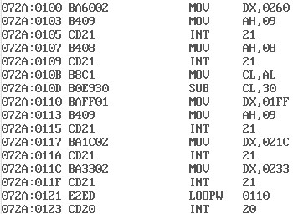

Memory

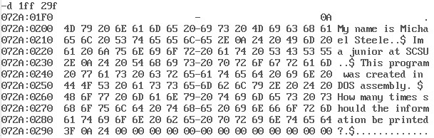

Program ran with 3 as input.

