Michael Steele

Lab 10

Seat 12

ASM

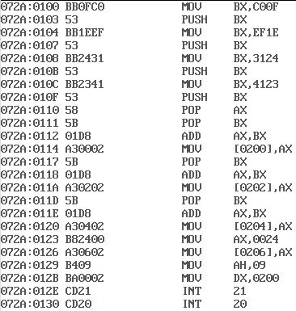

Memory



Program Run

