

Datsun Car maintenance system

User Manual



November 17, 2017

datsun

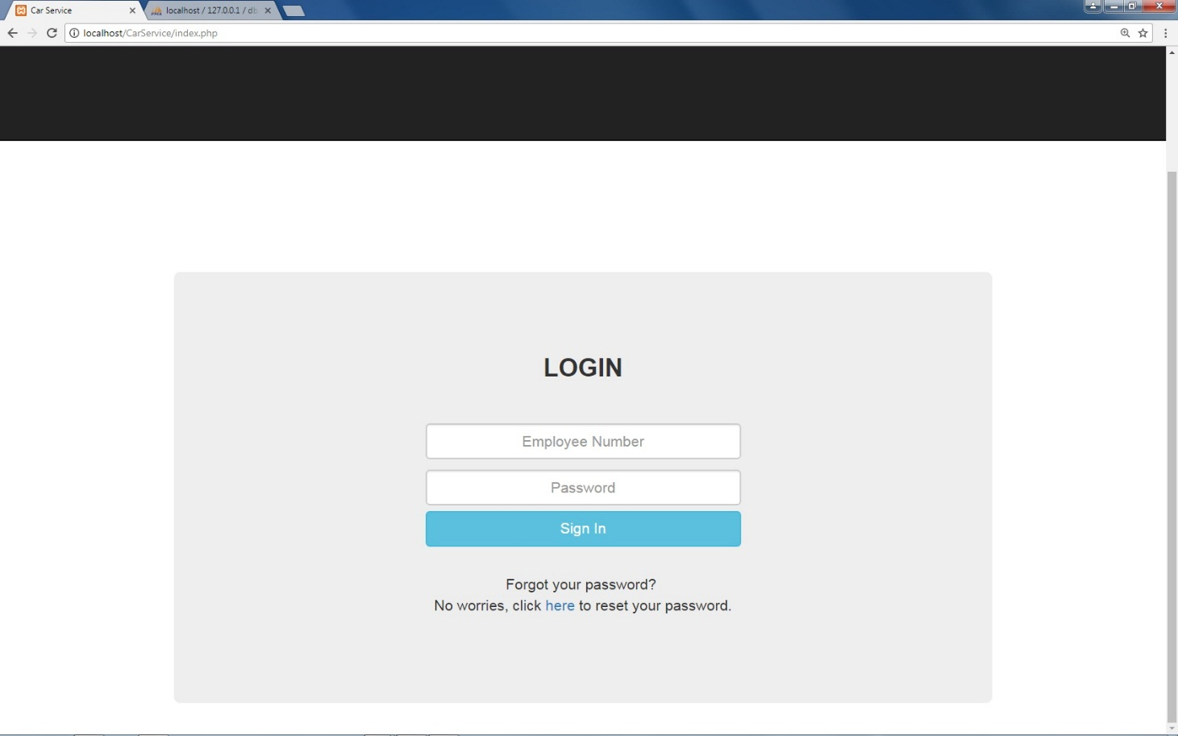**Login Page**

4

2

3

1

1. Employee Number text box that receives user input of their respective employee number.
2. Password text box that accepts and validates user’s password.
3. Sign In button that a user clicks on to allow the website to validate and verify login credentials
4. Forgot Your Password link that helps recover the user’s password using personal information questions.

**Home Page**

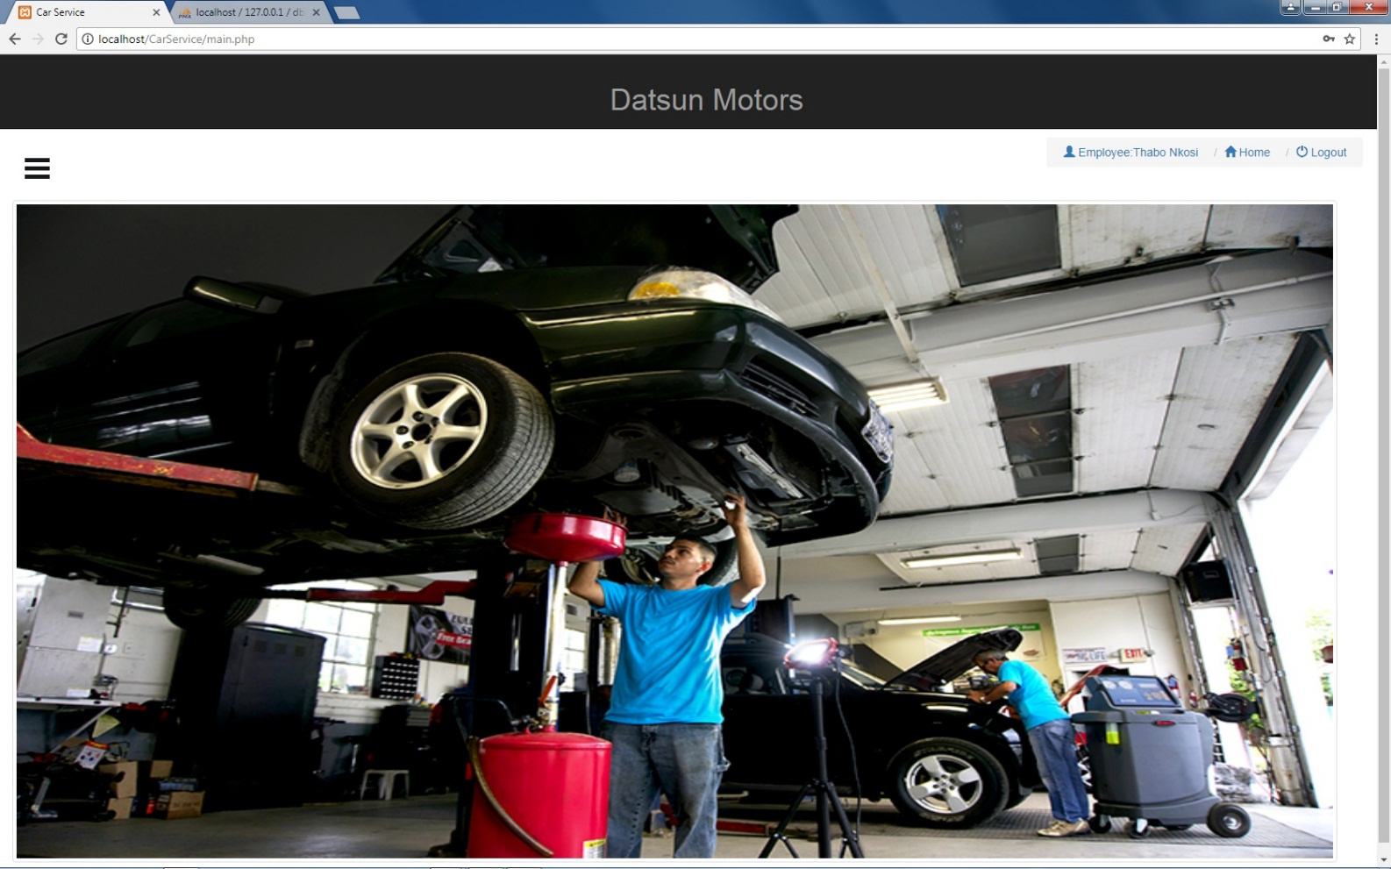

4

3

2

1

1. This is the employee name currently logged into the system.
2. This link brings you back to the home page from which ever form you’re on.
3. The logout link signs out the current user.
4. This button opens the Dashboard.

**Dashboard**

The dashboard helps the user to navigate the Home page and select a link of the form they want to work on.

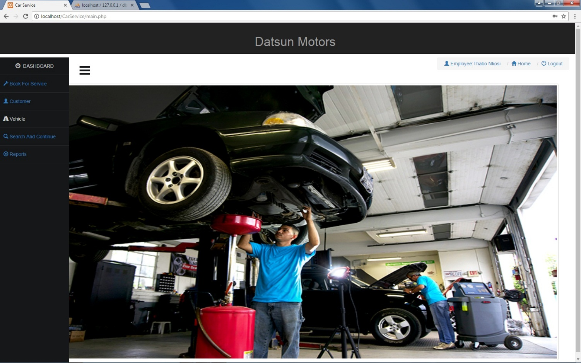

54

4

3

2

1

1. This link takes the user to the customer form where they get to register the user before creating a booking for them.
2. The customer link allows the user to navigate to the customer form where they can make changes to the customer details.
3. The vehicle link allows the user to make changes to the customer’s vehicle.
4. The search and continue link allows the user to go directly to certain forms and search for the desired id of that current form and continue from there.
5. The reports link allows the user to view certain reports.

**Customer Form**

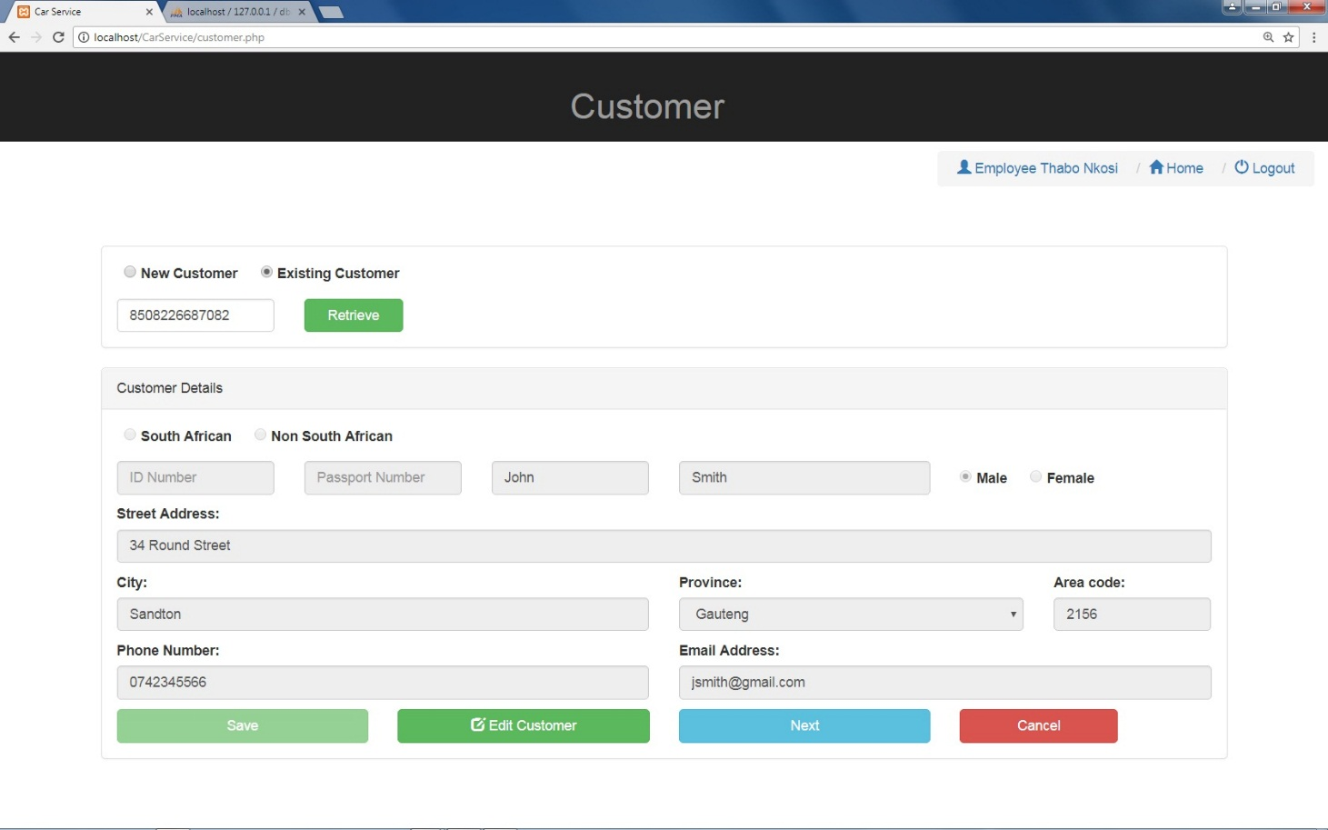

21

20

18

19

16

15

14

13

12

11

176

3

9

8

7

6

2

1

1. This radio button is selected only when adding a new customer to the database.
2. This radio button is selected only when the customer already exists in the database.
3. Id number textbox that allows the user to enter an existing customer’s id number and retrieve their information.
4. South African radio button that will be selected if the customer is south African.
5. Non-South African radio button that will be selected if the customer is non-south African.
6. To 16 accepts customer information as stipulated on the textboxes.

17. Determine the gender of the customer only if they are South African otherwise should be selected manually.

18. Edit customer button takes the user to the customer form where they can edit the customer information.

**Vehicle Form**

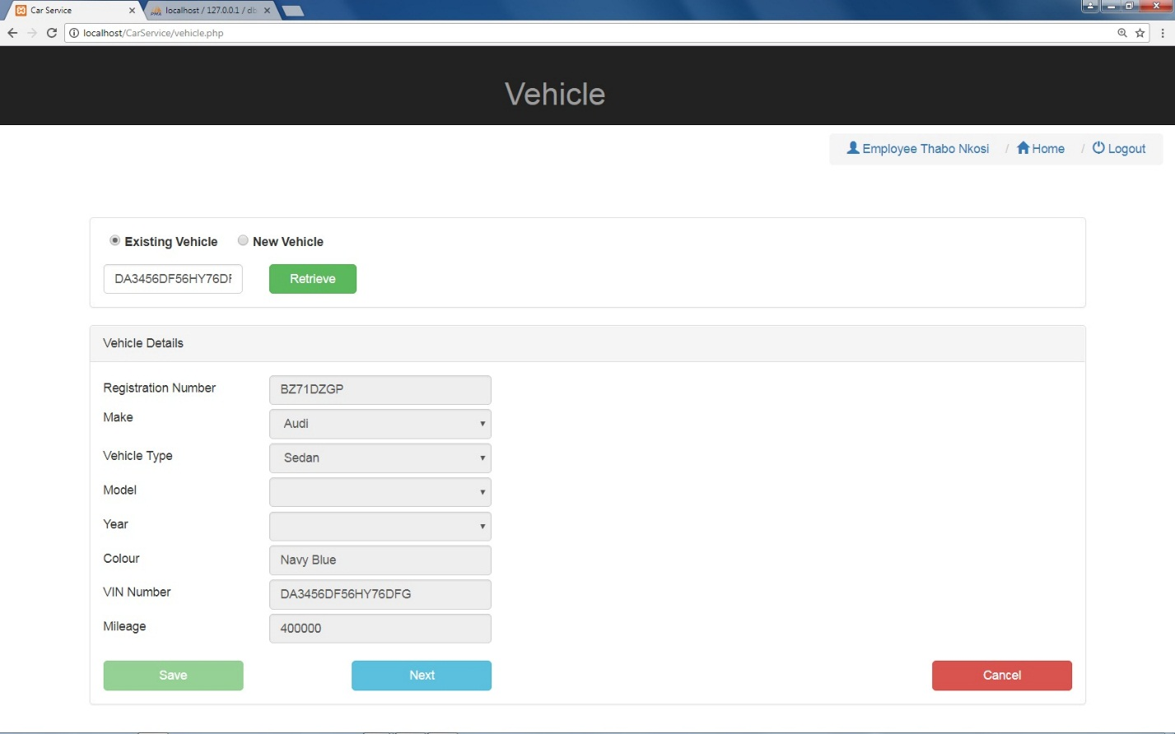

10

3

11

9

8

6

5

4

7

2

1

1. The existing vehicle radio button is used if a customer’s vehicle has been registered before.
2. The new vehicle radio button is used if the customer’s vehicle has never been captured before.
3. To 11 accepts vehicle details as stipulated in the respective controls.

12. The save button is used to save the vehicle information into the database.

13. The next button is used to proceed to next form.

14. The cancel button is used to cancel the process and return to the home page.

**Booking Form**

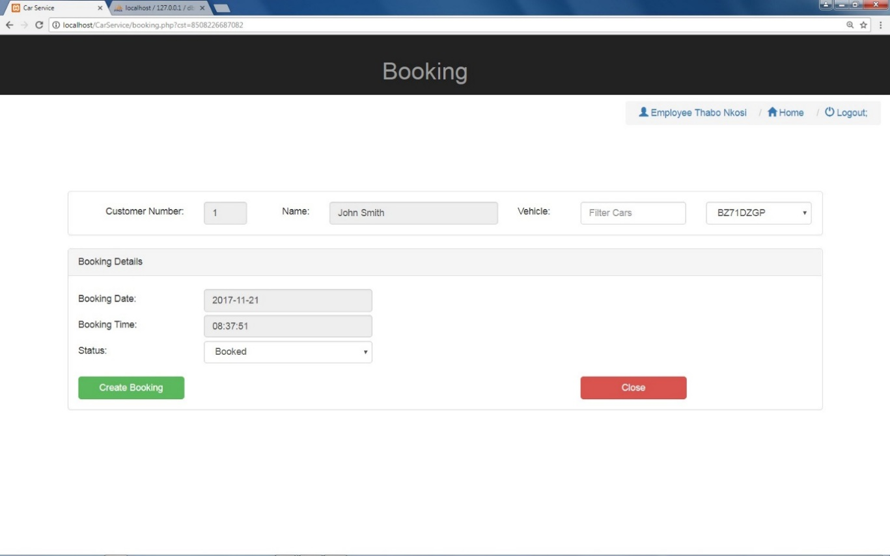

1, 2, 3 display information about the customer and vehicle currently being booked.

1. To 6 display the booking information as stipulated in the controls.
2. Create booking button creates a new booking and saves it in the database.
3. The close button cancels the booking and returns to the home page.

**Evaluation Form**

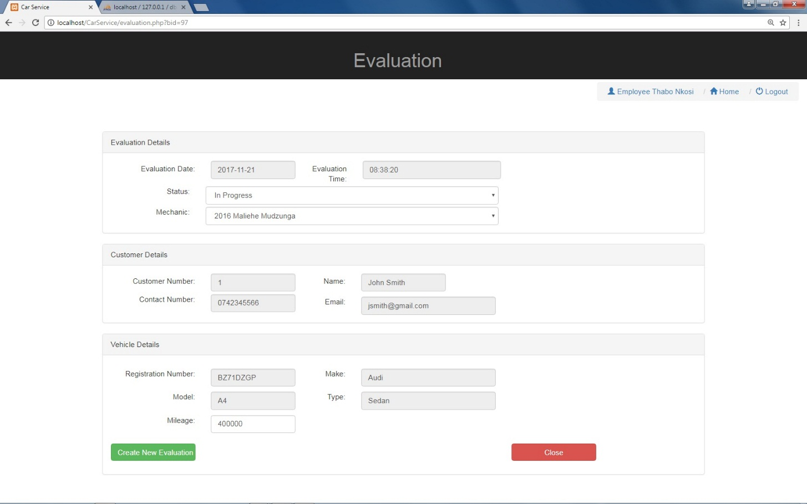

1. The status control allows the user to select the current status of the evaluation.
2. The mechanic control allows the user to assign a mechanic to a vehicle.
3. Create new evaluation button creates a new evaluation for the vehicle that’s been booked.

**Service Form**

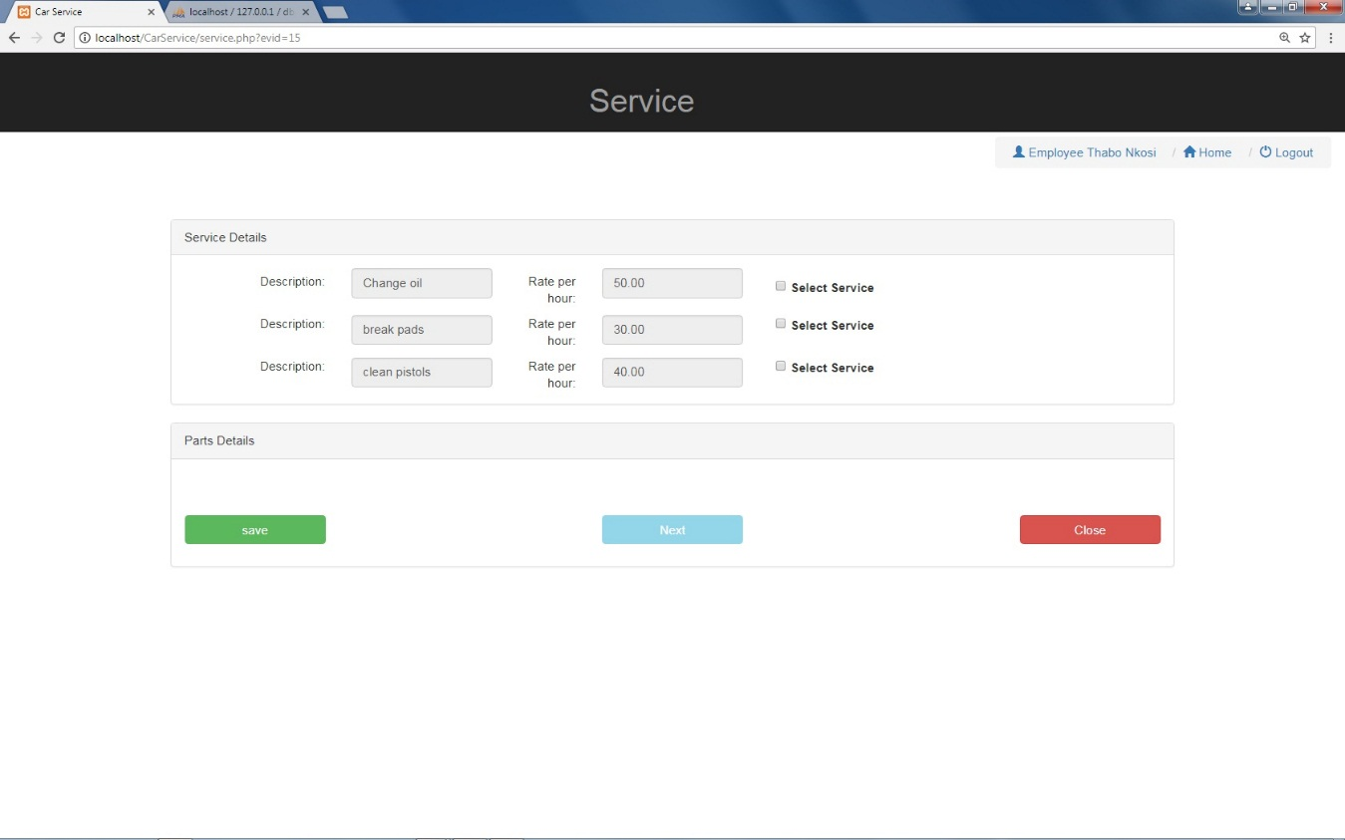

1 to 3 select service checkboxes are used to select the type of service that must be performed on the vehicle.

**Service Form Continued**

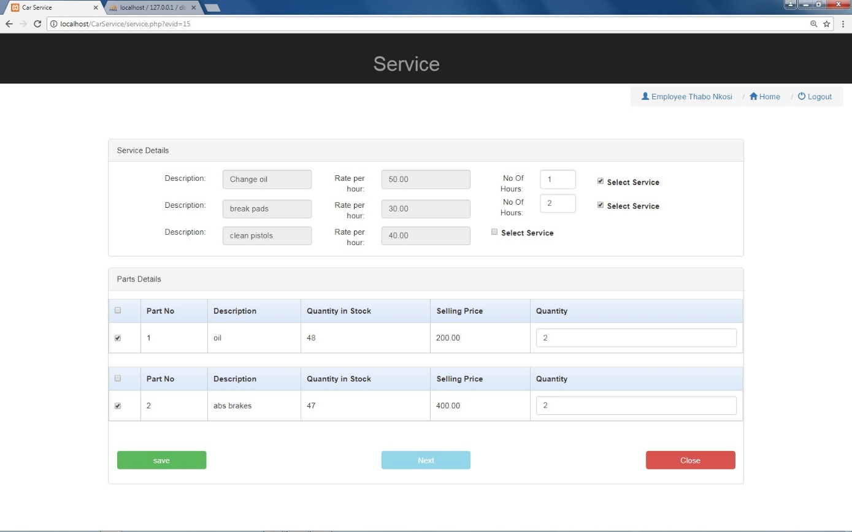

**Service Form Continued**

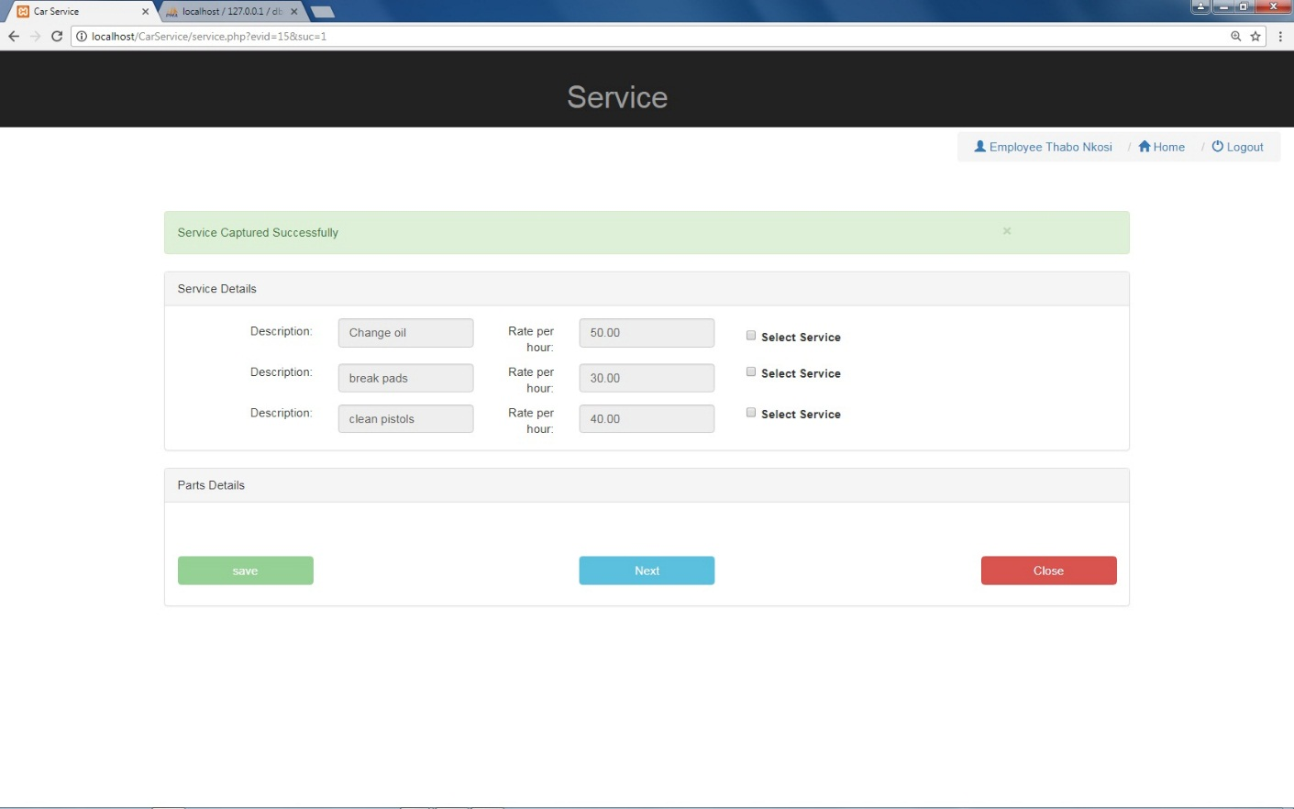

**Service Details Form**

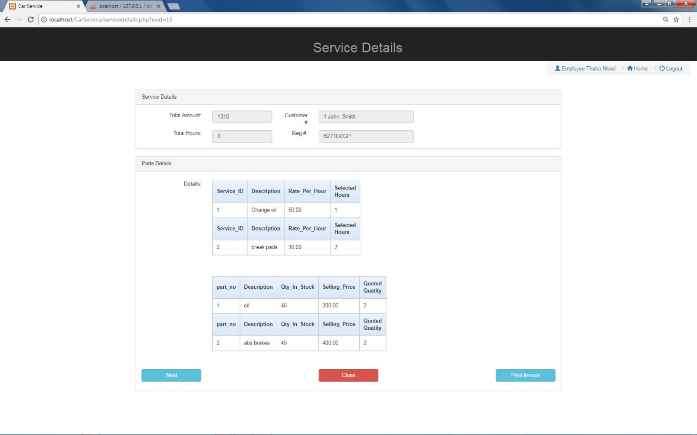

**Job Form**

