***BURGER BOX CAR WASH MANAGEMENT SYSTEM***

***User Manual***



**Table of Content**

**Login Form 3**

**DashBoard Form 4**

**Vehicle Management Form 5**

**Customer Management Form 6**

**Booking Management form 7**

**Employee Management Form 8 & 9**

**Service Management Form 10**

**Equipment Management Form 11**

**Allocation Management Form 12**

**Cash Receipt Form 13**

**Report Management Form 14**

***Login form***

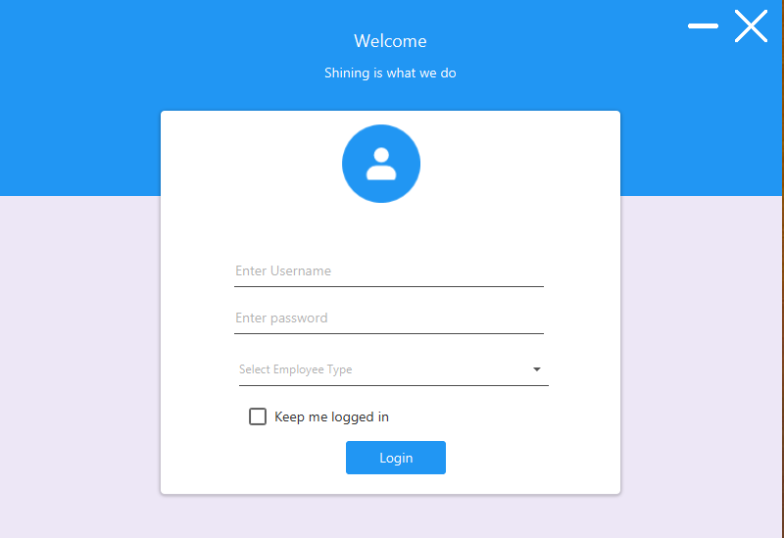

The login form contains information regarding login information form controls.

Follow the following Steps:

**Login Information**

* Enter the **Username** into the textbox.
* Enter the **Pin** into the textbox.
* Select an **Employee Type** on the Combo-box.

**The button do the following :**

* The **Login** button logs the user to gain access to the database system.

**DashBoard Screen**

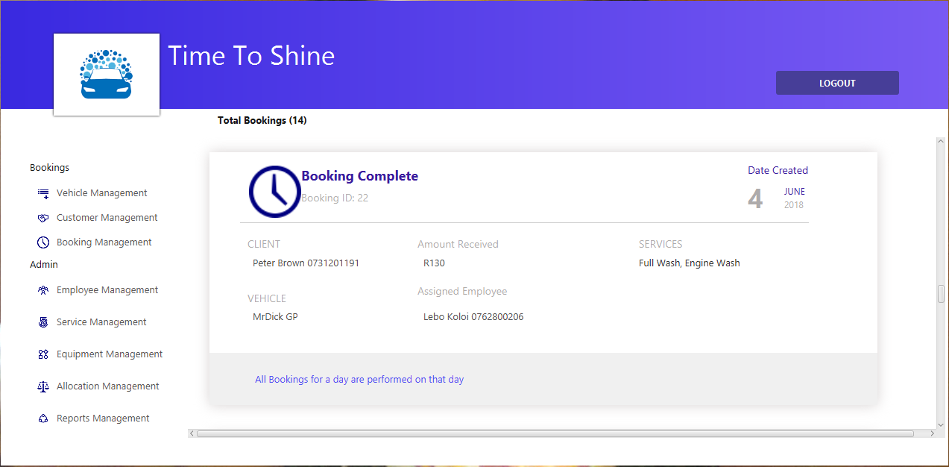

The Dashboard Screen contains information regarding system form controls.

**Dashboard Screen Information**

* The **Vehicle Management Menu** views the Vehicle Management Form.
* The **Customer Management Menu** Views the Customer Management Form.
* The **Booking Management Menu** Views the Booking Management Form.
* The **Employee Management Menu** Views the Employee Management Form.
* The **Service Management Menu** Views the Service Management Form.
* The **Equipment Management Menu** Views the Equipment Management Form.
* The **Allocation Management Menu** Views the Allocation Management Form.
* The **Reports Management Menu** Views the Reports Management Form.
* The **Logout** button closes the form and redirect you to the Login Form.

**Vehicle Management Form**

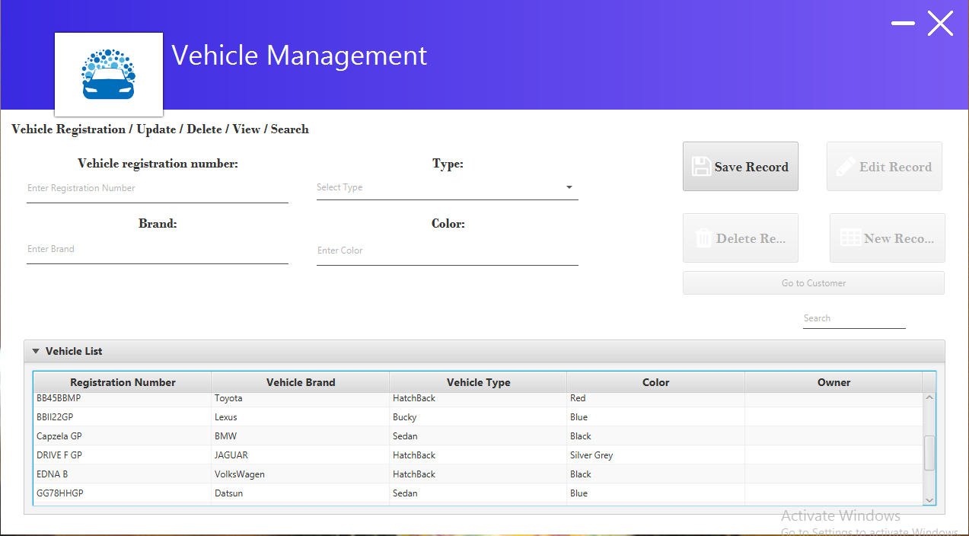

The Vehicle Form contains information regarding Vehicle Information Form controls.

Follow the following steps:

**Vehicle Information**

* Enter the **Vehicle registration number** into the textbox.
* Enter the **Brand** into the textbox.
* Select the **Type** on the drop down arrow.
* Enter the **Colour** into the textbox.

**The buttons do the following:**

* The **Save Record** Button saves the records.
* The **Edit Record** Button edits and save the records
* The **Delete Record** button deletes a record.
* The **New Record** button clears the texts for a new record.
* The **Search Tab** checks records on the Vehicle list.

**Customer Management Form**

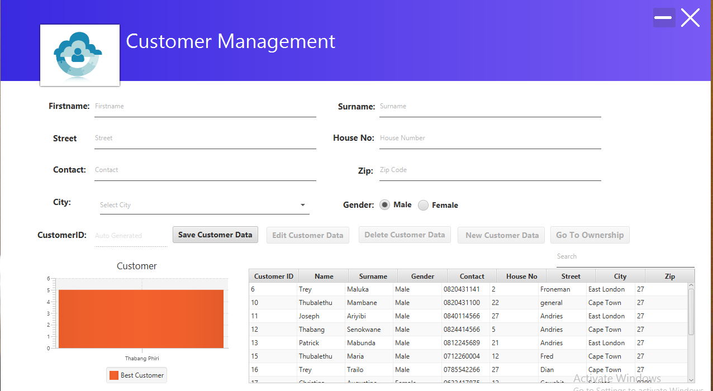

The Customer Form contains information regarding Customer Form controls.

**Follow the following Steps**:

**Customer Information**

* Enter Customer **First name** into the textbox.
* Enter Customer **Surname** into the textbox.
* Enter Customer **Street name** into the textbox.
* Enter Customer **House No** into the textbox.
* Enter Customer **Contacts** into the textbox.
* Enter Customer **Zip Code** into the textbox.
* Select Customer **City** on the combo-box.
* Select Customer **Gende**r on the radio buttons.
* **CustomerID** is auto generated.

**The buttons do the following:**

* The **Save Customer Data** Button saves the records.
* The **Edit Customer Data** Button edits and save the records
* The **Delete Customer Data** button deletes a record.
* The **New Customer Data** button clears the texts for a new record.
* The **Go to Ownership** Button views the Ownership Form.
* The **Search Tab** checks records on the Customer list.

**Booking Management Form**

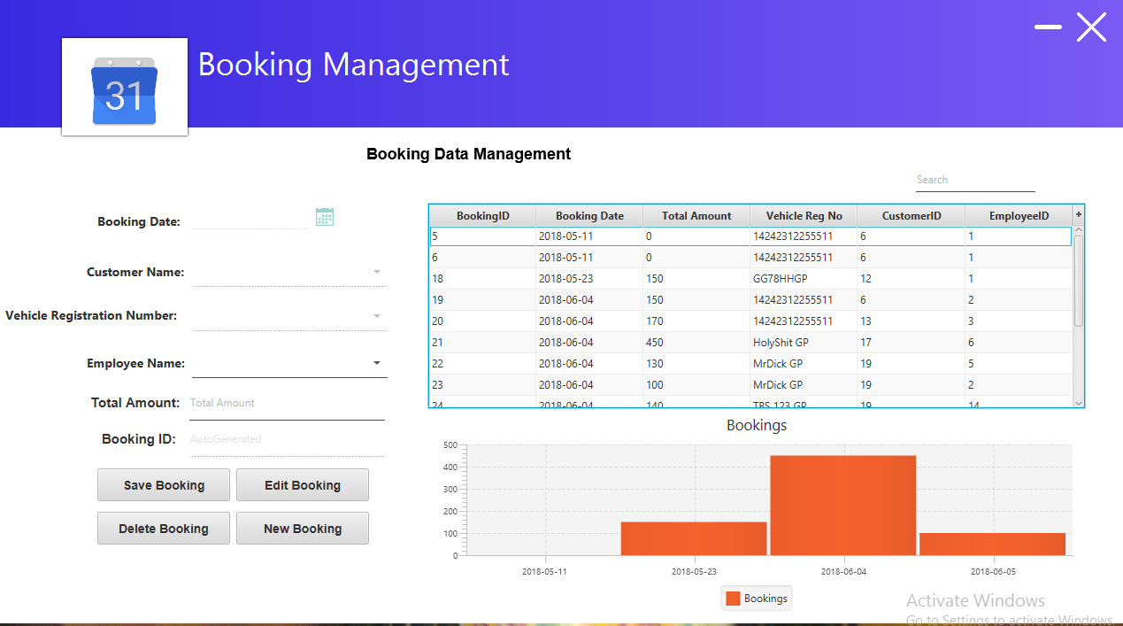

The Booking Form contains information regarding Booking Form controls.

**Follow the following Steps**:

**Booking Information**

* **Booking Date** is system.
* Select **Employee Name** on the Combo-box.
* Enter **Total Amount** into the textbox.
* **Booking ID** is auto generated.

**The buttons do the following:**

* The **Save Booking** Button saves the records.
* The **Edit Booking** Button edits and save the records
* The **Delete Booking** button deletes a record.
* The **New Booking** button clears the texts for a new record.
* The **Search Tab** checks records on the Booking list.

**Employee Management Form**

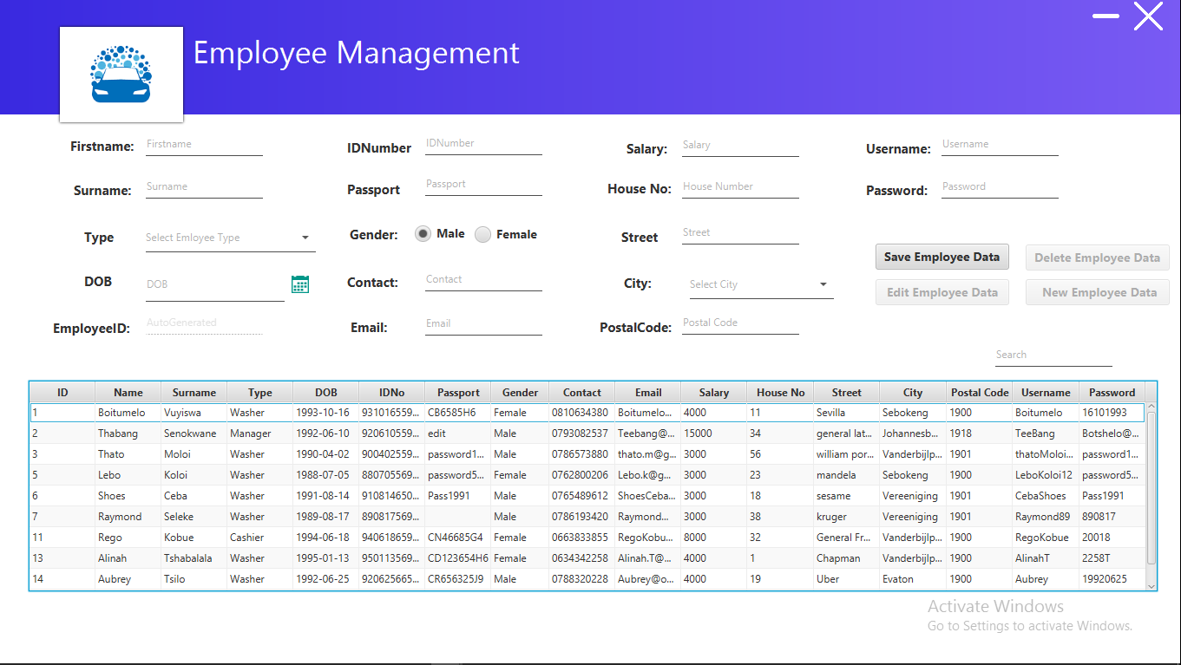

The Employee Form contains information regarding Employee Form controls.

**Follow the following Steps**:

**Employee Information**

* Enter Employee **First name** into the textbox.
* Enter Employee **Surname** into the textbox.
* Select Employee **Type** on the Combo-box.
* Select Employee **DOB** on the Calendar.
* **Employee ID** is auto generated.
* Enter Employee **ID Number** into the textbox.
* Enter Employee **Passport** into the textbox.
* Select Employee **Gender** on the Radio Button.
* Enter Employee **Contact** into the textbox.
* Enter Employee **Email** into the textbox.
* Enter Employee **Salary** into the textbox.
* Enter Employee **House No** into the textbox.
* Enter Employee **Street** into the textbox.
* Enter Employee **Postal Code** into the textbox.
* Enter Employee **Username** into the textbox.
* Enter Employee **Password** into the textbox.

**The buttons do the following:**

* The **Save Employee Data** Button saves the records.
* The **Edit Employee Data** Button edits and save the records
* The **Delete Employee Data** button deletes a record.
* The **New Employee Data** button clears the texts for a new record.
* The **Search Tab** checks records on the Employee list.

**Service Management Form**

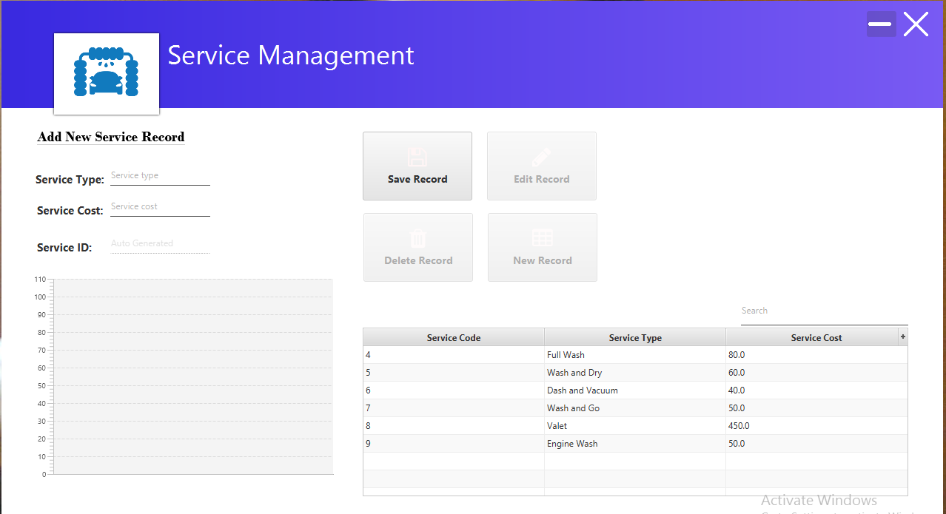

The Service Form contains information regarding Service Form controls.

**Follow the following Steps**:

**Service Information**

* Enter **Service Type** into the textbox.
* Enter **Service Cost** into the textbox.
* **Service ID** is auto generated.

**The buttons do the following:**

* The **Save Record** Button saves the records.
* The **Edit Record** Button edits and save the records
* The **Delete Record** button deletes a record.
* The **New Record** button clears the texts for a new record.

**Equipment Management Form**

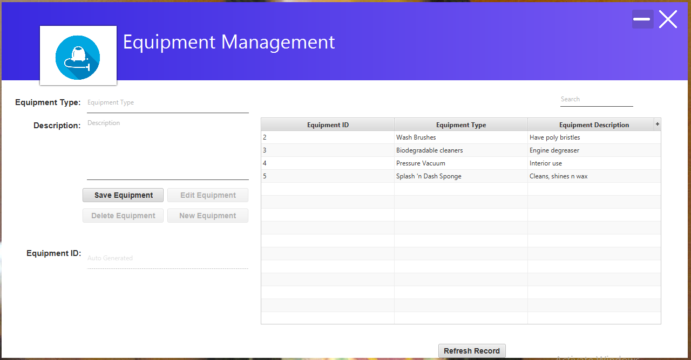

The Equipment Form contains information regarding Equipment Form controls.

**Follow the following Steps**:

**Equipment Information**

* Enter **Equipment Type** into the textbox.
* Enter **Equipment Description** into the textbox.
* **Equipment ID** is auto generated.

**The buttons do the following:**

* The **Save Equipment** Button saves the records.
* The **Edit Equipment** Button edits and save the records
* The **Delete Equipment** button deletes a record.
* The **New Equipment** button clears the texts for a new record.
* The **Search Equipment Tab** checks records on the Equipment list.

**Allocation Management Form**

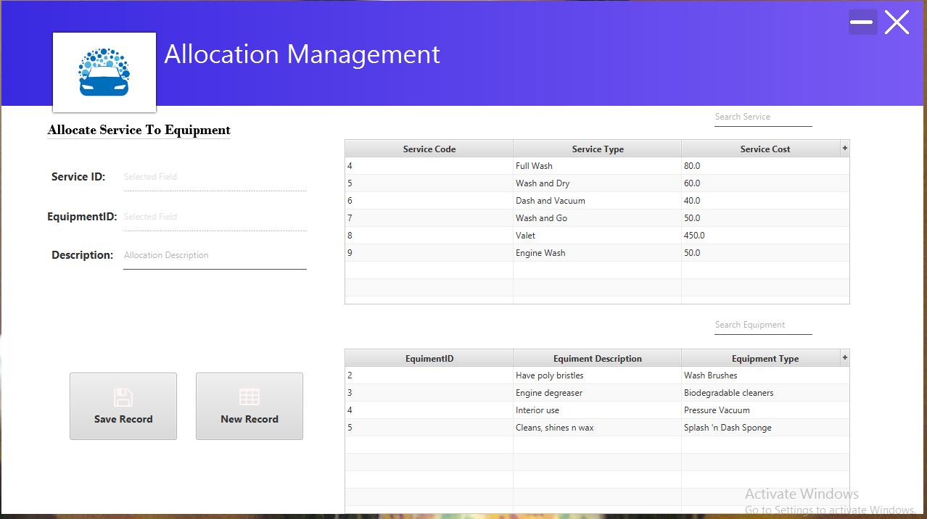

The Allocation Form contains information regarding Allocation Form controls.

**Follow the following Steps**:

**Allocation Information**

* Enter **Allocation Description** into the textbox.

**The buttons do the following:**

* The **Save Record** Button saves the records.
* The **New Record** button clears the textbox for a new record.
* The **Search Service Tab** checks records on the Service list.
* The **Search Equipment Tab** checks records on the Equipment list.

**Cash Receipt Form**

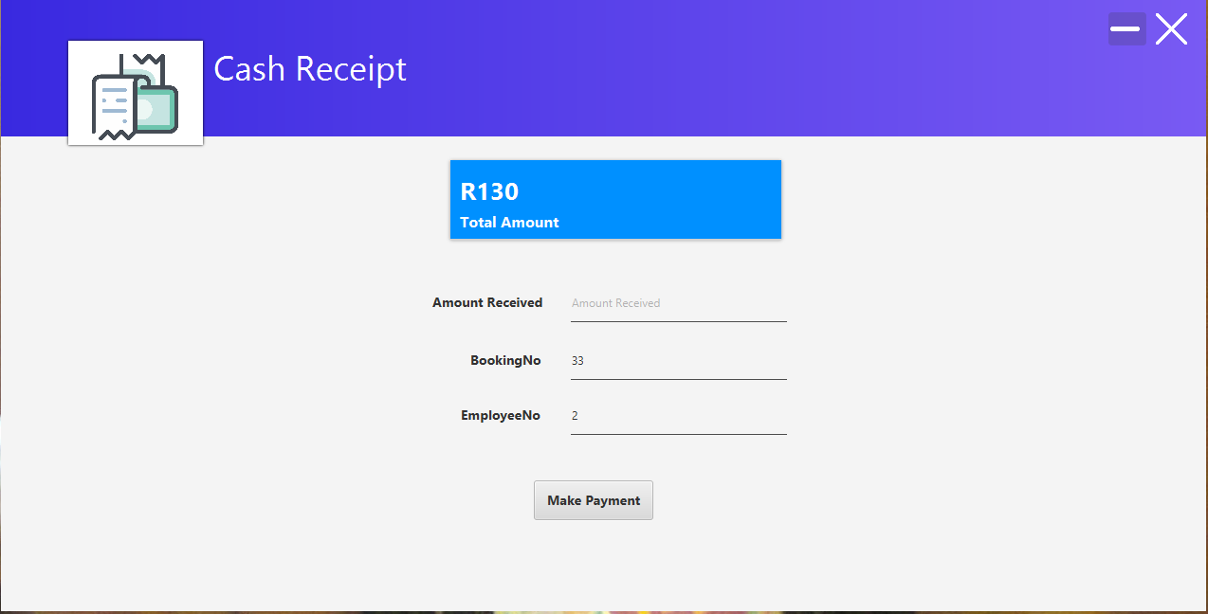

The Cash Receipt Form contains information regarding Cash Receipt Form controls.

**Cash Receipt Information**

* Enter the **Amount Received** into the textbox.

**The button do the following:**

* The **Make Payment** button processes the calculations and display the Cash Receipt.

**Report Management Form**

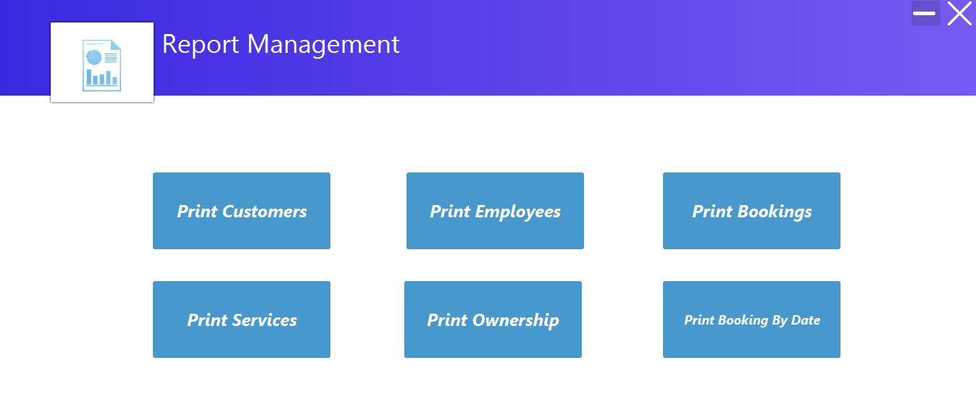

The Report Form contains information regarding Report Form controls.

**The buttons do the following:**

* The **Print Customer** button displays the customer report.
* The **Print Employee** button displays the employee report.
* The **Print Bookings** button displays the booking report.
* The **Print Service** button displays the Service report.
* The **Print Ownership** button displays the ownership report.
* The **Print Booking by Date** button displays the booking report by dates.