GUIA LEVEO (mía ctm)

Human

1-13 Elwynn Forest:

1-6 Northshire:
01) In front of you at Northshire Abbey's entrance, from Deputy Willem, accept "A Threat Within" 48.44.
02) Next to you, go in Northshire Abbey and turn in "A Threat Within" 49.42, accept "Kobold Camp Cleanup".
03) Just outside of Northshire Abbey's entrance, from Deputy Willem, accept "Eagan Peltskinner" 48.44 (#1 on map).
04) Outside on the NW side yard of Northshire Abbey, turn in "Eagan Peltskinner" 49.40, accept "Wolves Across the Border".
05) Do "Kobold Camp Cleanup" along with "Wolves Across the Border": kill Kobold Vermins /target and kill/loot wolves around 48.38. The Kobolds are just north of Northshire Abbey (#5 on map) and the Diseased wolves are scattered all around the starting zone (but west of the river).
06) Outside on the NW side yard of Northshire Abbey, turn in "Wolves Across the Border" 49.40 (#4 on map).
07) In front of the wagon & red tent, make sure you are resupplied 47.42.
Remember to Choose Your Class At Top of Screen!!!
08) Just inside of Northshire Abbey, turn in "Kobold Camp Cleanup" 49.42 (#2 on map). Accept "Investigate Echo Ridge" and your class's quest .
09) Go north of Northshire Abbey and do "Investigate Echo Ridge": kill Kobold Workers /target. There are multiple camps up north and there is a larger concentration before the cave entrance around 48.32.
10) Make sure you are 1,150 XP into level 3 or greater, grind until you are. Work your way to get resupplied while doing so 48.41.
11) Go inside of Northshire Abbey and turn in "Investigate Echo Ridge" 49.42 (#2 on map), accept "Skirmish at Echo Ridge".
12) Just outside of Northshire Abbey's entrance, from Deputy Willem, accept "Brotherhood of Thieves" 48.44(#1 on map).
13) Go east past the river and do "Brotherhood of Thieves": kill/loot the Defias Thugs around 54.49.
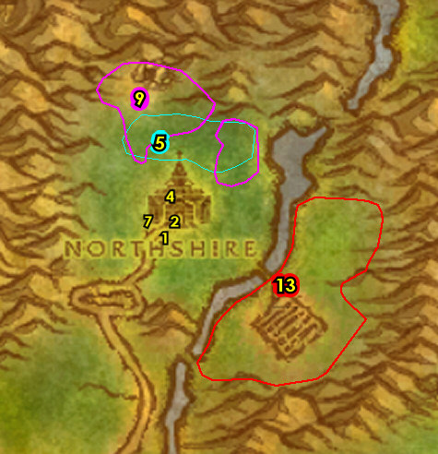

01) Just outside of Northshire Abbey's entrance, from Deputy Willem, turn in "Brotherhood of Thieves" 48.44. Accept "Milly Osworth" and "Bounty on Garrick Padfoot".
02) Just outside of Northshire Abbey make sure you are repaired/resupplied 47.42.
03) Go in the Echo Ridge Mine up north (entrance at 48.32) and do "Skirmish at Echo Ridge": kill Kobold Laborers.
04) Go to the NE outside of Northshire Abbey (next to the stables/wagon) and turn in "Milly Osworth" 51.39, accept "Milly's Harvest".
05) Go east across the river to Northshire Vineyards around 54.49 and do "Milly's Harvest": loot Milly's Harvest (crates) on the ground around the farm. Keep the next step in mind:
06) Just east of the Northshire Vineyards do "Bounty on Garrick Padfoot": kill/loot Garrick Padfoot /target (in front of the shack, 57.48).
07) Make sure you are level 5. Die on purpose, res at spirit, then go to the NE outside of Northshire Abbey (next to the stables/wagon) and turn in "Milly's Harvest" 51.39 (#4 on map), accept "Grape Manifest".
08) In front of Northshire Abbey's entrance, from Deputy Willem, turn in "Bounty on Garrick Padfoot" 48.44 (#1 on map).
09) Just inside of Northshire Abbey, turn in "Skirmish at Echo Ridge" 49.42. Accept "Report to Goldshire".
10) Make a right inside of Northshire Abbey, then go up through the spiral staircase entrance 50.41 to the top of the Abbey and turn in "Grape Manifest" 49.42.
11) Go outside of Northshire Abbey and make sure you are repaired/resupplied 47.42 (#2 on map).
12) Leave Northshire Valley by heading SW exit 47.48.
13) In front of the lion fountain, accept "Rest and Relaxation" 46.48.
#02
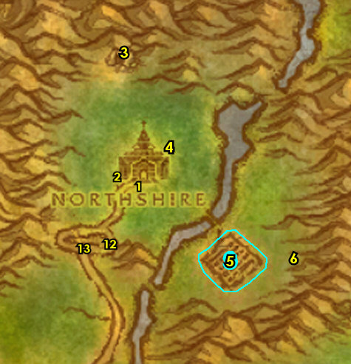

6-11 Goldshire (log)
01) Follow the main path south to Goldshire and make sure you are at least 325 XP away from level 6 (2,475 XP into lvl 5) for new spells/abilities (you can grind mobs west of the main path), then go to Goldshire and in front of the refinery, turn in "Report to Goldshire" 42.66, accept "The Fargodeep Mine".
02) Enter Goldshire's Inn (entrance at 43.66). Make a sharp left and accept "Kobold Candles" 43.66.
03) Next to you at Innkeeper Farley 44.66, turn in "Rest and Relaxation". Also make Goldshire your new home for your Hearthstone from the Innkeeper. Make sure you are resupplied.
04) Get your level 6 spells/abilities at Goldshire.
05) If you have an extra silver to spare: Upstairs in the Inn and in the middle room from the Physician 43.66, learn Apprentice First Aid.
06) On the south side of Goldshire by the wagon, accept "Gold Dust Exchange" 42.67.
07) Go SW to The Stonefield Farm and next to the house, accept "Lost Necklace" 34.84 and "Princess Must Die!" 35.84. ALSO: While on your way, start kill/looting boars to collect Chunk of Boar Meats (for a future quest), and don't sell them to a vendor!
08) Go east to The Maclure Vineyards and in front of the barn turn in "Lost Necklace" 43.86, accept "Pie for Billy".
09) Go south in The Maclure Vineyards and in the small house, accept "Young Lovers" 43.90.
10) Stop at the vendor /target 42.89 to get resupplied. NOTE: remember not to sell your Chunk of Boar Meats!
11) Go west to The Stonefield Farm (watch out for lvl 9 bears) and next to the river turn in "Young Lovers" 30.86, accept "Speak with Gramma". ALSO: While on your way, grind on Boars to collect 4 Chunk of Boar Meats (for a future quest), and don't sell them to a vendor!
12) All around southern Elwynn Forest around 33.85 do "Pie for Billy": kill/loot Boars. NOTE: You may already have the 4 Chunk of Boar Meats by grinding previously!
13) At the small house in The Stonefield Farm, next to the well (35.84, #7 on map), turn in "Pie for Billy", accept "Back to Billy".
14) In the small house east in The Stonefield Farm, turn in "Speak with Gramma" (35.84, #7 on map), accept "Note to William".
15) Go east to The Maclure Vineyards and in front of the barn turn in "Back to Billy" (43.86, #8 on map), accept "Goldtooth".
#03
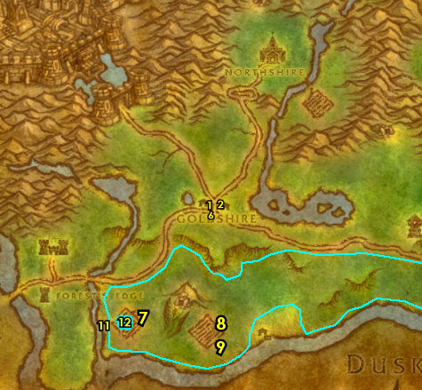

01) Go NW to Fargodeep Mine and take the upper mine entrance 39.82. Keep hugging the left side of the mine until you get to Goldtooth /target 42.78 and kill/loot him for "Goldtooth". Then make sure "Gold Dust Exchange" along with "Kobold Candles" is finished by kill/looting the Kobolds inside or outside the mine.
02) Exit the mine exit 39.82, then go turn in "Goldtooth" 35.84.
Vendor, 2a) Stop at the Fruit Seller /target 34.83 to sell your junk.
03) Grind your way back to Goldshire, make sure you are at least 2,680 XP into level 7 before getting there. Then by the wagon, turn in "Gold Dust Exchange" 42.67, accept "A Fishy Peril".
04) In front of the refinery, turn in "The Fargodeep Mine" 42.66, accept "The Jasperlode Mine". And turn in "A Fishy Peril", accept "Further Concerns".
05) Make sure you are repaired/resupplied (in the refinery) 42.66.
06) In the Inn, near the entrance, turn in "Kobold Candles" 43.66, accept "Shipment to Stormwind". Also turn in "Note to William", accept "Collecting Kelp".
First Aid? 6a) It's wise now to make sure you get Apprentice First Aid if you haven't yet: Go upstairs in the Inn and in the middle room from the Physician 43.66, learn Apprentice First Aid.
07) Get your level 8 spells/abilities at Goldshire.
08) Go east a bit to Crystal Lake around 56.69 and do "Collecting Kelp": kill/loot the murlocs around the lake. TIP: Avoid going to the islands in the lake, stay around the perimeter of the lake for easy spaced out targets.
09) Go NE and enter Jasperlode Mine (entrance at 62.53) and do "The Jasperlode Mine": work your way into the mine until you get it scouted.
10) Go SE to the bridge where the main path and the river meet and then turn in "Further Concerns" 74.72, accept "Find the Lost Guards" and "Protect the Frontier".
11) Go NE a bit to Eastvale Logging Camp at the small house and accept "Red Linen Goods" 80.69.
12) NE a bit more, next to the wagon, accept "A Bundle of Trouble" 81.66.
13) Just east, you can go to the Bowyer 83.66 to get repaired/resupplied.
#04
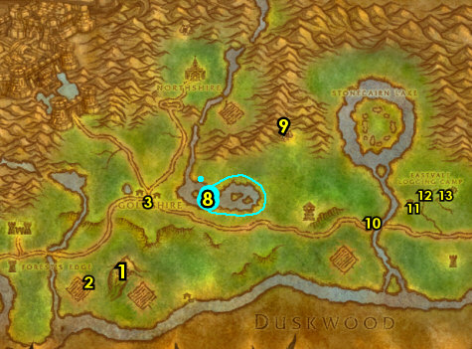

01) Go just north of Eastvale Logging Camp around 80.61 and start working on "Protect the Frontier" and "A Bundle of Trouble": kill Prowlers (wolves) and Young Forest Bears. Also loot the Bundle of Wood around the trees. Work your way to the next step:
02) Grind NW to the shore and click on A half-eaten body 73.60 to turn in "Find the Lost Guards", accept "Discover Rolf's Fate".
03) Go NE next to the murloc camp (watch out for the multiple murlocs) and click on Rolf's corpse 80.55 to turn in "Discover Rolf's Fate", accept "Report to Thomas".
04) Make sure "A Bundle of Trouble" is finished by looting the Bundle of Wood around the trees north of Eastvale Logging Camp. Also finish "Protect the Frontier" by killing Prowlers (wolves, #1 on map) and Young Forest Bears.
05) Go to the middle of Eastvale Logging Camp, next to the wagon and turn in "A Bundle of Trouble" 81.66.
06) You can go east a bit to the Bowyer 83.66 to get repaired/resupplied.
07) Go to where the main path and the river meets 74.72 and turn in "Protect the Frontier" and "Report to Thomas", accept "Deliver Thomas' Report". Also accept "Report to Gryan Stoutmantle".
08) Go SW to Brackwell Pumpkin Patch around 70.79 and do "Red Linen Goods": kill/loot the Defias mobs for the bandanas around the farm. NOTE: Any of the Defias mobs has a very low chance to drop an item called Westfall Deed, which starts "Furlbrow's Deed" (accept it if you are able to find it). Keep the next step in mind:
09) At Brackwell Pumpkin Patch, attempt "Princess Must Die!": try to kill/loot Princess /target. This lvl 9 boar patrols around the farm and has two lvl 7 bodyguards. TIPS: If you can get help near by, do so. You can use the fences to jump around them as the boars will keep running around them. If you did not succeed, you will be able to solo this later. Don't worry about dying because that is what we will want to do next anyways.
#05
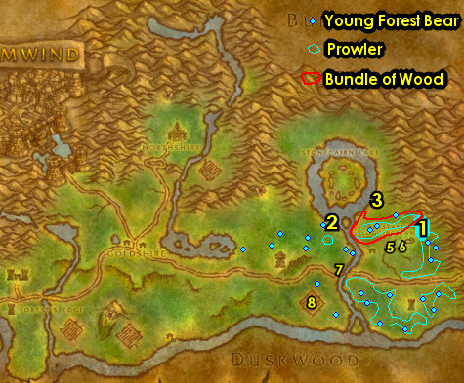

02) At the small house at Eastvale Logging Camp, turn in "Red Linen Goods" 79.69.
03) Hearth to Goldshire.
04) In the Inn, near the entrance, turn in "Collecting Kelp" 43.66. Wait a few seconds, then accept "The Escape".
05) Just outside of the Inn, in front of the refinery 42.66, turn in "The Jasperlode Mine" and "Deliver Thomas' Report", accept "Cloth and Leather Armor". Also accept "Westbrook Garrison Needs Help!".
06) Go into the refinery next to you and accept "Elmore's Task" 42.66. Make sure you are repaired/resupplied.
Remember to Choose Your Class At Top of Screen!!!
07) Go south to The Maclure Vineyards and in the small house, turn in "The Escape" 43.90.
08) Go west to The Stonefield Farm and in front of the small house, turn in (if you did it) "Princess Must Die!" 35.84.
09) Go NW to Westbrook Garrison and in front of the garrison's entrance, from the Wanted Poster 25.75, accept "Wanted: "Hogger".
10) Next to you, turn in "Westbrook Garrison Needs Help!" 24.74, accept "Riverpaw Gnoll Bounty".
#06
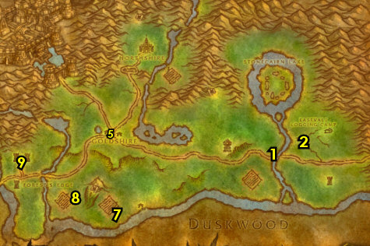

11-11 Westfall + Stormwind (log)
01) Follow the main path west to enter Westfall, and just off to your right next to the wagon, turn in (if you have it) "Furlbrow's Deed" (60.19 in Westfall). Next to you, accept "Westfall Stew".
02) Follow the main path south and off to your right go in the house at Saldean's Farm and turn in "Westfall Stew" 56.30, SKIP the next part.
03) Go south to Sentinel Hill at the tower and turn in "Report to Gryan Stoutmantle" 56.47, SKIP "The People's Militia".
04) Back inside the tower, accept "A Swift Message" 57.47.
05) Just south of the tower, at the Gryphon Master 57.53, turn in "A Swift Message", accept "Continue to Stormwind". Then take a flight to Stormwind, Elwynn.
06) In Stormwind, go to Old Town and in the Limited Immunity, turn in "Continue to Stormwind" 77.61, accept "Dungar Longdrink".
07) Near the entrance in Stormwind, enter Pestle's Apothecary and turn in "Shipment to Stormwind" 63.74.
08) Slightly north, you can go in Weller's Arsenal and from the Weapon Master 64.69, you can learn new weapon possibilities if you can afford to.
09) Go east to the Gryphon Master 71.73 in Stormwind and turn in "Dungar Longdrink", accept "Return to Lewis". Then fly to Sentinel Hill, Westfall.
10) In Westfall, go north a bit inside the tower and turn in "Return to Lewis" (57.47, #3 on map).
#07
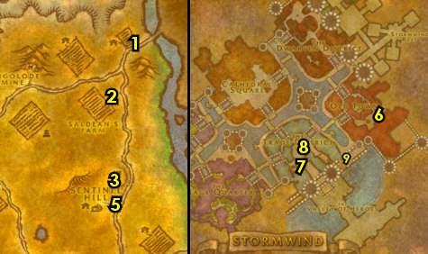

11-12 Elwynn Forest
01) Go to Forest's Edge around 27.86 and do "Riverpaw Gnoll Bounty": kill/loot Riverpaw gnolls. NOTES: While doing this quest any of the gnolls has a very small chance of dropping an item called Gold Pickup Schedule, which starts "The Collector", accept it if you are able to find it. A rare mob named Gruff Swiftbite /target has a 100% drop rate for that item, so keep an eye out for him. Also, while doing this quest you can gather a group and then work your way to do the next quest:
02) If you have a group you can try to do "Wanted: "Hogger": kill/loot Hogger /target (lvl 11 Elite gnoll). If you don't have a group, you can attempt to solo him if you dare, if not it can be skipped.
03) Go north to Westbrook Garrison and in front of the entrance, turn in "Riverpaw Gnoll Bounty" 24.74.
04) Die on purpose (res at spirit) to get back to Goldshire and in front of the refinery 42.66, turn in (if you have it) "The Collector" and (if you did it) "Wanted: "Hogger". If it's available, accept "Manhunt". Make sure you are repaired/resupplied in the refinery.
05) Go east on the main path and at the bridge/river accept "Bounty on Murlocs" 74.72.
06) Do (if you have it) "Manhunt": go SW to Brackwell Pumpkin Patch and in the small house kill/loot Morgan the Collector 71.81. ALSO: If you haven't yet, at Brackwell Pumpkin Patch you can try to do "Princess Must Die!": kill/loot Princess /target. This lvl 9 boar patrols around the farm and has two lvl 7 bodyguards. Try to team up with someone in the area if you can or you can try to solo it. If you can't do it, then skip it.
07) Do "Bounty on Murlocs": kill/loot Murlocs along the coast of the river south running through Elwynn Forest around 70.84.
08) Go back to the bridge where the main path and the river meet and turn in "Bounty on Murlocs" (74.72, #5 on map).
09) Go NE to Eastvale Logging Camp and at the small house turn in "Cloth and Leather Armor" 80.69.
10) Follow the main path east into Redridge Mountains (94.72 in Elwynn Forest).
11) Follow the main path east and at the first intersection, accept "Encroaching Gnolls" (15.71 in Redridge).
12) Go NE and on your left before the bridge turn in "Encroaching Gnolls" 31.60, accept "Assessing the Threat".
13) Next to you, get the Flight Path from the Gryphon Master 31.59.
14) If you need to turn in either "Manhunt" or "Princess Must Die!" then Hearth to Goldshire. If you cannot hearth then fly to Stormwind, drop in the water to die on purpose, and res at spirit to get back to Goldshire. If you DONT need to turn in either of those quests then just fly to Stormwind, Elwynn and skip to the next section below.
15) Upgrade First Aid in the Inn (if you need to), then exit the Inn, and in front of the refinery turn in "Manhunt" (42.66, #4 on map). Make sure you are repaired/resupplied.
16) If you did "Princess Must Die!", go SW to The Stonefield Farm and in front of the small house 35.84, turn it in. Afterwards go east a bit and die on purpose to the kobolds around 37.83, then res at spirit.
#09
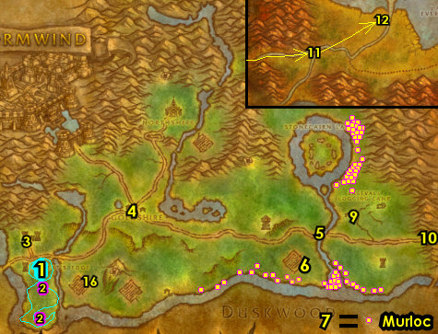

11-12 Ironforge + Dun Morogh
01) If you still have any of the following quests in your questbook, they can be Abandoned: "Wanted: "Hogger" and "Princess Must Die!".
02) Go north to enter Stormwind, then go to the Dwarven District and turn in "Elmore's Task" 60.34. Accept "Stormpike's Delivery".
03) Go NE in the Dwarven District to enter the Deeprun Tram 69.31. Then wait for the tram ride to show up and it will take you to Ironforge's side of the Deeprun Tram.
04) Once at the other side of the Deeprun Tram, accept "Deeprun Rat Roundup" (this is accepted between the two Tram tracks).
05) Just around the immediate area do "Deeprun Rat Roundup": use the Rat Catcher's Flute quest item on the Deeprun Rats.
06) Go back between the two tracks at the Deeprun Tram, and turn in "Deeprun Rat Roundup". NOTE: "Me Brother, Nipsy" will be skipped for now.
07) Exit the Deeprun Tram by heading north through the tunnel..
08) In the middle of Ironforge at The Great Forge, get the Flight Path there from the Gryphon Master 56.48.
First Aid? 08a) You can upgrade First Aid up in Ironforge Physician, entrance at 55.57.
09) Go SW to leave Ironforge (exit at 15.86).
10) In Dun Morogh, follow the main path east to Gol'Bolar Quarry and accept "The Public Servant" 69.56.
11) Next to you, behind the tent, accept "Those Blasted Troggs!" 69.56.
12) Drop down in the Quarry and enter the mine (entrance at 71.56) and do "The Public Servant" along with "Those Blasted Troggs!": kill Rockjaw Skullthumpers and Rockjaw Bonesnappers (only in mine). Focus inside the mine more, as both of the these mobs are found in there.
13) Go back up and turn in "The Public Servant" (69.56, #10 on map).
14) Next to you, behind the tent, turn in "Those Blasted Troggs!" 69.56.
15) Follow the main path east to enter Loch Modan (entrance at 86.51)..
#10
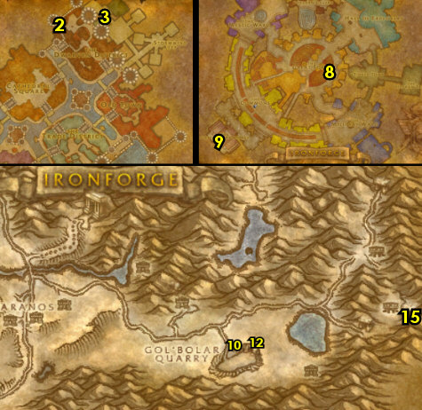

12-13 Loch Modan
01) Once you enter Loch Modan you will arrive at Valley of Kings, and in front of the watchtower, accept "In Defense of the King's Lands" (22.73 in Loch Modan).
02) Go up in the watchtower in front of you and accept "The Trogg Threat" 23.74.
03) Follow the main path NE, then make a right to go to Stonesplinter Valley around 32.73 and do "In Defense of the King's Lands" along with "The Trogg Threat": kill 10 Stonesplinter Troggs and 10 Stonesplinter Scouts, and loot them for the Stone Tooth.
04) Go back west to Valley of Kings and turn in "In Defense of the King's Lands" (22.73, #1 on map).
05) Go up in the watchtower and turn in "The Trogg Threat" 23.74.
06) Go north to Thelsamar around 34.48 and find Mountaineer Kadrell /target (he patrols around town) and accept "Rat Catching" and "Mountaineer Stormpike's Task".
07) Go in the Inn (the building with the big barrels around it) and the first NPC you see (Innkeeper Hearthstove, 35.48), talk to him to make this Inn your new home.
08) At the bar, from Vidra Hearthstove, accept "Thelsamar Blood Sausages" 35.49. Make sure you are resupplied. If you need 6 slot bags, you can purchase them from the General Supplies vendor in the Inn (if you can afford them).
#11
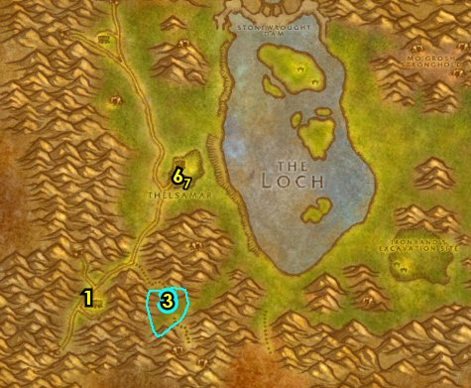

01) While working your way north to the next steps, also start working on "Rat Catching" by kill/looting Tunnel Rat mobs (kobolds) along the west side of the main path (#3 on map). Also start working on "Thelsamar Blood Sausages" by killing boars, bears and spiders (in the open fields of Loch Modan, #1 on map):
02) Grind north to Algaz Station, go up in the watchtower and turn in "Stormpike's Delivery". And turn in "Mountaineer Stormpike's Task" 25.18, accept "Stormpike's Order". Accept "Filthy Paws". NOTE: You can get repaired/resupplied at the bottom of the watchtower but do not sell your "Thelsamar Blood Sausages" quest items to a vendor!
03) Go east to Silver Stream Mine around 35.19 and finish "Rat Catching": kill/loot the Tunnel Rat mobs (kobolds) outside of the mine. And if you have a group, do "Filthy Paws": loot the Miner's League Crates inside the mine. You can skip the quest if you cannot get a group (but keep it accepted, as you will be able to solo it later).
04) If you did "Filthy Paws " go west and turn in up in the watchtower at Algaz Station, (25.18, #2 on map).
05) Finish "Thelsamar Blood Sausages": kill boars, bears and spiders (in the open fields of Loch Modan, #1 on map).
06) Hearth (if you can) to Stoutlager Inn (Thelsamar) and in the Inn at the bar, turn in "Thelsamar Blood Sausages" 35.49. Make sure you are repaired/resupplied.
07) In Thelsamar, find Mountaineer Kadrell /target (he patrols back and forth in the town around 34.48) and turn in "Rat Catching".
#12
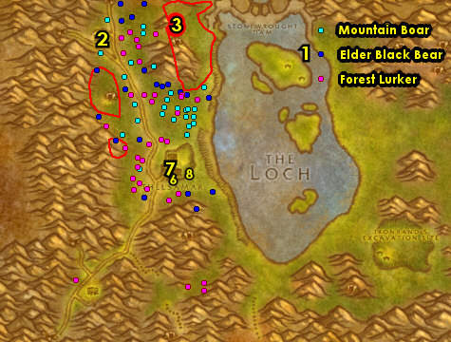

01) You should be level 12 now, if not grind to it.
02) South in the town, go to the Gryphon Master 34.51 and take a flight to Ironforge, Dun Morogh.
03) Get your level 12/14 spells/abilities.
04) You can upgrade First Aid upstairs in the Ironforge Physician 55.58..
05) If you can afford to, you can learn new weapon possibilities south at the two Weapon Masters inside Timberline Arms 62.89.
WOTLK, 10a) Go through the Deeprun Tram 77.51.
WOTLK, 10b) Then take one of the two Deeprun Trams to take you to Stormwind City...
WOTLK, 10c) Once you arrive at the other side of the Deeprun Tram, go north through the tunnel to get into Stormwind City.
WOTLK, 10d) At Stormwind City, go to Stormwind Harbor and get on the boat 23.56 to take you to Darkshore.
11) Once at Auberdine, follow the docks east, and on your right accept "For Love Eternal" (on the dock, 36.44).
12) Continue east on the dock toward the Inn, but go upstairs and accept "Buzzbox 827" 37.44.
13) Just south of the Inn, go up on the platform and from the Hippogryph Master (36.46 in Darkshore), get the Flight Path.
Night Elf
1-6 Shadowglen (Teldrassil)
First Pick the Class you are playing top left of screen!!!
Along with the Game Version you are playing on (Era, WotLK, or SoM)
01) In front of you from Conservator Ilthalaine, accept "The Balance of Nature" 59.45.
02) Start working on "The Balance of Nature": kill Young Nightsabers and Young Thistle Boars around the immediate area. Work your way to the next steps while doing this:
03) Go east to the entrance of Aldrassil and accept "The Woodland Protector" 60.42.
04) Near where you started from, at the Dryad Tarindrella, turn in "The Woodland Protector" 58.45, accept the next part.
05) Go just west to the Grell camps around 56.46 and do "The Woodland Protector": kill/loot Grell and Grellkin.
06) Back at the Dryad Tarindrella, turn in "The Woodland Protector" (58.45 #4 on map).
Remember to Choose Your Class At Top of Screen!!!
07) Make sure "The Balance of Nature" is finished, then turn it in (at the starting spot 59.45, #1 on map). Accept "The Balance of Nature" (Part2).
08) Go near the entrance of Aldrassil, next to the Cauldron and accept "A Good Friend" 61.42.
09) Go in Aldrassil to get repaired/resupplied 59.41.
10) Go to the west side of Aldrassil at the bottom of the ramp entrance and accept "Webwood Venom" 58.42.
#01
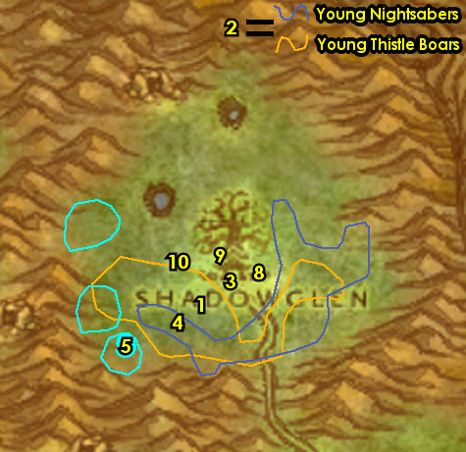

Remember to Choose Your Class At Top of Screen!!!
01) Grind NW to Iverron (sitting between some mountains) and turn in "A Good Friend" 55.33, accept "A Friend in Need".
02) Just east of you, do "Webwood Venom": kill/loot Webwood Spiders. A lot of spiders can be found outside of the cave and more inside 57.32.
03) All around the north side of Shadowglen, do "The Balance of Nature": kill Mangy Nightsabers and Thistle Boars.
04) Die on purpose, then res at Spirit Healer.
05) Go south to the starting spot and from Conservator Ilthalaine, turn in "The Balance of Nature" 59.45.
06) Go east near the entrance of Aldrassil, next to the Cauldron and turn in "A Friend in Need" 61.42, accept "Iverron's Antidote".
07) Go in Aldrassil to get repaired/resupplied 59.41.
08) Go to the west side of Aldrassil at the bottom of the ramp entrance and turn in "Webwood Venom" 58.42, accept "Webwood Egg".
09) Go west to the Grellkin camp around 55.39 and do part of "Iverron's Antidote": kill/loot Grellkin or Grell for the Hyacinth Mushrooms. NOTES: You can also find these from Hyacinth Mushroom objects around the trees & mountains all around Shadowglen, but focus on kill/looting the Grellkin for faster leveling.
10) Go east to the two small ponds around 58.38 and do part of "Iverron's Antidote": loot the Moonpetal Lily (yellow flowers) around the ponds.
#02
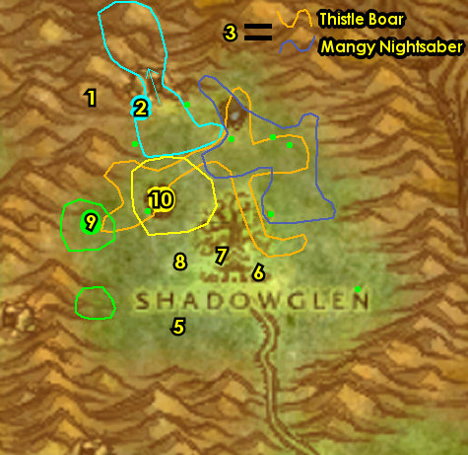

01) Go NW to Shadowthread Cave entrance 57.32 and do "Webwood Egg" along with finishing "Iverron's Antidote": kill/loot the spiders while working your way NW in the cave to eventually loot a Webwood Egg.
02) Use your Hearthstone to hearth to the starting spot.
03) Go east near the entrance of Aldrassil, next to the Cauldron and turn in "Iverron's Antidote" 61.42, accept the next part. NOTE: Work somewhat quickly to do the next steps as this quest is on a 5 min timer.
04) Go in Aldrassil to get repaired/resupplied 59.41.
05) Go to the west side of Aldrassil at the bottom of the ramp entrance and turn in "Webwood Egg" 58.42. Accept "Tenaron's Summons".
06) Go up the ramp next to you, to the very top and then turn in "Tenaron's Summons" 59.39, accept "Crown of the Earth".
07) Go NW to Iverron (sitting between some mountains) and turn in "Iverron's Antidote" 55.33.
08) Go east to the Moonwell 60.33 and do "Crown of the Earth": use the Crystal Phial quest item in the Moonwell.
09) Die on purpose, then res at Spirt Healer.
10) Go to the top of Aldrassil (ramp entrance at 58.41, #5 on map) and turn in "Crown of the Earth", accept the next part.
11) Follow the main path south to leave Shadowglen and on your way out, accept "Dolanaar Delivery" 61.48.
#03
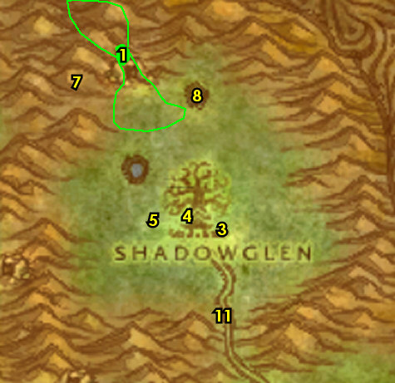

6-10 Dolanaar
01) Follow the main path to Dolanaar and on your way there, off to your right, from Zenn Foulhoof, accept "Zenn's Bidding" 60.56.
02) Keep going west to Dolanaar and make sure you are at least 340 XP away from level 6 before getting there for new spells/abilities. Once at Dolanaar, at the bottom of the tower entrance, accept "Denalan's Earth" 56.58.
03) Just up the ramp, accept "A Troubling Breeze" 56.57.
04) If you have 6 or more silver: Just inside the tower, from the First Aid Trainer 55.57, learn Apprentice First Aid. NOTE: If not, you will want to make sure you save your money for spells/abilities which is more important.
05) Next to you, go up the ramp to the very top of the tower and accept "Twisted Hatred" and "The Emerald Dreamcatcher" 55.57.
06) Drop down and go in the Inn to get repaired/resupplied 56.59.
07) Go up the ramp to the Innkeeper and turn in "Dolanaar Delivery" 56.60. Also make Dolanaar your new home for your hearthstone.
08) Go south in Dolanaar to the Moonwell and turn in "Crown of the Earth" 56.62, accept the next part. NOTE: If you are already lvl 6 right now, then do the next step first before doing this!
Remember to Choose Your Class At Top of Screen!!!
#04
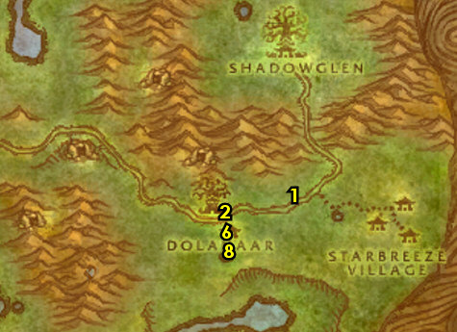

01) Go SE to the small camp at Lake Al'Ameth and turn in "Denalan's Earth" 61.68. Accept "Timberling Seeds" and "Timberling Sprouts".
02) All around Lake Al'Ameth do "Timberling Seeds" along with "Timberling Sprouts": kill/loot Timberling mobs and also loot the Timberling Sprouts on the ground.
03) Go back to the small camp at Lake Al'Ameth and turn in "Timberling Seeds" (61.68, #1 on map), accept "Rellian Greenspyre". Also turn in "Timberling Sprouts".
04) Start working on "Zenn's Bidding": kill/loot nightsabers (cats), spiders and owls. While working on this, work your way to the next steps:
05) Go NE to the Moonwell at Starbreeze Village and do "Crown of the Earth": use the Jade Phial quest item in the Moonwell 63.58.
06) Follow the path east and go up in the first building on your right and turn in "A Troubling Breeze" 66.59, accept "Gnarlpine Corruption".
07) Go in the east most building at Starbreeze Village and do "The Emerald Dreamcatcher": loot Tallonkai's Dresser 68.60.
08) Finish "Zenn's Bidding": kill/loot nightsabers (cats), spiders and owls around the open fields of Teldrassil (#4 on map).
09) Go to Zenn Foulhoof north of the main path between Dolanaar and Starbreeze Village and turn in "Zenn's Bidding" 60.56. NOTE: Make sure you save the quest reward item for later, do not sell it to a vendor!
10) Go west to Dolanaar and at the bottom of the tower entrance, accept "Seek Redemption!" 56.58. NOTE: Save any Small Spider Legs you have as you will use them for a later quest.
11) Just up the ramp, turn in "Gnarlpine Corruption" 56.57,
First Aid? 11b) If you have 6 or more silver (and haven't yet): Just inside the tower, from the First Aid Trainer 55.57, learn Apprentice First Aid. NOTE: You can also get resupplied in the tower. You will want to make sure you save your money for spells/abilities which is more important.
12) Go south in the Inn to get repaired/resupplied 56.59.
13) Go south in Dolanaar to the Moonwell and turn in "Crown of the Earth" 56.62, accept the next part.
14) Just east of you at the Cauldron, Learn Apprentice Cook from the Cook 57.61. Then accept "Recipe of the Kaldorei" (cooking quest). Then as you are doing the next sections start working on this by kill/looting any spiders along the way and do not sell the Small Spider Legs to a vendor. Also turn this in once you get all the legs.
#05
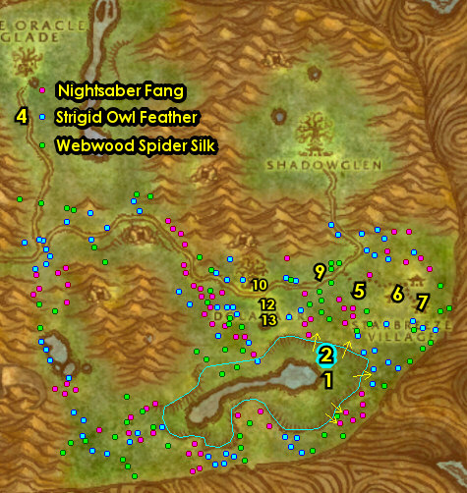

01) Do "Seek Redemption!": loot 3 Fel Cones. These are found around the trees of Teldrassil. See map for locations.
02) Go north of the main path between Dolanaar and Starbreeze Village at Zenn Foulhoof 60.56 and turn in "Seek Redemption!".
03) If you happen to have a group, continue on with the next steps (even if you are lvl 7). If you are going solo, make sure you are level 8 before proceeding, grind on any mobs in the immediate area to level 8.
04) Go to Dolanaar and in the Inn, get repaired/resupplied 56.59.
05) If you are level 8, get new spells/abilities at your class trainer (if you haven't yet).
06) Go just north to Fel Rock (cave entrance at 55.52), enter the cave and do "Twisted Hatred": keep hugging the right side of the cave and then make a left after the river, then see if Lord Melenas /target 52.50 (an orange satyr) is standing at the edge and kill/loot him. If he is not there, continue hugging the right side of the cave and you will eventually get to him. This mob can be hard to solo so be prepared. Use the Severed Voodoo Claw to help you kill him. If you cannot do it, then skip it. Then exit the cave by heading SE.
07) Go to the bottom of the tree tower at Dolanaar 55.57 to get resupplied at Danlyia, then go up to the top of the tower and turn in "Twisted Hatred" and "The Emerald Dreamcatcher", accept "Ferocitas the Dream Eater".
08) Go NE of Starbreeze Village and do "Ferocitas the Dream Eater": kill 7 Gnarlpine Mystics and kill/loot Ferocitas the Dream Eater (grey color furblog at 69.53), then loot the Gnarlpine Necklace that drops (in your inventory).
09) Hearth to Dolanaar.
10) In the Inn, get repaired/resupplied and get lvl 8 spells/abilities if you haven't yet.
11) Go to the top of the tree tower at Dolanaar 55.57 (#7 on map) and turn in "Ferocitas the Dream Eater".
#06
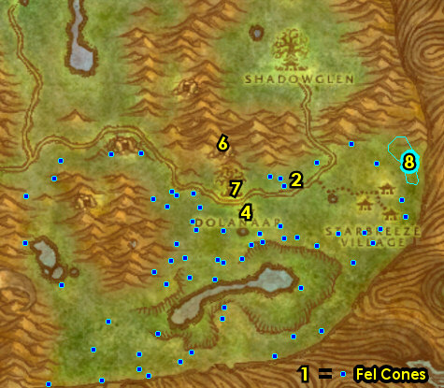

01) Follow the main path west until you run into 3 nightelfs on their mounts (no further than 50.54), and from Moon Priestess Amara, accept "The Road to Darnassus".
02) Drop down to Ban'ethil Hollow around 47.53 and do "The Road to Darnassus": kill 6 Gnarlpine Ambushers.
#07
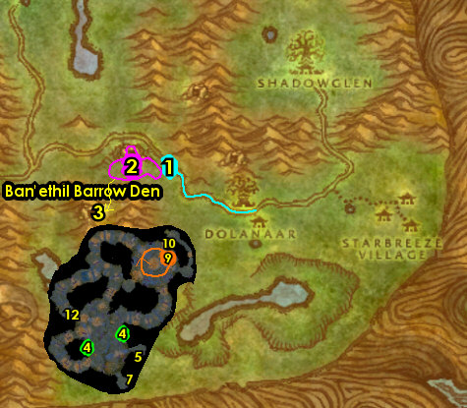

01) Go SW to the Pools of Arlithrien and do "Crown of the Earth": use the Tourmaline Phial quest item at the Moonwell there 42.67.
SoM/WotLK, 1a) Go south to Gnarlpine Hold and from the Strange Fruited Plant 43.76, accept "The Glowing Fruit".
02) Grind your way back towards Dolanaar and make sure you are at least 4,250 XP into lvl 9 before doing the next steps (or 5,050 into lvl 9 if you didn't do the Den). You can grind on Furblogs just west of Dolanaar, or any mobs in the open fields of Teldrassil.
03) Go north to the main path until you run into 3 nightelfs on their mounts (no further west than 50.54), and from Moon Priestess Amara, turn in "The Road to Darnassus".
04)
05) Go south to Dolanaar's Inn to get repaired/resupplied 56.59.
06) South at the Moonwell at Dolanaar, turn in "Crown of the Earth" 56.62, accept the next part.
07) You should be level 10 right now, if not grind to it.
Remember to Choose Your Class At Top of Screen!!!
#08
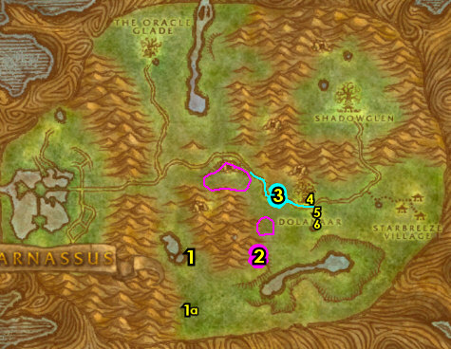

10-12 Teldrassil
01) N/A
02) N/A
04) In western Teldrassil, follow the main path north to The Oracle Glade and at the end of the path, off to your right, accept "The Enchanted Glade" (next to the Moonwell, 38.34 in Teldrassil).
05) Next to you, do "Crown of the Earth": use the Amethyst Phial quest item in the Moonwell there.
06) As you do the following steps start working on "Tumors" by kill/looting the Timberling mobs (#6 on map):
07) Go east past the river and see if Blackmoss the Fetid /target is there (a lvl 13 rare at around 44.30 with a 2 hour respawn) and try to kill/loot this mob. He drops an item, which starts "The Moss-twined Heart", accept it. This elemental could also be NW of the river as well (at around 43.27). NOTE: If you cannot find him, then my guide will remind you later to try again.
08) Go north and do "Tears of the Moon": kill/loot Lady Sathrah /target (lvl 12 grey spider, has 2 spawn locations (either east 48.25 or west 39.25, see map).
09) Just west at Wellspring River (around 43.28, #6 on map), finish "Tumors": kill/loot Timberling mobs.
10) Go west and from the Strange Fronded Plant (glowing red tree, 35.29), accept "The Shimmering Frond".
11) In the immediate area do "The Enchanted Glade": kill/loot the Bloodfeather harpies. While doing this, work your way to the next step:
12) Back in the harpy camp there is a black panther named Mist 32.32 that starts an escort quest "Mist", accept it.
13) Make sure "The Enchanted Glade" is finished, then lead Mist to the Moonwell at The Oracle Glade (38.34, #4 on map) and then turn in "The Enchanted Glade" and "Mist". Accept "Teldrassil".
14) If you need to, check again to see if Blackmoss the Fetid /target is there (a lvl 13 rare at around 44.30 or around 43.27 #7 on map). Try to kill/loot this mob, he drops an item, which starts "The Moss-twined Heart", accept it. NOTES: This mob has a 2 hour respawn, if you cannot kill him, then it can be skipped.
#16
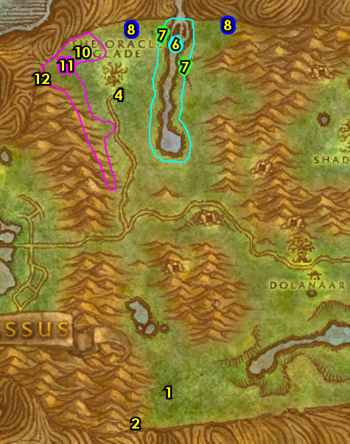

01) Go west of the main path at The Oracle Glade around 37.38, then die on purpose to get to Darnassus.
02) In Darnassus, go NW to Cenarion Enclave and turn in "Tumors" (38.22 in Darnassus), accept "Return to Denalan".
03) Follow the path straight forward and go up in the tree tower and turn in "Teldrassil" 35.9, accept "Grove of the Ancients".
04) Go south in Darnassus to enter Temple of the Moon, go up the ramp, then turn in "Tears of the Moon" 37.86, accept "Sathrah's Sacrifice".
05) Next to you, do "Sathrah's Sacrifice": drop down and use the Sathrah's Sacrifice quest item at the fountain in the middle of the temple.
06) Go back up the ramp in the Temple of the Moon and turn in "Sathrah's Sacrifice" (37.86, #4 on map).
07) Hearth to Dolanaar.
08) In the Inn, get repaired/resupplied.
09) N/A
10) Go south to the Moonwell at Dolanaar and turn in "Crown of the Earth" 56.62, accept the next part. Also turn in "Recipe of the Kaldorei" at the Cook 57.61 if its finished. If you turned level 12, then get new spells abilities.
11) Go SE to the small camp at Lake Al'Ameth 61.68 and turn in (if you have it) "The Moss-twined Heart", accept (if it's available) "Planting the Heart".
12) Next to you, click on Denalan's Planter to turn in (if you have it) "Planting the Heart" 61.69.
13) Also turn in "The Glowing Fruit", "The Shimmering Frond" and "Return to Denalan" 61.68, accept "Oakenscowl". Then, next to you, click on the Sprouted Frond in the planter to complete "The Sprouted Fronds".
#17
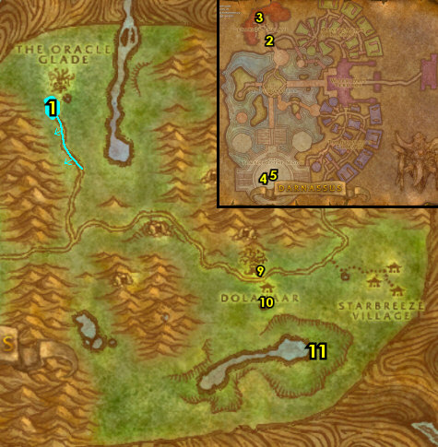

01) Go west to the small cave at Lake Al'Ameth and do "Oakenscowl": kill/loot Oakenscowl (lvl 9 at 54.75).
02) If you did "Oakenscowl", go back east to the small camp at Lake Al'Ameth and turn it in 61.68.
03) You should be level 12 by now, if not grind on mobs south of Lake Al'Ameth until you are. Then die on purpose (or run back) to Dolanaar to get new spells/abilities & repaired/resupplied.
First Aid? 3b) Just inside the tower, upgrade First Aid from the First Aid Trainer 55.57.
04) Follow the main path west and then just past the blue bridge around 43.51, die on purpose to get to Darnassus quicker.
05) Go NW in Darnassus and go up to the top of the tree tower and turn in "Crown of the Earth" 35.9.
06) Go south in Darnassus and enter the red glowing teleporter 28.42.
07) Once at Rut'theran Village, go down the path and turn in "Nessa Shadowsong" (56.92 in Teldrassil), accept "The Bounty of Teldrassil".
08) Go east on the bridge to the Hippogryph Master and turn in "The Bounty of Teldrassil" 58.94, accept "Flight to Auberdine". Then take a ride to Auberdine, Darkshore.
09) Go down in the Inn at Auberdine and turn in "Flight to Auberdine" 37.44, accept "Return to Nessa".
10) Go back up to the Hippogryph Master 36.46 at Auberdine and fly to Rut'theran Village, Teldrassil.
11) Go west past the bridge a bit and turn in "Return to Nessa" (56.92 in Teldrassil).
12) Go back east on the bridge to the Hippogryph Master 58.94 and fly to Auberdine, Darkshore.

Gnome/Dwarf
1-6 Coldridge Valley (Dun Morogh)
First Pick the Class you are playing top left of screen!!!
Along with the Game Version you are playing on (Era, WOTLK, or SoM)
01) In front of you from Sten Stoutarm, accept "Dwarven Outfitters" 30.72.
02) Just to the south of you, do "Dwarven Outfitters": kill/loot wolves around 29.74.
Vendor, 2a) Go back to the starting spot and get resupplied (sell junk) 30.72.
03) Next to you, turn in "Dwarven Outfitters" 30.72 (#1 on map). Accept "Coldridge Valley Mail Delivery". Remember to Choose Your Class At Top of Screen!!!
04) Next to you, accept "A New Threat" 30.71.
05) As you do the following steps start working on "A New Threat": kill Rockjaw Troggs and Burly Rockjaw Troggs:
06) Go SW at the small camp/tent and turn in "Coldridge Valley Mail Delivery" 23.71, accept the next part. Also accept "The Boar Hunter".
07) Just west and north of you do "The Boar Hunter": kill Small Crag Boars.
08) Go back to the small camp/tent and turn in "The Boar Hunter" (23.71, #6 on map).
#01
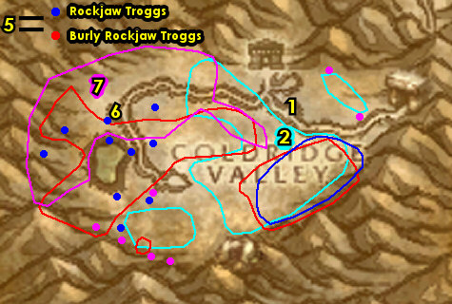

Remember to Choose Your Class At Top of Screen!!!
01) Follow the main path SE to the small dwarf camp and turn in "Coldridge Valley Mail Delivery" 25.76, accept "The Troll Cave".
02) Around southern Coldridge Valley, start working on "The Troll Cave": kill Frostmane Troll Whelps. There is a lot in the cave down south (entrance at 27.80). As soon as you hit level 4, stop what you are doing and go do the following steps:
03) Go to the dwarf camp south on the main path and accept "Scalding Mornbrew Delivery" 25.76. NOTE: This quest has a 5 min time limit, as long as you do not go AFK or something you should have plenty of time to get this in.
04) Hearth to the starting spot.
05) Go north and enter Anvilmar then accept "A Refugee's Quandary" patrols a bit 29.68. Next to you, make sure you are repaired/resupplied 29.68.
06) Go north in Anvilmar and turn in "Scalding Mornbrew Delivery" 29.66. Accept "Bring Back the Mug".
07) In Anvilmar, get your level 4 class's spells/abilities.
08) Exit Anvilmar south, then finish "A New Threat": kill Rockjaw Troggs (mostly east around 31.75) and Burly Rockjaw Troggs (mostly west).
09) At the starting spot, turn in "A New Threat" 30.71. Make sure you are repaired/resupplied (from the blue shirted dwarf under red tent) 30.72.
10) Go south to the small dwarf camp at the end of the main path and turn in "Bring Back the Mug" (25.76, #3 on map).
#02
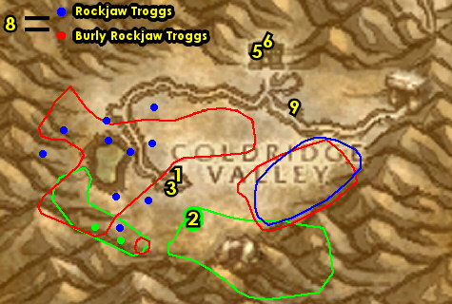

01) Go west and do "A Refugee's Quandary": loot the 3 objects at the troll camps. First loot Felix's Box (in front of the Campfire, 21.76). See next steps for the other two:
02) Loot Felix's Chest (next to the Campfire, 23.80).
03) Loot Felix's Bucket of Bolts (in front of the Campfire, 26.79).
04) Around southern Coldridge Valley, finish "The Troll Cave": kill Frostmane Troll Whelps. There is a lot in the cave down south (entrance at 27.80).
05) Go back to the dwarf camp south on the main path and turn in "The Troll Cave" 25.76, accept "The Stolen Journal".
06) Go SE and enter the troll cave (entrance at 27.80, #4 on map) and do "The Stolen Journal": keep hugging the left side of the cave until you get to Grik'nir the Cold /target 30.80 and kill/loot this troll.
07) Go NW to the small dwarf camp at the end of the main path and turn in "The Stolen Journal" (25.76, #5 on map), accept "Senir's Observations".
08) Hearth (if you can), or die on purpose to get to the starting spot.
09) Go north to enter Anvilmar then turn in "A Refugee's Quandary" patrols a bit 29.68. Make sure you are repaired/resupplied 29.68.
10) Exit Anvilmar (south) then head east on the main path to the entrance of Coldridge Pass and turn in "Senir's Observations" 33.72, accept the next part.
11) Just next to you up the hill, accept "Supplies to Tannok" 34.72.
12) Enter Coldridge Pass next to you (entrance at 34.71) and work your way through it.
#03
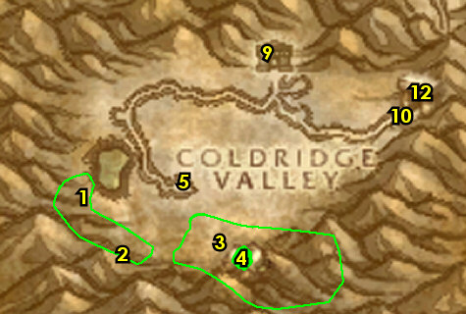

6-8 Dun Morogh (log)
01) Go NE to Kharanos and make sure you are at least 450 XP away from lvl 6 before getting there for new spells/abilities. Just south in Kharanos, off to your right, turn in "Senir's Observations" 46.54.
02) Go north into Kharanos and off to your right, accept "Beer Basted Boar Ribs" 47.52.
03) Next to you, enter Thunderbrew Distillery (the Inn) and turn in "Supplies to Tannok" 47.52.
04) Next to the fireplace, from the Physician, learn Apprentice First Aid 47.53.
05) Next to you by the bar, from Innkeeper Belm 47.53, talk to him to make Thunderbrew Distillery your new home for your Hearthstone. Make sure you are resupplied. NOTE: Do not sell any Crag Boar Ribs you may have.
06) Find your class trainer around Kharanos and learn your level 6 spells/abilities. Remember to Choose Your Class At Top of Screen!!!
07) Across from Thunderbrew Distillery, at the entrance of the blacksmith shop, accept "Tools for Steelgrill" 46.52.
08) Go NE to Steelgrill's Depot 49.48 and accept "Stocking Jetsteam", and next to you "The Grizzled Den".
09) Just to the east between the two huts, accept "Ammo for Rumbleshot" 50.49.
10) In front of the hut, turn in "Tools for Steelgrill" 50.49.
#04
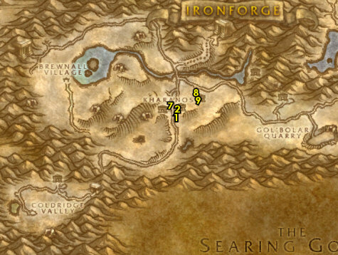

01) As you work on the following steps also start working on "Beer Basted Boar Ribs" along with "Stocking Jetsteam" by kill/looting boars and bears scattered all around Dun Morogh (also do not sell the quest items to a vendor!):
02) SW of Kharanos, do "Ammo for Rumbleshot": loot the Ammo Crate next to the tent/Campfire 44.57.
03) Go north a bit and do "The Grizzled Den": kill/loot Yetis. You can find a lot more in the Den (entrance at 42.54).
04) Go south to the small dwarf camp along the main path and turn in "Ammo for Rumbleshot" 41.65. Make sure you are repaired/resupplied. Do NOT sell your quest items!
05) Just north at the open fields of Dun Morogh, finish "Beer Basted Boar Ribs" along with "Stocking Jetsteam": kill/loot boars and bears. Focus mostly on the Crag Boars. NOTE: You will get the Rhapsody Malt later.
06) Make sure you are at least 625 XP away from level 7, then hearth to Thunderbrew Distellery (or run back if you are already close).
07) From Innkeeper Belm 47.52, purchase a Rhapsody Malt from him for "Beer Basted Boar Ribs". Make sure you are resupplied (Do NOT sell your quest items!).
08) Just outside of the Inn, turn in "Beer Basted Boar Ribs" 47.52. You should be lvl 7 now, if not grind to it.
09) South of Kharanos, next to the tent/wagon, accept "Frostmane Hold" 47.54.
10) North in Kharanos, down in the goblin hut, accept "Operation Recombobulation" 46.49.
11) Go east to Steelgrill's Depot 49.48 and turn in "Stocking Jetsteam", accept "Evershine". And next to you turn in "The Grizzled Den".
#05
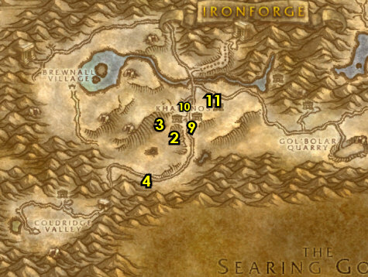

01) Go west (take the south route) and go up the mountain (entrance at 36.53)..
02) Up the mountain, accept "Tundra MacGrann's Stolen Stash" 35.52.
03) Go east back down the mountain and try to do "Tundra MacGrann's Stolen Stash": In the cave loot MacGrann's Meat Locker 38.51 and watch out for the lvl 11 patrolling elite yeti. You can simply wait for this elite yeti to leave the cave then run in there to loot it, although he stays in the cave for several minutes at a time. Try to group if you can to take him on, or you can skip it or try later (as you will pass this spot a few more times later) and it gets turned in back up the hill next to the cave.
04) Back up the mountain, turn in (if you did it) "Tundra MacGrann's Stolen Stash" (35.52, #2 on map).
05) Go NW to Brewnall Village and turn in "Evershine" 30.46, accept "A Favor for Evershine". Also accept "The Perfect Stout".
06) Next to you, accept "Bitter Rivals" 30.24.
07) You can get resupplied from Keeg Gibn under the red canopy 30.45.
08) While doing the next steps, start working on "A Favor for Evershine" by killing the Ice Claw Bears, Elder Crag Boars and Snow Leopards around the western open fields of Dun Morogh:
09) Go NE up to Shimmer Ridge (entrance at 38.42) and do "The Perfect Stout": kill/loot Frostmane Seers and loot Shimmerweed Baskets.
10) Go west to Brewnall Village and turn in "The Perfect Stout" (30.46, #5 on map), then if you are lvl 8 accept "Shimmer Stout". And get resupplied.
11) All around western Dun Morogh (past Iceflow Lake) continue working on "A Favor for Evershine" by killing the Ice Claw Bears, Elder Crag Boars and Snow Leopards (#7 on map). Once you hit level 8, Hearth, or just go back to Kharanos.
#06
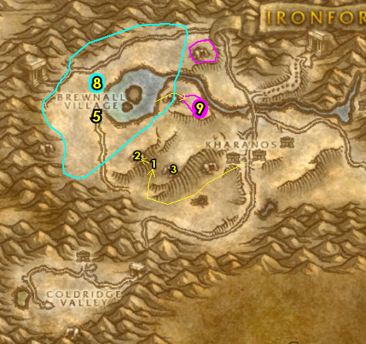

8-10 Dun Morogh (log)
01) In Thunderbrew Distillery (the Inn), at Innkeeper Belm 47.52, purchase a Thunder Ale. Make sure you are resupplied.
02) Go down the steps in Thunderbrew Distillery to the room with all the barrels 48.53 and do "Bitter Rivals": talk to Jarven Thunderbrew next to you to give him the Thunder Ale. Wait a few seconds, then click on the Unguarded Thunder Ale Barrel to turn in "Bitter Rivals", accept "Return to Marleth".
03) Find your class trainer around Kharanos and learn your level 8 spells/abilities.
04) Go west to Brewnall Village 30.46 and turn in "Return to Marleth". Also accept (if you haven't yet) "Shimmer Stout".
05) Go SW to enter Frostmane Hold (entrance at 25.51)..
06) Do "Frostmane Hold": work your way to the middle of the cave 23.52 to get it explored. Also kill 5 Frostmane Headhunters.
07) Leave the cave then go up north to the entrance of Gnomeregan around 25.44 and do "Operation Recombobulation": kill/loot the Leper Gnomes.
#07
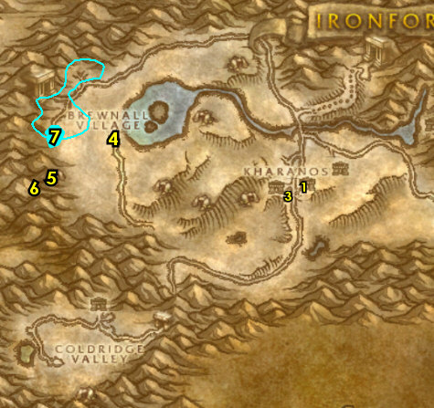

01) All around western Dun Morogh (past Iceflow Lake) finish "A Favor for Evershine": kill Ice Claw Bears, Elder Crag Boars and Snow Leopards around the open fields of Dun Morogh.
02) Go to Brewnall Village and turn in "A Favor for Evershine" 30.46, accept "Return to Bellowfiz".
03) Go to Kharanos and south in the town, turn in "Frostmane Hold" 47.54, accept "The Reports". Make sure you are repaired/resupplied.
04) North in Kharanos, down in the goblin hut, turn in "Operation Recombobulation" 46.49.
05) Go NE to Steelgrill's Depot and turn in "Return to Bellowfiz" 49.48.
06) At this point it is wise to get your level 10 spells/abilities before continuing, so grind on any mobs in the open fields of Dun Morogh until you are level 10. If you still have a ways to go before 10, you can go east and accept the two quests "The Public Servant" and "Those Blasted Troggs!" 69.56 and start working on them by killing the Rockjaw Skullthumpers at Gol'Bolar Quarry around 68.59 . You can also try to kill the Rockjaw Bonesnappers in the cave (entrance at 71.56). Turn these in if you complete them.
#08
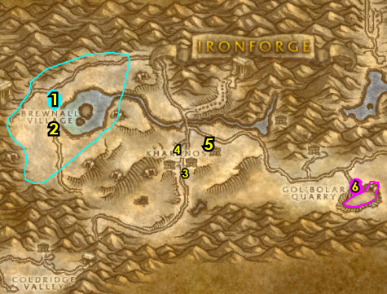

10-11 Dun Morogh
Remember to Choose Your Class At Top of Screen!!!
01) Follow the main path east to Gol'Bolar Quarry and finish (if you still need to) "Those Blasted Troggs!" by killing the Rockjaw Skullthumpers at Gol'Bolar Quarry around 68.59 and "The Public Servant" by killing Rockjaw Bonesnappers in the cave (entrance at 71.56). These quests are accepted at the Quarry there!
02) Go back up and turn in "The Public Servant" 69.56.
03) Next to you, behind the tent, turn in "Those Blasted Troggs!" 69.56.
04) Go north to Amberstill Ranch and accept "Protecting the Herd" 63.50.
05) Just to the west of you is a hidden path that leads up the mountain, go up it then head north and do "Protecting the Herd": kill/loot Vagash /target around 62.34. This lvl 11 Yeti patrols up around the mountain ledges. This can be skipped if it gives you troubles.
06) Back at Amberstill Ranch, turn in "Protecting the Herd" (63.50, #4 on map).
07) Follow the path NE to North Gate Outpost and accept "The Lost Pilot" 84.39.
08) Go NW a bit and click on A Dwarven Corpse to turn in "The Lost Pilot" 80.36, accept "A Pilot's Revenge".
09) Go just SW up the path a bit and do "A Pilot's Revenge": kill/loot Mangeclaw /target 78.38.
10) Back east at the Outpost turn in "A Pilot's Revenge" (84.39, #7 on map).
11) Go to the South Gate Outpost and turn in "Shimmer Stout" 86.49, accept "Stout to Kadrell".
12) Enter South Gate Pass (entrance at 17.59) and go through it to get to Loch Modan..
#16
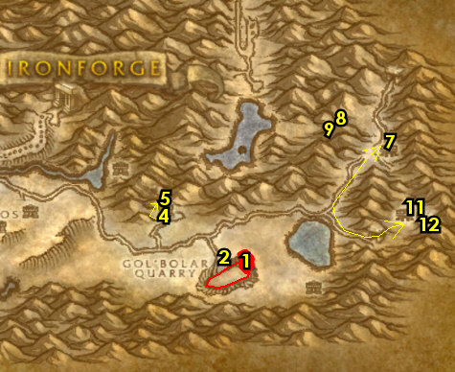

11-12 Loch Modan (log)
01) Once you enter Loch Modan you will arrive at Valley of Kings, and in front of the watchtower, accept "In Defense of the King's Lands" (22.73 in Loch Modan).
02) Go up in the watchtower in front of you and accept "The Trogg Threat" 23.74.
03) Follow the main path NE, then make a right to go to Stonesplinter Valley around 32.73 and do "In Defense of the King's Lands" along with "The Trogg Threat": kill 10 Stonesplinter Troggs and 10 Stonesplinter Scouts, and loot them for the Stone Tooth.
04) Go back west to Valley of Kings and turn in "In Defense of the King's Lands" (22.73, #1 on map).
05) Go up in the watchtower and turn in "The Trogg Threat" 23.74.
06) Go north to Thelsamar around 34.48 and find Mountaineer Kadrell (he patrols back and forth in the town) and turn in "Stout to Kadrell". From him accept "Rat Catching" and "Mountaineer Stormpike's Task".
07) Go in the Inn (the building with the big barrels around it), (entrance at 35.48).. and the first NPC you see (Innkeeper Hearthstove, 35.48), talk to him to make this Inn your new home.
08) At the bar, from Vidra Hearthstove, accept "Thelsamar Blood Sausages" 35.49. Make sure you are resupplied. If you need 6 slot bags, you can purchase them from the General Supplies vendor in the Inn (if you can afford them).
#17
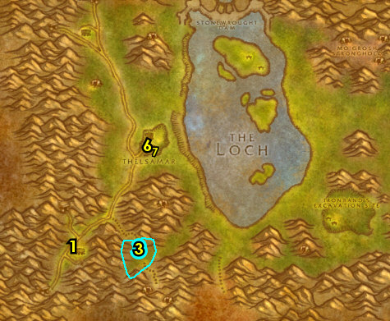

01) While working your way north to the next steps, also start working on "Rat Catching" by kill/looting Tunnel Rat mobs (kobolds) along the west side of the main path (#3 on map). Also start working on "Thelsamar Blood Sausages" by killing boars, bears and spiders (in the open fields of Loch Modan, #1 on map):
02) Grind north to Algaz Station, go up in the watchtower and turn in "Mountaineer Stormpike's Task" 25.18, Accept "Stormpike's Order". Also accept "Filthy Paws". NOTE: You can get repaired/resupplied at the bottom of the watchtower but do not sell your "Thelsamar Blood Sausages" quest items to a vendor!
03) Go east to Silver Stream Mine around 35.19 and finish "Rat Catching": kill/loot the Tunnel Rat mobs (kobolds) outside of the mine. And if you have a group, do "Filthy Paws": loot the Miner's League Crates inside the mine. You can skip the quest if you cannot get a group (but keep it accepted, as you will be able to solo it later).
04) If you did "Filthy Paws " go west and turn in up in the watchtower at Algaz Station, (25.18, #2 on map).
05) Finish "Thelsamar Blood Sausages": kill boars, bears and spiders (in the open fields of Loch Modan, #1 on map).
06) Hearth (if you can) to Stoutlager Inn (Thelsamar) and in the Inn at the bar, turn in "Thelsamar Blood Sausages" 35.49. Make sure you are repaired/resupplied.
07) In Thelsamar, find Mountaineer Kadrell (he patrols back and forth in the town) and turn in "Rat Catching".
08) East in Thelsamar, down in the hut, accept "Honor Students" 37.48 .
#18

01) You should be level 12 now, if not grind to it.
02) South in the town, go to the Gryphon Master 34.51 and turn in "Honor Students", accept "Ride to Ironforge". Then take a flight to Ironforge, Dun Morogh.
03) In Ironforge, go north to Deep Mountain Mining Guild and turn in "Ride to Ironforge" 51.26, accept "Gryth Thurden".
04) Go to the Gryphon Master 55.48 and turn in "Gryth Thurden", accept "Return to Brock". Then take a flight to Thelsamar, Loch Modan.
05) East in Thelsamar, down in the hut, turn in "Return to Brock" 37.48.
06) South in the town, go to the Gryphon Master (34.51, #2 on map) and take a flight to Ironforge, Dun Morogh.
07) You can upgrade First Aid upstairs in the Ironforge Physician 55.58..
08) If you can afford to, you can learn new weapon possibilities south at the two Weapon Masters inside Timberline Arms 62.89.
WOTLK, 13a) Go through the Deeprun Tram 77.51, and then between the two Tram track accept "Deeprun Rat Roundup".
WOTLK, 13b) Just around the immediate area do "Deeprun Rat Roundup": use the Rat Catcher's Flute quest item on the Deeprun Rats.
WOTLK, 13c) Go back between the two tracks at the Deeprun Tram, and turn in "Deeprun Rat Roundup", accept "Me Brother, Nipsy".
WOTLK, 13d) Then take one of the two Deeprun Trams to take you to Stormwind City.
WOTLK, 13e) Once you arrive at the other side of the Deeprun Tram, turn in "Me Brother, Nipsy" between the two tram tracks. Then go north through the tunnel to get into Stormwind City.
WOTLK, 13f) At Stormwind City, go to Stormwind Harbor and get on the boat 23.56 to take you to Darkshore.
14) Once at Auberdine, follow the docks east, and on your right accept "For Love Eternal" (on the dock, 36.44).
15) Continue east on the dock toward the Inn, but go upstairs and accept "Buzzbox 827" 37.44.
16) Just south of the Inn, go up on the platform and from the Hoppogryph Master (36.46 in Darkshore), get the Flight Path.

12+

12-17 Darkshore (log)
First Pick the Class you are playing top left of screen!!!
Along with the Game Version you are playing on (Era, SoM, TBC or WotLK)
01) At Auberdine on the Hippogryph dock, accept "Washed Ashore" 37.46.
02) Go in the Inn and from Innkeeper Shaussiy 37.44, make Auberdine your new home. NOTE: From the Fish Vendor /target in the Inn you can purchase Longjaw Mud Snapper, which is a cheap tier 2 food.
03) NIGHT ELF ONLY (other races should have already did this): Go west of the Inn on the long docks and accept "For Love Eternal" 36.44.
04) NIGHT ELF ONLY (other races should have already did this): Go back toward the Inn, but go upstairs and accept "Buzzbox 827" 37.44.
05) Just outside of the Inn, next to the mailbox, accept "Cave Mushrooms" 37.44.
06) Just across the path from you near the moonwell, accept "The Red Crystal" 38.43.
07) Go north across the bridge and into the merchant building then accept "Bashal'Aran" and "Tools of the Highborne" 37.40.
GET BAGS: At this point if you do not have all 6 slot bags it is highly recommended to buy them from the General Goods (37.40, /target) vendor in the merchant building, as long as you can afford them.
08) Take the SE bridge to the other building and at the entrance, accept "Plagued Lands" 39.43.
09) Go inside the building and accept "How Big a Threat?" 39.43.
10) Work your way down south along the shore while doing "Buzzbox 827": kill/loot crabs. Work your way to the Beached Sea Creature 36.51 and click on it to loot the Sea Creature Bones for "Washed Ashore".
11) Go back north to Auberdine and next to the Hippogryph dock, off in the grass, from Buzzbox 827 (37.46, #1 on map), turn in "Buzzbox 827", accept "Buzzbox 411".
12) On the Hippogryph dock, turn in "Washed Ashore" 37.46, accept the next part.
13) Go west out in the sea and do "Washed Ashore": loot the Skeletal Sea Turtle's head 32.46.
14) Around in the sea do "Buzzbox 411": kill/loot Darkshore Threshers /target.
#01
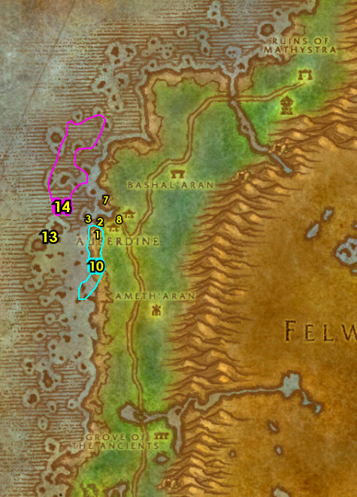

01) Go back to Auberdine on the Hippogryph dock and turn in "Washed Ashore" 37.46.
02) In the town, get repaired/resupplied 37.44.
03) Go north to the shore, at the Beached Sea Creature 42.31 and click on it to accept "Beached Sea Creature".
04) Go north along the shore and at Buzzbox 411 42.29, turn in "Buzzbox 411", accept "Buzzbox 323".
05) As you work your way to do the next steps, start working on "Buzzbox 323" by kill/looting the Moonstalkers (cats):
06) Go south to Bashal'Aran, up on the hill, in the blue mist, turn in "Bashal'Aran" 44.36, accept the next part.
07) Just south of where you are at around 45.37, do "Bashal'Aran": kill/loot Vile Sprites and Wild Grell.
08) Go back up on the hill at Bashal'Aran, in the blue mist, turn in "Bashal'Aran" (44.36, #6 on map), accept the next part.
09) Just south of where you are at around 45.37, do "Bashal'Aran": kill/loot Deth'ryll Satyr /target (orange colored patrolling satyr).
10) Go back up on the hill at Bashal'Aran, in the blue mist, turn in "Bashal'Aran" (44.36, #6 on map), accept the next part.
11) Grind down south and on top of the hill, simply run up close to the Mysterious Red Crystal 47.49 for "The Red Crystal".
12) Go west across the main path into the furbolg camp 40.54 to simply get it discovered for "How Big a Threat?".
13) Go down south on the main path and accept "The Fall of Ameth'Aran" 40.60.
#02
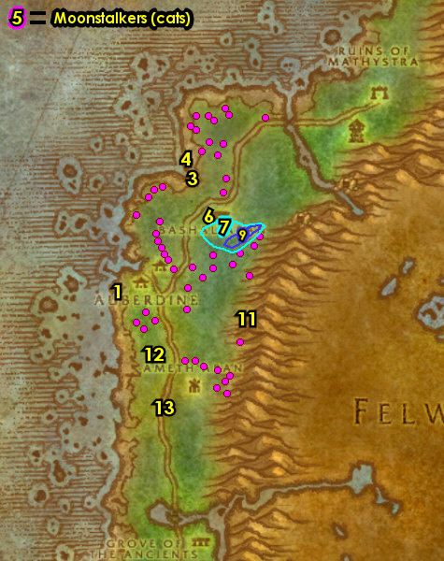

01) Go east at Ameth'Aran and start working on "Tools of the Highborne": kill/loot the Highborne mobs (apparitions). While doing this, also work your way to do the next steps:
02) Do part of "The Fall of Ameth'Aran": next to the old dark gazebo, click The Lay of Ameth'Aran 43.59 white tablet laying on the ground.
03) Go south to the other gazebo and do "Bashal'Aran": click on the Ancient Flame 42.62. Also do "For Love Eternal": find and kill/loot Anaya Dawnrunner /target, she patrols clockwise around this gazebo.
04) Go south a bit more and do the last part of "The Fall of Ameth'Aran": click on the The Fall of Ameth'Aran tablet standing upright 43.63.
05) Make sure "Tools of the Highborne" is finished: kill/loot the Highborne mobs (apparitions, #1 on map) around Ameth'Aran.
06) Make sure you are at least 6,000 XP into level 13 before continuing. Grind on Highborne mobs (apparitions) around Ameth'Aran until you are.
07) Go west to the main path and turn in "The Fall of Ameth'Aran" 40.60.
08) To the west of the main path do "Plagued Lands": use Tharnariun's Hope quest item on a Rabid Thistle Bear /target around 39.60. NOTE: Make sure you are in range and in clear view of the mob when using the quest item, otherwise you might miss and will have to go back to Auberdine to get a new one.
#03
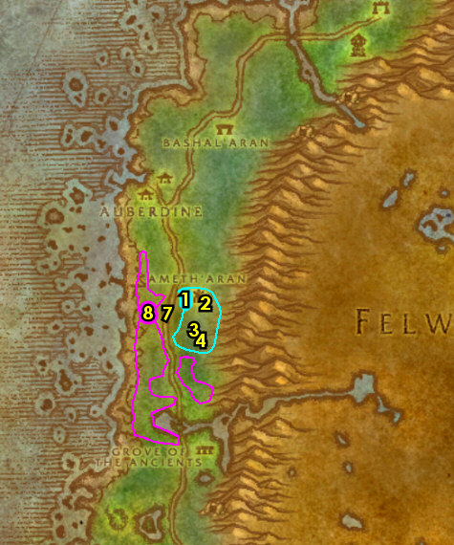

01) Hearth to Auberdine. Make sure you are repaired/resupplied.
02) Go west of the Inn on the long docks and turn in "For Love Eternal" 36.44.
03) Just outside of the Inn and across the path by the moonwell, turn in "The Red Crystal" 38.43, accept "As Water Cascades".
04) Use the Empty Water Tube quest item at the moonwell next to you 38.44.
05) Go east across the bridge and at the entrance to the building, turn in "Plagued Lands" 39.43, accept "Cleansing of the Infected".
06) Go in the building and turn in "How Big a Threat?" 39.43, accept the next part. Also accept "Thundris Windweaver".
07) Go up in the building and accept "The Tower of Althalaxx" 39.44.
08) Take the bridge going north and at the dwarf area by the wagon, accept "Deep Ocean, Vast Sea" 38.41.
09) Go in the merchant building next to you 37.40 and turn in "Tools of the Highborne" and "Thundris Windweaver", accept "The Cliffspring River".
10) Go to the Hippogryph dock (south of the Inn) and turn in "Beached Sea Creature" 37.46.
11) You should be level 14 now. If you are a Mage, Paladin, Hunter, Priest, Rogue or Warrior and could benefit from getting your level 14 spells/abilities, then you can do that now in Darnassus. The other classes can take the boat 32.44 to Stormwind to get their spells/abilities. So if you can benefit from getting your lvl 14 abilities, Night Elves can take a Hippogryph ride from the Hippogryph Master next to you. If you are dwarf, gnome or human you will have to take the Boat to Teldrassil 33.40, then to get back to Auberdine take the flight path (at 58.94 in Teldrassil).
#04
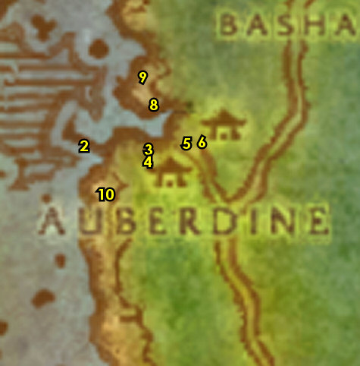

01) As you work on the following steps start working on "Cleansing of the Infected" by killing the Rabid Thistle Bears. Also continue working on "Buzzbox 323" by kill/looting the Moonstalkers (cats):
02) Go north to Bashal'Aran, up on the hill, in the blue mist, turn in "Bashal'Aran" 44.36.
03) Go NW out in the sea and do "Deep Ocean, Vast Sea": loot the two chests in the two sunken boats. First one, go under the boat and enter the crack on the bottom of the boat (entrance at 39.29), then head NW in the boat and loot the Silver Dawning's Lockbox 38.29:
04) Head NE and enter the bottom of the other boat 40.27, then head west in the boat and loot the Mist Veil's Lockbox 40.27.
05) Go NE on the shore and click on the Beached Sea Turtle's arm 44.21 to accept "Beached Sea Turtle".
06) Just south of you in the open fields of Darkshore, finish "Buzzbox 323" by kill/looting the Moonstalkers /target (cats, #1 on map).
07) Follow the main path east and just past the bridge on your left is Buzzbox 323 51.25, from it turn in "Buzzbox 323", accept "Buzzbox 525".
08) Next to you, drop down at the bottom of the waterfall and do "The Cliffspring River": use the Empty Sampling Tube quest item at the bottom of the waterfall 51.26.
#05
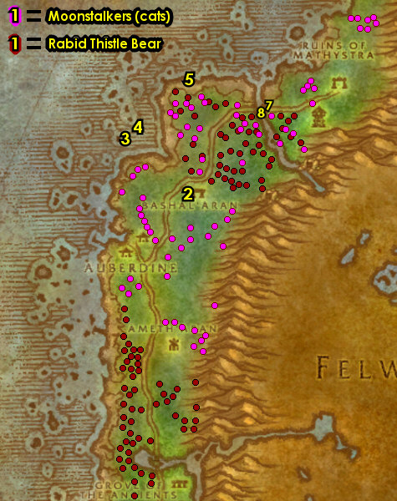

01) Go south and up on the hill, click on the Mysterious Red Crystal 47.49 to turn in "As Water Cascades", accept "The Fragments Within".
02) Go SW past the main path to the furbolg camp around 40.54 and do "How Big a Threat?": kill the required amount of Blackwood furbolgs.
03) Work your way down south while killing Rabid Thistle Bears (#7 on map) for "Cleansing of the Infected". Eventually make your way to the shoreline at the Beached Sea Turtle 37.62 and click on its head to accept "Beached Sea Turtle".
04) Continue down south while killing Rabid Thistle Bears (#7 on map) for "Cleansing of the Infected". Eventually make your way to the shoreline at the Beached Sea Creature 36.71 and click the body to accept "Beached Sea Creature".
05) Go south to the Beached Sea Creature 33.81 and click where the neck meets the body to accept "Beached Sea Creature".
06) If you have "Grove of the Ancients": Turn this in at Onu big tree NPC, 44.76.
07) East of you around the open fields of Darkshore around 38.71 finish "Cleansing of the Infected": kill Rabid Thistle Bears. Also start working on "Buzzbox 525" by kill/looting Grizzled Thistle Bears.
08) Go down south around 40.81 and finish "Buzzbox 525": kill/loot Grizzled Thistle Bears (#7 on map).
09) Just right off the main path go to Buzzbox 525 41.81 and turn in "Buzzbox 525".
#06
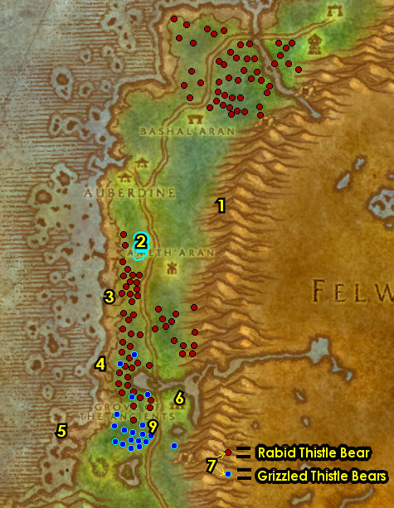

01) Keep grinding until you are 6,370 XP3,550 XP into level 15, then Hearth to Auberdine.
02) Go to the Hippogryph dock (south of the Inn, 37.46) and turn in ALL "Beached Sea" quests you may have.
03) Go below the Hippogryph dock, next to the shore and accept "Fruit of the Sea" 36.45. NOTE: "The Family and the Fishing Pole" is a fishing quest that takes too much time for XP and I recommend skipping it. If you are bored and want to learn fishing or do something different you can give it a try.
05) Just across the path from you, near the moonwell, turn in "The Fragments Within" 38.43.
06) Take the bridge north and just outside of the merchant building (to your left), accept "The Absent Minded Prospector" 37.42.
07) Go in the merchant building next to you and turn in "The Cliffspring River" 37.40, accept "The Blackwood Corrupted" (requires lvl 15). Make sure you are repaired/resupplied.
08) Just outside of the building at the dwarf camp next to the wagon, turn in "Deep Ocean, Vast Sea" 38.41.
09) Take the SE bridge to the other building and at the entrance, turn in "Cleansing of the Infected" 39.43, accept "Tharnariun's Hope".
10) Go in the building and turn in "How Big a Threat?" 39.43. Accept "A Lost Master".
11) Go to the moonwell in Auberdine and use your Empty Cleansing Bowl quest item in it 38.44.
12) You should be level 16 by now: If you are a Mage, Paladin, Druid, Priest, Rogue or Warrior and could benefit from getting your level 16 spells/abilities, you can do that now in Darnassus. The other classes can take the boat 32.44 to Stormwind to get their spells/abilities. So if you can benefit from getting your lvl 16 abilities, you can take a Hippogryph ride from the Hippogryph Master 36.46 or you might need to take the boat on the docks. Then hearth (or fly back) to Auberdine.
#07
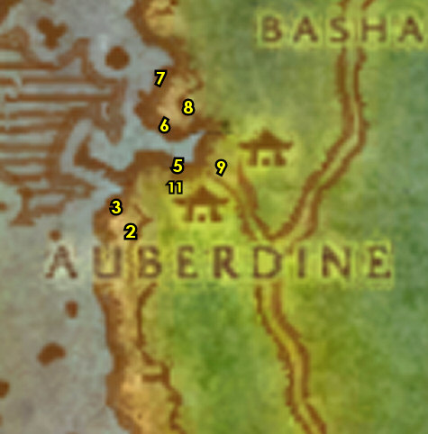

01) Go NE and do part of "The Blackwood Corrupted": loot the Blackwood Grain Stores 51.35.
02) Go up to the small cave (path entrance at 53.37). Once up there do "Tharnariun's Hope": kill Den Mother.
03) Go NE a bit to the other furbolg camp and finish "The Blackwood Corrupted": loot the Blackwood Nut Stores 52.33. See next steps for what else to do:
04) On the other side of this camp, loot the Blackwood Fruit Stores 53.33.
05) Use the Filled Cleansing Bowl quest item at the Bonfire in the middle of the camp 52.33. Kill Xabraxxis (lvl 19) that spawns, then loot Xabraxxis' Demon Bag that spawns on the ground. NOTES: You can use the Filled Cleansing Bowl 20 yards away from the Bonfire and when you do it will make you friendly with all the furblogs at the camp for a minute giving you an easier chance to kill the lvl 19 satyr.
06) Go south, then up and through the waterfall in front of the cave (path entrance at 55.32) and do "Cave Mushrooms": loot the mushrooms on the ground in the cave. NOTE: This can be hard to solo for some classes (rogues, warriors, etc), in that case try to get help or the guide will remind you once more to come back here once you are stronger later on (but it will be a tad off route).
07) Go NE and just off the main path next to a rock, turn in "The Tower of Althalaxx" 55.25, accept the next part.
08) Go SE a bit (around the tower, 55.27) and do "The Tower of Althalaxx": kill/loot Dark Strand Fanatics (female humans). Warning: Do NOT go inside the tower, as there is higher level mobs in there!
09) Back just off the main path next to a rock, turn in "The Tower of Althalaxx" (55.25, #7 on map), accept the next part.
10) Go north to the shore and click on the Beached Sea Turtle's head 53.18 to accept "Beached Sea Turtle".
11) Work your way west along the shore and do "Fruit of the Sea": kill/loot Encrusted Tide Crawlers (higher lvl crabs) and Reef Crawlers (lower lvl crabs more west).
#09
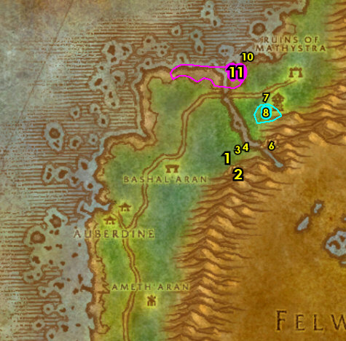

01) Hearth to Auberdine. If hearthstone is still on a cooldown, then die on purpose, res at spirit, then go to Auberdine. If you died on purpose, then turn in the following 5 quests in reverse:
02) Go below the Hippogryph dock, next to the shore and turn in "Fruit of the Sea" 36.45.
03) Go to the Hippogryph dock (south of the Inn) and turn in "Beached Sea Turtle" 37.46.
04) Just outside of the Inn, next to the mailbox, turn in "Cave Mushrooms" 37.44, accept "Onu".
05) Take the north bridge and in the merchant building, turn in "The Blackwood Corrupted" 37.40. Make sure you are repaired/resupplied.
06) Take the SE bridge to the other building and at the entrance, turn in "Tharnariun's Hope" 39.43.
10) Out on the long docks, take the boat to Stormwind City 32.44.
11) The goal now is to get to Loch Modan to continue questing. If you are a Dwarf, Gnome or Human then go to the Gryphon Master 71.73 and fly to Thelsamar, Loch Modan, then skip to the Loch Modan section below! Night Elves will have a much longer journey, so if you are a Night Elf, follow the steps below:
12) NIGHT ELF ONLY: Go NE in the Dwarven District to enter the Deeprun Tram 69.31. Then wait for the tram ride to show up and it will take you to Ironforge's side of the Deeprun Tram.
13) NIGHT ELF ONLY: Once at the other side of the Deeprun Tram, accept "Deeprun Rat Roundup" (this is accepted between the two Tram tracks).
14) NIGHT ELF ONLY: Just around the immediate area do "Deeprun Rat Roundup": use the Rat Catcher's Flute quest item on the Deeprun Rats.
15) NIGHT ELF ONLY: Go back between the two tracks at the Deeprun Tram, and turn in "Deeprun Rat Roundup". NOTE: "Me Brother, Nipsy" will be skipped for now.
16) NIGHT ELF ONLY: Exit the Deeprun Tram by heading north through the tunnel..
17) NIGHT ELF ONLY: At Ironforge get the Flight Path from the Gryphon Master 55.48.
18) NIGHT ELF ONLY: Exit Ironforge south 16.85.
19) NIGHT ELF ONLY: Run all the way east through Dun Morogh to the South Gate Pass 82.53 and go through it. Then go through the other tunnel of the South Gate Pass 17.59.
#10
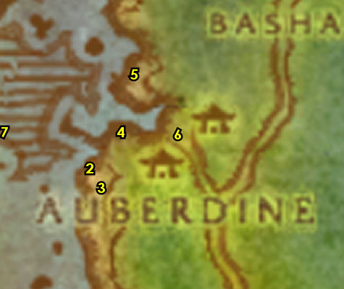

17-18 Loch Modan (log)
02) NIGHT ELF ONLY: Go NE to Thelsamar, find Mountaineer Kadrell (he patrols back and forth in the town around 35.47) and from him accept "Mountaineer Stormpike's Task".
03) NIGHT ELF ONLY: South in the town, go to the Gryphon Master 34.51 and get the FP.
04) At Thelsamar, go down in the eastern most hut and accept "Ironband's Excavation" (37.47 in Loch Modan).
05) Go east to Ironband's Excavation Site and turn in "Ironband's Excavation" 65.67, accept "Gathering Idols".
06) Across the camp, accept "Excavation Progress Report" 66.66.
07) Just to the east of you around the Excavation Site around 67.63, do "Gathering Idols": kill/loot the troggs.
08) Go back to the small camp at the Excavation Site and turn in "Gathering Idols" (65.67, #5 on map).
09) Go east to enter The Farstrider Lodge (entrance on the east side of the lodge), make a right, then accept "Crocolisk Hunting" 82.62.
10) At the other side of the lodge, accept "A Hunter's Boast" 83.65. NOTE: This quest is on a 15 min timer, so work somewhat quickly before it expires.
#11
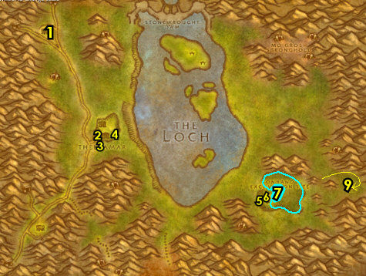

01) Just west of The Farstrider Lodge around 77.73, do "A Hunter's Boast": kill 6 Mountain Buzzards.
02) Go back to The Farstrider Lodge, make a left and turn in "A Hunter's Boast" 83.65, accept "A Hunter's Challenge". NOTE: This quest is on a timer, so work somewhat quickly before it expires.
03) Go NW (starting at starting at 76.46) and do "A Hunter's Challenge": kill 5 Elder Mountain Boars.
04) Go back to The Farstrider Lodge, make a left and turn in "A Hunter's Challenge" (83.65, #2 on map).
05) In the middle of the lodge, accept "Vyrin's Revenge" 82.64.
06) Go NW next to the lake and accept "Bingles' Missing Supplies" 64.48.
07) Along the eastern shore of The Loch lake and on the two smaller islands in the lake do "Crocolisk Hunting": kill/loot Loch Crocolisks.
08) Go up north to the bigger island, starting at the bottom eastern part and do "Bingles' Missing Supplies": loot the 4 quest objects on the ground. First one, loot Bingles's Blastencapper next to the hut 54.27. See next steps for the other 3 to loot:
09) Go west and loot Bingles's Toolbucket (wrench) next to the shore 49.30.
10) Go NE a bit and loot Bingles's Toolbucket (hammer) next to the light colored wagon 52.24.
11) Go NW a bit and loot Bingles's Toolbucket (screwdriver) at the trogg camp 48.20.
#12
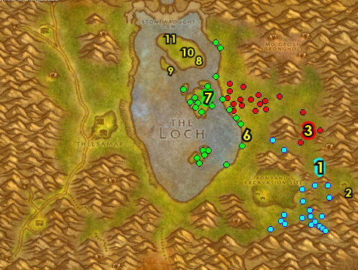

01) Go NW to the entrance of Stonewrought Dam, go inside and you can get repaired/resupplied 41.13. Be careful not to sell your Crocolisk Meat to a vendor!
02) Go SE in the Dam and then under the tent, accept "A Dark Threat Looms" 46.14.
03) Go east to exit the Dam, then on the outside entrance of the Dam, you will see two Dark Iron Sappers. They are guarding a Suspicious Barrel 56.13, click it to turn in "A Dark Threat Looms", accept the next part.
04) Go west back onto the Dam and under the tent, turn in "A Dark Threat Looms" (46.14, #2 on map), SKIP the next part.
05) Go west to Silver Stream Mine entrance 35.19 and do (if you haven't yet) "Filthy Paws": loot the Miner's League Crates inside the mine. NIGHT ELVES: You will not have this, so skip this step!
06) Turn in (if you need to) "Filthy Paws" up in the tower (west at 25.18). And for Night Elves: You won't have "Filthy Paws" quest, but do turn in "Mountaineer Stormpike's Task", accept "Stormpike's Order".
07) NOTE: You can get repaired/resupplied down below in the tower from Gothor Brumn 24.18.
08) Follow the main path south to Thelsamar and go down in the eastern most hut and turn in "Excavation Progress Report" 37.47, accept "Report to Ironforge".
09) Go SE around 43.65 and try to do "Vyrin's Revenge": kill/loot Ol' Sooty /target (lvl 20 at 3 different spawns, see map).
10) Go NE next to the lake and turn in "Bingles' Missing Supplies" 64.48.
11) Go east to The Farstrider Lodge, make a right in the lodge, then turn in "Crocolisk Hunting" 82.62.
12) At the other side of the lodge, turn in "Vyrin's Revenge" 83.65, accept the next part.
13) Turn in "Vyrin's Revenge" in the middle of the lodge 82.64.
15) First make sure you are level 20 (grind on any mobs until you are), then Go back to Thelsamar.
#13
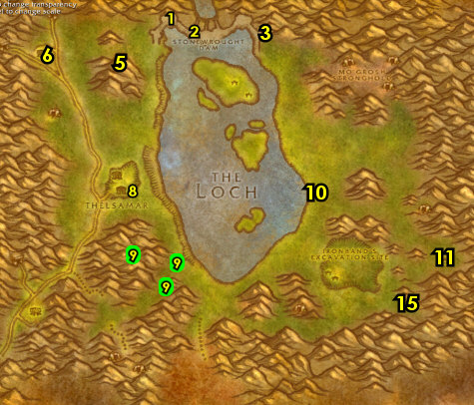

01) Go to the Gryphon Master 34.51 south in Thelsamar and take a flight to Ironforge, Dun Morogh.
02) You can upgrade First Aid up in the building from Nissa Firestone 55.58.
04) Go NE in Ironforge and turn in "Report to Ironforge" 75.12, SKIP "Powder to Ironband".
05) Find your class trainer and get new spells/abilities (if you need to). Also, If you can afford it, you can visit the Weapon Masters at Timberline Arms 62.89 to learn new weapon possibilities.
06) Go east to Tinker Town and accept "Speak with Shoni" 69.51.
07) Go east to enter The Deeprun Tram 75.51. Take the Tram ride and once you get to the other side exit north through the tunnel.
08) Once at Stormwind, just SW, turn in "Speak with Shoni" 63.34, SKIP "Underground Assault" (Dungeon).
09) Go just SE a bit and turn in "Stormpike's Order" 65.37.
10) You can stop at the Weapon Master (at The Trade District, 64.69) and learn new weapon possibilities if you can afford to.
11) N/A
11a) Go NW to The Park and accept "The Corruption Abroad" 21.5636.68.
Level 20 Mounts, 11b) At level 20 mounts become available. If you happen to be level 20 and if you have the gold then get your mount ASAP. It differs depending on your class & race and it costs roughly 5 gold. Check out my Mount Guide on where to find your mount trainer & vendor.
12) N/A
13) NIGHT ELF, GNOME & DWARF ONLY: SE in The Trade District, get the Flight Path from the Gryphon Master (71.73, #12 on map).
#14
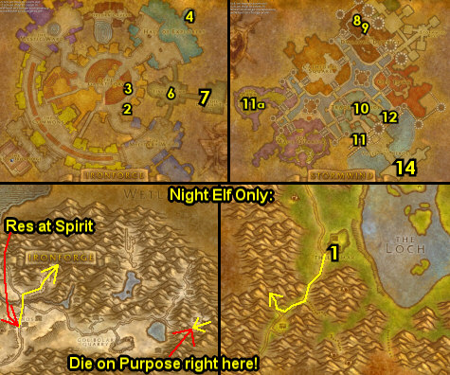

20-21 Darkshore (log)
01) Hearth to Auberdine.
02) Just outside of the Inn, from the WANTED: Murkdeep! sign, accept "WANTED: Murkdeep!" 37.44.
03) East in Auberdine, under the gazebo, turn in "The Corruption Abroad" 38.43 , SKIP "Researching the Corruption" (Dungeon).
Cave Mushrooms, 03b) IF YOU STILL NEED TO DO "Cave Mushrooms": Go NE, then up and through the waterfall in front of the cave (path entrance at 55.32 ) and loot the mushrooms on the ground in the cave.
Cave Mushrooms, 03c) IF YOU STILL NEED TO DO "Cave Mushrooms": Hearth (or go back) to Auberdine, and just outside of the Inn, next to the mailbox, turn in "Cave Mushrooms" 37.44, accept "Onu".
04) Follow the main path south to the Grove of the Ancients and from Onu big tree NPC, 44.76, turn in "Onu", accept "The Master's Glaive".
05) As you work on the following steps also start working on "A Lost Master" by kill/looting Moonstalker Sires and Moonstalker Matriarch (cats) south in Darkshore:
06) Go SW to The Master's Glaive (the big glowing sword 39.86) and get it discovered for "The Master's Glaive". Then use the Phial of Scrying quest item to spawn a Scrying Bowl next to you, then turn in "The Master's Glaive", accept "The Twilight Camp".
07) At The Master's Glaive there are two books around the altar (table), click on the Twilight Tome 39.86 on the north side of the altar to turn in "The Twilight Camp", accept "Return to Onu".
08) Go south a bit behind the big glowing sword and accept and do the escort "Therylune's Escape" 39.87. This escort only takes a couple minutes and leads to the main path east. NOTE: While kill/looting the Twilight mobs in this area you have a chance to get an item, that starts "The Powers Below", accept it if you were able to find it.
09) Go west to Remtravel's Excavation and turn in "The Absent Minded Prospector" 36.84. Accept and do the next part (escort). Simply escort him around the Excavation site. Try to keep aggro off of Prospector Remtravel /target, as he has low HP and can die easily.
#02
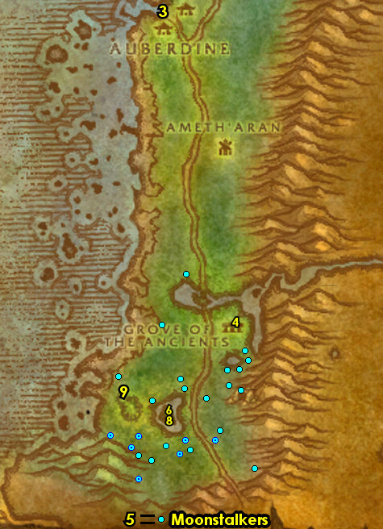

01) Go west to the shore at the small Greymist murloc camp 37.77 and do "WANTED: Murkdeep!": clear all the murlocs at the small camp, then kill the two Greymist Warriors that spawn, then kill Murkdeep that spawns after that. NOTE: These mobs spawn at the sea and run onto the coast.
03) Go south along the shore a bit more and click on the Beached Sea Turtle's arm 32.84 to accept "Beached Sea Turtle"
04) Go south along the shore a bit more and click on the Beached Sea Turtle's head 31.86 to accept "Beached Sea Turtle"
05) South a bit more, click on the Beached Sea Creature where the neck meets the body 31.87 to accept "Beached Sea Creature".
06) Go NE to the Grove of the Ancients and from Onu (big tree NPC, 44.76), turn in "Return to Onu". Wait a few seconds, then accept "Mathystra Relics".
07) Next to you, get resupplied 44.76. NOTE: At this point you no longer need the Phial of Scrying quest item. This can be destroyed to save bag space.
08) At the Grove of the Ancients, accept and do the escort "The Sleeper Has Awakened" 44.76. First thing to do is loot Kerlonian's Chest next to you to get the Horn of Awakening. Kerlonian Evershade /target falls asleep periodically and you will need to use this horn to wake him up, so keep an eye out for him. Lead him to the next step:
09) Go south a along the main path and right before entering Ashenvale make a left on the path into some mountains and from Sentinel Aynasha 46.90 /target, accept and do the escort "One Shot. One Kill." (no exclamation mark): simply wait right there and kill several waves of furblogs.
10) Keep escorting Kerlonian Evershade south into Ashenvale... 27.37
#03
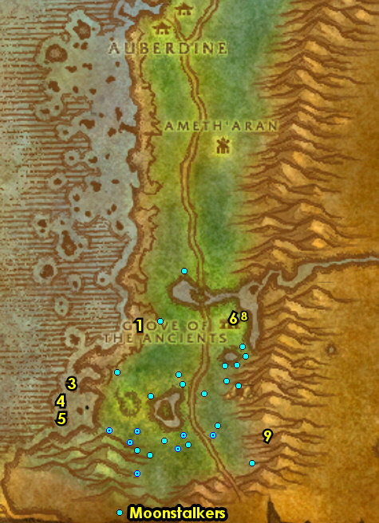

21-22 Ashenvale
01) Lead Kerlonian Evershade /target south into Ashenvale to Maestra's Post. Keep aggro off of Kerlonian Evershade as he can die easily. As you work your way south, there will be several tough spawns along the main path that can be avoided by staying away from the main path by at least 30 yards. I recommend traveling just east of the main path starting at 27.25, then work your way south through the wilderness to avoid the tough spawns. Right at the entrance to the hut, turn in "One Shot. One Kill." 27.37. Then go in the hut and turn in (if you succeeded with it) "The Sleeper Has Awakened" 27.36. If you failed the escort you will have another chance later in the guide to try again.
02) Just south at Maestra's Post, turn in "The Tower of Althalaxx" 26.39, accept the next part.
03) Next to you, accept "Bathran's Hair" 26.39.
04) N/A
05) Go north to The Ruins of Ordil' Aran around 30.32 and do "The Tower of Althalaxx": keep killing the mobs there until the Glowing Soul Gem drops (very low drop rate). If you have not found the item and the area is clear, then you can do the next step and come back to do this afterwards:
06) Go north to Bathran's Haunt around 31.26 and do "Bathran's Hair": loot the Plant Bundles around the area. They are kind of hard to see.
07) Go south in Maestra's Post and turn in "Bathran's Hair" (26.39, #2 on map), accept "Orendil's Cure".
08) Next to you, turn in "The Tower of Althalaxx" 26.39, accept the next part.
09) Go south to The Shrine of Aessina and turn in "Therylune's Escape" 23.52.
#04
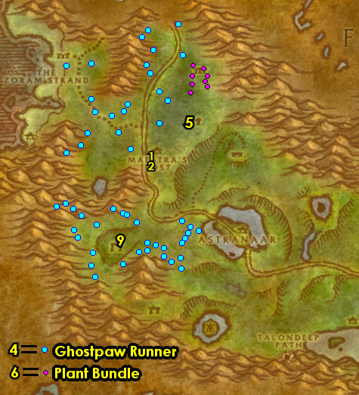

01) Follow the main path east into Astranaar, make a left after the blue bridge and get the Flight Path from the Hippogryph Master 34.48.
02) Along the main path as you enter the town, accept "The Zoram Strand" 35.49.
03) Go to the first house on your right and accept "On Guard in Stonetalon" 35.50. NOTE: Skip "A Helping Hand" (for now).
04) Go in the house to get repaired/resupplied 35.50. NOTE: You can sell all the Shredder Operating Manuals you find in Ashenvale as my guide will not tell you to do that quest.
05) Across the path, next to the glowing gazebo, accept "Journey to Stonetalon Peak" 36.49.
06) Go in the Inn just SE of you and accept "Raene's Cleansing" and "Culling the Threat" 37.50. Also turn in (if you have it) "Onward to Ashenvale".
07) Go up the ramp, then talk to the Innkeeper 37.49 to make Astranaar your new home.
08) At the SE most hut at Astranaar, turn in "Orendil's Cure" 37.52. Wait a few seconds then accept "Elune's Tear".
09) Follow the main path west, then north, then go west towards The Zoram Strand and at the small camp, accept "The Ancient Statuette" 15.31.
#05
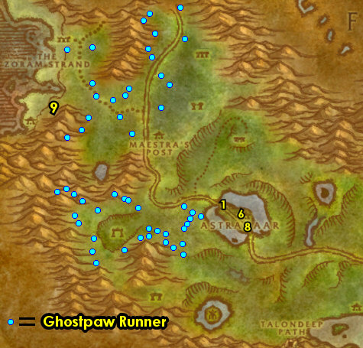

01) Along The Zoram Strand start working on "The Zoram Strand": kill/loot the Wrathtail naga while working your way to do the next steps:
02) Go up north along the shore and do "The Ancient Statuette": loot the Ancient Statuette (white statue laying on the ground, 14.21).
03) Go back south to the small camp and turn in "The Ancient Statuette" 15.31, wait a few seconds then accept "Ruuzel".
04) Go to the small island NW in The Zoram Strand and do "Ruuzel": kill/loot Ruuzel /target. She patrols clockwise around the small island with two bodyguards around 7.13.
05) Make sure "The Zoram Strand" is finished: kill/loot the Wrathtail naga around The Zoram Strand (#1 on map). Finish this as you work your way to the next step:
06) Go SE to the small camp and turn in "Ruuzel" (15.31, #3 on map).
07) Go SE to the little island in the middle of Lake Falathim and turn in "Raene's Cleansing" 20.42, accept the next part.
08) In the immediate area around Lake Falathim, do "Raene's Cleansing": kill/loot the Saltspittle murlocs until the Glowing Gem drops.
#06
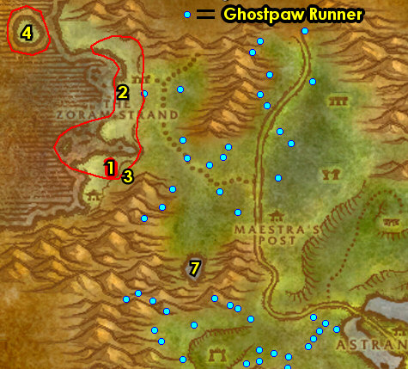

01) Hearth to Astranaar.
02) In the Inn, down the ramp, turn in "Raene's Cleansing" 37.50. Accept "Raene's Cleansing" and "An Aggressive Defense". Make sure you are resupplied. NOTE: The quest item Teronis' Journal can be destroyed as it is no longer used.
03) NW in Astranaar, turn in "The Zoram Strand" 35.49, accept "Pridewings of Stonetalon".
04) Go NE to Iris Lake (path entrance at 43.46)..
05) At the middle of Iris Lake, do "Elune's Tear": loot an Elune's Tear (white ball) on the ground 46.46.
06) Go east at Iris Lake and go up the mountains 47.49 to take a shortcut to go east..
07) Go NE to the Moonwell and turn in "Raene's Cleansing" 54.46, accept the next part.
09) Hearth (or run back if its still on a cooldown) to Astranaar.
11) At the SE most hut at Astranaar, turn in "Elune's Tear" 37.52. Wait a few seconds, then accept "The Ruins of Stardust".
12) Go down south to The Ruins of Stardust (the island in the middle of the lake around 34.67) and do "The Ruins of Stardust": loot Stardust Covered Bushes.
13) Go east to The Talondeep Path (cave entrance at 82.30) and go through it to get to Stonetalon Mountains..
#07
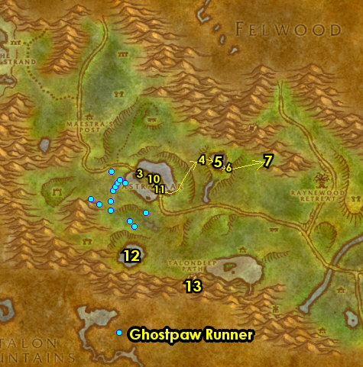

22-23 Stonetalon Mountains (log)
01) Grind SW to the goblin in the hut and accept "Super Reaper 6000" 59.63. NOTE: Start working on "Pridewings of Stonetalon" by kill/looting any Pridewing mobs (wyverns, #7 on map) you see along the way.
02) Go south a bit and up on the hill, turn in "On Guard in Stonetalon" 60.67, accept the next part.
03) Next to you, turn in "On Guard in Stonetalon" 60.67, accept "A Gnome's Respite".
04) All around Windshear Crag do "Super Reaper 6000" along with "A Gnome's Respite": kill/loot the Venture Co. Operators until the Blueprints drop (its a low drop rate). Also kill 10 Loggers /target and Deforesters /target (scattered all around Windshear Crag). NOTE: There are a lot of operators on the big tank shredder 63.54, and more around other structures in the area. Keep the next step in mind:
05) There is a goblin merchant 58.52 to the west in Windshear Crag that you can get repaired/resupplied at.
06) Go back SW to the goblin in the hut and turn in "Super Reaper 6000" (59.63, #1 on map), SKIP "Further Instructions".
07) Go south a bit and up on the hill, turn in "A Gnome's Respite" (60.67, #2 on map). Accept "An Old Colleague" and "A Scroll from Mauren".
08) Follow the main path north to Mirkfallon Lake starting around 50.43 and do "Pridewings of Stonetalon": kill/loot Pridewing wyverns around the lake. There is a large concentration of these mobs (NE around 53.38).
09) Go north to Stonetalon Peak and in front of the Moonwell turn in "Journey to Stonetalon Peak" 37.8, SKIP "Reclaiming the Charred Vale".
10) Next to the Moonwell, go to the Hippogryph Master 36.7 and fly to Auberdine, Darkshore..
#08
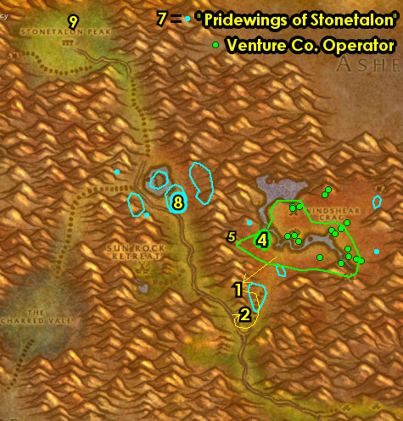

23-24 Darkshore (log)
01) Next to you when you land on the hippogryph dock at Auberdine, turn in ALL Beached Sea quests you may have 37.46.
02) Go in the Inn and from Innkeeper Shaussiy 37.44, talk to her to make Auberdine your new home. Make sure you are repaired/resupplied.
03) Just outside of the Inn, next to the Moonwell, turn in "WANTED: Murkdeep!" 38.43.
04) Go north across the bridge in Auberdine and just outside of the merchant building, turn in "The Absent Minded Prospector" 37.42, accept the next part.
05) Take a shortcut straight through the merchant building then go NE to Ruins of Mathystra around 58.23 and do "Mathystra Relics": loot the Mathystra Relics on the ground.
06) Go north to the shore and accept "Gyromast's Retrieval" (on the small hill 57.13).
07) Around the immediate area do part of "Gyromast's Retrieval": kill/loot the Raging Reef Crawlers until the Bottom of Gelkak's Key drops. This key can also drop from the Encrusted Tide Crawlers just SW.
08) Go north a bit into the water around the sunken ship around 55.12 and do part of "Gyromast's Retrieval": kill/loot the murlocs until the Middle of Gelkak's Key drops.
09) Go north in the open fields of Darkshore around 61.12 and finish "Gyromast's Retrieval": kill/loot Giant Foreststriders for the Top of Gelkak's Key. Also in this same area, finish "A Lost Master": kill/loot Moonstalkers (cats), there is only 7 spawns up north in Darkshore.
10) Go back to the shore and turn in "Gyromast's Retrieval" (on the small hill 57.13, #6 on map), accept "Gyromast's Revenge".
11) Go south a bit along the shore and do "Gyromast's Revenge": talk to The Threshwackonator 4100 56.18 to Insert key into it, then lead him to the next step:
12) Go back north to the small hill (57.13, #6 on map) and then kill The Threshwackonator 4100. Then turn in "Gyromast's Revenge". NOTE: Do NOT sell the reward received: Elixir of Water Breathing (you will be using this later).
#09
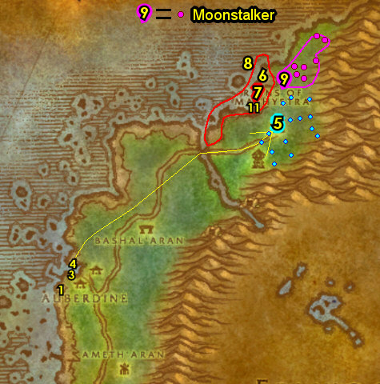

01) Hearth to Auberdine. Make sure you are repaired/resupplied. NOTE: The quest item Gyromast's Key is no longer used for anything and can be destroyed to free bag space.
02) Go east in Auberdine and in the building, turn in "A Lost Master" 39.43. Accept the next part.
03) Follow the main path south to Grove of the Ancients and from Onu (big tree NPC 44.76), turn in "Mathystra Relics". If you still need to do the escort "The Sleeper Has Awakened" 44.76, then you can accept and try it again, remember to first loot Kerlonian's Chest next to him to get the Horn of Awakening. Kerlonian Evershade /target falls asleep periodically and you will need to use this horn to wake him up. You will need to do the next few steps while on this as well.
04) Go south to the small cave at Blackwood Den and turn in "A Lost Master" 45.85.
05) Accept and do the escort "Escape Through Force". This leads west to the main path at Grimclaw 42.82.
06) If you are on "The Sleeper Has Awakened", then lead Kerlonian Evershade /target south into Ashenvale. Keep aggro off of Kerlonian Evershade as he can die easily. As you work your way south, there will be several tough spawns along the main path that can be avoided by staying away from the main path by at least 20 yards. I recommend traveling just off the main path starting at 27.25, then work your way south through the wilderness to avoid the tough spawns. Then go in the hut at Maestra's Post and turn in "The Sleeper Has Awakened" 27.36, if you fail again, then skip it.
#10
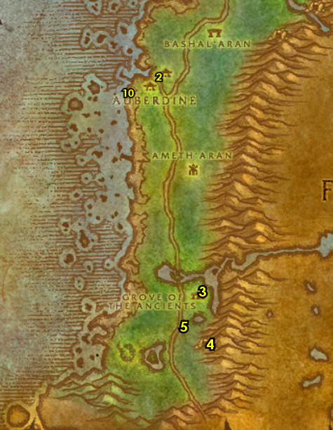

01) Hearth (or run back if its still on a cooldown) to Auberdine. If you can't hearth and are close to Astranaar, then go to the Hippogryph Master (34.48 in Ashenvale) and fly to Auberdine, Darkshore.
02) Make sure you are repaired/resupplied.
03) Go east in Auberdine and in the building, turn in "Escape Through Force" (39.43, #2 on map). Wait a few seconds, then next to you accept "Trek to Ashenvale".
04) Go to the Hippogryph Master (south of the Inn 36.46) and fly to Rut'theran Village, Teldrassil. NOTE: If you do not have the flight path for Rut'theran Village, then you will have to get on the boat on the docks 33.40.
05) Go up the path to enter Darnassus through the red portal 56.89.
06) In Darnassus, go south and just outside of The Temple of the Moon, turn in "The Absent Minded Prospector" 31.85, accept the next part.
Get New Abilities, 6b) NOTE: You can learn new weapon possibilities from the Weapon Master 58.47.
07) Upgrade First Aid if you need to from the First Aid Trainer 52.12.
08) Go to Darnassus's Bank 40.42 and put the following items into it: 5 Elixir of Water Breathing (and if you have it) Book: The Powers Below.
09) Go back through the red portal in Darnassus 29.41.
10) Go to the Hippogryph Master 58.94 on the dock and fly to Astranaar, Ashenvale.
#11
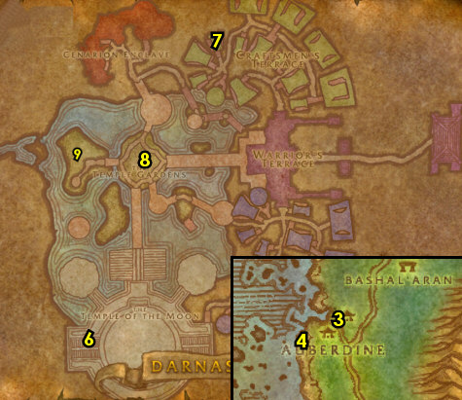

24-24 Ashenvale (log)
01) In Astranaar, on the main path, next to the direction sign, turn in "Pridewings of Stonetalon" 35.49, SKIP "Kayneth Stillwind" (for now).
02) Go in the Inn and turn in "Trek to Ashenvale" 37.50. Make sure you are repaired/resupplied.
03) At the SE most hut at Astranaar, turn in "The Ruins of Stardust" 37.52. Wait a few seconds, then accept "Fallen Sky Lake".
04) Go SW to Fire Scar Shrine and go to the path at 26.63..
05) Go up the path and do "The Tower of Althalaxx": kill/loot Ilkrud Magthrull /target 25.61.
06) Grind your way north through Thistlefur Village and then do "Culling the Threat": kill/loot Dal Bloodclaw /target (grey furblog patrols around 38.35).
07) Keep grinding on furblogs in Thistlefur Village until you are at least a 1/4 way into level 24.
08) Go west to Maestra's Post and turn in "The Tower of Althalaxx" 26.39, accept the next part.
09) Next to you, I recommend skipping the escort "Supplies to Auberdine" (overall) unless you have help. This difficult escort leads north to the border of Darkshore and Ashenvale and does not yield any crazy XP/time, but it is worth it if it can be done on the first try. If you do go for it, keep all aggro off of Delgren the Purifier /target as he is very fragile and will die quickly. There are several waves of tough mobs and you have very little opportunity to eat/drink as he runs quick. If you did succeed with it, then turn it in at Maestra's Post (26.39 in Ashenvale, #8 on map) when done.
10) N/A
11) Go to Astranaar and in the Inn, turn in "Culling the Threat" (37.50, #2 on map). Make sure you are repaired/resupplied.
11b) Go SE to the furbolg camp 51.60 and do "An Aggressive Defense": kill the required amount of Foulweald furblogs.
12) Go to Silverwind Refuge and accept "Elemental Bracers" 50.67.
13) NOTE: You can purchase Healing Potions and Lesser Mana Potions (in limited supply) from the Alchemy Supplies 51.67 vendor at the Refuge.
14) Just south of you at Mystral Lake do "Elemental Bracers": kill/loot the Befouled Water Elementals for 5 Intact Elemental Bracers, then use the Divining Scroll quest item to complete the quest.
15) Go back to Silverwind Refuge and turn in "Elemental Bracers" (50.67, #12 on map), SKIP "Mage Summoner" accept "Mage Summoner".
Hardcore, 15a) Do "Mage Summoner": go all the way into The Barrens entrance 48.5 (follow main path), then up a long mountain slope starting at 49.15, then kill/loot Sarilus Foulborne 48.19.
Hardcore, 15b) Go back to Ashenvale Entrance 48.5 and turn in "Mage Summoner" 50.67. IMPORTANT: The quest reward Light of Elune is very special for Hardcore because it can keep you alive easily with one use! Please read the comments on WowHead for a very useful macro this item can be used with. This can save your life under most circumstances (but with only a single use).
15c) Go back NW to Astranaar and in the Inn, turn in "An Aggressive Defense" 37.50 (#1 on map). Make sure you are repaired/resupplied.
16) Hearth to Auberdine.
17) Go out on the long docks at Auberdine and get on the boat to Stormwind City 32.44.
WOTLK, 17a) Go to the Gryphon Master 71.73and fly to Ironforge. DRAENEI ONLY: Draenei who did Bloodmyst Isle will only be able to get the Flight Path right now. You will then need to take The Deeprun Tram ride 69.31 in order to get to Ironforge. Then once you arrive at Ironforge, make a left and turn in "An Old Colleague" 72.52. Then get the Flight Path at Ironforge from the Gryphon Master56.48.
WOTLK, 17b) It is now time to travel to Menethil Harbor, Wetlands. We will take the big shortcut west in Dun Morogh. First leave Ironforge SW (exit at 15.86). NOTE: The normal route to get there would be to take the flight path to Thelsamar then go north through Dun Algaz to get to Menethil, but we wont be doing this!
WOTLK, 17c) Go west in Dun Morogh and above Brewnall Village take the hidden ramp up the mountains (starting at 31.33). This is kind of hard to find, See Video.
WOTLK, 17d) Continue north up the mountains, you will need to run for about 45 seconds then jump off the big mountain to your left about here 44.59to die on purpose. This should take you to the graveyard at Baradin Bay, res at spirit.
WOTLK, 17e) Go SW to enter Menethil Harbor and from the Gryphon Master (9.60 in Wetlands), get the Flight Path.
#12
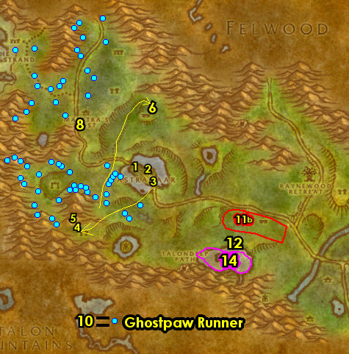

24-27 Wetlands (log)
01) On the docks at Menethil Harbor, accept "Claws from the Deep" 8.59.
02) Go north near the stables and accept "Young Crocolisk Skins" 8.56.
03) On the southern part of the town, next to the mailbox/Inn, accept "The Third Fleet" and "The Greenwarden" 11.60.
04) Go in the Inn next to you and talk to the Innkeeper (by the bar 11.61) to make Deepwater Tavern (Menethil Harbor) your new home. Also from the Innkeeper, purchase a Flagon of Dwarven Honeymead for "The Third Fleet". If you are lvl 25 remember to upgrade to the lvl 25 food/water!
05) Go upstairs in the Inn (at the middle room) and turn in "The Absent Minded Prospector" 11.60, accept the next part.
06) Please note that there is a First Aid Trainer 11.61 upstairs in the Inn that you can use to upgrade First Aid.
07) Just outside of the Inn, turn in "The Third Fleet" (11.60, #3 on map), accept "The Cursed Crew".
08) On the east side of town in front of the small house, accept "Digging Through the Ooze" 12.58.
09) Enter the Fortress, make two lefts and at Neal Allen 11.57, see if you can purchase a Bronze Tube and a Gyrochronatom from him (if you haven't yet elsewhere), these are used for later quests. If you did, you can store them in the mailbox by sending them to your ALT and return them back to you.
10) Go near the top of the fortress and accept "War Banners" 10.57.
11) As you exit Menethil Harbor NE on the bridge, accept "In Search of The Excavation Team" 12.52.
#13
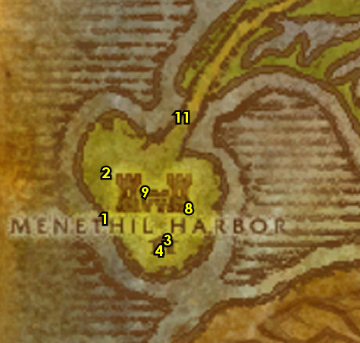

01) Just north of the main path do "Claws from the Deep": kill 12 Bluegill Murlocs /target and kill/loot Gobbler /target (he patrols around 18.40).
02) SE below the main path, enter Whelgar's Excavation Site entrance 34.42..
03) Next go to the path that leads up the mountain side ramp entrance 37.44..
04) Go up the path and right before the small cave, accept "Ormer's Revenge" 38.51.
05) Go in the small cave and turn in "In Search of The Excavation Team" 39.52, accept the next part.
06) Next to you on the ground, loot Flagongut's Fossil 39.52 for part of "The Absent Minded Prospector".
07) Exit Whelgar's Excavation Site (exit at 34.41, #2 on map)..
08) South of the main path at Black Channel Marsh around 23.50 do "Ormer's Revenge": kill 10 Mottled Raptors /target and 10 Mottled Screechers /target.
09) Make sure you are at least 1,900 XP away from level 25 before continuing, grind on any mobs in the immediate area until you are, and work your way to the next step while accomplishing this:
#14
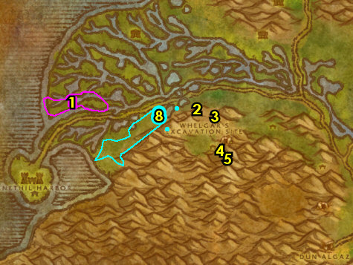

01) SE below the main path, enter Whelgar's Excavation Site entrance 35.42..
02) Go to the path that leads up the mountain side ramp entrance 37.44..
03) Go up the path and before the small cave, turn in "Ormer's Revenge" 38.51, accept the next part.
04) Go in the small cave and accept "Uncovering the Past" 39.52. Requires lvl 25.
05) Around Whelgar's Excavation Site, do "Ormer's Revenge": kill Mottled Scytheclaws and Mottled Razormaws. While doing this also do "Uncovering the Past": loot the four fragments. The fragments have random spawns around the Excavation Site. Here is a few of them: 37.42, 35.44, 34.44, 35.47 34.49.
-Loose Soil contains the Neru Fragment.
-Ancient Relic (large vase) contains the Golm Fragment. This could be up on the mountain 33.51.
-Ancient Relic (slim vase) contains the Modr Fragment.
-Ancient Relic (tomb) contains the Ados Fragment.
06) Once done with "Ormer's Revenge", go to the path that leads up the mountain side (ramp entrance 37.44, #2 on map)..
07) Go up the path and before the small cave, turn in "Ormer's Revenge" (38.51, #3 on map), accept the next part.
08) Go in the small cave and turn in "Uncovering the Past" (39.52, #4 on map).
09) At the Excavation Site do "Ormer's Revenge": kill/loot Sarltooth /target (lvl 29 blue raptor). This raptor stays up on the west ledge entrance 32.50 for awhile then goes down and patrols around the Excavation Site. He's not too hard but be prepared.
10) Go to the path that leads up the mountain side (ramp entrance 37.44, #2 on map)..
11) Go up the path and before the small cave, turn in "Ormer's Revenge" (38.51, #3 on map).
#15
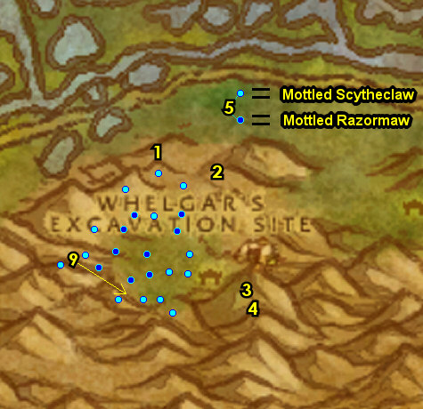

01) Go north to exit the Whelgar's Excavation Site exit 34.41..
02) Make sure "The Absent Minded Prospector" is finished by kill/looting the raptors around 24.47 for the Stone of Relu.
03) Go east to Angerfang Encampment around 43.43 and do "War Banners": kill/loot the orcs in the area.
04) Go north to the main path's intersection and accept "Daily Delivery" 50.39.
05) You can get resupplied at the goblin 50.38 next to the bridge. NOTE: This goblin might sell Healing Potions.
06) As you work on the rest of this section start working on "Young Crocolisk Skins" by kill/looting the Young Wetlands Crocolisk (found mostly along the rivers).
07) Go east to The Green Belt (past the main path a bit) and turn in "The Greenwarden" 56.40, SKIP "Tramping Paws".
08) N/A
10) N/A
11) At Ironbeard's Tomb around 44.26 do "Digging Through the Ooze": kill/loot the oozes (any type) until you get Sida's Bag (low drop rate).
13) Make sure "Young Crocolisk Skins" is finished by kill/looting the Young Wetlands Crocolisk (found mostly along the rivers, #6 on map).
14) Hearth to Deepwater Tavern (Menethil Harbor). Make sure you are repaired/resupplied. Remember to upgrade to lvl 25 food/water if you haven't yet.
#16
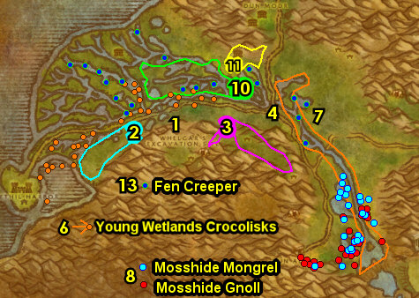

01) Go upstairs in the Inn (at the middle room) and turn in "The Absent Minded Prospector" 11.60. REMINDER: The First Aid Trainer 11.61 is in the other room upstairs if you need to upgrade First Aid.
02) Go west to the docks and turn in "Claws from the Deep" 8.59, accept "Reclaiming Goods".
03) Go north near the stables 9.56 and turn in "Daily Delivery" and "Young Crocolisk Skins", accept "Apprentice's Duties".
04) Go upstairs in the fortress and turn in "War Banners" 10.57, accept "Nek'Rosh's Gambit".
05) At the house east of the fortress, turn in "Digging Through the Ooze" 12.58.
06) As you exit Menethil Harbor NE on the bridge, turn in "In Search of The Excavation Team" 12.52.
07) Just north of the main path above Menethil Harbor, click on the Damaged Crate 14.41 to turn in "Reclaiming Goods", accept "The Search Continues".
08) Go north a bit to the next small murloc camp and click on the Sealed Barrel 14.38 on the ground to turn in "The Search Continues", accept "Search More Hovels".
09) Go north a bit more to the next small murloc camp and click on the Half-buried Barrel 14.35 to turn in "Search More Hovels", accept "Return the Statuette".
10) Go up north to the sunken ships and do "The Cursed Crew": go down in the southern boat and kill/loot First Mate Snellig /target (down at 14.30). Also kill 13 Cursed Sailors and 5 Cursed Marines. There are more of these mobs up north on the other sunken boat around 15.24.
#17
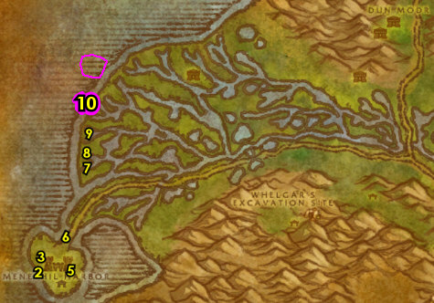

01) Just east of you around Sundown Marsh (starting at 18.27, then work east) do "Apprentice's Duties": kill/loot Giant Wetlands Crocolisks /target. There is only 13 spawns NW in Wetlands. If you run out of mobs do the next few steps then come back to this area to complete it.
02) You can stop at 26.26 to get repaired/resupplied. NOTE: At this small camp, you can have another chance to purchase a Gyrochronatom and a Bronze Tube from the NPC there (if you haven't yet elsewhere), these are used for later quests. If you did, you can store them in the mailbox by sending them to your ALT (next time you go to town) and return them back to you.
03) N/A
04) N/A
05) Go to the east of you and keep grinding on dragon whelps until your Hearthstone cooldown is at least 1.5 minutes left, then do next step:
06) Go north onto Thandol Span bridge and in the middle of the bridge where the two doors are at jump into the water on the west side of the bridge and under the water (44.93 in Arathi Highlands) click on the Waterlogged Letter (See Image) to loot an item which starts "Sully Balloo's Letter", accept it.
07) Hearth to Deepwater Tavern (Menethil Harbor).
08) Just outside of the Inn, turn in "The Cursed Crew" 11.60, accept "Lifting the Curse".
09) At the west side of the fortress, near the stables, turn in "Apprentice's Duties" 9.56.
10) On the docks, turn in "Return the Statuette" 8.59.
#18
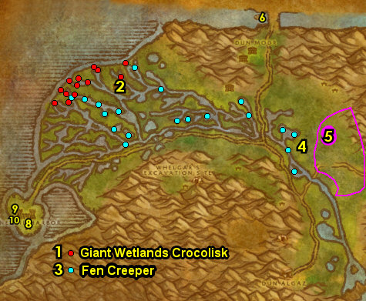

01) Go to the Gryphon Master 9.60 and fly to Ironforge, Dun Morogh.
02) At Ironforge, go to the bank 35.61 and put the following item into it: Dwarven Tinder. Get the following items out of the bank: (If you have them) 4 Minor Mana Potions and 2 Elixir of Minor Fortitude. Also get out (if you have it) a Bronze Tube (could be in your mailbox). You can also check the AH 25.73 for these items. Also, from the bank, get your Book: The Powers Below out as well (if you have it).
GET NEW ABILITIES, 2c) Get new spells/abilities in Ironforge.
03) If you have the Book: The Powers Below, go north and turn in "The Powers Below" 51.6.
04) Go east in Ironforge and turn in (Draenei may have already turned this in) "An Old Colleague" 72.52, and if you have 4 Minor Mana Potions and 2 Elixir of Minor Fortitude with you, accept and turn in "Ineptitude + Chemicals = Fun", SKIP the next part.
05) Go south to The Military Ward and turn in "Sully Balloo's Letter" 63.67. Wait a few seconds then accept "Sara Balloo's Plea".
06) Go NW to The High Seat and turn in "Sara Balloo's Plea" 39.56, accept "A King's Tribute".
07) Go south in Ironforge and turn in "A King's Tribute" 39.88, accept the next part.
08) Go to the Gryphon Master 56.48 and fly to Stormwind, Elwynn.
09) N/A
10) Go to The Mage Quarter and turn in "A Scroll from Mauren" 53.87, SKIP "Devils in Westfall".
11) Go west down in The Slaughtered Lamb 40.84 and accept "A Noble Brew" 40.85.
12) Follow the main path east through Elwynn Forest all the way to Redridge Mountains and get the Flight Path from the Gryphon Master 31.59.
#19
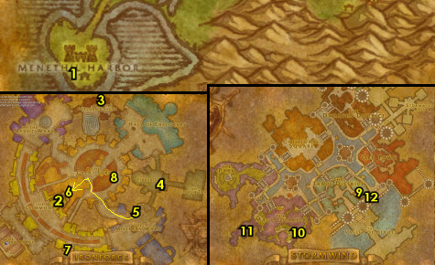

28-30 Duskwood (log)
01) In Duskwood, follow the path SW, then south to Manor Mistmantle and do part of "A Noble Brew": loot the Tear of Tilloa (78.36 in Duskwood) in the middle of the fenced area.
02) Go south to Darkshire and in the first house on your left 76.45, accept "The Legend of Stalvan" and "The Totem of Infliction".
03) Just across the path, next to the directional sign, go in the Inn and talk to the Innkeeper 74.44 to make Darkshire your new home.
05) As you exit the Inn, on your right, stop at the mailbox 74.46 and get out (if you have it) Bronze Tube. Then next to you accept "The Night Watch" 74.47.
06) Just inside the Town Hall next to you, turn in "The Legend of Stalvan" 73.47, accept the next part.
07) Just outside of the house next to the blacksmith shop, accept "Worgen in the Woods" 76.48 (patrols a bit).
08) Go inside the house next to you and accept "Raven Hill", "The Hermit" and "Deliveries to Sven" 75.49.
09) If you do not have a Bronze Tube or a Gyrochronatom yet: SE in Darkshire, you will see a gnome dressed in blue and red named Herble Baubbletump 78.48 /target standing outside, from him see if you can purchase a Bronze Tube (if one is not already in your inventory). From this NPC, you also have another chance to purchase a Gyrochronatom from him (if you haven't yet elsewhere), this is used for a later quest. If you did, you can store it by sending it to your ALT through the mailbox. NOTE: These items are on a random respawn timer from him, so they may not be available.
10) Go just north of the path in Darkshire and from the Gryphon Master 77.44, get the Flight Path.
11) Go SE a bit, and up in the small house, accept and then turn in "Look To The Stars" 80.48, accept the next part. NOTE: If you didn't have a Bronze Tube you will have to skip this entire quest chain!
12) Go south of Darkshire to the small house and turn in "Look To The Stars" 82.59, accept the next part.
#22
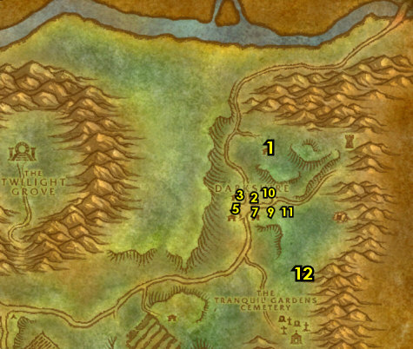

01) Go south to Tranquil Gardens Cemetery and do "The Night Watch": kill 8 Skeletal Warriors and 6 Skeletal Mages. Also do "Look To The Stars": kill/loot Insane Ghoul /target (usually in the church 80.71, or could be patrolling around the cemetery).
02) Go west to The Rotting Orchard around 66.66 and do "Worgen in the Woods": kill 6 Nightbane Shadow Weavers /target.
03) Go NE to Darkshire and in front of the Town Hall, turn in "The Night Watch" 74.47, accept the next part. Make sure you are repaired/resupplied.
04) South of the road, in front of the house turn in "Worgen in the Woods" 76.48, accept the next part.
05) In the small house east in Darkshire, turn in "Look To The Stars" 80.48, accept the next part.
06) Go west of Darkshire around 64.51 and do "Worgen in the Woods": kill 12 Nightbane Dark Runners /target.
07) Go back to Darkshire and in front of the house south of the road, turn in "Worgen in the Woods" (76.48 (patrols a bit), #4 on map), accept the next part. Make sure you are repaired/resupplied.
08) Go south to Roland's Doom mine entrance 73.76 and do "Worgen in the Woods": kill 8 Nightbane Vile Fangs (outside the mine) and 8 Nightbane Tainted Ones (inside the mine).
09) Go SW to Vul'Gol Ogre Mound cave entrance 34.78 and do "Look To The Stars": south in the cave, kill/loot Zzarc' Vul /target (lvl 30 ogre 37.84). He could spawn in another part in the cave.
10) Go NW to Raven Hill and turn in "Raven Hill" 18.56. Accept "Jitters' Growling Gut" (no exclamation mark).
#23
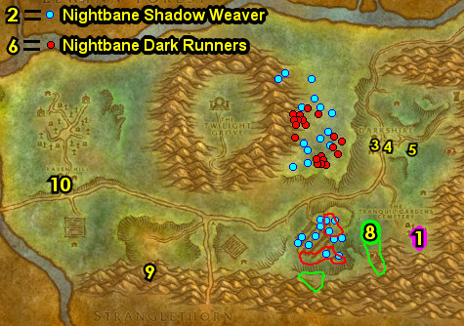

01) Go north to Raven Hill Cemetery around 21.47 and do "The Night Watch": kill 15 Skeletal Fiends /target and 15 Skeletal Horrors /target. These skeletons are found in the southern part of the cemetery. Before leaving the southern cemetery, make sure you have all 10 Skeleton Fingers for "The Totem of Infliction" from the skeleton mobs. Keep the next step in mind:
02) In the northern part of Raven Hill Cemetery around 24.37 finish "The Totem of Infliction": kill/loot the ghouls for the Ghoul Fangs and spiders for the Vial of Spider Venom. You can find a lot of spiders east of the cemetery. Also make sure you obtain 6 Gooey Spider Legs for a later quest, and do not sell them to a vendor! They can drop from any spider.
03) Go NE in Raven Hill Cemetery and in the small shack, turn in "The Hermit" 28.31. Accept "Supplies from Darkshire".
04) Go west and from A Weathered Grave 18.29, accept "The Weathered Grave".
05) Go west a bit more to the small camp by the river and turn in "Deliveries to Sven" 8.34. Accept "Sven's Revenge".
06) Hearth to Darkshire.
#24
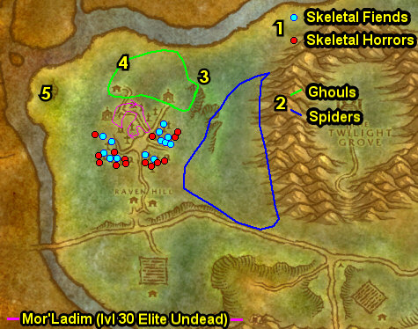

01) In the Inn's kitchen, turn in "Jitters' Growling Gut" patrols a bit 74.44. Also, accept and turn in "Dusky Crab Cakes". Accept "Return to Jitters" (no exclamation mark).
03) As you exit the Inn, in front of the Town Hall, turn in "The Night Watch" 74.47, SKIP the next part.
04) Go in the Town Hall next to you and turn in "The Weathered Grave" 73.48, accept "Morgan Ladimore".
05) Just outside of the Town Hall (#3 on map), turn in "Morgan Ladimore" 74.47, accept "Mor'Ladim". NOTE: The quest reward item The Story of Morgan Ladimore can be destroyed as it's not used for anything.
06) Go in the house north of the path in Darkshire 76.45 and turn in "The Totem of Infliction" and "Supplies from Darkshire", accept "Ghost Hair Thread".
07) In front of the other house across the road, turn in "Worgen in the Woods" 76.48 (patrols a bit), accept the next part.
08) Go in the house next to you and turn in "Worgen in the Woods" 75.49.
Vendor, 8b) Make sure you are resupplied from Herble Baubbletump 78.48 /target. From this NPC, you also have another chance to purchase a Gyrochronatom from him (if you haven't yet elsewhere), this is used for a later quest. If you did, you can store it by sending it to your ALT through the mailbox. NOTE: These items are on a random respawn timer from him, so they may not be available.
09) Go east in Darkshire to the small house and turn in "Look To The Stars" 80.48.
10) Go south to the small house and turn in "Ghost Hair Thread" 82.59, accept "Return the Comb".
11) Go back to Darkshire and in the house north of the path, turn in "Return the Comb" (76.45, #6 on map), accept "Deliver the Thread".
#25
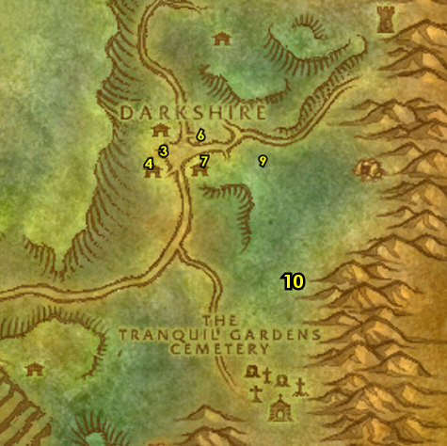

01) Go SW to The Yorgen Farmstead and between the two buildings, click on the Mound of loose dirt 50.78 to turn in "Sven's Revenge", accept "Sven's Camp".
02) Go NW to Raven Hill and turn in "Return to Jitters" 18.56.
03) NE in Raven Hill Cemetery, in the shack, turn in "Deliver the Thread" 28.31, accept "Zombie Juice".
04) GROUP (or soloable?): If you have a group you can Try to do "Mor'Ladim": kill/loot Mor'Ladim /target (lvl 30 Elite undead), he patrols around the outside cemetery. BIG TRICK: There is a big trick where you can kite him around one of the big trees in the area while doing damage to him, to kill him easily. If the tree trick is to difficult for you then skip it.
05) Go west to the small camp by the river and turn in "Sven's Camp" 8.34, accept "The Shadowy Figure".
06) NON HUMANS: Go west to Westfall at Sentinel Hill and go to the Gryphon Master (57.53 in Westfall) and get the Flight Path.
07) Go west into Westfall, and go in the old Town Hall at Moonbrook and click the Old Footlocker to turn in "The Legend of Stalvan" (42.67 in Westfall), accept the next part.
08) Hearth to Darkshire. If Hearthstone is still on a cooldown, go NE to Westfall at Sentinel Hill and go to the Gryphon Master (57.53 in Westfall, #6 on map) and fly to Darkshire, Duskwood.
#26
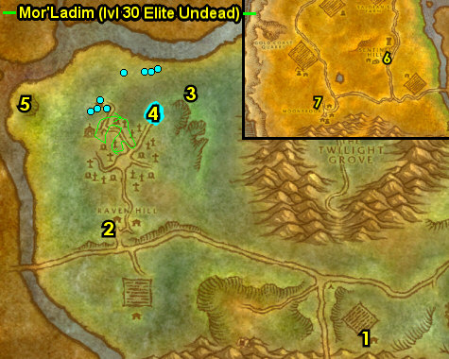

01) In the Inn, turn in "Zombie Juice" 74.44, SKIP "Gather Rot Blossoms".
02) Just outside of the Inn 74.47, turn in IF YOU DID IT: turn in "Mor'Ladim", accept "The Daughter Who Lived", then find Watcher Ladimore /target (she patrols around town) and turn in "The Daughter Who Lived", accept "A Daughter's Love".
03) Go in the house north of the path in Darkshire and turn in "The Shadowy Figure" 76.45, accept "The Shadowy Search Continues".
04) Go in the Town Hall building and turn in "The Legend of Stalvan" 73.47, accept the next part. Also turn in "The Shadowy Search Continues", accept "Inquire at the Inn".
05) In the Inn, turn in "Inquire at the Inn" 74.44, accept "Finding the Shadowy Figure". Make sure you are repaired/resupplied.
06) Go just NE of the path in Darkshire and from the Gryphon Master up at 77.44, fly to Sentinel Hill, Westfall.
07) Go east into Duskwood to Raven Hill and turn in "Finding the Shadowy Figure" (18.56 in Duskwood), accept "Return to Sven".
08) Go NW to the small camp by the river and turn in "Return to Sven" 8.34, accept "Proving Your Worth".
09) IF YOU HAVE "A Daughter's Love", turn this in east at A Weathered Grave 18.29.
10) At the NW side of Raven Hill Cemetery do "Proving Your Worth": kill 15 Skeletal Raiders /target, 3 Skeletal Healers and 3 Skeletal Warders (the warders are only found in the catacombs entrance 16.39).
12) Go NW to the small camp by the river and turn in "Proving Your Worth" (8.34, #8 on map), accept "Seeking Wisdom".
13) Hearth to Darkshire, or go west to Westfall at Sentinel Hill and go to the Gryphon Master (57.53 in Westfall) and fly to Darkshire, Duskwood.
#27
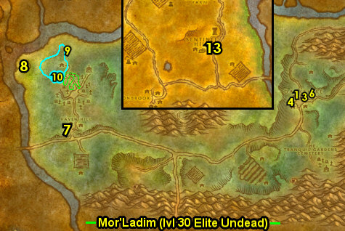

09) Steps #1 - #8 will be skipped for SoM/WotLK due to faster leveling rate. Make sure you are level 30 now, if not grind until you are.
10) Go just NE of the path in Darkshire and from the Gryphon Master up at 77.44, fly to Stormwind, Elwynn. Do next step while flying:
11) While questing in Duskwood you may have came across an item, which starts "An Old History Book" (accept it if you can). Also if "Mor'Ladim" is still in your questbook you can abandon it.
#28
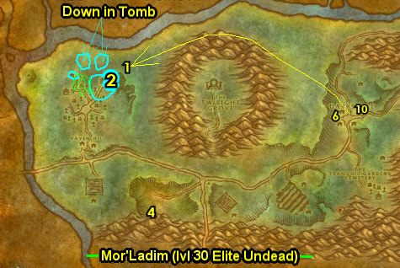

01) Inside Cathedral Square, from the Altar Boy patrolling around 51.47, accept "The Missing Diplomat".
02) From Brother Sarno in the cathedral, accept "Tinkmaster Overspark" 51.48.
03) In the cathedral, turn in "Seeking Wisdom" 50.46 patrols a bit, accept "The Doomed Fleet".
05) Go NE to Stormwind Keep and turn in "The Missing Diplomat" 80.44, accept the next part.
06) North at the Royal Library, turn in "An Old History Book" 77.30, accept "Southshore".
07) Go east in Stormwind City (near the entrance of the city) and turn in "The Missing Diplomat" 76.85, accept the next part.
08) Go SE into Elwynn Forest to Lion's Pride Inn and from Innkeeper Farley 44.66 turn in "The Legend of Stalvan", accept the next part.
09) Go upstairs in the Inn, make a right and back between the two beds do "The Legend of Stalvan": loot the Storage Chest 44.66.
10) Go NW to Stormwind and upstairs in Trias' Cheese, turn in "The Missing Diplomat" (66.74 in Stormwind), accept the next part.
11) Go to the bank 63.78 and put the following items in your bank: Tear of Tilloa, An Undelivered Letter and Sealed Note to Watcher Backus.
12) Go to the Gryphon Master 71.73 and fly to Menethil Harbor, Wetlands.
#29
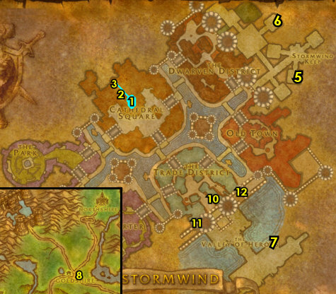
30-30 Wetlands (log)
First Pick the Class you are playing top left of screen!!!
Along with the Game Version you are playing on (Era, SoM, TBC or WotLK)
01) In Deepwater Tavern Inn, turn in "The Doomed Fleet" 11.61, accept "Lightforge Iron". NOTE: You can upgrade First Aid upstairs from the First Aid Trainer (if you have not learned Silk Bandage yet).
02) Go just south of Menethil Harbor, to the wrecked boat in the water and from the Waterlogged Chest 12.64, turn in "Lightforge Iron", accept "The Lost Ingots".
03) In the immediate area, do "The Lost Ingots": kill/loot Bluegill Raiders. These mobs extend down south to 10.72.
04) Go back in the Deepwater Tavern Inn and turn in "The Lost Ingots" (11.61, #1 on map), accept "Blessed Arm".
05) Go south on the docks at Menethil Harbor to get on the boat to go to Theramore, Dustwallow 5.64.
06) At Theramore, go to the Gryphon Master 67.51 and fly to Astranaar, Ashenvale.
#01
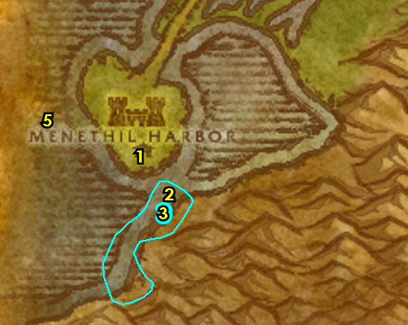
30-30 Ashenvale
01) At Astranaar, accept "Kayneth Stillwind" (next to the directional sign 35.49).
01b) At the entrance to the building, accept "A Helping Hand" 35.50.
02) Go up in the Inn and from the Innkeeper make Astranaar your new home 37.49. Make sure you are repaired/resupplied.
03) Head NE to Forest Song and from the patrolling Ancient of War around 85.46 accept "Reclaiming Felfire Hill".
04) Go up and get the Flight Path from the Hippogryph Master 85.43.
05) Go down and turn in "Kayneth Stillwind" 85.45. Accept "Forsaken Diseases" and "The Lost Chalice".
06) In the middle of town 86.44 accept "The Howling Vale" and next to you "Agents of Destruction". SKIP "Report from the Northern Front".
07) Accept "Destroy the Legion" 86.44.
08) Accept "Vile Satyr! Dryads in Danger!" 87.43.
09) Turn in "A Helping Hand", accept "A shameful Waste" 87.45.
10) Go south to Warsong Lumber Camp and do "Agents of Destruction" and part of "A shameful Waste": kill the required amount of mobs, Overseer Gorthak is up in the burrow 89.60. And pick up 15 Warsong Lumber (the wood will be obtained later).
11) Go SW to Felfire Hill around 81.66 and do "Destroy the Legion" and "Reclaiming Felfire Hill": kill the required amount of demons and click on the Fertile Dirt Mounds.
12) Go NW to enter the Night Run 64.44..
13) South in Night Run do part of "The Tower of Althalaxx": click on the Circle of Imprisonment (on the ground 67.57).
14) Exit Night Run NW and starting at 60.39 do "Raene's Cleansing": work your way NW to the next step while kill/looting the Crazed Ancients and Withered Ancients for a Wooden Key (goes in keyring):
15) Once you got the Wooden Key, loot the Worn Chest (on a cement block 54.35).
16) Go west up a path starting at 54.33 then through a small cave and do "The Howling Vale": click on the Tome of Mel'Thandris (on a small table 50.39).
#02
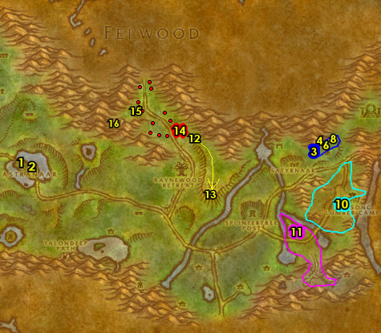

01) Go SW to the Moonwell and turn in "Raene's Cleansing" 54.46, accept the next part. NOTE: You will have to go all the way around the mountains to get to it, I found no shortcut.
02) Go east to Xavian (follow path on map), clear the Satyrs in the area, then turn in "Vile Satyr! Dryads in Danger!" 78.45, accept "The Branch of Cenarius".
03) Work your way north in Xavian and do "The Branch of Cenarius": kill/loot Geltharis /target (purple satyr, 78.42).
04) Go east to Forest Song and from the patrolling Ancient of War around 85.46 turn in "Reclaiming Felfire Hill".
05) In the middle of town turn in "The Howling Vale" 86.44, accept "Velinde Starsong". Next to you turn in "Agents of Destruction".
06) Turn in "Destroy the Legion" 86.44.
07) Turn in "The Branch of Cenarius" 87.43 (this dryad could be patrolling around the area). Accept "Satyr Slaying!".
08) Go west to Satyrnaar and do "The Lost Chalice": loot the Chalice of Elune on the red temple's ledge 81.49. Or this could be at the other side of the temple at 81.49.
09) Next to you do the last part of "The Tower of Althalaxx": click on the Circle of Imprisonment (on the ground, 82.49).
10) At Satyrnaar finish "Satyr Slaying!" and "A shameful Waste": kill/loot any satyr demons for the 16 horns. And pick up 5 Satyrnaar Fel Wood.
11) Go south of Splintertree Post (horde town) and do "Forsaken Diseases": loot a Bottle of Disease on either the table or barrel 75.72. Keep the next step in mind:
12) All around this area 73.74 do "Raene's Cleansing": kill/loot Rotting Slimes until you get the Iron Pommel. You can also find this in the Rusty Chests that drop from the slimes.
#03
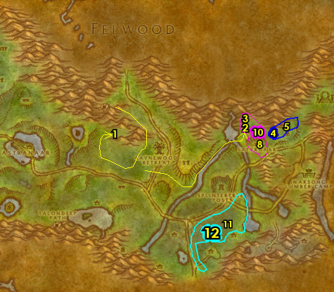
01) Go SW to the small island at Fallen Sky Lake and do "Fallen Sky Lake": kill/loot Shadethicket Oracle /target (swamp elemental) 67.82.
02) Go NE to Forest Song and turn in "Forsaken Diseases" 85.45 and "The Lost Chalice". SKIP "Insane Druids".
TBC, 2a) East in Forest Song turn in "Satyr Slaying!" (this dryad could be patrolling around the area) 87.43. Also from the patrolling Ancient of War turn in "A shameful Waste".
03) N/A
07) Hearth to Astranaar. Make sure you are repaired/resupplied.
08) In the small house east in Astranaar, turn in "Fallen Sky Lake" 37.52.
09) Go NE to the Moonwell and turn in "Raene's Cleansing" 54.46. Wait a few seconds then accept the next part.
10) Go to the path starting at 56.51 and work your way up the path to the next step:
11) At the top of the path click on the Hidden Shrine 56.49 to turn in "Raene's Cleansing", accept the next part.
12) Go back NW to the Moonwell and turn in "Raene's Cleansing" (54.46, #9 on map), accept the next part.
#06
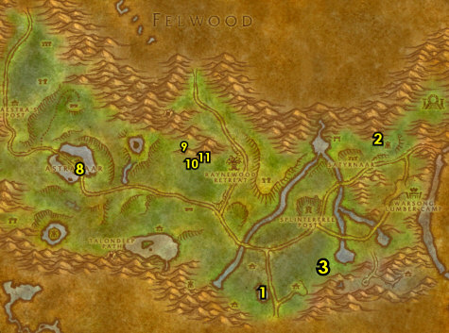

01) Hearth, or run back to Astranaar and down in the Inn turn in "Raene's Cleansing" 37.50, accept the next part.
02) Go SE and use your Dartol's Rod of Transformation quest item to turn in "Raene's Cleansing" 51.75, accept next part.
03) Go SE a bit and do "Raene's Cleansing": kill/loot Ran Bloodtooth at 55.80 and 4 Bloodtooth Guards.
04) Go back NW a bit (use your Dartol's Rod of Transformation) to turn in "Raene's Cleansing" (51.75, #2 on map) accept next part.
05) Jump in the lake next to you and then die on purpose and res at spirit so you can get back to Astranaar.
05) Hearth (or go back) to Astranaar.
06) In the Inn at Astranaar turn in "Raene's Cleansing" (37.50, #1 on map). Make sure you are repaired/resupplied. NOTE: You can destroy the Dartol's Rod of Transformation as its no longer used for anything else.
07) N/A
09) Go NW on the path to Maestra's Post and turn in "The Tower of Althalaxx" 26.39, SKIP the next part.
10) Hearth (if you can), or run back to Astranaar.
11) Go to the Hippogryph Master 34.48 and fly to Rut'theran, Teldrassil.
#07
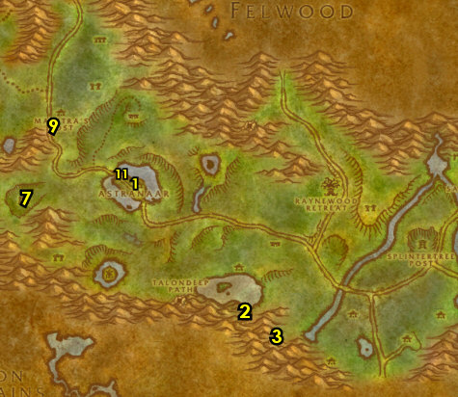

Darnassus (log)
01) At Rut'theran, go up through the red portal 56.89 to get to Darnassus.
02) Go to Darnassus's Bank 40.42 and get the following item out of your bank: Dwarven Tinder. And if you have them, get out Hillman's Cloak & Bolt of Woolen Cloth, Swiftness Potion, also a Swim Speed Potion. You can check the AH for these items on a few steps below and remember not to sell these items to a vendor!
03) Go east and accept "Klockmort's Essentials" 60.45. NOTE: Next to you in that same area you can visit the Weapon Master 58.47 to learn any new weapons.
04) East up the ramp, turn in "Velinde Starsong" 62.39, accept "Velinde's Effects".
05) You can stop at the AH at 57.53 and you can see if you can get (if you still need to): Hillman's Cloak & Bolt of Woolen Cloth. Also see if you can get 4 Lesser Bloodstone Ore and keep that in your mailbox/bank for now.
06) Go south and enter Mail Armor / Shields building entrance 57.78, go up and cross the bridge to the next step..
07) Up in the building do "Velinde's Effects": loot Velinde's Locker 62.83.
08) Go back north and turn in "Velinde's Effects" (62.39, #4 on map), accept "The Barrens Port".
09) Go back through the red portal to exit Darnassus 29.41.
10) At Rut'theran, go out on the docks to the Hippogryph Master 58.94 and fly to Theramore, Dustwallow.
11) At Theramore, go on the docks to get on the boat to take you to Menethil Harbor 72.56.
#08
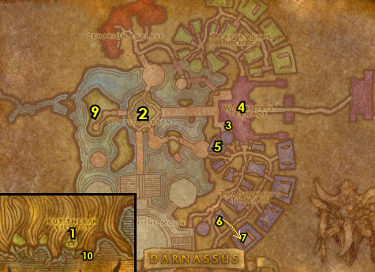

30-31 Wetlands (log)
01) Go in Deepwater Tavern Inn and make it your new home 11.61.
02) Go north to the northern sunken boat in the water and do "Lifting the Curse": kill/loot Captain Halyndor /target (on top of the boat 15.24).
03) Go underneath the boat (crack entrance at 14.24) and click on the Intrepid's Locked Strongbox (in the grassy area) to turn in "Lifting the Curse" 14.24, accept "The Eye of Paleth".
04) Go SE to Angerfang Encampment and click on the Dragonmaw Catapult 47.47 to turn in "Nek'rosh's Gambit", accept "Defeat Nek'rosh".
05) Go SE in the Angerfang Encampment and do "Defeat Nek'rosh": kill/loot Chieftain Nek'rosh /target 53.55.
06) Go SE just past the river and do the last part of "A Noble Brew": loot the Musquash Root 65.75. It looks like a thorn at the bottom of the waterfall.
07) Hearth to Deepwater Tavern (if you can) , then continue on:
#09
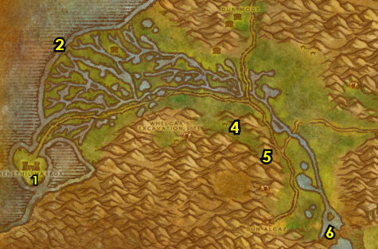

01) In the Inn, turn in "The Eye of Paleth" 11.61, accept "Cleansing the Eye". Make sure you are repaired/resupplied.
02) At the fortress entrance, accept "Fall of Dun Modr" 11.56. Accepted from Harlo Barnaby /target laying down (no exclamation mark).
03) Turn in (if you did it) "Defeat Nek'rosh" up in the Keep 10.57, if not, you can abandon the quest.
04) Go NE to Dun Modr and turn in "Fall of Dun Modr" 50.18.
05) Next to you, accept "The Thandol Span" 50.18.
10) Go north on the bridge and half-way across the bridge you will see two doors on both sides of the bridge, take either door (51.8 in Wetlands), and go down the stairs. Once down there, click on Ebenezer Rustlocke's Corpse 51.8 to turn in "The Thandol Span", accept the next part.
11) Go back south to Dun Modr and turn in "The Thandol Span" (50.18, #4 on map), accept the next part.
12) Go north and just past the bridge on your right is a wooden bridge (entrance at 46.88 in Arathi Highlands). Go across the bridge and do "The Thandol Span": just past the wooden bridge, click on the Cache of Explosives 49.88.
13) Go back south to Dun Modr and turn in "The Thandol Span" (50.18, #4 on map), accept "Plea To The Alliance".
#10
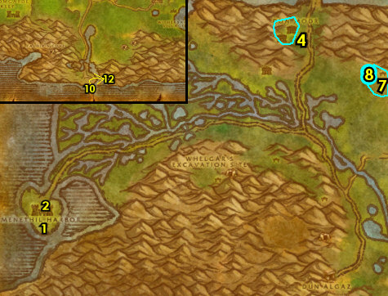

01) SWIFTNESS POTION ONLY (or try a difficult jump): (See Video Guide for this quest) Go north across the bridge and then make a left, then another left to a broken bridge (at 43.91 in Arathi Highlands). Make sure you have a Swiftness Potion and/or your mount on, then use that extra speed boost to take a jump onto the next structure in the middle of the water. Once over there, accept "MacKreel's Moonshine" 43.93. NOTE: This quest is on a 15 minute timer, so work quickly to do the next few steps:
02) Swim east (use a Swim Speed Potion if you have one) to get on the mountain ramp (starting at 53.90 in Arathi) to get back up the land.
04) Go north to Refuge Pointe and turn in "Plea To The Alliance" 46.48.
05) You can get repaired/resupplied from Jannos Ironwill 46.48 next to the Bonfire.
06) From the Gryphon Master 46.46 get the Flight Path.
07) N/A
08) N/A
09) Head NW into Hillsbrad Foothills (20.29 in Arathi Highlands)..
#11
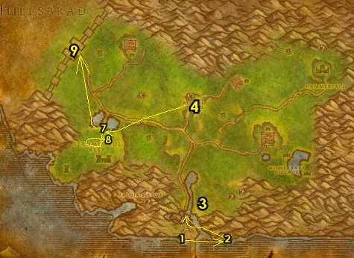

31-32 Hillsbrad Foothills (log)
01) N/A
02) Just west in front of the small house at Southshore, turn in "Southshore" 51.57, SKIP "Preserving Knowledge" (for now).
03) Just west at the bigger house, ONLY accept "Bartolo's Yeti Fur Cloak" 49.56 if you have the Hillman's Cloak and Bolt of Woolen Cloth items with you.
04) Go south and on your left enter the Inn and from the Innkeeper 51.59 make Southshore your new home.
05) At the bar, accept "Down the Coast" 51.58.
06) IF YOU ARE ON "MacKreel's Moonshine": Go down in the Inn's basement and turn in "MacKreel's Moonshine" 52.59.
TBC, 6a) In the Inn accept "Missing Crystals" 51.59.
07) NOTE: Sometimes you will see a pack of Shadowy Assassins attacking the guards in front of the Town Hall. If you manage to kill/loot one of them, you will be able to loot an item, which starts "Assassin's Contract", accept it if you can. If you were able to do it then turn it in (inside the town hall 48.59), SKIP "Baron's Demise" (for now).
09) Go to the shore SW of Southshore (starting at 48.64 and work your way west along the shore) and do "Down the Coast": kill 10 Torn Fin Tidehunters and 10 Torn Fin Oracles.
10) Go in the Inn at Southshore and at the bar turn in "Down the Coast" (51.58, #4 on map), accept "Farren's Proof".
11) Go back to the shore SW of Southshore (starting at 48.64 and work your way west along the shore, #9 on map) and do "Farren's Proof": kill/loot murlocs. Any of them can drop the heads you need.
12) Go in the Inn at Southshore and at the bar turn in "Farren's Proof" (51.58, #4 on map), accept the next part. Make sure you are repaired/resupplied.
#12
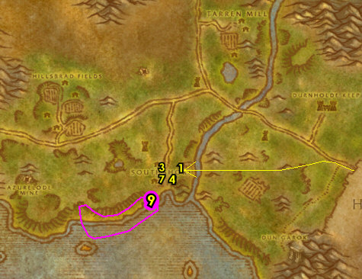

01) Just outside of the Inn, in front of the Town Hall, turn in "Farren's Proof" 49.59, accept the next part.
02) Back in the Inn at the bar, turn in "Farren's Proof" 51.58, accept "Stormwind Ho!".
03) Go SE to the shore starting at 53.65 and work your way east along the shore and do "Stormwind Ho!": kill 10 Daggerspine Shorehunters and 10 Daggerspine Sirens.
04) Go back to the Inn at Southshore and at the bar turn in "Stormwind Ho!" (51.58, #2 on map), accept "Reassignment". Make sure you are repaired/resupplied.
TBC, 4a) Go north and inside the tower do "Missing Crystals": loot the Unopened Crate 56.35.
05) Go NW to the Yeti cave entrance 46.32 and do "A King's Tribute": loot 5 Alterac Granite along the cave walls. And if you have the Hillman's Cloak & Bolt of Woolen Cloth items with you along with the quest "Bartolo's Yeti Fur Cloak", then kill/loot yeti for 10 Yeti Furs.
NOTE, 5b) Steps 6 - 8 will be skipped for SoM/WotLK.
#13
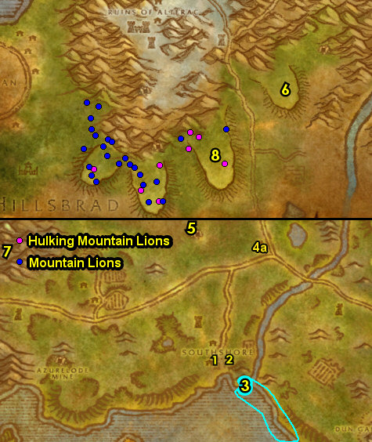

01) N/A
02) N/A
03) Hearth to Southshore. Make sure you are repaired/resupplied.
TBC, 3a) In the Inn turn in "Missing Crystals" 51.59.
04) N/A
06) N/A
07) If you were able to work on "Bartolo's Yeti Fur Cloak", then go across the path into the big house and on the lower floor from the Trade Goods vendor 49.55, purchase a Fine Thread. Then, just outside of the house, turn in "Bartolo's Yeti Fur Cloak" 49.56.
08) N/A
09) Go west across the path to the Gryphon Master 49.52 and fly to Refuge Pointe, Arathi.
#14
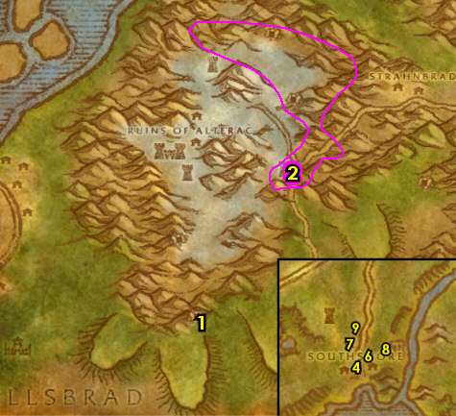

32-32 Arathi Highlands (log)
01) At Refuge Pointe, next to the tents, accept "Northfold Manor" 46.48.
02) Go NW to Northfold Manor around 33.30 and do "Northfold Manor": kill 10 Syndicate Highwayman /target and 6 Syndicate Mercenary /target.
03) Die on purpose, res then go NW a bit back to Refuge Pointe and turn in "Northfold Manor" (46.48, #1 on map), SKIP "Stromgarde Badges" (for now).
04) You can get repaired/resupplied from Jannos Ironwill 46.48 next to the Bonfire.
05) From the Gryphon Master 46.46, fly to Ironforge, Dun Morogh.
#15
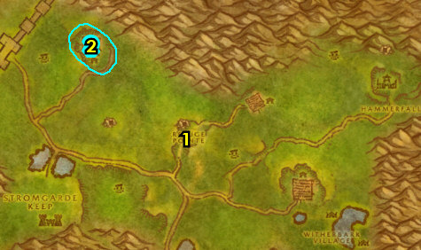

Ironforge
01) NOTE: You can turn in cloth donations at 43.32 for the Dwarf faction. You would need 60 Wool Cloth, then 60 Silk Cloth. You can buy the cloth from the AH as well.
GET NEW ABILITIES, 1b) Get new spells/abilities in Ironforge.
02) N/A
03) N/A
04) If you have extra cloth then go south to Tinker Town and make a left, you can turn in cloth donations for the Gnome faction 74.48.
05) At Tinker Town, turn in "Klockmort's Essentials" 68.46, SKIP "Essential Artificials" (Dungeon).
06) In the same room, turn in "Tinkmaster Overspark" 70.50. NOTE: Most of the quests you obtain from Tinker Town are done in the Gnomeregan (29-38 five-man Dungeon) found west in Dun Morogh and can be optionally done if you have a group, but my guide will not cover them.
07) Go SE at The Military Ward and accept "The Brassbolts Brothers" 73.94.
08) Go middle-south of Ironforge and turn in "A King's Tribute" 39.88. Then wait for this dwarf to go down stairs then back up and then accept the next part.
09) Go north to The High Seat and turn in "A King's Tribute" 39.56.
10) Go to the middle of Ironforge to the Gryphon Master 56.48 and fly to Stormwind, Elwynn.
#16
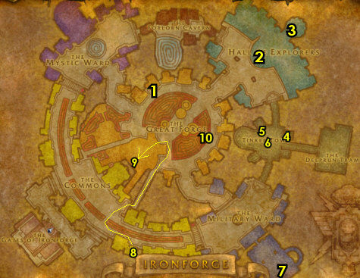

Stormwind
01) At Stormwind City, go in the Inn (The Gilded Rose) and at the Innkeeper 60.75, make Stormwind City your new home.
02) Go to bank 63.78 and get the following items out: An Undelivered Letter, Tear of Tilloa, Sealed Note to Watcher Backus. Put in your bank: Crate of Crash Helmets.
03) Go SW to The Mage Quarter and from Archmage Malin 50.87, accept "Malin's Request".
04) Go west down the steps 40.84 in The Slaughtered Lamb and turn in "A Noble Brew" 40.85, accept the next part.
05) Go north at The canals and turn in "The Legend of Stalvan" 43.72, accept next part.
06) Next to you, click on the Sealed Crate to turn in "The Legend of Stalvan", accept the next part.
07) Go north to the Cathedral of Light and turn in "Cleansing the Eye" 50.46.
08) Go NE to the Dwarven District and turn in "Blessed Arm" 60.34, SKIP "Armed and Ready".
09) Go NE to Stormwind Keep (in the Petitioner's Chamber) and turn in "A Noble Brew" 78.49.
10) North in Stormwind Keep, turn in "Reassignment" 76.37.
11) Go to the Gryphon Master 71.73 and fly to Lakeshire, Redridge.
12) Go SW into Elwynn Forest to Eastvale Logging Camp and turn in "The Legend of Stalvan" (85.69 in Elwynn), accept the next part.
13) Do "The Legend of Stalvan": go upstairs in the house next to you and loot Marshal Haggard's Chest (by the bed 86.70).
14) Just outside the house, turn in "The Legend of Stalvan" 85.69, accept the next part.
#17
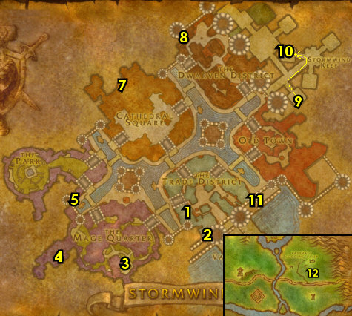

01) Go south into Duskwood, and just north of Darkshire on the main path find Watcher Backus (he patrols from Darkshire up to 73.33). From him, turn in "The Missing Diplomat", SKIP the next part.
02) Go in the Inn at Darkshire and turn in "The Legend of Stalvan" 74.44, accept the next part.
03) In front of the Town Hall, turn in "The Legend of Stalvan" 74.47, accept the next part.
04) Just in the Town Hall, turn in "The Legend of Stalvan" 73.47, accept the next part.
05) In front of the Town Hall, turn in "The Legend of Stalvan" 74.47, accept the next part.
06) Go north, then east to Manor Mistmantle and do "The Legend of Stalvan": in the small house, kill/loot Stalvan Mistmantle /target 77.36.
07) Go back to Darkshire and in the big house north of the path, turn in "The Legend of Stalvan" 76.45.
08) Follow the main path south to go to Stranglethorn Vale (45.89 in Duskwood)..
#18
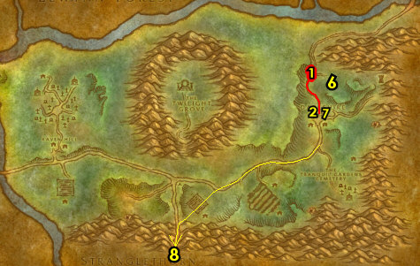

32-33 Stranglethorn Vale (log)
00) In STV, follow the path west then north to get to the Rebel Camp and get the Flight Path from the Gryphon Master 38.4.
01) Accept "The Second Rebellion" and "Bad Medicine" 38.3.
02) Also at the camp, accept "Krazek's Cookery" 38.3.
03) Next to you, make sure you are resupplied 38.3.
04) As you leave south from the camp, and if a friendly NPC named Private Thorsen /target is patrolling or attacking mobs, follow and protect him, then accept "Jungle Secrets" (this would be at 40.8). If you were able to accept this, then turn this in back north at the Rebel Camp (38.3, #1 on map) and accept "Bookie Herod". If you were not able to do this right now, keep this in mind in case when you run across this spot in the future.
05) Go SE to Kurzen's Compound and do "The Second Rebellion" and "Bad Medicine": kill 15 Kurzen Jungle Fighters /target, kill/loot the mobs for the Jungle Remedy and loot a Kurzen Supplies (crates). Also IF you have the "Bookie Herod" quest: Upstairs in the house, click on the Bookie Herod's Records to turn in "Bookie Herod" 44.9, accept "The Hidden Key".
06) Go back NW to the Rebel Camp and turn in "The Second Rebellion" and "Bad Medicine" (38.3, #1 on map), accept "Special Forces".
07) Go SW past the river to Nesingwary's Expedition and accept "Welcome to the Jungle" 36.11.
08) Next to you, turn in "Welcome to the Jungle" 36.11. NOTE: For SoM/WotLK we will skip all Nesingwary hunting quest due to the faster leveling rate.
09) NOTE: The "The Green Hills of Stranglethorn" quest requires that you save any Green Hills of Stranglethorn pages you find. These pages can drop from any humanoid mob in STV. You will need one of each of the following pages: 1, 4, 6, 8, 10, 11, 14, 16, 18, 20, 21, 24, 25, 26, and 27. I recommend mailing them to your alt for storage. Once your alt collects all the pages, mail them back to your main. You can also find these pages in the AH or from other players. You don't need to accept the quest to get the page drops, so accept and turn this in if you get all the pages. You will return to STV numerous times in the future for more chances to find the pages.
10) At the camp get repaired/resupplied from Jaquilina Dramet 36.11.
#19
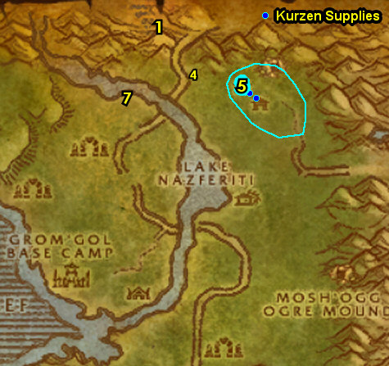

NOTE, 8b) Steps 1-8 will be skipped for SoM/WotLK due to the faster leveling rate.
09) N/A
10) Go south to enter Booty Bay, and up in the Inn, turn in "Krazek's Cookery" 27.77, SKIP "Favor for Krazek" (for now). Also accept "The Haunted Isle".
#20
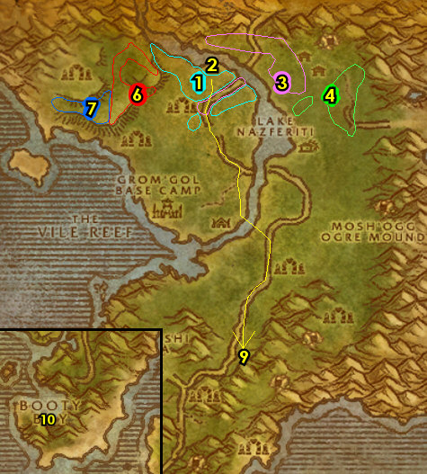

02) Just next to you up on the boat-deck, turn in "The Haunted Isle" 27.77, SKIP "The Stone of the Tides" (for now).
03) It's a bit hard to find, but stay up and go slightly south over to the ledge to get the Flight Path from the Gryphon Master 28.78.
04) Go to the end of the docks 26.73 at Booty Bay to get on the boat to take you to Ratchet.
05) At Ratchet, right when you get off the boat, turn in "The Barrens Port" 63.38, SKIP "Passage to Booty Bay" (for now).
06) Get the Flight Path at Ratchet from the Flight Master 63.37.
07) Go to the bank next to you 63.37 and get out your Crate of Crash Helmets.
08) Next to Ratchet's bank, enter Ironzar's Imported Weaponry to get repaired/resupplied 62.37.
09) Now travel all the way south through The Barrens to The Great Lift (44.92 in The Barrens). Watch out for Horde players!
10) Go down the Lift and you will see a dwarf corpse laying on the ground holding a journal (31.24 in Thousand Needles), loot it, and from it, accept "Lonebrow's Journal".
11) Head west in Thousand Needles to Thalanaar (90.47 in 1k Needles) and turn in "Lonebrow's Journal", SKIP "The Crone of the Kraul" (Dungeon).
12) Just east in Thalanaar get the Flight Path from the Hippogryph Master (89.46 in Feralas).
13) Go SE all the way to The Shimmering Flats (78.77 in 1k Needles)..
#21
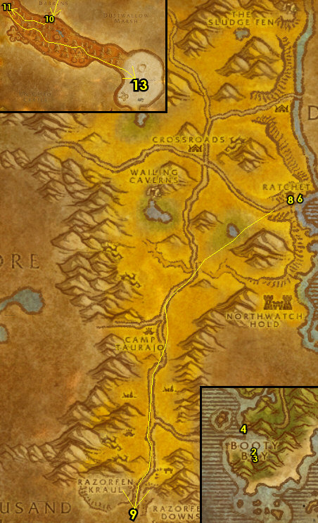

33-34 Thousand Needles (Shimmering Flats) (log)
01) At Mirage Raceway, turn in "The Brassbolts Brothers" 78.77. Accept "Hardened Shells". And next to you accept "Salt Flat Venom". Next to you from the dwarf, accept "Rocket Car Parts" 78.77. Make sure you are repaired/resupplied.
02) East at the Goblin's side of Mirage Raceway accept "Load Lightening" 80.76.
03) SE in Mirage Raceway by the starting line accept "A Bump in the Road" 82.78.
04) Do The Shimmering Flats grind. Do the following 5 steps below (in any order) all together around The Shimmering Flats:
05) "Rocket Car Parts": pick up Rocket Car Rubble from the ground. These are scattered all around The Shimmering Flats.
06) "Hardened Shells": kill/loot turtles all over The Shimmering Flats. ALSO: Make sure you collect 10 Turtle Meat for a later quest at Southshore in Hillsbrad, and do not sell them to a vender! You can get the Turtle Meat from any turtle at The Shimmering Flats and there is a large amount up north around 83.55.
07) "Load Lightening": kill/loot vultures (Salt Flats Scavengers & Salt Flats Vultures). There is a lot around 88.65.
08) "Salt Flat Venom": kill/loot scorpids (Scorpid Reavers & Scorpid Terrors). Large amount around 72.73.
09) "A Bump in the Road": kill basilisks. Saltstone Basilisks are NW, Saltstone Crystalhides are everywhere but NW, and the Saltstone Gazers /target are south at Tahonda Ruins around 77.86.
10) Once all done, go back to Mirage Raceway (at the gnomes section) and from the dwarf (at 78.77, #1 on map) turn in "Rocket Car Parts". Accept "Wharfmaster Dizzywig" and "Hemet Nesingwary". Then next to you 78.77, turn in "Salt Flat Venom" and "Hardened Shells". SKIP "Martek the Exiled" (for now).
11) East at the goblin section of the Mirage Raceway turn in "Load Lightening" (80.76, #2 on map), accept "Goblin Sponsorship".
12) SE in Mirage Raceway by the starting line turn in "A Bump in the Road" (82.78, #3 on map).
13) Make sure you are repaired/resupplied. Also make sure you are level 34, grind on any mobs until you are.
14) Go south to the path that leads into Tanaris (starting at 74.94)...
15) Follow the path south to Gadgetzan and at the SE corner of the town, go in the bank (hut at 52.29 in Tanaris) and put the following items in there: stack of 10 Turtle Meat. Get out the follow item: (if you have it) 4 Lesser Bloodstone Ore (or could be in mailbox).
17) At the Gryphon Master 51.29 fly to Ratchet, The Barrens.
18) At Ratchet, go in the engineering building and turn in "Goblin Sponsorship" 63.36, accept the next part.
19) Go to the goblin on the docks and turn in "Wharfmaster Dizzywig" 63.38, accept "Parts for Kravel". Also accept "Passage to Booty Bay".
20) At the end of the docks 64.39, get on the boat to take you to Booty Bay. NOTE: If you could benefit from getting new spells/abilities then hearth to Stormwind, get new abilities, then fly to Booty Bay, STV.
#22
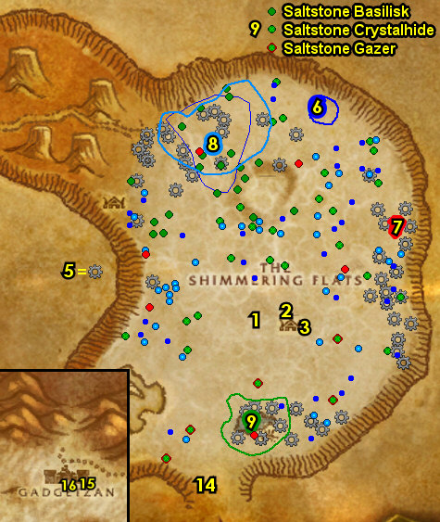

01) NOTE: The 34-36 Desolace section will be skipped for SoM/WotLK, so most of the steps here will be removed.
#23
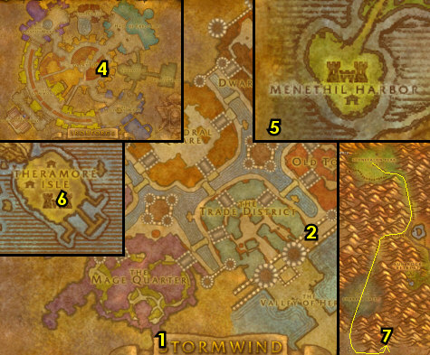

36-37 Stranglethorn Vale (log)
01) As soon as you get off the boat turn in "Goblin Sponsorship" 26.74, accept the next part.
02) Continue on the lower docks and turn in "Passage to Booty Bay" 27.74, SKIP "The Caravan Road".
03) Go in the Inn and make BB your new home 27.77. Next to you in the Inn, accept "Singing Blue Shards".
04) Go upstairs in the Inn and accept "Bloodscalp Ears", "Hostile Takeover", "Supplies to Private Thorsen", "Investigate the Camp"
05) If you have 4 Lesser Bloodstone Ore with you, accept and turn in "Favor For Krazek", then accept (if you can) "Return to Corporal Kaleb".
06) Go up the steps to Baron Revilgaz 27.77 on the boat-deck and turn in "Goblin Sponsorship", accept the next part. Also accept "The Stone of the Tides".
07) Stay up on the top of the docks and over past the FP to Tan-Your-Hide Leatherworks, accept "Supply and Demand" 28.78, (this may not have an exclamation mark).
08) REMINDER: The "The Green Hills of Stranglethorn" quest requires that you save any Green Hills of Stranglethorn pages you find. These pages can drop from any humanoid mob in STV. You will need one of each of the following pages: 1, 4, 6, 8, 10, 11, 14, 16, 18, 20, 21, 24, 25, 26, and 27. I recommend mailing them to your alt for storage. Once your alt collects all the pages, mail them back to your main. You can also find these pages in the AH or from other players. You don't need to accept the quest to get the page drops, so accept and turn this in at Nesingwary's Expedition 36.11 if you get all the pages. You will return to STV numerous times in the future for more chances to find the pages.
09) NOTE: You can destroy the Library Scrip as it's not used for gaining XP (or bank it if you are not in a hurry).
10) N/A
11) N/A
12) Go NW to the Venture Co. Operations Center entrance 42.18 and do "Hostile Takeover": kill/loot the Venture Co. Geologist /target scattered around the Operations for the crystals. Also do the first part of "Goblin Sponsorship": work your way to the top of the Operations Center and then kill/loot Foreman Cozzle (in the control room 43.18). See next step for where to use Cozzle's Key at:
13) Finish "Goblin Sponsorship": loot Cozzle's Footlocker (in the small house 43.20). NOTE: Your key will disappear as soon as you click the chest, so make sure you have room in your bags for the Blueprints first.
#28
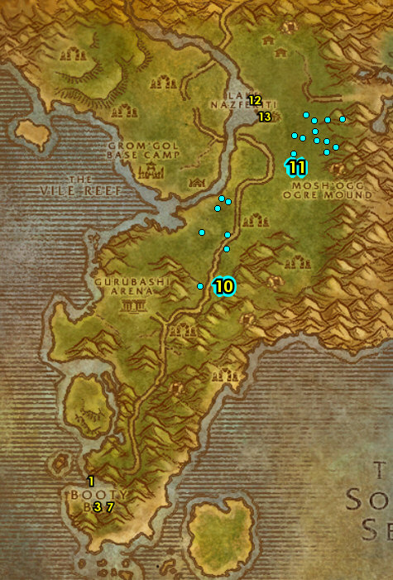

01) N/A
06) N/A
07) Go SW at Bal'lal Ruins around 30.19 and finish "Bloodscalp Ears": kill/loot any Bloodscalp trolls for the ears. If you run out of mobs, you can do the next step and come back:
08) Go to the ledges along the shore 27.19 and start working on "Singing Blue Shards": kill/loot Crystal Spine Basilisks. 80% drop rate. There's only 9 mob spawns in the area, so if you run out, just continue on with the next step:
09) Go west out to the island and do "The Stone of the Tides": simply go onto the island to get it discovered 21.23.
10) You can go back to the ledges along the shore (25.17, #8 on map) and continue working on "Singing Blue Shards": kill/loot Crystal Spine Basilisks. There is more later in the guide that you can kill, so if you run out just continue on:
11) Go east to Nesingwary's Expedition and turn in "Hemet Nesingwary" (36.11, # on map).
12) At the camp get repaired/resupplied from Jaquilina Dramet 36.11.
#29
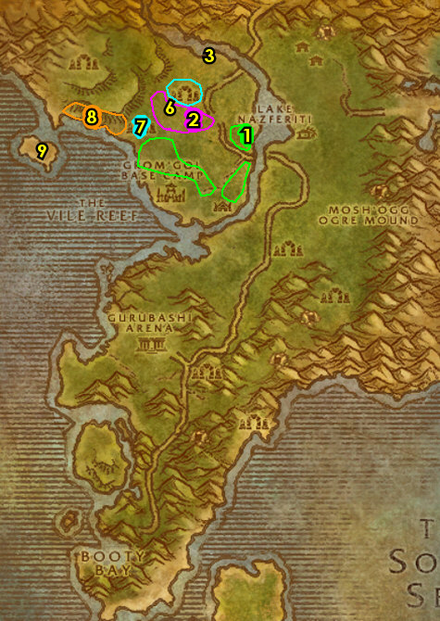

01) At the river to the east of you around 35.10 do "Supply and Demand": kill/loot River Crocolisk /target.
02) Enter The Stockpile (cave entrance at 46.8) and do "Special Forces": kill 10 Kurzen Commandos and 6 Kurzen Headshrinkers. If you have "The Hidden Key", then turn it in by hugging the right side of the cave until you get to an area with lots of boxes and click on Bookie Herod's Strongbox (50.8 in the cave) to turn it in, accept "The Spy Revealed!".
03) If you still need to finish "Singing Blue Shards": exit the cave (turn around and hug the left side), go east (outside of the cave) and kill/loot Crystal Spine Basilisks (up around the ledges 49.9).
04) Die on purpose, res at spirit.
05) Turn in "Supplies to Private Thorsen" 40.8. If he is not there, then he could be back at the Rebel Camp 38.3. He patrols back and forth between these two spots. Also from him, accept (if you haven't yet) "Jungle Secrets", if you were able to accept this, then turn this in back north at the Rebel Camp (38.3, #1 on map) and accept "Bookie Herod".
06) Next to you, turn in (if you have it) "Return to Corporal Kaleb" 38.3.
07) Back in the camp, turn in "Special Forces" 38.3, SKIP "Colonel Kurzen" (for now). And turn in (if you have it) "The Spy Revealed!", accept "Patrol Schedules". Also turn in (if you haven't yet) "Jungle Secrets", SKIP (if available) "Bookie Herod" (for now).
08) Next to you at the camp, turn in (if you have it) "Patrol Schedules" 38.3, accept "Report to Doren".
09) Back in the camp, turn in (if you have it) "Report to Doren" 38.3.
10) Next to you, make sure you are resupplied.
11) Hearth to Booty Bay. If hearthstone is still on a cooldown, fly there from the Gryphon Master at the Rebel Camp 38.4.
#30
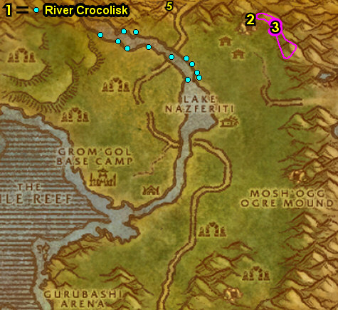

01) Next to you at the bottom of the Inn, turn in "Singing Blue Shards" 27.77, SKIP "Venture Company Mining" (for now).
02) Go to the top of the Inn and turn in "Bloodscalp Ears", "Hostile Takeover" and (next to you) "Investigate the Camp".
03) Next to you up the steps on the boat-deck, from Baron Revilgaz 27.77, turn in "The Stone of the Tides", SKIP "Water Elementals" (for now). And turn in "Goblin Sponsorship", accept the next part.
04) Stay up on the docks and over past the FP to Tan-Your-Hide Leatherworks and turn in "Supply and Demand" 28.78, accept "Some Assembly Required".
05) Go up to the Gryphon Master 28.78 and fly to Ironforge, Dun Morogh.
06) At Ironforge, go to the bank 35.61 and get the following items out: Stack of 10 Turtle Meat, your stack of Elixir of Water Breathing potions and any Swim Speed Potions you may have. Put in your bank: Kravel's Parts and Fuel Regulator Blueprints.
GET NEW ABILITIES, 07) Get new spells/abilities in Ironforge.
08) N/A
09) Go north a bit more 75.12 and accept "Ironband Wants You!".
10) Go to the middle of Ironforge to the Gryphon Master 55.48 and fly to Southshore, Hillsbrad.
#31
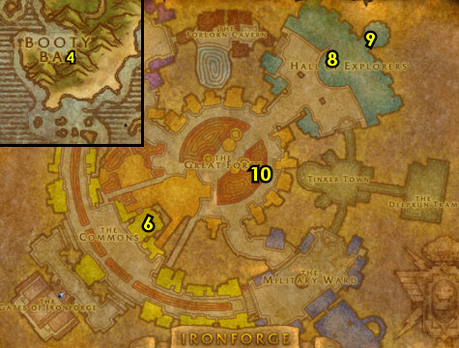

37-37 Alterac Mountains ( log )
01) N/A
02) Go in the Inn and from the Innkeeper 51.59, make Southshore your new home.
03) Back in the Inn's kitchen, accept and turn in (no exclamation mark) "Soothing Turtle Bisque" 52.59.
04) N/A
06) N/A
08) N/A
09) N/A
11) Just outside of the Inn, accept "Hints of a New Plague?" 50.59.
15) Go north a bit (on the west side of the path) to the Gryphon Master 49.52 and fly to Refuge Pointe, Arathi.
#32
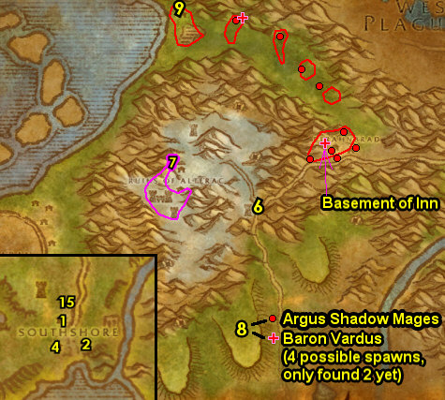

37-38 Arathi Highlands ( log )
01) At Refuge Pointe, turn in "Malin's Request" 47.47.
02) Next to the Bonfire, accept "Worth Its Weight in Gold" 46.48.
03) Go NE and click on the Shards of Myzrael 62.34 to accept "The Princess Trapped".
04) Go east of Hammerfall (Horde town, run south around it) and do "The Princess Trapped": kill/loot the Kobolds, in and outside of the cave entrance 83.36. TIP: Look for the tree and rock 81.40, it shows you where the hidden path is to the cave. NOTE: If you have mining, then mine as many Lesser Bloodstone Deposits as you can. These are used for an Alliance quest only at STV or sell good in the AH.
05) Once done, go to the Iridescent Shards (at the end of the cave 84.31) and turn in "The Princess Trapped", accept "Stones of Binding".
06) Exit the cave, then go west to the Circle of East Binding (go south of Hammerfall) and do part of "Stones of Binding": loot the Stone of East Binding 67.30 for the Cresting Key.
07) Go south to Go'Shek Farm and up at the ledge, turn in "Hints of a New Plague?" 60.54, accept the next part.
08) NOTE: The next part of "Hints of a New Plague?" involves kill/looting the Forsaken Courier /target (lvl 35 with four lvl 35 bodyguards). This NPC patrols on the main path between Go'Shek Farm and Tarren Mill (Horde town in Hillsbrad). So if you run into him go ahead and try to kill/loot him for this quest, but just continue on:
09) Go SE to Witherbark Village around 63.67 and do "Worth Its Weight in Gold": kill/loot the trolls around the village. The tusks can drop from any of them, the Witherbark Medicine Pouch drops only from Witherbark Witch Doctors, and the Shadow Hunter Knife drops only from the Witherbark Shadow Hunters (found only in the cave entrance 68.76).
#33
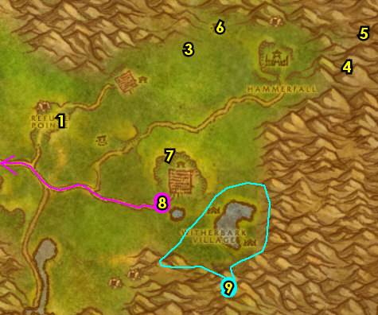

01) Go NW and do part of "Stones of Binding": click on the Stone of Outer Binding 52.51 for the Thundering Key.
02) Go west to Refuge Pointe and turn in "Worth Its Weight in Gold" 46.48.
03) Next to you by the Forge, accept "Wand over Fist" 47.47.
04) You can get repaired/resupplied from Jannos Ironwill 46.48 next to the Bonfire.
05) Go south to Boulderfist Hall and enter the southern most cave entrance 54.78 and do "Wand over Fist": hug the left side of the cave until you get to Kor'gresh Coldrage /target 55.82 and kill/loot this ogre.
06) Go back north to Refuge Pointe and turn in "Wand over Fist" (47.47, #2 on map).
08) N/A
09) N/A
10) N/A
11) Go NW and do the last part of "Stones of Binding": loot the Stone of West Binding 25.30 for the Burning Key. NOTE: As you work your way there, follow the main path to see if you can run into Forsaken Courier /target (lvl 35 with four lvl 35 bodyguards) and kill/loot her for the quest "Hints of a New Plague?".
12) Go SE to Circle of Inner Binding and click on the Stone of Inner Binding 36.57 to turn in "Stones of Binding", SKIP "Breaking the Keystone".
13) N/A
#34
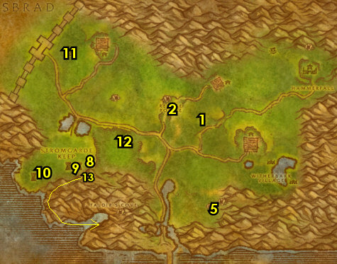

02) N/A
05) N/A
08) If you have not found the Forsaken Courier for "Hints of a New Plague?", then skip it and abandon the quest and then go to the next section below! If you did do the quest, then go SE to Go'Shek Farm and up at the ledge, turn in "Hints of a New Plague?" 60.54, accept the next part.
09) Next to you, turn in "Hints of a New Plague?" 60.54. Then accept and do the escort "Hints of a New Plague?": escort Kinelory through Go'Shek Farm.
10) Once back on top of the ledge, turn in "Hints of a New Plague?" (60.54, #8 on map), accept the next part.
#36
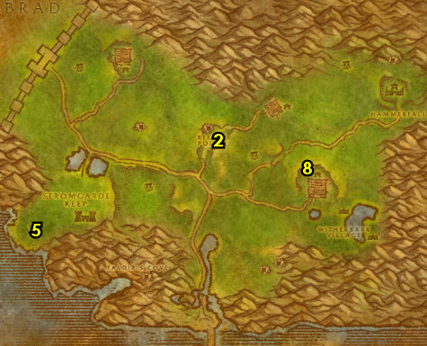

01) Hearth to Southshore.
02) Just outside of the Inn (turn in if you have it) "Hints of a New Plague?" 50.59. If it's not finished, then abandon the quest.
03) You should be level 38 or very close to it. If you are close, then go grind until you are on murlocs just SW of Southshore around 47.65.
04) N/A
05) Go north a bit (on the west side of the path) to the Gryphon Master 49.52 and if you know you can benefit from getting your level 38 spells/abilities then fly to Ironforge, Dun Morogh and get them. Then or otherwise fly to Menethil Harbor, Wetlands.
06) At Menethil Harbor, go on the docks and accept "James Hyal" 8.62.
07) Get on the boat (south on the docks 5.64) to get to Theramore.
08) At Theramore, go to the Gryphon Master 67.51, and fly to Gadgetzan, Tanaris.
09) Go to the Bank SE at Gadgetzan (hut at 52.29) and get the following items out: Kravel's Parts and Fuel Regulator Blueprints. Put the following items in the bank: your stack of Elixir of Water Breathing potions, Swim Speed Potions.
10) Go north to Mirage Raceway and at the dwarf, turn in "Parts for Kravel" (78.77 in Thousand Needles). Wait a few seconds, then accept "Delivery to the Gnomes".
11) Next to you, turn in "Delivery to the Gnomes" 78.77, accept "Martek the Exiled".
12) Next to you at the dwarf, accept "The Rumormonger" 78.77.
13) Go east to the Goblin's side and turn in "Goblin Sponsorship" 80.76, accept "The Eighteenth Pilot".
14) Next to you, turn in "The Eighteenth Pilot" 80.76, accept "Razzeric's Tweaking".
15) Go south to Gadgetzan and put the following item in the bank (52.29 in Tanaris, #7 on map): Fizzle Brassbolts' Letter.
16) Go to the Gryphon Master south of Gadgetzan 51.29 and fly to Theramore, Dustwallow Marsh..
#37
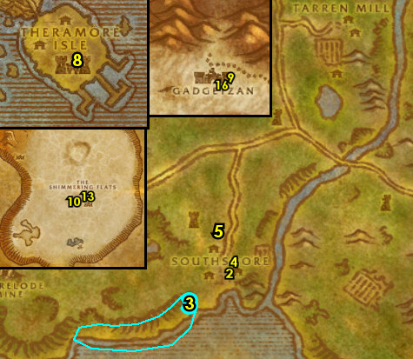
38-39 Dustwallow Marsh (log)
01) Near you when you land accept "This Old Lighthouse" 68.52.
02) Next to you accept "Traitors Among Us" 68.51.
03) At Theramore Isle start working on "Traitors Among Us": talk to 5 Deserter Agitators /target. Keep an eye out for these guys while continuing on:
04) Swim out east to the lighthouse and turn in "This Old Lighthouse" 72.47, accept "Thresher Oil".
05) Under the water around the docks at Theramore Isle around 72.51 do "Thresher Oil": kill/loot Young Murk Threshers.
06) Back at the lighthouse turn in "Thresher Oil" 72.47 (#4 on map), accept "Dastardly Denizens of the Deep".
07) On the docks turn in "Dastardly Denizens of the Deep" 69.52, accept "Is it Real?".
08) At Theramore Isle finish "Traitors Among Us": simply talk to 5 Deserter Agitators /target (#3 on map). They are spread out all around the town.
09) Back SE in town turn in "Traitors Among Us" 68.51 (#2 on map), accept "Propaganda War".
10) Go down in the boat SW at the docks and do "Propaganda War": loot the Deserter Propaganda 68.59 (crates in captain's room).
11) Back SE in town turn in "Propaganda War" 68.51 (#2 on map). Wait a moment then accept "Discrediting the Deserters".
12) Do "Discrediting the Deserters": talk to 6 Theramore Guards /target around the town (these are mostly around #3 on map). NOTE: You do not need to wait for the dialog to go by, just talk and move on.
13) Back SE in town turn in "Discrediting the Deserters" 68.51 (#2 on map), accept "The End of the Deserters".
14) Swim SE to get on the boat (ramp entrance at 77.55).
15) Go down in the boat to the captain's room and do "The End of the Deserters": attack Gavis Greyshield 76.57 /target until his health is nearly gone then the quest will complete.
16) Back SE in town turn in "The End of the Deserters" 68.51 (#2 on map).
17) North in Theramore Isle 66.46 accept "They Call Him Smiling Jim" and "Tabetha's Farm".
18) If your First Aid is 225, then go in Foothold Citadel (fortress) and at the first floor go to Doctor Gustaf VanHowzen <Trauma Surgeon> 68.49 and accept and do "Triage": use the Triage Bandage quest item right there in the room on the wounded soldiers. This quest becomes easier with Show Friendly Nameplates on. Once done, turn it in. You can then destroy the Triage Bandage in your inventory as it is no longer needed. NOTE: In WotLK, this doctor no longer advances your First Aid, you now just do that at any First Aid trainer.
19) Go upstairs in the Keep (Foothold Citadel) and turn in "James Hyal" 68.48.
20) Next to you in the room turn in "They Call Him Smiling Jim" 68.49 , accept "Inspecting the Ruins".
21) Go in the Inn (north in Theramore) and turn in (if you have it) "Morgan Stern" 66.45. Accept "Mudrock Soup and Bugs".
22) At the Innkeeper 67.45 next to the bar, make Theramore your new home.
23) NW in town accept "A Disturbing Development" 65.47.
#38
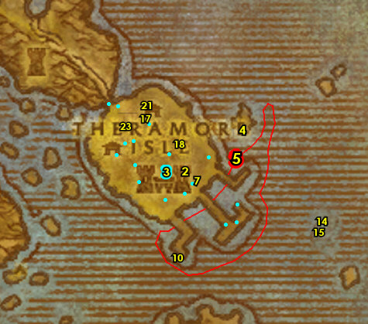

Jarl's Cabin
01) Just NW of Theramore Isle, go to Sentry Point (tower) and turn in "A Disturbing Development" 65.41 , accept "Defias in Dustwallow?".
02) Go east to the shore (starting at 65.40 and work north) to start working on "Mudrock Soup and Bugs": kill/loot turtles /target for the Forked Mudrock Tongues (can drop from any of the turtles). There are more turtles out in the water and around the small islands along the shore. Low drop rate! Work your way to do the next steps:
03) Go to the island on your right and do "Defias in Dustwallow?": kill/loot Garn Mathers (he patrols around the island 64.28 /target).
04) Go NW to Jarl's cabin 55.26 and accept "Marsh Frog Legs". Next to you at the cabin accept "What's Haunting Witch Hill?" (this NPC is either on the dock or inside the cabin).
05) Right next to Jarl's cabin, click on the Loose Dirt 55.26 to accept "The Orc Report".
06) All around Jarl's Cabin do "Marsh Frog Legs" along with "What's Haunting Witch Hill?": kill/loot Giant Marsh Frogs (frog critters /target). And kill the undead mobs (Risen Spirits and Risen Husks).
07) Back at Jarl's cabin 55.26 (#4 on map) turn in "Marsh Frog Legs", accept "Jarl Needs Eyes". Next to you at the cabin turn in "What's Haunting Witch Hill?", accept "The Witch's Bane".
08) All around the open marshlands of NE Dustwallow Marsh start working on "The Witch's Bane" by looting witchbane (plants, mostly around #6 on map), work your way to do the next steps:
09) Go west to North Point Tower and accept "Raptor Captor" 47.23.
10) Just north start working on "Raptor Captor": use the Sturdy Rope quest item on a nearly dead Bloodfen raptor (any type). Continue on with the escort quest below while doing this:
11) At the raptor area, accept and do the escort "Stinky's Escape" 47.18: escort "Stinky" Ignatz. NOTE: If he is not there, then skip this for now. You will have more opportunities to try this again later.
12) Finish "Raptor Captor": use the Sturdy Rope quest item on nearly dead Bloodfen raptors (any type, #10 on map).
13) Back at North Point Tower turn in "Raptor Captor" 47.23 (#9 on map). Accept "Prisoners of the Grimtotems" and "Unleash the Raptors".
14) Go west to Darkmist Cavern around 35.21 and do "Jarl Needs Eyes": kill/loot the Darkmist spiders for 20 eyes.
15) Go slightly south of Brackenwall Village (Horde town) and accept "Hungry!" (from the ogre at 35.38). NOTE: Hug the west mountains to avoid the Horde ogre guards.
16) Go SW to Shady Rest Inn and turn in "Inspecting the Ruins" 30.48.
17) On the ground next to you accept "Suspicious Hoofprints" 30.48.
18) In the torn down Inn, on a plank, click on the white dot to accept "Lieutenant Paval Reethe" 30.48.
19) On the fireplace accept "The Black Shield" 30.49.
20) Hearth to Theramore.
#39
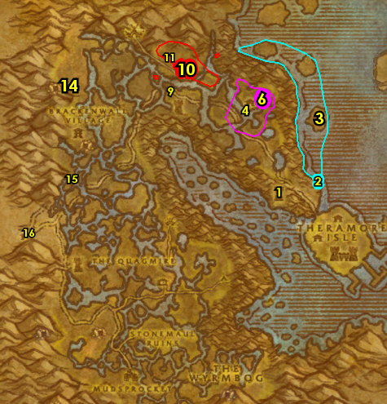

Theramore
01) In the Inn, turn in (if you did it) "Stinky's Escape" 66.45. Also turn in (if its done) "Mudrock Soup and Bugs", accept "... and Bugs".
02) NW in town turn in "The Orc Report" 65.47, accept "Captain Vimes".
03) Go up in the Keep 68.49 and turn in "Suspicious Hoofprints", "Captain Vimes", "Lieutenant Paval Reethe" (accept the next part), "The Black Shield" (accept the next part).
04) Next to you in the same room, turn in "Lieutenant Paval Reethe" 68.48, accept "Daelin's Men".
05) Go back next to you and turn in "Daelin's Men" 68.49, accept "The Deserters".
06) Exit the Keep, then go west to the Blacksmith and turn in "The Black Shield" 65.50, accept the next part. NOTE: We will turn the next part in later!
#40
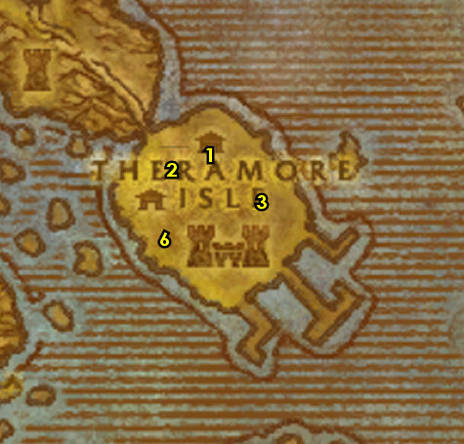

01) Just NW of Theramore Isle, go to Sentry Point (tower) and turn in "Defias in Dustwallow?" 65.47 , accept "Renn McGill".
02) If you still need to, run up the east coast (starting at 65.40 and work north) to continue working on "Mudrock Soup and Bugs": kill/loot turtles /target for the Forked Mudrock Tongues (can drop from any of the turtles). Work your way to the next steps:
03) Go to the east side of the middle island and down in the water turn in "Renn McGill" 64.17, accept "Secondhand Diving Gear".
04) At the island you are at do "Secondhand Diving Gear": loot the Tool Kit and Damaged Diving Gear (wooden box). These items have random spawns around the island around 63.19 but are usually around the tents. You may find the Damaged Diving Gear at the small wrecked boat at the island shore 62.18.
05) Back at the east part of the island in the water turn in "Secondhand Diving Gear" 64.17 (#3 on map), accept "Recover the Cargo!".
06) Do "Recover the Cargo!": open Renn's Supplies in your backpack, then equip the Repaired Diving Gear (its a head armor). Then out around the quest giver down in the water at the sea floor use the Salvage Kit quest item on 6 Shipwreck Debris. NOTE: You can spot these above the water with floating burning embers.
07) Back at the east part of the island in the water turn in "Recover the Cargo!" 64.17 (#3 on map). Accept "Jaina Must Know".
08) North at the shore around 58.16 do "Hungry!": kill/loot the Mirefin mobs (murlocs).
#41
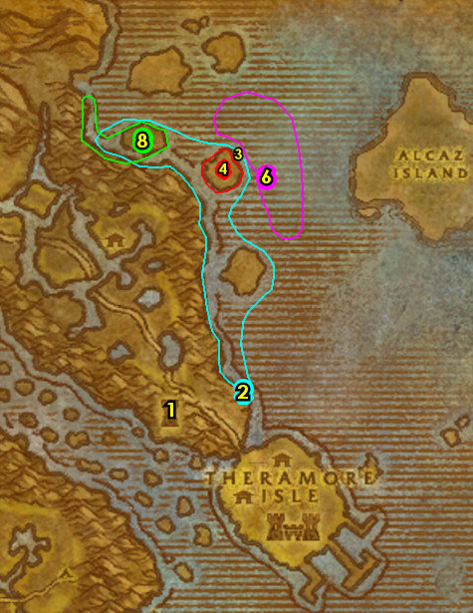

Jarl's Cabin
01) SW around Jarl's cabin ramp entrance at 58.19 continue working on "The Witch's Bane": loot witchbane (plants):
02) At Jarl's cabin turn in "Jarl Needs Eyes" 55.26, accept "Jarl Needs a Blade".
03) Just NE at Witch Hill do "Jarl Needs a Blade": kill/loot Razorspine /target patrols around 58.19. Spawns at 58.18.
04) Around Jarl's cabin finish "The Witch's Bane": loot 9 witchbane (plants, #1 on map).
05) Back at Jarl's cabin turn in "Jarl Needs a Blade" 55.26 (#2 no map).
06) At Jarl's cabin turn in "The Witch's Bane" 56.26, accept "Cleansing Witch Hill".
07) Do "Cleansing Witch Hill": at the end of the dock there at Jarl's cabin 55.27 use the Witchbane Torch quest item then kill Zelfrax (gargoyle) when he spawns.
08) Back at Jarl's cabin turn in "Cleansing Witch Hill" 56.26.
Stinky, 8b) If you have not done the escort "Stinky's Escape" 47.18: escort "Stinky" Ignatz. NOTE: If he is not there, then skip this for now. You will have one more opportunity to try this again later.
09) Go SW to the ogre (south of Brackenwall Village) and turn in "Hungry!" 35.38.
10) Go south to Lost Point (tower) and inside of it attack Balos Jacken /target (up on the ledge, 36.54) until he is down to 1/4 health, then turn in "The Deserters", accept the next part.
11) Hearth to Theramore. If Hearthstone is still on a cooldown, then go SE to the Flight Master 43.72 at Mudsprocket and fly to Theramore.
12) In the Inn, turn in (if you still need to) "Stinky's Escape" 66.45. Also turn in (if its done) "Mudrock Soup and Bugs", accept "... and Bugs".
#42
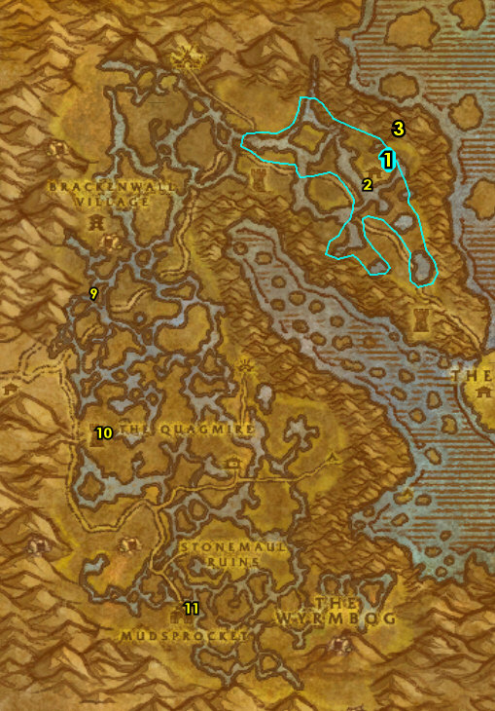

01) Go to the top of the Keep 68.49 and turn in "The Deserters" and "The Black Shield". Accept "A Grim Connection".
02) Go to the top of the wizard building and turn in "Jaina Must Know" 66.49, accept "Survey Alcaz Island".
04) NW in town accept "Mission to Mudsprocket" 65.47 (this requires lvl 39, which you should be by now).
05) LAST CHANCE FOR: If you still need to, run up the east coast (starting at 65.40 and work north) to finish "Mudrock Soup and Bugs": kill/loot turtles /target for the Forked Mudrock Tongues (can drop from any of the turtles).
06) Head NW to North Point Tower and turn in "A Grim Connection" 47.25. Accept "Confirming the Suspicion" and "Arms of the Grimtotems".
Stinky, 6b) If you have not done the escort "Stinky's Escape" 47.18: escort "Stinky" Ignatz. NOTE: If he is not there, then this will have to be skipped.
07) Go NW to Blackhoof Village and do the following 4 quests together:
08) "Unleash the Raptors": use the Raptor Bait quest item at the windmill in the middle of the village 42.12.
09) "Prisoners of the Grimtotems": kill/loot the Grimtotem (taurens) to obtain keys to open 5 cages.
10) "Confirming the Suspicion": kill/loot Grimtotem (taurens) to obtain 4 Grimtotem Notes, then click on them in your backpack.
11) "Arms of the Grimtotems": loot 7 Blackhoof Armaments (spear racks) around the village.
12) Back SW at North Point Tower 47.23 (#6 on map) turn in "Prisoners of the Grimtotems", "Unleash the Raptors".
13) Inside the tower 47.25 turn in "Confirming the Suspicion" and "Arms of the Grimtotems". Accept "Tabetha's Assistance".
#43
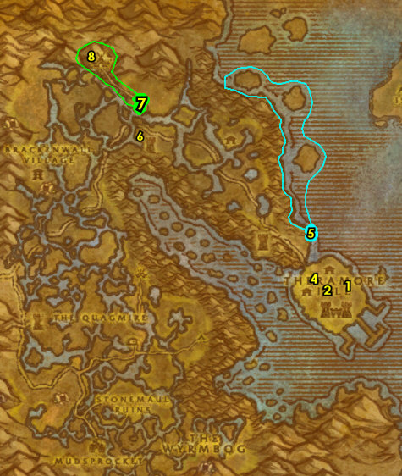

Tabetha's Farm
01) Head south to Tabetha's Farm 46.57 and inside the cabin turn in "Tabetha's Assistance" (accept "Raze Direhorn Post!") and "Tabetha's Farm". And next to you accept "The Grimtotem Weapon" and "The Reagent Thief".
02) Just outside at the side of the cabin 46.57 accept "Direhorn Raiders" and "The Zeppelin Crash".
03) Grind east to Beezil's Wreck 54.57 and turn in "The Zeppelin Crash". Accept "Corrosion Prevention" and "Secure the Cargo!".
04) Around the immediate area do "Corrosion Prevention" along with "Secure the Cargo!": stand near a Power Core Fragment to obtain a buff, then use the Ooze Buster quest item on oozes. NOTE: You don't actually need to attack the oozes. And loot 8 Zeppelin Cargo (boxes laying around). Also do the next step in the same area:
05) Go SE to Beezil's Wreck and do "Razzeric's Tweaking": loot the Gizmorium Shipping Crate (next to the crashed zeppelin, 54.56).
06) Back at Beezil's Wreck 54.57 (#3 on map) turn in "Corrosion Prevention" along with "Secure the Cargo!", accept "Delivery for Drazzit".
07) Go to the small island east and at the small dock turn in "Is it Real?" 59.60 , accept "Nat's Bargain".
08) Do "Nat's Bargain": first use the Pagle's Fish Paste, Extra Strength quest item at the quest giver then swim SW at the boat under the water around 56.63 and then kill the Lurking Shark /target that comes.
09) Back NE at the small island on the dock turn in "Nat's Bargain" 59.60 (#7 on map), accept "Oh, It's Real".
10) Go NW to Direhorn Post and do "Raze Direhorn Post!": use Tabetha's Torch quest item on the following 3 tents:
11) Burn the East Tent 48.48.
12) Burn the Northeast Tent 47.47. Also at this tent kill/loot Apothecary Cylla , she drops an item which starts "The Apothecary's Letter", accept it.
13) Burn the North Tent 47.46.
14) Around Direhorn Post finish "Direhorn Raiders": kill 12 Grimtotems (taurens of any type).
15) Around The Quagmire around 45.49 do the next 2 quests together:
16) "The Reagent Thief": kill/loot Noxious Shredders (green serpents) or Darkfang Creepers (orange spiders).
17) "The Grimtotem Weapon": use the Captured Totem quest item at the Mottled Drywallow Crocolisk or a Drywallow Daggermaw, then kill them. NOTE: The crocs must be pulsed by the totem on death to get credit.
18) Back at Tabetha's Farm on the small dock turn in "The Apothecary's Letter" 45.58 (next to #1 on map).
19) Inside the cabin 46.57 (#1 on map) turn in "Raze Direhorn Post!", accept "Justice for the Hyals". And next to you turn in "The Grimtotem Weapon" and "The Reagent Thief".
20) Just outside at the side of the cabin 46.57 turn in "Direhorn Raiders".
#44
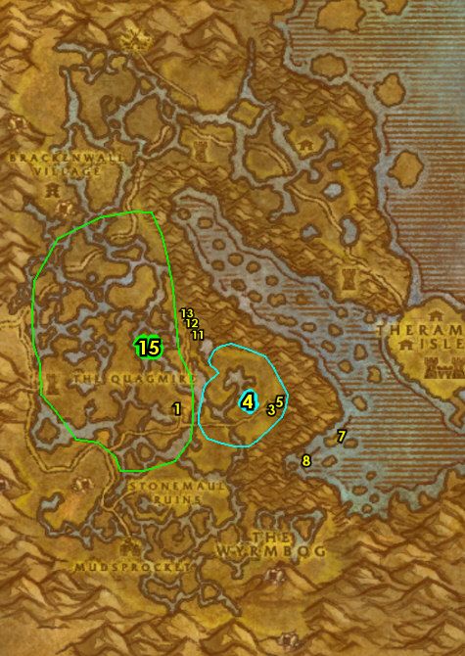

Mudsprocket
01) Go SW to Mudsprocket (neutral goblin town starting at TBC) and in the hut 42.73 turn in "Delivery for Drazzit" and "Mission to Mudsprocket".
02) From the Wanted Poster at the bottom of the steps accept "WANTED: Goreclaw the Ravenous" 42.73.
03) Next to you by the green containers accept "Catch a Dragon by the Tail" 42.73.
04) In the Inn accept "Bloodfen Feathers" 42.74.
05) Go NW to Bloodfen Burrow around 34.65 and do "Bloodfen Feathers" along with "WANTED: Goreclaw the Ravenous": kill/loot the Bloodfen raptors. And kill Goreclaw the Ravenous (big gray raptor /target).
06) Go back SE to Mudsprocket and in the small hut turn in "WANTED: Goreclaw the Ravenous" 42.73 (#1 on map).
07) In the Inn turn in "Bloodfen Feathers" 42.74 (#4 on map). Accept "Banner of the Stonemaul" and "The Essence of Enmity".
#45
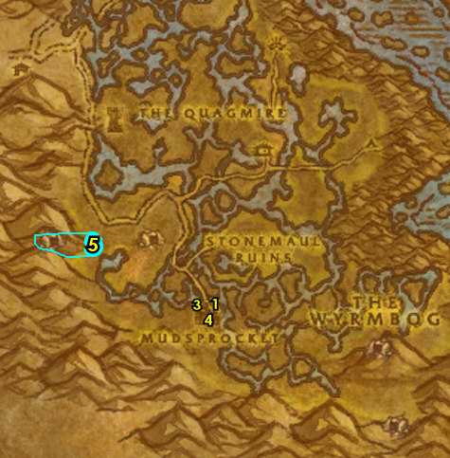

01) Go NW to The Den of Flame entrance at 40.67 and start working on "The Essence of Enmity" use the Brogg's Totem quest item on Fireman dragon corpses. While doing this continue on:
02) Enter the cave at The Den of Flame (entrance at 38.66).
03) Go to the end of the cave and do "Banner of the Stonemaul": loot the Stonemaul Clan Banner 38.69.
04) Finish "The Essence of Enmity": use the Brogg's Totem quest item on Firemane dragon corpses. These can also be found around #6 on map.
05) Back at Mudsprocket in the Inn turn in "Banner of the Stonemaul" and "The Essence of Enmity" 42.74 . Accept "Spirits of Stonemaul Hold".
06) NE at Stonemaul Ruins around 45.66 do "Spirits of Stonemaul Hold": click on the Ogre Remains (skeletons on the ground), then kill the ogre spirits that spawn.
07) Back in the Inn at Mudsprocket turn in "Spirits of Stonemaul Hold" 42.74 (#5 on map), accept "Challenge to the Black Flight".
08) Start working on "Catch a Dragon by the Tail" by looting any Wyrmtail (plants) you see along the way:
09) Go SE to the entrance of Onyxia's Lair and do "Challenge to the Black Flight": use the Stonemaul Banner quest item at the entrance 52.76. Then kill the dragon that spawns.
10) Work your way back NW to Mudsprocket while finishing "Catch a Dragon by the Tail": loot 8 Wyrmtail (plants). These are found all around Wyrmbog (#8 on map).
11) Back at Mudsprocket by the green containers turn in "Catch a Dragon by the Tail" 42.73 .
12) In the Inn turn in "Challenge to the Black Flight" 42.74 (#5 on map).
13) At the NE outskirts of Mudsprocket, go to the Flight Master 43.72 and fly to Theramore, Dustwallow Marsh.
#46
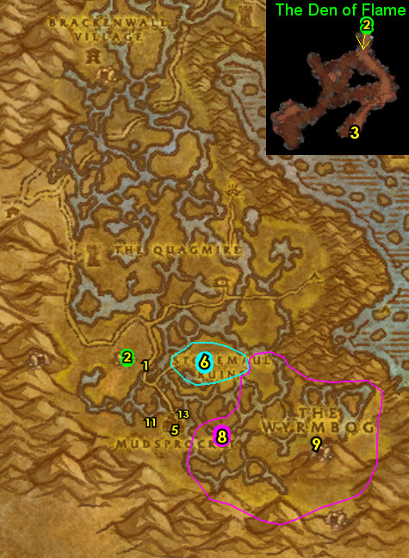

01) When you land do "Survey Alcaz Island": talk to Cassa Crimsonwing /target 67.51 to send you on a gryphon ride.
02) On the docks at Theramore turn in "Oh, It's Real" 70.52, accept "Take Down Tethyr!".
03) There on the docks do "Take Down Tethyr!": use the 3 Cove Cannons around the dock to fire and kill Tethry in the water. TIP: Tethry does a splash attack at every 2nd cannon shot you do at him that could knock you back. For every 2nd shot use the cannon closest to the quest giver at 70.52 , so you wont be knocked back into the water, giving you a faster time to recover.
04) On the docks turn in "Take Down Tethyr!" 70.52 (#2 on map).
05) Go up in the Keep and turn in "Justice for the Hyals" 68.49, accept "Peace at Last".
06) Go to the top of the wizard building and turn in "Survey Alcaz Island" 66.49 .
07) If you still need to: Go in the Inn and turn in "Stinky's Escape" 66.45, and "Mudrock Soup and Bugs" 66.45, accept "... and Bugs".
08) Go to the graveyard just NW of Theramore and do "Peace at Last": use the Wreath quest item on the Hyal Family Monument (grave 64.43).
09) Back up in the Keep turn in "Peace at Last" 68.49 (#5 on map). Dustwallow Marsh is finally finished, phew!!!!
10) South in the town, from the Gryphon Master 67.51, fly to Ratchet, The Barrens.
11) At the Ratchet Bank 63.37, get out the following item: Sample Elven Gem. And put the following items in the bank: Seaforium Booster.
12) Go on the dock to get on the boat to go to Booty Bay 64.39.
#47
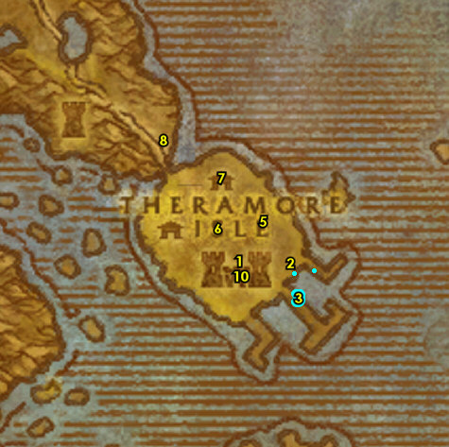
39-40 Stranglethorn Vale (log)
01) Once at BB, follow the lower docks and then accept "The Bloodsail Buccaneers" 28.76.
02) Go in the small cabin (next to the hanging shark) and accept "Scaring Shaky" 28.77.
03) Go in the Inn and make BB your new home 27.77.
04) Go upstairs in the Inn 27.77 and turn in "The Rumormonger", accept "Dream Dust in the Swamp".
06) Next to you, from Baron Revilgaz 27.77, accept "Water Elementals".
07) If you have all the pages for the "The Green Hills of Stranglethorn" quest then get them out now in your bank or mailbox 27.76. This quest requires that you have the following pages: 1, 4, 6, 8, 10, 11, 14, 16, 18, 20, 21, 24, 25, 26, and 27. You can also find these pages in the AH or from other players. If you have all of them, get them out now. If not, you will have a few more chances later to complete this optional quest.
08) N/A
09) Go north to the river (starting at 38.31) and do "Some Assembly Required": kill/loot Snapjaw Crocolisks along the river (until 40.15).
10) Go west to the island around 22.23 and do "Water Elementals": kill/loot Lesser Water Elementals.
11) N/A
12) Make sure you are level 39 right now, if not grind until you are.
#51
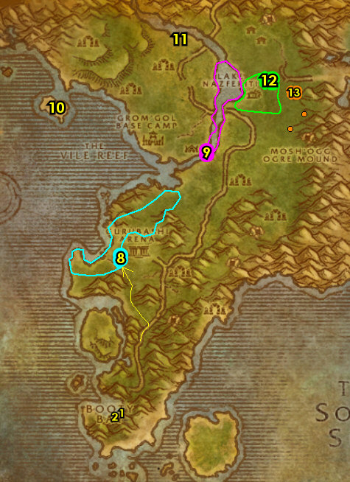

01) Hearth to Booty Bay.
02) Go to the top of the Inn and up at the boat-deck, from Baron Revilgaz, turn in "Water Elementals" (up at 27.77), SKIP "Magical Analysis" (for now).
03) Stay up on the docks and over past the FP to Tan-Your-Hide Leatherworks, turn in "Some Assembly Required" 28.78, accept "Excelsior".
04) Make sure you are repaired/resupplied.
05) Go NE to Mistvale Valley around 32.67 and do "Scaring Shaky": kill/loot the Elder Mistvale Gorillas.
06) Go just slightly NW of BB and clear the Bloodsail mobs from the area, then click on the Bloodsail Correspondence scroll (on the barrel 27.70) to turn in "The Bloodsail Buccaneers", accept the next part. (See Video)
07) It's time to do the 39-40 grind. Keep grinding on Jungle Stalkers & Cold Eye Basilisks around 33.41 or the Venture Co. mobs around 41.44 until you are 72,600 XP into lvl 39 or 13,100 XP away from 40, then Hearth to Booty Bay. You can also grind on Venture Co. Geologist around 44.20, or Murkgill murlocs around 34.22 NOTE: Instead of the solo grinding, you could get a 5 man group to do the Scarlet Monastery dungeon. If things get to messy in STV, you can also go grind Boulderfist ogres in Arathi Highlands at around 52.76 or around 32.44. (but do the first four steps in the next section first).
#52
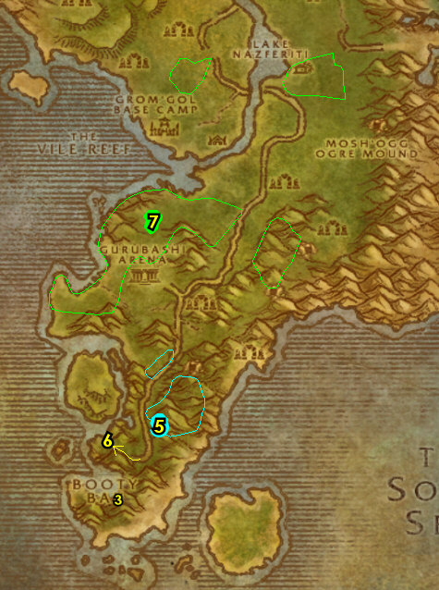

01) At Booty Bay, on the lower docks towards the boat drop off, turn in "Scaring Shaky" 27.74, accept "Return to MacKinley".
02) Follow the lower docks and turn in "The Bloodsail Buccaneers" 28.76, accept the next part.
03) Go in the cabin (next to the hanging shark) and turn in "Return to MacKinley" 28.77, SKIP "Voodoo Dues" (for now).
04) Go all the way upstairs in the Inn (on the boat-deck) and turn in "The Bloodsail Buccaneers" 27.77, SKIP the next part (for now).
05) You should be level 40 now, if not grind until you are.
06) Go up to the Gryphon Master 28.78 and fly to Ironforge, Dun Morogh.
07) N/A
08) And get the following items out of the bank 35.62: Fizzle Brassbolts' Letter, (if you can) stack of 9 Blue Pearls. And if you have a Frost Oil and Gyrochronatom in your bank, mailbox or AH 25.73, get them out now. NOTE: You can see if you can buy a Gyrochronatom from the NPC in Ironforge 68.43. If you were able to get them, you can also benefit from obtaining a Healing Potion, Lesser Invisibility Potion and a Patterned Bronze Bracers. All these items are used for easy turn-in quests in the Badlands. And remember to not sell these items to a vender.
09) Turn in any cloth donations if you have them at Dwarves 43.32 and at Gnomes 74.48.
10) N/A
GET NEW ABILITIES, 10a) Get new spells/abilities in Ironforge.
EPIC MOUNT? 10b) EPIC MOUNT: At level 40 epic ground mounts become available, and only cost about 12 gold. For more info go here.
11) Go to the middle of Ironforge to the Gryphon Master 55.48 and fly to Thelsamar, Loch Modan. First go to the Gryphon Master56.48 and fly to Thelsamar, Lock Modan. DRAENEI ONLY: Draenei who did Bloodmyst Isle will have to manually run all the way to Thelsamar to get the Flight Path there by first exiting Ironforge (exit at 15.86). Then enter and go through South Gate Pass entrance 82.53, then the other one entrance 17.59. Then head north in Lock Modan to get the Flight Path from the Gryphon Master 34.51.
40-41 Badlands
First Pick the Class you are playing top left of screen!!!
Along with the Game Version you are playing on (Era, SoM, TBC or WotLK)
01) At Loch Modan, go in the Inn (building with all the big barrels around it) and from the first NPC you see make Stoutlager Inn (Thelsamar) your new home 36.48.
02) Go in the small house just east of the Inn and accept "Badlands Reagent Run" 37.49.
03) Go east in Loch Modan to Ironband's Excavation Site and turn in "Ironband Wants You!" 66.66, accept "Find Agmond".
04) Head south into Badlands (47.82 in Loch Modan)..
05) Go south to the small dwarf camp 54.43 and accept "Fiery Blaze Enchantment", "Mirages" and (next to you) "A Dwarf and His Tools".
06) Grind your way SW to Valley of Fangs 42.53 and turn in "Martek the Exiled", accept "Indurium". Next to you, accept "Barbecued Buzzard Wings". And if you have 9 Blue Pearls with you, accept and turn in "Pearl Diving".
07) Go SE a bit to Agmond's End and from the Battered Dwarven Skeleton 51.62, turn in "Find Agmond", accept "Murdaloc".
08) Go south a bit around 52.67 and do "Indurium" along with "Murdaloc": kill/loot the Stonevault mobs for the Indurium Flakes, kill 12 Stonevault Bonesnappers and Murdaloc /target (at 50.66 back in the camp next to an outhouse).
09) Go back north to Valley of Fangs and turn in "Indurium" (42.53, #6 on map), wait a few seconds then accept "News for Fizzle". Make sure you are repaired/resupplied.
#01
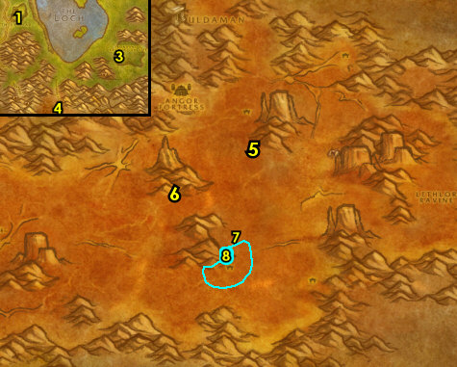

01) Go NW to The Dustbowl, and at the gnome 26.45, accept "Study of the Elements: Rock". If you have a Frost Oil item, accept and complete the quest "Coolant Heads Prevail". Then if you have a Gyrochronatom item, accept and complete the quest "Gyro... What?".
WOLK, 1b) Also, if you completed "Gyro... What?" and you have a Healing Potion and a Lesser Invisibility Potion with you, accept and complete "Liquid Stone" 26.44.
02) Do "Study of the Elements: Rock" kill/loot Lesser Rock Elementals up north on the cliffs around 20.44.
03) Go to The Dustbowl at the gnome (26.45, #1 on map) and turn in "Study of the Elements: Rock", accept the next part.
04) Grind your way down south and do "Study of the Elements: Rock": kill/loot Rock Elementals around 37.75.
05) Grind your way north to The Dustbowl at the gnome (26.45, #1 on map) and turn in "Study of the Elements: Rock", accept the next part.
06) Do "Barbecued Buzzard Wings": kill/loot Buzzards. There is a large amount of Giant Buzzards at 17.60. And remember to not sell the Buzzard Wings to a vendor.
07) Go south and do "Study of the Elements: Rock": kill/loot Greater Rock Elementals around 14.86, and more around 4.79.
08) Go north to The Dustbowl at the gnome (26.45, #1 on map) and turn in "Study of the Elements: Rock". If it's available, accept "This Is Going To Be Hard", and turn it in right next to you and accept the next part. Turn that in right next to you and accept the next part. Kill/loot the Fam'retor Guardian that spawns in. Then turn it in.
10) And also if you have a Patterned Bronze Bracers with you, accept (if it is available) "Stone Is Better than Cloth", then turn it in.
11) Go east (in the middle of Badlands) and turn in "Barbecued Buzzard Wings" 42.53. Make sure you are repaired/resupplied.
12) Go NE to Hammertoe's Digsite and under a canopy, next to a table, from a Crumpled Map on the ground 53.34, accept "A Sign of Hope".
13) In the immediate area around the Digsite do "A Dwarf and His Tools": kill/loot Shadowforge mobs (dwarves) until the Ryedol's Lucky Pick drops.
#02
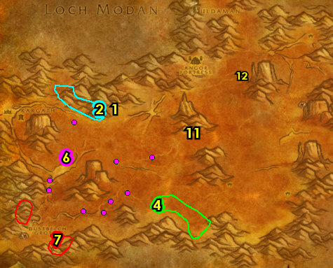

01) Go NE to Camp Kosh and do "Mirages": loot the Excavation Supply Crate 67.23. This could be at random spots around the camp.
02) Go SE to Lethlor Ravine (path entrance at 67.30) and do "Fiery Blaze Enchantment" (Elite): kill/loot the dragon whelps until the Black Drake's Heart drops (very low drop rate). NOTES: Watch out as you get deeper into the ravine there are high level elite dragons, but the whelps are easy to take down. There are more whelps down south in the ravine around 75.67. The elite dragons have a higher % droprate for the item though (I was able to solo the 43 elites as a lvl 40 hunter). The droprate is so bad (for at least the whelps) that if after you have grinded to lvl 41 you can skip the quest if you have not found the item by then.
03) Go west to the small dwarf camp 54.43 and turn in all quests: (if its done) "Fiery Blaze Enchantment", "Mirages" (accept "Scrounging"), "A Dwarf and His Tools" and "A Sign of Hope", SKIP the next part, (Dungeon).
04) Go south a bit to Garek (blood elf, male) and accept "Tremors of the Earth" 62.54.
05) As you do the following quests, keep an eye out for Boss Tho'grun /target (for the quest "Tremors of the Earth"). This ogre patrols in a large circle counter-clockwise around the SW part of Badlands. He has 5 bodyguards. (See Video). NOTE: You can focus on the next steps until he shows up...
#03
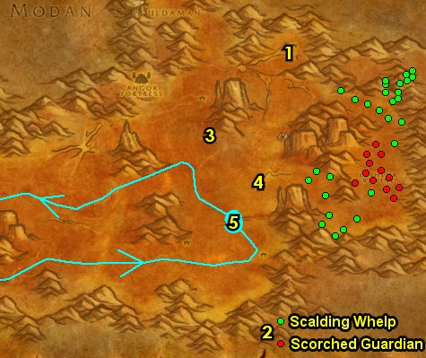

01) Go south a bit more to Camp Boff around 62.69 and start working on "Scrounging": kill/loot the ogres for the Scrap Metal. The scrap can drop from any ogre in Badlands. When you run out of ogres to kill, work west to the next step:
02) As you work west to Camp Cagg around 10.78 watch out for Boss Tho'grun (#3 on map) along the way, then finish "Scrounging": kill/loot ogres for the Scrap Metal.
03) Go east along Boss Tho'grun /target patrol path and do "Tremors of the Earth": kill/loot Boss Tho'grun. This ogre patrols in a large circle counter-clockwise around the SW part of Badlands. He has 5 bodyguards. (See Video).
04) Go east to Garek (night elf) and turn in "Tremors of the Earth" 62.54, SKIP the next part (high lvl Elite).
05) Go NW to the small dwarf camp and turn in "Scrounging" 54.43.
06) Make sure "Badlands Reagent Run" is finished. It should have gotten completed by doing all the other quests in Badlands.
07) Hearth to Stoutlager Inn (Thelsamar). Make sure you are resupplied.
08) Go in the small house just east of the Inn and turn in "Badlands Reagent Run" 37.49.
09) Go east in Loch Modan to Ironband's Excavation Site and turn in "Murdaloc" 66.66, SKIP "Agmond's Fate" (Dungeon).
10) Go to the Gryphon Master (SW in Thelsamar 34.51) and fly to Stormwind, Elwynn.
#04
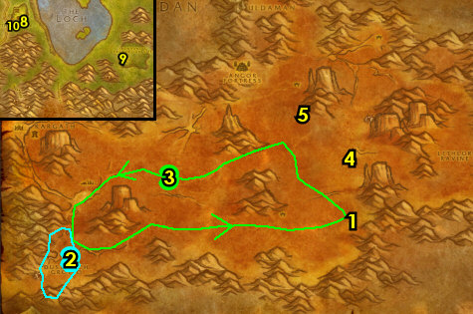

01) At Stormwind, go to the bank 63.78 and get out the following items: any extra cloth for cloth donations.
02) Go NE to The Dwarven District and in the tavern accept "In Search of The Temple" 69.40.
03) N/A
04) N/A
05) Just off The Canals, go in the small library and accept "Mazen's Behest" 52.74.
06) Just upstairs, turn in "Mazen's Behest" 51.74, accept the next part.
07) If you have cloth donations to turn in, you can do so in Duncan's Textiles upstairs 54.82.
09) At The Mage Quarter, go up the spiral ramp entrance 49.88 to Wizard's Sanctum and accept "Vital Supplies".
10) Go east to the Gryphon Master 71.73 and fly to Darkshire, Duskwood.
#05
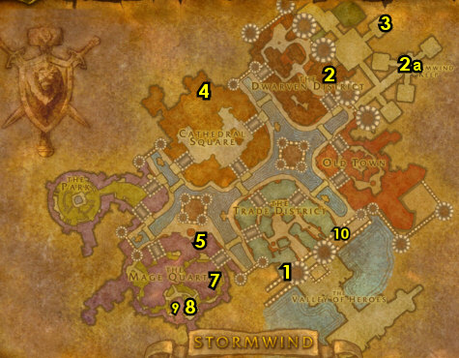

41-42 Swamp of Sorrows
01) At Darkshire, go in the Inn and from the Innkeeper 74.44 make Darkshire your new home.
02) In front of the big house (north of the path), turn in "Vital Supplies" 76.46, SKIP "Supplies for Nethergarde" (for now).
03) Run east through Deadwind Pass, follow the main path and then make a left into Ariden's Camp (52.38 in Deadwind Pass) just to discover it for XP.
04) Continue east into Swamp of Sorrows (SoS)... 14.60
05) While questing through out SoS keep an eye out for swamp elementals and kill/loot them for "Mazen's Behest". You only need one item, but it is a very low drop rate:
06) As you enter SoS start working on "Dream Dust in the Swamp": kill/loot the dragon whelps around the lake (around 14.60 in SoS) for the dream dust. Just clear the whelps in this area once. When you run out of whelps to kill, move on to the next steps (You can revisit this area later):
07) Go east a bit to Watcher Biggs 27.60 and accept "Encroaching Wildlife".
08) Right around the immediate start working on "Encroaching Wildlife": kill Young Sawtooth Crocolisks, Sorrow Spinners (spiders) and Swamp Jaguars (cats). While doing this, work your way to the next 2 steps:
09) Go north and then find and kill/loot Noboru the Cudgel /target. See patrol path on map (spawns at 47.39). He drops an item which starts "Noboru the Cudgel", accept it.
10) Go to 46.36 and see if there is a Scattered Crate there (its next to the river) and loot the item inside to accept "The Lost Supplies". If its not there, you will have another opportunity later, also keep an eye out for it as you continue on if you have not got it yet.
11) Go NW to The Harborage and turn in "Noboru the Cudgel" 26.31. Accept "Draenethyst Crystals" (no exclamation mark). NOTE: You can get resupplied here from Masat T'andr /target.
TBC, 11a) Next to you accept "Mercy for the Cursed" 26.32.
12) Go NW to Misty Valley around 15.39 and clear the swamp elementals there to see if you can get the item for "Mazen's Behest". If you can't find it, just move on:
14) Finish "Encroaching Wildlife" (#8 on map), then turn it in back at Watcher Biggs (27.60, #7 on map) and accept "The Lost Caravan".
#06
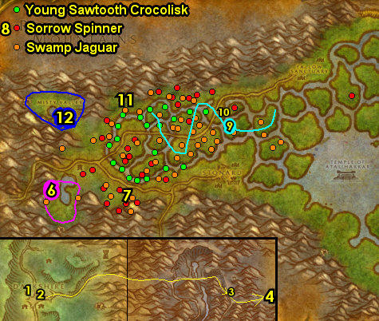

01) Go NE to Fallow Sanctuary and start working on "Draenethyst Crystals": loot the Draenethyst Crystals around the village while working your way to the broken down caravan NE in the sanctuary and loot the Caravan Chest 64.18 for "The Lost Caravan". Also if you haven't yet, keep an eye out for a Scattered Crate and accept "The Lost Supplies" from the item inside.
02) Next to you at the human /target in the cage 65.18, accept and do the escort "Galen's Escape". Also finish "Draenethyst Crystals" along with "Mercy for the Cursed": loot the Draenethyst Crystals around the village and also kill 3 Cursed Lost Ones.
03) Above Stonard (horde town), at Galen's Strongbox (next to a tent 48.40), turn in (if you were able to do it) "Galen's Escape".
04) Go west to The Harborage and turn in "Draenethyst Crystals" 26.31. Next to you turn in "Mercy for the Cursed". NOTE: You can get resupplied here from Masat T'andr /target.
05) If you still need to, go NW to Misty Valley around 15.39 and clear the swamp elementals there to see if you can get the item for "Mazen's Behest". If you can't find it, just move on:
06) Go south to Watcher Biggs 27.60 and turn in "The Lost Caravan", accept "Driftwood".
07) Go south on the main path to go into Blasted Lands (entrance at 33.68 in SoS)..
08) As soon as you enter Blasted Lands, immediately go SE (off the path) to get to Nethergarde Keep. At the blacksmith 66.17, make sure you are repaired/resupplied.
09) If its finished, turn in "Mazen's Behest" up in the tower 68.19.
10) At the stables, turn in "The Lost Supplies" 67.21.
11) At the south end of town, go up the spiral wood tower and from the Gryphon Master 66.24, fly to Darkshire, Duskwood.
12) At Darkshire, in front of the big house, accept "Supplies for Nethergarde" 76.46.
13) Go east a bit to the Gryphon Master (up at 77.44) and fly to Nethergarde Keep, Blasted Lands.
14) At Nethergarde Keep, at the stables, turn in "Supplies for Nethergarde" (67.21, #10 on map).
#07
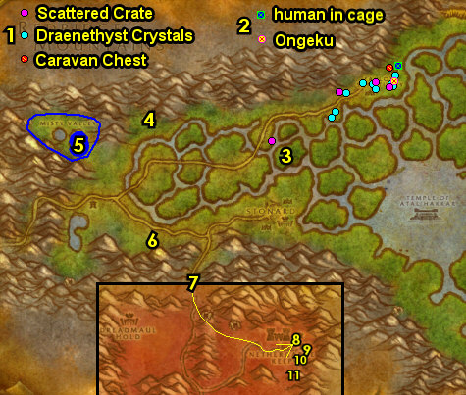

01) Run back north into SoS (52.5 in Blasted Lands) then start heading east, you can go south of the Horde town Stonard, you will have to run past a few high level guards...
02) Go just north and jump in the water towards Temple of Atal Hakkar 65.56 to get it discovered for "In Search of The Temple". And if you need to, finish "Dream Dust in the Swamp" by kill/looting the dragons around the Temple of Atal'Hakkar lake (Pool of Tears).
03) Continue east to the shore around 84.85 and do "Driftwood" along with "... and Bugs": work your way north along the shore and kill/loot crabs for the 12 Pristine Crawler Legs and loot the Sundried Driftwood.
04) Hearth to Darkshire. Make sure you are repaired/resupplied.
05) If you have a mount, then Mount east through Deadwind Pass then into SoS and at Watcher Biggs (27.60 in SoS) turn in "Driftwood", accept "Deliver the Shipment". OR: If you do not have a mount, then go east a bit to the Gryphon Master (up at 77.44) and fly to Nethergarde Keep, Blasted Lands, then head north to SoS and at Watcher Biggs (27.60 in SoS) turn in "Driftwood", accept "Deliver the Shipment".
06) If you still need the item for "Mazen's Behest", then go NW to Misty Valley around 15.39 and clear the swamp elementals there to see if you can get it. If you found the item and still need to turn in "Mazen's Behest", then keep grinding on any mobs until you are 1.5 bars away from lvl 42. Or if you have already turned in "Mazen's Behest" or have not found the item for it, then keep grinding until you are 1 bar away from lvl 42 before continuing..
07) Go back south into Blasted Lands, then go to Nethergarde Keep and (if you need to), go up in the tower and turn in "Mazen's Behest" 68.19.
08) At the stables, turn in "Deliver the Shipment" 67.21.
09) At the south end of town, go up the spiral wood tower and from the Gryphon Master 66.24, fly to Stormwind, Elwynn.
10) At Stormwind, go to the Bank 63.78 and put the following items in the bank: 12 Pristine Crawler Legs. And get out of the bank: (if you still need to and have it) 4 Lesser Bloodstone Ore (used for a quest in STV).
11) Go north to the Dwarven District and turn in "In Search of The Temple" 69.40, accept "To The Hinterlands".
GET NEW SPELLS/ABILITIES, 11b) You should be level 42 now. Get new spells/abilities.
12) Hearth (if you can), then at the Gryphon Master 77.44 fly to Booty Bay, STV. If you cannot hearth, then go to the Gryphon Master 71.73 in Stormwind and fly to Booty Bay, Stranglethorn.
#08
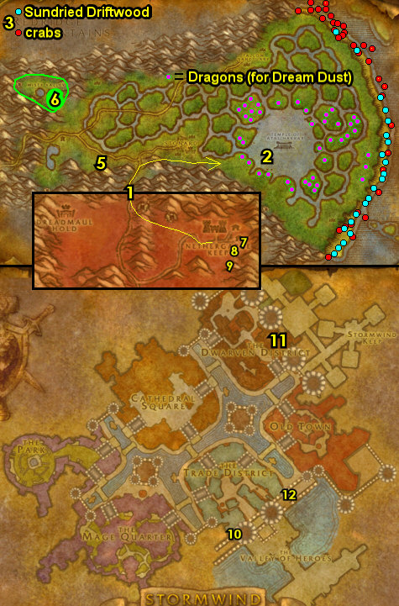

42-43 Stranglethorn Vale
01) At Booty Bay, upstairs in the Inn, turn in "Dream Dust in the Swamp" 27.77, wait a few seconds then accept "Rumors for Kravel":
02) Next to you from the dwarf, accept "Up to Snuff".
03) NOTE: If you still need to, and if you have 4 Lesser Bloodstone Ore with you, accept and turn in "Favor For Krazek", then accept "Return to Corporal Kaleb".
04) Next to the steps, accept "Skullsplitter Tusks".
05) Up on the boat-deck, from Fleet Master Seahorn 27.77, accept "The Bloodsail Buccaneers".
06) Drop down in the Inn and make BB your new home 27.77. Make sure you are repaired/resupplied.
07) Next to you 27.77, accept "Venture Company Mining" and "Zanzil's Secret".
08) Go next to the bank/mailbox and accept "Akiris by the Bundle" 27.76.
Green Hills, 8a) If you have all the pages for "The Green Hills of Stranglethorn", then get them out now. This quest requires that you have the following pages: 1, 4, 6, 8, 10, 11, 14, 16, 18, 20, 21, 24, 25, 26, and 27. You can also find these pages in the AH or from other players.
09) In the cabin (next to the hanging shark), accept "Voodoo Dues" 28.77.
10) Go up the docks and from Dizzy One-Eye, accept "Keep An Eye Out" 29.76.
11) Just east of BB along the shore, do "The Bloodsail Buccaneers" along with "Up to Snuff" and "Keep An Eye Out": kill/loot the Bloodsail mobs for the Snuff along with Dizzy's Eye. They can drop from any Bloodsail mob (low drop rates). Also, kill 10 Bloodsail Swashbucklers. And loot the Bloodsail Orders on the small boat 28.83 or it could be on the table 27.83 at the camp at the end of the beach (or at other spots at the camps). And next to you, loot the Bloodsail Charts 27.83 on top of the box next to the eastern most tent (See Image for Possible Locations). It could also be at other spots at the various camps along the beach.
12) Go west (follow path on map) and do "Akiris by the Bundle": kill/loot the Naga Explorers (starting at 25.64). Medium drop rate.
13) N/A
#09
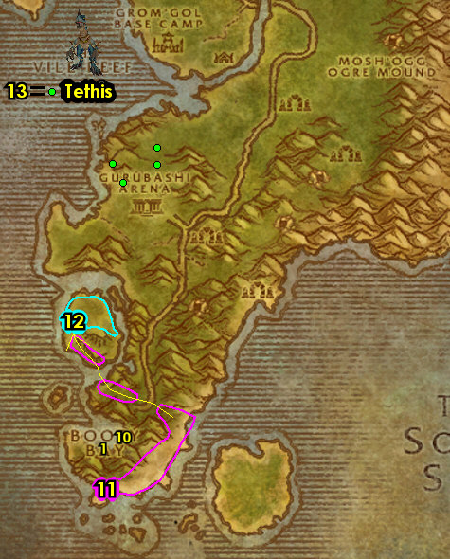

01) Go east across the path to the Ruins of Jubuwal and do "Zanzil's Secret" along with "Voodoo Dues": kill/loot the Zanzil mobs for Zanzil's Mixture and kill/loot the 3 named mobs. Maury "Club Foot" Wilkins /target 35.51. See next steps for the other 2 mobs to kill/loot...
02) Kill/loot Jon-Jon the Crow /target 35.52 by the Bonfire.
03) Kill/loot Chucky "Ten Thumbs" /target at the other Ruins path entrance 34.54 mob is at 40.58, see map on how to get there.
04) Go north a bit to the ledges around 41.44 and do "Venture Company Mining": kill/loot the Venture Co. (goblins).
Green Hills, 4b) If you have all the pages for "The Green Hills of Stranglethorn", then go to Nesingwary's Expedition, and accept and turn this in 36.11. NOTE: You will have another chance later to turn this in if you do not have all the pages now. Then you can get repaired/resupplied at the camp.
05) Go NE to Rebel Camp and turn in (if you have it) "Return to Corporal Kaleb" 38.3.
06) Next to you, accept "Colonel Kurzen" 38.3. NOTE: You can get resupplied next to you.
07) Go east and enter The Stockpile (cave entrance at 46.8)..
08) In the cave, try to do "Colonel Kurzen": hug the right of the cave until you get to the end of the cave, then kill/loot Colonel Kurzen /target ( at 50.4). Also, along the way, make sure you kill 6 Kurzen Elite and 4 Kurzen Subchief.
09) Exit the cave 46.8.
10) Go north to Rebel Camp and turn in (if you did it) "Colonel Kurzen" (38.3, #5 on map). NOTE: You can get resupplied next to you.
11) Next to you at the camp, accept "Kurzen's Mystery" 38.4.
#10
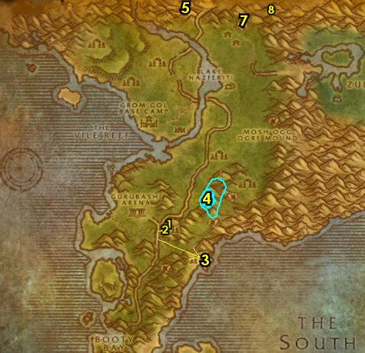

01) N/A
02) Go SW to Bal'lal Ruins and do part of "Kurzen's Mystery": loot the Moon Over the Vale tablet 29.19.
03) West at the shore do "Excelsior": kill/loot an Elder Saltwater Crocolisk /target. There are 4 possible spawn locations, see map (one spawns at 29.22). You should only need to kill/loot one of them. Also these share spawns with the Saltwater Crocolisks, so you may need to kill some of them first.
04) Go west under the sea at The Vile Reef and do part of "Kurzen's Mystery": loot the Gri'lek the Wanderer tablet 25.23.
05) Go north to the Ruins of Zul'Kunda and go up the mountain cliff (shortcut at 23.14)..
06) Go up the dirt slope and do part of "Kurzen's Mystery": loot the Fall of Gurubashi tablet 23.12. Watch out there are about 5-6 lvl 34-35s!
07) Work your way up in the Ruins of Zul'Kunda and do the last part of "Kurzen's Mystery": loot the The Emperor's Tomb tablet 25.9.
08) Go east to Rebel Camp and turn in "Kurzen's Mystery" 38.4, accept "Troll Witchery". Make sure you are resupplied.
09) Go south to the troll Ruins around 46.32 and do "Skullsplitter Tusks" along with "Troll Witchery": kill/loot Skullsplitter Mystics or Skullsplitter Witch Doctors for the 4 Skullsplitter Fetishes and kill/loot any Skullsplitter trolls for the tusks. There is more mobs just SW at the other Ruins around 42.36 and more south at 47.41.
11) Go north to Rebel Camp and turn in "Troll Witchery" (38.4, #8 on map).
12) Hearth to Booty Bay.
#11
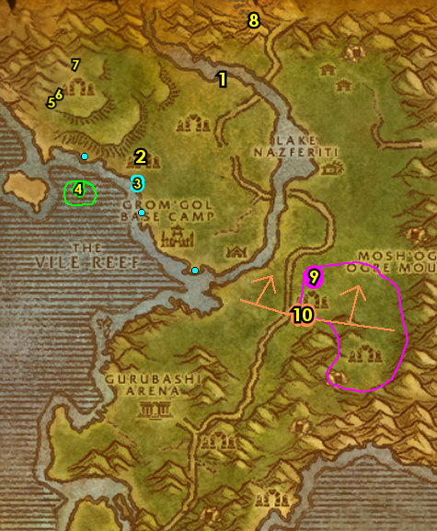

01) Next to you in the Inn, turn in "Venture Company Mining" and "Zanzil's Secret" 27.77.
02) Go up in the Inn and turn in "Skullsplitter Tusks" and "Up to Snuff". Also accept (if available) "Tran'rek".
03) Up at the boat-deck, turn in "The Bloodsail Buccaneers" 27.77, SKIP the next part (for now).
04) Next to you from Baron Revilgaz 27.77, accept "Magical Analysis" (no exclamation mark).
05) Stay up on the docks and over past the FP to Tan-Your-Hide Leatherworks, turn in "Excelsior" 28.78.
06) Drop down by the bank/mailbox and turn in "Akiris by the Bundle" 27.76. Accept the next part.
07) Go in the cabin (next to the hanging shark) and turn in "Voodoo Dues" 28.77. Accept "Stoley's Debt".
08) Go north up the docks and from Dizzy One-Eye, turn in "Keep An Eye Out" 29.76.
09) Make sure you are repaired/resupplied (just north a bit in the huts 29.75).
10) Get on the boat at the end of docks 26.73 to go to Ratchet.
11) Go to Ratchet's Bank 63.37 and get the following items out: 12 Pristine Crawler Legs. Put in the bank: Bag of Water Elemental Bracers.
12) Go to the Flight Master (63.37 in The Barrens) and fly to Theramore, Dustwallow Marsh.
13) At Theramore, turn in "Akiris by the Bundle", this NPC is either next to you where you land 68.52 or on the docks 69.53.
14) Go in the Inn and turn in "... and Bugs" 66.45.
16) N/A
17) From the Gryphon Master 67.51, fly to Gadgetzan, Tanaris.
#12
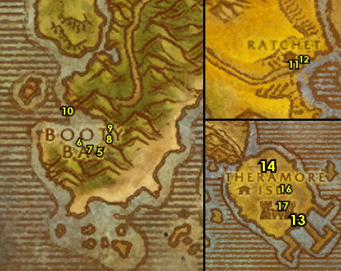

PLEASE READ: With all the faster leveling changes, by the time you get to this section you will most likely be well into level 43. Because of this when following my guide, you should skip this entire section and go right into 43-44 Tanaris section below. I will leave this section for reference purposes only. However if for some reason you are level 43 you can consider doing this section.
43-43 Desolace
01) At Nijel's Point, go up the ramp in the Inn and turn in "Brother Anton" 67.8, accept "Down the Scarlet Path".
02) Drop down and accept "Reagents For Reclaimers Inc" 66.10.
03) Go south to the Kodo Graveyard and accept "Ghost-o-Plasm Round Up" 48.62.
04) Go SW to Uthek the Wise (under the tent 36.79) and turn in "Ongeku", accept "Khan Jehn".
05) As you do the following quests you can start working on "Reagents For Reclaimers Inc" by kill/looting demons (fel hunters, succubuses and Doomwarder Captains) around Mannoroc Coven around 50.77. Also if you run into a patrolling group of 2 kodos and 2 goblins, from them you can accept and do an easy escort "Gizelton Caravan" (no exclamation mark), which leads you through Mannoroc Coven:
06) Go east to the Magram Village and do "Khan Jehn": kill/loot Khan Jehn (in the tent 66.80).
07) Go SW to the Valley of Bones 64.91 and do "Ghost-o-Plasm Round Up": at the big skeleton bones sticking out of the ground, first clear out the skeletons, then use the Crate of Ghost Magnets quest item there, then kill/loot the Magrami Spectre that spawn in for the plasms.
08) In the immediate area around the Valley of Bones, finish "Down the Scarlet Path": kill 30 Undead Ravagers.
09) Go to the Kodo Graveyard and turn in "Ghost-o-Plasm Round Up" (48.62, #3 on map).
10) Go SW to Uthek the Wise (under the tent 36.79, #4 on map) and turn in "Khan Jehn", SKIP "Khan Hratha".
11) Just east off the main path check to see if Super-Seller 680 /target 40.79 is there so you can get resupplied from it. Most of the time he is not there.
12) Go east to Mannoroc Coven around 50.77 and finish "Reagents For Reclaimers Inc": kill/loot demons (fel hunters, succubuses and Doomwarder Captains). These are found around #5 on map. And again, if you run into a patrolling group of 2 kodos and 2 goblins, from them you can accept and do an easy escort "Gizelton Caravan" (no exclamation mark), which leads you through Mannoroc Coven. If you cannot find them in time it can be skipped. Also the Doomwarder Captains /target are only found around (52.84, #5 on map), I recommend going there first.
13) If you did it, turn in "Gizelton Caravan" NE at Scrabblescrew's Camp 61.62.
14) Go back north to Nijel's Point and turn in "Reagents For Reclaimers Inc" (66.10, #1 on map), accept the next part.
15) Go up the ramp in the Inn and turn in "Down the Scarlet Path" 67.8, accept the next part.
16) Hearth to Theramore Isle.
17) Go to the Gryphon Master 67.51 and fly to Gadgetzan, Tanaris.
#13
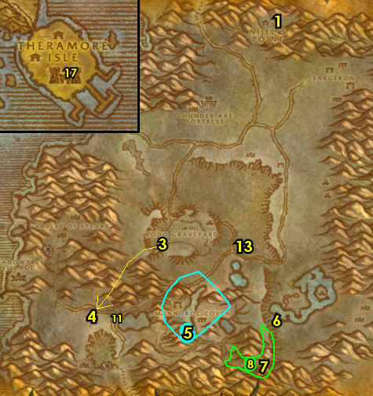

43-44 Tanaris
01) Enter Gadgetzan and at the western side on top of the hill, accept "Gadgetzan Water Survey" 50.27.
02) Next to the crane, turn in (if you have it) "Tran'Rek" 52.27, SKIP "Scarab Shells" (Dungeon).
03) From the Wanted Poster next to the cage entrance 52.27, accept "WANTED: Caliph Scorpidsting" and "WANTED: Andre Firebeard".
04) Just to the east of you, next to the teleporter device, accept "Handle With Care" 52.27.
05) Go in the Inn and make Gadgetzan your new home 53.28. Get resupplied.
06) Next to the Inn at the windmill 52.28, accept "Water Pouch Bounty" and "Wastewander Justice".
07) Go to the Bank SE at Gadgetzan (hut at 52.29) and get the following items out: Seaforium Booster. Put the following items in the bank: A Carefully-packed Crate.
08) Go north to the Shimmering Flats at the Mirage Raceway and from the dwarf turn in "Rumors for Kravel" (78.77 in Thousand Needles). Wait a few seconds, then accept "Back to Booty Bay".
09) Next to you from the gnome, turn in "News for Fizzle" 78.77.
10) Go east to the goblin's side of the Mirage Raceway and turn in "Razzeric's Tweaking" 80.76, accept "Safety First". Next to you, accept "Keeping Pace".
11) At the goblin Zamek 80.77 /target next to the Goblin Racer, click on Complete Quest to setup a distraction, then go in the gnome's hut and click on Rizzle's Unguarded Plans 77.77 to turn in "Keeping Pace", accept "Rizzle's Schematics".
12) Go to the goblin Pozzik and turn in "Rizzle's Schematics" 80.76. NOTE: If the Sample of Indurium Ore quest item still remains in your inventory after turning this in, then you can destroy the item (it's no longer needed).
13) Hearth to Gadgetzan (if you can), if not just run back south to get there, then from Shreev at the western side of Gadgetzan, turn in "Safety First" (51.27 in Tanaris), SKIP the next part (for now).
14) Go to the Bank SE at Gadgetzan (hut at 52.29, #7 on map) and put the following item in the bank: Kravel's Scheme.
#14
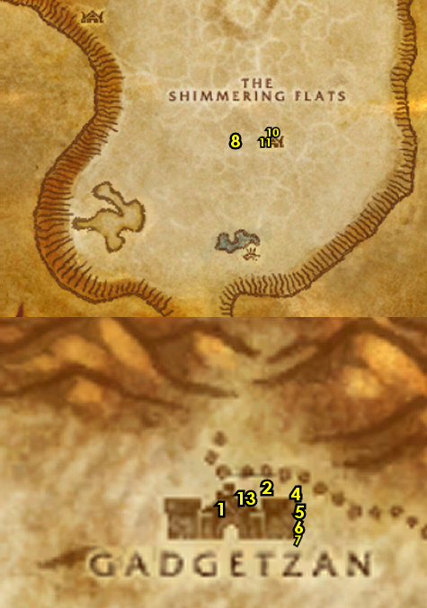

01) Grind your way east to the Noonshade Ruins around 60.24 and start working on "Wastewander Justice" along with "Water Pouch Bounty": kill/loot the Wastewander mobs. NOTES: Do not sell the Wastewander Water Pouches to a vendor! Just clear the area once and continue on...
02) Go east to Steamwheedle Port and from the female goblin under the red tent, accept "Pirate Hats Ahoy!" 67.22.
03) From the male troll under the green tent, accept "Screecher Spirits" 67.22.
04) At the other side of the Port, in the hut 67.24, turn in "Stoley's Debt", accept "Stoley's Shipment". And next to you, accept "Southsea Shakedown".
05) Go SW to the Waterspring Field around 64.30 and finish "Wastewander Justice" along with "Water Pouch Bounty": kill/loot the needed Wastewander mobs. Also, keep an eye out for Caliph Scorpidsting /target , he patrols around the area and has 2 rouges following him. This is for "WANTED: Caliph Scorpidsting", and you will have another opportunity later to do this if you cannot find him now.
06) Go to Lost Rigger Cove (entrance at 69.42)...
07) Start working on "Southsea Shakedown" along with "Pirate Hats Ahoy!": kill/loot the Southsea mobs (the Southsea Dock Workers are up at 75.47). Any of these mobs has a chance to drop a Pirate's footlocker, which could contain an item which starts "Ship Schedules", accept it if you are able to find it, if not at least grind for awhile as it might show up (at least until 6 blocks into lvl 44), otherwise it can be skipped. While doing this, also go do the following 2 steps below in this same area:
08) "Stoley's Shipment": loot the Stolen Cargo up in the building 72.47.
09) "WANTED: Andre Firebeard": kill/loot Andre Firebeard /target in the middle of the cove 73.47. Watch out this fight usually involves 3 adds. (See Video)
10) Once all these are done (including "Southsea Shakedown" along with "Pirate Hats Ahoy!"), hearth to Gadgetzan.
#15
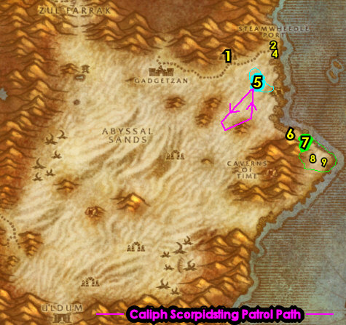

01) Next to the Inn at the windmill 52.28, turn in "Water Pouch Bounty" and "Wastewander Justice", accept "More Wastewander Justice". Also turn in (if you happen to have done it already) "WANTED: Caliph Scorpidsting".
02) At the Forge, get repaired/resupplied 51.29.
03) Go west to Sandsorrow Watch and do "Gadgetzan Water Survey": use the Untapped Dowsing Widget quest item in the pool 39.29. Watch out, as soon as you fill the widget, a few high level bugs will spawn. Either run away or try to kill them.
04) Go back to the western side of Gadgetzan and on top of the hill, turn in "Gadgetzan Water Survey" 50.27, SKIP the next part (for now).
05) Go east to Steamwheedle Port and from the female goblin under the red tent, turn in "Pirate Hats Ahoy!" 67.22.
06) At the other side of the Port, in the hut 67.24, turn in "Stoley's Shipment", accept "Deliver to MacKinley". Next to you, turn in "WANTED: Andre Firebeard", "Southsea Shakedown" and (if you have it) "Ship Schedules".
07) Go SW to the Waterspring Field around 60.38 and do "More Wastewander Justice" along with (if you still need to) "WANTED: Caliph Scorpidsting": kill the needed Wastewander mobs and kill/loot Caliph Scorpidsting /target, he patrols around the area and has 2 rouges following him. He usually spawns at 59.40.
08) Hearth (or run back) to Gadgetzan and at the windmill next to the Inn (52.29, #1 on map), turn in "More Wastewander Justice" and "WANTED: Caliph Scorpidsting". NOTE: You can use up any remaining Wastewander Water Pouches for the repeatable quest here.
09) Go into the bank next to you 52.29 and put the following item in the bank: Stoley's Bottle. Also, if you have found the item called OOX-17/TN Distress Beacon, put that in your bank as well (and don't accept the quest from it yet).
10) Go to the Gryphon Master (south of Gadgetzan 51.29) and fly to Thalanaar, Feralas.
11) Travel all the way west through Feralas, go north above the Horde town Camp Mojache to avoid it. Work your way all the way to Feathermoon and get the Flight Path there from the Hippogryph Master 30.43.
#16
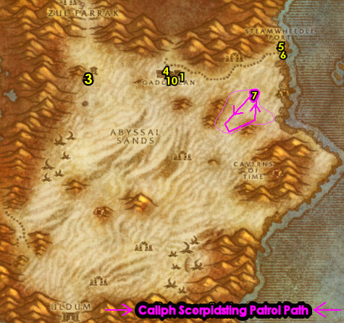

44-46 Feralas
01) At Feathermoon, next to you at the gazebo between the sea and the Inn, accept "The Mark of Quality" 31.43. Make sure you are repaired/resupplied.
02) Go in the Inn and from the Innkeeper 31.43, make Feathermoon your new home.
03) Go in the big building south of the Inn and accept "The Missing Courier" and "The Ruins of Solarsal" 30.46.
04) Go in the small building just east of you and accept "In Search of Knowledge" and "The High Wilderness" 32.46.
05) Go upstairs and turn in "The Missing Courier" 32.45, accept the next part.
06) Go SW to Ruins of Solarsal and click on the Solarsal Gazebo 26.52 to turn in "The Ruins of Solarsal", accept "Return to Feathermoon Stronghold".
07) Go back NE to Feathermoon and in the big building, turn in "Return to Feathermoon Stronghold" (30.46, #3 on map). Accept "Against the Hatecrest".
08) Next to you, turn in "Against the Hatecrest" 30.46, accept the next part.
09) Go SW to Ruins of Solarsal around 29.52 and do "Against the Hatecrest": kill/loot the nagas (any of them can drop the item you need).
10) Go back NE to the big building at Feathermoon and turn in "Against the Hatecrest" (30.46, #3 on map), accept "Against Lord Shalzaru".
11) Go straight down to the other big island and enter Shalzaru's Lair (cave entrance at 26.67).
12) In Shalzaru's Lair, do "Against Lord Shalzaru": kill/loot Lord Shalzaru /target in the middle of the cave (lvl 47 blue naga 29.70). Also keep grinding here until you are at least 2,900 XP from lvl 45. These naga yield good XP.
13) Die on purpose, then res at spirit.
14) Go north a bit to Feathermoon and in the big building across from the Inn turn in "Against Lord Shalzaru" (30.46, #3 on map), accept "Delivering the Relic".
15) Inside the same building, turn in "Delivering the Relic" 30.45.
16) Go in the Inn and from the Cloth and Armor Merchant /target, make sure you get repaired/resupplied (31.43, #2 on map). Also make sure you upgrade to the lvl 45 tier food/drink.
#17
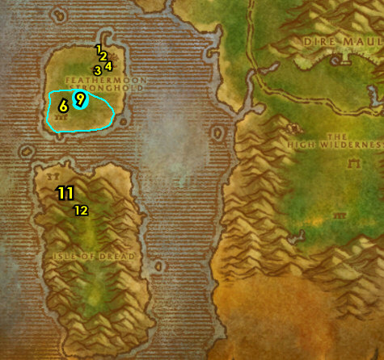

01) Go up the ramp in the Inn and onto the dock to get on the boat to take you east 31.40. If the boat is not there or within view that it is almost there, then just swim east to the shore at the next step:
02) Along The Forgotten Coast do "Screecher Spirits": kill the Screecher mobs around 46.38, then use the Yeh'kinya's Bramble quest item on the corpse, then talk to the Screecher Spirit that spawns.
03) Go south along the shore (watch out for high lvl enemies) and under the water click on the small Wrecked Row Boat 45.65 to turn in "The Missing Courier", accept "Boat Wreckage".
04) Hearth to Feathermoon. Make sure you are repaired/resupplied.
05) Go up to the 2nd floor in the small building at Feathermoon and turn in "Boat Wreckage" 32.45, accept "The Knife Revealed".
06) Go to the top of the tree tower and turn in "The Knife Revealed" 32.44. Wait a few seconds, then accept "Psychometric Reading".
07) Go up to the 2nd floor in the small building and turn in "Psychometric Reading" (32.45, #5 on map), accept "The Woodpaw Gnolls".
08) Go through the Inn and onto the dock to get on the boat to take you east (31.40, # 1 on map):
09) If the boat is not there or within view that it is almost there, then just swim east to the shore at 47.44, then go up the path.
10) Go SE to the Feral Scar Vale around 56.56 and do "The Mark of Quality": kill/loot the Feral Scar mobs (Yetis). NOTE: While questing in Feralas, you may come across an item called OOX-22/FE Distress Beacon, from it accept "Find OOX-22/FE!" and turn this in through the small cave at Feral Scar 53.56, but do NOT do the follow-up escort quest.
11) Go north to the entrance of Dire Maul at 43.70 only to get it Discovered. Simply discovering Dire Maul in this area will allow you to accept a future quest. You need to actually discover the zone, you will know when you achieved that when your general chat switches over to Dire Maul.
12) Go east to the Ruins of Isildien (starting at 61.56 and work your way south) and do "The High Wilderness": kill the needed Gordunni ogres. The Brutes are north, Shamans are south, and the Warlocks are everywhere.
13) Go down south along the cliffs around 57.77 and loot a Hippogryph Egg in one of the nests. This will be turned in at Tanaris for a later quest. And remember to not sell this!
#18
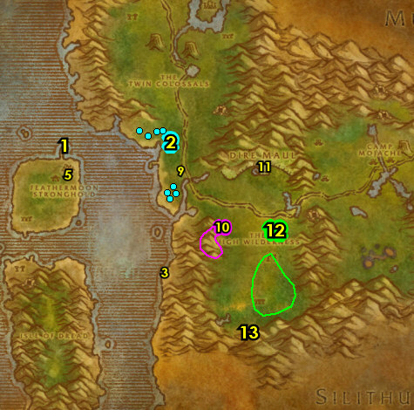

01) Go NE to the Grimtotem camp and clear the enemies around the Captured Sprite Darter cage around 67.47 before doing the next step's escort quest:
02) At the Grimtotem camp is a hidden path next to a tree (starting at 66.47). Go up the path and at the end of the ledge, accept and do the escort "Freedom for All Creatures": escort Kindal Moonweaver /target (you need to lead her) to the Captured Sprite Darter cage and click on the Cage Door (67.47, #1 on map) to open it. Then follow the Sprite Darters and make sure that 6 survive.
03) Go back up the hidden path next to a tree (starting at 66.47, #2 on map). Go up the path and at the end of the ledge, turn in "Freedom for All Creatures". Then next to you, accept "Doling Justice".
04) In the immediate area at the Grimtotem camp, do "Doling Justice": kill the required amount of Grimtotem taurens around the camp. There is another camp up north around 69.40 for more mobs, especially the Naturalists /target.
05) Go back up the hidden path next to a tree (starting at 66.47, #2 on map). Go up the path and at the end of the ledge, turn in "Doling Justice". Accept the next part.
06) Go south to the gnoll camps and click on the Large Leather Backpacks hanging on a big tree 73.56 to turn in "The Woodpaw Gnolls", accept "The Writhing Deep".
07) In your inventory is an Undelivered Parcel (backpack), from it accept "Thalanaar Delivery".
08) Go south to The Writhing Deep and go down into the last tunnel (entrance at 73.64), then keep right in the cave and then click on the Zukk'ash Pod to turn in "The Writhing Deep", accept and do "Freed from the Hive": simply wait until Raschal the Courier appears then wait right there until the quest completes itself.
09) Hearth to Feathermoon. Make sure you are repaired/resupplied.
10) Just outside of the Inn at the Gazebo by the sea, turn in "The Mark of Quality" 31.43.
11) Across the Inn, inside the small house, turn in "The High Wilderness" 32.46.
12) Go upstairs and turn in "Freed from the Hive" 32.45, accept "A Hero's Welcome".
13) Go in the big building and turn in "A Hero's Welcome" 30.46, accept "Rise of the Silithid".
#19
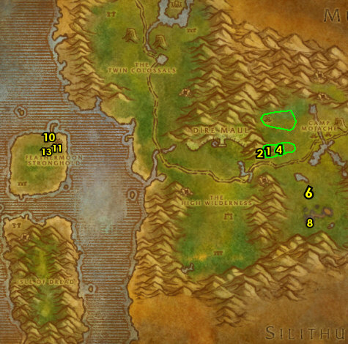

01) GRIND TIME: At this point, grind all the way to level 46 ! I recommend grinding on the Hatecrest nagas straight down to the other big island, in and outside of the cave around 26.67. These nagas are considered one of the best grinding spots in the game, especially for Alliance. Another alternative is to do the Dungeon Uldaman (found in the Badlands). There are a lot of quests that were opened for Uldaman from the previous questing you have done through out the guide and the Dungeon can get you to level 46 most likely. Once you are level 46, then continue on..
02) Hearth to Feathermoon and get repaired/resupplied 31.43.
2a) In the small building, accept "The Sunken Temple" 32.46 (requires lvl 46).
03) Go to the Hippogryph Master 30.43 and fly to Thalanaar, Feralas.
04) At Thalanaar, turn in "Thalanaar Delivery" 90.47.
05) Next to you, at the Hippogryph Master 89.46 fly to Rut'theran Village, Teldrassil.
06) At Rut'theran Village, go up the path through the red portal to get to Darnassus 56.89.
07) Go to the bank in Darnassus 40.42 and get the following item out: A Carefully-packed Crate. Put the following item(s) in the bank: Yeh'kinya's Bramble, Hippogryph Egg and (if you found it) OOX-22/FE Distress Beacon (and don't accept the quest from it yet)..
08) At Darnassus, go south in Temple of the Moon, go up and turn in "Rise of the Silithid" 42.86.
09) Also up in the temple, turn in "Doling Justice" 39.82.
Get New Abilities, 10) NOTE: You can learn new weapon possibilities from the Weapon Master 58.47.
11) If you have cloth donations to turn in for XP, you can do so from the Alliance Cloth Quartermaster 64.23. Requires: 60 Wool Cloth --> 60 Silk Cloth --> 60 Mageweave Cloth.
12) Go through the red portal 29.41..
13) At Rut'theran Village, go down in the house and turn in "Handle With Care" 55.92. Accept "Favored of Elune?".
14) Go upstairs and turn in "In Search of Knowledge" 55.92.
15) Next to you upstairs by the bookshelves is a green book on the ground called Feralas: A History 55.91, click on it to accept "Feralas: A History".
16) Next to you upstairs, turn in "Feralas: A History" 55.92, accept "The Borrower".
17) Go to the Hippogryph Master 58.94 on the bridge and fly to Forest Song, Ashenvale.
18) At Ashenvale, head east on the main path to enter Azshara (95.48 in Ashenvale)..
#20
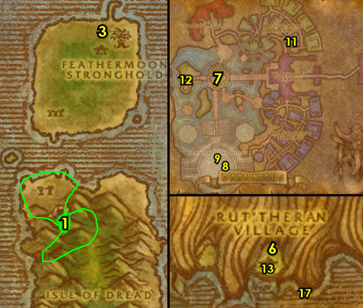

46-46 Azshara
01) As soon as you enter Azshara, go south to Talrendis Point and get the Flight Path there from the Hippogryph Master 12.78.
02) At the camp, accept "Spiritual Unrest" and "A Land Filled with Hatred" 11.78.
03) Go just north above the main path to Shadowsong Shrine around 14.72 and do "Spiritual Unrest": kill the required amount of Highborne mobs (undead apparitions).
04) Go east to Haldarr Encampment around 19.62 and do "A Land Filled with Hatred": kill the needed Haldarr mobs (satyr demons).
05) Go back SW to Talrendis Point and turn in "Spiritual Unrest" and "A Land Filled with Hatred" (11.78, #1 on map).
06) Make sure you are repaired/resupplied from the Bowyer 12.78.
07) Hearth (if you can) to Feathermoon Stronghold. Then fly to Gadgetzan, Tanaris from the Hippogryph Master 30.43 at Feathermoon. If hearthstone is still on a cooldown, then go to the Hippogryph Master at Talrendis Point 12.78 and fly to Gadgetzan, Tanaris.
08) Go to the Bank SE at Gadgetzan (hut at 52.29) and get the following items out: Bag of Water Elemental Bracers.
09) At Gadgetzan, next to the teleporter, turn in "The Borrower" 52.27, accept "The Super Snapper FX".
10) Go to the Gryphon Master (south of Gadgetzan 51.29) and fly to Theramore, Dustwallow Marsh.
12) Get on the boat (72.56 on the docks) to take you to Menethil Harbor.
#21
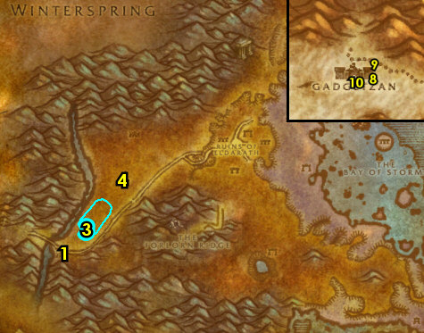

02) fly to Southshore, Hillsbrad (Gryphon Master, 9.60) then skip to step #8 below.
04) N/A
05) N/A
06) N/A
07) N/A
08) Go NW to Dalaran (big purple globe) and turn in "Magical Analysis" (19.78 in Alterac Mountains). Accept "Ansirem's Key" (no exclamation mark).
09) Go back SE to Southshore.
#22
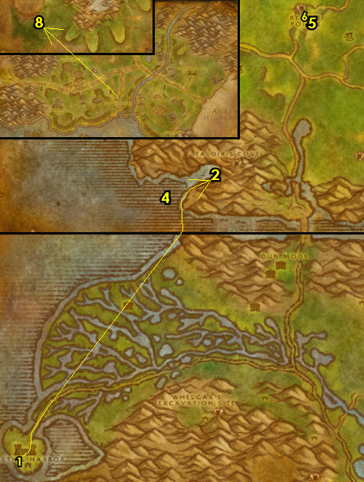

PLEASE READ: With all the faster leveling changes, by the time you get to this section you will most likely be well into level 46. Because of this when following my guide, you should skip this entire section and go right into 46 ST section below. I will leave this section for reference purposes only. However if for some reason you are early into level 46 you can consider doing this section. If you are not doing this section then abandon "Favored of Elune?"
46-46 The Hinterlands
01) Follow the path into The Hinterlands, then make a sharp left at Aerie Peak, go up the path and turn in "To The Hinterlands" 12.47, accept "Gryphon Master Talonaxe".
02) Go up the ramps and get the Flight Path from the Gryphon Master 11.46.
03) Go in the building next to you and turn in "Gryphon Master Talonaxe" 10.44, accept "Rhapsody Shindigger". Also accept "Witherbark Cages".
04) Drop down, make a right in the Inn and accept "Skulk Rock Clean-up" and "Troll Necklace Bounty" 15.45.
05) Go up and NE in the Inn to the Innkeeper 14.42 patrols a bit and make Wildhammer Keep (Aerie Peak) your new home.
06) On the same level of the Innkeeper, on the SW side of the Inn, get repaired/resupplied from Harggan 13.44.
07) As you go out questing in The Hinterlands also start working on "Favored of Elune?": loot the Wildkin Feathers on the ground scattered all around The Hinterlands:
08) Go to the path (starting at 21.48).
09) Go up to Shindigger's Camp and turn in "Rhapsody Shindigger" 27.49, accept "Rhapsody's Kalimdor Kocktail".
#23
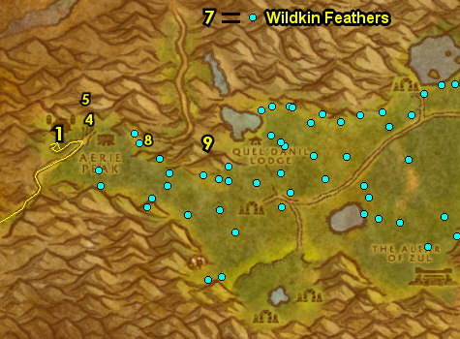

01) Go SW to the troll camp of Zun'watha and do part of "Witherbark Cages": open the First and Second Witherbark Cages at the camp 23.59. Also start working on "Troll Necklace Bounty" by kill/looting the trolls.
02) Go NE to the other troll camp of Hiri'watha and finish "Witherbark Cages": open the Third Witherbark Cage 32.57. Also finish "Troll Necklace Bounty" by kill/looting the trolls for the necklaces (and remember not to sell these to a vendor)!
03) Go NE to Agol'watha around 47.42 and do "Skulk Rock Clean-up": kill 10 Green Sludge and 10 Jade Ooze. There is more of these mobs east at Skulk Rock around 58.43.
04) While questing, you may have found an item called OOX-09/HL Distress Beacon, from it accept "Find OOX-09/HL!". If so, go turn this in in the middle of the lake on top of the hill 49.38, but do NOT do the escort yet!
05) Make sure "Favored of Elune?" is finished: loot the Wildkin Feathers on the ground scattered all around The Hinterlands.
06) Go east to the shore (path entrance downward starting at 72.66). Once down to the shoreline, do "The Super Snapper FX": use the Super Snapper FX quest item on Gammerita /target. This lvl 48 turtle patrols up and down the shore line (see map). You don't actually need to kill it.
07) Hearth to Wildhammer Keep (Aerie Peak). Make sure you are repaired/resupplied. Remember to not sell your necklaces!
08) Down near the SE front of the Inn, turn in "Skulk Rock Clean-up" and "Troll Necklace Bounty" 15.45.
09) Go all the way up at Aerie Peak and turn in "Witherbark Cages" 10.44, accept "The Altar of Zul".
10) Up at Aerie Peak go to the Gryphon Master 11.46 and fly to Ironforge, Dun Morogh.
#24
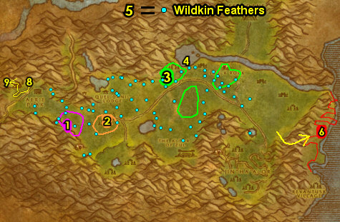

46-47 Stranglethorn Vale
00) At Southshore go to the Gryphon Master 49.52 and fly to Ironforge, Dun Morogh.
01) Go to the Bank 35.61 and get the following items out: Kravel's Scheme and Stoley's Bottle. Put the following items in the bank: Super Snapper FX.
02) NOTE: If you need to, cloth donations can be turned in at Tinker Town 74.48 for the Gnome faction and at The Great Forge 43.32 for the Dwarf faction.
03) N/A
04) N/A
05) N/A
06) N/A
07) Go to the Gryphon Master 56.48 in the middle of Ironforge and fly to Booty Bay, Stranglethorn.
#25
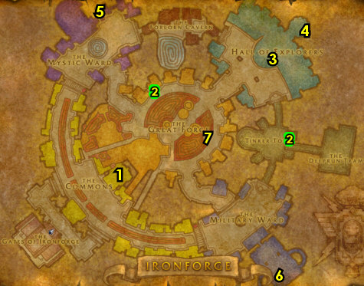

01) When you land stay up and go over to the boat-deck and from Fleet Master Seahorn accept "The Bloodsail Buccaneers" 27.77.
02) Go to the middle level of the Inn and turn in "Ansirem's Key" 27.78, accept ""Pretty Boy" Duncan".
03) Drop down in the Inn and make BB your new home 27.77.
04) Next to you in the Inn, turn in "Back to Booty Bay" 27.77.
05) Go in the cabin (next to the hanging shark) and turn in "Deliver to MacKinley" 28.77.
07) Go near the end of the docks and accept "The Captain's Chest" 27.74.
08) Exit BB north and then go west towards the coast and do ""Pretty Boy" Duncan": kill/loot "Pretty Boy" Duncan 27.69.
09) Go east to the shore and attempt to do "The Captain's Chest" (Elite): kill/loot Gorlash /target. This lvl 42 elite giant patrols up and down the shore around 37.70. You may need to group up with someone, if you cannot do it, it can be skipped.
10) Search the shore east of BB for Half-Buried Bottles until a Carefully Folded Note shows up, from it accept "Message in a Bottle".
11) Go to the island east of BB (use Swim Speed if you can), plus watch out for the lvl 41 stealthed panthers there, then turn in "Message in a Bottle" 39.81, accept the next part. NOTE: If the Carefully Folded Note item remains in your inventory, you can destroy it.
12) East on the island do "Message in a Bottle": kill/loot King Mukla /target (lvl 42 big gorilla, at 41.84).
13) Back NW on the island turn in "Message in a Bottle" (#11 on map, 39.81).
#26
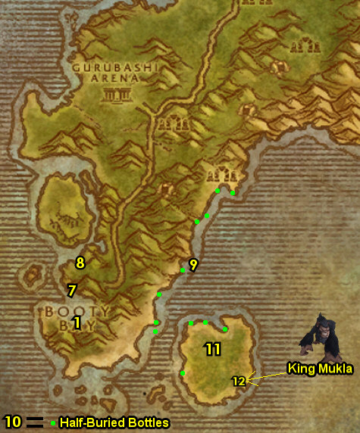

01) Do "The Bloodsail Buccaneers": kill the 3 pirates in each of the 3 ships. Also find a scroll laying on the ground (can be in any of the 3 ships) called Cortello's Riddle, and from it accept "Cortello's Riddle". Sometimes this scroll can be in the basement of the ships, so search there too. The first pirate to kill is Captain Stillwater down the first flight of stairs in the ship 33.88. See next steps for the other two:
02) Kill Fleet Master Firallon down the first flight of stairs in the middle ship 31.91. Watch out for Ironpatch in the room before Firallon, take him on alone first.
03) Kill Captain Keelhaul down the first flight of stairs in the last ship 29.88. Make sure you find the scroll that starts "Cortello's Riddle" before leaving this area.
04) Die on purpose and res at spirit to get to Booty Bay.
05) At the end of the docks, turn in (if you did it) "The Captain's Chest" 27.74.
06) Go towards the Inn and next to the teleporter at the Blade Trader /target 27.78, get repaired/resupplied.
07) Go up in the middle level of the Inn and turn in ""Pretty Boy" Duncan" 27.78
08) Up in the Inn on the boat-deck, from Fleet Master Seahorn turn in "The Bloodsail Buccaneers" 27.77.
09) This is the last time my guide will tell you to turn in "The Green Hills of Stranglethorn" if it is complete. This quest requires that you have the following pages: 1, 4, 6, 8, 10, 11, 14, 16, 18, 20, 21, 24, 25, 26, and 27. You can also find these pages in the AH or from other players.
10) N/A
11) If you have all the Green Hills pages, first fly to Rebel Camp, then go to Nesingwary's Expedition, accept and turn in "The Green Hills of Stranglethorn" 36.11. Make sure you are repaired/resupplied.
12) N/A
13) N/A
14) N/A
15) N/A
#27
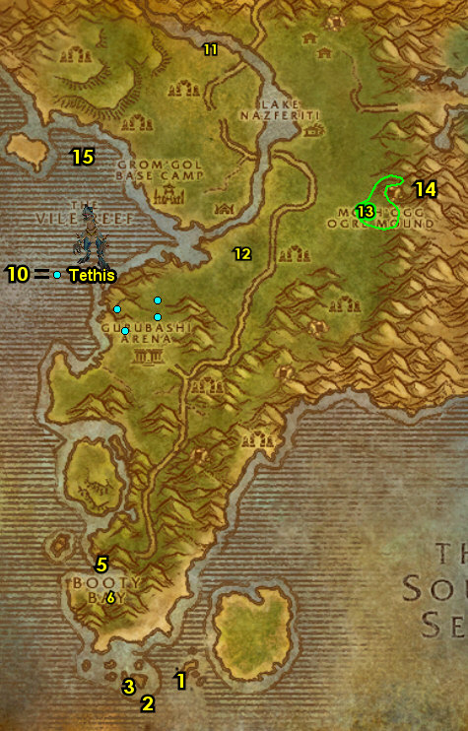

01) N/A
02) N/A
03) If you went to Nesingwary's Expedition: Hearth to Booty Bay.
04) Next to you in the Inn, accept "Whiskey Slim's Lost Grog" 27.77.
05) N/A
07) Make sure you get 15 Silk Cloth out of your bank, mailbox or AH 27.77, for a later quest.
09) Go up to the Gryphon Master 28.78 and fly to Lakeshire, Redridge.
10) At Redridge, follow the main path north to get into Burning Steppes (entrance at 47.7 in Redridge Mountains).
11) When you enter Burning Steppes, keep hugging the right side of the mountains to get to Morgan's Vigil, and get the Flight Path from the Gryphon Master (84.68 in Burning Steppes).
12) Head west on the main path through Burning Steppes and first head to 23.52 just to discover Draco'dar for XP.
13) Go north to enter Blackrock Mountain 29.38. Then go north to get to Searing Gorge.
#28
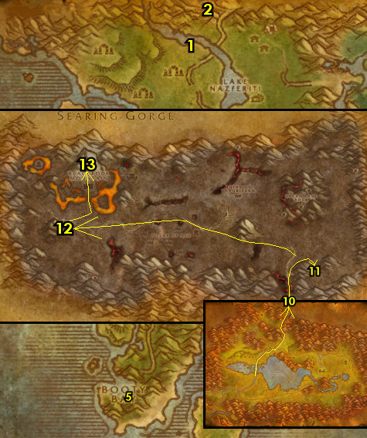

47-48 Searing Gorge
01) Go east in Searing Gorge and from the Wooden Outhouse 66.62, accept "Caught!".
02) At the Grimesilt Dig Site next to you, start working on "Caught!": kill the Dark Iron Geologists /target. Also make sure you have 15 Silk Cloth (it can drop from the dwarves at the Dig Site). Also at the Dig Site, is a dwarf /target 64.61 and from him accept and do the escort "Suntara Stones": simply escort him up north along the path, once he falls down, then next to him turn this quest in from the Singed Letter 74.19 on the ground, accept the next part.
03) Go back south to Grimesilt Dig Site around 62.61 and finish "Caught!": kill the Dark Iron Geologists and obtain 15 Silk Cloth (#2 on map).
04) Go back to the Wooden Outhouse (66.62, #1 on map), and turn in "Caught!", accept "Ledger from Tanaris". Then pick up the Goodsteel Ledger (it drops on the ground next to the outhouse).
05) Go SE up around the mountains and kill/loot Margol the Rager /target (a lvl 48 grey dinosaur, patrols around 73.76), he drops an item, which starts "The Horn of the Beast", accept it.
06) Do part of "Ledger from Tanaris": kill/loot Glassweb Spiders /target for the Leg Shafts. These are scattered on the eastern side of Searing Gorge around 62.70.
07) Go up NW and from Kalaran Windblade 39.39 accept "Divine Retribution", then do it by simply talking to him. Then turn it in. From him, accept "The Flawless Flame".
08) Make sure your Hearthstone is less than 6 minutes until the cooldown resets (grind on any mobs in the immediate area until it is), then continue on..
09) Go up to Thorium Point entrance 32.33...
10) Accept ALL quests at Thorium Point: From the WANTED/Missing/Lost & Found sign 38.26 accept "WANTED: Overseer Maltorius", "STOLEN: Smithing Tuyere and Lookout's Spyglass" and "JOB OPPORTUNITY: Culling the Competition". .
WOTLK, 10b) Next to you accept "Kill 'Em With Sleep Deprivation" 38.28.
11) Next to you 39.28 accept "Curse These Fat Fingers", "Fiery Menace!" and "Incendosaurs? Whateverosaur is More Like It"
12) Next to you by the Forge accept "What the Flux?" 39.29. Make sure you are repaired/resupplied by this NPC as well.
13) Go to the Gryphon Master 38.31 at Thorium Point and fly to Ironforge, Dun Morogh.
#29
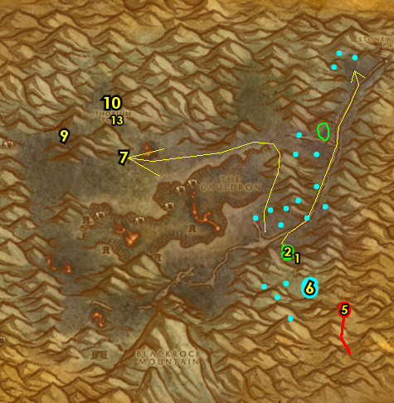

01) Go to the Ironforge Bank 35.62 and put the following items into it: Goodsteel Ledger and 20 Solid Crystal Leg Shafts.
02) Go in the Inn and make Ironforge your new home from the Innkeeper 18.51.
03) Go NE to Hall of Explorers and from Curator Thorius (he patrols around 70.18), turn in "Suntara Stones", accept "Dwarven Justice".
04) Go to the Gryphon Master 56.48 in the middle of Ironforge and if you have "The Horn of the Beast" previously from killing Margol the Rager at Searing Gorge, then fly to Thelsamar, Loch Modan, otherwise just fly back to Thorium Point, Searing Gorge and skip to the Searing Gorge Grind section below.
#30
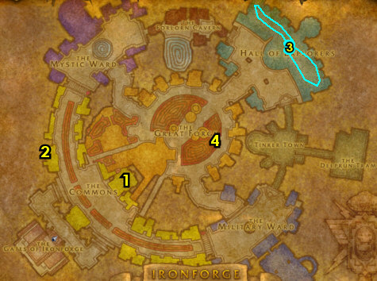

Loch Modan Door to Searing Gorge
01) If you haven't yet, go to the Gryphon Master 56.48 in the middle of Ironforge and fly to Thelsamar, Loch Modan.
02) At Loch Modan, follow the path SW to the locked door and turn in "The Horn of the Beast" 18.84, accept "Proof of Deed".
03) Hearth to Ironforge.
04) At Ironforge, go NE to Hall of Explorers and from Curator Thorius patrols around 70.18, turn in "Proof of Deed". Wait a few seconds, then accept "At Last!".
GET NEW ABILITIES, 4b) If you need to, get new spells/abilities in Ironforge.
05) Go to the Gryphon Master (56.48, #1 on map) in the middle of Ironforge and fly to Thelsamar, Loch Modan.
06) At Loch Modan, follow the path SW to the locked door and turn in "At Last!" (18.84, #2 on map).
07) With the Key you have now, open the gated Door in front of you, then go straight through the tunnel to get back to Searing Gorge.
#31
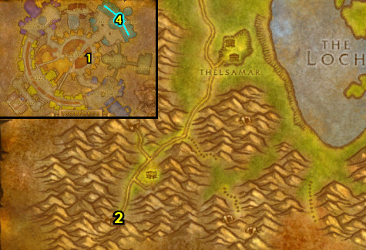

Searing Gorge Grind
NOTE: Do this section all at once (in any order):
01) "The Flawless Flame": kill/loot Magma Elementals, Tempered War Golems, and Heavy War Golems for the Golem Oil. See next step for the Heart of Flame:
02) Kill/loot the fire elementals for the Heart of Flame, these include: Inferno Elementals, Blazing Elementals and Magma Elementals.
03) "Fiery Menace!": kill Greater Lava Spiders around the western side of Searing Gorge.
04) "Curse These Fat Fingers": kill Heavy War Golems around the middle of Searing Gorge.
05) "STOLEN: Smithing Tuyere and Lookout's Spyglass": kill/loot Dark Iron Steamsmith for the Smithing Tuyere around 40.50. See next step for where to find the Lookout's Spyglass:
06) Kill/loot Dark Iron Lookouts for the Lookout's Spyglass, these mobs are scattered around the watchtowers at Searing Gorge, there is a large amount around 53.59, see map for other locations.
07) Once "The Flawless Flame" is done, turn it in at Kalaran Windblade 39.39 and accept "Forging the Shaft".
#32
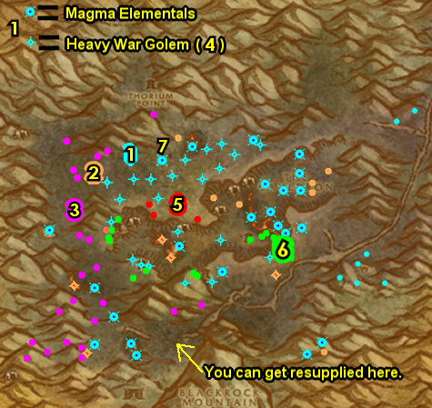

01) "JOB OPPORTUNITY: Culling the Competition": enter one of the caves down in The Cauldron (middle of Searing Gorge), I recommend going into the eastern most cave entrance 49.45 and then kill the needed Dark Iron dwarves in the cave.
02) "What the Flux?" and "WANTED: Overseer Maltorius": loot the Secret Plans: Fiery Flux 40.36 behind Overseer Maltorius (41.36 in the cave). And kill/loot Overseer Maltorius (lvl 50).
WOTLK, 2b) In the hallways across the room around 45.31 do "Kill 'Em With Sleep Deprivation": loot the pillows along side the walls where the beds are at. Watch out groups of sleepy dwarves patrol this hall and an elite mob can spawn in the middle of that hall, so be careful! You can skip this if you don't want to wait for the pillows to respawn or deal with the mobs that are in the way.
03) Work your way in the mine and turn in "Dwarven Justice" 41.26, accept "Release Them".
04) "Forging the Shaft": kill/loot Dark Iron dwarves for the Thorium Plated Daggers. NOTES: This quest requires "The Flawless Flame" to be finished and turned in first. Save any Dark Iron Scraps you find, you will need 30 of them for a later quest, but you will also have another good chance to find a lot more later on in the lvl 53-54 Burning Steppes section as well.
05) "Incendosaurs? Whateverosaur is More Like It": enter the cave 47.46 and kill Incendosaurs.
#33
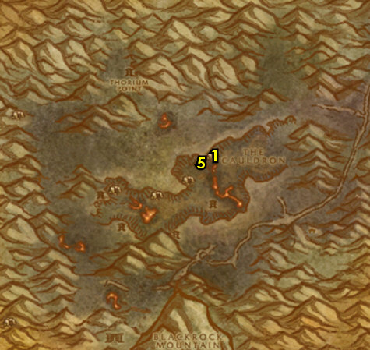

01) Go to Kalaran Windblade 39.39 and turn in "Forging the Shaft", accept "The Flame's Casing".
02) Go up to Thorium Point (entrance at 33.33)...
03) Turn in "WANTED: Overseer Maltorius" 38.27.
WOTLK, 3b) Next to you, turn in (if you did it) "Kill 'Em With Sleep Deprivation" 38.28.
04) Next to you, turn in "Curse These Fat Fingers", "Fiery Menace!" and "Incendosaurs? Whateverosaur is More Like It" 39.28.
05) Next to you, turn in "STOLEN: Smithing Tuyere and Lookout's Spyglass" and "JOB OPPORTUNITY: Culling the Competition" 39.28.
06) At the Forge next to you turn in "What the Flux?" 39.29. Make sure you are repaired/resupplied from this NPC.
07) Go west around 25.35 and do "The Flame's Casing": kill/loot the Twilight mobs until the Symbol of Ragnaros drops (low drop rate). While doing this do the next steps as well:
08) Go up the path at Firewatch Ridge (starting at 24.33)..
09) Go up the path (at the dead fat tree, make a left) and do "Release Them": in the middle of the lava pit, loot the Twilight Artifact 29.26.
10) Next to you by the lava pit, from the caged NPC, accept "Prayer to Elune" 30.26, then simply talk to the NPC to complete it, turn it in and accept the next part.
11) Do "Prayer to Elune": kill/loot the Twilight mobs to obtain the Prayer to Elune. There is more mobs to kill down below around the cave entrance (around 24.36, #4 on map).
12) Go east to Kalaran Windblade (39.39, #1 on map) and turn in "The Flame's Casing", accept "The Torch of Retribution".
13) Wait a minute, then turn in "The Torch of Retribution", accept the next part. Then click on the Torch of Retribution in the air next to you to turn in the next part of "The Torch of Retribution". Accept "Squire Maltrake". Next to you, turn in "Squire Maltrake", accept "Set Them Ablaze!".
#34
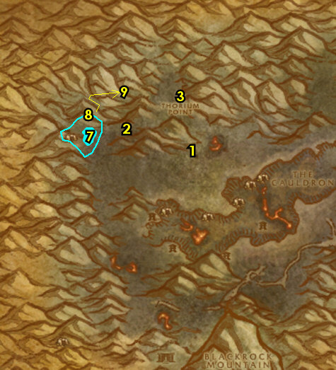

01) Do "Set Them Ablaze!": equip the Torch of Retribution quest item and at the top of the 4 watchtowers, click on the Sentry Braziers. The Northern Tower is at 33.54. See next steps for the others:
02) The Western Tower is at 36.61.
03) You can stop at the small camp 42.75 to get repaired/resupplied from Graw Cornerstone.
04) The Southern Tower is at 44.61.
05) The Eastern Tower is at 50.55. NOTE: You must cross a bridge to get to it.
06) While doing these quests (specifically from killing the Dark Iron dwarves), you should have obtained an item called Grimsite Outhouse Key, from it accept "The Key to Freedom". Then go SE and turn this in at the Wooden Outhouse 66.62.
07) Go back north to Kalaran Windblade (39.39, #1 on map) and turn in "Set Them Ablaze!".
08) Wait a minute (grind while waiting), then click on the Hoard of the Black Dragonflight 39.39 chest on the ground next to Kalaran Windblade and accept "Trinkets...". Then click on the chest again to turn this in. Loot the chest received. NOTE: The Black Dragonflight Molt will be used for a later quest.
09) Drop down (at the eastern big crane) to enter the eastern most cave at The Cauldron 49.45.
10) Go into the cave and click on the Altar of Suntara (in the middle of the big room 41.25) to turn in "Release Them".
11) Next to you accept and do "Rise, Obsidion!": next to you in the room, kill/loot Obsidion (lvl 52 golem) and kill/loot Lathoric the Black (lvl 52 dwarf).
12) Die on purpose, then res at spirit.
13) At Thorium Point, make sure you are repaired/resupplied from Master Smith Burninate 39.28 next to the Forge.
14) N/A
15) Go to the Gryphon Master 38.31 at Thorium Point and fly to Nethergarde Keep, Blasted Lands.
#35
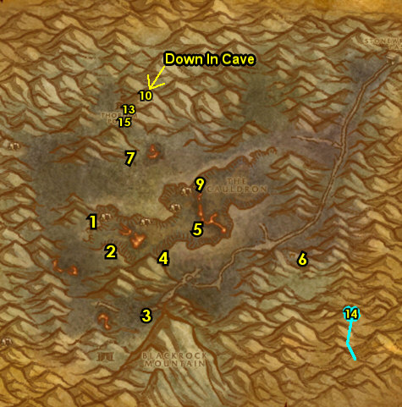

01) Go north to enter Swamp of Sorrows, then follow the path NW and click on A Soggy Scrolll under the bridge (23.48 in SoS) to turn in "Cortello's Riddle", accept the next part.
02) Go all the way east to the middle of the shore at SoS and do part of "Ledger from Tanaris": kill/loot Jarquia /target 95.52, he drops the Goodsteel's Balanced Flameberge.
03) Hearth to Ironforge.
04) At Ironforge's Inn, from the Innkeeper 18.51, accept "Assisting Arch Druid Staghelm".
05) Go NE to Hall of Explorers and from Curator Thorius (he patrols around 74.20), turn in (if you did it) "Rise, Obsidion!".
06) Also at the Hall of Explorers, accept "A Little Slime Goes a Long Way" 76.23. NOTE: Do not loot the item received (yet).
GET NEW ABILITIES, 07) Get your level 48 spells/abilities.
08) Go to the bank 35.62 and put the following items in the bank: Package of Empty Ooze Containers, stack of Dark Iron Scraps, Black Dragonflight Molt, Torch of Retribution (can be used as a future light source) and (if you have it) Prayer to Elune.
09) Go to the Gryphon Master 56.48 in the middle of Ironforge and fly to Menethil Harbor, Wetlands.
10) At Menethil Harbor, go on the docks and get on the southern boat to take you to Theramore Isle 5.64..
#36
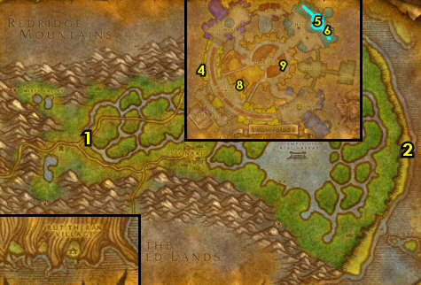

PLEASE READ: With all the faster leveling changes, by the time you get to this section you will most likely be well into level 48. Because of this when following my guide, you should skip this entire section and go right into 49 Dustwallow Marsh section below. I will leave this section for reference purposes only. However if for some reason you are early into level 48 you can consider doing this section.
48-49 Feralas
01) At the gazebo between the Inn and the Sea, accept "Improved Quality" 31.43.
02) Go across the Inn to the small building and turn in "Return to Troyas" 32.45, wait a few seconds then accept "The Stave of Equinex".
03) Next to you, accept "The Sunken Temple".
04) Go through the Inn and onto the dock to get on the boat to take you east 31.40. If the boat is not there or within view that it is almost there, then just swim east at 45.43 and accept "Zapped Giants" and "Fuel for the Zapping". NOTE: "Zapped Giants" and its quest item Zorbin's Ultra-Shrinker is on a 2 hour timer, so work somewhat quickly, but you should have plenty of time.
05) Do "Fuel for the Zapping" (starting at 44.39): kill/loot water elementals, which include Sea Elementals and Sea Sprays (low drop rate). Watch out for the elite giants (you can use the Zorbin's Ultra-Shrinker quest item on them to make them non-elite).
06) Go back to the goblin next to the dock and turn in "Fuel for the Zapping" (45.43, #4 on map). NOTE: The repeatable quest "Refuel for the Zapping" does not yield much XP.
07) Follow the path up the hill 46.38..
08) Go east to Rage Scar Hold entrance 52.32 and do "Improved Quality": kill/loot the yeti for the hides. Also keep grinding on the yetis until you get the Pristine Yeti Hide, from it accept "Pristine Yeti Hide".
#37
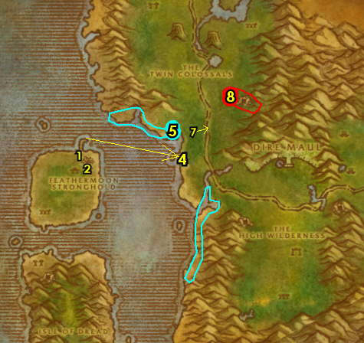

01) As you work your way north (starting around 50.33), do part of "Rhapsody's Kalimdor Kocktail": kill/loot the Ironfur Patriarchs (bears) and the Groddoc Thunderers (gorillas) for their livers. NOTE: The Roc Gizzards will be done later in Tanaris. You can work your way to the next step while working on this:
02) Go NW and from Rockbiter (big giant 42.22), accept "The Giant Guardian".
03) Just to the west of you (around 40.24 and work north) do "Zapped Giants": use Zorbin's Ultra-Shrinker quest item on the giants (this removes the elite status) then kill/loot them.
04) Go north to Ruins of Ravenwind and do "The Stave of Equinex": loot the following Flames: First one is the Flame of Byltan under the gazebo 39.16. See next step for the others:
05) Go north and up at the gazebo, loot the Flame of Lahassa 38.12.
06) Go east and loot the Flame of Imbel 40.9.
07) The last flame is a bit hidden. Go to the stone ruins and hop on the stone bridge at 40.11, go up it then you will have to do a few more jumps to get up there. Once up there, loot the Flame of Samha 41.13.
08) Go west to the Equinex Monolith 39.13 and use your Troyas' Stave quest item at it. Then click on the Equinex Monolith to turn in "The Stave of Equinex", accept "The Morrow Stone".
09) Go up north and turn in "The Giant Guardian" 38.10, then accept and do the escort "Wandering Shay": The first thing to do is loot Shay's Chest next to you, then simply escort her /target (you lead her) to the next step:
10) Lead her to Rockbiter (big giant 42.22, #2 on map). If she starts roaming aimlessly, use Shay's Bell quest item to call her back to you. At Rockbiter, turn in "Wandering Shay".
#38
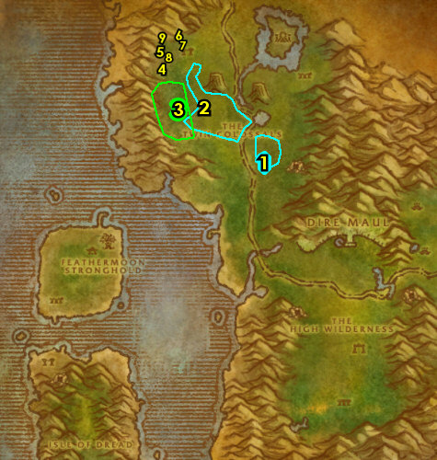

01) Follow the main path south then NE to the entrance of Dire Maul at 43.70 only to get it Discovered. Simply discovering Dire Maul in this area will allow you to accept a future quest. You need to actually discover the zone, you will know when you achieved that when your general chat switches over to Dire Maul.
02) East at the Grimtotem camp is a hidden path next to a tree (starting at 66.47). Go up the path and at the end of the ledge, accept "An Orphan Looking For a Home" 66.46.
04) While questing in Feralas, you may come across an item called OOX-22/FE Distress Beacon, from it accept "Find OOX-22/FE!". Then turn this in through the small cave 53.56 and do the escort "Rescue OOX-22/FE!". TIP: Before doing the escort, clear the path of yetis to the main path, otherwise this escort can be really tough. Try to keep aggro off of the Robot Chicken /target, as it can die easily. This is also a fairly long escort (12.5 minute).
05) Go west a bit to the goblin next to the dock and turn in "Zapped Giants" 45.43. You can get resupplied from him now.
06) Go just NW along the shore (to the specific spot of 41.38), then die on purpose and res at spirit to get back to Feathermoon. NOTE: Otherwise you will end up at the Dire Maul graveyard.
07) Go across the Inn to the small building and turn in "The Morrow Stone" 32.46.
08) At the gazebo next to the Inn/Sea 31.43, turn in "Improved Quality" and "Pristine Yeti Hide".
09) Make sure you are repaired/resupplied from the Cloth Armor Merchant 31.43 in the Inn.
10) Near you at the Hippogryph Master 30.43 fly to Theramore, Dustwallow Marsh.
#39
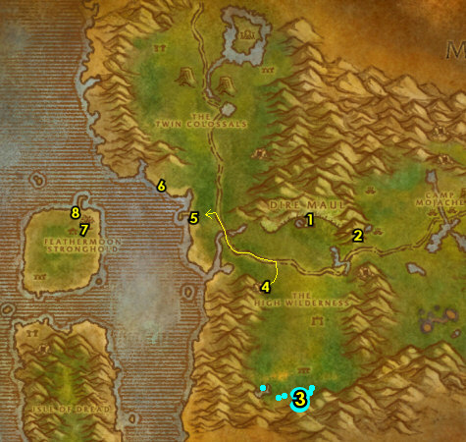

49-49 Dustwallow Marsh
01) At Theramore, go west along the outside walls of the town to 64.52, then make a swim west to the next step:
02) At the other side of the river at 55.50, go up the hill to get into Beezil's Wreck..
03) Go south a bit and do the last part of "Ledger from Tanaris": loot the Damaged Crate for the Overdue Package 54.56.
04) Go west to Bloodfen Burrow (small cave 31.66) and click on the Musty Scroll to turn in "Cortello's Riddle", accept the next part.
05) Go to the NE outskirts of Mudsprocket, to the Flight Master 43.72 and fly to Gadgetzan, Tanaris.
06) N/A
07) N/A
#40
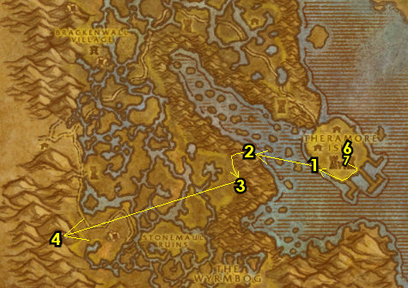

49-50 Tanaris
01) As you enter Gadgetzan, make a right at the Bank (hut at 52.29) and get the following items out: Hippogryph Egg, Yeh'kinya's Bramble, Goodsteel Ledger, 20 Solid Crystal Leg Shafts.
02) Next to the Forge, turn in "Ledger from Tanaris" 51.29. Make sure you are repaired/resupplied.
03) On the western side of Gadgetzan, up on the hill, accept "Noxious Lair Investigation" 50.27.
04) Next to the crane 52.27 accept "Thistleshrub Valley" and "Super Sticky".
05) Go to the Egg-O-Matic machine in Gadgetzan (next to the teleporter 52.27), and turn in your Hippogryph Egg for "The Super Egg-O-Matic" quest (additional eggs do not yield XP). NOTE: You can turn in different types of eggs at the NPC next to the machine for a non-XP reward.
06) Behind the Inn, next to the Bonfire, accept "The Dunemaul Compound" 53.27.
07) On the south end of Gadgetzan, next to the AH, accept "The Thirsty Goblin" 52.29.
08) Go south to the Broken Pillar and turn in "The Sunken Temple" 53.46, accept "The Stone Circle". Also accept "Gahz'ridian".
09) Go SW and do part of "The Dunemaul Compound": kill Gor'marok the Ravager (in the small cave 42.58).
10) N/A
11) Go south to Southmoon Ruins around 41.72 and finish "The Dunemaul Compound" along with "Gahz'ridian": kill Dunemaul Brutes and Dunemaul Enforcers. Also loot the Gahz'ridian from the ground. TIP: You can equip the Gahz'ridian Detector helm to help you see the Gahz'ridian on the minimap. Also, there is another area of mobs, but with less Gahz'ridian, around 46.66.
12) Go west to The Noxious Lair around 34.46 and do "Noxious Lair Investigation": kill/loot the Centipaar mobs (bugs), and any of them can drop the insect parts.
13) Go south to Thistleshrub Valley around 30.65 and do "Thistleshrub Valley" along with "The Thirsty Goblin": kill 8 Gnarled Thistleshrubs and 8 Thistleshrub Rootshapers. Also kill/loot the Thistleshrub Dew Collectors /target for the Laden Dew Gland (low drop rate).
#41
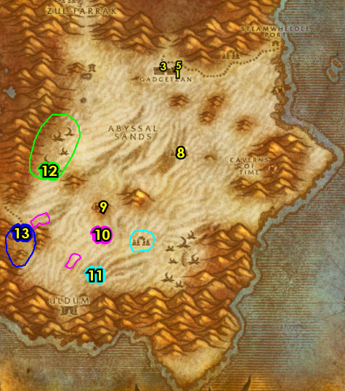

01) At the Thistleshrub Valley 32.74 or 29.63 accept and do the escort quest "Tooga's Quest": escort Tooga /target (turtle) NE to Torta (At next step). NOTE: If you cannot find this turtle, then someone else is probably doing the escort, if so, then just skip this.
02) Once at Torta 67.26, turn in "Tooga's Quest".
03) Just north a bit at Steamwheedle Port, in the hut, accept "Yuka Screwspigot" 67.24.
04) North at Steamwheedle Port, turn in "Screecher Spirits" 67.22, SKIP "The Prophecy of Mosh'aru" (Zul'Farrak Dungeon).
05) You can get resupplied from Jabbey 67.22 in the hut.
06) Grind back to Gadgetzan and next to the AH turn in "The Thirsty Goblin" 52.29, accept "In Good Taste". Make sure you are repaired/resupplied.
07) At Sprinkle (next to the hut), turn in "In Good Taste" 51.27, accept "Sprinkle's Secret Ingredient".
08) In the hut next to you, turn in "Noxious Lair Investigation" 51.27.
09) Next to the crane near the north Gadgetzan entrance, turn in "Thistleshrub Valley" 52.27.
10) Behind the Inn, next to the Bonfire, turn in "The Dunemaul Compound" 53.27.
11) If you have the OOX-17/TN Distress Beacon item in your bank 52.29, get that out now.
12) On the western side of Gadgetzan, up on the hill, accept "The Scrimshank Redemption" 50.27.
13) Go south to the Broken Pillar and turn in "Gahz'ridian" 53.46.
14) N/A
15) If you have the item OOX-17/TN Distress Beacon, from it accept "Find OOX-17/TN!". Then turn this in at 60.65 NOTE: The chicken escorts are skipped due to faster leveling rates.
16) Go SE to The Gaping Chasm and do "The Scrimshank Redemption": go in the specific cave entrance 56.69 and keep making right turns in the cave, which will lead you to the item you need to loot.
17) Die on purpose and res at spirit exit 56.69, then head north to get back to Gadgetzan.
#42
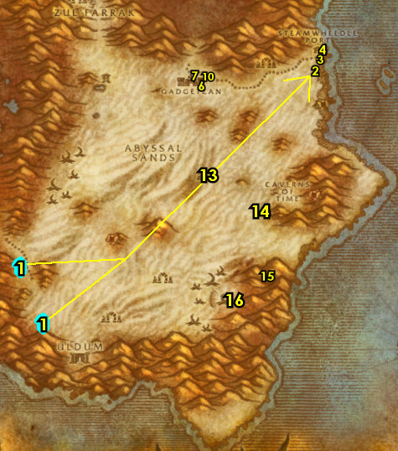

01) On the western side of Gadgetzan, up on the hill, turn in "The Scrimshank Redemption" 50.27, accept "Insect Part Analysis".
02) In the hut NW in Gadgetzan, turn in "Insect Part Analysis" 51.27, accept the next part.
03) Go back to the western side of Gadgetzan, up on the hill (50.27, #1 on map) and turn in "Insect Part Analysis". Accept "Rise of the Silithid".
04) Go down the hill and between the two huts, from Shreev /target, accept (no exclamation mark) "Safety First" 51.27.
05) At this point, make sure you are level 50 before continuing (grind on any mobs in Tanaris until you are). If you are still a few bars away I recommend grinding on the ogres at the Dunemaul Compound around 41.53.
06) Make sure you are repaired/resupplied from Krinkle 51.29 by the Forge..
07) Go to the Bank SE at Gadgetzan (hut at 52.29) and get the following items out: Super Snapper FX. Put the following item in the bank: Insect Analysis Report.
08) Go north into The Shimmering Flats and at the Night Elf standing by the bleachers (78.75 in Thousand Needles), turn in (you probably wont have this for TBC/SOM, if so ignore this) "An Orphan Looking For a Home", and if you have 2 Elixir of Fortitude with you, accept and turn in "A Short Incubation", then accept "The Newest Member of the Family". NOTE: This quest has a 1 hour countdown limit, so you must work somewhat quickly with the following steps to get this completed successfully...
09) Go to the goblin side of the Mirage Raceway and turn in "Safety First" 80.76.
10) Hearth to Ironforge.
10b) Check the AH 26.72 for a Mithril Casing and if you are able to get it, store it in your bank for now for a later quest at Un'goro Crater.
GET NEW ABILITIES, 10b) At Ironforge, get your level 50 spells/abilities.
11) Go to the Gryphon Master 56.48 in the middle of Ironforge and fly to Southshore, Hillsbrad.
50-50 The Hinterlands (log)
First Pick the Class you are playing top left of screen!!!
Along with the Game Version you are playing on (Era, SoM, TBC or WotLK)
01) Go NE to the path that goes into The Hinterlands (starting at 89.27 in Hillsbrad).
02) Follow the path into The Hinterlands, then make a sharp left at Aerie Peak, then a right into the Inn and accept "Troll Necklace Bounty" and "Skulk Rock Clean-up" 15.45.
03) Go up in the Inn to the Innkeeper 14.42 patrols a bit and make Wildhammer Keep (Aerie Peak) your new home.
TBC, 3b) Just outside 15.47, accept "Featherbeard's Endorsement" and "A Gesture of Goodwill".
04) As you go out questing in The Hinterlands also start working on "Favored of Elune?": loot the Wildkin Feathers on the ground scattered all around The Hinterlands you see along the way:
TBC, 4a) Just south, enter Featherbeard's Hovel and from the book by the fireplace, turn in "Featherbeard's Endorsement" 13.55, accept "In Pursuit of Featherbeard".
TBC, 4b) SE, inside of a small cave 25.66 do "A Gesture of Goodwill": kill the two named mobs (troll and his spider).
TBC, 4c) Enter Shadra'Aldor entrance 36.65.
TBC, 4d) Go up the temple and turn in "In Pursuit of Featherbeard" 37.72, accept "Reclaiming the Eggs".
TBC, 4e) In the immediate area around the SE side of Shadra'Aldor do "Reclaiming the Eggs": loot Gryphon Eggs. There is a lot up in the wooden crate 34.75. Also do "Troll Necklace Bounty": kill/loot trolls around the temples.
05) Go east to Valorwind Lake 41.60 and do "Sprinkle's Secret Ingredient": under the water loot a Violet Tragan (mushroom).
06) Go NE to Agol'watha around 47.42 and do "Skulk Rock Clean-up": kill 10 Green Sludge /target and 10 Jade Ooze /target. There is more of these mobs east at Skulk Rock around 58.43.
07) NOTE: While questing, you may find an item called OOX-09/HL Distress Beacon, from it accept "Find OOX-09/HL!". If so, go turn this in in the middle of the lake on top of the hill 49.38, but do NOT do the escort!
08) Make sure "Favored of Elune?" is finished: loot the Wildkin Feathers on the ground scattered all around The Hinterlands (#4 on map).
09) Along the east shore ramp down entrance 73.66 do "Whiskey Slim's Lost Grog": loot the Pupellyverbos Port (blue bottles on the ground). Also do "The Super Snapper FX" by using the Super Snapper FX quest item on Gammerita /target. This lvl 48 turtle patrols up and down the shore line. You don't actually need to kill it. While doing this, work your way to do the next step as well:
10) Go north at the shore and underneath the waterfall, loot Cortello's Treasure chest 81.47 to turn in "Cortello's Riddle" (14 slot bag reward)!
11) Hearth to Wildhammer Keep (Aerie Peak). If Hearthstone is still on a cooldown, keep grinding (or take a break) until you are able to hearth. Make sure you are resupplied. Do not sell your Troll Tribal Necklaces to a vendor!
12) Down in the Inn turn in "Troll Necklace Bounty" and "Skulk Rock Clean-up" 15.45 (#2 on map).
TBC, 12b) Just outside 15.47, turn in "A Gesture of Goodwill" and "Reclaiming the Eggs". NOTE: Featherbeard's Map can be destroyed as its not used for anything.
13) Go up and turn in "To The Hinterlands" 12.47, accept "Gryphon Master Talonaxe".
14) Go up in the building and turn in "Gryphon Master Talonaxe" 10.44, SKIP "Rhapsody Shindigger".
15) Just outside of the building, at the Gryphon Master 11.46, fly to Menethil Harbor, Wetlands.
#01
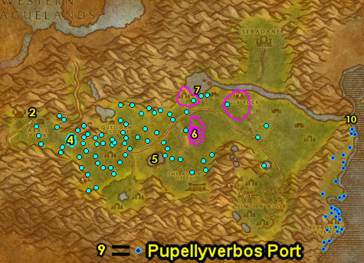 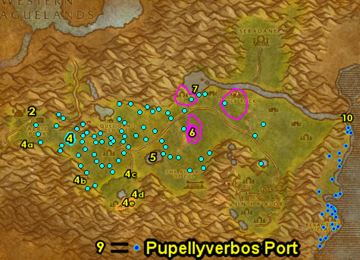
01) At Menethil Harbor, take the southern boat (5.64 on the docks) to go to Theramore.
02) At Theramore, go in the Inn and from the Innkeeper 67.45 make it your new home.
03) Go south to the Gryphon Master 67.51, fly to Ratchet, The Barrens.
04) At Ratchet do "The Stone Circle": just right outside of Liv Rizzlefix's hut (at the entrance), loot Marvon's Chest 62.39. Also, go in Liv Rizzlefix's hut and accept "Volcanic Activity".
#04
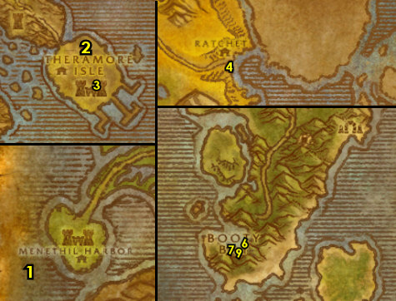

PLEASE READ: With all the faster leveling changes, by the time you get to this section you will most likely be well into level 50. Because of this when following my guide, you should skip this entire section and go right into the section 51 Ungoro Crator below. I will leave this section for reference purposes only. However if for some reason you are early into level 48 you can consider doing this section.
50-51 Blasted Lands
00) Go up to the Gryphon Master 28.78 and fly to Nethergarde Keep, Blasted Lands.
01) At Nethergarde Keep, go up to the top of the tower and accept "Petty Squabbles" 68.19.
02) Next to you up in the tower, turn in (if you have it) "Thadius Grimshade" 67.19, SKIP "Nekrum's Medallion" (Dungeon).
03) Go north to the border of Blasted Lands and SoS, to the Fallen Hero of the Horde (34.66 in SoS) and turn in "Petty Squabbles", accept and do "A Tale of Sorrow" by simply talking to the NPC. Then turn it in and accept "The Stones That Bind Us".
04) Go back south to enter the Blasted Lands and there is a small quest hub at 51.14 that gives 5 quests. These 5 quests requires the following total number of items to complete them, and they can drop without needing to accept the quests. The color codes below show where the mobs are at on the images and stars represent rare mobs that may not be there. Work on the rest of this section all at once):
Mob - Total Items Needed - After "The Decisive Striker" - And then "Vulture's Vigor"
05) Vulture Gizzards =14 - 12 - 2
06) Basilisk Brain =11 - 11 - 11
07) Blasted Boar Lungs =6 - 5 - 5
08) Scorpok Pincers =6 - 3 - 3
09) Snickerfang Jowls =5 - 5 - 3
10) 2+ PLAYERS (or could be soloable): While grinding for these items, try to do "The Stones That Bind Us": drag the different servants close to their Stone of Binding crystal next to each of them, then kill them along with attacking the crystal as well. This allows you to actually kill the mob and get quest credit. Each of these different servants are located at different parts of the Blasted Lands. See map for locations. If for some reason you cannot solo this quest (or find help), it can be skipped.
11) While grinding make sure you get everything discovered for XP (including The Tainted Scar at 44.57).
12) As you get these items, you can turn the quests in for a 60 min stat reward that will help you grind faster in Blasted Lands or even for the next section Un'Goro Crater (although they don't stack). Go to the quest hub at 51.14 and turn in all 5 of these quests: "Snickerfang Jowls" (+25 Strength), "A Boar's Vitality" (+25 Stamina), "The Decisive Striker" (+25 Agility), "The Basilisk's Bite" (+25 Intellect) and "Vulture's Vigor" (+25 Spirit). NOTE: The follow up quests do NOT yield XP: "Rage of Ages", "Spirit of the Boar", "Salt of the Scorpok", "Infallible Mind", and "Spiritual Domination".
13) While questing in Blasted Lands, you may have came across an item called Imperfect Draenethyst Fragment, turn these in at 52.36 for the quest "Everything Counts In Large Amounts". NOTE: I have NEVER found a Flawless Draenethyst Sphere for the quest "To Serve Kum'isha" ..good luck on that. Also, the follow up quest "One Draenei's Junk" is repeatable but yields no XP.
14) Go to the border of Blasted Lands and SoS, to the Fallen Hero of the Horde (34.66 in SoS) and turn in (if you did it) "The Stones That Bind Us", SKIP "Kirith". Accept "Heroes of Old".
15) Next to you on the other side of the path, turn in (if you have it) "Heroes of Old" (33.66 in SoS), accept the next part. Then click on the Spectral Lockbox on the ground next to you to turn it in.
16) Hearth to Theramore. NOTE: If you did not do "The Stones That Bind Us", then abandon the quest.
18) From the Gryphon Master 67.51, fly to Gadgetzan, Tanaris.
#05
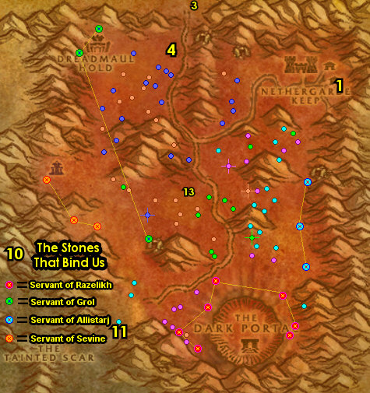

51-52 Un'Goro Crater
TBC/SoM, 00b) If you skipped Blasted lands section: Go to the Flight Master 63.37 and fly to Gadgetzan, Tanaris..
01) Go to the bank SE in Gadgetzan (hut at 52.29) and put the following items into it: Snapshot of Gammerita and Super Snapper FX. Get the following item out: Mithril Casing (it could be in your mailbox 52.28). This is used for a quest in Un'Goro Crater, and remember to not sell this to a vendor. Make sure you are repaired/resupplied.
02) At Gadgetzan, go to Sprinkle (by the NW hut 51.27) and turn in "Sprinkle's Secret Ingredient". Accept "Delivery for Marin".
03) Next to the AH, from Marin Noggenfogger 52.29, turn in "Delivery for Marin" NOTE: "Noggenfogger Elixir" can take up to a minute for the NPC to make the item for you, it does not yeild any XP, so you can do this when you are not in a hurry (such as after level 60). The Noggenfogger Elixir item is used for fun and can be stored in the bank when you want to use it.
04) NOTE: The Noggenfogger Elixir item is used for fun and can be stored in the bank 52.29when you want to use it.
05) Head south to the Broken Pillar and turn in "The Stone Circle" 53.46.
06) Go SW into Un'Goro Crater (entrance at 27.54 in Tanaris)...
#06
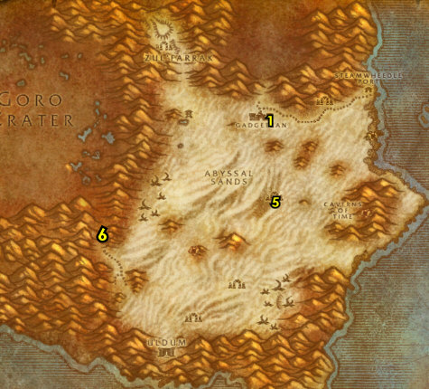

(log)
01) At the bottom of the path into Un'Goro Crater, go up the hill next to the waterfall and accept "The Apes of Un'Goro" and "The Fare of Lar'korwi" 72.76.
02) Go north a bit and do "The Fare of Lar'korwi": loot the big Fresh Threshadon Carcass lying on the ground 69.57.
03) Grind north to the entrance of Marshal's Refuge and accept "Chasing A-Me 01" 46.13. NOTE: On the way to Marshal's Refuge, grind on Bloodpetal mobs (plants) to start collecting Savage Fronds for a later quest. Also start collecting crystals (the red, blue, green and yellow) scattered everywhere.
04) Go up into Marshal's Refuge and accept ALL quests there: From the goblin on top of the hill, accept "Shizzle's Flyer" 44.12.
05) Go up the hill a bit to Muigin and accept "Muigin and Larion" 43.10.
06) Move into Marshal's Refuge 44.8 and accept "Lost!", (from the Wanted Sign Beware of Pterrordax) "Beware of Pterrordax".
07) Make sure you are repaired/resupplied 43.8.
08) Next to you accept "Roll the Bones" 43.7.
09) Next to you 44.7 accept "Alien Ecology" and "Expedition Salvation". NOTE: If you have already found A Mangled Journal, accept and turn in "Williden's Journal".
10) Time to do the Un'Goro Grind! NOTES For the Grind:
- Don't worry about looting the Un'Goro Dirt Piles, you will find enough Un'Goro Soil from mob drops. Also do not sell the Un'Goro Soil to vendors, you will need these for quest turn-ins!
- Don't worry about looting the Bloodpetal Sprouts, as they are not turned in for any XP.
- The Dinosaur Bones you need for the quest "Roll the Bones" will drop from many different mobs as you do the other quests.
- Also while questing, loot 7 crystals of each color (red, blue, green, and yellow) for a later quest. These crystals are scattered all around Un'Goro Crater.
- As you see the Bloodpetel mobs (plants spread all around Un'Goro) along the way kill/loot them for the quest "Muigin and Larion". These plants also drop Savage Fronds, you could collect 30 of these for a later quest at lvl 59. As you are doing the Un'Goro quests associated with these mobs you should get about half, so grind on these that you see along the way and see what you can get before leaving Un'Goro Crater, and you could always check the AH for more of these, or just skip this entirely.
- Watch out for the Elite Devilsaurs patrolling around this zone. I highlighted them through out the images so you can be alerted if you are in a danger zone for them.
#07
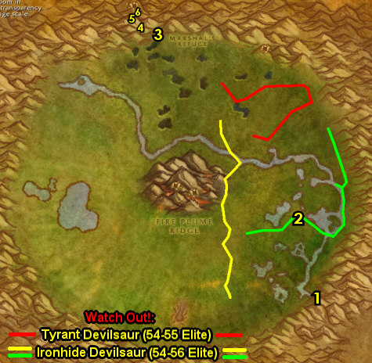

LET THE GRIND BEGIN:
01) Just south of Marshal's Refuge around 46.16 do "Super Sticky": kill/loot the Tar mobs around the tar pits.
02) Go NE to Fungal Rock and start working on "The Apes of Un'Goro": kill/loot the apes (in and outside of the cave). Also go in the cave entrance 64.16 and then make a right and turn in "Chasing A-Me 01", then if you have a Mithril Casing with you, accept and turn in "Chasing A-Me 01". Then accept and do the escort "Chasing A-Me 01": escort A-Me 01 to Marshal's Refuge, and then turn it in once you get there.
03) Go up on the mountain ledge (ramp entrance at 55.12) and start working on "Shizzle's Flyer": kill/loot the Pterrordax /target. There are only 6 mob spawns here, so clear the area once and move on to the next step..
04) Make sure "The Apes of Un'Goro" is finished: kill/loot the apes (in and outside of the cave around 64.16, #2 on map).
05) Go SE and do part of "Expedition Salvation": under the tent, loot the Crate of Foodstuffs 69.37.
06) Kill/loot Bloodpetal mobs (plants) starting below the river around 61.48 and work you way south. Kill/loot any Diemetradon you see as well for "Shizzle's Flyer".
07) Grind your way SE to Torwa Pathfinder on top of the hill by the waterfall and turn in "The Apes of Un'Goro" 72.76. Accept "The Mighty U'cha". And turn in "The Fare of Lar'korwi", accept "The Scent of Lar'korwi".
#08
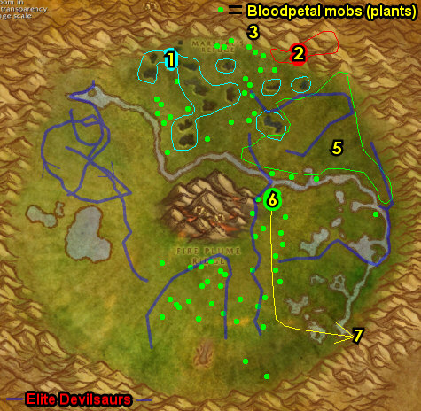

01) Just to the west of you at The Marshlands around 67.73 do "The Scent of Lar'korwi": run across the raptor egg nests (there is 5 total: 67.73 63.77 67.67 61.72 62.66) and then kill/loot the Lar'korwi Mates that spawn in. Keep the next step in mind:
02) At The Marshlands, at the western most pond, north on it's shore, click on A Wrecked Raft 63.69 to accept "It's a Secret to Everybody". Then right next to the wrecked raft, under the water, click on A Small Pack 63.69 to turn in "It's a Secret to Everybody", accept the next part. NOTE: To free up bag space, do NOT loot A Small Pack yet!
03) Go east to Torwa Pathfinder on top of the hill by the waterfall and turn in "The Scent of Lar'korwi" 72.76, accept "The Bait for Lar'korwi". NOTE: Do NOT loot Torwa's Pouch yet!
04) Go west to The Slithering Scar and do "Alien Ecology": enter the cave entrance 50.81. Make a left in the cave and then use your Unused Scraping Vial quest item on the mound in the center of the room 49.85.
05) Go south up at the ledges around 56.90 to continue obtaining the Webbed Pterrordax Scales (you will be able to get more of these later) for "Shizzle's Flyer". There is another spot of these mobs around 45.90.
06) Grind NW a bit to the old camp site 38.66 and do the last part of "Expedition Salvation": loot the Research Equipment (looks like a stack of brown boxes next to a tent).
07) All around the western side of Un'Goro Crater, finish up "Muigin and Larion" (kill Bloodpetal Trappers) along with finishing up "Beware of Pterrordax", "Shizzle's Flyer" and "Roll the Bones" (kill/loot Frenzied Pterrordax). The Dinosaur Bones can also drop from Elder Diemetradon and regular Diemetradon mobs (found south-middle). Keep the next step in mind:
08) At the Golakka Hot Springs (below the hotspring mountain), accept "Finding the Source" 31.50.
#09
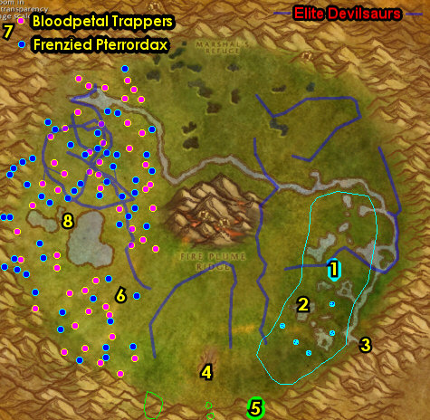

01) Do "Volcanic Activity" along with "Finding the Source". First go to the north entrance at Fire Plume Ridge (spiky bridge entrance at 53.43). Follow the path upwards to the top and use Krakle's Thermometer quest item at the Fire Plume Ridge Hot Spot (the one at 50.46). Watch out for the lvl 56 Elite mob in the cave at the top of the Ridge. Also kill/loot the fire elementals around Fire Plume Ridge for the 9 Un'Goro Ash and to start collecting Core of Elements for a future quest (I recommend at least getting about 10 for now).
02) Make sure all the quests above are done, including obtaining 7 crystals of each color (red, blue, green, and yellow), then go to the small cave at the eastern side of Fire Plume Ridge and turn in "Lost!" 52.50.
03) Accept and do the escort "A Little Help From My Friends": escort Ringo /target back to Marshal's Refuge 44.9. You will need to use the quest item Spraggle's Canteen on Ringo to wake him up if he faints.
04) turn in "A Little Help From My Friends" and "Beware of Pterrordax" 44.9.
05) Make sure you are repaired/resupplied 43.8.
06) Next to you turn in "Roll the Bones"43.7.
07) Next to you 44.7 turn in "Alien Ecology", "Expedition Salvation" and (if you haven't yet) accept and turn in "Williden's Journal" from the item A Mangled Journal (this item/quest is obtained while killing any mob in Un'Goro Crater that should be in your inventory by now). Make sure you are repaired/resupplied.
08) Open and loot A Small Pack in your inventory and then go to Linken (in the middle of Marshal's Refuge behind some trees 45.8) and turn in "It's a Secret to Everybody", accept the next part. NOTE: The Faded Photograph is not needed and will remain in your inventory forever unless you destroy or bank it.
09) At the western side of Marshal's Refuge up on the hill, turn in "Muigin and Larion" 43.10, SKIP "A Visit to Gregan".
10) Enter the cave at Marshal's Refuge entrance 43.6 and at the very end of the cave accept and turn in "Crystals of Power" 42.3. Then accept the 3 Pylon quests: "The Northern Pylon", "The Eastern Pylon" and "The Western Pylon". You can destroy any remaining crystals in your inventory (to free bag space).
11) Leave the cave, and then south in Marshal's Refuge on top of the hill, turn in "Shizzle's Flyer" 44.12.
#10
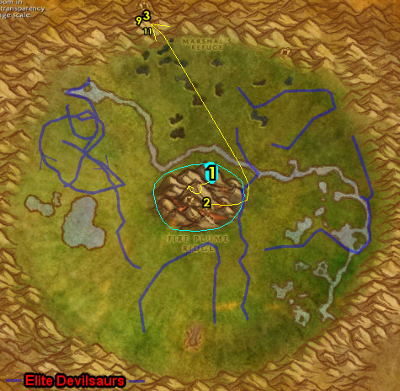

01) Go east up on the ledges and do "The Northern Pylon": click on the Northern Crystal Pylon 57.13.
02) Go east to Fungal Rock and do "The Mighty U'cha": enter the cave entrance 65.16, then keep left in the cave until you get to U'cha (lvl 55 red colored ape) and kill/loot him.
03) On the eastern side of Un'Goro Crater, go up on the ledges and do "The Eastern Pylon": click on the Eastern Crystal Pylon 77.50.
04) Just to the east of you on the mountain ledges there, do "The Bait for Lar'korwi": at the old dinosaur bones, there is a gray flat rock on the ground at 80.50. At this spot open your Torwa's Pouch quest item and first use the Preserved Threshadon Meat quest item, then use the Preserved Pheromone Mixture at this spot, then kill/loot Lar'korwi that spawns in (See Video).
05) Go south to Torwa Pathfinder 72.76 on top of the hill by the waterfall and turn in "The Bait for Lar'korwi" and "The Mighty U'cha".
06) Go west up on the mountain ledges and do "The Western Pylon": click on the Western Crystal Pylon 24.59.
07) Go NE to Golakka Hot Springs (below the hotspring mountain) and turn in "Finding the Source" 31.50, accept "The New Springs".
08) Grind your way back north to Marshal's Refuge entrance 46.13. Also at this time see if you can obtain 30 Savage Fronds from the Bloodpetel mobs (plants all around Un'Goro), 30 of these can be used for a later quest at lvl 59. If you are still far behind on that then don't worry about it, you may find more in the AH (or just skip it). Also remember to not sell your Un'Goro Soil!
09) Enter the cave at Marshal's Refuge entrance 43.6 and work your way to the end of the cave and turn in at 42.3 "The Northern Pylon", "The Eastern Pylon" and "The Western Pylon". Then accept and turn in "Making Sense of It". NOTE: The Crystal Pylon User's Manual can be destroyed or saved in your bank for later reference and you can always get a new one from this NPC in the cave.
10) Leave the cave, make sure you are repaired/resupplied 44.7.
11) Go up on the eastern side of Marshal's Refuge, to the Flight Master 45.6 and fly to Gadgetzan, Tanaris.
#11
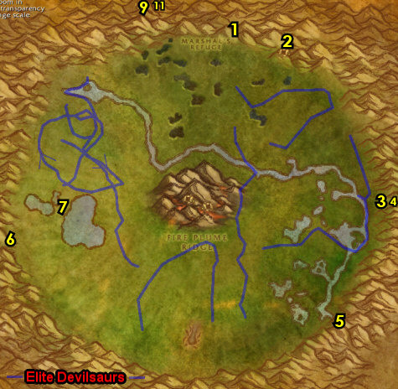

01) Go to the Bank SE at Gadgetzan (hut at 52.29) and put the following items in the bank: 9 Un'Goro Ash, Savage Fronds, Core of Elements. Get the following items out of the bank: Snapshot of Gammerita and Super Snapper FX.
02) North in Gadgetzan (next to the crane) turn in "Super Sticky" 52.27.
03) If you are not level 52 then grind on any mob in Tanaris until you are.
04) Hearth to Theramore.
05) N/A
08) At Theramore go to the Gryphon Master 67.51 and fly to Rut'theran Village, Teldrassil.
09) At Rut'theran Village, go in the house 55.92 and turn in "Favored of Elune?", accept "Moontouched Wildkin".
09b) Go upstairs in the house and turn in "The Super Snapper FX" 55.92, SKIP "Return to Troyas".
10) Go up the path through the red portal 56.89 to get to Darnassus.
#12
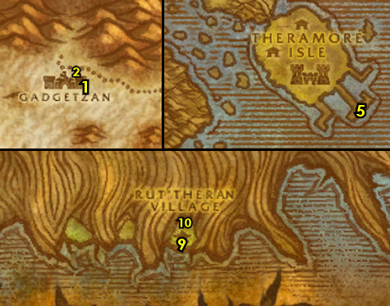

01) While in Darnassus, if you run across Herald Moonstalker /target (she patrols all around the city), from her, accept "A Call to Arms: The Plaguelands!". If you cannot find her, then don't worry you will have another chance later:
02) North at the Cenarion Enclave, go to the top of the tree tower and turn in "Assisting Arch Druid Staghelm" 35.9, accept "Un'Goro Soil".
03) Drop down behind the tree tower and turn in "Un'Goro Soil" 31.8.
04) Go back up to the top of the tree tower and accept "Morrowgrain Research" (35.9, #2 on map). NOTE: It's a long walk around unless you go through the shortcut right behind you.
05) Go down to the middle level in the tree tower and turn in "Morrowgrain Research", SKIP the next part.
06) You can sell any remaining Packet of Tharlendris Seeds and Un'Goro Soil to this vendor.
07) N/A
09) Go to the Bank 40.42 and get the following items out: Package of Empty Ooze Containers, Insect Analysis Report and (if you have it) Prayer to Elune.
10) Go south to Temple of the Moon and turn in "Rise of the Silithid" up at 42.86 , SKIP "March of the Silithid" (for now).
11) If you have "Prayer to Elune", then turn this in as well (up in the Temple of the Moon 38.81).
12) Exit Darnassus by going through the red portal 29.40.
13) On the docks, go to the Hippogryph Master 58.94 and fly to Astranaar, Ashenvale.
#13
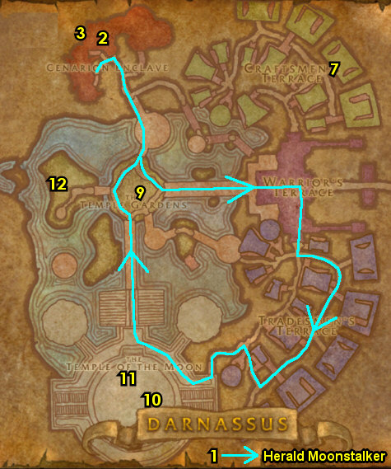

PLEASE READ: With all the faster leveling changes, by the time you get to this section you will most likely be well into level 52. Because of this when following my guide, you should skip this entire section and go right into the section 53-54 Felwood below. I will leave this section for reference purposes only. Also its not wise to even do this zone if you wanted to since we skipped getting the quests for this zone earlier.
52-53 Azshara
01) At Azshara, go east to Ruins of Eldarath and start working on "Arcane Runes": loot 3 of 4 Runes at the ruins. First one is Rune of Beth'Amara 37.53. See next steps for 2 more (for now):
02) Go SE a bit and loot Rune of Markri 39.55.
03) Go north a bit and loot Rune of Jin'yael 40.50.
04) Exit Ruins of Eldarath by heading east through The Shattered Strand, and then exit north 46.38..
05) Go NE to the hill entrance 53.20...
06) Go up to the top of the hill and accept "Kim'jael Indeed!" 53.22.
07) Go south to Thalassian Base Camp around 58.28 and do "Kim'jael Indeed!": loot Kim'jael's Equipment boxes on the ground around the camp.
08) Go NE to the hill entrance (53.20, #5 on map)...
09) Go up to the top of the hill and turn in "Kim'jael Indeed!" 53.22. Accept "Kim'jael's "Missing" Equipment".
10) Drop down to The Shattered Strand 51.36 (be careful, its a long drop), then do "Kim'jael's "Missing" Equipment": kill/loot Spitelash mobs (naga) until Some Rune drops (low drop rate).
11) Exit The Shattered Strand by heading north (at 46.38, #4 on map)..
12) Head east to the hill entrance (53.20, #5 on map)...
13) Go up to the top of the hill and turn in "Kim'jael's "Missing" Equipment" 53.22.
#14
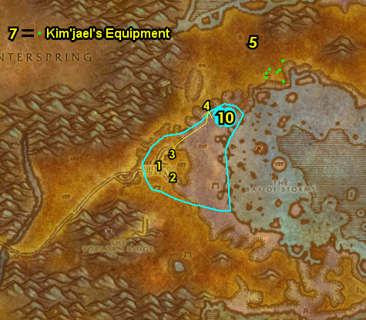

01) GRIND TIME: At this point you should be about level 53. Grind all the way to level 53 and a half (53.5) on Blood Elves around Thalassian Base Camp around 58.28. NOTE: Blood Elves are squishy mobs (mobs that have 30% fewer health/armor, than the average mob that level), so they die relatively fast and yield good XP/hour. Another decent grinding spot is the Satyrs at the Legash Encampment around 61.25. Also make sure "Morrowgrain Research" is finished too. OPTIONAL: Instead of the grinding, you could go do BRD Dungeon instead.
02) Go SW to Ruins of Eldarath and do the last part of "Arcane Runes": loot Rune of Sael'hai 42.64.
03) Go all the way SE in Azshara at the little island 78.91 and use your Standard Issue Flare Gun quest item at the helicopter pad, then from the NPC that spawns, turn in "Arcane Runes", accept "Return to Tymor".
04) Hearth to Craftsmen's Terrace (Darnassus). Make sure you are repaired/resupplied. NOTE: If the Standard Issue Flare Gun is still in your inventory you can destroy it.
05) Go west to the middle level of the tree tower 35.8 and turn in "Morrowgrain Research". NOTES: The quest is repeatable but you only get 550 XP on the next turn in, then no more afterwards. After turning this in, you can sell any remaining Packet of Tharlendris Seeds, Morrowgrains and Un'Goro Soil to a vendor. And you can destroy the Evergreen Pouch as well.
06) Go to the bank at Darnassus 40.42 and
07) Exit Darnassus by going through the red portal 29.41.
08) On the docks, go to the Hippogryph Master 58.94 and fly to Astranaar, Ashenvale.
#15
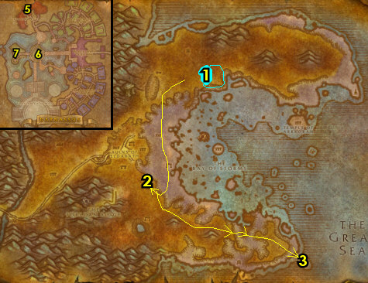

53-54 Felwood
02) Head east on the main path, then north to Felwood (entrance at 56.29 in Ashenvale)..
03) As you enter Felwood, and off to your right of the main path, accept "Cleansing Felwood" (54.87 in Felwood).
04) Go north a bit to Emerald Sanctuary and accept "Forces of Jaedenar" 51.82. And next to you in the tent 51.82, accept "Verifying the Corruption" and (if you are lvl 53) "To Winterspring!". And in the house, accept "The Corruption of the Jadefire" 51.82. Also, get the FP from the Flight Master 52.82.
05) Just south a bit next to the main path, from Grazle /target (furblog 51.85), accept "Timbermaw Ally".
06) Go south to Deadwood Village around 49.91 and do "Timbermaw Ally": kill the required amount of Deadwood mobs.
07) Go north a bit along the main path to Grazle (51.85, #5 on map) and turn in "Timbermaw Ally". Accept "Speak to Nafien".
08) Go up north to the two small ponds on your left around 41.71 and do part of "A Little Slime Goes a Long Way": first loot your Package of Empty Ooze Containers quest item, then use the Empty Cursed Ooze Jar quest item on Cursed Ooze corpses.
09) Just west of you do "The Corruption of the Jadefire": kill the required amount of Jadefire Satyrs and Xavathras /target 32.67 is at the west end of the camp by the green well.
10) Go up north and start working on the last part of "A Little Slime Goes a Long Way" around 41.59: use the Empty Tainted Ooze Jar quest item on Tainted Ooze corpses. When you run out of mobs, just continue on:
11) Go west into Jaedenar around 39.59 and do "Forces of Jaedenar": kill the required amount of mobs in the area.
#16
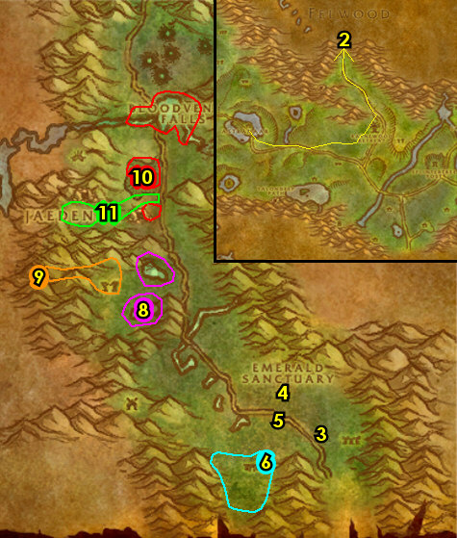

01) Back south a bit off the main path around 41.59 finish "A Little Slime Goes a Long Way": use the Empty Tainted Ooze Jar quest item on Tainted Ooze corpses. NOTE: There is even more of these slimes up north a bit around around 40.56.
02) Go south to Emerald Sanctuary and turn in "Forces of Jaedenar" 51.82, accept "Collection of the Corrupt Water".
03) Go in the house and turn in "The Corruption of the Jadefire" 51.82. Accept "Further Corruption".
04) Go north in Jaedenar and do "Collection of the Corrupt Water": use your Empty Canteen quest item in the green moonwell 35.60.
05) Go back south to Emerald Sanctuary and turn in "Collection of the Corrupt Water" (51.82, #2 on map), accept "Seeking Spiritual Aid". If you are level 53, accept (if you haven't yet) "To Winterspring!" 51.82. If not don't worry (it's not needed).
06) Go up north and on the east side of the path to Shatter Scar Vale around 42.43 do "Verifying the Corruption": walk across one of the craters in the Vale to get it explored, and kill the required amount of fire elementals.
07) Go north to enter Jadefire Run 42.20..
08) Grind south in Jadefire Run and kill/loot Xavaric 39.22 /target, he drops an item, which starts "Flute of Xavaric", accept it.
09) In the immediate area around Jadefire Run, do "Further Corruption" along with "Flute of Xavaric": kill the required amount of Jadefire Satyrs (demons) and loot them for the 5 Jadefire Felbinds.
#17
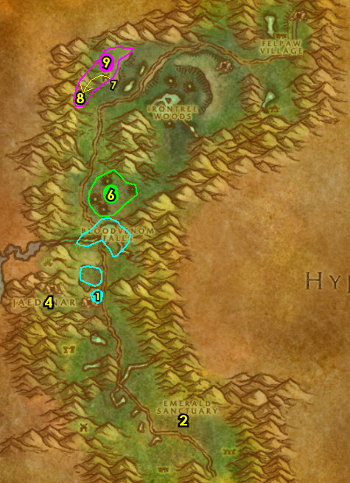

01) Follow the main path up NE to Irontree Woods and do "Cleansing Felwood": kill/loot the Warpwood elementals. There is more mobs in the Irontree Cavern entrance 56.17.
02) Go east to Talonbranch Glade and get the Flight Path from the Hippogryph Master 62.24. NOTE: You can get repaired/resupplied at the NPCs by the gazebo 62.26 .
03) Follow the main path north (right before the Timbermaw Hold entrance) and from Nafien 65.8, turn in "Speak to Nafien". And accept "Deadwood of the North".
04) Drop down west to Felpaw Village around 63.9 and do "Deadwood of the North": kill the required amount of Deadwood furbolgs.
05) Go back up to Nafien by the Timbermaw Hold entrance (65.8 #3 on map) and turn in "Deadwood of the North". Accept "Speak to Salfa". Also turn in any feathers you may have (repeatable quest to increase rep). NOTE: Becoming friendlier with Timbermaw Hold will allow you to enter their cave without them attacking you and allowing you to get additional quests and items from them.
06) Enter Timbermaw Hold next to you entrance 65.7 and go through the cave , make a right in the middle after the bridge to enter Moonglade up north.
07) Once in Moonglade, go east and just right after the first lake you see, get the Flight Path from the Hippogryph Master 48.67.
08) Exit Moonglade back to Timbermaw Hold (36.73 in Moonglade).
09) In Timbermaw Hold, make a right after the stairs to go into Winterspring..
#18
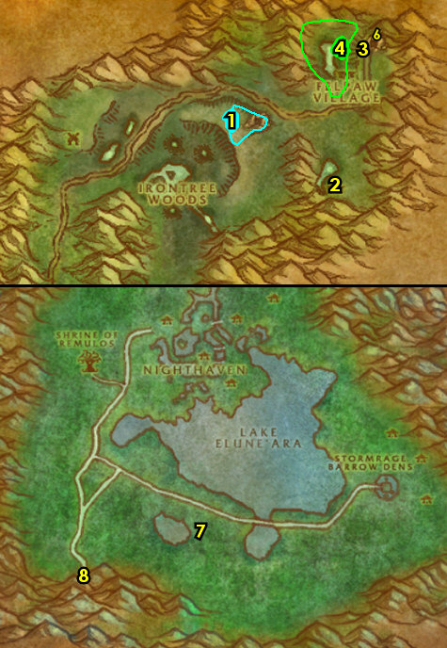

54-54 Winterspring (log)
01) Right outside of the cave, turn in "Speak to Salfa" (28.34 in Winterspring). And accept "Winterfall Activity".
02) Follow the main path south to Donova Snowden 31.45 and accept "Threat of the Winterfall". Turn in "The New Springs", accept "Strange Sources". Also turn in "It's a Secret to Everybody", SKIP "The Videre Elixir". NOTE: You do not have to wait for the NPC, just leave..
03) As you go east through the open fields of Winterspring start working on "Moontouched Wildkin": loot the Moontouched Feathers on the ground (south of the main path). While doing this, head east to the next step:
04) Head NE to Starfall Village and turn in (if you have it) "To Winterspring!" 52.30, accept "The Ruins of Kel'Theril".
05) Next to you, turn in "The Ruins of Kel'Theril" 52.30, accept "Troubled Spirits of Kel'Theril". Also accept "Enraged Wildkin".
06) Make sure you are resupplied at Food & Drink 52.29 or General Goods 51.31.
07) Go SE and just above Everlook go to the Hippogryph Master 62.37 to get the Flight Path.
08) Go around the west side of Everlook to enter it on the south side. As you enter Everlook, on your left, accept "Are We There, Yeti?" 61.38.
09) Go in the Inn and from the Innkeeper, make Everlook your new home 61.39.
TBC, 9b) Back in Everlook by the cage 62.38, accept "Ursius of the Shardtooth".
10) Go to Everlook's Bank 61.37 and put the following items into it: Flute of Xavaric, 5 Jadefire Felbind, Corrupt Moonwell Water, 15 Blood Amber, 6 Filled Cursed Ooze Jar, 6 Filled Tainted Ooze Jar, any Core of Elements you may have, any Deadwood Headdress Feathers you may have, and (if you have it) Deadwood Ritual Totem.
#19
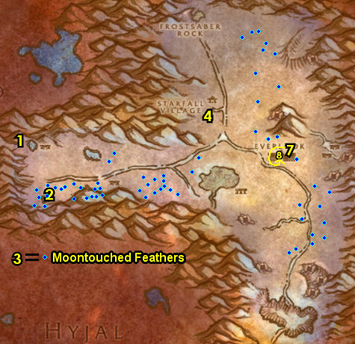

01) As you work on the following quests also start working on "Are We There, Yeti?" by kill/looting yeti (any will do), but don't make it your main priority:
02) Go SW to The Ruins of Kel'Theril and do "Troubled Spirits of Kel'Theril": loot the 4 Relic Fragments on the ground. Watch out for the high level water elementals. Just run in, loot them and run out. First one to loot is First Relic Fragment 55.43. See next steps for the other 3:
03) Go west a bit and loot the Third Relic Fragment 53.43.
04) Go east a bit and loot the Fourth Relic Fragment 52.41.
05) Go NW a bit and loot the Second Relic Fragment 51.42.
06) Go south to the small wrecked camp and click on the Damaged Crate 59.60 to turn in "Enraged Wildkin", accept the next part.
07) Go SE a bit and click on Jaron's Wagon 61.61 to turn in "Enraged Wildkin", accept the next part.
08) Do part of "Enraged Wildkin": right next to the wagon, loot Jaron's Supplies (small crate 61.61).
09) Go east to Owl Wing Thicket entrance 64.59 and finish "Enraged Wildkin": kill/loot the owls until you get the Blue-feathered Amulet (high drop rate). Try to avoid the higher level owls, you can find more owls up around the hills at the Owl Wing Thicket and more owls around 59.60.
10) Follow the main path south to discover Darkwhisper Gorge at 60.74 for "Strange Sources". You actually need to go further south past the bridge to get this discovered.
11) Hearth to Everlook. Make sure you are repaired/resupplied 62.38.
12) Go to Everlook's Bank 61.37 and put the following items into it: Jaron's Pick, First Relic Fragment, Second Relic Fragment, Third Relic Fragment, and Fourth Relic Fragment.
#20
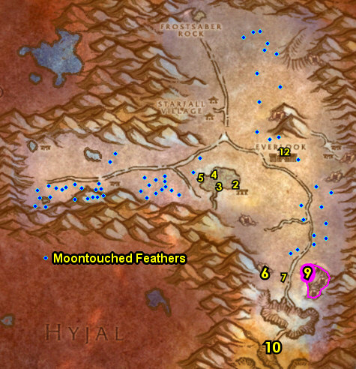

TBC, 00) As you go questing, keep an eye out for a bear named Ursius /target (he looks just like all other other ones), if so, kill him for "Ursius of the Shardtooth", but don't intentionally try to find him now:
01) Exit Everlook to the right, then go east to Winterfall Village around 67.35 and do "Winterfall Activity": kill the required amount of Winterfall furbolgs. NOTE: This place is usually busy with lvl 60+ players farming Winterfall Firewater here. If that's the case then this quest can be skipped (there is no follow up). You can also skip this if you are only level 53 right now as it is kind of a higher level quest.
02) Go west to Starfall Village and turn in "Enraged Wildkin" 52.30. Make sure you are resupplied.
03) Go west and do "Threat of the Winterfall": kill the required amount of Winterfall furbolgs. There are two camps of these mobs (one at 42.43 and one at 31.36). While doing this quest you should find an item, which starts "Winterfall Firewater" (accept it).
04) Go SW to Donova Snowden 31.45 and turn in "Strange Sources", "Threat of the Winterfall" and "Winterfall Firewater", accept "Falling to Corruption".
05) Make sure "Moontouched Wildkin" is finished now: loot the Moontouched Feathers on the ground (south of the main path).
06) Hearth (or run back if its still on a cooldown) to Everlook. Make sure you are repaired/resupplied 62.38.
TBC, 6b) IF YOU DID IT: Back in Everlook by the cage 62.38, turn in "Ursius of the Shardtooth".
07) Go SE to Ice Thistle Hills around 66.41 and finish "Are We There, Yeti?": kill/loot yeti (any will do).
08) Hearth (or go back) to Everlook and turn in "Are We There, Yeti?" 61.38, accept the next part.
#21
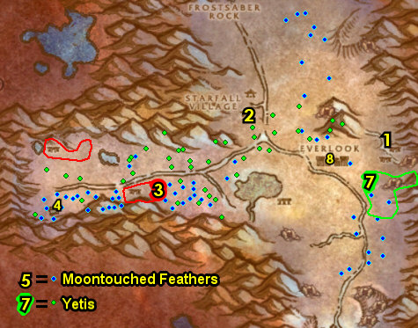

01) Go SE back to Ice Thistle Hills around 66.41 and do "Are We There, Yeti?": kill/loot Ice Thistle Matriarchs and Ice Thistle Patriarchs for the 2 horns (low drop rate). There is a higher concentration of these mobs in the cave entrance up at 68.42.
02) Hearth if you can . If you can't hearth, then go back to Everlook if you are close, or die on purpose and res at spirit if you are deep in the cave. Once at Everlook turn in "Are We There, Yeti?" 61.38, accept the next part.
03) Do part of "Are We There, Yeti?": at Legacki 62.39 /target (next to the Inn), use Umi's Mechanical Yeti quest item to scare her.
04) In the Inn 61.39 accept "The Everlook Report", "Duke Nicholas Zverenhoff" and (next to you) "Sister Pamela".
05) Go to Everlook's Bank 61.37 and put the following items into it: 10 Moontouched Feathers, Umi's Mechanical Yeti, Everlook Report, Studies in Spirit Speaking and (if you have it) Winterfall Ritual Totem. The totem could have dropped by one of the Winterfall furbolgs. And get the following items out: 15 Blood Amber, 9 Un'Goro Ash, Flute of Xavaric, 5 Jadefire Felbind and Corrupt Moonwell Water.
06) Exit Everlook to your right and go to the Hippogryph Master (north of Everlook 62.37) to fly to Talonbranch Glade, Felwood.
08) Go north to Felpaw Village and clear the mobs around the Deadwood Cauldron at 60.6, or distract the mobs some how (See Video), then click on the Cauldron to turn in "Falling to Corruption", accept "Mystery Goo".
09) Go through the cave NE entrance 65.7 to get to Winterspring and right outside of the cave, turn in "Winterfall Activity" (28.34 in Winterspring).
10) Follow the main path south to Donova Snowden 31.45 and turn in "Mystery Goo", accept "Toxic Horrors".
11) Hearth (or go east) to get to Everlook.
12) Go to the Hippogryph Master (62.37, #6 on map) to fly to Ratchet, The Barrens.
#22
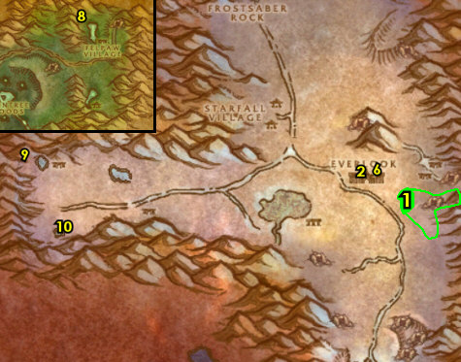

54-55 Felwood (log)
01) At Ratchet, In Liv Rizzlefix's hut (62.39 in The Barrens), turn in "Volcanic Activity".
02) Go up to the Inn and make Ratchet your new home 62.39.
03) Go south of Ratchet to The Tidus Stair (small Tauren camp 66.44) and turn in "Seeking Spiritual Aid". Wait a minute, then accept "Cleansed Water Returns to Felwood".
04) Go north to the Flight Master 63.37 at Ratchet and fly to Emerald Sanctuary, Felwood.
10) At Emerald Sanctuary turn in "Cleansed Water Returns to Felwood" 51.82, accept "Dousing the Flames of Protection".
11) In the house 51.82, turn in "Flute of Xavaric", accept "Felbound Ancients". Also turn in "Further Corruption"
12) In the tent, turn in "Verifying the Corruption" 51.82.
13) Go SE, and just off the main path, turn in "Cleansing Felwood" (54.87 in Felwood). Then click the NPC again and talk to her to get a Cenarion Beacon.
#23
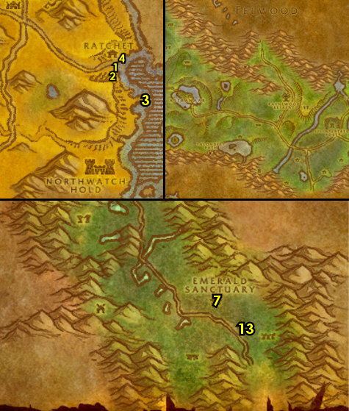

01) Go north to Jaedenar, and enter Shadow Hold entrance 35.58, then do "Dousing the Flames of Protection": click on the 4 Braziers. The cave is relatively linear and if you keep following it you will see the 4 Braziers to click on. The first one is at the bottom of the ramp that enters the cave 36.56. Go up a bit and you will see the 2nd one 36.55. Keep moving in and you will run into a big room that has the last two (37.53, 38.53). Keep the next step in mind:
01b) Exit the cave grinding backwards out of it. Also if you found a Blood Red Key (in keyring), then turn it in near the entrance of the cave from the caged night elf 36.56. Then go ahead and do the escort "Rescue From Jaedenar" which leads back into the cave and then back out of it.
02) Go back south to Emerald Sanctuary and turn in "Dousing the Flames of Protection" 51.82. Accept "A Final Blow" (this will be done later at level 58). Also, next to you, turn in (if you did it) "Rescue From Jaedenar", accept "Retribution of the Light" (this would also be done later at level 58).
03) Go south and just to the east of the main path, turn in "Salve via Hunting" 54.87. NOTES: If for some reason you do not have the 6 Corrupted Soul Shards, grind on any mob in Felwood until you get them. The quest is repeatable, but doesn't yield additional XP. The reward item Cenarion Plant Salve is used to cleanse the various corrupted plants around Felwood and the reward you get from them is decent (but no XP).
04) Go south and grind on Deadwood furblogs around 49.89 until you are able to hearth.
05) Hearth to Ratchet . Make sure you are repaired/resupplied.
06) Go north to the Flight Master 63.37 at Ratchet and fly to Theramore, Dustwallow Marsh.
07) N/A
08) At Theramore, go SE at the end of the docks to get on the boat to take you to Menethil Harbor 72.56.
09) At Menethil, go to the Gryphon Master 9.60 and fly to Ironforge, Dun Morogh.
#24
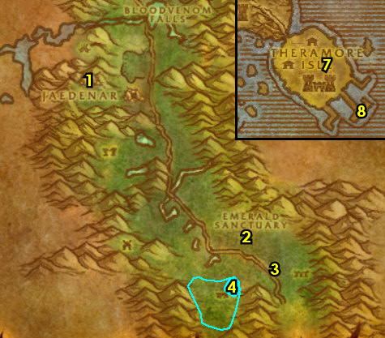

01) At Ironforge, go west to The High Seat and accept "The Smoldering Ruins of Thaurissan" 38.55. Then do it by talking to the NPC. Turn it in and accept the next part.
02) Go west to the Inn and make Ironforge your new home from the Innkeeper 18.51.
03) Go to the bank 35.62 and get the following items out: current stack of Dark Iron Scraps, Black Dragonflight Molt, 6 Filled Cursed Ooze Jar, 6 Filled Tainted Ooze Jar and any cloth for cloth donations. Put in the bank: Eridan's Vial, your Cenarion Beacon, any Cenarion Plant Salves and any Corrupted Soul Shards you may have.
04) You can turn in any cloth donation for the Dwarf Faction north from Mistina Steelshield 43.32.
05) N/A
GET NEW ABILITIES, 5b) Get your level 54 spells/abilities (if you haven't yet).
06) Go east to Hall of Explorers (at The Library) and turn in "A Little Slime Goes a Long Way" 76.23. Accept the next part.
07) You can go south to Tinker Town and turn in any cloth donations for the Gnome faction from Bubulo Acerbus 74.48.
GET NEW ABILITIES, 7b) Get your level 54 spells/abilities (if you haven't yet).
08) Go to the Bank (35.62, #3 on map) and put the following item into it: Bag of Empty Ooze Containers.
09) Go to the Gryphon Master 56.48 in the middle of Ironforge and fly to Morgan's Vigil, Burning Steppes.
#25
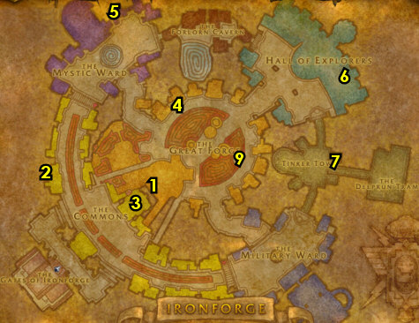

55-56 Burning Steppes
01) Next to you when you land at Morgan's Vigil 85.69, accept "Extinguish the Firegut" and "FIFTY! YEP!".
03) Grind your way north to Flame Crest ramp entrance 64.28..
04) Go up to Flame Crest and accept "Broodling Essence" and "Tablet of the Seven" 65.24.
05) Go in the small cave there and turn in "Yuka Screwspigot" 66.22, SKIP the next part (Dungeon). Make sure you are repaired/resupplied.
06) Go to the east side of Burning Steppes (starting around 73.28, #8 on map) and work on the following 4 steps together:
07) Start working on "FIFTY! YEP!" by kill/looting any Worgs you see. Don't make this a main priority now!
08) Start working on "Broodling Essence": use the Draco-Incarcinatrix 900 quest item on Broodlings (dragon whelps), then kill them and loot the Broodling Essence crystal that drops. Also throughout questing in Burning Steppes, kill any dragon whelps you see, they are squishy mobs that die real fast.
09) N/A
10) If you have the Black Dragonflight Molt with you, work your way east to the small cave 95.32 then accept and turn in "A Taste of Flame" (you will need to talk to him first after getting the quest), SKIP the next part (Dungeon quest).
11) At Dreadmaul Rock (in the middle of the east side of Burning Steppes) do "Extinguish the Firegut": kill the required amount of Firegut ogres. Also finish "Broodling Essence": use the Draco-Incarcinatrix 900 quest item on Broodlings (dragon whelps), then kill them and loot the Broodling Essence crystal that drops.
#26
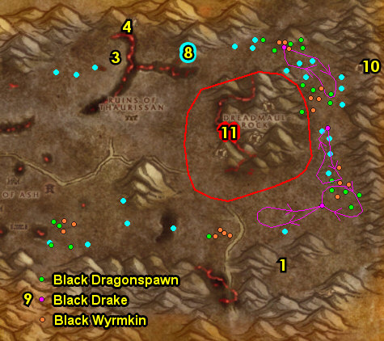

01) Go west to Ruins of Thaurissan (starting at 69.38) and do "The Smoldering Ruins of Thaurissan": loot the Thaurissan Relics (small stones). Keep the next step in mind:
02) Work west in Ruins of Thaurissan and do "Tablet of the Seven": loot the Tablet of the Seven next to the dwarf statue 54.41.
03) Grind your way north to Flame Crest ramp entrance 64.29..
04) Go up to Flame Crest and turn in "Broodling Essence" 65.24, accept "Felnok Steelspring". And turn in "Tablet of the Seven".
05) At Flame Crest make sure you are repaired/resupplied from Yuka Screwspigot 66.22 in the small cave.
06) Grind south to Morgan's Vigil and turn in "Extinguish the Firegut" 85.69, accept "Gor'tesh the Brute Lord".
07) Go west to The Pillar of Ash (starting at 53.53) and finish "FIFTY! YEP!": kill/loot the Blackrock orcs. Keep the next step in mind:
08) Work your way west in The Pillar of Ash and do "Gor'tesh the Brute Lord": kill/loot Gor'tesh /target (ogre that patrols around the bunker entrance 39.55).
09) Grind back east to Morgan's Vigil and turn in "Gor'tesh the Brute Lord" (85.69, #6 on map), accept "Ogre Head On A Stick = Party". Also turn in "FIFTY! YEP!". Make sure you are repaired/resupplied. If you have any Blackrock Medallions left over after turning in "FIFTY! YEP!", they can be destroyed.
10) Go up to the top of Dreadmaul Rock (bridge entrance at 76.38)..
11) Once at the top do "Ogre Head On A Stick = Party": next to the bonfire, click on the Soft Dirt Mound 81.47.
12) While at Dreadmaul Rock, make sure you collect a total of 30 Dark Iron Scraps, this will be used for a later quest. All the Ogres in Burning Steppes can drop them.
13) N/A
14) Go back south to Morgan's Vigil and turn in "Ogre Head On A Stick = Party" (85.69, #6 on map).
#27
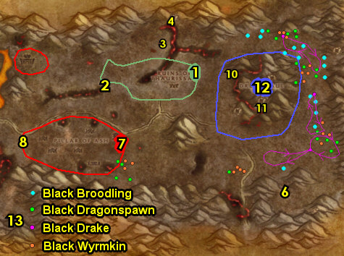

16) Make sure you are repaired/resupplied 85.68. NOTE: Steps 1 - 16 are taken out for WoTLK due to the Onyxia key quest chain was taken out for it!
[TBC/SOM] 16a) Go to the Gryphon Master 84.68 at Morgan's Vigil and fly to Booty Bay, STV.
[TBC/SOM] 16b) At Booty Bay, STV go in the Inn and turn in "Whiskey Slim's Lost Grog".
17) Hearth to Ironforge.
#28
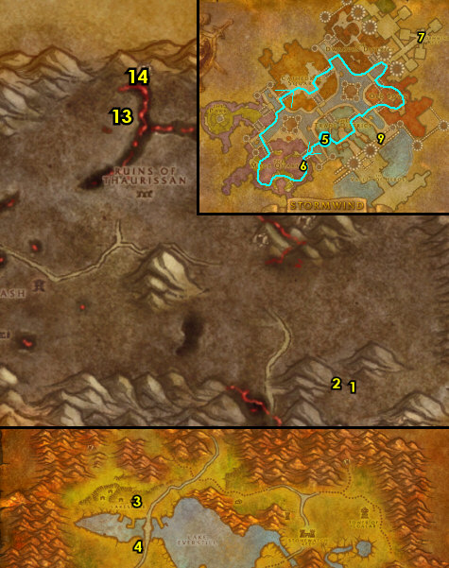

01) At Ironforge, go to the bank 35.61 and get the following item out: Everlook Report.. Put the following items in the bank: stack of 30+ Dark Iron Scraps and Tinkee's Letter.
02) If you have not accepted "The New Frontier" and "A Call to Arms: The Plaguelands!" from Stormwind previously, then find Courier Hammerfall /target (he patrols around Ironforge, See Map) and accept these quests from him. As you work on the following steps you might run into him, but make sure these are accepted before flying out of Ironforge:
03) You can turn in any cloth donation for the Dwarf faction from Mistina Steelshield 43.32 and cloth donations for the Gnome faction from Bubulo Acerbus 74.48.
04) Go to The High Seat and turn in "The Smoldering Ruins of Thaurissan" 38.55.
05) If you turned level 56 then get new spells/abilities for your class.
06) Make sure "The New Frontier" and "A Call to Arms: The Plaguelands!" are accepted from Courier Hammerfall /target (he patrols around Ironforge, (#2 on map), then go to the Gryphon Master 56.48 in the middle of Ironforge and fly to Southshore, Hillsbrad.
#29
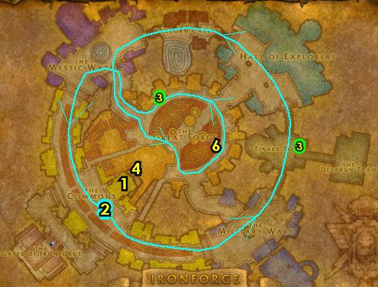

56-56 Western Plaguelands (log)
01) At Southshore, go NE (follow path to take on map) to get to Chillwind Camp, Western Plaguelands...
02) At Chillwind Camp, right as you get there and next to the shack/torn down house, accept "A Plague Upon Thee" (43.85 in Western Plaguelands).
03) Behind the shack, get the Flight Path from the Gryphon Master she patrols a bit around 43.85.
TBC, 3a) From the male Draenei 43.84 accept "The Mark of the Lightbringer".
04) From the bald human male by the tent, turn in "A Call to Arms: The Plaguelands!" 43.84, accept "Clear the Way".
05) In front of the other tent, from The Argent Dawn female human 43.84, turn in "The Everlook Report". Also complete "Argent Dawn Commission". NOTE: The trinket received called Argent Dawn Commission will allow you to collect Scourgestones from undead mobs in the Plaguelands (both eastern and western). Right-click it in your inventory to wear it. As long as you have it on, this will allow you to increase your rep with The Argent Dawn, which will allow you to buy items such as Enriched Manna Biscuits later.
06) Go east to Sorrow Hill around 48.81 and do "Clear the Way": kill 10 Skeletal Flayers and 10 Slavering Ghouls.
07) Go back west to Chillwind Camp and from the bald human male by the tent (43.84, #2 on map), turn in "Clear the Way". Accept "All Along the Watchtowers" and "The Scourge Cauldrons".
08) Next to you by the wagon 43.85, turn in "The Scourge Cauldrons", accept "Target: Felstone Field".
09) Make sure you are repaired/resupplied /target 43.84.
#30
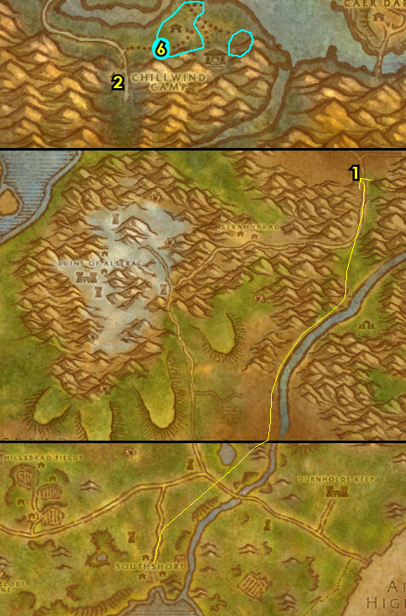

GROUP IF YOU CAN: The rest of the entire 56-56 WPL section is soloable but is probably the hardest section to do in the entire guide and I recommend seeing if you can group with someone to do the rest of this section, if not you should be able to solo it, some sections will be a bit rough. Proceed with caution

01) Follow the main path NW to get into Ruins of Andorhal and do part of "All Along the Watchtowers": use the Beacon Torch quest item at Tower One 40.72. NOTE: You must use the torch item right in the doorway of these towers in order for it to work, don't waste your charges!
02) Go north and enter the Andorhal Inn entrance 40.68, go upstairs and accept "A Matter of Time" 39.67.
03) Go NE and do part of "All Along the Watchtowers": use the Beacon Torch quest item at Tower Two 42.66.
04) Go NE and do the last part of "All Along the Watchtowers": use the Beacon Torch quest item at Tower Three 44.63.
05) Go east a bit and do "A Matter of Time": use the Temporal Displacer quest item near the silos around 47.63 then kill the Temporal Parasites that spawn. NOTE: The quest item only works on the silos emitting blue beams of light.
06) Go south and do part of "All Along the Watchtowers": use the Beacon Torch quest item at Tower Four 47.71.
07) Go NW and enter the Andorhal Inn (entrance 40.68, #2 on map), go upstairs and turn in "A Matter of Time". Accept "Counting Out Time".
08) All around Ruins of Andorhal do "Counting Out Time": loot the Small Lockboxes all around the broken down houses. There is usually one at each broken down house.
09) Enter the Andorhal Inn (entrance 40.68, #2 on map), go upstairs and turn in "Counting Out Time". NOTES: This quest is repeatable, but you will not get additional XP from it. The quest reward Attuned Dampener can only be used on Araj the Summoner in the middle of Andorhal, and there will be quests later associated with killing him.
10) Cauldron Quest Chain Info: You need to kill the Cauldron Lord at each targeted farm field (listed below), grab their key and use it at the big cauldron in the middle of the farm fields. You will be going back and forth from Chillwind Camp to the next field. As you enter each field, the Cauldron Lords spawns near the Scourge Cauldron in the middle of each field, if the Cauldron Lord is not there, leave the field and come back.
11) At Felstone Field, do "Target: Felstone Field": kill/loot Cauldron Lord Bilemaw /target 37.57. Then click on the Scourge Cauldron 37.57 to turn in "Target: Felstone Field", accept "Return to Chillwind Camp".
12) North in Felstone Field, go up in the house and accept "Better Late Than Never" 38.54.
13) Go in the barn next to the house and click on Janice's Parcel 39.55 to turn in "Better Late Than Never". Then click Janice's Parcel again to accept the next part of "Better Late Than Never".
14) Make sure you are at least 10,000 XP away from 56 (if you aren't yet). Keep grinding on any undead mobs to increase rep with The Argent Dawn until you are.
#31
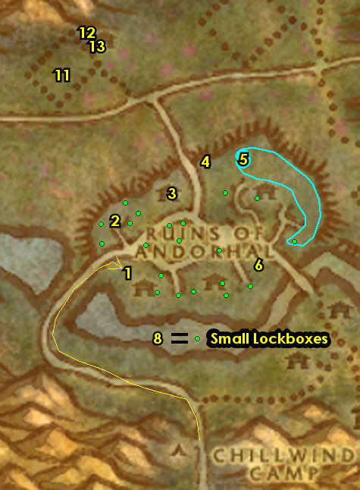

01) Hearth to Ironforge.
02) At Ironforge, go to the Bank 35.61 and get the following items out: First Relic Fragment, Second Relic Fragment, Third Relic Fragment, Fourth Relic Fragment, Studies in Spirit Speaking, (if you can) Swim Speed Potion, (if you have them) 30+ Dark Iron Scraps and 30+ Savage Fronds. There is a quest in Eastern Plaguelands that wants these items: 2 Thorium Bar, Golden Rod, 8 Hi-Explosive Bomb, 8 Unstable Trigger (get these out, either from the AH or bank if you can get all of them). You can then mail these items (including the 30+ Dark Iron Scraps and 30+ Savage Fronds) to yourself and retrieve them from the mailbox at Light's Hope in EPL):
03) Also, put in the bank: Attuned Dampener.
04) Go to the Gryphon Master 55.48 in the middle of Ironforge and fly to Stormwind, Elwynn.
05) At the side entrance of the Cathedral Square, go up in the City Hall building and turn in "Better Late Than Never" 57.48, accept "Good Natured Emma".
06) Find Ol' Emma /target, she patrols around the northern part of The Trade District. She patrols from up in the house at 60.57 to 67.72. From her, turn in "Good Natured Emma", accept "Good Luck Charm".
07) Go NE to Stormwind Keep and accept "The First and the Last" 80.38.
GET NEW ABILITIES, 7b) You should be level 56 now. Get new lvl 56 spells/abilities if you haven't yet.
08) Go south to Old Town and up in SI:7, turn in "The First and the Last" 78.71, accept and turn in "Honor the Dead", then accept "Flint Shadowmore".
09) Hearth if you can, then fly to Chillwind Camp, WPL. If you can't hearth then just go to the Gryphon Master 71.73 and fly to Chillwind Camp, Western Plaguelands.
10) When you land at Chillwind Camp, next to you by the wagon, turn in "Return to Chillwind Camp" 43.85, accept "Target: Dalson's Tears".
11) From the bald human male by the tent 43.84, turn in "All Along the Watchtowers". Accept "Scholomance". You can then destroy the Beacon Torch item.
12) Next to you, turn in "Scholomance" 43.84, accept "Skeletal Fragments". NOTE: "Skeletal Fragments" quest involves kill/looting skeleton type mobs around Ruins of Andorhal, Felstone Field and Dalson's Tears. Start working on this quest as you continue working on other WPL quests:
13) In front of the torn down house, turn in "Flint Shadowmore" 44.85, accept "The Eastern Plagues".
#32
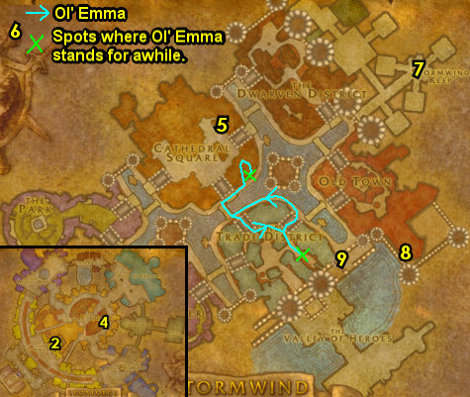

01) Go north to Felstone Field and up in the house, turn in "Good Luck Charm" 38.54, accept "Two Halves Become One".
02) Go south in Felstone Field and do "Two Halves Become One": kill/loot the Jabbering Ghoul /target (only one mob spawn that patrols around the farm). This mob drops Good Luck Other-Half-Charm. Right-click this item in your inventory.
03) Go back up in the house at Felstone Field and turn in "Two Halves Become One" (38.54, #1 on map).
04) Go east to Dalson's Tears farm and do "Target: Dalson's Tears": kill/loot Cauldron Lord Malvinious /target 46.52. Then click on the Scourge Cauldron to turn in "Target: Dalson's Tears", accept "Return to Chillwind Camp".
05) There is a small quest chain here at this farm that yields good XP: Go in the Barn at Dalson's Tears and click on Mrs. Dalson's Diary laying on the ground 48.51 to complete "Mrs. Dalson's Diary".
06) Next, find and kill/loot the Wandering Skeleton /target. This one skeleton wanders around the NE side of Dalson's Tears. He circles around the barn as well.
07) Click on the Outhouse 48.50 behind the barn to complete "Locked Away". Then Farmer Dalson will spawn next to the Outhouse, kill/loot this zombie.
08) Go up in the house (next to the barn) and click on the Locked Cabinet 47.50 to turn in "Locked Away".
09) Go back south to Chillwind Camp and turn in "Return to Chillwind Camp" 43.85, accept "Target: Writhing Haunt". Make sure you are repaired/resupplied.
10) Go NE to The Writhing Haunt and do "Target: Writhing Haunt": kill/loot Cauldron Lord Razarch /target 53.66. Then click on the Scourge Cauldron to turn in "Target: Writhing Haunt", accept "Return to Chillwind Camp".
#33
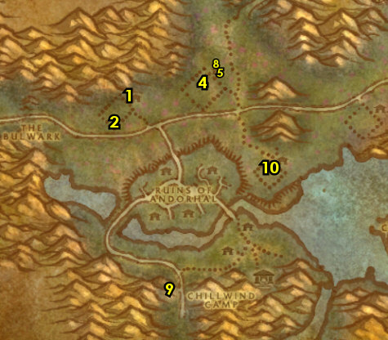

01) Go back to Chillwind Camp and turn in "Return to Chillwind Camp" 43.84, accept "Target: Gahrron's Withering". Make sure you are repaired/resupplied.
02) From the The Argent Dawn female human 43.84 by the tent, turn in any Scourgestones you may have to increase your rep with The Argent Dawn. Also, it's important to make sure you save at least one Argent Dawn Valor Token for a later quest.
03) Go NE to Gahrron's Withering and do "Target: Gahrron's Withering": kill/loot Cauldron Lord Soulwrath /target 63.59. Then click on the Scourge Cauldron to turn in "Target: Gahrron's Withering", accept "Return to Chillwind Camp".
04) Make sure "Skeletal Fragments" is finished: kill/loot skeleton type mobs. You can find a large amount at Ruins of Andorhal (starting at 49.67).
05) Go back to Chillwind Camp (#1 on map) and turn in "Skeletal Fragments" 43.84, SKIP "Mold Rhymes With...".
06) At the wagon, turn in "Return to Chillwind Camp" 43.85. Make sure you are repaired/resupplied. You can also turn in Scourgestones to increase rep with The Argent Dawn, but it's important to make sure you save at least one Argent Dawn Valor Token for a later quest.
07) From the bald human male by the tent 43.84, complete "Mission Accomplished!".
08) If for some reason you are already friendly with The Argent Dawn, then stock up on Enriched Manna Biscuits next to you from Argent Quartermaster Lightspark (gnome 43.84). These biscuits will help you level faster by receiving mana faster from consuming these biscuits.
09) Go east into Eastern Plaguelands (follow path on map)..
#34
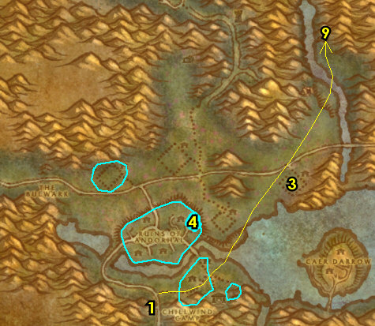

56-57 Eastern Plaguelands (log)
01) Go north along Thondoril River to Tiron Fordring 5.38 and accept "Demon Dogs", "Blood Tinged Skies" and "Carrion Grubbage".
02) Grind SE to The Marris Stead and do "The Eastern Plagues": loot the 3 skeleton remains. First one to loot is Mangled Human Remains [Turyen] (up on a hill 25.68). See next steps for the other two:
03) Go west a bit (watch out for the elites) and loot the Mangled Human Remains [Fredo] (up on a hill 24.68). Getting this also gets The Blightcaller Uncovered as well.
04) South a bit click on Mangled Human Remains [Rutger] (just north of the road 25.73).
05) Go south to The Undercroft and down in the crypt, from the Torn Scroll laying on the ground, accept "Hameya's Plea" 24.78.
06) Grind east to Darrowshire (kill/loot every mob you see along the way) to Pamela Redpath and turn in "Sister Pamela" 32.84, accept "Pamela's Doll".
07) At Darrowshire do "Pamela's Doll": find the 3 parts to Pamela's Doll: the head, the left side and right side. These parts have multiple spawn locations around Darrowshire in each of the 3 buildings in the area (excluding the building where Pamela is at). They look like little yellow things. Search the buildings for the 3 parts: big house 34.85, torn down house 35.85, small house 35.83, then click one of them to combine them to make Pamela's Doll. (See Video)
08) Go back to Pamela Redpath at Darrowshire and turn in "Pamela's Doll" ( 32.84, #6 on map). Accept "Auntie Marlene" and "Uncle Carlin".
09) Around southern EPL around 36.76, finish "Blood Tinged Skies": kill 30 Plaguebats. Also do part of "Demon Dogs": kill 20 Plaguehound Runts. And start working on "Carrion Grubbage": kill/loot Carrion mobs for the worm meat. All of these mobs are found in southern Eastern Plaguelands and the Carrion worm mobs are all over Eastern Plaguelands. Once you are nearing completion, work your way east to the next step:
10) Grind to Light's Hope Chapel 74.58 and accept "The Restless Souls" and "Zaeldarr the Outcast". Get resupplied here.
11) Go north a bit and turn in "Duke Nicholas Zverenhoff" 76.54.
#35
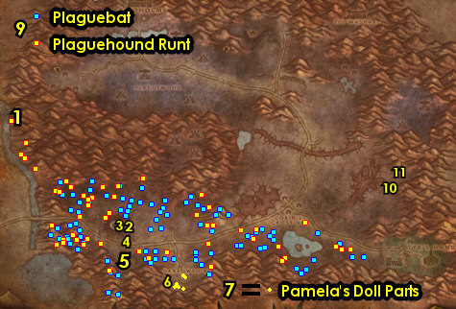

01) Next to you, turn in "Uncle Carlin" 76.54, accept "Defenders of Darrowshire".
02) Next to you from the Gryphon Master 76.53 get the Flight Path.
03) Get repaired from Craftsman Wilhelm 75.54 next to the Forge.
04) Right in front of the Inn's Entrance, go to Rayne and if you have 30 Savage Fronds accept and turn in "Savage Fronds" 75.53. NOTE: This and all 30 item turn-in quests here at Light's Hope requires you to be friendly with The Argent Dawn. If you are not friendly yet, ignore these for now and you will be able to turn these in a bit later once you are.
05) Go in the Inn and in the back from the human with black hair 76.52, accept and turn in "Binding the Dreadnaught" (requires the 30 Dark Iron Scraps).
06) If you have all 30 Bone Fragments, then you can accept and turn in "Bonescythe Digs" 76.53 (if not you can have more opportunities later).
07) If you were able to obtain the items needed for "That's Asking A Lot", then turn it in (at the dwarf by the Campfire, 75.52 ), accept "When Smokey Sings, I Get Violent".
08) Next to you at the human on the horse and with your one Argent Dawn Valor Token you saved earlier, accept and turn in "They Call Me "The Rooster" 75.52.

#36
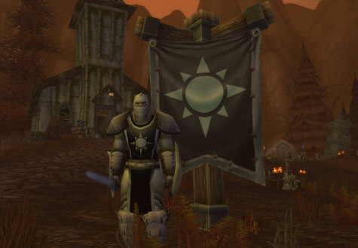

01) Do part of "Demon Dogs": kill 5 Plaguehounds /target. These evil dogs are found in the middle-eastern side of Eastern Plaguelands around 66.50.
02) Go NE a bit around 61.35 and start working on "Defenders of Darrowshire": kill any Gibbering Ghouls or Diseased Flayers and then talk to the spirit that spawns. If the area is cleared, you can continue on and revisit this place later:
03) Grind north to Zul'Mashar (ramp entrance at 59.19)..
04) Go up into Zul'Mashar and do "Hameya's Plea": kill/loot Infiltrator Hameya /target. This lvl 60 troll patrols around in front of the temple around 64.13.
05) Finish up "Carrion Grubbage" and "Demon Dogs": kill/loot Carrion mobs for the worm meat and kill 5 Frenzied Plaguehounds. These mobs are found NE around the open fields of Eastern Plaguelands around 52.26. Keep the next step in mind:
06) Go north (just below Quel'Lithien Lodge) and turn in "Troubled Spirits of Kel'Theril" 49.18 , accept "Fragments of the Past".
07) Go west to Plaguewood (starting at 41.29 ) and do the following 3 quests together:
08) "A Plague Upon Thee": loot the Large Termite Mounds, these are spaced all around Plaguewood (see map).
09) "Defenders of Darrowshire": continue working on this by killing Cannibal Ghouls and talk to the spirits that spawn. You will have more opportunities later to finish this.
10) If you have it do "When Smokey Sings, I Get Violent": go in the various ziggurat buildings around Plaguewood and use Smokey's Special Compound quest item inside the buildings.
#37
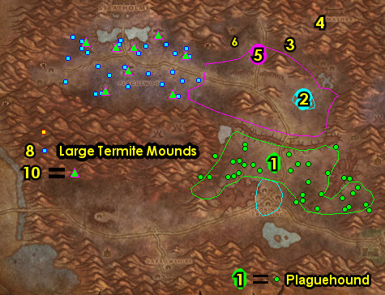

01) Go west to Terrordale and in the hut turn in "The Restless Souls" 11.29 , SKIP the next part (dungeon). And next to you, accept "Augustus' Receipt Book".
02) Do "Augustus' Receipt Book": go NE a bit to the Terrordale Inn (the largest building in the area entrance 14.28 ) and go up in the Inn, make a right and between two split open barrels loot Augustus' Receipt Book 14.26 on the ground. NOTE: Kill/loot all Crypt Fiends you see to start obtaining Crypt Fiend Parts (used for a later quest).
03) Go back to the hut in Terrordale and turn in "Augustus' Receipt Book" ( 11.29 , #1 on map). NOTE: You can now get resupplied from this NPC.
04) Grind on Crypt Fiend mobs all around Terrordale to potentially collect 30 Crypt Fiend Parts. This can be used for a later quest. There is more in the next step as well (but watch out for the Elite):
05) Go through the long cave entrance 12.25. NOTES: This cave journey is not easy. There is a lvl 60 elite spider /target (with a 1 hour respawn) that patrols back and forth to the 2 entrances of this cave. Try to sneak past it if you can. If this cave is too hard for you, then another possible quick alternative is to take the Tower Gryphon ride from the Plaguewood Tower 19.27 to the Crown Guard Tower, as long as the Alliance has control over the towers that is. Try to get all 30 Crypt Fiend Parts before leaving this area. If you are still far off from that, then you can skip getting the remaining ones.
06) Once you get out to the other side of the cave (or take the tower ride), north along Thondoril River at Tiron Fordring 5.38 , turn in "Demon Dogs" "Blood Tinged Skies" and "Carrion Grubbage". Accept "Redemption". Simply talk to Tiron Fordring to complete "Redemption", accept "Of Forgotten Memories".
07) Go south to The Undercroft, go down in the crypt and then do "Zaeldarr the Outcast": kill/loot Zaeldarr the Outcast 24.78. (See Video)
08) Behind the crypt, next to the wooden wagon, click on the Mound of Dirt to turn in "Hameya's Plea" 24.79.
09) Next to you, do "Of Forgotten Memories": click on the Loose Dirt Mound 25.80 that is next to Tirion Fordring's Grave, then kill/loot Mercutio Filthgorger (he has 3 bodyguards). IMPORTANT TIP: These mobs spawn between the two dirt mounds (from the previous step). Mercutio Filthgorger spawns in first, then his bodyguards soon after. So act fast and immediately pull Mercutio Filthgorger away from his spawn point to avoid fighting his guards too, as this fight can be really tough to do solo without this tactic.
#38
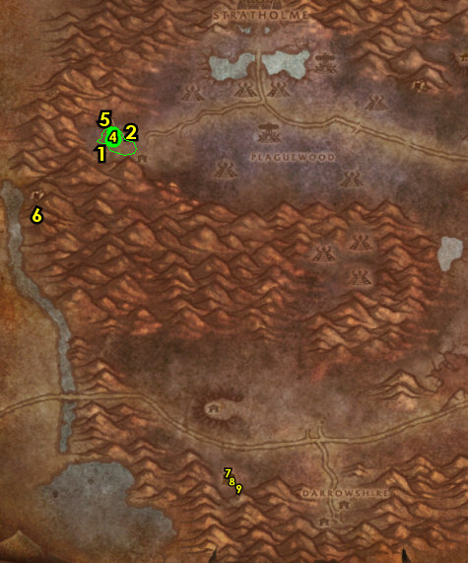

01) Go NW to Tiron Fordring, 5.38 and turn in "Of Forgotten Memories", accept "Of Lost Honor".
02) Go to the south side of Light's Hope Chapel (grind on all mobs along the way), then turn in "Zaeldarr the Outcast" 74.58.
03) Go north in Light's Hope Chapel and turn in (if it's finished) "Defenders of Darrowshire" 76.54.
04) Next to you at Duke Nicholas Zverenhoff 76.54, turn in any Scourgestones you have.
05) Get resupplied/repaired from Craftsman Wilhelm 75.54 next to the Forge. NOTE: If for some reason you are already Friendly with The Argent Dawn, then stock up on Enriched Manna Biscuits from the female dwarf Miranda Breechlock 76.54 by the tent.
06) Go in the Inn and with your 30 Crypt Fiend Parts, accept and turn in "Cryptstalker Armor Doesn't Make Itself..." 76.53.
07) If you have all 30 Bone Fragments, then you can accept and turn in (if you haven't yet) "Bonescythe Digs" 76.53 (if not you can have another opportunity later).
08) Go north a bit more in Light's Hope Chapel and turn in (if you did it) "When Smokey Sings, I Get Violent" 75.52. If you turned this in, you can then destroy Smokey's Special Compound.
Phase6, 8b) If you still need to: Next to you at the human on the horse and with your Argent Dawn Valor Token, accept and turn in "They Call Me "The Rooster" 75.52.
09) Go NE a bit around 61.35 and finish (if you still need to) "Defenders of Darrowshire": kill any Gibbering Ghouls or Diseased Flayers and then talk to the spirit that spawns.
10) Go north to Northdale and do "Of Lost Honor": loot the Symbol of Lost Honor (under the lake 66.29).
11) IF YOU STILL NEED TO: Go SE to Light's Hope Chapel and turn in "Defenders of Darrowshire" (#3 on map) 76.54.
12) Grind all the way back west to Tiron Fordring, ( 5.38, #1 on map) and turn in "Of Lost Honor", accept "Of Love and Family".
13) Go down south at the island of Caer Darrow 66.75 in WPL (use a Swim Speed Potion if you have one) and turn in "Of Love and Family". SKIP the next part (Dungeon).
#39
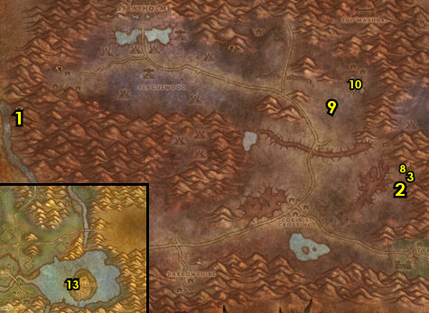

57-58 Western Plaguelands (log)
01) Go west to Sorrow Hill and in the house turn in "Auntie Marlene" 49.79, accept "A Strange Historian". NOTE: She could be upstairs as well.
02) Do "A Strange Historian": next to the house your at, loot Joseph Redpath's Monument in the graveyard 50.77. (See Video)
03) Go west to Chillwind Camp and in front of the torn down house, turn in "The Eastern Plagues" 44.85, accept "The Blightcaller Cometh".
04) Next to you at the shack, turn in "A Plague Upon Thee" 43.85, accept the next part.
05) Make sure you are repaired/resupplied 43.84. NOTE: If you have any remaining Plagueland Termites in your inventory, you can destroy them.
06) Enter Ruins of Andorhal on the west side and go upstairs in the Andorhal Inn entrance 40.68 and turn in "A Strange Historian", accept "The Annals of Darrowshire".
07) Enter the City Hall building in the middle of Andorhal entrance 44.69 and do "The Annals of Darrowshire": loot the Annals of Darrowshire (blue book). The actual Annals of Darrowshire book looks different from the others, it has a lighter tint on the top portion of the pages in the book, unlike the rest which has a darker tint on the top portion of the pages. (See Video)
08) Go back west to the Andorhal Inn entrance 40.68 and turn in "The Annals of Darrowshire" (#6 on map). Accept "Brother Carlin".
09) Go east to The Writhing Haunt and in the small house accept "The Wildlife Suffers Too" 54.65.
10) Work your way north (to the next step) while starting on "The Wildlife Suffers Too": kill Diseased Wolves /target:
11) Go north to Northridge Lumber Camp and do "A Plague Upon Thee": clear the mobs at the lumber camp, click on the Northridge Lumber Mill Crate 48.32 to place the termite barrel. Then click on the spawned Termite Barrel on top of the crate to turn in "A Plague Upon Thee", accept the next part. (See Video)
12) Go down the long slope in Northridge Lumber Camp and accept "Unfinished Business" 52.28.
#40
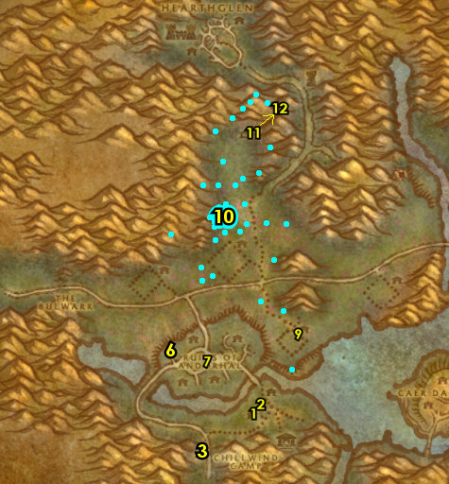

01) Go south a bit and do "Unfinished Business": kill the needed Scarlet human mobs in the area. The mages and knights (are around 50.41). NOTE: They share spawns with each other. See next step for the medics and hunters:
02) Go south a bit to the small Scarlet camp and kill the needed medics and hunters around 52.44.
03) Go back up NE in Northridge Lumber Camp, down the long slope and turn in "Unfinished Business" 52.28, accept the next part.
04) Go east a bit and do "Unfinished Business": kill Huntsman Radley /target 58.36. See next step for the other named mob to kill:
05) Kill Cavalier Durgen /target. He patrols around in the tower 55.24. Also go up this tower and do "The Mark of the Lightbringer" by looting the Holy Coffer.
06) Go back down in Northridge Lumber Camp and turn in "Unfinished Business" (52.28, #3 on map), accept the next part.
07) Go north to Hearthglen and do the last part of "Unfinished Business": go to the top of the watchtower 46.18 to complete the quest. Just mount up and avoid the mobs. Having a healing potion on hand helps. (Watch This Video to see a shortcut and how to do this quest).
08) Go back down in Northridge Lumber Camp and turn in "Unfinished Business" (52.28, #3 on map).
09) Make sure "The Wildlife Suffers Too" is finished: kill 8 Diseased Wolves /target. These wolves are found mostly above Dalson's Tears farm around 47.45. They share spawns with the spiders in the area, so kill them if not enough wolves. Work your way to the next step:
10) Go south to the small house at The Writhing Haunt and turn in "The Wildlife Suffers Too" 54.65, accept the next part.
11) Do "The Wildlife Suffers Too" (part 2): kill 8 Diseased Grizzly /target. These bears are found north and east of The Writhing Haunt. They share spawns with the spiders, so kill spiders if not enough bears.
12) Go back to the small house at The Writhing Haunt and turn in "The Wildlife Suffers Too" (54.65, #10 on map). Accept "Glyphed Oaken Branch".
13) At this point make sure you have at least 30 Bone Fragments (if you still need to turn in The Argent Dawn EPL quest). You can farm this item at Ruins of Andorhal (starting at 49.67 ).
14) Go to Chillwind Camp and in front of the shack, turn in "A Plague Upon Thee" 43.85.
15) Also turn in "The Mark of the Lightbringer" 43.84, accept "Tomb of the Lightbringer". NOTES: Accepting this starts an escort, which we will do on next step: Also if this male Draenei is not there, it means someone else is currently doing the escort, if so just skip it then, or consider doing it later.
16) Do "Tomb of the Lightbringer": escort the quest giver to Uther's Tomb 52.83 to complete it.
17) Go to Chillwind Camp and turn in "Tomb of the Lightbringer" 43.84.
#41
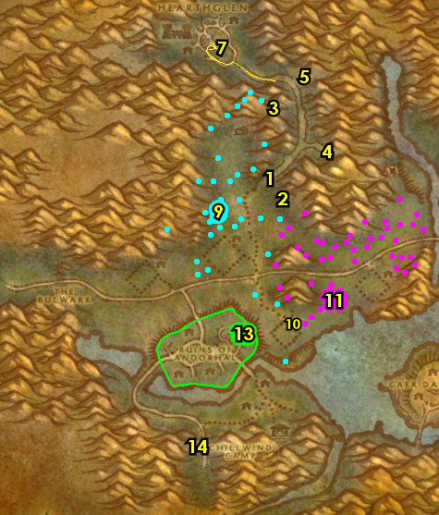

01) Make sure you are repaired/resupplied. You can stock up on Enriched Manna Biscuits from the gnome 43.84 (I get about 300 biscuits).
02) You should be level 58 by now, if not, grind on any mobs until you are.
03) Hearth to Ironforge.
04) At Ironforge, go to the Bank 35.61 and put the following items in the bank: Extended Annals of Darrowshire, any remaining Crypt Fiend Parts, Bone Fragments, Savage Fronds, Dark Iron Scraps, any Insignias and any Scourgestones you may have. Get the following items out: Eridan's Vial and 10 Moontouched Feathers.
05) Get your level 58 spells/abilities for your class.
06) Near the Gryphon Master accept "Taking Back Silithus" 59.47.
07) Go to the Gryphon Master 55.48 in the middle of Ironforge and fly to Stormwind, Elwynn.
08) At Stormwind, go NE to Stormwind Keep and turn in "The Blightcaller Cometh" 80.38, accept "Order Must Be Restored". NOTE: "Order Must Be Restored" can be kept in your quest book until you want to do this in EPL with a raid, but my guide will not cover it.
09) Go to the docks and take the southern boat 22.56to take you to Auberdine.
#42
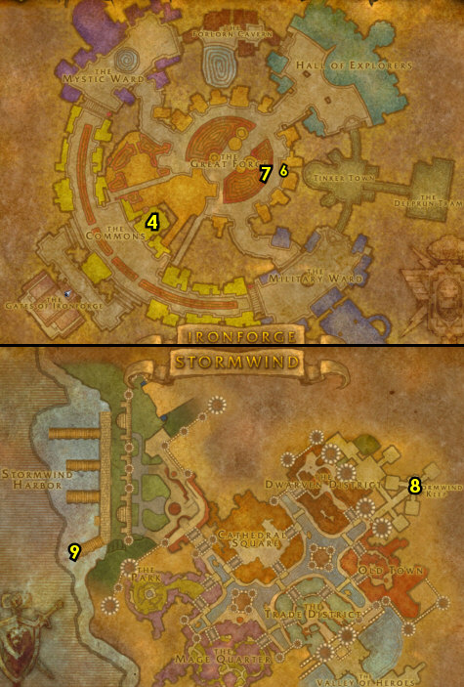

01) At Auberdine, on the small dock next to the Inn, go to the Hippogryph Master 36.46and fly to Rut'theran Village, Teldrassil.
02) At Rut'theran Village, go in the house and turn in "Moontouched Wildkin" 55.92, accept "Find Ranshalla".
03) Go up the path through the red portal 56.89 to get to Darnassus.
04) At Darnassus, go north to Cenarion Enclave and at the middle level of the tree tower 35.8, turn in "Glyphed Oaken Branch".
05) Go to the top of the tree tower and turn in "The New Frontier", accept the next part.
06) Go down to the middle level of the tree tower and turn in "The New Frontier" 35.8, accept "Rabine Saturna".
07) Go south to Temple of the Moon and in the water fountain in the middle 39.85 do "Felbound Ancients": use the Eridan's Vial quest item in the waterfall.
08) Go up in Temple of the Moon (on the east side) and from Gracina Spiritmight /target accept (no exclamation mark) "March of the Silithid" 42.86.
09) Any cloth donations are turned in at 64.23 for the Night Elf faction.
10) Exit Darnassus by going through the red portal 29.41.
11) On the docks, go to the Hippogryph Master 58.94 and fly to Moonglade.
12) Once in Moonglade, go to Nighthaven and turn in "Rabine Saturna" 52.45, accept "Wasteland". Also accept "A Reliquary of Purity". NOTE: In order to accept the purity quest, you need to have been in the Dire Maul zone in Feralas before talking to Rabine Saturna in order to unlock the dialog option (which you also need to read) in order to get this quest. If you can't get it, you can just skip it and ignore any future notations of it.
13) Go south (just east of the small lake) to the Hippogryph Master 48.67 and fly to Talonbranch Glade, Felwood.
#43
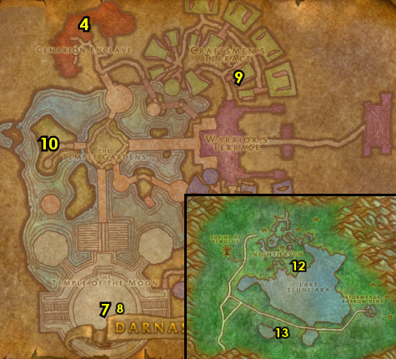

58-58 Felwood / Azshara (log)
01) Go SW to Irontree Woods (around 50.23 in Felwood) and do "Toxic Horrors": kill/loot Toxic Horrors (green water elementals).
02) Go south to Jaedenar and enter Shadow Hold, entrance 35.58 . Keep going through the cave then do (if you have it) "Retribution of the Light" by killing Rakaiah 38.51, then turn it in on the slab next you in that room, accept the next part. Then do "A Final Blow": keep going through the cave (it is relatively linear), then kill/loot Shadow Lord Fel'dan /target and his two succubus minions (in the cave at 39.47). Then exit the cave going backwards.
03) Go south to Emerald Sanctuary and turn in "A Final Blow" 51.82. And turn in (if you have it) The Remains of Trey Lightforge.
04) In the small house, turn in "Felbound Ancients" 51.82. Accept "Purified!". Wait a few seconds, then turn in "Purified!". NOTE: Hold onto the item received Flute of the Ancients. It involves an escort quest that can be done later (but my guide wont cover it). You can do that escort if you run out of quests to do at the very end of the guide. There is also a trick you can do with the flute, as it spawns in extra Toxic Horrors during the escort which can be used to help you farm a valuable item.
05) Go south into Ashenvale, make a right off the main path and die on purpose (around 55.34 in Ashenvale). Res at spirit.
06) NW in Astranaar, go to the Hippogryph Master 34.48 and fly to Talrendis Point, Azshara.
07) Go east inside Temple of Zin-Malor and down below loot the Sacred Highborne Writings (light green book on the ground 42.53).
09) Go west to Talrendis Point and you can get repaired/resupplied from the Bowyer 12.78.
10) Go to the Hippogryph Master 12.78 at Talrendis Point and fly to Gadgetzan, Tanaris.
#44
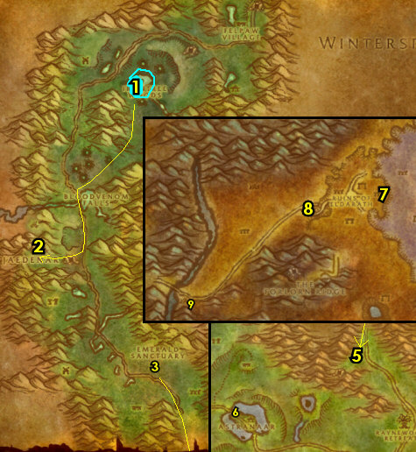

58-58 Tanaris / Un'Goro (log)
01) SE in Gadgetzan, go to the Bank 52.29 and get the following items out: Bag of Empty Ooze Containers, Umi's Mechanical Yeti and your stack of Core of Elements. Put the following items in the bank: 3 Toxic Horror Droplet and Sacred Highborne Writings.
02) NW in Gadgetzan, do part of "Are We There, Yeti?": use Umi's Mechanical Yeti quest item to scare Sprinkle /target 51.27.
03) In the hut next to you, turn in "March of the Silithid" 51.27, accept "Bungle in the Jungle".
04) Go SW into Un'Goro Crater (entrance 27.54 in Tanaris).
05) At Un'Goro Crater, go west to The Slithering Scar around 50.81 and do "Bungle in the Jungle": keep kill/looting the Gorishi mobs (bugs) until you get the Gorishi Scent Gland (can drop from any of them, but has a low drop rate) and also 5 Un'Goro Soil. These bugs can be found in and outside of the cave. You can find more soil from the slimes on the next step.
06) Do "A Little Slime Goes a Long Way". First loot your Bag of Empty Ooze Containers, then use the Empty Pure Sample Jar quest item on the corpses of slimes through out Un'Goro Crater (any slimes will do). Work your way to the next step:
07) Go north to Marshal's Refuge and do the last part of "Are We There, Yeti?": use the Umi's Mechanical Yeti quest item to scare Quixxil /target 44.9.
08) Make sure you are repaired/resupplied 43.8. Remember to not sell your Un'Goro Soils!
09) Go west to enter Silithus (entrance 29.22 in Un'Goro Crater)..
#45
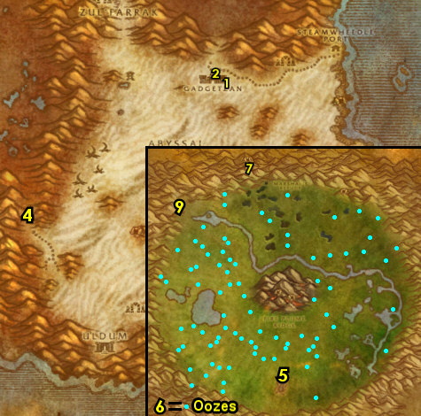

58-59 Silithus (log)
01) As you enter Silithus go to the small camp on your left (Valor's Rest) and turn in "Wasteland" 82.19, accept "The Spirits of Southwind".
02) Follow the main path west to Cenarion Hold and turn in "Taking Back Silithus" 51.38, accept "Securing the Supply Lines".
03) Next to you at the Wanted Poster: Deathclasp 51.38, accept "Wanted - Deathclasp, Terror of the Sands" (Elite).
04) Go up in the Inn next to you and accept "Deadly Desert Venom" 52.39.
05) Go up in Cenarion Hold and accept "The Twilight Mystery" 50.37.
06) Behind the moonwell, accept "Secret Communication" 49.38. And IF YOU ARE LVL 60 accept: "Abyssal Contacts", and (next to you) "Twilight Geolords".
07) Go in the building next to you and accept "Dearest Natalia" 49.34.
08) Exit the building and make a left to go up the dirt ramp and accept "Report to Marshal Bluewall" 51.35.
09) At the Hippogryph Master 51.34 in Cenarion Hold get the FP.
10) Go south to Southwind Village around 62.52 and do "The Spirits of Southwind" along with "A Reliquary of Purity": kill 8 Tortured Druids and 8 Tortured Sentinels around the village and work your way up in the village into the building and loot the Dusty Reliquary 63.55.
11) Grind/loot all mobs as you go NE to Valor's Rest and turn in "The Spirits of Southwind" (82.19, #1 on map), accept "Hive in the Tower".
12) Grind back down SW to Southwind Village and do "Hive in the Tower": go to the top of the swarming bug tower 60.53 and click on the Hive'Ashi Pod, then kill/loot the Hive'Ashi Ambushers until you get the Encrusted Silithid Object. Also while doing Southwind Village quests you should find an item (which drops from the bugs), which starts "Brann Bronzebeard's Lost Letter", accept it. And keep grinding until you get it.
13) Go NE to Valor's Rest and turn in "Hive in the Tower" (82.19, #1 on map), accept "Umber, Archivist".
#46
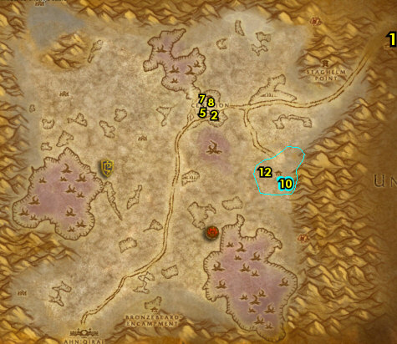
01) Go to the small camp above Staghelm Point around 66.21 and do "Secret Communication": kill/loot the Twilight mobs. NOTE: IF YOU ARE LVL 60 the quest "Abyssal Contacts" can be done here and multiple times later in this zone but my guide will not cover it or the follow ups, but its worth doing. And keep the next step in mind:
02) All around NE Silithus do "Deadly Desert Venom" along with "Securing the Supply Lines": kill/loot Stonelash Scorpids (scorpids), kill/loot Sand Skitterers (spiders), and kill Dredge Strikers (snakes).
03) Go to Cenarion Hold and turn in "Securing the Supply Lines" 51.38, accept "Stepping Up Security". Make sure you are repaired/resupplied.
04) Go up in the Inn next to you and turn in "Deadly Desert Venom" 52.39. Accept "Noggle's Last Hope".
05) Go up in Cenarion Hold and behind the moonwell, turn in "Secret Communication" 49.38. NOTE: The repeatable quest "Encrypted Twilight Texts" does not yield XP, only rep with the Cenarion Circle. But save your additional Encryped Twilight Texts for a future quest.
06) Go to the NW end of Silithus around 27.15 and do "The Twilight Mystery": loot the tablets on the ground. And grind on Dust Stormers & Whirling Invaders (wind elementals) until you get a total of 30 Core of Elements (used for a later quest), however if you are far off from the 30, you can optionally skip this.
07) All around the middle of Silithus do "Stepping Up Security": kill 20 Dredge Crushers. Also do part of "Noggle's Last Hope": kill/loot Stonelash Pincers. Work your way to the next step:
08) South at the small Alliance camp, turn in "Report to Marshal Bluewall" 33.51, accept "Scouring the Desert". NOTE: For "Scouring the Desert", keep an eye out for a Silithyst Geyser which looks like a glowing red thing all around Silithuis, click on it and you will get a buff, maintain the buff while bringing it back to the PVP Alliance base and stand in the teleporter looking thing 33.51, then turn the quest in next to you at Marshal Bluewall 33.51.
09) Grind south to Bronzebeard Encampment and turn in "Brann Bronzebeard's Lost Letter" 41.88. Also at this same NPC, talk to him to do part of "Dearest Natalia".
10) Next to you at Frankal Stonebridge 41.89 (sitting down at a tent), finish "Dearest Natalia" by talking to this NPC.
#47
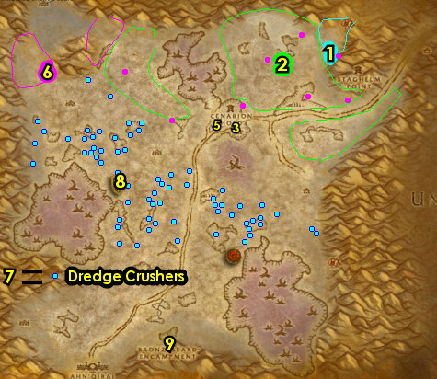
01) All around southern Silithus finish "Noggle's Last Hope": kill/loot Stonelash Flayers (scorpids) and Rock Stalker (spiders).
02) Grind north to Cenarion Hold and just outside of the Inn, turn in "Stepping Up Security" 51.38. Make sure you are repaired/resupplied.
03) Next to you, go up in the Inn and turn in "Noggle's Last Hope" 52.39. Then next to you, accept "Noggle's Lost Satchel".
04) Go up in Cenarion Hold and turn in "The Twilight Mystery" 50.37, accept "The Deserter".
05) Go in the building next to you and turn in "Dearest Natalia" 49.34, SKIP "Into The Maw of Madness" (group quest).
06) Go SE to Ortell's Hideout (small cave) and turn in "The Deserter" 67.70, accept "The Twilight Lexicon".
07) Grind NW to Twilight Base Camp and do "The Twilight Lexicon": kill/loot the 3 named mobs. First one is Twilight Keeper Havunth /target. This orc patrols around the Twilight Base Camp 42.44. Also IF YOU ARE LVL 60 start working on "Twilight Geolords" by killing the Twilight Geolords (and you will see more of these mobs in the next 2 camps coming up). See next steps for the other two:
08) Grind west to Twilight Post and kill/loot Twilight Keeper Mayna /target (female human 26.37). NOTE: Feel free to grind on the Twilight mobs here to obtain Encryped Twilight Texts. You will need 10 for a future quest and you will have one more opportunity in the next step to get some more:
09) Go south to Twilight Outpost and kill/loot Twilight Keeper Exeter /target (red armored human with fiery sword 16.86). NOTES: You can avoid Hive'Zora & get there quicker by hugging the west side of Silithus mountains. Also keep grinding on the Twilight mobs until you get 10 Encryped Twilight Texts, this will be used for an easy turn-in quest later. And IF YOU ARE LVL 60 make sure "Twilight Geolords" is finished now.
10) Go right behind Bronzebeard Encampment to the mountain entrance 43.90 and try to do "Wanted - Deathclasp, Terror of the Sands" (Elite): kill/loot Deathclasp /target. This level 59 Elite scorpid is soloable but could give you some troubles. If you cannot solo it, or find a group to help you, then it can be skipped. (See Video)
11) Also at the same area of Deathclasp, do "Noggle's Lost Satchel": loot Noggle's Satchel (yellow sack on ground 45.91). (See Video)
#48
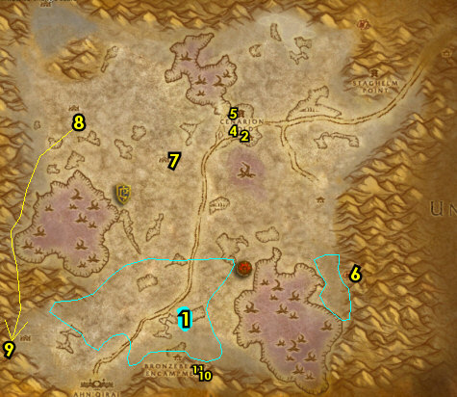
01) Grind east to Ortell's Hideout (small cave) and turn in "The Twilight Lexicon" 67.70, accept "A Terrible Purpose". Also accept, and then turn in "True Believers". Also this quest is repeatable, but no additional XP.
02) Grind back to Cenarion Hold and up in the Inn turn in "Noggle's Lost Satchel" 52.39. Make sure you are repaired/resupplied.
03) Go up in Cenarion Hold and in the building, turn in "A Terrible Purpose" 49.34, SKIP "Into The Maw of Madness" (requires group). Also, IF YOU ARE LVL 60 turn in "Twilight Geolords" 49.38 (by the moonwell), NOTE: "Vyral the Vile" is a solable quest that can be done, but wont be covered here.
04) As you exit the building, make a left and go all the way to the top of the tower and turn in (if you did it) "Wanted - Deathclasp, Terror of the Sands" 51.34.
05) Drop down and at the Hippogryph Master 51.34 fly to Gadgetzan, Tanaris.
06) NW in Gadgetzan, in the hut, turn in "Bungle in the Jungle" 51.27.
07) Hearth to Ironforge.
08) At Ironforge, go to the bank 35.61 and get the following items out: Sacred Highborne Writings, 3 Toxic Horror Droplet, Tinkee's Letter, Extended Annals of Darrowshire and (if you still need to) 30+ Bone Fragments. NOTE: 30 Core of Elements could already be in your inventory, if not get them out too (if you have them). You can put into the bank any remaining Encrypted Twilight Text you may have.
09) This is the last time I will remind you to turn in any cloth donations for Ironforge that you may have. These are found from the Dwarf faction from Mistina Steelshield 43.32 and cloth donations for the Gnome faction from Bubulo Acerbus 74.48.
10) Go north to Hall of Explorers (at The Library) and turn in "A Little Slime Goes a Long Way" 76.23.
11) Go to the Gryphon Master 55.48 in the middle of Ironforge and fly to Light's Hope Chapel, Eastern Plaguelands.
#49
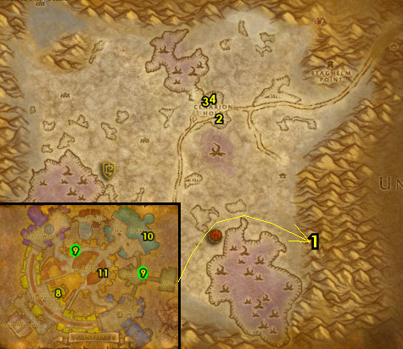

59-59 Eastern Plaguelands (log)
01) At Light's Hope Chapel, next to you when you land, by the tent, turn in "Brother Carlin" 76.54 , accept "Villains of Darrowshire". NOTE: "Heroes of Darrowshire" (and all follow up quests) is a quest chain you could do if you have a group, and it's worth doing, especially later when you get the chance.
02) Next to you from Quartermaster Miranda Breechlock <The Argent Dawn> 76.54, you can re-stock up on Enriched Manna Biscuits if you need to.
03) Go in the Inn and from the female human 76.52 sitting at the table, (if you have the 30 Core of Elements) complete The Elemental Equation.
04) (If you still need to) Next to you by the entrance, (with 30 Bone Fragments), accept and turn in "Bonescythe Digs" 76.53.
05) Go NW (just below Quel'Lithien Lodge 49.18) and turn in "Fragments of the Past", SKIP the next part.
06) Go south to Blackwood Lake and do part of "Villains of Darrowshire": loot Horgus' Skull under the water (look for the purple glow 47.44).
07) Go south to The Infectis Scar and do the last part of "Villains of Darrowshire": loot Shattered Sword of Marduk 49.60. Look for the pink glow.
08) Go back to Light's Hope Chapel at Carlin Redpath and turn in "Villains of Darrowshire" ( 76.54, #1 on map).
09) Go to the Gryphon Master 76.53 and fly to Menethil Harbor, Wetlands. NOTE: If your Hearthstone cooldown is almost up (less than 15 minutes), then go grind on any mobs in EPL (or take a break) until you are able to hearth to Ironforge, then fly to Menethil Harbor.
#50
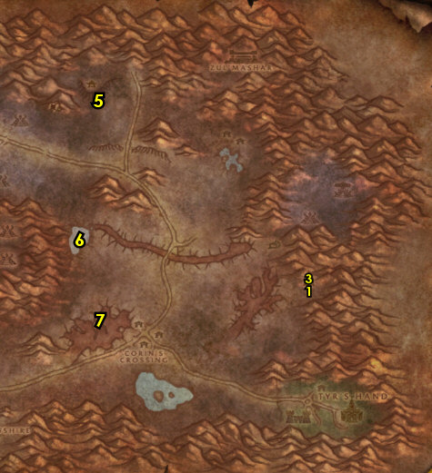

01) At Menethil Harbor, go on the docks and get on the southern boat 5.64 to take you to Theramore.
02) At Theramore go to the Gryphon Master 67.51 and fly to Moonglade.
03) Once in Moonglade, go to Nighthaven and at Umber, turn in "Umber, Archivist" 45.36 or could be at 48.40, accept "Uncovering Past Secrets".
04) Go into Nighthaven and turn in (if you have it) "A Reliquary of Purity" 52.45, SKIP "Shards of the Felvine" (Dungeon). Also turn in "Uncovering Past Secrets".
05) Go back to Umber at Nighthaven and complete "Under the Chitin Was..." (48.40 or could be at 45.36, #3 on map).
06) Exit Moonglade at the SW path to go to Timbermaw Hold (36.72 in Moonglade).
07) In Timbermaw Hold, make a right after the stairs (NOT the bridge) to go into Winterspring..
#51
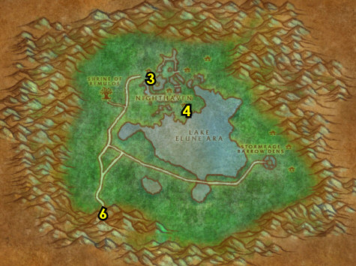

59-60 Winterspring (log)
01) Go south to Donova Snowden (31.45 in Winterspring) and turn in "Toxic Horrors", accept "Winterfall Runners".
02) Try to do "Winterfall Runners": try to find the pack of Winterfall Runners /target (three lvl 57s) that patrols the main path from the Timbermaw Hold cave 28.34 to Winterfall Village 68.38 and kill/loot them for the Winterfall Crate. See map for exact patrol path. If after making one pass and you cannot find these mobs, then this can be skipped for now.
03) If (or when ever) you have completed "Winterfall Runners", go back to Donova Snowden (31.45, #1 on map) and turn it in. Accept "High Chief Winterfall" . NOTE: My guide will not cover "High Chief Winterfall".
04) Frostsaber Mounts Only (NO XP): Follow the main path east, then north to Frostsaber Rock and up on the ice ledge, accept "Frostsaber Provisions" 50.10. NOTE: This is a repeatable quest that only yields rep points that can eventually allow you to purchase unique Frostsaber mounts from him.
05) Go to Everlook while starting on (if you have it) "Frostsaber Provisions": kill/loot bears and chimera.
06) Just to your left as you enter Everlook (next to the hut) turn in "Are We There, Yeti?" 61.38. Then complete (if you have the engineering profession) "A Yeti of Your Own".
07) From Felnok Steelspring under the blue tent 62.39, turn in "Felnok Steelspring", accept "Chillwind Horns".
08) Back in Everlook by the cage 62.38, accept "Luck Be With You" (Elite). And accept (if you don't have it) "Ursius of the Shardtooth" OR (if available) "Brumeran of the Chillwind".
09) Go in the Inn and make Everlook your new home 61.39. Make sure you are repaired/resupplied.
10) You can Bank 61.37 any remaining Core of Elements, Bone Fragments and Insignias you may have.
#52
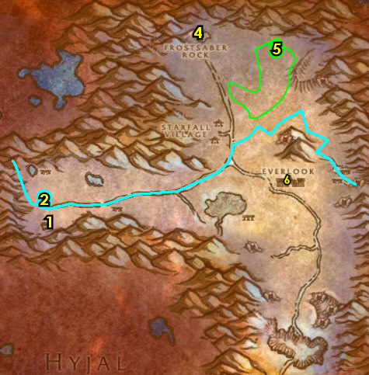

01) As you do the rest of this section, start working on "Chillwind Horns" (kill/loot chimera) and continue working on (if you have it) "Frostsaber Provisions" (kill/loot bears & chimera) along the way, also (if you still need to) keep an eye out for a bear named Ursius /target (he looks just like all other other ones), if so, kill/loot him for "Ursius of the Shardtooth" OR if you have (instead) "Brumeran of the Chillwind" then keep an eye out for Brumeran /target (lvl 58 Chimera) and kill it.:
02) Go to the entrance of the Owl Wing Thicket and from Ranshalla 63.59, turn in "Find Ranshalla". Then accept and do the escort "Guardians of the Altar": follow Ranshalla through the Owl Wing Thicket and click on the 5 Fire of Elune torches (one in each cave). Then click on the Altar of Elune at the end of the escort.
03) Go south to Frostwhisper Gorge (entrance 59.66, you can even just go directly south from the escort) and start working on "Luck Be With You" (Elite): loot Frostmaul Shards. Just try to distract the giants to loot the shards. Try to sneak in a take as much as you can, you can return here later to get more.
04) Grind north to Everlook.
05) In Everlook, by the cage 62.38, and turn in (if its done) "Luck Be With You", then accept and turn in "Cache of Mau'ari". NOTE: The Cache of Mau'ari allows you to turn in E'kos for a temporary stat boost as long as the item remains in your bags. Also turn in (if you did any of them) "Ursius of the Shardtooth" OR "Brumeran of the Chillwind".
06) Make sure you are repaired/resupplied 62.38.
07) North of Everlook around 56.21 finish "Chillwind Horns" (kill/loot chimera) and (if you have it) "Frostsaber Provisions" (kill/loot bears and chimera).
08) Frostsaber Mounts Only (NO XP): Go north to Frostsaber Rock and up on the ice ledge, turn in "Frostsaber Provisions" 50.10. NOTE: This is a repeatable quest that only yields rep points that can eventually allow you to purchase unique Frostsaber mounts from him.
#53
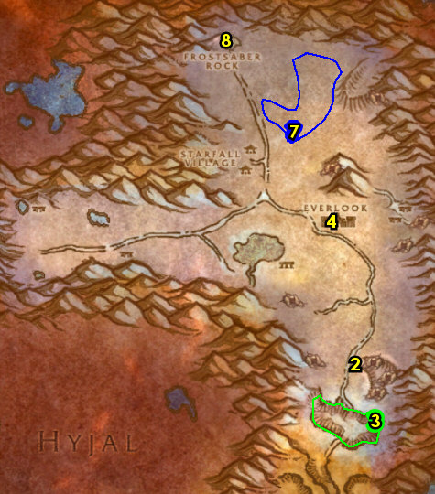

01) Die on purpose to get back to Everlook.
02) In Everlook, from Felnok Steelspring under the blue tent 62.39, turn in "Chillwind Horns", accept "Return to Tinkee". NOTE: My guide will not cover "Return to Tinkee", but you can turn this in next time you head to Burning Steppes.
03) Make sure you are repaired/resupplied 62.38.
04) Exit Everlook to your right and go to the Hippogryph Master 62.37 to fly to Rut'theran Village, Teldrassil.
05) At Rut'theran Village, go in the house and turn in "Guardians of the Altar" 55.92, accept "Wildkin of Elune".
06) Go up the path through the red portal 56.89 to get to Darnassus.
07) Go north to Cenarion Enclave to the top of the tree tower and turn in "Wildkin of Elune" 35.9.
08) While in Darnassus, any cloth donations are turned in at 64.23 for the Night Elf faction.
09) Hearth to Everlook.
10) If you still need to, finish "Luck Be With You": go south to Frostwhisper Gorge entrance 59.66 and loot Frostmaul Shards. Distract the elite giants and sneak in to loot the shards. Then turn this in at Everlook once finished.
11) At this point you should be very close to level 60. I usually grind the rest of the way to level 60 at the Owl Wing Thicket entrance 64.59. But here is a list of other things you could do instead of the owl grinding:
#54
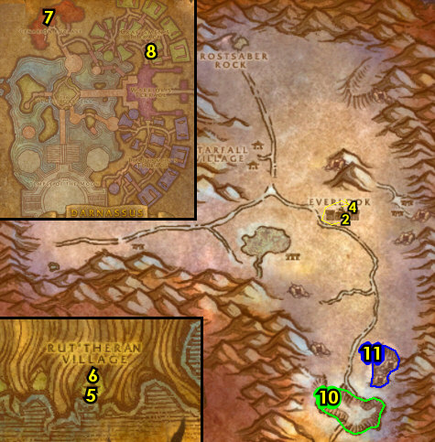

Here are the things you can do to level from 59-60:
--> You can go back into Eastern Plaguelands and do the many group quests that you couldn't solo.
--> You can grind away at mobs in Andorhal to increase your rep with The Argent Dawn.
--> You can grind away at Deadwood furbolgs up north in Felwood to gain rep with the Timbermaw.
--> You can do Black Rock Depths Instance and all the quests associated with it.
--> You can also do Stratholme Instance and all the quests associated with that.
--> You can simply grind on any mob you like until you hit 60.

