HORDE
Orc-Troll
1-6 Valley of Trials (Durotar)
First Pick the Class you are playing top left of screen!!!
And pick the Version you are playing on (Era, WotLK, or SoM)
01) Right in front of you, accept "Your Place In The World" 43.69.
02) West at The Den entrance, turn in "Your Place In The World" 42.68, accept "Cutting Teeth".
03) Start working on "Cutting Teeth" by killing the Mottled Boars all around the area. Work your way to accept "Sarkoth" 41.63.
04) Go south a bit and do "Sarkoth": kill/loot the scorpid Sarkoth /target patrols a bit 41.67.
05) Turn in "Sarkoth" (41.63 #3 on map), accept the next part.
Remember to Choose Your Class At Top of Screen!!!
06) Make sure "Cutting Teeth" is complete (kill Mottled Boars, #3 on map), then go back to Valley of Trails and get resupplied 43.67.
07) Go to The Den entrance and turn in "Cutting Teeth" and "Sarkoth" (42.68, #2 on map), accept "Sting of the Scorpid" and .
08) Just outside of The Den, next to the wagon, accept "Vile Familiars" 43.69.
09) By the cauldron / cooking area, accept "Galgar's Cactus Apple Surprise" 43.67. Make sure you get resupplied here.
10) East a bit, accept "Lazy Peons" 45.69 (requires lvl 3).
11) Around the starting area, do: "Galgar's Cactus Apple Surprise", "Sting of the Scorpid", "Lazy Peons" . Pick up Cactus Apples, kill/loot Scorpid Workers, use the Foreman's Blackjack quest item on the Lazy Peons /target.
12) Once everything is done, go turn in "Galgar's Cactus Apple Surprise" (at the cooking area 43.67, #9 on map). Then make sure you get resupplied (next to you).
13) In The Den entrance, turn in "Sting of the Scorpid" (42.68, #2 on map).
14)
15) Go east a bit and turn in "Lazy Peons" (45.69, #10 on map), accept "Thazz'ril's Pick".
16) Go north inside the cave entrance at 45.56 and do "Burning Blade Medallion" and "Thazz'ril's Pick": keep hugging the right side of the cave until you get to Yarrog Baneshadow /target 43.53 and kill/loot him. Then drop down and keep hugging the left side of the cave until you get to Thazz'ril's Pick 44.54, and loot it.
17) Make sure you are at least level 5, grind in the cave until you are, then use your Hearthstone to go back to the Valley of Trials and then by the wagon, turn in "Burning Blade Medallion" (43.69, #8 on map), accept "Report to Sen'jin Village".
18) Go east a bit and turn in "Thazz'ril's Pick" (45.69, #10 on map).
19) Leave starting noob zone by heading east on the path...
#01
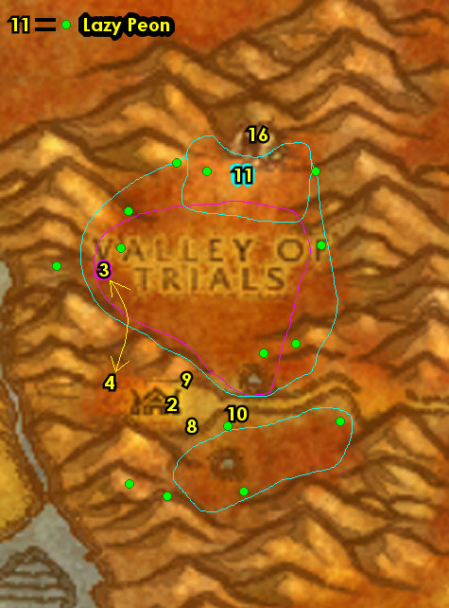

6-8 Durotar (log)
Remember to Choose Your Class At Top of Screen!!!
01) Follow the main path just east and accept "A Peon's Burden" 52.68.
02) Go SE towards Sen'jin Village and then accept "Thwarting Kolkar Aggression" (NPC /target patrols around 54.74 and hides behind rocks and trees).
03) At Sen'jen Village 56.75, turn in "Report to Sen'jin Village", accept all quests there: "Minshina's Skull", "Report to Orgnil" and "Zalazane". Next to you, accept "A solvent Spirit" 56.74. Then next to you up in the little hut, accept "Practical Prey" 56.74. You can get resupplied by the dancing male troll 56.74 by the Raging Bonfire.
04) Run up north to Razor Hill. Once there, on your left, turn in "Report to Orgnil" 52.43, accept "Dark Storms". In the burrow next to you 52.43, accept "Vanquish the Betrayers" and "Encroachment".
05) Go up to the top of the watchtower NW of Razor Hill, (up at 50.40) and accept "Carry Your Weight".
06) Drop down SE and accept "Break a Few Eggs" (at the cooking area, 51.43).
07) Go in the Inn next to you and turn in "A Peon's Burden" 52.42. And also make Razor Hill your new home for your Hearthstone. Make sure you are resupplied.
08) If you have an extra silver to spare: in the Barracks, get Apprentice First Aid from Rawrk 54.42.
09) Go SE to Tiragarde Keep and do "Vanquish the Betrayers" along with "Carry Your Weight": kill/loot the humans around and in the fortress, also work your way to the top of the fortress and kill/loot Lieutenant Benedict 60.58. Once you loot the key from his corpse, then go up the other steps to open Benedict's Chest up at 59.58, to accept "The Admiral's Orders" from the Aged Envelope inside.
10) Once done, die on purpose at the NW side of the fortress and res at spirit to get back to Razor Hill and up in the burrow, turn in "Vanquish the Betrayers" (52.44, #4 on map), accept "From The Wreckage....". Also turn in "The Admiral's Orders", accept the next part.
11) Go up to the top of the watchtower NW of Razor Hill, (up at 50.40, #5 on map) and turn in "Carry Your Weight".
12) Make sure you are repaired/resupplied 52.41.
13) Go east to the beach and under the water around 60.44 do "A solvent Spirit" along with "From The Wreckage....": kill/loot the crabs and makrura mobs and loot the Gnomish Toolboxes.
14) Go just SW of Razor Hill around 49.49 and do the first half of "Encroachment": kill the Razormane Quilboars and Razormane Scouts.
15) Then go to Razor Hill and at the top of the burrow turn in "From The Wreckage...." (52.44, #4 on map). Also make sure you are repaired/resupplied.
17) If you have not learned Apprentice First Aid, then get that now in the Barracks from Rawrk 54.42.
#02
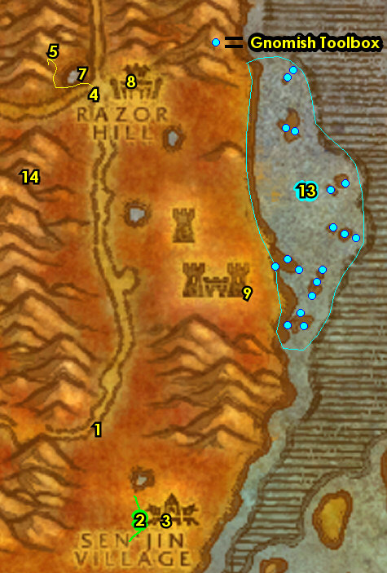

8-10 Durotar (log)
01) Run way down south to Kolkar Crag (entrance at 51.79) and do "Thwarting Kolkar Aggression": click on the attack plans (scrolls) on the ground. Follow the steps below to find all the scrolls...
02) Click on Attack Plan: Valley of Trials 50.81.
03) Click on Attack Plan: Sen'jin Village 48.77.
04) Click on Attack Plan: Orgrimmar 46.79.
05) Go east towards Sen'jin Village to the NPC /target that patrols and hides around tress/rocks around 54.76 and turn in "Thwarting Kolkar Aggression".
06) Go to Sen'jin Village and turn in "A solvent Spirit" 56.74. Make sure you are repaired/resupplied.
07) Go to Echo Isles (the islands SE of Durotar) and do the following 4 quests together "Break a Few Eggs", "Practical Prey", "Minshina's Skull" and "Zalazane": kill/loot Durotar Tigers, pickup Taillasher Eggs, and (at 67.88) pickup Minshina's Skull (on the little hill with candles around it) and in that same area kill the needed trolls and kill/loot Zalazane /target (See Video).
08) After completing all these quests, die on purpose (then res) to get to Sen'jin Village quickly, and turn in "Minshina's Skull" and "Zalazane" 56.75. NOTE: Save the quest reward item Faintly Glowing Skull for a later quest.
09) In the little hut next to you, turn in "Practical Prey" 56.74.
10) Hearth to Razor Hill and turn in "Break a Few Eggs" (by the cooking area next to the Inn, 51.43). Make sure you are repaired/resupplied.
11) Go west of Razor Hill around 44.40 and do the second half of "Encroachment": kill the Razormane Dustrunners and Razormane Battleguards.
12) Grind north to the little house 43.30 and accept "Lost But Not Forgotten".
13) Go NE to the goblin and accept "Winds in the Desert" 46.23.
14) Go east a bit 49.22 and do "Winds in the Desert": loot Stolen Supply Sacks around the harpies.
15) Go back to the goblin and turn in "Winds in the Desert" (46.23, #13 on map), accept "Securing the Lines".
16) Keep grinding on any mob in the area until you are at least 1.5 bars away from level 10, then run back to Razor Hill [Don't Hearth] (or you can die on purpose south in the Razorwind Canyon harpy camp at about 48.34).
17) At the top of the burrow turn in "Encroachment" 52.43. Make sure you are repaired/resupplied.
Remember to Choose Your Class At Top of Screen!!!
18) On the west side in Razor Hill, accept "Conscript of the Horde" 51.44.
#03
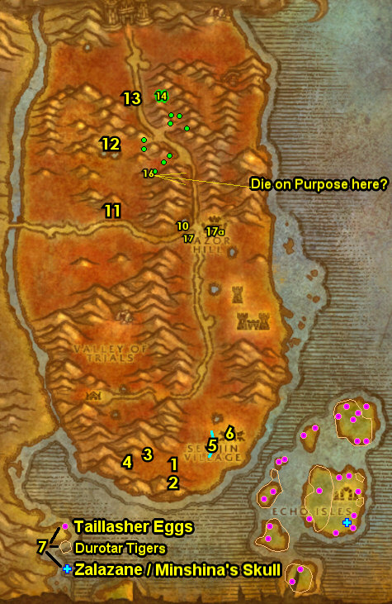
Crossroads (The Barrens)
01) Go west across the river and next to the path, turn in "Conscript of the Horde" (62.19 in The Barrens), accept "Crossroads Conscription".
03) Head safely to XRs and accept "Meats to Orgrimmar" 53.30.
04) At Sergra Darkthorn, turn in "Crossroads Conscription" 52.31. Accept "Plainstrider Menace".
05) South in XRs accept "The Forgotten Pools" 52.32. Then next to you, get repaired/resupplied from the Clothier.
06) Right outside the Inn and next to the mailbox, accept "Raptor Thieves" 52.30.
07) At the orc standing at the bottom of the watchtower accept "Disrupt the Attacks" 52.31, and "Supplies for the Crossroads".
08) Go north a bit to the undead under the red canopy and accept "Fungal Spores" and "Wharfmaster Dizzywig" 51.30.
09) Next to you at the Wind Rider Master 52.30 turn in "Meats to Orgrimmar", accept "Ride to Orgrimmar". Then take a flight to Orgrimmar, Durotar.
#05
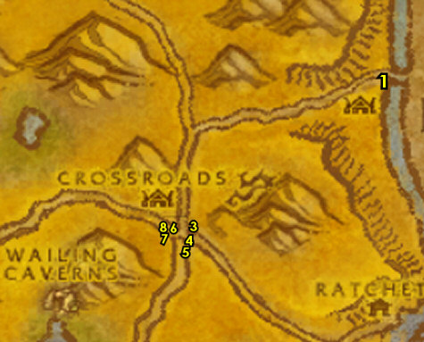
Orgrimmar
02) Stay up (cross the bridge), then Go north to Thrall and accept "Hidden Enemies" 32.38. In that room turn in "The Admiral's Orders".
#06
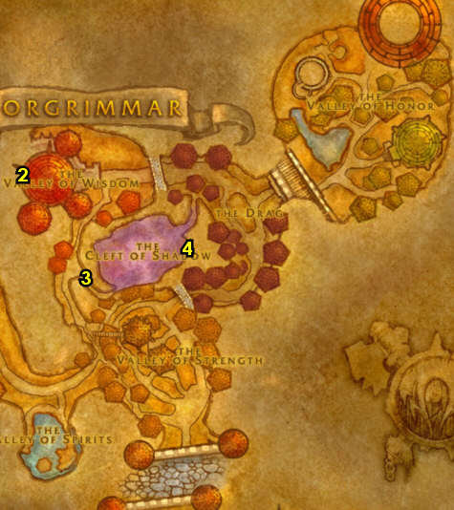
10-12 Durotar
01) and do "Securing the Lines": kill the harpies (through the other side of the small cave 52.28 in Durotar).
02) At the goblin, turn in "Securing the Lines" 46.23.
03) Along the river west of Durotar 37.21 do "Lost But Not Forgotten": kill/loot the Dreadmaw Crocolisk until Kron's Amulet drops.
04) Enter Thunder Ridge (at 39.31)...
05) In Thunder Ridge, do "Dark Storms": work your way to Fizzle Darkstorm (a goblin at 42.27, /target) and kill/loot him. Be careful he is heavily guarded..
06) Exit Thunder Ridge, then go east to the little house and turn in "Lost But Not Forgotten" 43.30.
07) Go SE to Razor Hill and turn in "Dark Storms" (52.43). Accept "Margoz". Make sure you are repaired/resupplied. ALSO: If you destroyed your Hearthstone earlier, then get a new one in Razor Hill's Inn 52.42 by making it your new home. If for some reason you are already level 12, get new spells/abilities while in town.
08) Go NE and turn in "Margoz" 56.20, accept "Skull Rock".
09) Go north to enter Skull Rock (cave entrance at 55.10) and do "Skull Rock" along with "Hidden Enemies": kill/loot the mobs in the cave. If you can, try to kill Gazz'uz /target (has multiple spawn locations in cave), he drops Eye of Burning Shadow item which starts "Burning Shadows". TIPS: use the quest reward item Faintly Glowing Skull to help you kill him, he's tough without it. Also use a Sticky Glue on his voidwalker, or pull Gazz in a water pool since his voidwalker cant swim. If you are an Orc, don't use Blood Fury before you have used your healing items. Try to party up with somebody if you can. (See Video on how I killed Gazz'uz). Also don't leave this cave until you have grinded out First Aid (50) to learn Journeyman First Aid soon.
10) Exit the cave and go directly south to turn in "Skull Rock" (56.20, #8 on map). Accept "Neeru Fireblade".
#10
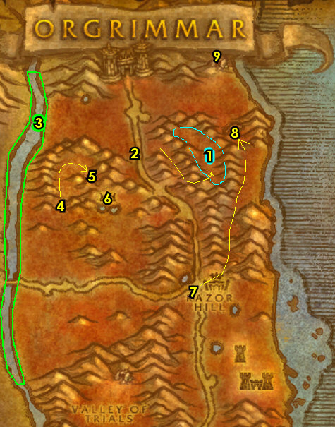

Orgrimmar
01) Go into Orgrimmar and go to the Inn and turn in "Ride to Orgrimmar" 54.68, accept "Doras the Wind Rider Master".
02) Go up to the Wind Rider Master 45.64 and turn in "Doras the Wind Rider Master", accept "Return to the Crossroads.".
03) Go north to Thrall and turn in "Hidden Enemies" 32.38. Accept the next part.
04) Go to Cleft of Shadows (entrance at 42.57 in Orgrimmar).
05) In Cleft of Shadows 50.51, turn in "Neeru Fireblade" (accept "Ak'Zeloth") and (if you have it) "Burning Shadows". Also keep talking to this NPC to complete "Hidden Enemies".
06) Go back to Thrall (32.38, #3 on map) and turn in "Hidden Enemies", SKIP the next part (Dungeon). NOTE: You can destroy the Lieutenant's Insignia, as its not used for anything else.
07) Hearth (or run) to Razor Hill. Make sure you are level 12 (grind on any mobs until you are). Make sure you get repaired/resupplied. Upgrade First Aid in the Barracks from Rawrk 54.42 to learn Journeyman First Aid.
08) Run west into the Barrens...
#11
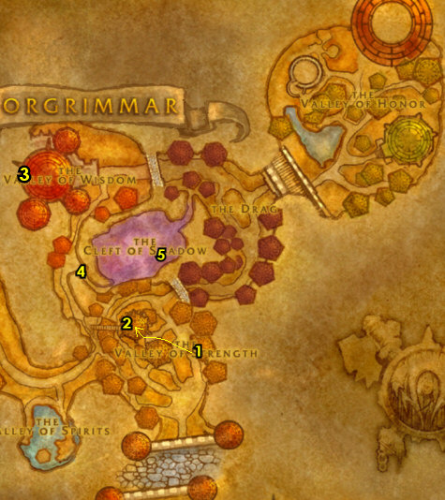
Levels 12-15 Barrens (log)
01) Over the bridge, next to the watchtower, turn in (if you have it from the Durotar section) "Ak'Zeloth" 62.20, accept "The Demon Seed". Then loot a Flawed Power Stone from the table next to you. NOTE: The Flawed Power Stone item received only lasts 30 minutes, so you need to do the next few steps somewhat quickly (but you should have plenty of time).
02) While working on the following steps, also start working on "Plainstrider Menace" and "Raptor Thieves" by killing plainstriders and raptors all around the fields of the Barrens, but don't make it your main priority:
03) Go west across the main path, then go up the big mountain ramp (begins at 51.22).
04) Once you get at the top do "The Demon Seed": go in the small cave and use your Flawed Power Stone quest item on The Altar of Fire 48.19. NOTES: Watch out for a rare elite named Rathorian, he is very dangerous. If he is in the way, then either try to team up with someone to help you kill him, or this quest can be skipped. His respawn is every 5.5 hours.
05) Go east and do "Disrupt the Attacks": kill the required amount of Razormane quilboars around 54.27. ALSO: Back in the Razormane camp is a barrel called Chen's Empty Keg keg 56.27, loot it and accept the quest from the item received.
06) Go to the NE side of XRs and turn in "Return to the Crossroads." 53.30.
07) Turn in (if it's complete) "Plainstrider Menace" (from Sergra Darkthorn 52.31), accept "The Zhevra".
08) Go in the Inn and make XRs your new home 52.30.
09) At the orc standing at the bottom of the watchtower, turn in "Disrupt the Attacks" (52.31, #7 on map). Accept "The Disruption Ends". Make sure you are repaired/resupplied.
10) Go up the watchtower next to you and accept "Harpy Raiders".
#12
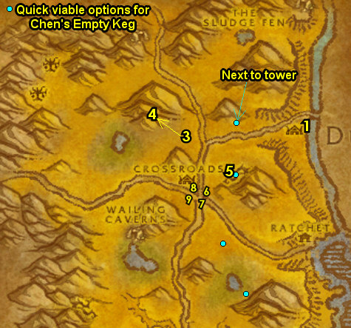

Tauren

1-6 Mulgore
First Pick the Class you are playing top left of screen!!!
Along with the Game Version you are playing on (Era, WotLK, or SoM)
01) Right in front of you, accept "The Hunt Begins" 45.77.
02) In the big hut, accept "A Humble Task" 44.76.
03) Start working on "The Hunt Begins" by kill/looting Plainstriders as you go SE to turn in "A Humble Task" 50.81, accept the next part.
04) Do "A Humble Task": next to you pick up a Water Pitcher 50.81 on the well (next to the quest giver).
05) Finish "The Hunt Begins" by kill/looting Plainstriders (#3 on map) as you head back to Camp Narache 45.77.
06) Go back to Camp Narache and turn in "The Hunt Begins" 45.77, accept "The Hunt Continues" and Remember to Choose Your Class At Top of Screen!!!
07) Stop at the General Goods 45.77 vendor (in small hut) to sell junk to gain money.
09) In the big hut, turn in "A Humble Task" 44.76, accept "Rites of the Earthmother".
10) Go south and turn in "Rites of the Earthmother" 43.92, accept "Rite of Strength". Also start working on "The Hunt Continues" by kill/looting any Mountain Cougars (cats) you see along the way.
11) Do "The Hunt Continues": kill/loot Mountain Cougars around the mountain slopes around 45.91.
12) Grind your way back to Camp Narache (make sure you are at least 3 bars away from level 4) and then turn in "The Hunt Continues" 45.77, accept "The Battleboars". Also accept (from the NPC patrolling around) "Break Sharptusk!".
13) Stop at the General Goods 45.77 vendor (in small hut) to sell junk to gain money.
14) Get new spells/abilities.
15) Go to the area around 57.86 and do most of "The Battleboars" by kill/looting Battleboars. Get about half (4/8 of each item needed), then continue on..
16) Go to the cave at entrance 58.85 while continue killing Battleboars along the way for "The Battleboars". Once you get to the cave, then go to the next step..
17) Grind your way to the big tent while kill/looting Bristlebacks for "Rite of Strength". Once you get to the tent, kill/loot Chief Sharptusk Thornmantle /target 65.78 for "Break Sharptusk!".
18) Then grind to the small cave and on the inside is a Dirt-stained Map 63.83. Loot it, then use the item to start "Attack on Camp Narache".
19) Make sure all other quests are complete then Hearth to Camp Narache and turn in all quests: (in front of you) "The Battleboars" 45.77, (from patrolling NPC) "Break Sharptusk!", (in hut 44.76) "Attack on Camp Narache" and "Rite of Strength" then accept "Rites of the Earthmother" (part 2).
20) In the tent, get repaired/resupplied 44.77.
21) Go west on the path and accept "A Task Unfinished" 39.82.
22) The starting noob zone is complete, continue following the road to Bloodhoof Village 47.62 while grinding mobs along the way and make sure you are level 6 before getting there for new spells/abilities. Once you hit level 6, you can then die on purpose and res at spirit healer to get you to Bloodhoof Village faster (or just run there if you are close).
#01
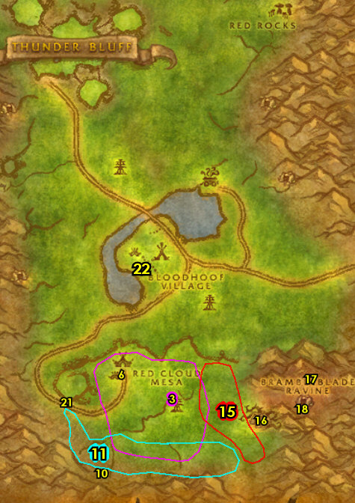

6-8 Mulgore (log)
Remember to Choose Your Class At Top of Screen!!!
01) Once at Bloodhoof Village accept "Dangers of the Windfury" 47.62.
02) Go into the Inn (entrance is at 47.61) and from the First Aid Trainer train Apprentice First Aid. And talk to the Innkeeper 47.61 to turn in "A Task Unfinished" and to make Bloodhoof Village your new home for your hearthstone.
03) Just outside of the inn 48.60, turn in "Rites of the Earthmother" and accept "Sharing the Land", "Dwarven Digging" and "Rite of Vision".
04) East a bit accept "Poison Water" 49.60.
05) Go in the hut (next to you) and accept "Swoop Hunting" 49.59.
06) North a bit by the fire turn in "Rite of Vision" 48.58, accept the next part.
07) West a bit accept "Mazzranache" 47.57.
08) Get new spells/abilities for your class. Remember to Choose Your Class At Top of Screen!!!.
09) Go east of the main path and do "Rite of Vision": loot Ambercorns around the trees and loot Well Stones (around the well at 54.66). Grind any mobs you see along the way.
10) All around the area, start doing "Poison Water", "Swoop Hunting" and "Mazzranache": kill & loot Swoops, Wolves, Plainstriders and Cougars. Work your way south to do the next steps as well:
11) Go south a bit and do "Sharing the Land" around 52.70. NOTE: There are several camps of these mobs and the Poachers are only in certain camps.
12) Go east a bit and do "Dangers of the Windfury" 62.71: kill and loot the harpies.
13) Find Morin Cloudstalker /target along the path (patrols around 54.60) and accept "The Ravaged Caravan".
14) Go north to the ravaged caravan 54.48 and do "The Ravaged Caravan": open the Sealed Supply Crate to turn the quest in, accept the next part.
15) Make sure all quests are complete (besides "Dwarven Digging" and "Swoop Hunting"), then Hearth (or die on purpose) to go back to Bloodhoof Village and turn in "Sharing the Land" 48.60.
16) South a bit turn in "Dangers of the Windfury" 47.62.
17) NE a bit turn in "Poison Water" 49.60, accept "Winterhoof Cleansing".
18) If you completed "Swoop Hunting" turn it in next to you in the hut 49.59.
19) North a bit by the fire and turn in "Rite of Vision" 48.58, accept the next "Rite of Wisdom". NOTE: Don't bother using Water of the Seers quest item.
20) West a bit and turn in "Mazzranache" 47.57. Make sure you are all repaired, supplied and new spells/abilities. Remember to Choose Your Class At Top of Screen!!!
#02
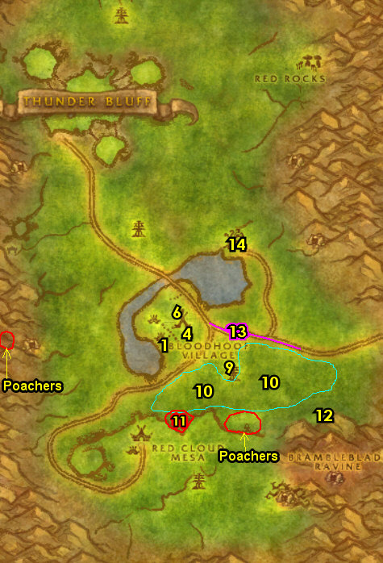

8-10 Mulgore (log)
Remember to Choose Your Class At Top of Screen!!!
01) Go to Morin Cloudstalker /target along the main path going east around 54.60 and turn in "The Ravaged Caravan", accept "The Venture Co." and "Supervisor Fizsprocket".
02) Go south a bit and do "Winterhoof Cleansing": use the Winterhoof Cleansing Totem quest item on the well 54.66.
03) Go NW to Bloodhoof Village and turn in "Winterhoof Cleansing" 49.60, accept "Thunderhorn Totem".
04) While focusing on the next steps, also start working on "Thunderhorn Totem" by kill/looting Prairie Stalkers (wolves) and Flatland Cougars (cats)...
05) Go NW and start working on "Dwarven Digging" around 33.49: find Prospector's Picks and use them at a Forge. NOTE: Without grouping, it's hard to get to the Forge there 31.50. Instead, there will be other easier Forges later on in the guide you can use. For now, just get 5 Prospector's Picks. The diggers are easier to kill solo, and taurens can use their War Stomp ability to prevent the Appraiser's from healing themselves.
06) Go up north (past the harpy camp) to the cave 33.36 and turn in "Rite of Vision", accept "Rite of Wisdom".
07) Work your way east and accept "A Sacred Burial" 60.26.
08) Work your way to the Ancestral Spirit 61.21 and turn in "Rite of Wisdom" accept "Journey into Thunder Bluff". Keep the next step in mind:
09) In the Immediate area around Red Rocks do "A Sacred Burial": kill 8 Bristleback Interlopers (#8 on map).
10) Go SW a bit and turn in "A Sacred Burial" (60.26, #7 on map)
11) Finish up "Thunderhorn Totem": kill/loot Prairie Stalkers and Flatland Cougars (around the middle of Mulgore around 52.35).
12) If you are not level 10 (or at least 1 bar away from it), grind until you are,
13) Right outside of the Inn, accept (if you are lvl 10) "The Hunter's Way" 47.60. If you're not lvl 10 do the next step before this one:
14) East turn in "Thunderhorn Totem" 49.60, accept "Thunderhorn Cleansing". Also turn in (if you need to) "Swoop Hunting" (in the tent next to you 49.59).
15) Get new spells/abilities and accept your class's level 10 quests. NOTE: You can destroy the Water of the Seers item to free bag space.
16) Go north and do "Thunderhorn Cleansing": use the Thunderhorn Cleansing Totem on the well 45.45.
17) Go north to Thunder Bluff (a Lift is at 36.30 in Mulgore), and build up First Aid while waiting for the Lift.
#03
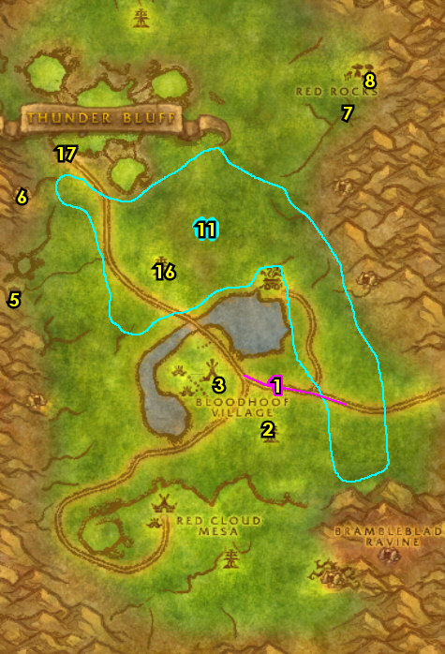
Thunder Bluff (TB) (log)
01) In TB, accept "Preparation for Ceremony" 38.60.
02) Finish up "Dwarven Digging" by using your 5 Prospector's Picks at the Thunder Bluff Forge 40.56.
03) Go up east and turn in "Journey into Thunder Bluff" 60.52, accept "Rites of the Earthmother".
04) Go north and leave TB by taking the Lift down 54.28.
#04
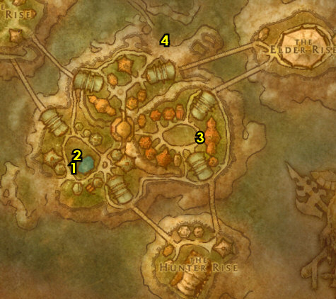
10-12 Mulgore (log)
01) Go SE and do "Supervisor Fizsprocket" along with "The Venture Co.": kill/loot Supervisor Fizsprocket in the cave (entrance 62.47, /target). Keep hugging the right side of the cave straight through to get to him.
02) Make sure "The Venture Co." is finished before continuing, then die on purpose to get to Bloodhoof Village and turn in "Dwarven Digging" (by the big totem, 48.60).
03) Go east a bit and turn in "Thunderhorn Cleansing" 49.60, accept "Wildmane Totem".
04) Go east and find Morin Cloudstalker /target along the path around 54.60 and turn in "The Venture Co." and "Supervisor Fizsprocket".
05) While doing the following steps up north also focus on doing "The Hunter's Way" along with "Wildmane Totem" by kill/looting the Flatland Prowler & Prairie Wolf Alphas (mostly north of TB):
06) Do "Rites of the Earthmother": kill Arra'chea and loot his horn. Arra'chea /target is a kodo that patrols clockwise just to the right of TB. His original spawn point is at 49.19. If you can't find him in time, then it can be skipped.
07) Work your way to the very north of Mulgore around 55.17 and do "Preparation for Ceremony": kill/loot the harpies (These harpies are in many camps north and NW of Mulgore).
08) Make sure "The Hunter's Way" along with "Wildmane Totem" are finished: kill/loot Flatland Prowlers & Prairie Wolf Alphas (mostly north of TB).
09) Go to the Lift 41.22 to go into TB. NOTE: If you are real far away from that, you can die on purpose to get right to the Lift.
#06
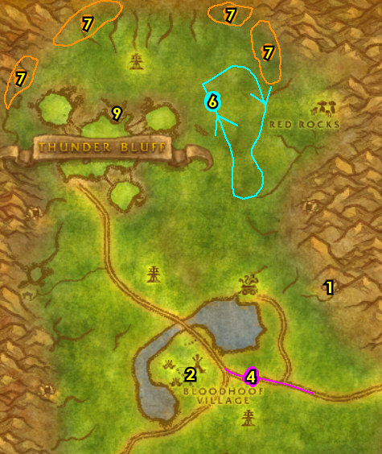

Thunder Bluff (log)
01) Go to the Elder Rise and accept "The Barrens Oases" 70.29.
02) Turn in (if you did it) "Rites of the Earthmother" 60.52.
03) Go to the Hunter Rise and turn in "The Hunter's Way" 62.81, accept "Sergra Darkthorn".
04) Turn in "Preparation for Ceremony" 38.60.
#07
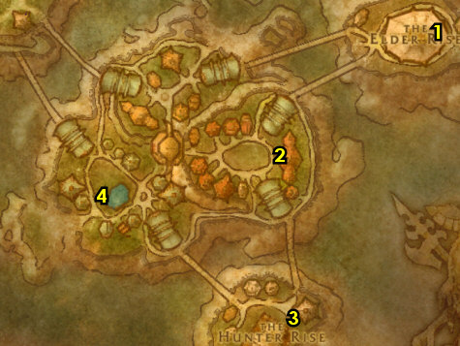
11-12 Mulgore (log)
01) Hearth to Bloodhoof Village.
02) East a bit and turn in "Wildmane Totem" 49.60, accept "Wildmane Cleansing".
03) If you turned level 12, get your lvl 12 spells/abilities. Remember to Choose Your Class At Top of Screen!!!
04) Grind your way north to 47.33 then die on purpose and res at spirit.
05) Go north a bit and do "Wildmane Cleansing": use the Wildmane Cleansing Totem quest item at the well 43.14.
06) Hearth or grind south to 47.38 and die on purpose to get back to Bloodhoof Village.
07) Turn in "Wildmane Cleansing" (49.60, #2 on map).
08) If you haven't got your lvl 12 spells/abilities yet then make sure you are lvl 12 (grind until you are) and get them at Bloodhoof Village. Remember to Choose Your Class At Top of Screen!!!
#08
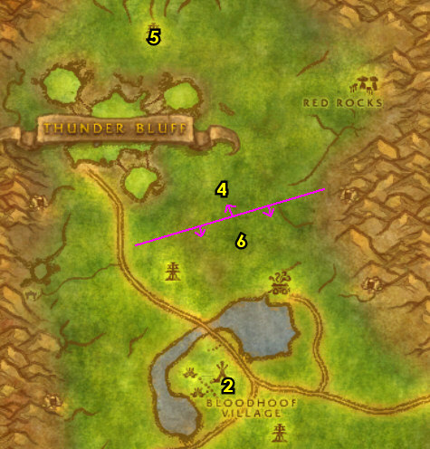
12 The Barrens (log)
01) Run east into the Barrens and get the Flight Path in Camp Taurajo from the Wind Rider Master (44.59 in the Barrens).
02) In the middle of CT accept "Journey to the Crossroads" 45.59.
03) Follow the path north to the Crossroads (XRs) and turn in "The Barrens Oases" (south in XRs, 52.32), accept "The Forgotten Pools".
04) At Sergra Darkthorn, turn in "Sergra Darkthorn" 52.31, accept "Plainstrider Menace".
05) Go in the Inn and make XRs your new home 52.30.
06) Right outside the Inn on your right accept "Raptor Thieves" 52.30.
07) At the orc standing at the bottom of the watchtower, turn in "Journey to the Crossroads" 52.31, accept "Disrupt the Attacks" and "Supplies for the Crossroads".
08) Go up the watchtower next to you and accept "Harpy Raiders" 52.31.
09) Drop down, and right next to the Wind Rider Master 51.30 accept "Fungal Spores" and "Wharfmaster Dizzywig".
10) NW in XRs, accept "A Bundle of Hides" 51.29.
11) At the Wind Rider Master 51.30, turn in "A Bundle of Hides", SKIP "Ride to Thunder Bluff" (for now).
12) While working on the following steps, also start working on "Plainstrider Menace" and "Raptor Thieves" by killing plainstriders and raptors all around the fields of the Barrens, but don't make it your main priority:
13) Go NE and do "Disrupt the Attacks": kill the needed Razormane mobs around 54.27. ALSO: Back in the Razormane camp is a barrel called Chen's Empty Keg 56.27, loot it and accept the quest from the item received.
14) Go back SW to XRs and at the orc standing at the bottom of the watchtower turn in "Disrupt the Attacks" (52.31, #7 on map). Accept "The Disruption Ends". Make sure you are repaired/resupplied.
#10
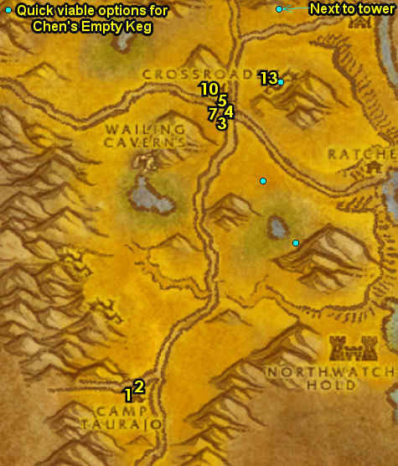

Undead – Blood Elf

1-6 DeathKnell (Tirisfal Glades)
First Pick the Class you are playing top left of screen!!!
Along with the Game Version you are playing on (Era, WotLK, or SoM)
00) First thing to do is to destroy your Hearthstone in your Backpack. NOTE: The Hearthstone is not needed right now and you will get a new one later. This will give you an extra bag space.
01) Right in front of you accept "Rude Awakening" 30.72.
02) Go in the church building and turn in "Rude Awakening" 31.66, accept "The Mindless Ones".
03) Go down the hill a bit around 32.63 and do "The Mindless Ones": kill the needed zombies.
04) Go back to the church (31.66, #2 on map) and turn in "The Mindless Ones". Accept and "Rattling the Rattlecages". Next to you accept "The Damned" 31.66.
05) Remember to Choose Your Class At Top of Screen!!!".
06) Do "The Damned" along with "Rattling the Rattlecages": kill Rattlecage Skeletons /target (in the village area) and kill/loot wolves and bats all around the outside of the village area. Both are around 32.60.
07) Go back to the church and turn in "The Damned". (31.66, #2 on map). Accept "Marla's Last Wish". Next to you, turn in "Rattling the Rattlecages".
08) Right outside the church (from the patrolling NPC) accept "Scavenging Deathknell" patrols a bit 32.66, and "Night Web's Hollow" 32.66.
09) Do "Scavenging Deathknell": pick up the Equipment Boxes in and around the village buildings around 32.64.
10) Go NW and do "Night Web's Hollow": kill the Young Night Web Spiders outside of the mine and the Night Web Spiders inside the mine (mine entrance at 27.59).
11) Die on purpose and res at spirit.
12) Turn in "Scavenging Deathknell" 32.66.
13) Make sure you are resupplied 32.65.
14) Turn in "Night Web's Hollow" 32.66, accept "The Scarlet Crusade".
15) Go east of the village around 37.67 and do "The Scarlet Crusade": kill/loot the Scarlet humans.
16) Go north a bit and do part of "Marla's Last Wish": kill/loot the zombie Samuel Flipps 37.62 /target.
17) Die on purpose (res at spirit), then next to you in the graveyard do the last part of "Marla's Last Wish": click on Marla's Grave 31.65 (dirt mound).
18) In the church, turn in "Marla's Last Wish" (31.66, #2 on map).
19) Just outside, turn in "The Scarlet Crusade" 32.66, accept "The Red Messenger".
20) Make sure you are repaired/resupplied 32.65.
21) Go east and do "The Red Messenger": kill/loot Meven Korgal 37.69 /target. He is guarded by a few other mobs, but it can be soloed.
22) Back west, turn in "The Red Messenger" 32.66, accept "Vital Intelligence".
23) Follow the path NE out of Deathknell and accept "A Rogue's Deal" 38.57. The starting noob zone is complete.
#01
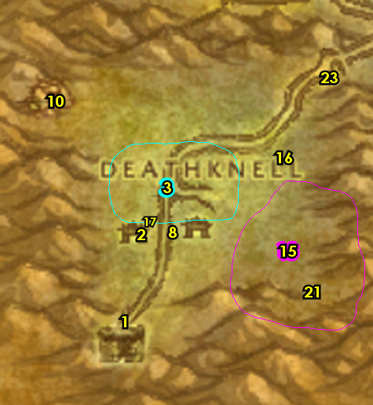

6-10 Tirisfal Glades (log)
Remember to Choose Your Class At Top of Screen!!!
01) Down the path at the intersection, accept "Fields of Grief" 41.54.
02) Run east to Brill 58.51 along the main path, grinding mobs along the way, and make sure you get to level 6 before you get there (for new spells/abilities). Along the way on the path accept "Gordo's Task" (from the abomination Gordo /target).
03) Once at Brill, in front of the graveyard entrance, accept "A Putrid Task" 58.51.
04) Go in the first house on your right and accept "A New Plague" 59.52.
05) Just outside of the house pick up Apprentice Herbalist from the Herbalism Trainer /target 60.52. NOTE: I recommend getting this at least temporarily for helping you find the Gloom Weed and Doom Weeds later in this zone.
06) In front of the Town Hall building, turn in "Vital Intelligence" 61.52. Accept "At War with the Scarlet Crusade".
07) Right behind this NPC, accept "Wanted: Maggot Eye" 61.51 (from the Wanted! sign).
08) Go in the Town Hall building right next to you and accept "Graverobbers" 61.51.
09) Enter the Inn entrance 62.53 and at the Innkeeper 62.52 turn in "A Rogue's Deal". Make this Inn your new home for your Hearthstone (by talking to the Innkeeper). Make sure you are resupplied.
10) In Brill's Inn, get your level 6 spells/abilities.
11) Go just west of Brill and do "Gordo's Task" along with "A Putrid Task": pick up Gloom Weed and kill/loot zombies. Also, start working on "A New Plague" (kill/loot darkhounds). TIPS: There is a merchant in the small house 53.56 that you can sell items to. Don't forget to turn Find Herbs on to spot the Gloom Weed on mini map.
12) Finish "A New Plague": kill/loot darkhounds (blue dots on map). Focus on finishing this west around 42.45.
13) Go west and do "At War with the Scarlet Crusade": kill/loot the Scarlet Warriors. Also start working on "Fields of Grief" by looting Tirisfal Pumpkins you see along the way. TIP: Work your way along the main path, looting pumpkins you see along the north side of the farm, you will find a few more around the tower around 32.47. The Scarlet Warriors are north and west of the farm.
14) Finish "Fields of Grief": pickup Tirisfal Pumpkins around the farm 36.51.
15) Die on purpose and res at spirit.
16) In the graveyard next to you around 58.49 turn in "Gordo's Task" (the NPC /target patrols around the grave), accept "Doom Weed".
17) In front of the graveyard entrance turn in "A Putrid Task" (58.51, #3 on map). Accept "The Mills Overrun".
18) In the small house 59.52 (#4 on map), turn in "Fields of Grief" and "A New Plague", accept the next part to both of these quests.
19) In front of the Town Hall, turn in "At War with the Scarlet Crusade" 61.52 (#6 on map), accept the next part.
20) Next to you accept "Proof of Demise" 61.52.
21) Get resupplied 61.53.
22) Just inside of the Inn entrance 62.53, stop at the First Aid Trainer /target 62.53 and get Apprentice First Aid. NOTE: If you could not afford this, then get this when you can.
23) Inside the Inn, accept "Deaths in the Family" and "The Haunted Mills" 62.52.
24) Go downstairs in the Inn and turn in "Fields of Grief" 62.51.
25) Go upstairs in the Inn and accept "The Chill of Death" 62.53.
#02
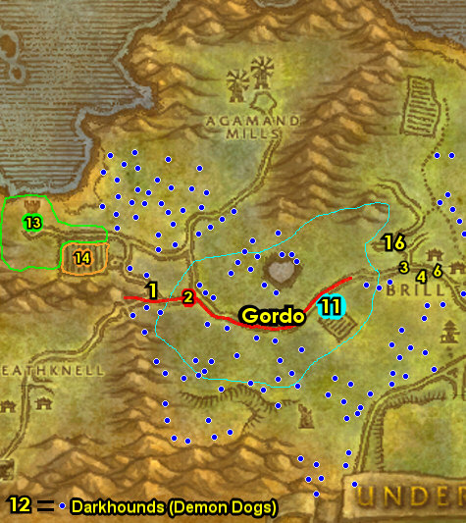

01) If you have an extra silver to spare, it's wise to check to see if you can buy any health potions from Selina Weston /target 62.50 behind Brill. It will come in handy for tough solo quests soon.
02) Go just north above Brill and do "Graverobbers" along with "Doom Weed": kill/loot the Rot Hide Graverobbers, and pickup Doom Weeds all around the area around 55.42. You will find the Rot Hide Mongrels /target north around the farm 59.36. Don't forget to turn Find Herbs on to spot the Doom Weeds on mini map. Keep the next step in mind:
03) First make sure you are level 8, then do "Wanted: Maggot Eye": kill/loot Maggot Eye in the hut 59.31. TIPS: This can be hard to solo, make sure you are prepared and use a potion if you have one. If you cant do it then skip it or try later.
04) Go north to the beach around 60.28 and do "A New Plague": kill/loot the murlocs. NOTE: Be careful, these murlocs are not easy.
05) Hearth to Gallows' End Taven (Brill). Get resupplied, then get your level 8 spells/abilities. Remember to Choose Your Class At Top of Screen!!!
06) In front of the Town Hall, turn in (if you did it) "Wanted: Maggot Eye" 61.52.
07) Go in the Town Hall and turn in "Graverobbers". Accept "Forsaken Duties" 61.51.
08) Make sure you are all repaired/resupplied 60.53.
09) In the small house 59.52, turn in "A New Plague", accept the next part.
10) Go to the grave and turn in "Doom Weed" (NPC /target patrols around 58.49).
#03
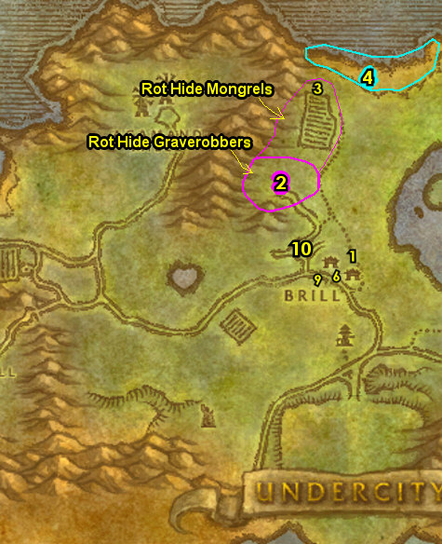

NOTE: While doing this section start working on "The Chill of Death" by kill/looting Duskbats you see along the way:
01) Go NW to Agamand Mills and do "The Mills Overrun" (kill/loot the skeletons around the mill) while also killing the named mobs for "Deaths in the Family" and "The Haunted Mills". Follow the steps below to kill the named mobs for these quests:
02) Kill/loot Devlin Agamand /target, a skeleton warrior patroling around the grassy area around 47.41.
03) Kill/loot Nissa Agamand /target, she is a ghost that patrols around in the house entrance at 50.36.
04) Kill/loot Gregor Agamand /target , a ghoul that patrols around the windmill around 46.29.
05) Kill/loot Thurman Agamand /target, a zombie that patrols between the two windmills next to the cliff around 44.34.
06) Make sure "The Mills Overrun" is finished, then hearth to Gallows' End Taven (Brill). If you cannot hearth, then die on purpose and res at spirit. If you died on purpose then do step #10 next before continuing on.
07) In the Inn 62.52 turn in "Deaths in the Family" and "The Haunted Mills", accept "Speak with Sevren".
08) NOTE: While doing the Agamand quests, you may have received an item called A Letter to Yvette, accept "A Letter Undelivered" from it, then turn it inside the Inn, near the entrance 62.53.
09) In the Town Hall turn in "Speak with Sevren" 61.51, accept "The Family Crypt".
10) At the graveyard entrance, turn in "The Mills Overrun" 58.52.
11) Make sure you are now level 10, if not grind until you are. You can continue to work on "The Chill of Death" by kill/looting bats around Brill until you are. If you happen to get all 5 Pelts before hitting level 10, then go to the Trade Supplies /target vendor (under the red tent 61.52) and purchase a Coarse Thread, then go upstairs in the Inn and turn in "The Chill of Death" (but it doesn't need to be completed now).
#04
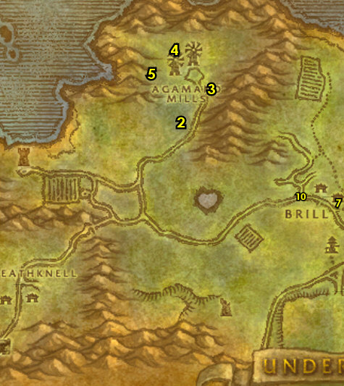

10-12 Tirisfal Glades (log)
01) In front of the Town Hall, turn in "At War with the Scarlet Crusade" 61.52, accept the next part. Also turn in next to you (if it is done) "Proof of Demise". Make sure you are repaired/resupplied.
02) If you are still working on "The Chill of Death", then go to the Trade Supplies /target vendor (under the red tent 61.52) and purchase a Coarse Thread (remember not to sell this!)
03) Go SE to the small camp along the main path and turn in "Forsaken Duties" 66.60, accept "Return to the Magistrate" and "Rear Guard Patrol".
04) Go east to Balnir Farmstead around 76.61 and do "Rear Guard Patrol": kill the zombies and spirits around the farm.
05) Go NE a bit and do "At War with the Scarlet Crusade": kill 5 Scarlet Friars, and kill Captain Vachon (in the watchtower 79.56). NOTE: "Proof of Demise" does not need to be completed now.
06) Go east and do "A New Plague": kill/loot the spiders around 84.54. Also, make sure you have all 5 of the Duskbat Pelts for "The Chill of Death".
08) In front of the Town Hall, turn in "Proof of Demise" (if it is done) 61.52, and next to you "At War with the Scarlet Crusade", accept the next part.
#09
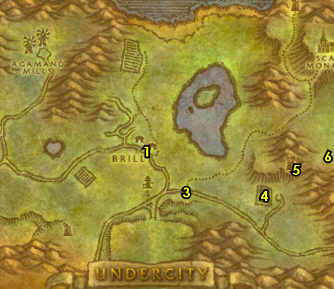

01) In the small house 59.52, turn in "A New Plague", accept the next part. Also accept "Delivery to Silverpine Forest". Make sure you are repaired/resupplied.
02) Above Agamand Mills, go down in the crypt (entrance at 52.27) and do "The Family Crypt": kill the zombies and ghosts, and kill/loot Captain Dargol, he is at the very bottom of the crypt. NOTE: This quest is not easy, but every class should be able to solo it at level 11 with good skill.
03) Die on purpose and res at the spirit, then go in the Town Hall 61.51 and turn in "The Family Crypt" and "Return to the Magistrate".
04) Go in the basement of the Inn and turn in "A New Plague". Make sure you are repaired/resupplied.
05) Do "At War with the Scarlet Crusade": kill Captain Melrache and his two bodyguards in the watchtower 79.25. Also make sure "Proof of Demise" is now finished.
06) Hearth, or run back to Brill and in front of the Town Hall, turn in "At War with the Scarlet Crusade" 61.52 and (if you still need to) "Proof of Demise".
07) At the First Aid Trainer 62.53 just in the entrance of the Inn, learn Heavy Linen Bandage (skill 40), and if possible Journeyman First Aid (skill 50).
09) Make sure you are level 12, grind on any mobs around Brill until you are. Then go in Brill's Inn and get your level 12 spells/abilities.
#10
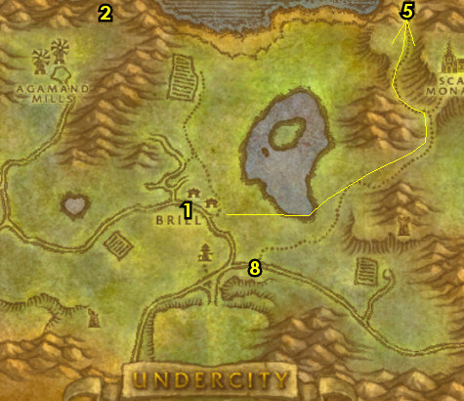

Levels 12+ Options
Now you have two options on where to go. You can go to The Barrens, or you can go to Silverpine Forest (next section below). Overall with WotLK 50% faster quest XP rate, I recommend skipping Silverpine Forest and just jump right into The Barrens guide, otherwise you will be too far ahead after doing Silverpine. So for WotLK 50% XP rate, I would highly recommend skipping Silverpine and going to The Barrens.
If you decide to go to The Barrens right away, then abandon "Delivery to Silverpine Forest" and follow the steps in this section to get to The Barrens. Otherwise, skip to the Silverpine Forest 12-15 section below.
To The Barrens Only:
01) Get on the Zeppelin to go to Orgrimmar (61.59 in Tirisfal Glades). NOTE: There are two Zeppelins, the eastern one takes you to Stranglethorn Vale and the western one to Orgrimmar.
02) Once in Orgrimmar, get the Flight Path from the Wind Rider Master (up at 45.64).
03) Leave Orgrimmar (south) and run to Razor Hill and on the west side of the town, accept "Conscript of the Horde" (51.44 in Durotar).
04) Then go to the Levels 15 Barrens (Undead) section down below in this guide.
#11
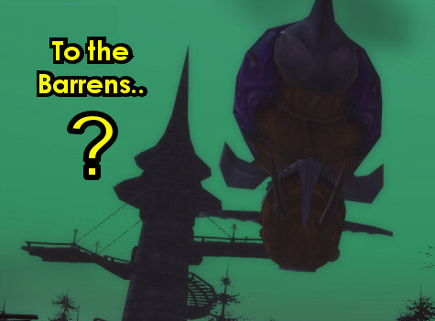

Silverpine Forest 12-15 (log)
01) Head south on the main path to enter Silverpine Forest (54.76 in Tirisfal Glades).
02) Just to your right off the main path at Malden's Orchard, in the small house house 56.9, accept and do the escort "Escorting Erland" by escorting Deathstalker Erland SW a bit to The Ivar Patch. Then turn it in from the NPC 53.13 in front of the big house and accept "The Deathstalkers' Report". Do NOT accept "Wild Hearts" yet.
03) Die on purpose and res at spirit to get to The Sepulcher. NOTE: Save any Discolored Worg Hearts you may have.
04) At the Innkeeper just outside of the crypt/Inn 43.41, make The Sepulcher your new home.
05) Go down in the Inn/crypt and turn in "The Deathstalkers' Report" (down at 43.41), accept "Speak with Renferrel". Also accept "Lost Deathstalkers" and "The Dead Fields".
06) Exit the crypt and make a sharp left to the NPC 43.41 under the canopy and turn in "Delivery to Silverpine Forest" and "Speak with Renferrel", SKIP "Zinge's Delivery" (for now). Also accept "A Recipe For Death".
07) At the largest tombstone in the graveyard, accept "Border Crossings" 44.41.
08) Just north from the NPC in purple, accept "Prove Your Worth" 44.40. Make sure you are repaired/resupplied.
#12
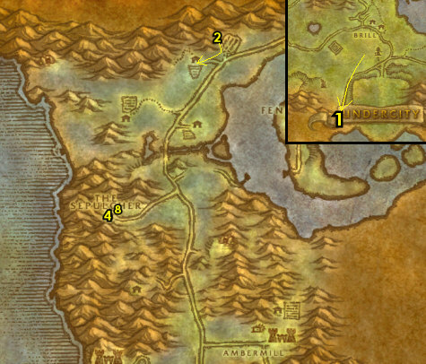

01) As you do the following steps also start working on part of "A Recipe For Death" by kill/looting any bears you see along the way:
02) Work your way north and east of the main path around Valgan's Field around 52.25 do "Prove Your Worth": kill 5 Moonrage Whitescalps (worgen).
03) Work your way north to The Ivar Patch and from the NPC 53.13 in front of the big house, turn in "Lost Deathstalkers". Also accept "Wild Hearts".
04) Around the immediate area do "Wild Hearts": kill/loot worgs.
05) Grind south to The Dead Fields and do "The Dead Fields": keep killing the gnolls until Nightlash /target spawns in the middle of the field 45.21, then kill/loot her.
06) Grind west to The Skittering Dark (watch out for the lvl 24 elite) and do part of "A Recipe For Death": kill/loot the spiders (in and outside of the cave, 36.14, #1 on map). Keep the next step in mind:
07) You can get resupplied from the Fisherman 33.18 by the shore. Be careful not to sell your Discolored Worg Hearts!
08) Finish "A Recipe For Death" by kill/looting the rest of bears you need. You can find a lot of Giant Grizzled Bears around where you are at and Ferocious Grizzled Bears a bit more east. #1 on map.
09) Die on purpose to get to The Sepulcher.
10) Down in the crypt/inn turn in "The Dead Fields" 43.41, accept "The Decrepit Ferry".
11) Exit the crypt and make a sharp left to the NPC 43.41 under the canopy and turn in "Wild Hearts", accept "Return to Quinn".
12) Just north from the NPC in purple, turn in "Prove Your Worth" 44.40, accept "Arugal's Folly". Make sure you are repaired/resupplied.
#13
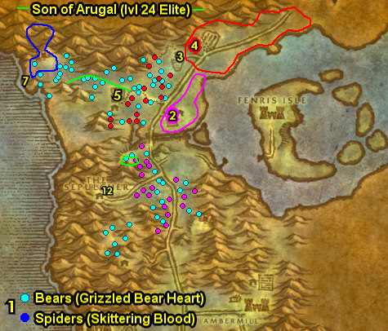

01) Go east to the shore and click on the Corpse Laden Boat 58.35 to turn in "The Decrepit Ferry", accept "Rot Hide Clues".
02) Go north to Valgan's Field and do "Arugal's Folly": upstairs in the big house, loot the Dusty Spellbooks 53.29 on the ground.
03) Go north to The Ivar Patch and upstairs in the big house, turn in "Return to Quinn" 53.13.
04) Just outside the house, accept "Ivar the Foul" 53.13.
05) Go in the barn next to you and do "Ivar the Foul": kill/loot Ivar the Foul 51.14. Be careful there is a few other mobs around this ghoul.
06) Go back to Rane in front of the big house and turn in "Ivar the Foul" (53.13, #3 on map).
07) Die on purpose to get to The Sepulcher.
08) Down in the crypt/inn, turn in "Rot Hide Clues" 43.41, SKIP "Rot Hide Ichor".
09) Exit the crypt, and just north from the NPC in purple, turn in "Arugal's Folly" 44.40, accept the next part. Make sure you are repaired/resupplied.
10) Go east to Deep Elem Mine around 56.46 and do "Arugal's Folly": kill/loot Moonrage Glutton and Darksoul (worgen). You will find more Darksouls in the mine.
11) Go SW to the small Dalaran camp and click on the Dalaran Crate (next to a canopy, 50.60) to turn in "Border Crossings", accept "Maps and Runes".
#14
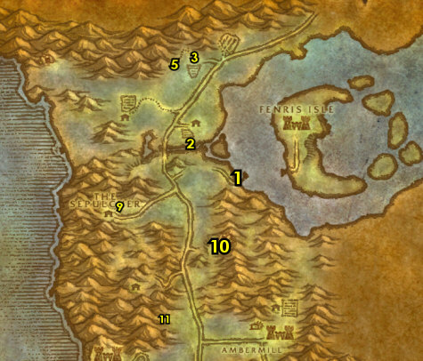

01) At The Sepulcher, outside at the largest tombstone in the graveyard, turn in "Maps and Runes" 44.41, accept "Dalar's Analysis".
02) Just north from the NPC in purple, turn in "Arugal's Folly" 44.40, accept the next part. And turn in "Dalar's Analysis", accept "Dalaran's Intentions". Make sure you are repaired/resupplied.
03) Back at the largest tombstone in the graveyard, turn in "Dalaran's Intentions" 44.41, accept "Ambermill Investigations".
04) Go SE back to Deep Elem Mine and do "Arugal's Folly": enter the mine (entrance at 57.46) and at the end of the mine kill/loot Grimson the Pale.
05) Go south to Ambermill around 56.63 and do "Ambermill Investigations": kill/loot the Dalaran Protectors, Mages and Conjurors for the 8 pendants.
07) At The Sepulcher, next to the Inn/crypt/mailbox, accept "Supplying the Sepulcher" 43.42.
08) Next to the crypt/inn, from the NPC 43.41 under the canopy, accept "Zinge's Delivery".
09) At the largest tombstone in the graveyard, turn in "Ambermill Investigations" 44.41, SKIP "The Weaver".
10) Just north from the NPC in purple, turn in "Arugal's Folly" (44.40, #2 on map), SKIP the next part. Make sure you are repaired/resupplied.
11) SE in town from the Bat Handler 46.43, turn in "Supplying the Sepulcher", accept "Ride to the Undercity". Then take a bat ride to Undercity, Tirisfal.
#15
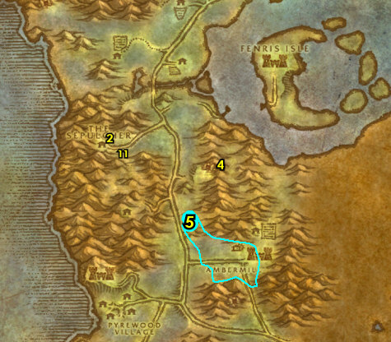

01) When you land at the UC, go across the room in the Trade Quarter and turn in "Ride to the Undercity" 61.42, accept "Michael Garrett".
02) Go to the Bat Handler 63.49 and turn in "Michael Garrett", accept "Return to Podrig". Skip the ride for now.
03) Go SW down in The Apothecarium and turn in "A Recipe For Death" 49.69, SKIP the next part.
04) Next to you in the room, turn in "Zinge's Delivery" 50.68, accept "Sample for Helbrim".
05) Hearth to The Sepulcher.
06) Next to the crypt/Inn/mailbox, turn in "Return to Podrig" (43.42 in Silverpine Forest).
07) SE at the Bat Handler 46.43, take a bat ride to Undercity, Tirisfal.
08) Once at the UC, exit it and head north to the Zeppelin to go to Orgrimmar (61.59 in Tirisfal Glades). NOTE: There are two Zeppelins, the eastern one takes you to Stranglethorn Vale and the western one to Orgrimmar.
09) Once in Orgrimmar, get the Flight Path from the Wind Rider Master (up at 45.64).
10) Leave Orgrimmar (south) and run to Razor Hill (in Durotar) to get new spells/abilities. You can also upgrade First Aid if you need to in the Barracks from the First Aid Trainer 54.42.
11) At the west entrance of Razor Hill accept "Conscript of the Horde" 51.44.
12) Head west on the main path to enter The Barrens..
#16
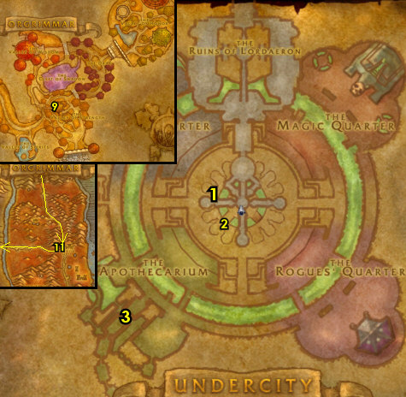

Levels 15 Barrens (Undead) (log)
01) Just over the bridge, next to the path, turn in "Conscript of the Horde" (62.19 in the Barrens), accept "Crossroads Conscription".
02) Go SW to XRs and in the Inn, make XRs your new home from the Innkeeper 52.30.
03) Right outside the Inn on your right accept "Raptor Thieves" 52.30.
04) At the orc standing at the bottom of the watchtower accept "Disrupt the Attacks" 52.31, and "Supplies for the Crossroads".
05) Go up the watchtower next to you and accept "Harpy Raiders" 52.31.
06) Drop down and get the FP from the Wind Rider Master 52.30.
07) Right next to you under the red canopy, turn in (if you have it) "Sample for Helbrim" 51.30. Also accept "Fungal Spores" and "Wharfmaster Dizzywig".
08) At Sergra Darkthorn, turn in "Crossroads Conscription" 52.31. Accept "Plainstrider Menace".
09) Go south in XRs and accept "The Forgotten Pools" 52.32. Then next to you, get repaired/resupplied from the Clothier.
10) While working on the following steps, also start working on "Plainstrider Menace" and "Raptor Thieves" by killing plainstriders and raptors all around the fields of the Barrens, but don't make it your main priority:
11) Go NE and do "Disrupt the Attacks": kill the needed Razormane mobs around 54.27. ALSO: Back in the Razormane camp there is a barrel called Chen's Empty Keg 56.27, loot it and accept the quest from the item received.
12) Go back SW to the XRs and at the orc standing at the bottom of the watchtower, turn in "Disrupt the Attacks" (52.31, #4 on map). Accept "The Disruption Ends". Make sure you are repaired/resupplied.
NOTE: As you continue on in The Barrens, you might be a few levels above what the guide indicates, but that is ok, simply follow The Barrens guide entirely (whether you did the Silverpine section or not).
#17
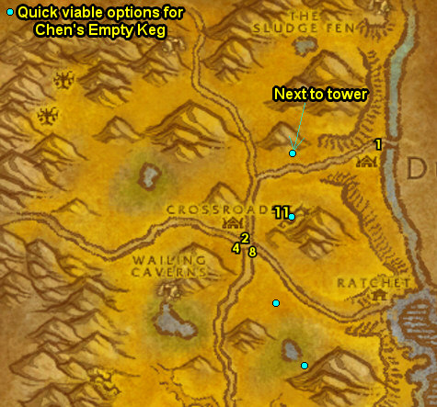
First Pick the Class you are playing top left of screen!!!
Along with the Game Version you are playing on (Era, SoM, TBC or WotLK)
(log)
01) Go back to the other Razormane camps up NE around 57.25 and do "The Disruption Ends" and "Supplies for the Crossroads": kill the required amount of Razormane quilboars and loot a Crossroads' Supply Crates (there are multiple locations of these crates). Kreenig Snarlsnout is at 59.27 /target.
02) Make sure you are level 13 as you work your way SE to Ratchet (stay next to the river for mobs more your level) and then go up in the engineering building and accept "Southsea Freebooters" 63.36.
03) Go to the Flight Master 63.37 to get the FP, then next to you accept "Samophlange". NOTE: To free up bag space you can destroy the Control Console Operating Manual as it is not needed.
04) Go to the goblin on the docks and turn in "Wharfmaster Dizzywig" 63.38. Accept "Miner's Fortune".
05) At the WANTED sign next to the bank, accept "WANTED: Baron Longshore" 63.38.
06) Accept "Raptor Horns" (next to Ratchet's bank, 62.38).
07) Turn in "Chen's Empty Keg" (male orc next to the Plate-n-Chain hut, 62.38), accept the next part. Also focus on doing this quest while throughout The Barrens by kill/looting cats, plainstriders and Thunderlizards...
08) NOTE: At the Ratchet's Inn 62.39 you can buy Longjaw Mud Snapper food for really cheap. Make sure you are repaired/resupplied.
09) Follow the path south of Ratchet to The Merchant Coast and do "Southsea Freebooters" along with "WANTED: Baron Longshore": kill the needed Southsea pirates and kill/loot Baron Longshore /target, he has 3 possible spawns at the southern most tents (starting at 64.47).
10) Go back to Ratchet, and in the engineering building turn in "Southsea Freebooters" (accept "The Missing Shipment") and "WANTED: Baron Longshore" 63.36.
11) Go to the goblin at the docks and turn in "The Missing Shipment" (63.38, #6 on map), accept the next part.
12) Go back in the engineering building and turn in "The Missing Shipment" 63.36, accept "Stolen Booty".
#01
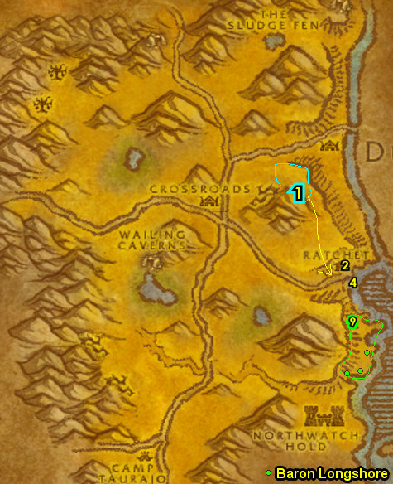

01) South of Ratchet again at The Merchant Coast, do "Stolen Booty": loot the Fragile - Do Not Drop box for the Lens 64.49. For the boots, see next step:
02) Go SW a bit to the other small pirate camp and loot Drizzlik's Emporium box for the boots 63.50.
03) Hearth to XRs.
04) Go to the orc at the bottom of the watchtower and turn in "The Disruption Ends" and "Supplies for the Crossroads" 52.31.
05) Turn in (if you haven't yet) "Plainstrider Menace" (it should be done by now) 52.31, accept "The Zhevra". NOTES: If "Plainstrider Menace" is not done yet, you can find a lot of Plainstriders just around the outskirts of the XRs. Also make sure you are level 14 before continuing.
06) South in XRs, accept "Consumed by Hatred" and "Lost in Battle" 52.32.
07) At this point, I make sure I have 3/4 six slot bags, if I don't, I buy them at the bag vendor /target (the southern most vendor in XRs, 52.32). Make sure you are repaired/resupplied.
08) NW in Crossroads 51.29, you can possibly upgrade your weapons from the Weaponsmith.
#02
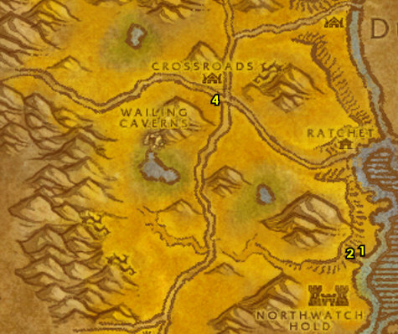

01) Go west of XRs (grinding on zhevra, plainstriders and raptors along the way), to the orc 45.28 in the burrow and accept " Kolkar Leaders" and "Centaur Bracers".
02) While focusing on the following quests, also kill any Plainstriders, Centaur, Raptors and Zhevra along the way, but don't make them your main focus...
03) Grind your way to The Forgotten Pools and do "The Forgotten Pools": discover the fissure under the water 45.23. Also start working on (or finish?) "Fungal Spores": loot the Laden Mushrooms around The Forgotten Pools. ALTERNATE ROUTE CHOICE: Some classes can get away without needing to get all the shrooms for "Fungal Spores" right now, or for other classes that can get away without needing to go to TB at lvl 16 for new spells/abilities and wait to lvl 20 to get them instead. This choice dramatically changes the route below for the 16-20 sections. Speedlevelers may want to skip going to TB at 16 and get their spells/abilities instead at lvl 20 to save travel time. With all that being said, choose your route:
Choose Your Route: Fungal Spores Incomplete / TB at 20
04) Do "Kolkar Leaders": grind your way to Barak Kodobane 43.23 /target, and kill/loot him. NOTE: "Centaur Bracers" does not need to be completed now.
05) Go NW to The Dry Hills and do "Harpy Raiders": kill/loot the harpies around 41.19. Watch out there is an Rare Elite /target that wanders around in the area.
06) Grind your way west (at 35.28 in The Barrens) and accept "Goblin Invaders" and "Avenge My Village".
#03
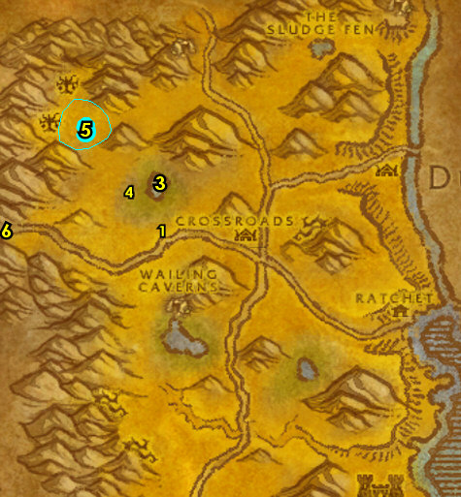

15-16 Stonetalon Mountains (log)
01) Go west into Stonetalon Mountains and do "Avenge My Village": kill the required amount of Grimtotem taurens around 81.90. TIP: Kill the Grimtotem Sorcerers first as they do a lot of damage.
02) Go back and turn in "Avenge My Village" 35.28, accept "Kill Grundig Darkcloud".
03) Go back into Stonetalon, to the path that goes up into Grimtotem post hill entrance 76.89. NOTE: If this entrance is to tough for you then a safer entrance is at 72.87 (which will also clear the path for the future escort coming up).
04) Do "Kill Grundig Darkcloud": kill 6 Grimtotem Brutes and also kill Grundig Darkcloud /target, he is standing on the steps outside the hut 74.86.
05) Accept and do the escort quest there ("Protect Kaya" 73.86 in the hut). TIPS: Make bandages during the escort. When reaching down to Camp Aparaje, kill the Ruffian behind the big totem before the final fight starts. Try to keep aggro off of Kaya Flathoof, as she has low HP. Kill the Sorcerer first that pops out during the one battle you have to fight. If it's too hard for you, skip it.
06) Once done, go back and turn in (if you did it) "Protect Kaya" (at 35.28 in The Barrens, #2 on map), accept "Kaya's Alive". Also turn in "Kill Grundig Darkcloud".
#04
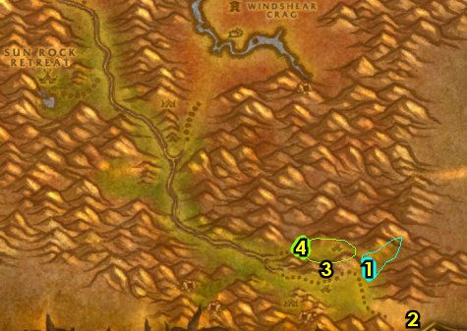

16-20 Barrens (log)
01) Grind your way to the orc in the burrow and turn in "Kolkar Leaders" 45.28. Accept "Verog the Dervish". Also turn in (if it's done) "Centaur Bracers" if not don't worry.
02) At this point, make sure "The Zhevra" is finished, kill/loot Zhevra while you work your way to the XRs...
03) Go to XRs and turn in all quests and accept new ones: Turn in (If it's complete) "Fungal Spores" 51.30 (next to Wind Rider Master). SKIP (if it's available) "Apothecary Zamah" (for now).
04) Go up in the watchtower and turn in "Harpy Raiders" 52.31, accept "Harpy Lieutenants".
05) If you finished "Raptor Thieves", turn it in next to the Inn 52.30, accept "Stolen Silver". If not, don't worry, I will mention when it needs to be finished.
06) At Sergra Darkthorn turn in "The Zhevra" 52.31, accept "Prowlers of the Barrens".
07) South in XRs, turn in "The Forgotten Pools" 52.32, accept "The Stagnant Oasis". Then next to you, get repaired/resupplied from the Clothier.
#05
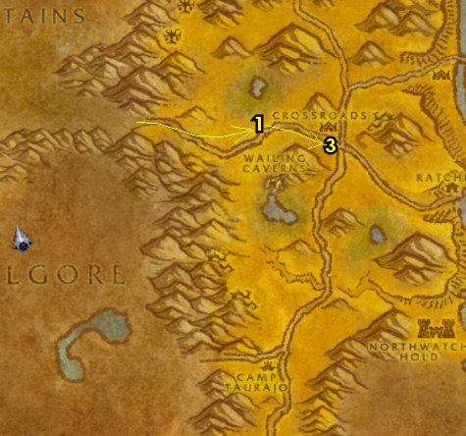
01) Make sure you are upgraded to lvl 15 food/water!
02) Go NW of XRs and do "Prowlers of the Barrens" along with "Raptor Thieves" (if you still need to): kill/loot raptors and Savannah Prowlers starting at 42.29, then work your way up north. Look for the green grassy areas for the Prowlers. Work your way to the next step:
03) Go up north to The Dry Hills (harpy camp) and do "Harpy Lieutenants" around 40.17: kill/loot the Witchwing Slayers (they are the only ones that drop the rings). Watch out there is an Rare Elite /target that wanders around in the area.
04) Grind east and you can get repaired/resupplied from Vrang Wildgore next to the hut 44.12.
05) Grind your way east and do "Samophlange": clear the Venture Co. mobs out of the area, then click on the Control Console 52.12 to turn in the quest and accept the next part. Do the next part by clicking on the 3 Valves around the research facility. Then click on the Control Console again to turn it in and accept the next part. (See Video of whole quest chain) See next step:
06) Go NE a bit and do the next part of "Samophlange": kill/loot Tinkerer Sniggles /target (in the hut, 53.10).
07) Go back to the research facility's Control Console 52.12 to turn in "Samophlange" (#5 on map), accept the next part.
08) Go NE to The Sludge Fen at Wizzlecrank's Shredder 56.7 and accept "Ignition". NOTE: This shredder may currently be in an escort, if this is the case keep grinding on mobs until the escort completes then accept this.
09) Go up to the top of the building in the middle of the pond and do "Ignition": kill/loot Supervisor Lugwizzle /target (he patrols around at the top around 56.9).
10) Go back down to Wizzlecrank's Shredder (56.7, #8 on map) and turn in (as long as he is currently not in an escort) "Ignition". Then accept and do the escort "The Escape" by escorting the shredder out of The Sludge Fen. (See video on how I do Ignition and Escape)
11) Go NE to Boulder Lode Mine and do "Miner's Fortune" 62.6: kill/loot the mobs there until the Cats Eye Emerald drops. NOTE: The mobs outside of the mine can drop the emerald as well (it's a low drop rate).
#08
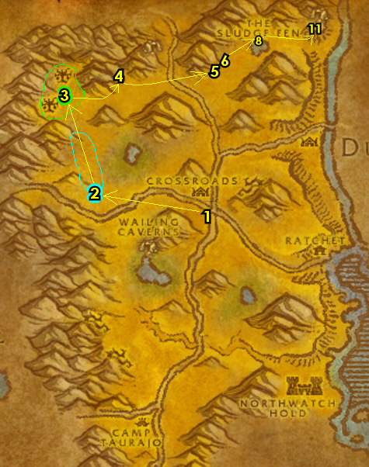

01) ORC & TROLL ONLY: Grind your way south to the watchtower and turn in (if you have it) "The Demon Seed" 62.20.
02) Continue south to Ratchet and in the engineering building turn in "Stolen Booty" 63.36.
03) Near the Flight Master 63.37, turn in "The Escape" and "Samophlange". Accept "Ziz Fizziks" , SKIP "Wenikee Boltbucket".
04) At the goblin at the docks, turn in "Miner's Fortune" 63.38.
05) By the Bank 62.38 accept "Deepmoss Spider Eggs". And turn in (if it is complete) "Raptor Horns". Then in the hut next to you, make sure you are repaired/resupplied.
06) Turn in (if it's done) "Chen's Empty Keg" (male orc next to the Plate-n-Chain hut, 62.38), accept the next part. If it's not done yet, don't worry.
07) Go west of Ratchet, and do "The Stagnant Oasis": click on the Bubbling Fissure down in the lake 56.43. Also continue working on "Fungal Spores" (if you still need to): loot Laden Mushrooms around the lake (and it doesn't need to be completed now).
08) Go west a bit and do "Verog the Dervish": by kill/looting Verog the Dervish (spawns at 53.42 /target). NOTE: Verog spawns in randomly when a centaur has been killed around the area, and there will be a yell notice to let you know he spawns in. Also, make sure "Centaur Bracers" is finished.
09) Go to XRs and turn in "The Stagnant Oasis" (south in XRs, 52.32), accept "Altered Beings". NOTE: If the Dried Seeds is still in your bags, you can destroy it, as it now has no use.
10) At Sergra Darkthorn turn in "Prowlers of the Barrens" 52.31, accept "Echeyakee".
11) Next to the Inn, turn in (if it's complete) "Raptor Thieves" 52.30, accept "Stolen Silver".
12) At the bottom of the watchtower, accept "Report to Kadrak" 52.31.
13) Go up the watchtower and turn in "Harpy Lieutenants" 52.31, accept "Serena Bloodfeather".
13b) Drop down and turn in (If it's complete) "Fungal Spores" (next to Wind Rider Master, 51.30). SKIP (if it's available) "Apothecary Zamah" (for now).
14) Get repaired/resupplied NW in XRs at the Forge/blacksmith area 51.29.
#12
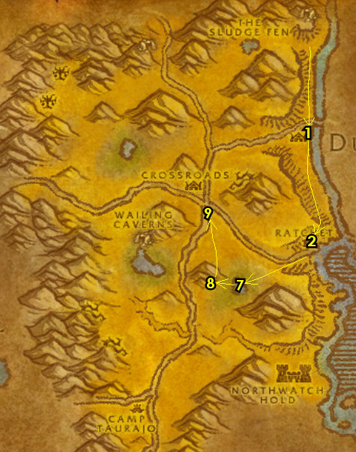

01) Go west from XRs to the orc 45.28 at the burrow and turn in "Verog the Dervish" and (if you still need to) "Centaur Bracers", accept "Hezrul Bloodmark".
02) Grind your way north to The Dry Hills (harpy camp) and do "Serena Bloodfeather": far back in the camp, kill/loot Serena Bloodfeather 39.12 /target.
03) Go east (grind mobs along the way) and do "Echeyakee": use your Horn of Echeyakee quest item at the kodo bones 56.17, then kill/loot Echeyakee /target (See Video). Also make sure "Raptor Thieves" is finished now (kill/loot raptors if you still need to).
04) Hearth to XRs. Get resupplied in the Inn.
05) At Sergra Darkthorn, turn in "Echeyakee" 52.31, accept "The Angry Scytheclaws".
06) Next to the Inn, turn in (if you still need to) "Raptor Thieves" 52.30, accept "Stolen Silver".
07) Go to the top of the watchtower and turn in "Serena Bloodfeather" 52.31. Accept "Letter to Jin'Zil".
08) Go SW to The Lushwater Oasis and do "Altered Beings" along with "Hezrul Bloodmark": kill/loot the Oasis Snapjaw (turtles) in and around the lake around 46.38. Also kill/loot Hezrul Bloodmark /target, he patrols clockwise around the lake. TIPS: Try to avoid the gray lvl mobs. If you can't find Hezrul in time, the quest can be skipped. Also finish "Fungal Spores" (if you still need to): loot Laden Mushrooms around the lake.
09) Go SE to the Raptor Grounds and do "Stolen Silver" along with continuing (if you still need to) "Raptor Horns": kill/loot raptors and loot the Stolen Silver chest 58.54. (See Video)
10) Go NW and do "The Angry Scytheclaws" around 52.46: kill/loot raptors for Sunscale Feathers, then use them at the 3 Raptor nests. Make sure "Raptor Horns" is complete now as well.
#13
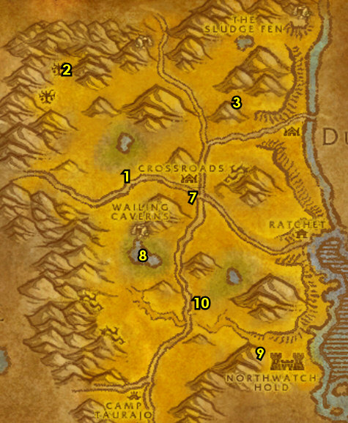
01) Go SW across the main path/bridge (to 49.50) and do "Lost in Battle" (Manrik's Wife): She's laying dead by the hut. Simply examine the Beaten Corpse.
02) Go west around 50.53 and see if a lvl 22 gray kodo named Lakota'mani /target is there and kill/loot him. He might also be on the right side of the main path around 47.51. He drops Hoof of Lakota'mani which starts "Lakota'mani", accept it if you can spot him soon (if not you can try again later)..
03) Grind south to Camp Taurajo (CT) and accept "Weapons of Choice" (by the Forge, 45.58).
04) Turn in (if you have it) "Lakota'mani" 45.59.
05) At the quilboar in the cage accept "Tribes at War" 45.59. And get the FP there next to you from the Wind Rider Master. Get resupplied while in town. NOTE: Don't sell Blood Shards to a vendor.
06) Go north to Agama'gor and do "Tribes at War" along with "Consumed by Hatred" around 43.46: kill/loot the Bristlebacks (Quilboar). The Geomancers are north in the area around 43.47, Thornweavers are in the middle around 44.52 and Water Seekers are south around 45.54. If you go to the area east of the main path around 53.54 they are evenly spaced out there.
07) Go south to CT and turn in (if you have it) "Lakota'mani" (45.59, #4 on map).
08) Go to the quilboar in the cage and turn in "Tribes at War" (45.59, #5 on map). Accept "Blood Shards of Agamaggan" and then talk to the NPC to turn it in. Then accept "Betrayal from Within" NOTE: You can turn in Blood Shards for ability boosts here. You can turn in multiple and they will stack. Save Blood Shards for later (I recommend storing them in the mailbox and use some for the next step).
09) At this point, make sure you are at least 5 bars away from level 20. If you aren't then I recommend grinding on Bristlebacks (Quilboar, #6 on map) to obtain Wool Cloth so you can get skill 115 for Heavy Wool Bandage sooner. You can also grind on beasts around where Lakota'mani is at (around 47.51, #2 on map). You can use some Blood Shards to help the grind. NOTES: Instead of the grinding, you could get a 5 man group and do the Wailing Caverns dungeon 46.36. Also make sure "Chen's Empty Keg" (part 2 is finished by now if you still need to).
10) From CT, fly to XRs (or run there if you are close by).
#16
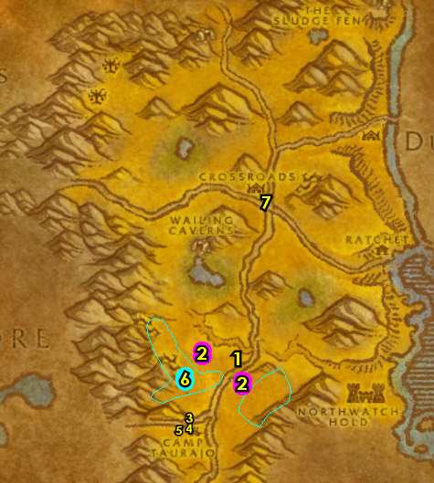
01) Next to XR's Inn, turn in "Stolen Silver" 52.30.
02) At Sergra Darkthorn turn in "The Angry Scytheclaws" 52.31, accept "Jorn Skyseer".
03b) South in XR's, turn in "Consumed by Hatred" and "Lost in Battle" 52.32.
04) Across the path, turn in "Altered Beings" 52.32. Make sure you are level 20 now and repaired/resupplied next to you at the Clothier.
05) By the Wind Rider Master 52.30 accept "Apothecary Zamah". NOTE: Work somewhat quickly with the next number of steps as this quest is on a timer!
06) At the Wind Rider Master next to you, fly to Camp Taurajo, The Barrens.
07) At CT, turn in "Jorn Skyseer" 45.59, accept "Ishamuhale". Also accept "Melor Sends Word".
08) Follow the path west into Mulgore and as you enter on your right around 67.59, die on purpose, then res at spirit. If you are a Tauren, just fly to Thunder Bluff, Mulgore and skip to the TB section below.
09) At Mulgore, follow the path north and then get on a Lift (at 32.66 in Mulgore) to go into Thunder Bluff.
#17
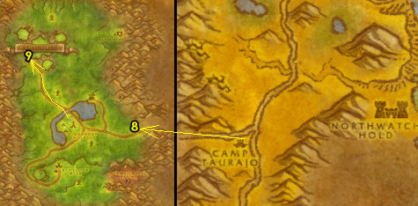
01) As you do the following steps in TB keep an eye out for Bluff Runner Windstrider /target and accept "The Ashenvale Hunt" if you see him (optional, not required quest). He patrols around TB, see patrol path on map:
02) Go to the weapon master 41.63 and get new weapon possibilities.
03) Turn in (if you have it) "Melor Sends Word" (on The Hunter's Rise, 62.81), then accept "Steelsnap".
Get New Abilities, 3b) Get new spells/abilities.
04) NON TAURENS: Go to the top of the tower in the middle of TB and get the FP from the Wind Rider Master 47.50.
06) Go to the Pools of Vision cave underneath The Spirit Rise (entrance is 30.30) and turn in "Apothecary Zamah" 23.21.
07) Above The Spirit Rise, upgrade First Aid from the First Aid Trainer 30.21. NOTE: You need skill 80 for Wool Bandage and skill 115 for Heavy Wool Bandage.
Level 20 Mounts, 7b) At level 20 mounts become available. If you happen to be level 20 and if you have the gold then get your mount ASAP. It differs depending on your class & race and it costs roughly 5 gold. Check out my Mount Guide on where to find your mount trainer & vendor.
08) Hearth back to XRs.
#20
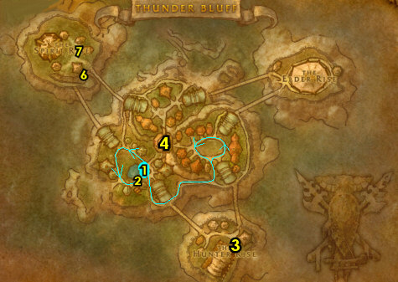
01) Go to XR's Wind Rider Master 52.30 and fly to Ratchet (east of XRs).
02) By Ratchet's Bank, turn in (if you still need to) "Raptor Horns" 62.38. Accept (if you haven't yet) "Deepmoss Spider Eggs".
03) Turn in (if you still need to) "Chen's Empty Keg" (male orc next to the Plate-n-Chain hut, 62.38), accept the next part.
04) N/A
05) N/A
06) N/A
07) N/A
08) Hearth to XRs. Or if Hearthstone is still on a cooldown, fly to XRs (Flight Master is at 63.37 in Ratchet). Make sure you are repaired/resupplied.
09) Go west from the XR's to the orc in the burrow and turn in (if you did it) "Hezrul Bloodmark" 45.28. NOTE: SKIP "Counterattack!" (requires group and can fail or take to long for xp/time).
#23
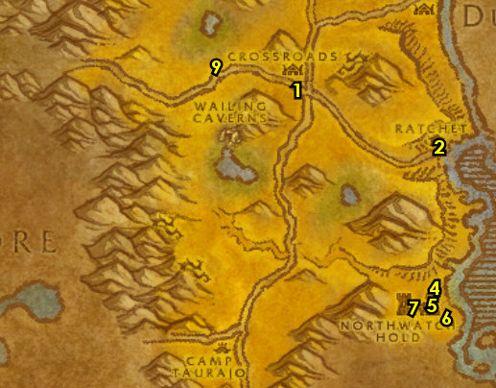
20-21 Stonetalon Mountains (log)
First Pick the Class you are playing top left of screen!!!
Along with the Game Version you are playing on (Era, SoM, TBC or WotLK)
01) Run west into Stonetalon Mountains. When you get there take the path (starting at 82.98 in Stonetalon)..
02) Go to the witch doctor in the small cave and turn in (if you have it) "Letter to Jin'Zil" 75.98. Accept "Jin'Zil's Forest Magic".
03) At the other side of the village, accept "Blood Feeders" 71.95.
04) Go NW to the Wanted Poster: Besseleth and accept "Arachnophobia" 59.76.
05) Follow the path west to Sishir Canyon around 54.76 and start working on "Deepmoss Spider Eggs" (loot Deepmoss Eggs) and do part of "Blood Feeders": kill 10 Deepmoss Creepers (the Deepmoss Venomspitters does not need to be completed now). Keep the next step in mind:
06) West in Sishir Canyon do "Arachnophobia": kill/loot Besseleth (lvl 21 orange spider, with several possible spawn locations: 55.72 53.72 52.74, /target ).
07) Go north to Windshear Crag and turn in "Ziz Fizziks" at the goblin in the hut 59.63, accept "Super Reaper 6000".
08) Do "Goblin Invaders", "Super Reaper 6000" and finish up "Deepmoss Spider Eggs" and "Blood Feeders" around Windshear Crag: kill the Venture Co. Loggers, kill/loot the Venture Co. Operators until the Blueprints drop (its a low drop rate). Also loot the Deepmoss Eggs and kill Deepmoss Venomspitters. NOTES: There are a lot of operators on the big tank shredder, 63.54 and more around other structures in the area. Keep the next step in mind:
09) There is a goblin merchant to the west in Windshear Crag 58.52 that you can get repaired/resupplied at.
10) Go back to the goblin in the hut and turn in "Super Reaper 6000" (59.63, #7 on map), accept "Further Instructions".
#01
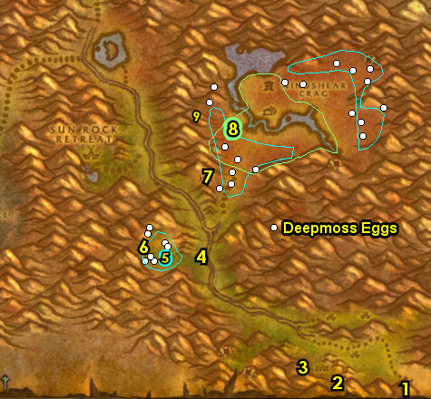

01) Head to Sun Rock Retreat and at the tauren next to the Inn turn in "Arachnophobia" 47.61.
02) Just north of you at the female tauren, turn in (if you have it) "Kaya's Alive" 47.58. Also accept "Cycle of Rebirth".
03) West in the village, get the FP from the Wind Rider Master 45.60. Then next to you from the Bowyer 45.59 under the red tent, make sure you are repaired/resupplied.
04) Run up the little pathway SW in Sun Rock Retreat, make a left at 45.63 and then accept "Trouble in the Deeps" 47.64.
05) N/A
06) Go east to the small village of Malaka'Jin and turn in "Blood Feeders" 71.95. You can get resupplied in the village 74.95.
07) Run east and turn in "Goblin Invaders" (at 35.28 in The Barrens). Accept "Shredding Machines".
#02
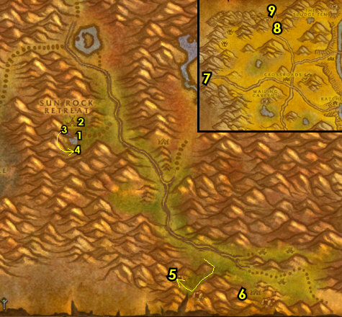

22-23 Southern Barrens (log)
01) Hearth to XRs. Make sure you are repaired/resupplied.
02) West in XRs, accept "Egg Hunt" 51.30.
03) Go to the Wind Rider Master 52.30 and fly to Camp Taurajo, The Barrens.
04) Turn in (if you haven't yet ) "Jorn Skyseer" 45.59, accept (if you haven't yet) "Ishamuhale". And (if you haven't yet) accept "Melor Sends Word".
05) Go in the Inn and make CT your new home from the Innkeeper 46.59.
06) If you have Blood Shards, give them to the quilboar in the cage 45.59.
07) First go south of CT around 46.62 to see if a blue thunderlizard named Owatanka /target is roaming around the area and kill/loot him. If he is not there then go check east across the main path (he could patrol randomly around the east area around 49.60). He drops Owatanka's Tailspike which starts "Owatanka", accept it. NOTE: If you've been grinding for awhile looking for Owatanka, then return to CT to turn in the quest, get resupplied and refresh your Blood Shard buffs.
08) Go south and do "Egg Hunt": loot the Silithid Mounds. NOTE: There is a rare mob called Silithid Harvester (at around 43.70 or around 48.70, /target) that drops an item which starts "The Harvester", accept it if you are able to kill this mob. This rare has a 2 hour 45 min respawn, so he may not be there. You can try again later at the level 25 Southern Barrens section below.
09) As you focus on the follow quests below, also start working on "Chen's Empty Keg" by kill/looting the Stormhides, Greater Thunderhawks and kodos along the way. Also if you run across a reddish thunderhawk named Washte Pawne /target, kill/loot him, he drops Washte Pawne's Feather, which starts "Washte Pawne", accept it. Washte Pawne randomly wonders around Blackthorn Ridge (or to the east of the main path).
10) Go south to Blackthorn Ridge and do "Betrayal from Within" along with "Weapons of Choice": kill the Razormane Seers for the Wand, Razormane Warfrenzy for the Shield, and the Razormane Pathfinder for the Backstabber. Also, kill/loot the 3 named mobs, Kuz wonders around (around 45.80 /target), see below for the other named mobs to kill...
11) Kill/loot Lok Orcbane up in the tent (40.81 /target).
12) Kill/loot Nak in the middle of the field (around 44.83 /target). Watch out for the stealthed mobs in the area!
#05
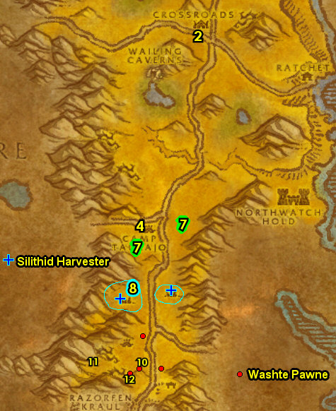

01) Once done, go find the tauren Gann Stonespire /target, he patrols up and down the main path to the right of Blackthorn Ridge around 46.81. From him, accept "Gann's Reclamation".
02) Go down south to Bael Modan (entrance is 47.85)...
03) Do "Gann's Reclamation": kill the Bael'dun dwarves and kill/loot Prospector Khazgorm down in Bael Modan 48.86.
04) Find the tauren Gann Stonespire /target along the main path (around 46.81, #1 on map) and turn in "Gann's Reclamation", accept "Revenge of Gann".
05) Make sure "Chen's Empty Keg" is finished by kill/looting the Stormhides, Greater Thunderhawks and kodos.
06) Hearth to Camp Taurajo. NOTE: DONT vendor items yet!
07) North at CT by the Forge, turn in "Weapons of Choice" 45.58.
08) Turn in (if you haven't yet) "Owatanka", "Washte Pawne" and (if you did it) "The Harvester" 45.59.
09) Go to the quilboar in the cage and turn in "Betrayal from Within" 45.59, accept the next part.
10) At the Wind Rider Master 44.59 next to you, fly to XRs.
11) West in XRs, turn in "Egg Hunt" 51.30. After turning this in you can destroy any remaining Silithid Eggs left.
12) Go to the orc at the bottom of the watchtower and turn in "Betrayal from Within" 52.31. Make sure you are repaired/resupplied now.
13) Go east (above Ratchet) and do "Ishamuhale". First find and kill/loot a Zhevra along the way there. Then use the Fresh Zhevra Carcass quest item at the dead tree 60.30, then kill/loot Ishamuhale /target when he appears.
14) Go SE to Ratchet and next to the bank turn in "Deepmoss Spider Eggs" 62.38. NOTE: If you have any leftover Deepmoss Eggs, you can destroy them.
15) Turn in "Chen's Empty Keg" (male orc next to the Plate-n-Chain hut, 62.38). NOTE: This quest is now repeatable, but you do not get additional XP from it.
17) Next to the Flight Master turn in "Further Instructions" 63.37, accept the next part.
18) At the Flight Master 63.37 next to you fly to Sun Rock Retreat, Stonetalon Mountains.
#06
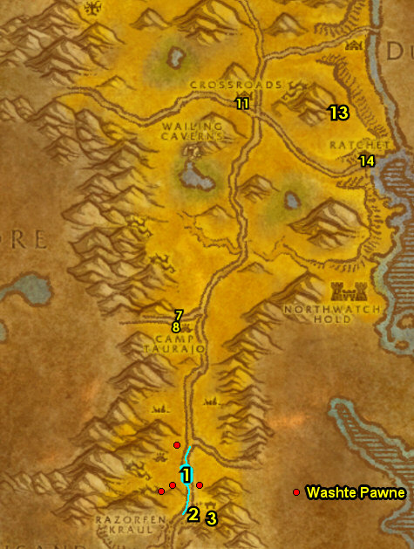

23-25 Stonetalon Mountains (log)
01) At Sun Rock Retreat, accept Cenarius' Legacy" at the blood elf 46.60.
02) At the tauren by the Inn, accept "Harpies Threaten" 47.61.
03) Go in the Inn next to you and make Sun Rock Retreat your new home from the Innkeeper 47.62. NOTE: Upstairs in the Inn is a vendor 48.62 that can sell healing/mana potions (on a timer).
04) Follow the path SW of Sun Rock Retreat entrance 45.62 and from the water elemental, accept "Elemental War" 47.64.
05) Go north to Mirkfallon Lake around 50.43 and do "Cycle of Rebirth": loot Gaea Seeds from the ground around the lake. Also start working on "Jin'Zil's Forest Magic" by kill/looting the deer around the lake.
06) Work your way north while kill/looting deer & saps for "Jin'Zil's Forest Magic". Once you get to Stonetalon Peak around 36.13 do "Cenarius' Legacy": kill the Cenarion night elf mobs around the middle of Stonetalon Peak. Keep the next step in mind:
07) Go to the south and west side of Stonetalon Peak and finish up "Jin'Zil's Forest Magic": kill the deer, cats (west), saps (south), and fey dragons. There are 3 spawn locations for the fey dragons, (see map for locations).
08) Once done, Hearth to Sun Rock Retreat, get resupplied at Innkeeper, then go to the goblin in the hut and turn in "Further Instructions" 59.63, accept "Gerenzo Wrenchwhistle".
#07
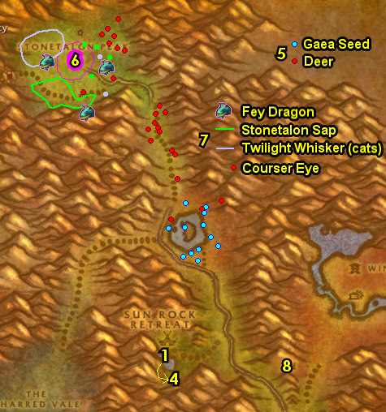

01) Go north into Windshear Crag and do "Shredding Machines": kill the two shredder machines. XT:9 patrols around the south side of the river in Windshear Crag and XT:4 patrols around the north side of the river around 65.46. TIP: Use /target xt to find either of them. Keep the next step in mind:
02) N/A
03) Go NE to the path at 70.41...
04) Do "Gerenzo Wrenchwhistle": follow the path up to the construction site and go down to kill/loot Gerenzo Wrenchwhistle (has several spawn locations on the platforms around 64.40 /target). (See Video)
05) Go back to the goblin in the hut and turn in "Gerenzo Wrenchwhistle" 59.63.
06) N/A
07) N/A
08) Go SE to the witch doctor in the cave and turn in "Jin'Zil's Forest Magic" 75.98.
09) Go east to the border of Stonetalon & Barrens and turn in "Shredding Machines" (35.28 in The Barrens).
10) Hearth if you can, if not consider waiting until you can hearth or just run back to Sun Rock Retreat.
#08
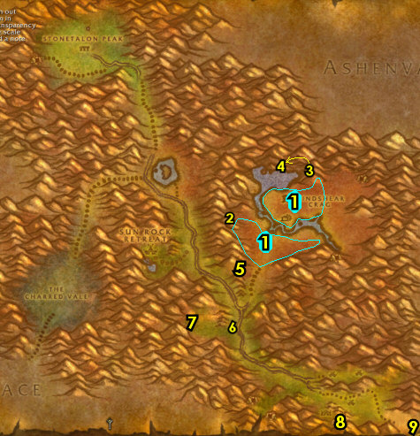

02) At the female tauren, turn in "Cycle of Rebirth" 47.58. Accept "New Life".
03) At the blood elf, turn in "Cenarius' Legacy" 46.60, SKIP "Ordanus". Make sure you are repaired/resupplied.
04) Go to the path SW in Sun Rock Retreat entrance 45.62 and continue following it SW into The Charred Vale around 37.67 and do "Harpies Threaten" along with "Elemental War" and "New Life": kill/loot the fire elementals, click on the Gaea Dirt Mounds on the ground and kill the harpies. NOTE: All these are evenly done throughout The Charred Vale, but the Bloodfury Harpy & Bloodfury Ambushers are north, while the Bloodfury Slayers & Bloodfury Roguefeathers are south.
05) Once they are all done, make sure you are at least 4 bars away from level 25, so you may have to grind a little, then go to the path that leads back to Sun Rock Retreat 38.68...
06) Go to the water elemental and turn in "Elemental War" 47.64.
07) Drop down and from the tauren by the Inn, turn in "Harpies Threaten" 47.61, SKIP "Bloodfury Bloodline" (for now). Accept "Calling in the Reserves".
08) Just north a bit at the female tauren, turn in "New Life" (47.58, #2 on map).
09) Make sure you are repaired/resupplied.
10) Go to the Wind Rider Master 45.60 and fly to Thunder Bluff, Mulgore. BLOOD ELVES: Blood elves who did Ghostlands will need to fly to Camp Taurajo, then head west into Mulgore, then go NW to get to Thunder Bluff 36.30.
#09
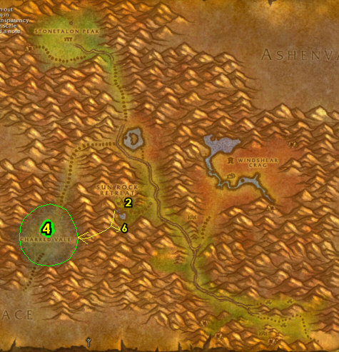
Thunder Bluff (log)
01) Go east a bit to the Cooking Trainer (51.53 in TB) and get Apprentice Cook. NOTE: Make sure you get this side profession so you can do an easy turn-in XP quest at level 30 Hillsbrad.
02) Just east a bit by the Bonfire, accept "The sacred Flame" 55.51.
03) Turn in (if you haven't yet) "Melor Sends Word" (on The Hunter Rise, 62.81), accept "Steelsnap".
GET NEW ABILITIES, 3b) Get new spells/abilities for your class.
04) If you still need to upgrade to Heavy Wool Bandage (requires First Aid skill 115), then go to the top of The Spirit Rise to the First Aid Trainer 30.21 to get that.
05) Go up to the Wind Rider Master in the middle of TB 47.50 and fly to Camp Taurajo, The Barrens.
#10
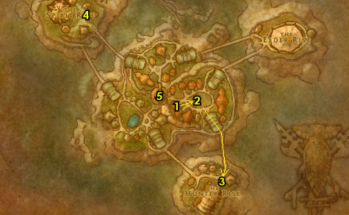
25-25 Southern Barrens (log)
01) Turn in "Ishamuhale" 45.59, accept "Enraged Thunder Lizards".
02) Go in the Inn and Make CT your home from the Innkeeper 46.59. Don't forget to upgrade to lvl 25 food/water!
03) North in CT by the Forge, accept "A New Ore Sample" 45.58. NOTE: you need to be lvl 25 to get this.
04) As you do the following steps start working on "Enraged Thunder Lizards" by kill/looting thunderlizards (stegosaurus dinos) along the way. They are scattered everywhere in the open fields of southern Barrens:
05) If you haven't killed/looted the mob called Silithid Harvester (around 43.70 or around 48.70 /target), then go give it a try right now. This drops an item which starts "The Harvester", accept it if you are able to kill this mob. This has a 2 hour 45 min respawn. If not there, it can be skipped.
06) At Bael'dun Keep (up at 49.84) do "Revenge of Gann": kill/loot the Bael'dun dwarves there for the items you need. OPTIONAL GROUP QUEST HERE: If you can find the help of one other player, then down and SE of the Bael'dun Keep entrance is a quest giver next to a tent 49.86 that gives "The Tear of the Moons". This is done down in the keep by looting General Twinbraid's Strongbox down 49.84 in front of the fireplace. There is a lvl 30 mob and numerous other dwarf mobs in the area. If done, turn it in.
07) Find the tauren Gann Stonespire patrolling along the main path (around 46.81 /target) and turn in "Revenge of Gann", accept the next part.
08) Do "Revenge of Gann": go south to Bael Modan and click on the Bael Modan Flying Machine on top of the small tower 47.86. NOTE: You can be about 30 yards away to activate it.
09) Go back to the tauren Gann Stonespire along the main path (around 46.81, #7 on map, /target) and turn in "Revenge of Gann".
10) Make sure "Enraged Thunder Lizards" is finished: kill/loot thunderlizards (stegosaurus dinos) scattered everywhere in the open fields of southern Barrens.
11) Head south of the main path to The Great Lift (at 44.92 in The Barrens) and turn in "Calling in the Reserves". Next to you there, accept (if it's available) "Message to Freewind Post" 32.22.
12) Go down the Lift to enter Thousand Needles...
#11
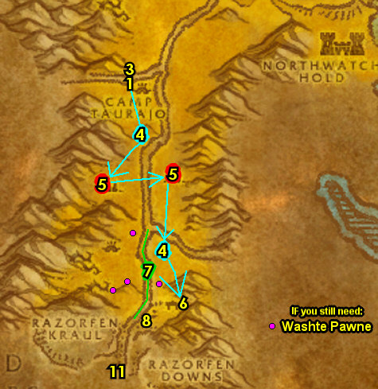

25-26 Thousand Needles (log)
01) First off, keep an eye out for the Galak Messenger /target and kill/loot this centaur when you see him in 1k Needles. He has a very large patrol path. He drops an item which starts "Assassination Plot", accept it (if you can). But, don't intentionally do this yet, continue on with the next step:
02) Go to the Lift, to go up to Freewind Post (47.48 in Thousand Needles).
03) Once up at Freewind Post, by the Bonfire turn in (f you have it) "Message to Freewind Post" 46.51, accept "Pacify the Centaur".
04) From the Wanted Poster - Arnak Grimtotem next to the Inn, accept "Wanted - Arnak Grimtotem" 46.51.
TBC, 4a) Next to you from the female blood elf accept "A Different Approach" 46.50.
05) On the west side of Freewind Post, accept "Alien Egg" 45.50.
06) NW at Freewind Post, accept "Wind Rider" 45.49. Next to you there, get the FP from the Wind Rider Master. Make sure you are repaired/resupplied.
07) Go back down the Lift (47.48, #2 on map).
08) Go just north to Splithoof Crag and do "Pacify the Centaur": kill the required amount of Galak Centaur around 46.43.
09) As you work east start working on "A New Ore Sample": kill/loot the Gravelsnout Surveyors or Gravelsnout Diggers /target until an Unrefined Ore Sample drops. NOTES: The drop rate is about 20%, but there are only a few of these mob spawns all around 1k Needles at the bottom of the pinnacles. Don't intentionally try to find this right now, but keep this in mind while in 1k needles (and future trips back to 1k needles). If you can't find the ore sample then this can be skipped for now. You'll have easier opportunities to try again later:
10) Go up the mountain ramp (entrance is east at 55.44)...
11) Once you get to the top in the cave, accept and do "Test of Faith" 54.41. Once teleported, simply jump (or walk) off the wooden plank to complete the quest, then turn it in, SKIP "Test of Endurance" (Elite).
TBC, 11a) Go east starting around 64.48 and do "A Different Approach": kill/loot Thundering Boulderkin for the 2 Purifying Earths. There are only 6-8 spawns (see map). 100% drop rate.
12) Do "Alien Egg": loot an Alien Egg. This egg has several possible spawn points (either: 56.50 52.55 38.56).
13) Make sure you are at least 2 bars away from level 26, then go get on the Lift to go back to Freewind Post ( 47.49, #2 on map).
#12
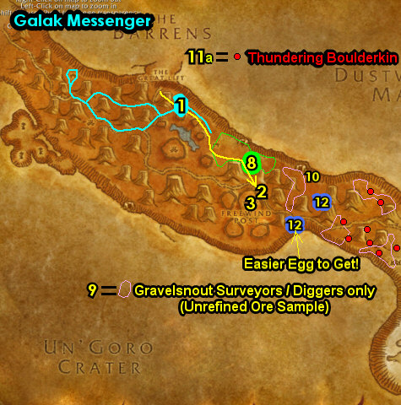

01) At Freewind Post, next to the Bonfire turn in "Pacify the Centaur" (46.51, #3 on map), accept "Grimtotem Spying".
02) West in Freewind Post turn in "Alien Egg" 45.50. Accept "Serpent Wild".
03) Hearth to Camp Taurajo.
04) Turn in (if you did it) "A New Ore Sample" (north in CT at the Forge, 45.58 in The Barrens).
05) Turn in "Enraged Thunder Lizards" (accept "Cry of the Thunderhawk"), (if you have it) "Washte Pawne" and (if you did it) "The Harvester" 45.59.
06) Go just south of CT around 45.64 and do "Cry of the Thunderhawk": kill/loot a Thunderhawk /target. 6 spawns around CT (see map). Drop rate is 100%.
07) Go back to CT and turn in "Cry of the Thunderhawk" (45.59, #5 on map), SKIP "Mahren Skyseer".
08) Go to the Wind Rider Master at CT 44.59 and fly to Crossroads, The Barrens.
10) Go north and turn in "Report to Kadrak" (up in the watchtower 48.5), SKIP "The Warsong Reports".
#13
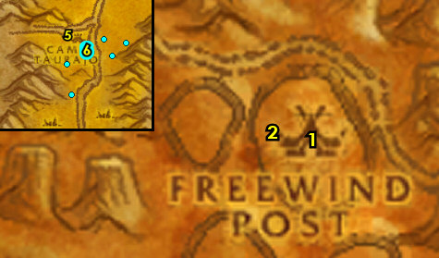

26-27 Ashenvale (log)
01) Go to Splintertree Post and turn in (if you have the initial quest) "The Ashenvale Hunt" 74.61. Then accept and turn it in again.
02) Get the Flight Path there from the Wind Rider Master 73.62.
04) You can get repaired/resupplied from Burkrum 74.60 next to the Inn.
05) Next to the Inn, accept "Stonetalon Standstill" 74.60.
06) Go in the Inn and make Splintertree Post your new home from the Innkeeper 74.61.
TBC, 6b) At the outskirts of Splintertree Post, turn in (if you have it) "Report to Splintertree Post" 71.68.
07) Accept "Ashenvale Outrunners" 71.68.
08) Just south of Splintertree Post, kill the first of the three mobs related to the Ashenvale hunt: Sharptalon /target. This lvl 31 blue hippogryph (patrols around and spawns at around 75.70). This mob drops an item, which starts "Sharptalon's Claw", accept it. TIP: An easy way to kill this mob is to bring his health to a 3rd left, then drag him into the guards at Splintertree Post, they will finish em.
09) Just south of Splintertree Post, do "Ashenvale Outrunners": kill 9 Ashenvale Outrunners /target.
10) Go slightly west and do the escort quest "Torek's Assault" (starts at 68.75): escort Torek /target & his raiders west into the Silverwing Outpost.
11) Go west to Mystral Lake and do "Stonetalon Standstill": kill 12 Befouled Water Elementals around the lake and discover the gazebo on the small island in the middle of the lake 49.70. Also, make sure you find and kill/loot Tideress /target, this water elemental patrols around under the lake, he drops an item which starts "The Befouled Element", accept it.
12) Kill the next mob related to the Ashenvale Hunt: Ursangous /target, this bear patrols clockwise around the mountain and trees around 42.68. He drops an item, which starts "Ursangous's Paw", accept it.
13) Kill the last mob related to the Ashenvale Hunt: Shadumbra /target, this black panther patrols around around 57.56. This cat drops an item, which starts "Shadumbra's Head", accept it.
14) Do "The Sacred Flame". First kill/loot the Laughing Sisters around Raynewood Retreat around 59.55 until you get an Etched Phial (low drop rate), then see next step...
15) Use the quest item Etched Phial at the Moonwell down south 60.73.
#15
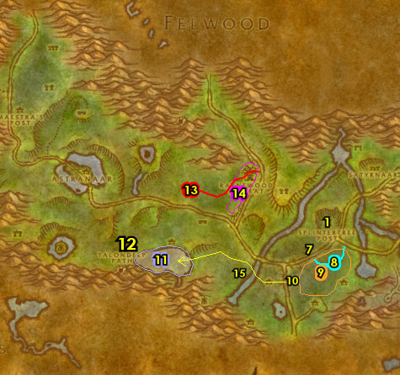

01) Hearth (or run back) to Splintertree Post.
02) Right outside the Inn on your left turn in the 3 Ashenvale Hunt quests: "Sharptalon's Claw", "Ursangous's Paw" and "Shadumbra's Head" 74.61. Then accept and complete "The Hunt Completed".
03) Next to the Inn, turn in "Stonetalon Standstill" and "The Befouled Element" 74.60, accept "Je'neu of the Earthen Ring". Make sure you are repaired/resupplied.
04) At the orc next to the western watchtower, turn in "Torek's Assault" 73.62.
05) At the outskirts of Splintertree Post, turn in "Ashenvale Outrunners" 71.68.
06) The goal now is to go all the way to the other side of Ashenvale, to Zoram Strand (follow path on map) and then get the Flight Path there from the Wind Rider Master 12.34. NOTE: Once you get to Astranaar 37.55(alliance town), go south of it to get around it.
07) At Zoram 'gar Outpost, first accept "Vorsha the Lasher" (starts in front of the bigger tent 12.35) (IMPORTANT: This starts an escort. If he is not there you can try later in the guide. Do the next few steps quickly in the village before following Muglash for the escort:
08) turn in "Je'neu of the Earthen Ring" 12.34 (up in hut). Also turn in "Trouble in the Deeps" 12.34, SKIP "The Essence of Aku'Mai" (Blackfathom Deeps dungeon).
09) From the troll up in the other tent, accept "Troll Charm" 12.35. From the female troll next to you, accept "Naga at the Zoram Strand" 12.35 (no exclamation mark).
10) From the orc next to the Cauldron accept "Between a Rock and a Thistlefur" 12.35.
11) Do the escort you previously accepted (if you were able to) "Vorsha the Lasher": follow and protect Muglash /target until you can click on the Naga Brazier, then after a few waves of Naga mobs, kill Vorsha the Lasher. (See Video). Do this along with "Naga at the Zoram Strand" by kill/looting Naga along the coast.
12) Grind your way to the Thistlefur Hold cave (entrance is 39.31) killing mobs for "Between a Rock and a Thistlefur". Also, before getting to the cave, make sure Rorgish Jowl /target is dead. He is a rare mob that patrols around (before the cave entrance) making your future escort quest difficult. He has a 5.5 hour respawn.
13) In the cave do "Troll Charm": loot the Troll Chests on the ground. Then, in the back of the cave, from the white bear in the cage 42.35, accept and try to do the escort quest "Freedom to Ruul". You may have to fight 3-5 mobs at once several times, if you fail then it can be skipped.
#16
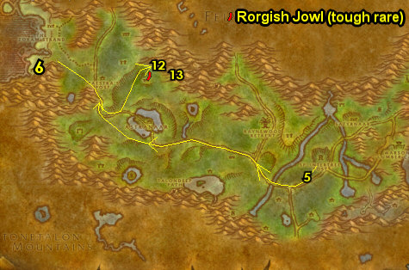

01) Make sure "Between a Rock and a Thistlefur" is finished, then go back to Zoram Strand and then make sure "Naga at the Zoram Strand" is finished by kill/looting naga along the coast, then turn in "Vorsha the Lasher" 12.34. NOTE: If you didn't do "Vorsha the Lasher" previously you can try now.
(click to show instructions):
02) At the orc next to the Cauldron, turn in "Between a Rock and a Thistlefur" 12.35.
03) Up in the tent, turn in "Troll Charm" 12.35. From the female troll next to you, turn in "Naga at the Zoram Strand" 12.35.
04) Hearth to Splintertree Post.
05) In the Inn, turn in (if you did it) "Freedom to Ruul" 74.61. Make sure you are repaired/resupplied.
TBC, 5a) If you are level 27 go north in Splintertree Post and accept "Destroy the Legion" 73.60 (if not we will get this in a bit).
07) N/A
TBC, 7a) If you have not accepted "Destroy the Legion" 73.60 at Splintertree Post, then go there to accept it (requires level 27).
TBC, 7b) Go SE to Felfire Hill around 80.68 and do "Destroy the Legion": kill the required amount of demons. While doing this quest you may find an item (low drop rate) which starts "Diabolical Plans", accept it (if you can). If you can't find it then skip it.
08) N/A
TBC, 8a) Run back to Splintertree Post (don't hearth) and turn in "Destroy the Legion" (73.60, #5 on map). If you found an item that started "Diabolical Plans", then turn that in as well.
TBC, 8b) OPTIONAL: If you were able to turn in "Diabolical Plans" then you could accept and do "Never Again!" (especially if you want one of the quest rewards) by going SE to Demon Fall Canyon (entrance 84.73) and killing the two named mobs. Gorgannon patrols around 89.77, and Diathorus the Seeker is in the cave (entrance at 78.82), and he's far back in it at 79.85. Cave exit is at 77.83. Then turn the quest in at 73.61.
10) at the Wind Rider Master 73.62, fly to Thunder Bluff, Mulgore.
#17
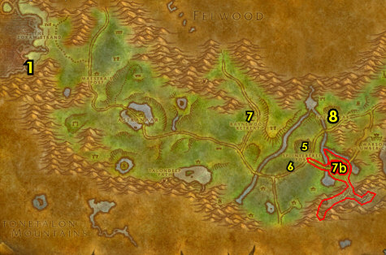

27-28 Stonetalon Mountains (log)
01) NOTE: SoM (100% quest rate) will NOT do steps 1-7 in Stonetalon!
08) East at the Bonfire, turn in "The Sacred Flame" (55.51 in TB), accept the next part.
GET NEW ABILITIES, 8b) Get your level 28 spells/abilities.
09) Go to TB's Inn and make Thunder Bluff your new home from the Innkeeper 46.65.
OPTIONAL, 9b) If you have an open 2nd profession and have not got Herbalism yet then I recommend getting it (its only 10 copper) at 50.40. This can help you track an item pickup for a later quest.
10) If you still need to upgrade to Heavy Wool Bandage (requires First Aid skill 115), then go to the top of The Spirit Rise to the First Aid Trainer 30.21 to get that.
11) Go to the Wind Rider Master at the top of the tower in the middle of TB 47.50 and fly to Freewind Post, Thousand Needles.
#18
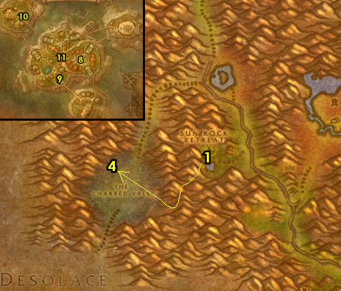

28-29 Thousand Needles (log)
01) In the Inn, turn in "The Sacred Flame" (46.52 in Thousand Needles), accept the next part. Make sure you are repaired/resupplied.
02) Take the Lift down from Freewind Post and then go to the cave north (entrance is at 44.38) and do "The Sacred Flame": keep hugging the left side of the cave until you get to the Ancient Brazier 42.31, then loot it (See Video).
03) REMINDER: Keep an eye out for the Galak Messenger /target and kill/loot this centaur when you see him in 1k Needles. He has a very large patrol path. He drops an item which starts "Assassination Plot", accept it (if you can). But, don't intentionally do this yet, continue on with the next step...
04) Grind west to Whitereach Post 21.32 and turn in "Serpent Wild", accept "Sacred Fire". And next to you, accept "Hypercapacitor Gizmo". Also turn in "A Different Approach", accept "A Dip in the Moonwell". NOTES: If you have already killed Galak Messenger /target and accepted the quest from the item he dropped, then turn in "Assassination Plot", then accept, do & turn in the follow up escort quest. You can also get resupplied here from Laer Stepperunner /target.
05) Go east to the Boiling Pool around 35.35 and do "Sacred Fire": loot 10 Incendia Agave from the ground and under the water. TIP: Use Find Herbs in Spellbook (if you have it) to help you locate these easier.
06) Go west and do "Steelsnap": kill/loot Steelsnap /target. This hyena patrols counter-clockwise around a somewhat large circle (starting at 18.27) and has two bodyguards. Original spawn is in Camp E-thok 17.19. (See Video)
07) If you are still working on "A New Ore Sample", then see if you can find the Ore Sample: kill/loot the Gravelsnout Surveyors /target (there are two spawns nearby to check) for the Unrefined Ore Sample (see map for locations).
TBC, 7a) Go west and enter the bottom mountain ramp entrance 12.19, then do "A Dip in the Moonwell": use your quest item Robotron Control Unit at the Concealed Control Panel 9.19 at the bottom of the mesa. Then control your robot to the Alliance moonwell 90.46 close by and use its collect water ability in it. NOTE: Classes that use pets must dismiss them first in order for this to work right.
08) Go to the Highperch (ramp entrance 14.33) and do "Wind Rider": loot 10 Highperch Wyvern Eggs from the ground.
09) In Highperch, go up the mountain ramp 13.40. Once up there watch out for Heartrazor /target (a patrolling rare elite with a 12 hour respawn) and then accept and do the escort quest there "Homeward Bound" 18.41. You can have the escort try to help you kill the rare elite. It's also possible to time it so you can start and complete the escort so the rare is out of the way (just as he passes from the escortee). If you fail, then this escort can be skipped.
10) Once again, if you are still working on "A New Ore Sample": kill/loot the Gravelsnout Surveyors /target (there are two spawns nearby to check) for the Unrefined Ore Sample (see map for locations, #7 on map).
#19
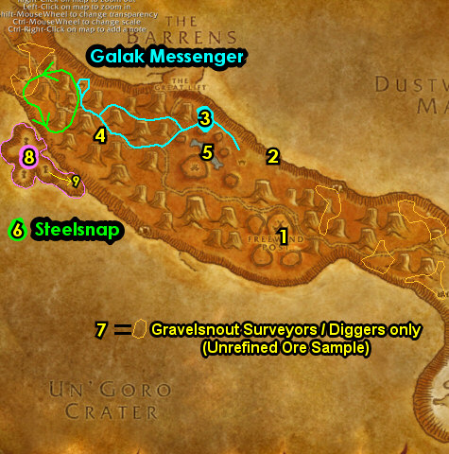

Thunder Bluff (log)
01) Hearth to Thunder Bluff.
02) Go to The Hunter Rise and turn in "Steelsnap" 62.81. Accept "Frostmaw".
03) Go to The Elder Rise and turn in "Sacred Fire" 70.31. Accept "Arikara".
04) Go to the Wind Rider Master at the top of the tower in the middle of TB 47.50 and fly to Freewind Post, Thousand Needles.
05) Right when you land back at Freewind Post, turn in "Wind Rider" (45.49 in Thousand Needles).
06) Go in the Inn 46.52 and make Freewind Post your new home.
07) Next to you in the Inn, turn in "The Sacred Flame" 46.52. Make sure you are repaired/resupplied.
#20
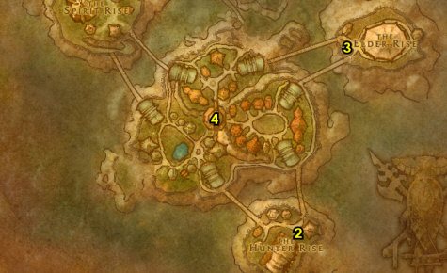

01) Go up the mountain ramp (starting at 32.37) that allows you to enter Darkcloud Pinnacle at the top...
02) Once you get to the top do "Grimtotem Spying": loot the three Document Chests for the secret notes. For Secret Note #1, cross the bridges up in Darkcloud Pinnacle until you get to the Document Chest 32.33 and loot it. For the other two, see next steps...
03) Secret Note #2 is in the hut 34.40.
04) Secret Note #3 is in the hut 39.42.
05) Go over to the other pinnacle (up at 38.35) and do "Arikara": click on the Sacred Fire of Life in the middle of the pinnacle, then kill/loot Arikara (lvl 28).
06) Stay up and go north (to 38.27) then do "Wanted - Arnak Grimtotem": kill/loot Arnak Grimtotem /target.
07) Do the escort "Free at Last" (same area 38.26, #6 on map): escort Lakota Windsong /target all the way out of Darkcloud Pinnacle.
08) Go to Whitereach Post 21.32 and turn in "Homeward Bound" and "Arikara".
TBC, 8a) Next to you turn in "A Dip in the Moonwell" 21.33, accept "Testing the Tonic". You can also get resupplied here from Laer Stepperunner /target.
09) You should be level 29 by now, if not grind to level 29, I grind away at centaurs around Camp E'Thok 19.25 or wyverns at Highperch (entrance is 13.34).
10) Do "Hypercapacitor Gizmo" (Elite): clear the mobs around the Panther Cage 23.25, open the cage and kill/loot the lvl 30 elite panther.
11) This is your last chance to kill/loot the centaur Galak Messenger /target. He has a very large patrol path (see map). He drops an item which starts "Assassination Plot", accept it. If you can't find him in time, then skip it along with the follow up quest.
12) Go to Whitereach Post (21.33, #8 on map) and turn in "Hypercapacitor Gizmo". Also turn in (if you did it) "Assassination Plot", then accept and do the short escort "Protect Kanati Greycloud", then turn it in.
#21
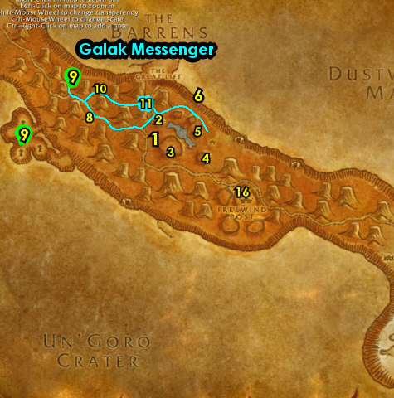

01) Hearth to Freewind Post.
02) In the Inn, turn in (if you did it) "Free at Last" 46.52.
TBC, 2a) Just outside the Inn on your right turn in "Testing the Tonic"46.50.
03) By the Bonfire turn in "Grimtotem Spying" and "Wanted - Arnak Grimtotem" 46.51.
03b) At this point make sure you are level 30 (or 2000 away from 30 if you can turn in "A New Ore Sample" at the next step). Just grind on any mobs in 1kNeedles until you are there.
04) Go to the Wind Rider Master (north in Freewind Post 45.49) and if you have "A New Ore Sample" finished fly to Camp Taurajo, The Barrens to turn it in 45.58. Then, (or otherwise) fly to Orgrimmar, Durotar.
05) Once at Orgrimmar, go get new spells/abilities.
06) Go in the Inn and make Orgrimmar your new home from the Innkeeper 54.68.
07) Go to the Bank 50.70 and put the following item into it: Kodo Skin Scroll. And get out (if you have it) Swim Speed Potions, you can get these from the AH as well.
08) The goal now is to go all the way to Hillsbrad Foothills. To get there, first leave Orgrimmar at the south entrance, then get on The Undercity Zeppelin (51.14 in Durotar). Make sure you get on the Undercity Zeppelin (south landing) and not the STV zeppelin (north landing)! You can save some time by jumping off the zeppelin at a certain timing so you won't die and continue south onto the path!
#23
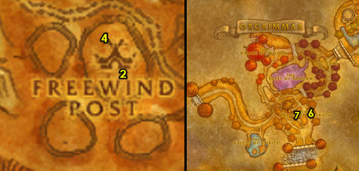

30-30 Hillsbrad Foothills (log)
01) Run all the way to Tarren Mill in Hillsbrad Foothills and get the FP there from the Bat Handler (60.19 in Hillsbrad). ALSO: You can just bypass the UC for now (no need to get UC's FP yet) and just follow the path shown on the map to get to Hillsbrad. NOTES: If you can, use a Swim Speed Potion to cross the lake. Once you reach Alterac Mountains you can start grinding on some mobs along the way to Tarren Mill. TIP: Focus on killing some Snapjaw turtles along the shore and save the Turtle Meat for a later quest, I recommend obtaining at least 4 Turtle Meat before moving on (you can get more later on), and remember to not sell them to a vendor!
Remember to get the FP at Tarren Mill from the Bat Handler (60.19 in Hillsbrad)!
06) In the church building, accept "Regthar Deathgate" 63.21.
07) Go east into Arathi Highlands... entrance 63.21
#24
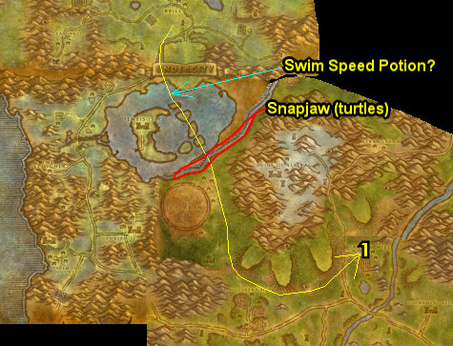
30-30 Arathi Highlands (log)
First Pick the Class you are playing top left of screen!!!
Along with the Game Version you are playing on (Era, SoM, TBC or WotLK)
01) Follow the path all the way to Hammerfall and accept "Hammerfall" (down by the Forge, 73.34 in Arathi Highlands). Then get repaired/resupplied next to you 73.33.
02) SE at Hammerfall, turn in "Hammerfall" 75.36, accept "Raising Spirits".
03) Go up the steps and get the FP from the Wind Rider Master 73.33.
04) Just to the west of Hammerfall around 70.35, do "Raising Spirits": kill/loot Highland Striders (raptors). 23% drop rate.
05) Go back to Hammerfall (at Tor'gan, #2 on map) and turn in "Raising Spirits" 75.36, accept the next part.
06) Down in Hammerfall, turn in "Raising Spirits" (73.34, #1 on map), accept the next part.
07) Go back to Tor'gan and turn in "Raising Spirits" (75.36, #2 on map), SKIP "Guile of the Raptor" (for now).
08) Hearth to Orgrimmar.
10) At Orgrimmar, get your level 30 spells/abilities if you haven't yet.
11) Leave Orgrimmar at the south entrance, then get on the Zeppelin (51.13 in Durotar) to go to Grom'Gol (in STV).
13) Get the FP SE at Grom'Gol from the Wind Rider Master 33.29 . NOTE: For SoM/WotLK 100% quest rate, we come here only to get the FP, and we will be skipping all Nesingwary hunting quests.
#01
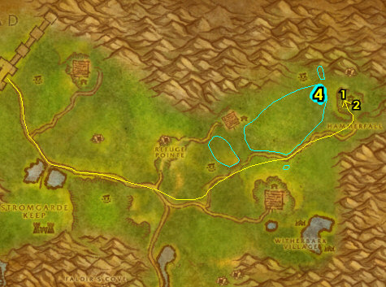

01) Hearth to Orgrimmar. If hearthstone is still on a cooldown, then get back on the zeppelin to take you to Orgrimmar.
02) Go up to the Wind Rider Master 45.64 and fly to Crossroads, The Barrens.
03) Go west in the XRs and accept "The Swarm Grows" 51.30.
04) Go west from the XRs to the orc up in the burrow and turn in "Regthar Deathgate" 45.28, accept "The Kolkar of Desolace".
05) Run back to the Wind Rider Master at XRs 52.30 and fly to Freewind Post, Thousand Needles.
06) At Freewind Post, IF you are level 32, accept "Family Tree" by the Bonfire 46.51.
#03
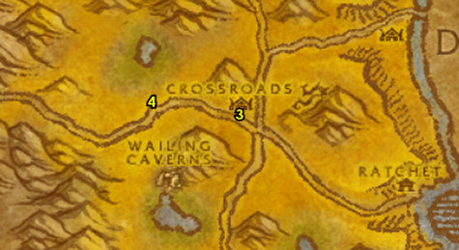

31-32 Thousand Needles (Shimmering Flats)
01) Go SE to the Mirage Raceway in the middle of The Shimmering Flats and from the dwarf, accept "Rocket Car Parts" 78.77. Next to you at the two gnomes 78.77, accept "Salt Flat Venom" and "Hardened Shells". NOTE: SKIP "Wharfmaster Dizzywig" and "Hemet Nesingwary Jr." (for now).
02) East at the Goblin's side of Mirage Raceway accept "Load Lightening" 80.76.
03) SE in Mirage Raceway by the starting line accept "A Bump in the Road" 82.78.
04) Do The Shimmering Flats grind. Do the following 5 steps below (in any order) all together around The Shimmering Flats:
05) "Rocket Car Parts": pick up 30 Rocket Car Rubble from the ground.
06) "Hardened Shells": kill/loot turtles all over The Shimmering Flats. ALSO: If you have not completed the Turtle Meat turn in quest at Tarren Mill in Hillsbrad yet, then make sure you save 10 Turtle Meat for later (do not sell to vender). You can get the Turtle Meat from any turtle at The Shimmering Flats and there is a large amount up north around 83.55.
07) "Load Lightening": kill/loot vultures (Salt Flats Scavengers & Salt Flats Vultures). Large amount around 88.66.
08) "Salt Flat Venom": kill/loot scorpids (Scorpid Reavers & Scorpid Terrors). Large amount around 72.73.
09) "A Bump in the Road": kill basilisks. Saltstone Basilisks are NW, Saltstone Crystalhides are everywhere but NW, and the Saltstone Gazers are south at Tahonda Ruins around 77.86.
10) Once all done, go back to Mirage Raceway (at the gnomes section) and from the dwarf (78.77, #1 on map) turn in "Rocket Car Parts". Accept "Wharfmaster Dizzywig" and "Hemet Nesingwary Jr.". Then next to you 78.77, turn in "Salt Flat Venom" and "Hardened Shells". Accept "Encrusted Tail Fins".
11) East at the goblin section of the Mirage Raceway turn in "Load Lightening" (80.76, #2 on map), accept "Goblin Sponsorship".
12) SE in Mirage Raceway by the starting line turn in "A Bump in the Road" (82.78, #3 on map).
13) Make sure you are level 32 (grind on any mobs until you are).
14) Go south to the path that leads into Tanaris (starting at 74.94)...
15) Follow the path south to Gadgetzan and get the FP there from the Wind Rider Master (52.25 in Tanaris).
16) If you have not accepted "Family Tree" from Freewind Post yet (requires lvl 32), then fly to Freewind Post, Thousand Needles and accept this by the Bonfire.
17) Hearth to Orgrimmar. Make sure you are repaired/resupplied.
#04
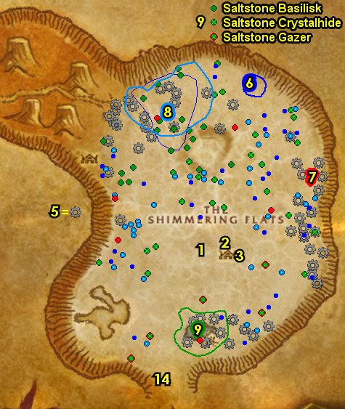

Orgrimmar (log)
01) Go to the Bank 50.69 and put the following items into it: Kravel's Parts Order, Kravel's Crate and (if you are still on the turtle meat quest) your stack of Turtle Meat. Also get the following items out: (if you have any) water breathing potions and Swim Speed Potions (for the Desolace section), try to get a stack of each if you can (you can try the AH too). Also, make sure you save all your extra Cloths in either your bank or mailbox 51.70, you will need them later for Cloth Donation turn-ins. If you happen to have 60 (or 120) Wool Cloth (get that out now).
02) Go NE to Magar's Cloth Goods and (if you have the 60 Wool Cloth) accept and turn in the wool cloth donation quest from Rashona Straglash 64.51. NOTE: We will save the Silk Cloth to build up First Aid first before the silk donations.
03) Go to the Valley of Honor and turn in "The Swarm Grows" 75.34, accept the next part.
04) Get your level 32 spells/abilities.
05) Go down to the Cleft of Shadow (entrance at 55.41) and accept "Alliance Relations". The NPC patrols around in the Cleft of Shadow.
06) If you have 60 more Wool Cloth you can turn this in for more Wool Cloth Donations from the Troll Faction at 38.88.
07) If you haven't got Silk Bandage for First Aid yet, do that now at the First Aid Trainer 34.85 at the Valley of Spirits.
08) West in Orgrimmar, turn in "Alliance Relations" (in the hut 23.53), accept the next part.
09) Stay up and go over to the Wind Rider Master 45.64 and fly to Sun Rock Retreat, Stonetalon Mountains.
10) Go to the path SW in Sun Rock Retreat 45.62 to go to the Charred Vale, then run south into Desolace (entrance 30.78)...
#05
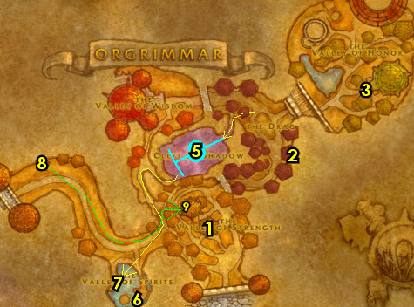

32-34 Desolace (log)
01) N/A
02) N/A
03) Go to Ghost Walker Post (entrance at 57.57)...
04) Make a left at the main entrance, then turn in "The Kolkar of Desolace" 56.60. Accept "Khan Dez'hepah".
05) Just north a bit at the hut get repaired/resupplied and turn in "Family Tree" 55.56. Then go across the bridge in Ghost Walker Post and turn in "Alliance Relations" 53.54. Accept the next part. Also accept (from the same NPC) "Befouled by Satyr".
06) Next to you, turn in "Alliance Relations" 52.53, accept "The Burning of Spirits".
07) Go east to the Kolkar Village and do "Khan Dez'hepah": kill/loot Khan Dez'hepah /target. This big bearded centaur is usually in the bigger tent 73.42, but can sometimes be found in other areas around the Kolkar Village as well, so you may need to grind around the village to find him.
#06
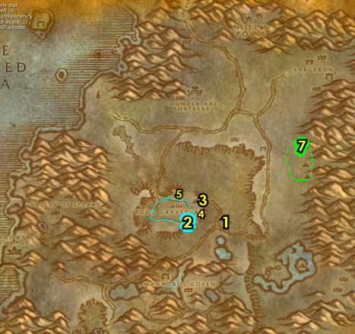

01) N/A
02) N/A
03) Go to Ghost Walker Post, make a left at the entrance (56.57, #3 on map) and then turn in "Khan Dez'hepah" 56.60. SKIP "Centaur Bounty".
04) N/A
05) Continue following the main path west to Shadowprey Village and accept "Hunting in Stranglethorn" 25.72.
06) Go up in the village and accept "Hand of Iruxos" (on top of the mound next to the gong 26.68).
07) Go in the Inn 24.68 and make Shadowprey Village your new home from the Innkeeper. Make sure you are repaired/resupplied. If you still have "A New Ore Sample" in your log, abandon it.
#07
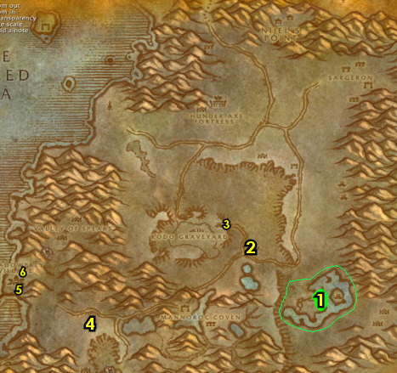

01) Go down to the docks and accept "Other Fish to Fry" 23.73.
02) Next to you in the hut, accept "Clam Bait" 23.72.
03) N/A
04) Make sure you are resupplied from Lah'Mawhani 23.72 up in the hut. Then swim north up the water (use Swim Speed Potions if you have them) and work your way to the wrecked boat at the shore and from Rackmore's Log 36.30 sitting on the barrel, accept "Claim Rackmore's Treasure!".
05) Go up to The Argent Dawn dude and accept "Sceptre of Light" 39.27.
06) Go east to the Thunder Axe Fortress (entrance at 56.29) and do "The Burning of Spirits": use the Burning Gem quest item on the mobs at the fortress right before they die to collect the Infused Burning Gems. While working on this, do the following 2 steps below as well:
07) Do "Sceptre of Light": as you enter Thunder Axe Fortress, make a left, go up the watchtower (ramp entrance at 55.30) and kill/loot the Burning Blade Seer.
08) GROUP 2+ Players: Go in the fortress entrance 55.27 and do "Hand of Iruxos": click on the Hand of Iruxos Crystal 55.27 in the middle and then kill/loot the Demon Spirit that spawns. Be prepared to kill the lvl 37 demon! (See Video).
#08
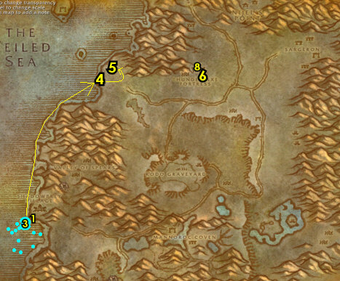

01) Before leaving the Thunder Axe Fortress, make sure you have found an item called Flayed Demon Skin (2% drop rate), which starts "The Corrupter".
02) Go to Ghost Walker Post (shortcut at 56.54)...
03) N/A
04) Then go across the bridge in Ghost Walker Post 52.53 and turn in "The Burning of Spirits" and "The Corrupter", accept the next part.
05) Go NE to Sargeron around 74.22 and do "Befouled by Satyr" along with "The Corrupter": kill the required amount of Hatefury Satyrs: Rogue Felsworn Betrayer Hellcaller . And kill/loot the Hatefury Shadowstalkers /target until a Shadowstalker Scalp drops.
06) Go SW to Kormek's Hut and accept "Bone Collector" 62.39. Requires lvl 33. If you are not 33, ignore this step and you will be able to accept this later in the guide. NOTE: You can get resupplied from Vendor-Tron 1000 /target if he is there.
07) Go to Ghost Walker Post (shortcut at 56.54, #2 on map), then go across the bridge and turn in "Befouled by Satyr" (53.54, #4 on map), accept "Alliance Relations".
08) Next to you, turn in "The Corrupter" 52.53, accept the next part. Make sure you are resupplied 51.53.
#09
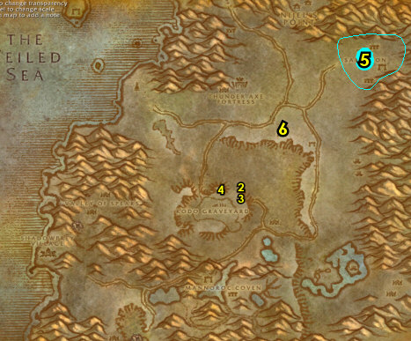

01) Go NW up to The Argent Dawn dude and turn in "Sceptre of Light" 39.27, accept "Book of the Ancients".
02) Go to where the boat is under the water around 34.32 and do the first part of "Claim Rackmore's Treasure!": kill/loot the Drysnap mobs for the Silver Key (15% drop rate). Also start working on "Clam Bait" by kill/looting crabs and looting Giant Softshell Clams. Use a water breathing potion if you have one. As you do the following steps, you should find the Golden Key from any Slitherblade mob...
03) Do "Book of the Ancients": grind your way to the NW end of the bigger island and click on the Serpent Statue 28.7, then kill/loot Lord Kragaru when he spawns. (See Video)
04) Do the last part of "Claim Rackmore's Treasure!": Once you find the Golden Key from any Slitherblade mob, click on Rackmore's Chest 30.9 on the bigger island to turn this in.
05) Do "The Corrupter": kill/loot the Slitherblade Oracles /target in the water and on the 2 bigger islands until you get the Oracle Crystal (low drop rate). Use a water breathing potion if you have one.
06) Finish up "Other Fish to Fry": kill the needed Slitherblade mobs. The Myrmidon are scattered between the two biggest islands, the Naga are more towards the shore around 36.24 and there are only a few Sorceresses scattered everywhere.
07) Make sure "Clam Bait" is finished: collect Soft-shelled Clam Meat from Enraged Reef Crawlers (crabs) or from the Giant Softshell Clams under the water (around #2 on map around 36.24 and slightly north of it as well).
08) Go up to The Argent Dawn dude and turn in "Book of the Ancients" (39.27, #1 on map).
09) If you have not accepted "Bone Collector" yet, do so now at Kormek's Hut 62.39.
10) Go to Ghost Walker Post (shortcut at 56.54)....
11) Make sure you are repaired/resupplied 56.56, then go across the bridge and turn in "The Corrupter" 52.53. Wait a few seconds, then accept the next part.
12) Next to you, turn in "The Corrupter" 53.54, SKIP the next part (for now).
#10
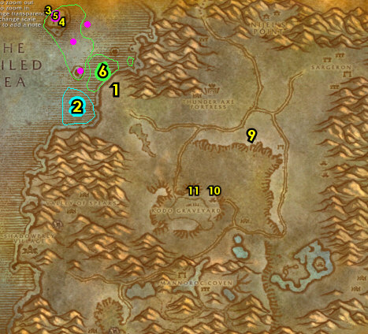

01) At the Kodo Graveyard next to you around 53.57, do "Bone Collector": loot the Kodo Bones on the ground. NOTE: Looting some of these bones spawns a high lvl Kodo Apparition.
02) N/A
03) Go to Ghost Walker Post, entrance 57.57...
04) N/A
05) Stop at the hut just north to get repaired/resupplied from Muuran 56.57.
06) Grind your way NE to Kormek's Hut and turn in "Bone Collector" 62.39.
07) Hearth to Shadowprey Village.
08) Just outside of the Inn, and up on the mound, turn in (if you have it) "Hand of Iruxos" 26.68, SKIP "Portals of the Legion" (for now).
09) N/A
10) Go back west to Shadowprey Village and down at the docks turn in "Other Fish to Fry" 23.73 and next to you at the hut "Clam Bait" 23.72.
11) Go to the Wind Rider Master 22.74 at the end of the docks at Shadowprey Village and fly to Camp Taurajo, The Barrens.
#11
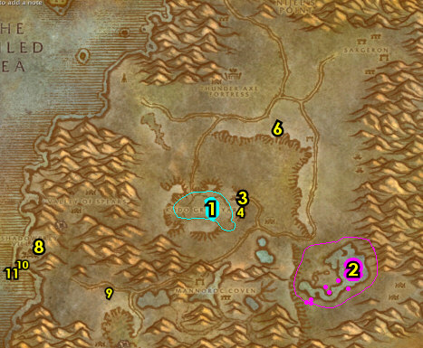

01) Once at CT, run SE into Dustwallow Marsh ( 51.79 in The Barrens) and collect the 3 quest-objects at the Shady Rest Inn (See Video): "Suspicious Hoofprints" (on the ground in front of the old Inn 51.79), "Lieutenant Paval Reethe" (a small white dot on a plank 30.48) and "The Black Shield" (on the fireplace 30.49).
02) Go NE to Brackenwall Village 36.32 and turn in "The Black Shield" (accept the next part), "Suspicious Hoofprints" and "Lieutenant Paval Reethe".
03) Next to you from Do'gol, turn in "The Black Shield" 37.31, SKIP the next part (for now).
05) Go to the Wind Rider Master 36.32 and fly to Ratchet, The Barrens.
06) Go to Gazlowe in the engineering building and turn in "Goblin Sponsorship" (63.36 in The Barrens), accept the next part.
07) Go to the Bank 63.37 and get the following items out: Kravel's Parts Order, Kravel's Crate and Silk Cloth (to build up First Aid). Put in the bank: Belgrom's Sealed Note.
08) Go to the goblin on the docks and turn in "Wharfmaster Dizzywig" 63.38, accept "Parts for Kravel".
09) Get on the boat to go to BB (Booty Bay) 64.39. While waiting for the boat, build up First Aid.
#12
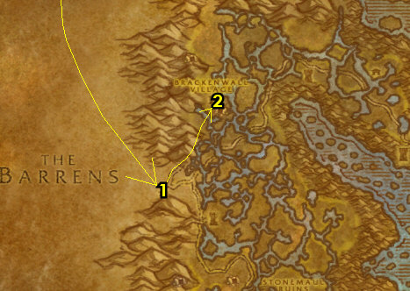

34-36 Stranglethorn Vale (log)
01) As soon as you get off the boat, turn in "Goblin Sponsorship" 26.74, accept the next part.
02) Go in the Inn (The Salty Sailor Tavern) and make BB your home from the Innkeeper 27.77. Next to you in the Inn, accept "Singing Blue Shards".
03) Go upstairs in the Inn and accept "Bloodscalp Ears", "Hostile Takeover" and "Investigate the Camp".
04) Stay up on the top of the docks and go over past the Alliance FP to Tan-Your-Hide Leatherworks and accept "Supply and Demand" 28.78.
05) Go back over to the top of the Inn and then go up the steps to Baron Revilgaz 27.77 on the boat-deck and turn in "Goblin Sponsorship", accept the next part.
06) Next to you on the roof, go to the Wind Rider Master 27.77 and fly to Grom'gol, Stranglethorn.
07) In Grom'gol accept the following: "The Defense of Grom'gol" 32.29, "Mok'thardin's Enchantment" 32.29, "Bloodscalp Insight" (next to Bonfire 32.29), "Hunt for Yenniku" 32.28,"Bloody Bone Necklaces"and "The Vile Reef". Make sure you are repaired/resupplied.
08) REMINDER: The "The Green Hills of Stranglethorn" quest requires that you save any Green Hills of Stranglethorn pages you find. These pages can drop from any humanoid mob in STV. You will need one of each of the following pages: 1, 4, 6, 8, 10, 11, 14, 16, 18, 20, 21, 24, 25, 26, and 27. I recommend mailing them to your alt for storage. Once your alt collects all the pages, mail them back to your main. You can also find these pages in the AH or from other players. You don't need to accept the quest to get the page drops, so accept and turn this in at Nesingwary's Expedition 36.11 if you get all the pages. You will return to STV numerous times in the future for more chances to find the pages.
#13
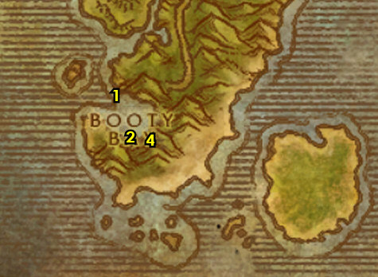

01) Go to the ledges along the shore around 27.19 and start working on "Singing Blue Shards": kill/loot Crystal Spine Basilisks. 80% drop rate. There's only 9 mob spawns in the area. If you run out of mobs, you can start working on the next step(s) then come back to this spot. You will also have more opportunities later in the guide to complete this.
02) Go south at Bal'lal Ruins, just off the shore around 29.20 and do "Bloodscalp Ears" along with "Hunt for Yenniku", "Bloodscalp Insight" and start working on "Bloody Bone Necklaces": kill/loot the trolls at the ruins. Kill/loot Bloodscalp Shamans for the totem. There is another Ruins up NE around 34.16 for more mobs. NOTE: "Bloody Bone Necklaces" does not need to be finished now.
03) N/A
04) Go south (just north of Grom'gol, around 32.23) and do "The Defense of Grom'gol": kill Lashtail Raptors.
05) Go to Grom'gol and turn in "Hunt for Yenniku" 32.28, accept "Headhunting".
TBC, 5a) Next to the Bonfire turn in "Bloodscalp Insight" 32.29, accept "An Unusual Patron".
06) Turn in "The Defense of Grom'gol" 32.29, accept the next part.
07) Make sure you are repaired/resupplied 32.29. REMINDER: Once you turn lvl 35, start using the higher tier food/drink.
08) Go NW under the water at The Vile Reef and do "The Vile Reef" along with "Encrusted Tail Fins": loot the Gri'lek the Wanderer tablet 25.23. Also kill/loot the murlocs. Use Swim Speed Potions and an Elixer of Water Breathing (unless you are Undead) if you can.
09) Go west to the The Savage Coast island and at the Altar of Naias 20.23 do "An Unusual Patron": use the quest item Gift of Naias then kill/loot Naias (water elemental) when he spawns.
#14
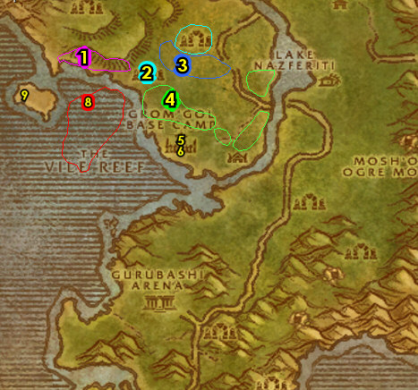

01) Go up north to the troll Ruins around 20.14 and do "Headhunting" along with finishing up "Bloody Bone Necklaces": kill/loot the trolls around the Ruins for the necklaces (low drop rate). And kill/loot the Bloodscalp Headhunters for the Shrunken Heads. You can kill lower level trolls for the necklaces down south at the two ruins (between step #3 on map).
02) Go to Nesingwary's Expedition 36.11 and turn in "Hemet Nesingwary Jr.", "Hunting in Stranglethorn" Get repaired/resupplied from Jaquilina Dramet.
03) N/A
05) At the river east around 34.9 of you do "Supply and Demand": kill/loot River Crocolisk. And continue working on (if you still need to) "Singing Blue Shards" by kill/looting Stone Maw Basilisk around the north end of the river. Work your way to the next step:
06) Go SE across the river to the Venture Co. Operations Center and do "Hostile Takeover": kill/loot the Venture Co. Geologist /target scattered around the Operations for the 8 crystals. Also do the first part of "Goblin Sponsorship": work your way to the top of the Operations Center entrance 42.18 and then kill/loot Foreman Cozzle (in the control room, 43.18). See next step for where to use Cozzle's Key at...
07) Do the last part of "Goblin Sponsorship": loot Cozzle's Footlocker (in the small house 43.20). NOTE: Your key will disappear as soon as you click the chest, so make sure you have room in your bags for the Blueprints.
08) Go east and do "Mok'thardin's Enchantment": kill/loot Shadowmaw Panthers /target around 49.23. Also kill/loot Stranglethorn Tigress around the same area for the fang.
09) Finish (if you still need to) "Singing Blue Shards": kill/loot Crystal Spine Basilisks just NE around the mountain ledges around 48.8.
10) Go west across the river to Mizjah Ruins around 37.31 and do "The Defense of Grom'gol": kill the required amount of Mosh'Ogg ogres.
12) Hearth to BB.
#15
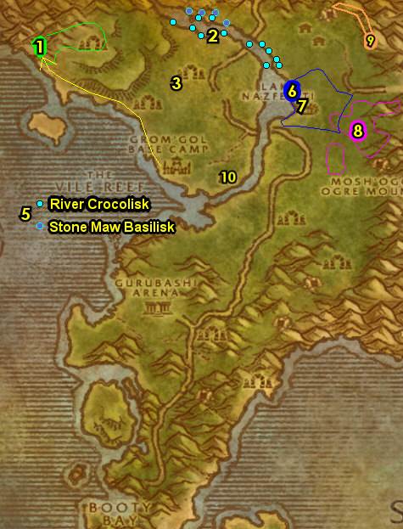

01) In the Inn, turn in "Singing Blue Shards" 27.77, SKIP "Venture Company Mining" (for now).
02) Go upstairs in the Inn and turn in "Bloodscalp Ears", "Hostile Takeover" and "Investigate the Camp".
03) Stay up on the top of the docks and go over past the Alliance FP to Tan-Your-Hide Leatherworks and turn in "Supply and Demand" 28.78. Accept "Some Assembly Required".
04) Go back over to the top of the Inn and then go up the steps to Baron Revilgaz 27.77 on the boat-deck and turn in "Goblin Sponsorship", accept the next part.
05) Next to you on the roof, go to the Wind Rider Master 27.77 and fly to Grom'gol, Stranglethorn.
06) Turn in ALL quests in Grom'gol: "The Defense of Grom'gol", "Mok'thardin's Enchantment" (SKIP the next part for now), "An Unusual Patron", "Headhunting", "Bloody Bone Necklaces" and "The Vile Reef". Accept "Trollbane".
07) You should be level 36 now, if not grind to it.
08) Get on the zeppelin to go to the The Undercity (up in the Inn, 32.29). Build up First Aid while waiting.
10) Go to the Bank in the middle of UC 66.44 and get out the following items: (if you have any) Elixir of Water Breathing potions. If you were able to get an Elixir of Water Breathing, also get out (if you have any) a stack of Swim Speed Potions, and (if you are still on the turtle meat quest) your stack of Turtle Meat . Also put in the bank: 10 stack of Encrusted Tail Fin, Fuel Regulator Blueprints and Kravel's Parts.
11) Go up and accept "To Steal From Thieves" 64.49.
12) Next to you at the Bat Handler 63.49, fly to Tarren Mill, Hillsbrad.
13) Once at Tarren Mill, accept "The Hammer May Fall" (from Tallow 62.20).
14) If you have not finished the Turtle Meat turn-in yet, do so now... Go in the Inn (bigger house 62.19). From Christoph Jeffcoat, accept "Soothing Turtle Bisque" (requires the cooking profession to accept). From this NPC, buy a Soothing Spices. Then wWith your Turtle Meat you farmed earlier, simply turn in the quest right there.
15) Go to the Bat Handler 60.19 and fly to Hammerfall, Arathi.
#16
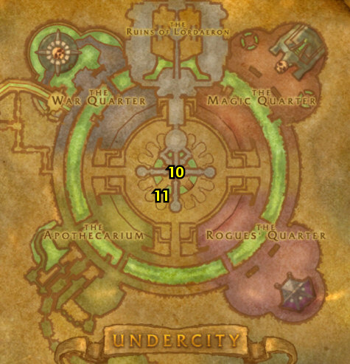

36-37 Arathi Highlands (log)
01) Go in the Inn and make Hammerfall your new home from the Innkeeper 74.32. Make sure you are repaired/resupplied.
02) On the balcony next to you, turn in "Trollbane" 74.34, accept "Sigil of Strom".
03) Go down to Tor'gan 75.36 and accept "Foul Magics" and "Guile of the Raptor".
04) Go west and click on the Shards of Myzrael 62.34 to accept "The Princess Trapped".
05) Go east of Hammerfall and do "The Princess Trapped": kill/loot the Drywhisker kobolds, in and outside of the cave (entrance at 83.36). TIPS: Look for the tree and rock 81.40, it shows you where the hidden path is to the cave. If you have mining, then mine as many Lesser Bloodstone Deposits as you can. These are used for an Alliance quest only at STV and sell good in the neutral AH.
06) Once done, go to the Iridescent Shards (at the end of the cave 84.31) and turn in "The Princess Trapped", accept "Stones of Binding".
07) If you have 225 First Aid now, then go to Hammerfall and in the building accept and do "Triage" 73.37: use the Triage Bandage quest item right there in the room on the wounded soldiers (See Video). Once done, turn it in. You can also destroy the Triage Bandage in your inventory as it is no longer needed. If you were not able to do this quest yet, you will be farming more cloth in Arathi to try again later. NOTE: In WotLK, this doctor no longer advances your First Aid, you now just do that at any First Aid trainer.
08) Go up the steps in Hammerfall and make sure you are repaired/resupplied. Then take the north exit 73.30 and go west to the Circle of East Binding and do part of "Stones of Binding": loot the Stone of East Binding 67.30 for the Cresting Key.
09) Go west to Dabyrie's Farmstead and do "To Steal From Thieves": kill/loot the 3 named mobs. Kill/loot Kenata Dabyrie /target (up in the small house 56.36). See next steps for the other 2...
10) Kill/loot Fardel Dabyrie /target (standing outside next to the barn 57.39, or in front of the stables 54.38)...
11) Kill/loot Marcel Dabyrie /target (in the stables 54.38).
#17
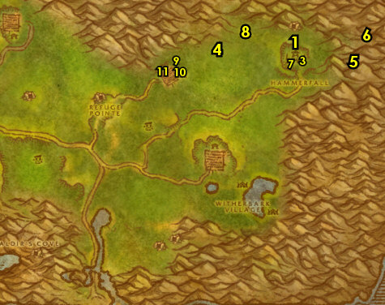

01) Go south a bit and do part of "Stones of Binding": loot the Stone of Outer Binding 52.51 for the Thundering Key.
02) Go south and do "Guile of the Raptor": kill/loot Highland Fleshstalkers around 50.64.
03) Go NW to Boulder'gor and do "The Hammer May Fall": kill the Boulderfist Ogres (outside of the mine) and the Boulderfist Enforcers (inside of the mine 35.44).
04) Go north to Northfold Manor around 32.28 and do "Foul Magics": kill/loot the Syndicate mobs. Any of them can drop the amulets.
05) Go west and do the last part of "Stones of Binding": loot the Stone of West Binding 25.30 for the Burning Key.
07) Do "Sigil of Strom": at the east side in Stromgarde Keep around 28.61 kill/loot the Syndicate Prowlers, Conjurors and Magus for the Sigil of Strom.
08) Go slightly east and click on the Stone of Inner Binding to turn in "Stones of Binding" 36.57, accept "Breaking the Keystone".
#18
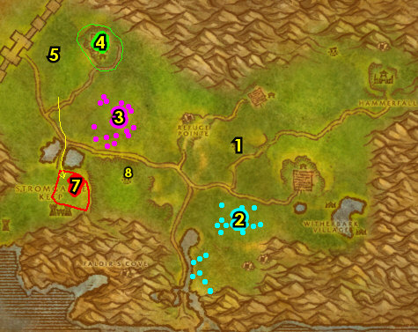

01) Hearth to Hammerfall.
02) On the balcony just outside the Inn, turn in "Sigil of Strom" 74.34, SKIP "The Broken Sigil" (for now).
03) Next to you on the balcony turn in "The Hammer May Fall" 74.34, accept "Call to Arms".
04) Go SE in Hammerfall at Tor'gan 75.36 and turn in "Foul Magics" and "Guile of the Raptor" (accept the next part).
05) Go down in Hammerfall and turn in "Guile of the Raptor" 73.34. Wait a few seconds then accept the next part. Make sure you are repaired/resupplied by the Forge.
06) Go back up to Tor'gan (75.36, #4 on map) and turn in "Guile of the Raptor", SKIP "Foul Magics".
07) Grind south to Witherbark Village around 67.63 and do "Call to Arms": kill the required amount of Witherbark trolls around the village.
08) Grind back north to Hammerfall and up the steps turn in "Call to Arms" 74.34, accept the next part. Make sure you are repaired/resupplied.
09) While doing the rest of Arathi quests, if you happen to run across the lvl 42 Giant named Fozruk /target, you can kill/loot him for "Breaking the Keystone". This giant has a large patrol path (see map). Don't intentionally try to find him. If you did kill/loot him, then turn this in (at 36.58) and accept the next part. NOTE: The follow up quests are worth doing as they are easy to solo, but are not covered in the guide.
10) Grind SW to Boulderfist Hall around 54.73 and do "Call to Arms": kill the required amount of Boulderfist ogres. If you still need to do "Triage", then make sure you get your First Aid skill to 225 before proceeding.
11) Hearth (or grind back 74.34 if its still on a cooldown) to Hammerfall. Make sure you are repaired/resupplied.
12) On the deck turn in "Call to Arms" 74.34.
13) NOTE: due to the faster leveling changes, we will be skipping the Stromguard quests ("Call to Arms", "The Broken Sigil", "The Real Threat" and "Foul Magics").
14) If you have not done the First Aid quest "Triage" yet, do so now:
(click to show instructions):
15) Go up to the Wind Rider Master 73.33 and fly to Tarren Mill, Hillsbrad. If "Breaking the Keystone" is still in your quest book, abandon it.
#20
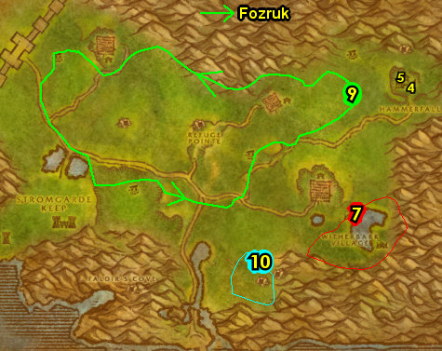

37-37 Alterac Mountains (log)
01) Once at TM, go in the small house 62.21 and accept "Prison Break In" & "Stone Tokens".
TBC, 1a) At the church entrance accept "The Crown of Will" 63.21.
02) Go north to the small cave (38.66 in Alterac Mountains) and on the way kill/loot a cat for a Fresh Carcass.
03) At the small cave do "Frostmaw": use the Fresh Carcass quest item at the Flame of Uzel (38.66, #2 on map), then kill/loot Frostmaw /target when he spawns. This yeti spawns just outside of the cave. (See Video)
TBC, 3a) Go up north (take hill entrance at 39.62) to Ruins of Alterac and do "The Crown of Will": kill 10 Crushridge Maulers /target around 41.49.
04) Go west (take hill exit at 38.61) to Lordamere Internment Camp and do "Stone Tokens" along with "Prison Break In": kill/loot the Dalaran humans for the tokens and kill/loot the 4 named mobs. First one is Ricter 20.84 outside in front of the outhouses. See next steps for the others...
05) Kill/loot Alina and Dermot inside the building 20.86 next to the outhouses.
06) Kill/loot Kegan Darkmar upstairs in the other building 18.83. NOTE: There are more Dalaran mobs to kill for the tokens at Dalaran (just outside of the big purple globe).
07) N/A
08) Run back to Tarren Mill and in the small house 62.21, turn in "Prison Break In" and "Stone Tokens", accept "Dalaran Patrols" and "Bracers of Binding". Make sure you are repaired/resupplied.
TBC, 8a) At the church entrance turn in "The Crown of Will" 63.21 , SKIP the next part.
09) Go north into Alterac Mountains (follow path on map) and do "Bracers of Binding" along with "Dalaran Patrols": kill 4 Dalaran Summoners and kill/loot the Elemental Slaves. Done around the purple Dalaran globe (around 19.76 in Alterac Mountains).
10) Once done, go back to Tarren Mill. Make sure you are repaired/resupplied.
11) In the small house, turn in "Dalaran Patrols" and "Bracers of Binding" (62.21, #8 on map).
12) Go to the Bat Handler 60.19 and fly to Undercity, Tirisfal.
#21
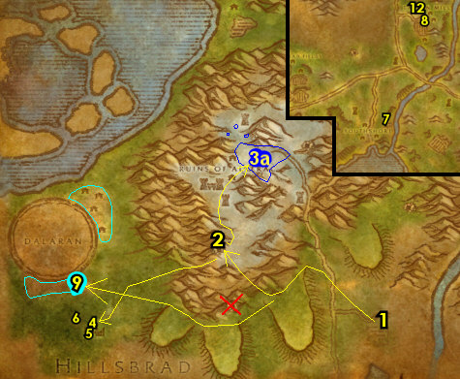

01) Right where you land at the UC, turn in "To Steal From Thieves" 64.49.
02) Go to the Bank (in the middle of UC, 66.44) and get the following items out: 10 stack of Encrusted Tail Fin, Belgrom's Sealed Note, Fuel Regulator Blueprints and Kravel's Parts. Also get out (if you have it) 60 Wool Cloth and then 60 Silk Cloth for cloth donations in Orgrimmar. Put in the bank: any Swim Speed Potions.
03) Leave the UC and get on a zeppelin to go to Orgrimmar (61.59 in Tirisfal Glades).
04) Go west in Orgrimmar (take the ramp at 42.62)...
05) Go SW to Valley of Spirits in Darkbriar Lodge and (if you have them) turn in 60 Wool Cloth and then 60 Silk Cloth for cloth donations from Vehena 38.88 for the Troll faction.
WOTLK, 5b) You can stop at the First Aid Trainer 34.85 to upgrade First Aid.
06) Continue west to Keldran in the hut and turn in "Alliance Relations" 23.53.
07) Stay up and go over to the Wind Rider Master 45.64 and fly to Crossroads, The Barrens.
08) Go in XR's Inn 52.30 and make it your new home.
09) Go to the Wind Rider Master 52.30 and fly to Freewind Post, Thousand Needles.
#22
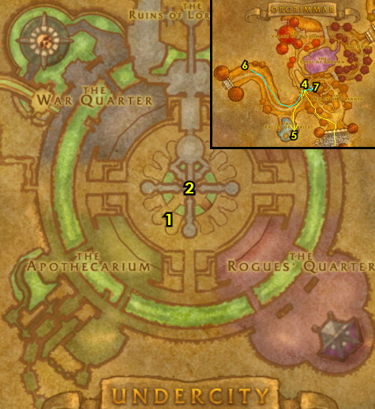

37-38 Thousand Needles (Shimmering Flats) (log)
01) Make sure you are repaired/resupplied.
02) Run east towards Ironstone Camp (right next to Shimmering Flats) and turn in "The Swarm Grows" 68.64, accept the next part.
03) Go to the west side of Mirage Raceway and at the dwarf 78.77, turn in "Parts for Kravel". Wait a few seconds, then accept "Delivery to the Gnomes".
04) Next to you, turn in "Delivery to the Gnomes" 78.77. Accept "Martek the Exiled". Also turn in "Encrusted Tail Fins".
05) Back at the dwarf next to you accept "The Rumormonger" (78.77, #3 on map).
06) Go east to the Goblin's side and turn in "Goblin Sponsorship" 80.76, accept "The Eighteenth Pilot".
07) Next to you, turn in "The Eighteenth Pilot" 80.76, accept "Razzeric's Tweaking".
08) Go SW to The Rustmaul Dig Site and do "The Swarm Grows": kill the required amount of Silithid bugs. There is only a few Invaders in the cave entrance 66.86 so go for these guys first. The Searchers are up and around the Dig Site. Within the first few mobs you kill, you should receive an item which starts "Parts of the Swarm", accept it and start doing it in the same area by kill/looting the Silithid mobs, and the items you need can drop from any of them.
09) Make sure you are at least 2 bars away from level 38. Grind on the bugs until you are.
10) Go north to Ironstone Camp and turn in "The Swarm Grows" (68.64, #2 on map).
#23
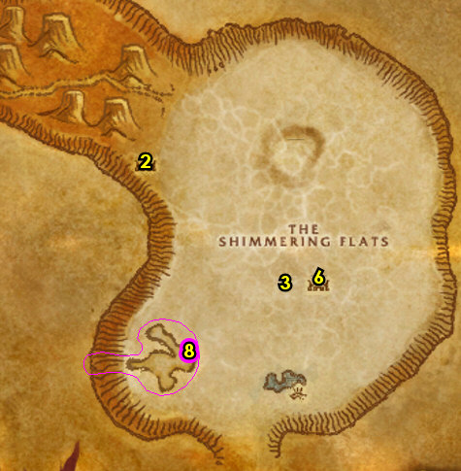

01) Hearth to XRs.
02) Go west in the XRs and turn in "Parts of the Swarm" 51.30, accept the next part. NOTE: If the Cracked Silithid Carapace remains in your bags, destroy it.
03) Go to the Wind Rider Master 52.30 and fly to Thunder Bluff, Mulgore.
04) N/A
05) Go to The Hunter Rise and turn in "Frostmaw" 62.81. Accept "Deadmire".
GET NEW ABILITIES, 5b) You should be level 38 now. Get new spells/abilities for your class.
06) Go to the Bank 47.59 and put the following item into it: Fizzle Brassbolts' Letter.
07) Go up to the Wind Rider Master in the middle of TB 47.50 and fly to Brackenwall Village, Dustwallow Marsh.
#24
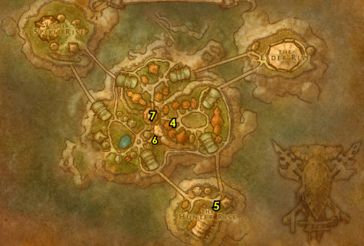
38-38 Dustwallow Marsh (log)
01) West at Brackenwall Village, from Nazeer Bloodpike 35.31, accept "Theramore Spies" and "Check Up on Tabetha".
02) From the male blood elf accept "Twilight of the Dawn Runner" 36.32.
03) From Do'gol (ogre), accept "The Black Shield" 37.31. Make sure you are repaired/resupplied.
04) Go to the Innkeeper (blue ogre at small cave entrance 37.32) to make Brackenwall Village your new home.
05) In the small cave accept "The Hermit of Witch Hill" 37.33.
06) Go slightly south of Brackenwall Village and accept "Hungry!" (from the ogre at 35.38).
07) Start working on "Theramore Spies" along with "The Black Shield": kill Theramore Infiltrators /target and kill/loot any type of spiders. Grind your way to the next step...
Stinky, 7b) See if you can do the escort "Stinky's Escape" 47.18 (#16 on map): escort "Stinky" Ignatz. NOTE: If he is not there, then skip this for now. You will have more opportunities to try again later.
08) Go east to North Point Tower (entrance at 47.24) and do "Twilight of the Dawn Runner": at the bottom of the tower talk to Ithania /target to free her, then go to the top of the tower to loot the Warped Crates.
09) Go east to Jarl's cabin 55.26 and turn in "The Hermit of Witch Hill", accept "Marsh Frog Legs". Next to you at the cabin accept "What's Haunting Witch Hill?" (this NPC is either in the cabin or on the dock).
10) Right next to Jarl's cabin, click on the Loose Dirt 55.26 to accept "The Lost Report".
11) All around Jarl's Cabin do "Marsh Frog Legs" along with "What's Haunting Witch Hill?": kill/loot Giant Marsh Frogs (frog critters /target). And kill the undead mobs (Risen Spirits and Risen Husks).
12) Back at Jarl's cabin 55.26 (#9 on map) turn in "Marsh Frog Legs", accept "Jarl Needs Eyes". Next to you at the cabin turn in "What's Haunting Witch Hill?", accept "The Witch's Bane".
13) All around Jarl's cabin start working on "The Witch's Bane" by looting witchbane (plants, mostly around #11 on map), that you see along the way:
14) Go NE to the shore around 57.17 and do "Hungry!": kill/loot the Mirefin (murlocs).
15) Exit at 58.19.
16) If you have not done the escort "Stinky's Escape" 47.18: escort "Stinky" Ignatz and grind mobs during the escort. NOTE: If he is not there, then skip this for now. You will have one more opportunity to try this again later.
17) All around Jarl's cabin finish "The Witch's Bane": loot 9 witchbane (plants, mostly around #11 on map).
18) Back at Jarl's cabin turn in "The Witch's Bane" 56.26 (#9 on map), accept "Cleansing Witch Hill".
19) Do "Cleansing Witch Hill": at the end of the dock there at Jarl's cabin 55.27 use the Witchbane Torch quest item then kill Zelfrax (gargoyle) when he spawns.
20) Back at Jarl's cabin turn in "Cleansing Witch Hill" 56.26 (#9 on map).
21) Finish up "Theramore Spies": kill 9 Theramore Infiltrators /target just NE of Brackenwall Villagearound 42.26 (#7 on map).
22) Go west to Darkmist Cavern around 35.22 and do "Jarl Needs Eyes": kill/loot the Darkmist spiders for 20 eyes. Also make sure "The Black Shield" is finished by kill/looting any spiders.
23) Go to the west side in Brackenwall Village 35.31 (#1 on map) and turn in "Theramore Spies", accept "The Theramore Docks". And turn in "The Lost Report".
24) From the male blood elf turn in "Twilight of the Dawn Runner" 36.32 .
25) Turn in "The Black Shield" 37.31, accept the next part.
26) At Krog, turn in "The Black Shield" 36.32. Make sure you are repaired/resupplied.
27) Go just south of Brackenwall Village at the ogre and turn in "Hungry!" 35.38 (#6 on map).
28) Go SE to the ogre (41.37 /target) on the path and accept and do the escort "Questioning Reethe": follow Ogron, then kill the mobs that spawn in next to Paval Reethe.
#27
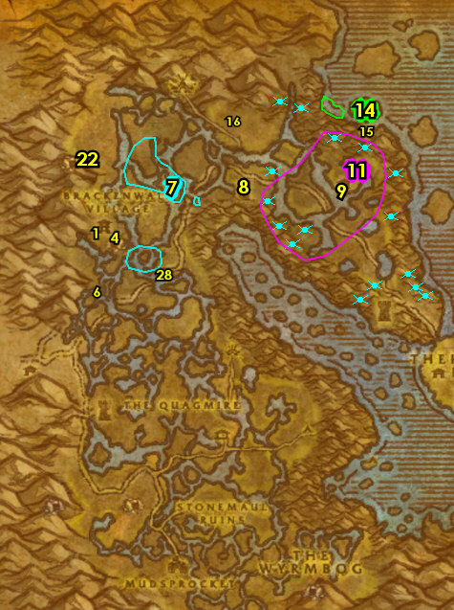
01) Head SE to Tabetha's Farm and inside the cabin turn in "Check Up on Tabetha" 46.57. Accept "Help for Mudsprocket". And next to you accept "The Grimtotem Weapon" and "The Reagent Thief".
02) Just outside at the side of the cabin 46.57 accept "Direhorn Raiders" and "The Zeppelin Crash".
03) Go east to Beezil's Wreck 54.57 and turn in "The Zeppelin Crash". Accept "Corrosion Prevention" and "Secure the Cargo!".
04) At Beezil's Wreck do "Razzeric's Tweaking": loot the Gizmorium Shipping Crate (box at 54.56).
05) Around the immediate area do "Corrosion Prevention" along with "Secure the Cargo!": stand near a Power Core Fragment to obtain a buff, then use the Ooze Buster quest item on oozes. NOTE: You don't actually need to attack the oozes. And loot 8 Zeppelin Cargo (boxes laying around).
06) Back at Beezil's Wreck 54.57 (#4 on map) turn in "Corrosion Prevention" along with "Secure the Cargo!", accept "Delivery for Drazzit".
07) Go NW to Direhorn Post and in the NE tent kill/loot Apothecary Cylla 47.47, she drops an item which starts "Signs of Treachery", accept it.
08) In the immediate area around Direhorn Post do "Direhorn Raiders": kill 12 Grimtotems (taurens of any type).
09) Around The Quagmire around 43.49 do the next 3 quests together:
10) "The Reagent Thief": kill/loot Noxious Shredders (green serpents) or Darkfang Creepers (orange spiders). These are around #1 on map.
11) "The Grimtotem Weapon": use the Captured Totem quest item at the Mottled Drywallow Crocolisk or a Drywallow Daggermaw, then kill them. NOTE: The crocs must be pulsed by the totem on death to get credit.
12) "Deadmire": kill/loot Deadmire /target. This white crocolisk patrols around, mostly around the eastern part of #11 on map around 48.56.
13) Back at Tabetha's Farm and inside the cabin 46.57 (#2 on map) turn in "The Grimtotem Weapon" and "The Reagent Thief".
14) Just outside at the side of the cabin 46.57 turn in "Direhorn Raiders".
#28
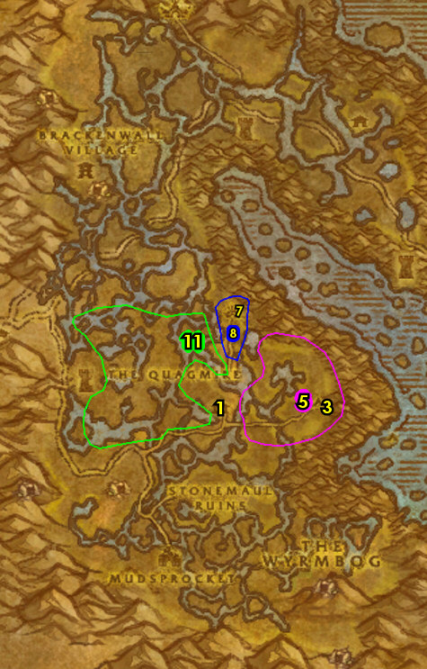
01) Go SW to Mudsprocket (neutral goblin town specific to TBC) and in the hut 42.73 turn in "Delivery for Drazzit" and "Help for Mudsprocket".
02) At the NE outskirts of town, go to the Flight Master 43.72 and fly to Brackenwall Village, Dustwallow Marsh. NOTE: We will do the Mudsprocket quests when we return back to Dustwallow Marsh at level 43.
03) At Krog, turn in "Questioning Reethe" 36.32. Accept "The Black Shield".
04) If you have not done the escort "Stinky's Escape" 47.18: escort "Stinky" Ignatz. NOTE: If he is not there, then this will have to be skipped.
05) Go east to Jarl's cabin 55.26 and turn in "Jarl Needs Eyes", accept "Jarl Needs a Blade".
06) Right next to Jarl's cabin, click on the Loose Dirt to accept "The Severed Head" 55.26.
07) Just NE at Witch Hill do "Jarl Needs a Blade": kill/loot Razorspine patrols around 58.19. Spawns at 58.18.
08) Back at Jarl's cabin turn in "Jarl Needs a Blade" 55.26 (#5 on map).
09) Go all the way behind the Alliance town (Theramore Isle) and do "The Theramore Docks": loot Captain's Footlocker (under the water 72.51). NOTE: Do not go through the town, just go around the side of the town and into the water. (See Video)
10) Hearth to Brackenwall Village.
11) West in Brackenwall Village 35.31, turn in "The Theramore Docks", "The Severed Head" (accept "The Troll Witchdoctor") and "Signs of Treachery".
12) Go to the Wind Rider Master 36.32 /target and fly to Thunder Bluff, Mulgore.
#29
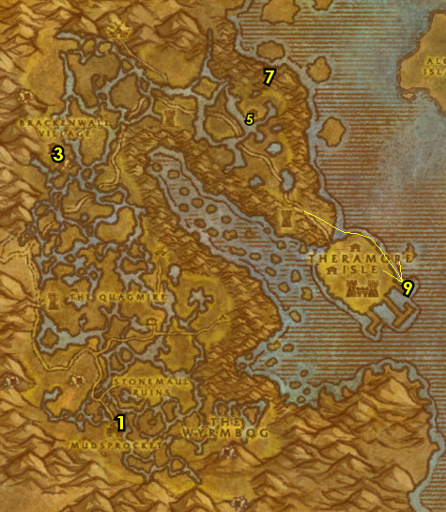
01) CLOTH DONATIONS? If you happen to have 60 Wool Cloth, then 60 Silk Cloth and then 60 Mageweave Cloth, get those out (for cloth donations in a bit). Bank 47.59.
02) Go to the NW hut on The Hunter Rise and turn in "The Black Shield" 54.81, accept "Return to Krog".
03) Also on the Hunter Rise, turn in "Deadmire" 62.81.
05) If you have either 60 Wool Cloth, 60 Silk Cloth or 60 Mageweave Cloth go turn them in up in the hut from Rumstag Proudstrider 43.43 (Tauren faction cloth donations).
06) Go to the top of the tower to the Wind Rider Master 47.50 and fly to Ratchet, The Barrens.
07) At Ratchet next to the bank, turn in "Stinky's Escape" 62.38.
08) At the Bank 63.37, get the following items out: (if you have any) Swim Speed Potions and any Elixer of Water Breathing potions. Put into the Bank: Seaforium Booster.
09) Get on the boat 64.39 to go to BB...
#30
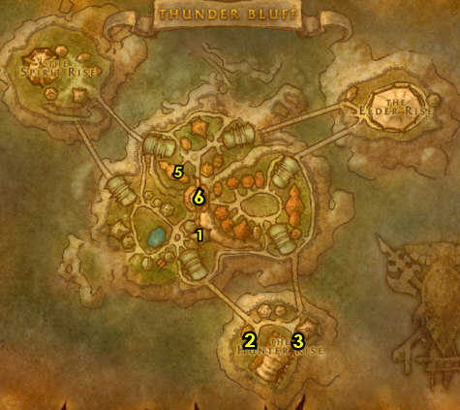
38-40 Stranglethorn Vale (log)
01) Once at BB, follow the lower docks and then accept "The Bloodsail Buccaneers" 28.76.
02) Go in the small cabin (next to the hanging shark) and accept "Scaring Shaky" 28.77.
03) Go in the Inn and make BB your new home 27.77.
04) Go up the stairs in the Inn and turn in "The Rumormonger", accept "Dream Dust in the Swamp".
06) Next to you on the roof, go to the Wind Rider Master 27.77 and fly to Grom'gol, Stranglethorn.
07) At Grom'gol, accept "Mok'thardin's Enchantment" 32.29.
08) By the Cauldron, turn in "The Troll Witchdoctor" 32.28.
09) Make sure you are repaired/resupplied.
10) Go south around 31.42 and do "Mok'thardin's Enchantment": kill/loot Jungle Stalkers.
11) Make sure you are at least a half a bar away from level 39 (keep grinding on Jungle Stalkers & Cold Eye Basilisks until you are).
12) Then go back to Grom'gol and turn in "Mok'thardin's Enchantment" (32.29, #7 on map), accept the next part. Make sure you are repaired/resupplied.
13) N/A
15) Go east to the river around 39.29 and do "Some Assembly Required": kill/loot Snapjaw Crocolisks /target along the river.
16) N/A
17) N/A
18) Hearth to BB. Make sure you are repaired/resupplied.
#31
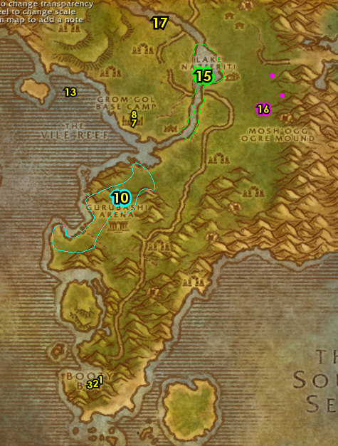

01) Go just slightly NW of BB and clear the Bloodsail (humans) from the area, then click on the Bloodsail Correspondence scroll (on the barrel 27.70) to turn in "The Bloodsail Buccaneers", accept the next part. (See Video)
02) Go NE to Mistvale Valley around 32.67 and do "Scaring Shaky" along with "Mok'thardin's Enchantment": kill/loot the Elder Mistvale Gorillas. Very low drop rate for the Aged Gorilla Sinew (but keep grinding until you get it).
03) Run back SW to BB and near the boat pickup turn in "Scaring Shaky" 27.74, accept "Return to MacKinley".
04) On the lower docks, turn in "The Bloodsail Buccaneers" 28.76, accept the next part.
05) Go in the cabin (next to the hanging shark) and turn in "Return to MacKinley" 28.77, SKIP "Voodoo Dues" (for now).
06) Go all the way upstairs in the Inn then go over past the Alliance FP to Tan-Your-Hide Leatherworks and turn in "Some Assembly Required" 28.78, accept "Excelsior".
07) Go back to the top of the Inn (on the boat-deck) and turn in "The Bloodsail Buccaneers" 27.77, SKIP the next part (for now).
08) Next to you on the roof, go to the Wind Rider Master 27.77 and fly to Grom'gol, Stranglethorn.
09) At Grom'gol, turn in "Mok'thardin's Enchantment" 32.29, accept the next part.
10) By the Bubbling Cauldron, accept "Split Bone Necklace" 32.28.
11) Go in the Inn and make Grom'gol your new home 31.30. Make sure you are repaired/resupplied.
12) You should be a little over half way to level 40. Now I grind the rest of the way to 40 on Jungle Thunderers around 42.27 or the Venture Co. Geologists around 45.21. These mobs have less armor and die faster. Instead of the grinding, you could get a 5 man group to do the Scarlet Monastery dungeon.
13) Once you are level 40, hearth to Grom'gol.
#32
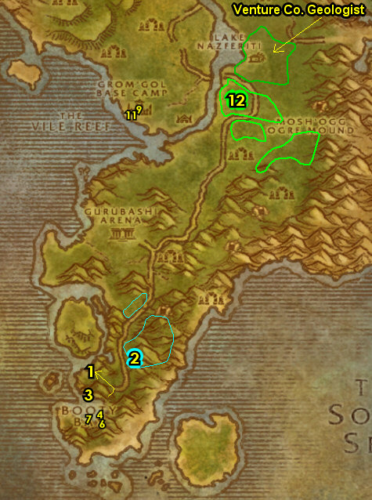
01) At the top of Grom'gol's Inn, get on the zeppelin to go to the UC 32.29.
02) At UC's Bank 66.44, Mailbox 68.38 or AH get the following items out: Fizzle Brassbolts' Letter, (if you can) stack of 9 Blue Pearls, (if you have them) Frost Oil, Gyrochronatom, stack of Elixir of Water Breathing + Swim Speed Potions. And if you have Healing Potion, Lesser Invisibility Potion and a Patterned Bronze Bracers get those out as well. These items are used for easy turn-in quests in the Badlands. And remember to not sell these items to a vendor. Put in the bank: any Split Bone Necklaces you may have.
03) EPIC MOUNT: At level 40 epic ground mounts become available, and only cost about 12 gold. For more info go here.
04) Go to the Bat Handler (63.49 in the UC) and fly to Hammerfall, Arathi.
#33
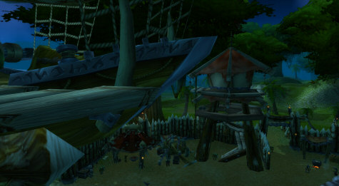
Badlands Run Map:
02) N/A
03) Run all the way to the Badlands entrance 49.8. See map for directions depending on where you are coming from.
#36
How to run to the Badlands from Arathi Highlands:
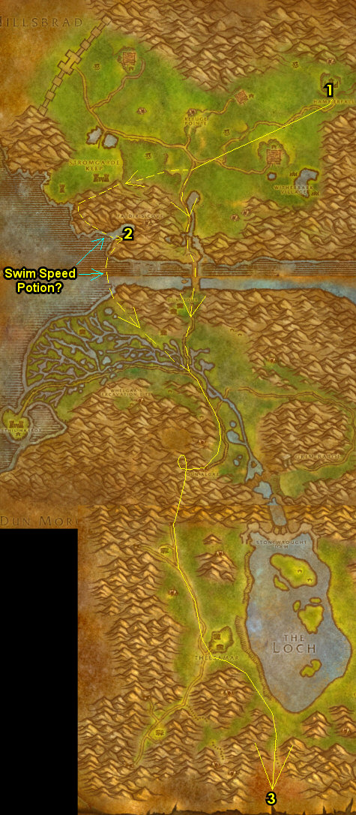
40-41 Badlands (log)
First Pick the Class you are playing top left of screen!!!
Along with the Game Version you are playing on (Era, SoM, TBC or WotLK)
01) As you enter Badlands, grind your way SW to Valley of Fangs and turn in "Martek the Exiled" 42.53, accept "Indurium". Next to you, accept "Barbecued Buzzard Wings". And if you have 9 Blue Pearls with you, accept and turn in "Pearl Diving".
02) Go south a bit around 52.66 and do "Indurium": kill/loot the Stonevault troggs.
03) Go back north to Valley of Fangs and turn in "Indurium" (42.53, #1 on map). Wait a few seconds then accept "News for Fizzle".
04) Go NW to The Dustbowl, and at the gnome 26.45, accept "Study of the Elements: Rock". If you have a Frost Oil item, accept and complete the quest "Coolant Heads Prevail". Then if you have a Gyrochronatom item, accept and complete the quest "Gyro... What?".
05) Grind west to Kargath and get the FP there from the Wind Rider Master 4.45. NOTE: Keep your Hearthstone set to Grom'gol!
TBC, 5a) At the watchtower entrance accept "Unclaimed Baggage" 6.48.
06) Go up the watchtower and accept "Coyote Thieves" and "Report to Helgrum" 6.47.
07) Go in the Inn 3.46 and accept "Broken Alliances" and (upstairs) "Badlands Reagent Run". Make sure you are repaired/resupplied.
08) Do "Study of the Elements: Rock" kill/loot Lesser Rock Elementals up north on the cliffs around 17.43.
09) Go to The Dustbowl at the gnome (26.45, #4 on map) and turn in "Study of the Elements: Rock", accept the next part.
10) Grind your way south and do "Study of the Elements: Rock": kill/loot Rock Elementals around 38.74.
11) Grind your way north to The Dustbowl at the gnome (26.45, #4 on map) and turn in "Study of the Elements: Rock", accept the next part.
TBC, 11a) Go NE to Angor Fortress entrance 43.30, and do "Unclaimed Baggage": make a left at the entrance then in the room before going down the steps loot the orange Empty Barrel 41.29. Then go back to the main entrance and make a right at it, then at the room before going down the steps loot the Weapon Rack 42.27.
#01
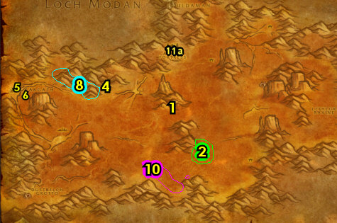

01) Do the following 4 steps below (in any order) around the western part of Badlands:
02) "Broken Alliances": kill/loot Boss Tho'grun /target. This ogre patrols in a large circle counter-clockwise around the SW part of Badlands. He has 5 bodyguards. Pull/kite him away from his guards to take him on 1v1. (See Video). NOTE: You can focus on the next steps until he shows up...
03) "Barbecued Buzzard Wings": kill/loot Buzzards. There is a large amount of Giant Buzzards at 16.61. And remember to not sell the Buzzard Wings to a vendor.
04) "Coyote Thieves": kill/loot Coyotes. Focus more on the Elder Crag Coyotes around the western side of Badlands.
05) "Badlands Reagent Run": kill/loot Buzzards, Coyotes and Rock Elementals. This quest will naturally get done by doing the others.
06) Go south and do "Study of the Elements: Rock": kill/loot Greater Rock Elementals around 14.86, and more around 4.79.
07) Once all that is done, go back to Kargath, and at the bottom of the watchtower turn in "Unclaimed Baggage" 6.48, then go up in the watchtower and turn in "Coyote Thieves".
08) Go in the Inn 50.66 and turn in "Broken Alliances", SKIP the next part (high level group quest).
09) Go upstairs and turn in "Badlands Reagent Run" 50.66, SKIP the next part (dungeon). Make sure you are repaired/resupplied.
10) Go east to The Dustbowl at the gnome 51.66 and turn in "Study of the Elements: Rock". If it is available, accept "This Is Going To Be Hard", and turn it in right next to you and accept the next part. Turn that in right next to you and accept the next part. Kill/loot the Fam'retor Guardian that spawns in. Then turn it in.
11) Also, if you have a Healing Potion and a Lesser Invisibility Potion with you, accept (if it is available) "Liquid Stone", then turn it in.
12) And also if you have a Patterned Bronze Bracers with you, accept (if it is available) "Stone Is Better than Cloth", then turn it in.
13) Go east (in the middle of Badlands) and turn in "Barbecued Buzzard Wings" 42.53.
14) N/A
#02
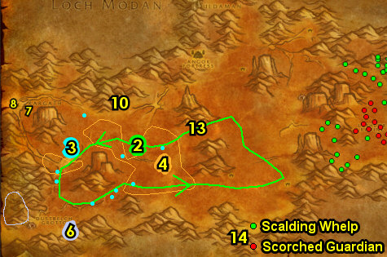

01) Hearth to Grom'gol.
02) Make sure you are repaired/resupplied.
03) Now could be a good time to see if you have all the pages for "The Green Hills of Stranglethorn". This quest requires that you have the following pages: 1, 4, 6, 8, 10, 11, 14, 16, 18, 20, 21, 24, 25, 26, and 27. You can also find these pages in the AH or from other players. If you have all of them, get them out now and go to Nesingwary's Expedition 36.11 and turn this quest in. If not, you will return to STV numerous times in the future for more chances to find the pages.
04) Run all the way to Swamp of Sorrows, stopping along the way at Beggar's Haunt to accept "Nothing But the Truth" (in Duskwood at 88.36).
05) Next to you, turn in "Nothing But the Truth" 87.35, skip the next part.
06) Run east through Deadwind Pass, follow the main path and then make a left into Ariden's Camp (52.38 in Deadwind Pass) just to discover it for XP.
07) Continue east into Swamp of Sorrows 61.41...
#03
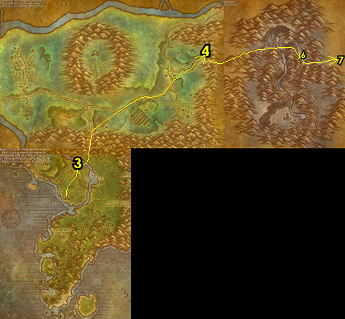

41-42 Swamp of Sorrows (log)
01) As you enter Swamp of Sorrows (SoS) start working on "Dream Dust in the Swamp": kill/loot the dragon whelps around the lake (SW around 13.60 in SoS) for the dream dust. Just clear the whelps in this area once. When you run out of whelps to kill, move on to the next steps:
02) N/A
04) Go east and then find and kill/loot Noboru the Cudgel /target. See patrol path on map (spawns at 47.39). He drops an item which starts "Noboru the Cudgel", accept it.
05) Go NW to The Harborage and turn in "Noboru the Cudgel" 26.31. Accept "Draenethyst Crystals" (no exclamation mark).
06) Go SE to Stonard and in the Inn make it your new home from the Innkeeper 45.57. Make sure you are repaired/resupplied. NOTE: You can purchase potions from the vendor upstairs in the Inn.
07) Next to you in the Inn, accept "Lack of Surplus" 45.57.
08) Go in the building and accept "Little Morsels" 48.55. Go upstairs and turn in "Report to Helgrum". Next to you, accept "Pool of Tears".
Potions, 8a) NOTE: There is another potion vendor 46.53 here you can check for Healing/Mana potions.
09) Do "Pool of Tears": loot the Atal'ai Artifacts under the lake around the Temple of Atal Hakkar around 65.54. Use water breathing potions (if you're not undead) and any Swim Speed Potions if you have any. ALSO: Continue working on (if you still need to) "Dream Dust in the Swamp" by kill/looting any dragons you see around the lake.
10) Do "Lack of Surplus": kill/loot crocolisks. There are Sawtooth Crocolisks (around the middle of SoS around 57.53) and Sawtooth Snappers (around the NE of SoS around 80.28).
11) Go SE to Misty Reed Post and turn in "Lack of Surplus" 81.81, SKIP the next part.
#04
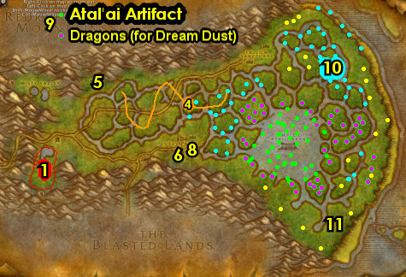
01) Go north to the Fallow Sanctuary and from the human /target in the cage 65.18, accept and try to do the escort "Galen's Escape" (it's wise to clear the mobs around the cage first). While doing the escort also do "Draenethyst Crystals": loot the Draenethyst Crystals around the village. And do "Little Morsels": use the Fel-Tainted Morsels quest item on the 3 captured animals to feed them, listed below:
02) Feed Captured Jaguar 65.23.
03) Feed Captured Tarantula 63.24.
04) Feed Captured crocolisk 60.22.
05) Make sure "Dream Dust in the Swamp" is finished now by kill/looting the dragons around the Pools of Tears lake around 63.39.
06) Above Stonard, at Galen's Strongbox (next to a tent 48.40), turn in (if you were able to do it) "Galen's Escape".
07) Go west to The Harborage and turn in "Draenethyst Crystals" 26.31.
08) Hearth (or go SE) to Stonard and in the building turn in "Little Morsels" 48.55. Then go up in the building and turn in "Pool of Tears", accept "The Atal'ai Exile". Make sure you are repaired/resupplied.
09) Go to the Wind Rider Master 46.55 and fly to Booty Bay, Stranglethorn...
#06
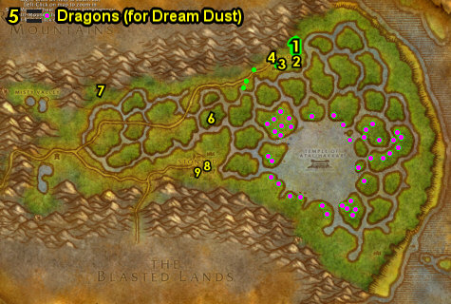
42-43 Stranglethorn Vale (log)
01) Once you land, next to you from Fleet Master Seahorn, accept "The Bloodsail Buccaneers" 27.77.
02) Next to you at the top of the Inn, accept "Skullsplitter Tusks" 27.77.
03) Next to you, turn in "Dream Dust in the Swamp" 27.77, SKIP "Rumors for Kravel" (for now).
04) Next to you from the dwarf 27.77, accept "Up to Snuff".
05) Drop down in the Inn and make BB your new home 27.77. Make sure you are repaired/resupplied. You will not come back to town for awhile, so make sure you are well stocked.
06) Next to you 27.77, accept "Venture Company Mining" and "Zanzil's Secret".
07) Go next to the bank and accept "Akiris by the Bundle" 27.76.
08) At the Bank 27.77 next to you put the following item into it: Bundle of Atal'ai Artifacts. Get out of the bank: any Split Bone Necklaces you may have.
09) In the cabin (next to the hanging shark), accept "Voodoo Dues" 28.77.
10) Go north up the docks and from Dizzy One-Eye, accept "Keep An Eye Out" 29.76.
11) Just east of BB along the shore, do "The Bloodsail Buccaneers" along with "Up to Snuff" and "Keep An Eye Out": kill/loot the Bloodsail mobs for the Snuff along with Dizzy's Eye. They can drop from any Bloodsail mob (low drop rates). Also, kill 10 Bloodsail Swashbucklers. And loot the Bloodsail Orders on the small boat 28.83 or it could be on the table 27.83 at the camp at the end of the beach (or other spots around the camps). And next to you, loot the Bloodsail Charts 27.83 on top of the box next to the eastern most tent (See Image for Possible Locations). It could also be at other spots at the various camps along the beach.
12) Go west (follow path on map) and do "Mok'thardin's Enchantment" along with "Akiris by the Bundle": kill/loot the Naga Explorers and then work your way up to the top and loot The Holy Spring water fountain over the bridge 29.62.
#07
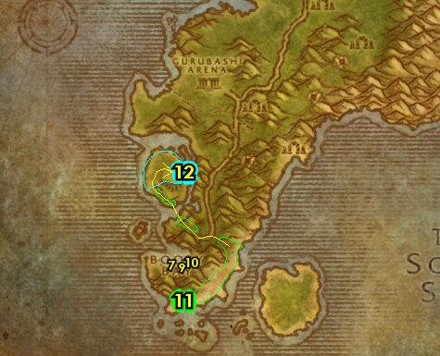

01) N/A
02) Go east across the path to the Ruins of Jubuwal and do "Zanzil's Secret" along with "Voodoo Dues": kill/loot the Zanzil mobs for Zanzil's Mixture and kill/loot the 3 named mobs. Kill/loot Maury "Club Foot" Wilkins /target 35.51. Mobs are tightly packed so be careful. See next step for the other 2 mobs to kill/loot...
03) Kill/loot Jon-Jon the Crow /target 35.52 by the Bonfire.
04) Kill/loot Chucky "Ten Thumbs" /target at the Ruins of Aboraz east path entrance 34.54 (mob is at 40.58, see map on how to get there). Watch out there is numerous stealthed panthers on the pathway there.
05) Go back west to the main path, then north a bit to the ledges around 41.44 and do "Venture Company Mining": kill/loot the Venture Co. goblins.
06) Go north to the troll Ruins around 42.36 and do "Skullsplitter Tusks" along with "Split Bone Necklace": kill/loot the Skullsplitter trolls. There is more mobs just SE at the other Ruins around 47.40 and NE around 46.33.
07) N/A
08) N/A
09) Go to Grom'gol (by the Cauldron) and turn in "Split Bone Necklace" 32.28. And click the Bubbling Cauldron to accept "Marg Speaks".
10) Turn in "Mok'thardin's Enchantment" 32.29. Make sure you are repaired/resupplied.
11) Now could be a good time to see if you have all the pages for "The Green Hills of Stranglethorn". This quest requires that you have the following pages: 1, 4, 6, 8, 10, 11, 14, 16, 18, 20, 21, 24, 25, 26, and 27. You can also find these pages in the AH or from other players. If you have all of them, get them out now (we will turn it in a few steps later). If not, you will return to STV one more time in the future for one last chance to find the pages.
12) West at the shore do "Excelsior": kill/loot an Elder Saltwater Crocolisks /target (lvl 38). There are 4 possible spawn locations try this one first 33.33, see map. You should only need to kill/loot one of them. Also these spawn by killing the regular Saltwater Crocolisks, so you may need to kill some of them first to get these to spawn in.
#08
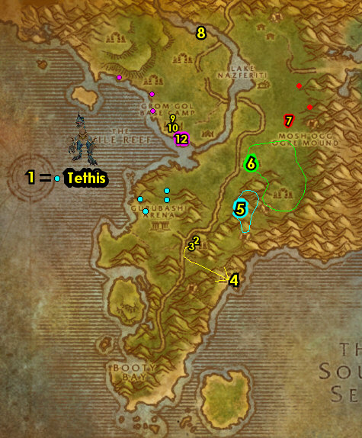

01) N/A
03) At Nesingwary's Expedition, turn in (if you have all the Green Hills pages) "The Green Hills of Stranglethorn" 36.11.
04) Hearth to BB.
05) Next to you in the Inn 27.77, turn in "Venture Company Mining" and "Zanzil's Secret".
06) Go up in the Inn and turn in "Skullsplitter Tusks" and "Up to Snuff". Also accept "Rumors for Kravel" and "Tran'rek".
07) Next to you up the steps on the boat-deck, turn in "The Bloodsail Buccaneers" 27.77, SKIP the next part (for now).
08) Stay up on the top of the docks and go over past the Alliance FP to Tan-Your-Hide Leatherworks and turn in "Excelsior" 28.78.
09) Drop down by the bank and turn in "Akiris by the Bundle" 27.76. Then at the Bank next to you, put into it: Goblin Rumors.
10) Go in the cabin (next to the hanging shark) and turn in "Voodoo Dues" 28.77. Accept "Stoley's Debt".
11) Go north up the docks and from Dizzy One-Eye 29.76, turn in "Keep An Eye Out".
12) Get on the boat at the end of docks 26.73 to go to Ratchet.
13) Once at Ratchet, go to the Flight Master (63.37 in The Barrens) and fly to Brackenwall Village, Dustwallow Marsh.
#09
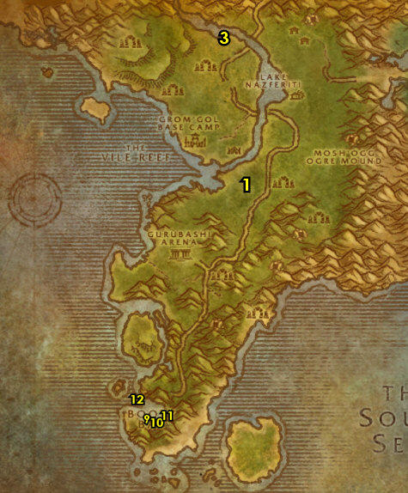
43-44 Dustwallow Marsh (log)
01) You can get repaired/resupplied from Zulrg (ogre) 36.32.
02) By the Bonfire accept "Overlord Mok'Morokk's Concern" 36.31.
03) At Krog, turn in "Return to Krog" 36.32, accept "More than Coincidence" and "The Grimtotem Plot".
04) At the Innkeeper, make Brackenwall Village your new home.
05) In the small cave at Brackenwall Village, accept "Identifying the Brood" 37.33.
06) At the east entrance of Brackenwall Village accept "Army of the Black Dragon" 37.31.
07) Go north to Blackhoof Village around 42.13 and do "The Grimtotem Plot" along with "More than Coincidence": kill/loot Grimtotem (taurens) to obtain 4 Grimtotem Notes, then click on them in your backpack. Also loot 7 Blackhoof Armaments (spear racks) around the village.
08) Hearth (or go back), and at Krog 36.32, turn in "More than Coincidence" and "The Grimtotem Plot". Accept "Seek Out Tabetha".
09) At the Wind Rider Master /target 36.32 fly to Mudsprocket, Dustwallow Marsh.
10) At Mudsprocket, by the green containers accept "Catch a Dragon by the Tail" 42.73.
11) Next to you from the Wanted Poster accept "WANTED: Goreclaw the Ravenous" 42.73.
12) In the Inn accept "Bloodfen Feathers" 42.74.
13) In the Inn, talk to the Innkeeper (goblin) to make Mudsprocket your new home. He is most likely up the steps 42.74.
14) Go NW to Bloodfen Burrow around 34.65 and do "Bloodfen Feathers" along with "WANTED: Goreclaw the Ravenous": kill/loot the Bloodfen raptors. And kill Goreclaw the Ravenous (bigger raptor /target).
15) Hearth (or go back) to Mudsprocket and in the small hut turn in "WANTED: Goreclaw the Ravenous" 42.73.
16) In the Inn turn in "Bloodfen Feathers" 42.74. Accept "Banner of the Stonemaul" and "The Essence of Enmity".
#11
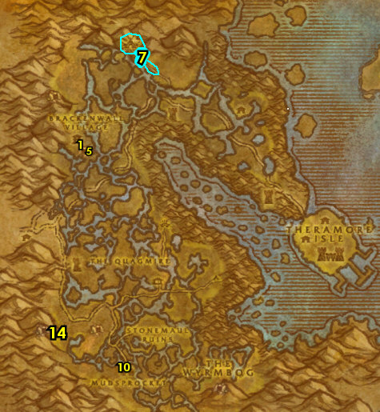

01) As you do this section start working on the following: "Army of the Black Dragon" (kill required amount of Firemane dragons), "The Essence of Enmity" (use the Brogg's Totem quest item on Firemane dragon corpses), "Catch a Dragon by the Tail" (loot Wyrmtail plants) and "Identifying the Brood" (kill/loot any dragon whelps):
02) Work your way NE to Tabetha's Farm and in the hut turn in "Seek Out Tabetha" 46.57, accept "Raze Direhorn Post!".
03) Go NW to Direhorn Post and do "Raze Direhorn Post!": use Tabetha's Torch quest item on the following 3 tents:
04) Burn the East Tent 48.48.
05) Burn the Northeast Tent 47.47. Also at this tent kill/loot Apothecary Cylla , she drops an item which starts "The Apothecary's Letter", accept it.
06) Burn the North Tent 47.46.
07) Back inside the cabin 46.57 (#2 on map) turn in "Raze Direhorn Post!", accept "Justice Dispensed".
08) Go east to the shore/water around 56.61 and do "Marg Speaks": kill/loot the Muckshell mobs until the Jeweled Pendant drops (very low drop rate).
09) Exit the shore (at 53.64).
10) Go west to Stonemaul Ruins and do "Overlord Mok'Morokk's Concern": pick up the 3 quest objects. First one is Mok'Morokk's Snuff (middle of the fenced area 45.66). See next steps for other two:
11) Go west and loot Mok'Morokk's Grog (before the cave entrance 39.66). Then kill the dragon that spawns.
12) Go in the cave next to you and at the end of it loot Mok'Morokk's Strongbox 37.70.
13) Also in the same cave do "Banner of the Stonemaul": loot the Stonemaul Clan Banner 38.69.
14) Before leaving the cave (exit at 39.66) make sure you finish killing the 5 Firemane Scalebanes /target needed for "Army of the Black Dragon" (as they are generally only found here).
15) Finish "The Essence of Enmity": use the Brogg's Totem quest item on Firemane dragon corpses.
#12
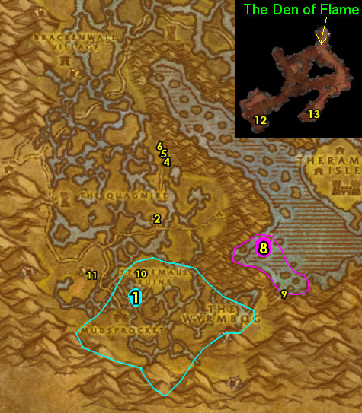

01) Go back SE to Mudsprocket and in the Inn 42.74 turn in "Banner of the Stonemaul" and "The Essence of Enmity". Accept "Spirits of Stonemaul Hold".
02) NE at Stonemaul Ruins around 45.66 do "Spirits of Stonemaul Hold": click on the Ogre Remains (skeletons on the ground), then kill the ogre spirits that spawn.
03) Around Stonemaul Ruins finish "Army of the Black Dragon": kill required amount of Firemane dragons.
04) Back in the Inn at Mudsprocket turn in "Spirits of Stonemaul Hold" 42.74 (#1 on map), accept "Challenge to the Black Flight".
05) Continue working on "Catch a Dragon by the Tail" by looting any Wyrmtail (plants) you see along the way:
06) Go SE to the entrance of Onyxia's Lair 53.77 and do "Challenge to the Black Flight": use the Stonemaul Banner quest item at the entrance.
07) Work your way back NW to Mudsprocket while finishing "Catch a Dragon by the Tail" and "Identifying the Brood": loot 8 Wyrmtail (plants). And kill/loot any dragon whelps. These are found all around Wyrmbog (#5 on map).
08) Back at Mudsprocket by the green containers turn in "Catch a Dragon by the Tail" 42.73 (#1 on map).
09) In the Inn turn in "Challenge to the Black Flight" 42.74.
10) At the NE outskirts of town, go to the Flight Master 43.72 and fly to Brackenwall Village, Dustwallow Marsh.
11) At the west side of Brackenwall Village, turn in "Marg Speaks" 35.31, accept "Report to Zor".
12) By the Bonfire, turn in "Overlord Mok'Morokk's Concern" 36.31.
13) At the east entrance of Brackenwall Village turn in "Army of the Black Dragon" 37.31.
14) In the small cave, turn in "Identifying the Brood" 37.33. Wait a few seconds then accept "The Brood of Onyxia".
15) At Krog, turn in "Justice Dispensed" 36.32.
16) Next to the Bonfire, turn in "The Brood of Onyxia" 36.31, accept the next part.
17) Back in the small cave turn in "The Brood of Onyxia" 37.33, SKIP the next part (for now).
18) Make sure you are repaired/resupplied. If for some reason you turned level 45, remember to get the lvl 45 food/drink 37.32.
19) Go to the Wind Rider Master /target 36.32 and fly to Gadgetzan, Tanaris.
#13
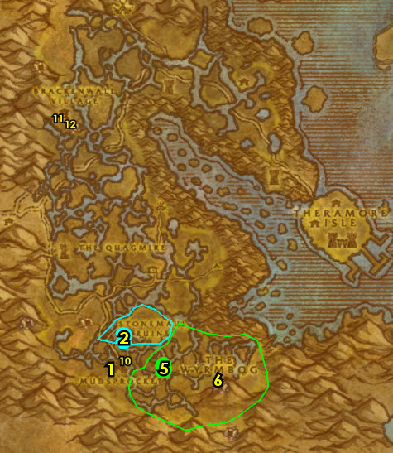
PLEASE READ: With all the faster leveling changes, by the time you get to this section you will most likely be well into level 44. Because of this when following my guide, you should skip this entire section and go right into 44-45 Tanaris section below. I will leave this section for reference purposes only. However if for some reason you are in level 43 you can consider doing this section.
44-44 Desolace
01) At Shadowprey Village, on top of the mound next to the gong 26.68, accept (if it's available) "Portals of the Legion" (no exclamation mark). Make sure you are repaired/resupplied.
02) N/A
03) N/A
04) Go NE to the Kodo Graveyard and accept "Ghost-o-Plasm Round Up" (48.62).
05) Go east to Ghost Walker Post (entrance is 56.57)...
06) Make a left at the entrance, then go across the bridge and accept "The Corrupter" 53.54.
07) N/A
08) Go SW to the Valley of Bones around 64.91 and do "Ghost-o-Plasm Round Up": at the big skeleton bones sticking out of the ground, first clear out the skeletons, then use the Crate of Ghost Magnets quest item there, then kill/loot the Magrami Spectre that spawn in for the plasms.
09) Go NW to the Mannoroc Coven and do "The Corrupter" (Elite): kill Lord Azrethoc /target (lvl 40 elite doomguard that patrols around) and also kill Jugkar Grim'rod /target (lvl 40 orc warlock, at 56.78).
10) At the Mannoroc Coven do (if you have it) "Portals of the Legion": click on the Demon Portals, then kill the Demon Portal Guardians that spawn to banish the portals. Portal locations are: 55.79 54.79 53.80 53.82 53.84 51.81 50.77 50.74 51.71 55.72
11) Go to Ghost Walker Post (entrance is 56.58, #5 on map)...
12) Make a left at the entrance, then go across the bridge and turn in "The Corrupter" (53.54, #6 on map).
13) Go to the Kodo Graveyard and turn in "Ghost-o-Plasm Round Up" (48.62, #4 on map).
16) Go back to Shadowprey Village and on top of the mound next to the gong (26.68, #1 on map), turn in (if you have it) "Portals of the Legion". Make sure you are repaired/resupplied.
17) Hearth to Thunder Bluff.
18) Go to the Wind Rider Master at the top of the tower in the middle of TB 47.50 and fly to Gadgetzan, Tanaris.
#15
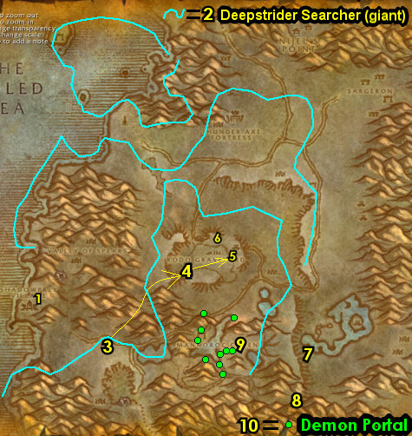

44-45 Tanaris (log)
01) As you enter Gadgetzan (next to the crane 52.27) turn in "Tran'Rek", SKIP "Scarab Shells" (Dungeon).
02) From the Wanted Poster next to the cage entrance 52.27, accept "WANTED: Caliph Scorpidsting" and "WANTED: Andre Firebeard".
03) Go in the Inn on the east side and make Gadgetzan your new home from the Innkeeper 53.28.
04) Next to the Inn at the windmill (just south 52.28), accept "Water Pouch Bounty" and "Wastewander Justice".
05) At the Bank next to you 52.29, get the following items out: Goblin Rumors and Seaforium Booster. Put in the bank: Jeweled Pendant.
06) At the western side of Gadgetzan on top of the hill, accept "Gadgetzan Water Survey" 50.27.
07) Go north to the Shimmering Flats at the Mirage Raceway and from the dwarf turn in "Rumors for Kravel" (78.77 in Thousand Needles). Wait a few seconds, then accept "Back to Booty Bay".
08) Next to you from the gnome, turn in "News for Fizzle" 78.77.
09) Go over to the goblin's side of the Mirage Raceway and turn in "Razzeric's Tweaking" 80.76, accept "Safety First". Next to you, accept "Keeping Pace".
10) At the goblin Zamek 80.77 /target next to the Goblin Racer, click on Complete Quest to setup a distraction, then go in the gnome's hut and click on Rizzle's Unguarded Plans 77.77 to turn in "Keeping Pace", accept "Rizzle's Schematics".
11) Go to the goblin Pozzik and turn in "Rizzle's Schematics" 80.76.
12) Hearth (or go back) to Gadgetzan. NOTE: You can now destroy the Sample of Indurium Ore as it is no longer used for anything.
13) From Shreev at the western side of Gadgetzan, turn in "Safety First" 51.27, SKIP the next part.
#16
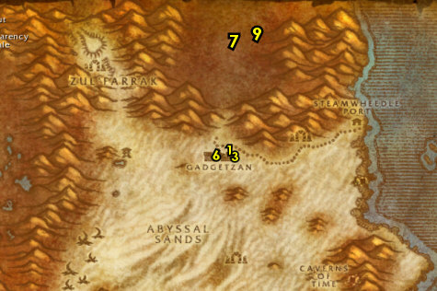

01) Grind your way east to the Noonshade Ruins around 60.24 and start working on "Wastewander Justice" along with "Water Pouch Bounty": kill/loot the Wastewander humans. NOTES: Do not sell the Wastewander Water Pouches to a vendor! Just clear the area once and continue on...
02) Go east to Steamwheedle Port and from the female goblin under the red tent, accept "Pirate Hats Ahoy!" 67.22.
03) From the male troll under the green tent, accept "Screecher Spirits" 67.22.
04) At the other side of the Port, in the hut 67.24, turn in "Stoley's Debt", accept "Stoley's Shipment". And next to you, accept "Southsea Shakedown".
05) Go SW to the Waterspring Field around 64.30 and finish "Wastewander Justice" along with "Water Pouch Bounty": kill/loot the needed Wastewander mobs. Also, keep an eye out for Caliph Scorpidsting /target, he patrols around the area and has 2 rogues following him. This is for "WANTED: Caliph Scorpidsting", and you will have another opportunity later to do this if you cannot find him now.
06) Go to Lost Rigger Cove (entrance at 69.42)...
07) Start working on "Southsea Shakedown" along with "Pirate Hats Ahoy!": kill/loot the Southsea pirates (the Southsea Dock Workers are up at wood platforms 75.47). Any of these mobs has a chance to drop a Pirate's footlocker, which could contain an item which starts "Ship Schedules", accept it if you are able to find it, otherwise it can be skipped. While doing this, also go do the following 2 steps below in this same area:
08) "Stoley's Shipment": loot the Stolen Cargo up in the building 72.47.
09) "WANTED: Andre Firebeard": kill/loot Andre Firebeard /target in the middle of the cove 73.47. Watch out this fight usually involves 3 adds. (See Video).
10) Once all these are done (including "Southsea Shakedown" along with "Pirate Hats Ahoy!"), then hearth to Gadgetzan. Make sure you are repaired/resupplied.
#17
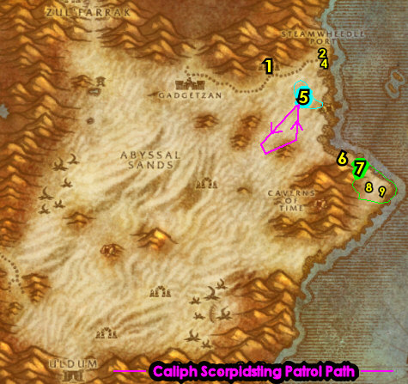

01) Next to the Inn at the windmill 52.28, turn in "Water Pouch Bounty" and "Wastewander Justice", accept "More Wastewander Justice".
02) Go west to Sandsorrow Watch and do "Gadgetzan Water Survey": use the Untapped Dowsing Widget quest item in the pool 39.29. Watch out, as soon as you fill the widget, a few high level bugs will spawn. Either run away or try to kill them.
03) Hearth (or go back east) to Gadgetzan and on top of the hill, turn in "Gadgetzan Water Survey" 50.27, SKIP "Noxious Lair Investigation" (for now).
04) Grind east to Steamwheedle Port and from the female goblin under the red tent, turn in "Pirate Hats Ahoy!" 67.22. Then you can get resupplied in the hut next to you.
05) At the other side of the Port, in the hut 67.24, turn in "Stoley's Shipment", accept "Deliver to MacKinley". Next to you, turn in "WANTED: Andre Firebeard", "Southsea Shakedown" and (if you have it) "Ship Schedules".
06) Go SW to the Waterspring Field around 60.37 and do "More Wastewander Justice" along with (if you still need to) "WANTED: Caliph Scorpidsting": kill the needed Wastewander humans and kill/loot Caliph Scorpidsting /target, he patrols around the area and has 2 rogues following him. He usually spawns at 59.40.
07) Hearth (or run back) to Gadgetzan and at the windmill next to the Inn (52.29, #1 on map), turn in "More Wastewander Justice" and "WANTED: Caliph Scorpidsting".
08) Go into the Bank next to you 52.29 and put into it: Kravel's Scheme, Stoley's Bottle, any Wastewander Water Pouches and if you have found the item called OOX-17/TN Distress Beacon, put that in your bank as well (and don't accept the quest from it yet).
09) Go to the Wind Rider Master (north of Gadgetzan, 52.25) and fly to Freewind Post, Thousand Needles.
10) Go west into Feralas entrance 7.10...
#18
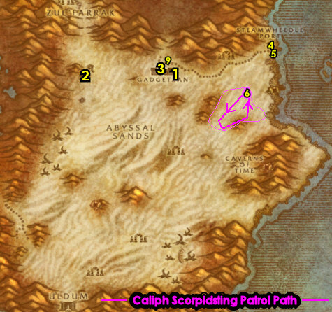

45-46 Feralas (log)
01) Run into Camp Mojache, make a right, then accept "A New Cloak's Sheen" 76.43.
02) Continue into the town and from Rok Orhan /target (she patrols back and forth in the town), accept "The Ogres of Feralas".
WOTLK, 2b) In the hut 76.44, accept "Dark Heart" and "Vengeance on the Northspring".
03) From the goblin on the small mound, accept "Gordunni Cobalt" 76.44.
Flight Path, 3b) Get the FP next to you 75.44.
04) Between the tents, accept "War on the Woodpaw" 75.42.
05) In the big tent accept "The Mark of Quality" 74.43.
06) Just outside of the big tent on your right (from Witch Doctor Uzer'i) accept "A Strange Request" 74.43 and "The Sunken Temple".
07) Go in the Inn and make Camp Mojache your new home 75.45. Make sure you are repaired/resupplied. If you turned level 45, remember to get the lvl 45 food/drink.
08) Go just north of Camp Mojache around 73.39 and do "War on the Woodpaw": kill/loot the Woodpaw gnolls.
WOTLK, 8b) Go just across the river over to Lariss Pavilion and turn in "A Strange Request" 77.38, accept "Retrun to Witch Doctor Uzer'i".
09) Go NE to the Gordunni Outpost entrance 75.35 and do "The Ogres of Feralas" along with "Gordunni Cobalt": kill the needed Gordunni ogres and use Orwin's Shovel quest item on the bluish haze from the ground, then click on the Gordunni Dirt Mounds for the Gordunni Cobalt. And loot one of the Gordunni Scrolls laying on the ground around the Outpost (there could be one next to the tree log 75.30), then accept "The Gordunni Scroll" from it.
WOTLK, 9b) Hearth (or go back) to Camp Mojache and next to the big tent from Witch Doctor Uzer'i 74.43, turn in "Retrun to Witch Doctor Uzer'i". Wait a few seconds then accept "Testing the Vessel" and "Natural Materials". NOTE: We will turn the rest of the quests in a few steps later.
10) Just north around Camp Mojache around 72.43, do "Testing the Vessel": use the Beast Muisek Vessel quest item on the corpses of Ironfur Bears or Longtooth Runners (wolves).
#19
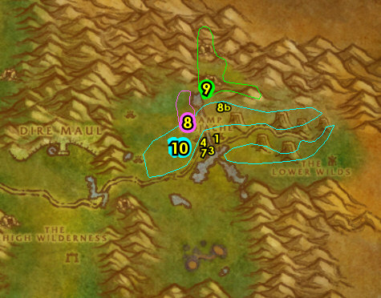

WOTLK, 00) Hearth (or go back) to Camp Mojache and next to the big tent from Witch Doctor Uzer'i 74.43, turn in "Testing the Vessel", accept "Hippogryph Muisek".
01) Between the two tents, turn in "War on the Woodpaw" 75.42, accept "Alpha Strike".
02) From the goblin on the small mound, turn in "Gordunni Cobalt" 76.44.
03) From Rok Orhan /target (she patrols back and forth in the town), turn in "The Ogres of Feralas" (accept the next part) and "The Gordunni Scroll", accept "Dark Ceremony".
05) NOTE: You can check the Alchemy Supplies vendor for potions and sell junk 76.43.
06) Go south to Woodpaw Hills and do "Alpha Strike": kill 5 Woodpaw Alphas /target. There is generally one Alpha at each of the bigger camps in the area, which include: 75.56 71.56 72.57 73.56 69.56 69.54 77.57.
07) Hearth (or go back) to Camp Mojache and between the two tents, turn in "Alpha Strike" (75.42, #1 on map), accept "Woodpaw Investigation".
08) Go back to Woodpaw Hills and from the Woodpaw Battle Map scroll on the crate 72.56 turn in "Woodpaw Investigation", accept "The Battle Plans".
10) Hearth (or go back) Camp Mojache.
11) Between the two tents, turn in "The Battle Plans" (75.42, #1 on map). Accept "Zukk'ash Infestation" and "Stinglasher".
#20
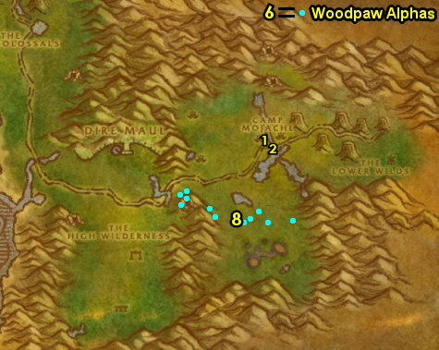

01) Go south to The Writhing Deep and do "Stinglasher" along with "Zukk'ash Infestation": kill/loot the Zukk'ash bugs and also kill/loot Stinglasher /target. He is at the cave entrance of either 77.61 or 74.64.
02) Go NW and do "Screecher Spirits": kill the Screecher mobs, then use the Yeh'kinya's Bramble quest item on the corpse, then talk to the Screecher Spirit that spawns. There are some Screechers around 59.51 and see map for more locations. NOTES: The Screechers have a spell silence attack. Do the next step in that same area while doing this:
03) Go north to the entrance of Dire Maul at 43.70 only to get it Discovered. Simply discovering Dire Maul in this area will allow you to accept a future quest. You need to actually discover the zone, you will know when you achieved that when your general chat switches over to Dire Maul.
04) Go to the Ruins of Isildien (starting at 61.56 and work your way south) and do "The Ogres of Feralas": kill the required amount of Gordunni ogres. The Maulers are north and the Shamans are south. Keep the next step in mind:
05) Do "Dark Ceremony": kill/loot the Gordunni Mage-Lords until you get the Gordunni Orb. These mobs are south in the Ruins of Isildien 61.95.
WOTLK, 5a) Go just west to The High Wilderness around 55.66 and do "Hippogryph Muisek": use the Hippogryph Muisek Vessel quest item on any Frayfeather hippogryph corpses. Also do part of "Natural Materials": kill/loot the Frayfeather mobs (hippogryphs) for the 20 Resilient Sinew and 40 Metallic Fragments. Keep next step in mind:
WOTLK, 5b) South of the Hippogryphs along the cliffs around 58.76, loot a Hippogryph Egg in one of the nests. This will be turned in at Tanaris for a later quest. And remember to not sell this!
06) Go NW to the Feral Scar Vale around 55.56 and do "The Mark of Quality": kill/loot the Feral Scar yetis. NOTE: While questing in Feralas, you may come across an item called OOX-22/FE Distress Beacon, from it accept "Find OOX-22/FE!" and turn this in through the small cave at Feral Scar 53.56, but do NOT do the follow-up escort quest. Also the yetis can be quite dangerous inside the cave so try to avoid that if you can.
WOTLK, 6b) Hearth (or go back) to Camp Mojache, then next to the big tent from Witch Doctor Uzer'i 74.43, turn in "Hippogryph Muisek", accept "Faerie Dragon Muisek". REMINDER: Do not sell your Hippogryph Egg.
07) In the big tent turn in "The Mark of Quality" 74.43.
08) Between the two tents, turn in "Zukk'ash Infestation" and "Stinglasher" 75.42. Accept "Zukk'ash Report".
09) From Rok Orhan /target (she patrols back and forth in the town), turn in "Dark Ceremony" and "The Ogres of Feralas", accept "The Gordunni Orb". Make sure you are repaired/resupplied.
WOTLK, 9a) Go SW around 69.48 and do "A New Cloak's Sheen" (kill/loot the Sprite Darters), and do "Faerie Dragon Muisek" (use the Faerie Dragon Muisek Vessel quest item on Sprite Darter corpses). Also do part of "Natural Materials": kill/loot the Sprite Darters for the 6 Encrusted Minerals.
WOTLK, 9b) Hearth (or go back) to Camp Mojache, and at Witch Doctor Uzer'i 74.43 turn in "Faerie Dragon Muisek", accept "Treant Muisek". Also turn in (if it's complete) "Natural Materials".
WOTLK, 9c) On the eastern side of Camp Mojache, turn in "A New Cloak's Sheen" 76.43, accept "A Grim Discovery".
WOTLK, 9d) Do "Treant Muisek" and finish (if you still need to) "Natural Materials": kill/loot Wandering Forest Walkers /target for the 2 Splintered Logs and use the Treant Muisek Vessel quest item on Wandering Forest Walker /target corpses. There is several around 72.43.
WOTLK, 9e) Go north and do "A Grim Discovery": kill/loot the Grimtotem taurens for the horns around 67.46. There's another camp of mobs just north around 69.40.
WOTLK, 9f) Hearth (or go back) to Camp Mojache, and at Witch Doctor Uzer'i 74.43 turn in "Treant Muisek", accept "Mountain Giant Muisek". And turn in (if you haven't yet) "Natural Materials".
WOTLK, 9g) On the eastern side of Camp Mojache, turn in "A Grim Discovery" 76.43, accept the next part. Make sure you are repaired/resupplied.
WOTLK, 9h) Head west on the main path all the way to the goblin 45.43 and accept "Zapped Giants".
WOTLK, 9i) Go north (exit at 47.38) to Ruins of Ravenwind around 40.13 and do "Vengeance on the Northspring": kill the needed Northspring harpies. Also, keep grinding on harpies until the Horn of Hatetalon drops, then use this item for the next quest:
WOTLK, 9j) Up north in Ruins of Ravenwind do "Dark Heart": use the Horn of Hatetalon quest item at the two big stones 41.9 to summon Edana Hatetalon (lvl 50), then kill/loot her..
WOTLK, 9k) Go just SW to The Twin Colossals around 39.24 and do "Mountain Giant Muisek" along with "Zapped Giants": use Zorbin's Ultra-Shrinker quest item on any giant (this removes the elite status), then use the Mountain Giant Muisek Vessel quest item on the corpses.
WOTLK, 9l) Go south to the goblin next to the dock and turn in "Zapped Giants" 45.43 (#9h on map).
WOTLK, 9m) Hearth (or go back) to Camp Mojache.
WOTLK, 9n) From Witch Doctor Uzer'i 74.43, turn in "Mountain Giant Muisek". Accept "Weapons of Spirit". Then instead of waiting for the doc, just do the next step:
WOTLK, 9o) At the other side of Camp Mojache under the hut 76.44, turn in "Dark Heart" and "Vengeance on the Northspring".
WOTLK, 9p) Go back to Witch Doctor Uzer'i 74.43 and turn in "Weapons of Spirit".
10) Go to the Wind Rider Master 75.44 and fly to Orgrimmar, Durotar.
#21
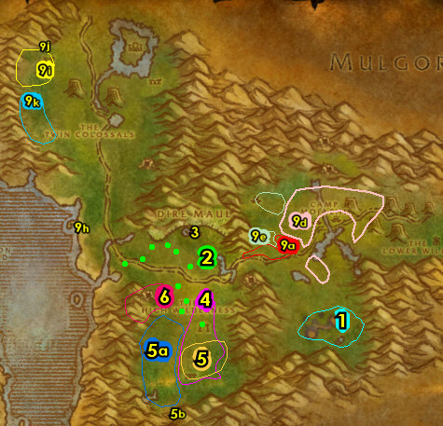

Orgrimmar (log)
01) Go to the Bank 50.69 and put in the bank: Hippogryph Egg, Yeh'kinya's Bramble. And get the following items out of the bank: Jeweled Pendant. Also (depending on what cloth donations you already turned in at Orgrimmar) get your Silk Cloth and Mageweave Cloth out of your bank or mailbox 51.70. You would need 60 or 120 Silk Cloth and 60 or 120 Mageweave Cloth. This is for Cloth Donation quests you are about to turn in.
02) Go to The Drag and up in the hut, turn in "Zukk'ash Report" 56.47.
03) Drop down to Magar's Cloth Goods and turn in the cloth donations to the Orc's Horde Cloth Quartermaster 64.51. Also, if you only have 60 Silk Cloth, save that for the other Silk Cloth turn in later instead!
04) Go in Droffers And Sons Salvage and accept "Ripple Recovery" 60.37. Next to you, turn that in and accept the next part.
05) Go east to the Valley of Honor at Belgrom Rockmaul 75.34 and turn in "Parts of the Swarm" and "A Grim Discovery". Accept "Betrayed".
GET NEW ABILITIES, 5b) If you need to, get new spells/abilities.
07) Go to Grommash Hold in The Valley of Wisdom and turn in "Report to Zor" 39.38. Accept/Complete "Service to the Horde"
08) Go to Darkbriar Lodge in the Valley of Spirits and turn in "The Gordunni Orb" 39.86.
09) Next to you, turn in as much cloth as you can to the Horde Cloth Quartermaster 38.88 (for the troll faction).
11) Get on the zeppelin (51.14 in Durotar) to go to The Undercity.
#22
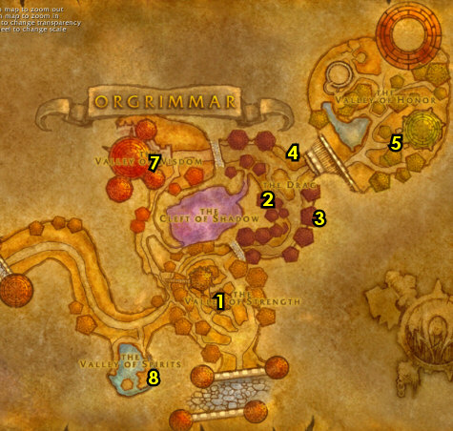

The Undercity
01) Go to the Bank in the middle of The Undercity 66.44 and put the following items into the bank: Sealed Letter to Ag'tor. Get out (if you can) 60 Wool Cloth, then 60 Silk Cloth, and then 60 Mageweave Cloth (for cloth donation quests).
02) N/A
03) Next to you, turn in any cloth you have to the Undead's Horde Cloth Quartermaster 72.29.
04) Go west to The War Quarter to the Weapon Master 57.33 and if you have extra gold to spare, feel free to learn all the weapons from him.
05) Go SW to The Apothecarium entrance 52.80 and accept "Seeping Corruption" 49.71.
06) Next to you in the same room, accept "Errand for Apothecary Zinge" 50.68.
07) Out in the other room, turn in "Errand for Apothecary Zinge" 59.55, accept the next part.
08) Go back down in the Apothecarium Quarter entrance 52.80 and turn in "Errand for Apothecary Zinge" (50.68, #5 on map), accept "Into the Field".
08b) Check the AH 71.47 for a Mithril Casing and if you are able to get it, store it in your bank for now for a later quest at Un'goro Crater. If you can't get it now, you will be reminded twice more later to see if you can get this.
09) Go to the Bank in the middle of The Undercity (66.44, #1 on map) and put the following items into it: Kravel's Scheme, Stoley's Bottle, Field Testing Kit and Box of Empty Vials. Get the following items out: (if you have one) Swim Speed Potion.
12) Leave the UC and get on the zeppelin to go to Grom'gol, STV (62.59 in Tirisfal Glades).
#25
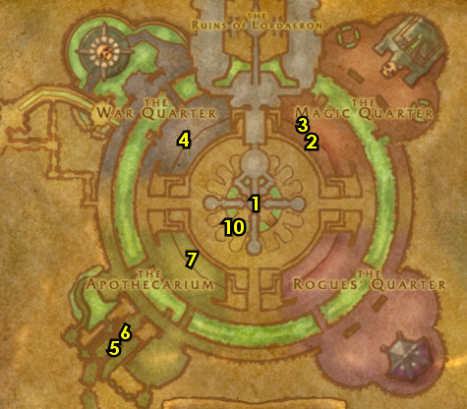

PLEASE READ: With all the faster leveling changes, by the time you get to this section you should already be either well into level 47 or level 48. Because of this when following my guide, you should skip this entire section and go right into 47-47 Stranglethorn Vale section below. I will leave this section for reference purposes only. However if you are in your 46s you should consider doing this section. If you are NOT doing this section then abandon "Testing the Vessel", "Lines of Communication".
47-47 Hinterlands
Here are the prerequisites to this section:
-Accept: "Lines of Communication" in the UC (magic quarter)
-Accept: "Grim Message" at Grom'gol (in STV)
01) Go into the Hinterlands (entrance at 87.29 in Hillsbrad Foothills). NOTE: Grind on any Trained Razorbeaks or Wild Gryphons you see along the way as they drop Long Elegant Feathers, you need 10 of these for a later quest, and remember to not sell these to a vendor.
02) Go up to Shindigger's Camp and turn in "Ripple Recovery" 27.49, accept "A Sticky Situation".
03) Go all the way to Revantusk Village and from the Blacksmithing Supplies vendor, accept "Vilebranch Hooligans" 78.80.
04) Up in the hut (next to the wagon), from Mystic Yayo'jin, accept "Cannibalistic Cousins" 79.78.
05) At the other hut next to you, from Otho Moji'ko, accept "Message to the Wildhammer" 79.79.
06) Next to you from the Stable Master 79.80, accept "Stalking the Stalkers", "Hunt the Savages" and "Avenging the Fallen".
07) Make sure you are repaired/resupplied. Before you go out and start questing make sure you stock up heavily on food/water/supplies because you won't be back to town for while.
08) Time to do the good ol' Hinterlands grind! Do the following 12 steps below. They don't need to be done in that specific order, but start doing the ones on top first. Have fun!
#26
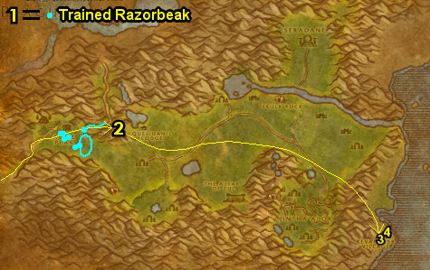

01) At any time you find an item called OOX-09/HL Distress Beacon, from it accept "Find OOX-09/HL!". If so, go turn this in in the middle of the lake on top of the hill 49.38, but do NOT do the escort yet!
02) "Stalking the Stalkers": kill Silvermane Stalkers (eastern side of Hinterlands ramp entrance 76.62) and Silvermane Howlers (middle of Hinterlands).
03) "Cannibalistic Cousins": kill Vilebranch Scalpers and Vilebranch Soothsayers (trolls). There are several camps of these mobs (starting at 71.48), another one around 66.45, 53.39, and 48.67.
04) "Testing the Vessel": use the Wildkin Muisek Vessel quest item on the corpse of any Owlbeast scattered around The Hinterlands. These include the following Owlbeasts: Marauding, Primitive, Savage, and Vicious. Focusing on the Savages /targetthe most (#4 on map), because of the next step:
05) "Hunt the Savages": kill Savage Owlbeasts. There are only 11 mob spawns around the middle-eastern part of Hinterlands. (this is also #4 on map)
06) "Vilebranch Hooligans": loot Slagtree's Lost Tools. There are 5 possible spawn locations (73.53, 71.49, 66.45, 57.43, or 53.39).
07) "A Sticky Situation": loot the Horde Supply Crates in the cave at Skull Rock (entrance at 58.40). Once this is completed, keep the first 2 steps in mind from the next section.
08) "Avenging the Fallen": kill/loot the Razorbeak Skylord /targetfor the Skylord Plume. There are only two spawn locations. One patrols around 54.50, and another one patrols around 68.53.
09) "Lines of Communication": at Quel'Danil Lodge, click on the following 3 scrolls on the ground: The Highvale Records 32.47 in the building. The Highvale Notes 30.49 outside by the well, barrel and lamppost. The Highvale Report 29.46 under the gazebo. While you are here, keep the next step in mind:
10) "Message to the Wildhammer": kill the required amount of Highvale elves around Quel'Danil Lodge.
11) "Rin'ji is Trapped!": in the building and from Rin'Ji in the cage (31.47, #10 on map), accept the escort from him and then escort him out of Quel'Danil Lodge. TIP: Clear out the path in front of the lodge first.
12) "Grim Message": kill/loot the Witherbark trolls to obtain 20 Witherbark Skulls. There is one village 32.58 and another one 23.58. Then use Nimboya's Pike quest item at the Hiri'watha village (32.58, #12 on map). Use it twice: first to combine the skulls, then to plant the pike in the ground. Also while doing this quest, accept "Venom Bottles" from one of those little Venom Bottles on the table (at either village).
#27
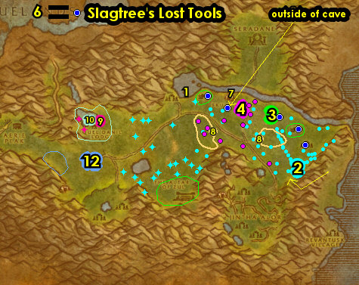

01) Go to the path (starting at 21.48)...
02) Go up the path to Shindigger's Camp and turn in "A Sticky Situation" 27.49. Accept "Ripple Delivery".
03) Go east to the little island at the sea (use a Swim Speed Potion if you have one) and click on Rin'ji's Secret tablet 86.59 to turn in "Rin'ji is Trapped!", accept "Rin'ji's Secret".
04) Go to Revantusk Village and from the Blacksmithing Supplies vendor, turn in "Vilebranch Hooligans" 78.80. NOTE: Save 10 Long Elegant Feathers you have, as it is used for a later quest, and do not sell them to a vendor.
05) Up in the hut (next to the wagon), from Mystic Yayo'jin, turn in "Cannibalistic Cousins" 79.78.
06) At the other hut next to you, from Otho Moji'ko, turn in "Message to the Wildhammer" 79.79. Only accept and turn in "Another Message to the Wildhammer" if you have 10 Long Elegant Feathers with you then SKIP "The Final Message to the Wildhammer" (for now). If not, you will have another opportunity to turn this in later.
07) Next to you from the Stable Master 79.80, turn in "Stalking the Stalkers", "Hunt the Savages" and "Avenging the Fallen".
08) Go to the end of the docks and from the Wind Rider Master 82.82, fly to Hammerfall, Arathi.
10)Go to the Wind Rider Master 82.82 and fly to Tarren Mill, Hillsbrad.
11) Go in the small house 61.19 and turn in "Venom Bottles", accept "Undamaged Venom Sac".
#28
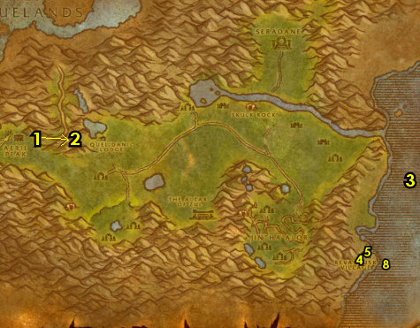

01) Go back into the Hinterlands (don't fly) (entrance at 87.29 in Hillsbrad)...
02) Go to Shadra'Alor entrance 36.64, go to the top of the temple (grind mobs along the way), then drop down and turn in "The Atal'ai Exile" 34.75 (See Video on where to find this dude at), accept "Return to Fel'Zerul"
03) In the immediate area, do "Undamaged Venom Sac": kill/loot Witherbark Broodguards (spiders) for the Undamaged Venom Sac (low drop rate).
04) REMINDER: While questing, you may have found an item called OOX-09/HL Distress Beacon, from it accept "Find OOX-09/HL!". If so, go turn this in in the middle of the lake on top of the hill 49.38, but do NOT do the escort yet!
05) Hearth to Tarren Mill.
06) In the small house next to the Inn, turn in "Undamaged Venom Sac" (61.19 in Hillsbrad). NOTE: Only accept "Consult Master Gadrin" if you still need to get a mount as a troll, as you turn it in in the same spot, otherwise skip it.
07) Go to the Bat Handler 60.19 and fly to Undercity, Tirisfal.
08) Go to the Bank 66.44 in the middle of the UC and get the following items out: Kravel's Scheme and Stoley's Bottle. And put in the Bank: Dran's Ripple Delivery, 10 Wildkin Muisek, Wildkin Muisek Vessel and your stack of Long Elegant Feathers (if you still need to turn in the quest for them).
09) If you still need to, go to The Magic Quarter 72.29 and turn in "A Donation of Mageweave" (you need 60 Mageweave Cloth for this).
10) Next to you at the Magic Quarter 73.33, turn in "Rin'ji's Secret" and "Lines of Communication". Then complete "Oran's Gratitude".
11) Check the AH 71.47 for a Mithril Casing and if you are able to get it, store it in your bank for now for a later quest at Un'goro Crater. If you can't get it now, you will be reminded once more later to see if you can get this.
12) Leave the UC and get on the zeppelin to go to Grom'gol (62.59 in Tirisfal Glades).
#29
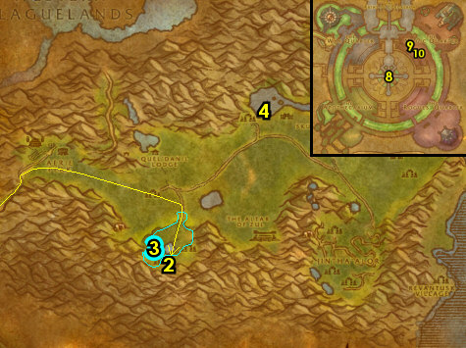

47-47 Stranglethorn Vale (log)
01) N/A
02) N/A
03) Go to the Wind Rider Master 33.29 and fly to Booty Bay, Stranglethorn.
04) When you land, next to you from Fleet Master Seahorn accept "The Bloodsail Buccaneers" 27.77.
05) Drop down in the Inn and make BB your new home 27.77.
06) Next to you in the Inn, turn in "Back to Booty Bay" 27.77.
07) Go in the cabin (next to the hanging shark) and turn in "Deliver to MacKinley" 28.77.
08) N/A
09) Go near the end of the docks and accept "The Captain's Chest" 27.74.
10) Go east to the shore and attempt to do "The Captain's Chest" (Elite): kill/loot Gorlash /target. This lvl 42 elite giant patrols up and down the shore around 37.70. You may need to group up with someone, if you cannot do it, it can be skipped.
11) Search the shores east of BB for Half-Buried Bottles until a Carefully Folded Note shows up, from it accept "Message in a Bottle".
12) Go to the island east of BB (use Swim Speed if you can), plus watch out for the lvl 41 stealthed panthers there, then turn in "Message in a Bottle" 39.81, accept the next part. NOTE: If the Carefully Folded Note item remains in your inventory, you can destroy it.
13) East on the island do "Message in a Bottle": kill/loot King Mukla /target (lvl 42 big gorilla, at 41.84).
14) Back NW on the island turn in "Message in a Bottle" (#12 on map, 39.81).
#30
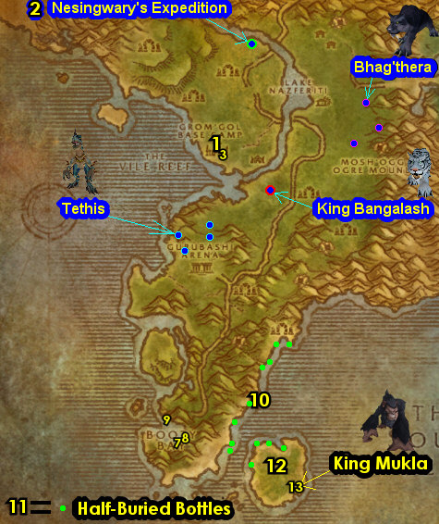

01) Do "The Bloodsail Buccaneers": kill the 3 pirates in each of the 3 ships. Also find a scroll laying on the ground (can be in any of the 3 ships) called Cortello's Riddle, and from it accept "Cortello's Riddle". Sometimes this scroll can be in the basement of the ships, so search there too. The first pirate to kill is Captain Stillwater down the first flight of stairs in the ship 33.88. See next steps for the other 2:
02) Kill Fleet Master Firallon down the first flight of stairs in the middle ship 31.91. Watch out for Ironpatch in the room before Firallon, take him on alone first.
03) Kill Captain Keelhaul down the first flight of stairs in the last ship 29.88. Make sure you find the scroll that starts "Cortello's Riddle" before leaving this area. NOTE: After accepting "Cortello's Riddle" you can then destroy the scroll that started the quest as it will no longer be used for anything.
04) Hearth to BB, if Hearthstone is still on a cooldown, die on purpose and res at spirit. Make sure you are repaired/resupplied.
05) Turn in (if you did it) "The Captain's Chest" (at the end of the docks 27.74).
06) Go to the Bank 27.77 and get out 15 Silk Cloth from the bank, mailbox or AH, for a later quest.
07) Up in the Inn, from Fleet Master Seahorn turn in "The Bloodsail Buccaneers" 27.77.
08) This is the last time my guide will tell you to turn in "The Green Hills of Stranglethorn" if it is complete. This quest requires that you have the following pages: 1, 4, 6, 8, 10, 11, 14, 16, 18, 20, 21, 24, 25, 26, and 27. You can also find these pages in the AH or from other players. If you have all of them, get them out now and go to Nesingwary's Expedition 36.11 and turn this quest in. If you do go turn it in, afterwards go to Grom'gol's Wind Rider Master 33.29 and fly to Kargath, Badlands. Otherwise, skip to next step:
09) Next to you on the roof, go to the Wind Rider Master 27.77 and fly to Kargath, Badlands.
10) Go SW into Searing Gorge (entrance at 1.63 in Badlands).
#31
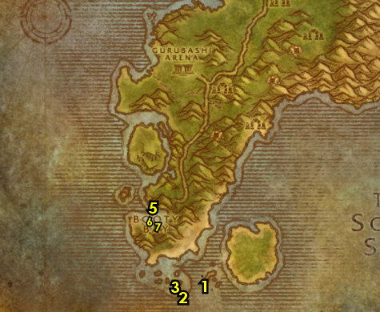

47-48 Searing Gorge (log)
01) Go SE in Searing Gorge and from the Wooden Outhouse 66.62, accept "Caught!".
02) At the Grimesilt Dig Site next to you around 63.62, do "Caught!": kill 8 Dark Iron Geologists /target. Also make sure you have 15 Silk Cloth (it can drop from the dwarves at the Dig Site). The Geologists are limited, so you will most likely need to grind on mobs until they respawn (or go north for a few more).
03) Go back to the Wooden Outhouse (66.62, #1 on map), and turn in "Caught!", accept "Ledger from Tanaris". Then pick up the Goodsteel Ledger (it drops on the ground next to the outhouse).
04) Do part of "Ledger from Tanaris": kill/loot Glassweb Spiders /target for the Leg Shafts. These are scattered on the eastern side of Searing Gorge starting around 61.70.
05) Go up NW and from Kalaran Windblade 39.39 accept "Divine Retribution", then do it by simply talking to him. Then turn it in. From him, accept "The Flawless Flame".
06) Go up to Thorium Point (entrance at 33.30)...
07) Accept ALL quests at Thorium Point: From the WANTED/Missing/Lost & Found sign 38.26 accept "WANTED: Overseer Maltorius", "STOLEN: Smithing Tuyere and Lookout's Spyglass" and "JOB OPPORTUNITY: Culling the Competition".
WOTLK, 7b) Next to you accept "Kill 'Em With Sleep Deprivation" 38.28.
08) Next to you 39.28 accept "Curse These Fat Fingers", "Fiery Menace!" and "Incendosaurs? Whateverosaur is More Like It"
09) Next to you by the Forge accept "What the Flux?" 39.29. Make sure you are repaired/resupplied by this NPC as well.
10) Get the FP from the Wind Rider Master 35.31 at Thorium Point.
#32
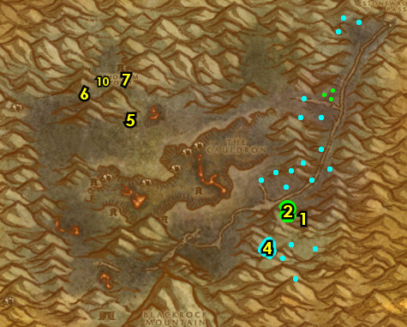

NOTE: Do the Searing Gorge grind! Do this section all at once (in any order):
01) "The Flawless Flame": kill/loot Magma Elementals, Tempered War Golems, and Heavy War Golems for the Golem Oil. See next step for the Heart of Flame:
02) Kill/loot the fire elementals for the Heart of Flame, these include: Inferno Elementals, Blazing Elementals and Magma Elementals.
03) "Fiery Menace!": kill Greater Lava Spiders around the western side of Searing Gorge.
04) "Curse These Fat Fingers": kill Heavy War Golems around the middle of Searing Gorge.
05) "STOLEN: Smithing Tuyere and Lookout's Spyglass": kill/loot Dark Iron Steamsmith for the Smithing Tuyere around 40.50. See next step for where to find the Lookout's Spyglass:
06) Kill/loot Dark Iron Lookouts for the Lookout's Spyglass, these mobs are scattered around the watchtowers at Searing Gorge, there is a large amount around 53.59, see map for other locations.
07) Once "The Flawless Flame" is done, turn it in at Kalaran Windblade 39.39 and accept "Forging the Shaft".
#33
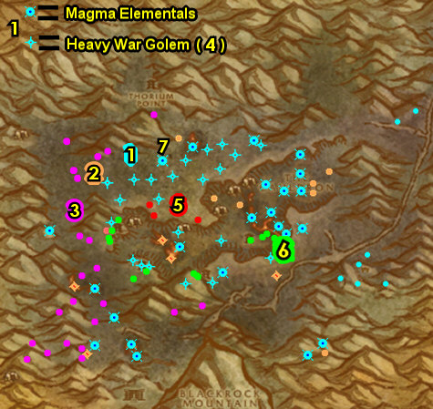

01) "JOB OPPORTUNITY: Culling the Competition": enter one of the caves down in The Cauldron (middle of Searing Gorge), I recommend going into the eastern most cave entrance 49.45 and then kill the required amount of Dark Iron dwarves in the cave.
02) "What the Flux?" and "WANTED: Overseer Maltorius": loot the Secret Plans: Fiery Flux 40.36 behind Overseer Maltorius (41.36 in the cave). And kill/loot Overseer Maltorius (lvl 50).
WOTLK, 2b) In the hallways across the room around 45.31 do "Kill 'Em With Sleep Deprivation": loot the pillows along side the walls where the beds are at. Watch out groups of sleepy dwarves patrol this hall and an elite mob can spawn in the middle of that hall, so be careful! You can skip this if you don't want to wait for the pillows to respawn or deal with the mobs that are in the way.
03) "Forging the Shaft": kill/loot Dark Iron dwarves for the Thorium Plated Daggers. NOTES: This quest requires "The Flawless Flame" to be finished and turned in first. Save any Dark Iron Scraps you find, you will need 30 of them for a later quest, but you will also have another good chance to find a lot more later on in the lvl 53-54 Burning Steppes section as well.
04) "Incendosaurs? Whateverosaur is More Like It": enter the cave (at 47.46) and kill 20 Incendosaurs.
#34
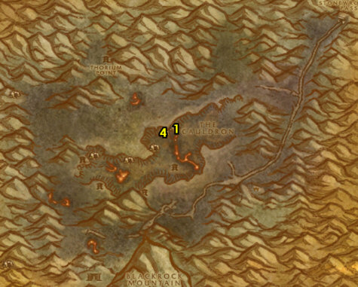

01) Go to Kalaran Windblade 39.39 and turn in "Forging the Shaft", accept "The Flame's Casing".
02) Go up to Thorium Point (entrance at 33.30)...
03) Turn in "WANTED: Overseer Maltorius" 38.27.
WOTLK, 3b) Next to you, turn in (if you did it) "Kill 'Em With Sleep Deprivation" 38.28.
04) Next to you, turn in "Curse These Fat Fingers", "Fiery Menace!" and "Incendosaurs? Whateverosaur is More Like It" 39.28.
05) Next to you, turn in "STOLEN: Smithing Tuyere and Lookout's Spyglass" and "JOB OPPORTUNITY: Culling the Competition" 39.28.
06) At the Forge next to you turn in "What the Flux?" 39.29. Make sure you are repaired/resupplied from this NPC.
07) Go west around 25.35 and do "The Flame's Casing": kill/loot the Twilight mobs until the Symbol of Ragnaros drops (low drop rate).
08) Go east to Kalaran Windblade (39.39, #1 on map) and turn in "The Flame's Casing", accept "The Torch of Retribution".
09) Wait a few seconds, then turn in "The Torch of Retribution", accept the next part. Then click on the Torch of Retribution in the air next to you to turn in the next part of "The Torch of Retribution". Accept "Squire Maltrake". Next to you, turn in "Squire Maltrake", accept "Set Them Ablaze!".
#35
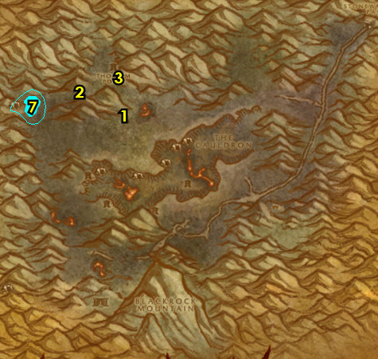

01) Do "Set Them Ablaze!": equip the Torch of Retribution quest item and at the top of the 4 watchtowers, click on the Sentry Braziers. The Northern Tower is at 33.54. See next steps for the others:
02) The Western Tower is at 36.61.
03) The Southern Tower is at 44.61.
04) The Eastern Tower is at 50.55. NOTE: You must cross a bridge to get to it.
05) While doing the quests associated with killing the Dark Iron dwarves, you should have obtained an item called Grimsite Outhouse Key, from it accept "The Key to Freedom". Then go SE and turn this in at the Wooden Outhouse 66.62.
06) N/A
07) Go NW to Kalaran Windblade 39.39 and turn in "Set Them Ablaze!".
08) Wait a minute (build up First Aid while waiting), then click on the Hoard of the Black Dragonflight 39.39 chest on the ground next to Kalaran Windblade and accept "Trinkets...". Then click on the chest again to turn this in. Loot the chest received.
09) NOTES: Make sure you keep the Black Dragonflight Molt in your inventory as you will need it for a later quest. Also make sure you have all 20 Solid Crystal Leg Shafts for the quest "Ledger from Tanaris".
10) Head south into Burning Steppes (entrance at 35.87 in Searing Gorge). NOTE: You have to go through Black Rock Mountains.
11) Once at Burning Steppes, first head to 25.53 just to discover Draco'dar for XP.
12) N/A
13) Go up the ramp into Flame Crest. You can get repaired/resupplied in the small cave from the female goblin 66.22.
14) At the Wind Rider Master 66.24 fly to Stonard, Swamp of Sorrows. NOTE: If you still have "What the Flux?" or "WANTED: Overseer Maltorius" they can be abandoned.
#36
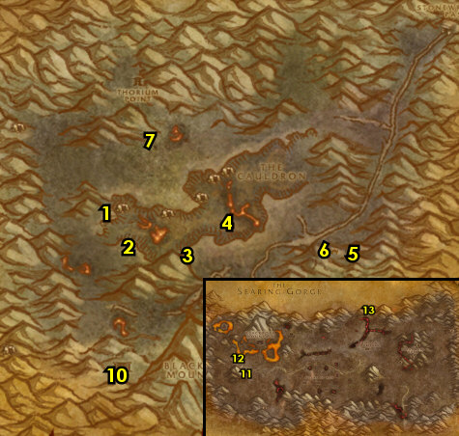

48-49 Swamp of Sorrows (log)
01) Go in the Inn and make Stonard your new home from the Innkeeper 45.57.
02) Go SW on the main path and from Fallen Hero of the Horde 34.66 accept "Fall From Grace". Then do it by simply talking to the NPC. Turn it in and accept "The Disgraced One".
03) Go NW and click on A Soggy Scrolll under the bridge 23.48 to turn in "Cortello's Riddle", accept the next part.
05) Go back to Stonard.
06) N/A
07) Up in the building 48.55, turn in "The Disgraced One", accept "The Missing Orders". And turn in (if you have it) "Return to Fel'Zerul", SKIP "The Temple of Atal'Hakkar" (Dungeon).
08) In the Inn turn in "The Missing Orders" (45.57, #1 on map), accept "The Swamp Talker".
09) N/A
10) Go west to Stagalbog Cave entrance 66.78 and do "The Swamp Talker": back in the cave kill/loot Swamp Talker 63.88 or at 64.80 /target for the Warchief's Orders. To get to the Swamp Talker take the middle path in the cave and keep left.
#37
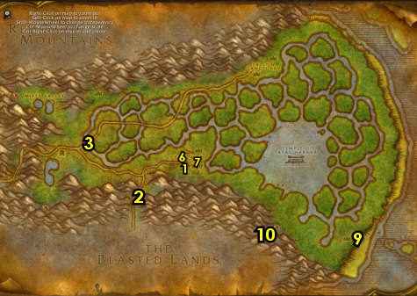

01) At the middle of the shore of SoS, do part of "Ledger from Tanaris": kill/loot Jarquia (around 95.52, /target), he drops the Goodsteel's Balanced Flameberge.
02) Hearth to Stonard. Make sure you are repaired/resupplied.
03) Go SW on the main path and from Fallen Hero of the Horde 34.66 turn in "The Swamp Talker", accept and do "A Tale of Sorrow" by simply talking to the NPC. Then turn it in, SKIP "The Stones That Bind Us" (for now).
04) Back at Stonard, go to the Wind Rider Master 46.55 and fly to Booty Bay, Stranglethorn...
05) Drop down in the Inn at BB and accept "Whiskey Slim's Lost Grog" 27.77.
06) Get on the boat at the end of docks 26.73 to go to Ratchet. NOTE: If the boat is not there yet you can do the next step at BB's Bank!
07) Once at Ratchet, go to the Bank 63.37 and put the following items into it: Torch of Retribution (can be used as a future light source), Black Dragonflight Molt, and any of Dark Iron Scraps or Core of Elements you may have. Get out of the bank: Yeh'kinya's Bramble, Wastewander Water Pouches and Hippogryph Egg.
08) Go to the Flight Master at Ratchet 63.37 and fly to Brackenwall Village, Dustwallow Marsh.
#38
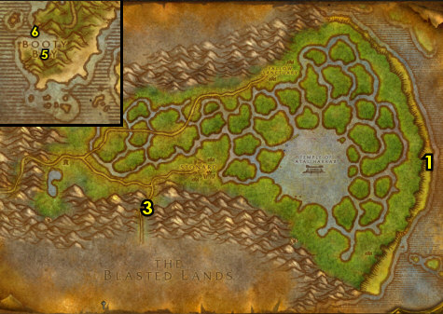

49-49 Dustwallow Marsh (log)
01) Once at Brackenwall Village, go in the small cave and accept "The Brood of Onyxia" 37.33.
02) Go SE to the crashed zeppelin and do the last part of "Ledger from Tanaris": loot the Damaged Crate 54.56 for the Overdue Package.
03) Go south and do "The Brood of Onyxia": look for the red steam nests holding the Eggs of Onyxia and click on them to destroy them. There is one at 54.73, and another one at 48.74.
04) Go west to Bloodfen Burrow (small cave) and click on the Musty Scroll 31.66 to turn in "Cortello's Riddle", accept the next part.
TBC, 4a) Go to the Flight Master 43.72 at Mudsprocket and fly to Brackenwall Village, Dustwallow Marsh.
05) Go in the small cave and turn in "The Brood of Onyxia" (37.33, #1 on map).
06) GROUP 2+ Players: From Overlord Mok'morokk by the Bonfire 36.31, accept and do "Challenge Overlord Mok'Morokk" by beating him to a duel. You only need to get his health down to 1/3 left.
07) Turn in (if you did it) "Challenge Overlord Mok'Morokk" (in the small cave 37.33, #1 on map).
08) Go to the Wind Rider Master 36.32 and fly to Gadgetzan, Tanaris.
#39
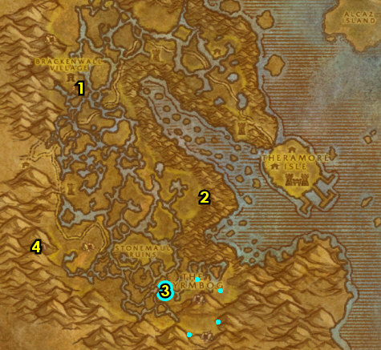

49-50 Tanaris (log)
01) As you enter Gadgetzan (next to the crane 52.27), accept "Thistleshrub Valley".
01a) Go to the Egg-O-Matic machine 52.27 in Gadgetzan (next to the teleporter), and turn in your Hippogryph Egg for "The Super Egg-O-Matic" quest (additional eggs do not yield XP). NOTE: You can turn in different types of eggs at the NPC next to the machine for a non-XP reward.
02) Behind the Inn, next to the Bonfire, accept "The Dunemaul Compound" 53.27.
03) Go in the Inn and make Gadgetzan your new home 53.28.
05) Next to the Inn/Bank at the windmill 52.29, turn in "Into the Field", accept and complete "Slake That Thirst". Do not accept the quest from the item received yet, this will be done later.
07) Next to the AH, accept "The Thirsty Goblin" 52.29.
08) Next to the Forge, turn in "Ledger from Tanaris" 51.29.
09) On the western side of Gadgetzan, up on the hill, accept "Noxious Lair Investigation" 50.27.
10) Go south to the Broken Pillar and turn in "The Sunken Temple" 53.46, accept "The Stone Circle". Also accept "Gahz'ridian".
11) Go SW and do part of "The Dunemaul Compound": kill Gor'marok the Ravager (in the small cave 41.58).
12) Go south to Southmoon Ruins around 40.72 and do "The Dunemaul Compound" along with "Gahz'ridian": kill 10 Dunemaul Brutes and 10 Dunemaul Enforcers. Also loot the Gahz'ridian from the ground. TIP: You can equip the Gahz'ridian Detector helm to help you see the Gahz'ridian on the minimap. Also, there is another area of mobs, but with less Gahz'ridian, around 47.65.
#43
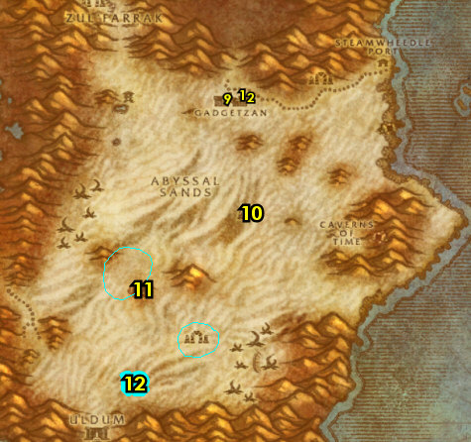

01) Go west to The Noxious Lair around 35.48 and do "Noxious Lair Investigation": kill/loot the Centipaar bugs, and any of them can drop the insect parts.
02) Go south to Thistleshrub Valley around 30.65 and do "Thistleshrub Valley" along with "The Thirsty Goblin": kill 8 Gnarled Thistleshrubs and 8 Thistleshrub Rootshapers. Also kill/loot the Thistleshrub Dew Collectors /target for the Laden Dew Gland (low drop rate).
03) At the Thistleshrub Valley (32.74 or 29.63) accept and do the escort quest "Tooga's Quest": escort Tooga /target (turtle) NE to Torta (At next step):
04) Once at Torta 67.26, turn in "Tooga's Quest".
05) Just north of you at Steamwheedle port, go in the southern hut and accept "Yuka Screwspigot" 67.24.
06) North at Steamwheedle Port turn in "Screecher Spirits" 67.22, SKIP "The Prophecy of Mosh'aru" (Zul'Farrak Dungeon).
07) Hearth to Gadgetzan. Make sure you are repaired/resupplied.
08) Next to the AH, turn in "The Thirsty Goblin" 52.29, accept "In Good Taste".
09) At Sprinkle 51.27 (NW hut), turn in "In Good Taste", accept "Sprinkle's Secret Ingredient".
10) In the hut next to you, turn in "Noxious Lair Investigation" 51.27.
11) Next to the crane near the Gadgetzan entrance, turn in "Thistleshrub Valley" 52.27.
12) Behind the Inn, next to the Bonfire, turn in "The Dunemaul Compound" 53.27.
13) Go to the Gadgetzan Bank 52.29 (SE hut) and get the following items out: Field Testing Kit and (if you have it) OOX-17/TN Distress Beacon.
14) On the western side of Gadgetzan, up on the hill, accept "The Scrimshank Redemption" 50.27.
#44
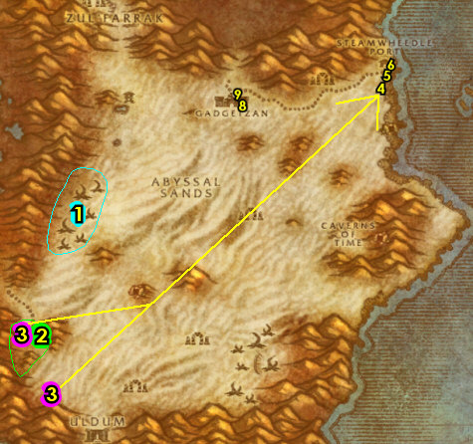

01) From the item Model 4711-FTZ Power Source in your inventory, accept and do "Tanaris Field Sampling": start killing beasts just south of Gadgetzan. You need to kill/loot any Basilisks, Hyenas, and Scorpids. You will find these beasts all around the open fields of Tanaris. You only have 2 hours to do this and the next few steps, so work quickly. While doing this, do the following 3 steps as well:
02) Grind your way down south to the Broken Pillar and turn in "Gahz'ridian" 53.46.
03) N/A
04) If you have the item OOX-17/TN Distress Beacon, from it accept "Find OOX-17/TN!". Then turn this in at 60.65. NOTE: The chicken escorts are skipped for TBC/SOM.
05) Make sure "Tanaris Field Sampling" is complete. Then go SE to The Gaping Chasm and do "The Scrimshank Redemption": go in the specific cave entrance 56.69 and keep making right turns in the cave, which will lead you to the item you need to loot.
06) Hearth (if you can), or Die on purpose, then head north to get back to Gadgetzan.
07) Next to the Inn at the windmill 52.29, turn in "Tanaris Field Sampling", accept "Return to Apothecary Zinge". You can then destroy the Model 4711-FTZ Power Source item if it remains in your inventory.
08) On the western side of Gadgetzan, up on the hill, turn in "The Scrimshank Redemption" 50.27, accept "Insect Part Analysis".
09) In the hut NW in Gadgetzan, turn in "Insect Part Analysis" 51.27, accept the next part.
10) Go back to the western side of Gadgetzan, up on the hill (50.27, #8 on map) and turn in "Insect Part Analysis". Accept "Rise of the Silithid".
11) Make sure you are level 50, grind on any mob until you are.
12) Go to the Wind Rider Master (north of Gadgetzan 52.25) and fly to Orgrimmar, Durotar.
13) Go in Orgrimmar's Inn and make it your new home 54.68. And from the Innkeeper, accept "Assisting Arch Druid Runetotem". Make sure you are resupplied.
14) Go to the Bank 50.69 and get the following items out: Sealed Letter to Ag'tor, Box of Empty Vials.
GET NEW ABILITIES, 14b) Get your level 50 spells/abilities.
15) Go up to the Wind Rider Master 45.64 and fly to Splintertree Post, Ashenvale.
16) Follow the main path east into Azshara entrance 95.48.
50-50 Azshara (log)
First Pick the Class you are playing top left of screen!!!
Along with the Game Version you are playing on (Era, SoM, TBC or WotLK)
01) Head NE to Valormok, Azshara, and turn in "Betrayed" 22.51, SKIP the next part.
TBC, 1b) From Jediga accept "Stealing Knowledge" 23.51.
03) Go east to the Ruins of Eldarath around 37.53 and do "Stealing Knowledge": loot the 4 tablets, they are scattered around the ruins (see map for possible spawn locations).
04) Go east to Southridge Beach and do "Seeping Corruption": open your Box of Empty Vials to get your 4 Vials out, then go to the 4 tide pools and use your vials at each of them. Fill Vial #1 at Tide Pool #1 48.61. See next steps for the other three:
05) Go north to Tide Pool #2 to fill Vial #2 48.51.
06) Go north to Tide Pool #3 to fill Vial #3 49.48.
07) Go north to Tide Pool #4 to fill Vial #4 47.46.
08) Go back to Valormok at Jediga (23.51, #1 on map) and turn in "Stealing Knowledge". Accept ALL 4 Delivery quests from her.
09) You can get resupplied at Valormok from Kurll 22.52. Or repaired from Gruul Darkblade /target 22.51.
10) N/A
11) Go east to Sanath Lim-yo (28.50, #2 on map) and turn in "A Meeting with the Master". Then click on him again to teleport you to see his master. Once teleported, go up the path and go up in the tower to Archmage Xylem /target to turn in "Delivery to Archmage Xylem", accept "Xylem's Payment to Jediga".
12) Drop down in the tower to leave it and go back down the path to Nyrill 26.46 and have him teleport you back down.
13) Go west to Valormok and from Jediga turn in "Xylem's Payment to Jediga"(23.51, #1 on map).
14) Go north in Valormok to the Wind Rider Master 22.50 and fly to Thunder Bluff, Mulgore.
#01
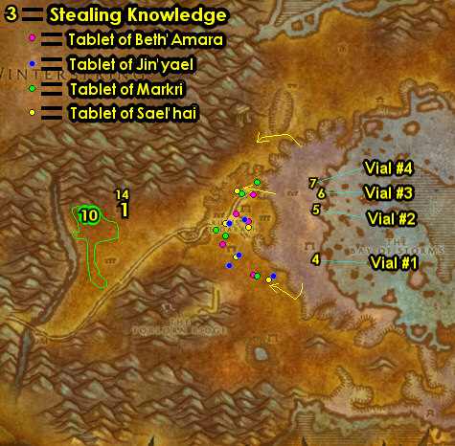

01) Go to The Elder Rise and turn in "Delivery to Magatha" 70.31, accept "Magatha's Payment to Jediga".
02) Go just east in the big tent and turn in "Assisting Arch Druid Runetotem" 79.29, SKIP "Un'Goro Soil" (for now).
03) Hearth to Orgrimmar.
03b) Check the AH 54.64 for a Mithril Casing and if you are able to get it, store it in your bank for now for a later quest at Un'goro Crater.
04) Go to the Bank 50.69 and get the following items out: Bundle of Atal'ai Artifacts. Also get out (if you need to) 60 Silk Cloth and 60 Mageweave Cloth (for cloth donations to the Orc faction).
05) Go to The Drag and up in the hut turn in "Rise of the Silithid" 56.47. Accept "March of the Silithid".
06) Drop down to Magar's Cloth Goods and turn in the cloth donations you have to the Orc's Horde Cloth Quartermaster 64.51.
07) North in The Drag (up in Yelmak's Alchemy and Potions), turn in "Delivery to Jes'rimon" up 56.34, accept "Jes'rimon's Payment to Jediga". Also accept "Bone-Bladed Weapons".
08) IF YOU HAVE IT: In Droffers And Sons Salvage, turn in "Ripple Delivery" 59.37 , SKIP "Necklace Recovery".
09) If you need to, get new spells/abilities.
#02
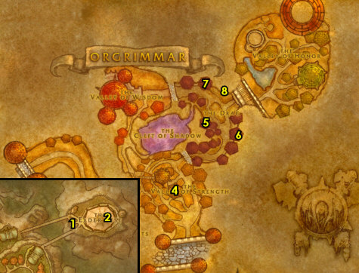

01) Leave Orgrimmar south and get on the zeppelin (51.14 in Durotar) to go to The Undercity.
02) Once at the UC, head to The Apothecarium and turn in "Delivery to Andron Gant" 55.76, accept "Andron's Payment to Jediga".
03) Go down in The Apothecarium entrance 52.81 and turn in "Seeping Corruption" 49.71. Wait a few seconds, and accept the next part. Then right next to you (at the female tauren), turn in "Seeping Corruption". Then next to you at Chemist Cuely, turn it in again.
04) In the same room, turn in "Return to Apothecary Zinge" 50.68. Accept "Vivian Lagrave". NOTE: After turning this in, if the Field Testing Kit remains in your inventory you can destroy it.
05) Across the same room from Chemist Fuely 47.73, accept "A Sample of Slime..." and "... and a Batch of Ooze".
06) Go to the Bat Handler 63.49 and fly to Tarren Mill, Hillsbrad.
#03
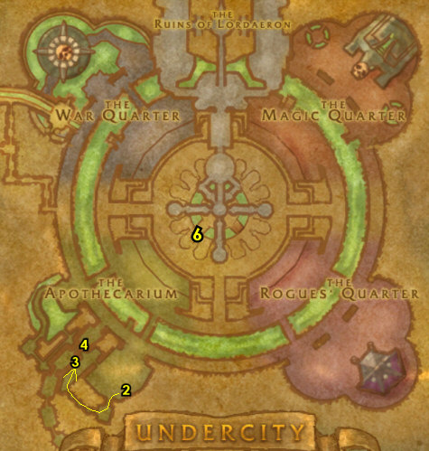
50-51 Hinterlands (log)
01) Go into the Hinterlands (entrance at 89.27 in Hillsbrad Foothills).
02) Go up to Shindigger's Camp and turn in "Ripple Recovery" 27.49, SKIP "A Sticky Situation".
03) Go south to Shadra'Alor, to the top of the temple entrance 36.65, then drop down and turn in "The Atal'ai Exile" 34.75 (See Video on where to find this dude at), SKIP "Return to Fel'Zerul".
04) Go north to Valorwind Lake 41.59 and do "Sprinkle's Secret Ingredient": under the water loot a Violet Tragan (mushroom).
05) N/A
06) Go east to Revantusk Village and on the docks accept "Snapjaws, Mon!" and "Gammerita, Mon!" 80.82.
07) In the Inn accept "Lard Lost His Lunch" 78.81. Make sure you are repaired/resupplied. NOTE: Maintain hearthstone with Orgrimmar!
08) Just north of Revantusk Village along the shore, do "Snapjaws, Mon!" along with "Whiskey Slim's Lost Grog": kill Saltwater Snapjaws (turtles) and loot the Pupellyverbos Port (blue bottles on the ground). Do the next step as well at the same time as these:
09) Do "Gammerita, Mon!": kill/loot Gammerita /target. This lvl 48 turtle patrols up and down the shore line. He spawns just south of the waterfall/shore (underneath #6 on map).
10) Go north and right underneath the waterfall 81.47, loot Cortello's Treasure chest to turn in "Cortello's Riddle" (14 slot bag along with 6100 XP)!
11) Go to the little island NE and do "Lard Lost His Lunch": loot Lard's Picnic Basket 84.41 and then kill/loot the two lvl 49 trolls that spawn, you will get Lard's Lunch from the first one you loot.
#05
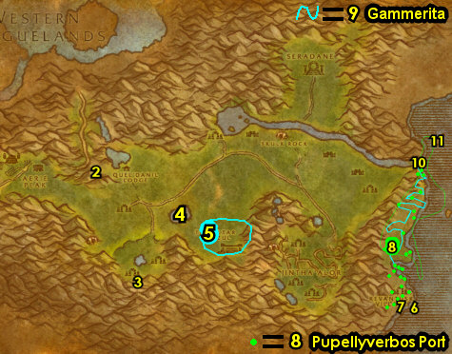
01) Go in the Inn and turn in "Lard Lost His Lunch" 78.81.
02) On the docks, turn in "Snapjaws, Mon!" and "Gammerita, Mon!" 80.82.
04) Hearth to Orgrimmar. Make sure you are repaired/resupplied.
05) Go up to the Wind Rider Master 45.64 and fly to Valormok, Azshara.
06) Once at Valormok, Azshara, from Jediga 23.51 turn in the 3 Delivery quests: "Magatha's Payment to Jediga", "Jes'rimon's Payment to Jediga" and "Andron's Payment to Jediga".
07) Go north in Valormok to the Wind Rider Master 22.50 and fly to Ratchet, The Barrens.
08) At Ratchet do "The Stone Circle": just right outside of Liv Rizzlefix's hut (at the entrance 62.39), loot Marvon's Chest. Also, go in Liv Rizzlefix's hut and accept "Volcanic Activity".
#07
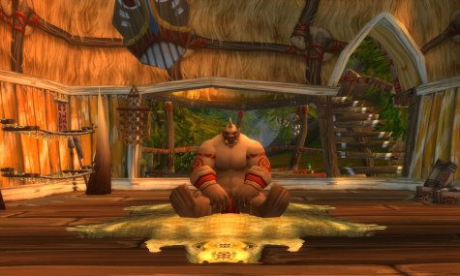

01) Go in the Inn and make Ratchet your new home 62.39.
02) Stop at Ratchet's Bank 63.37 and put the following items into it: stack of Pupellyverbos Port.
#08
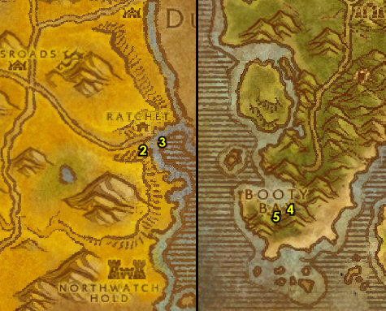

51-51 Blasted Lands
PLEASE READ: With all the faster leveling changes, by the time you get to this section you will most likely be well into level 51+. Because of this when following my guide, you should skip this entire section and go right into the section right before 51-53 Un'Goro Crator below. I will leave this section for reference purposes only. However if for some reason you are still level 50 you can consider doing this section. If you are NOT doing this section then abandon (if you have any of them): "The Stones That Bind Us".
01) Go up in the Inn on the roof and from the Wind Rider Master 27.77 fly to Stonard, Swamp of Sorrows.
02) Follow the main path SW and from the Fallen Hero of the Horde 34.66 accept "The Stones That Bind Us".
03) Head south into Blasted Lands...
04) As you enter Blasted Lands go to the small quest hub at 51.14. Accept all 5 quests there. These 5 quests requires the following total number of items to complete them. The items needed can drop without needing to accept the quests. The color codes below show where the mobs are at on the images and stars represent rare mobs that may not be there. Work on the rest of this section all at once):
Mob - Total Items Needed - After "The Decisive Striker" - And then "Vulture's Vigor"
05) Vulture Gizzards =14 - 12 - 2
06) Basilisk Brain =11 - 11 - 11
07) Blasted Boar Lungs =6 - 5 - 5
08) Scorpok Pincers =6 - 3 - 3
09) Snickerfang Jowls =5 - 5 - 3
10) 2+ PLAYERS (or could be soloable): While grinding for these items, do "The Stones That Bind Us": drag the different servants close to their Stone of Binding crystal next to each of them, then kill them along with attacking the crystal as well. This allows you to actually kill the mob and get quest credit. Each of these different servants are located at different parts of the Blasted Lands. See map for locations. If for some reason you cannot solo this quest, it can be skipped.
11) While grinding make sure you get everything discovered for XP (including The Tainted Scar at 44.57).
12) As you get these items, you can turn the quests in for a 60 min stat reward that will help you grind faster in Blasted Lands or even for the next section Un'Goro Crater (although they don't stack). I recommend only showing the quests on screen that you want the rewards first. Go to the quest hub (at 51.14, #1 on map) and turn in all 5 of these quests: "Snickerfang Jowls" (+25 Strength), "A Boar's Vitality" (+25 Stamina), "The Decisive Striker" (+25 Agility), "The Basilisk's Bite" (+25 Intellect) and "Vulture's Vigor" (+25 Spirit). NOTE: The follow up quests do NOT yield XP: "Rage of Ages", "Spirit of the Boar", "Salt of the Scorpok", "Infallible Mind", and "Spiritual Domination".
13) While questing in Blasted Lands, you may have came across an item called Imperfect Draenethyst Fragment, turn these in at 52.36 for the quest "Everything Counts In Large Amounts". NOTE: I have NEVER found a Flawless Draenethyst Sphere for the quest "To Serve Kum'isha" ..good luck on that. Also, the follow up quest "One Draenei's Junk" is repeatable but yields no XP.
14) Go to the border of Blasted Lands and SoS, to the Fallen Hero of the Horde (34.66 in SoS) and turn in (if you did it) "The Stones That Bind Us", SKIP "Kirith". Accept "Heroes of Old".
15) Next to you on the other side of the path, turn in (if you have it) "Heroes of Old" (33.66 in SoS), accept the next part. Then click on the Spectral Lockbox on the ground next to you to turn it in.
16) Hearth to Ratchet. NOTE: If you did not do "The Stones That Bind Us", then abandon the quest.
17) At Ratchet's Bank 63.37, get the following items out: Violet Tragan and (if you have it) Stone Circle.
18) Go into Ironzar's Imported Weaponry to get repaired/resupplied from Ironzar 62.37. You can destroy any remaining unsellable Blasted Lands beast items you have (or bank them if you want).
#09
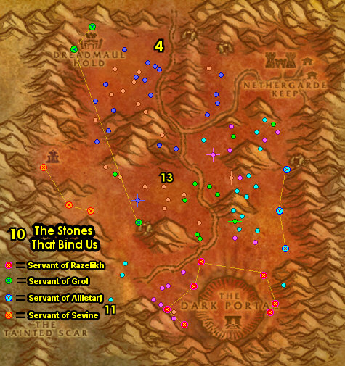

51-53 Un'Goro Crater
01) Go to the Flight Master 63.37 and fly to Gadgetzan, Tanaris.
02) As you enter Gadgetzan (next to the crane 52.27), accept "Super Sticky".
03) At Sprinkle (by the NW hut 51.27), turn in "Sprinkle's Secret Ingredient". Wait a few seconds (do next step while waiting) then accept "Delivery for Marin".
04) In the hut next to you, turn in "March of the Silithid" 51.27, accept "Bungle in the Jungle".
05) Next to the AH, from Marin Noggenfogger 52.29, turn in "Delivery for Marin". NOTE: "Noggenfogger Elixir" can take up to a minute for the NPC to make the item for you, it does not yeild any XP, so you can do this when you are not in a hurry (such as after level 60). The Noggenfogger Elixir item is used for fun and can be stored in the bank when you want to use it.
06) At the Bank 52.29, get out: (if you have it) Mithril Casing (this item may be in your mailbox 52.28), this is used for a quest in Un'Goro Crater, and remember to not sell this to a vendor. You can also check the neutral AH in Gadgetzan for it as well.
07) Head south to the Broken Pillar and turn in "The Stone Circle" 53.46.
08) Go SW into Un'Goro Crater (entrance at 27.54 in Tanaris)...
#10
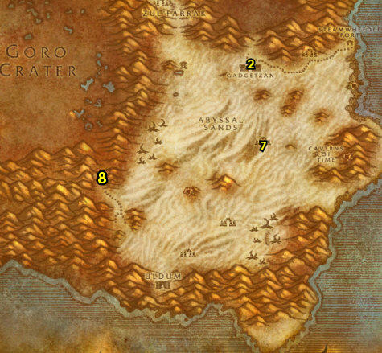

(log)
01) At the bottom of the path into Un'Goro Crater, go up the hill next to the waterfall 72.76 and accept "The Apes of Un'Goro" and "The Fare of Lar'korwi".
WOTLK, 1b) Just down the hill a bit, accept "Toxic Tolerance" 71.74.
02) Go north a bit and do "The Fare of Lar'korwi": loot the big Fresh Threshadon Carcass lying on the ground 69.57.
03) Grind north to the entrance of Marshal's Refuge and accept "Chasing A-Me 01" 46.13. While on your way, also start collecting crystals (the red, blue, green and yellow) scattered everywhere. Kill/loot oozes too!
04) Go up into Marshal's Refuge and accept ALL quests there: From the goblin on top of the hill, accept "Shizzle's Flyer" 44.12.
05) Move into Marshal's Refuge 44.8 and accept "Lost!", (from the Wanted Sign Beware of Pterrordax) "Beware of Pterrordax".
06) Make sure you are repaired/resupplied 43.8.
07) Next to you accept "Roll the Bones" 43.7.
08) Next to you 44.7 accept "Alien Ecology" and "Expedition Salvation". NOTE: If you have already found A Mangled Journal, accept and turn in "Williden's Journal".
09) On the east side of Marshal's Refuge behind the hill, accept "Larion and Muigin" 46.9.
10) Time to do the Un'Goro Grind! NOTES For the Grind:
- Don't worry about looting the Un'Goro Dirt Piles, you will find enough Un'Goro Soil from mob drops. Also do not sell the Un'Goro Soil to vendors, you will need these for quest turn-ins!
- Don't worry about looting the Bloodpetal Sprouts, as they are not turned in for any XP.
- The Dinosaur Bones you need for the quest "Roll the Bones" will drop from many different mobs as you do the other quests.
- As your questing, kill/loot Oozes (slimes) you see, and collect15 Ooze samples (15 is the max you can hold for WOTLK), this is for "... and a Batch of Ooze". These Oozes are scattered all around Un'Goro Crater.
- Also while questing, loot 7 crystals of each color (red, blue, green, and yellow) for a later quest. These crystals are scattered all around Un'Goro Crater.
- The Bloodpetel mobs (plants) drop Savage Fronds, you could collect 30 of these for a later quest at lvl 59. As you are doing the Un'Goro quests associated with these mobs you should get about half, so grind on these that you see along the way and see what you can get before leaving Un'Goro Crater, and you could always check the AH for more of these, or just skip this entirely.
- Watch out for the Elite Devilsaurs patrolling around this zone. I highlighted them through out the images so you can be alerted if you are in a danger zone for them.
#11
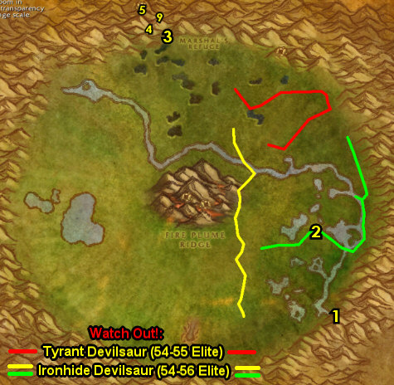

LET THE GRIND BEGIN:
01) Just south of Marshal's Refuge around 46.16 do "Super Sticky": kill/loot the Tar mobs around the tar pits.
02) Go NE to Fungal Rock and start working on "The Apes of Un'Goro": kill/loot the apes (in and outside of the cave). Also go in the cave entrance 64.16 and then make a right and turn in "Chasing A-Me 01" 68.17, then if you have a Mithril Casing with you, accept and turn in "Chasing A-Me 01". Then accept and do the escort "Chasing A-Me 01": escort A-Me 01 to Marshal's Refuge, and then turn it in once you get there.
03) Start working on "Larion and Muigin": kill Bloodpetal Flayers around the north-middle of Un'goro Crater. NOTE: These mobs are also found south-middle as well, so you don't need to finish all of this now, work your way to the next step..
04) Go up on the mountain ledge (ramp entrance at 55.12) and start working on "Shizzle's Flyer": kill/loot the Pterrordax /target. There are only 6 mob spawns here, so clear the area once and move on to the next step..
05) Make sure "The Apes of Un'Goro" is finished: kill/loot the apes (in and outside of the cave around 64.16, #2 on map).
06) Do the next part of "Larion and Muigin": kill Bloodpetal Lashers and Threshers around the NE side of Un'goro Crater. Also, kill/loot any Dinosaurs you see for part of "Shizzle's Flyer" (don't need to finish it now though). Keep the next step in mind:
07) Go SE and do part of "Expedition Salvation": under the tent, loot the Crate of Foodstuffs 69.37.
08) Finish up killing the Bloodpetal Flayers for "Larion and Muigin" by starting below the river around 61.48 and work you way south. Kill/loot any Diemetradon you see as well for "Shizzle's Flyer". NOTE: Try to avoid the Raptors as you will be grinding them soon with more quests associated with them.
09) Grind your way SE to Torwa Pathfinder on top of the hill by the waterfall and turn in "The Apes of Un'Goro" 72.76. Accept "The Mighty U'cha". And turn in "The Fare of Lar'korwi", accept "The Scent of Lar'korwi".
#12
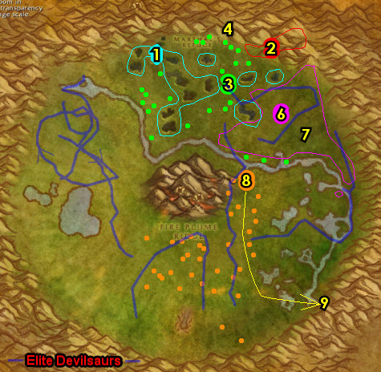

01) Just to the west of you at The Marshlands do "Bone-Bladed Weapons" along with "The Scent of Lar'korwi": kill/loot raptors and to get the Ravasaur Pheromone Glands you need, run across the egg nests (there is 5 total: 67.73 63.77 67.67 61.72 62.66) and then kill/loot the Lar'korwi Mates that spawn in. Keep the next step in mind:
WOTLK, 1b) Also more north in the raptor area around 69.53 do "Toxic Tolerance" by letting the Venomhide Ravasaurs /target (darker colored ones) spit poison on you 20 times.
02) At The Marshlands, at the western most pond, north on it's shore, click on A Wrecked Raft 63.69 to accept "It's a Secret to Everybody". Then right next to the wrecked raft, under the water, click on A Small Pack to turn in "It's a Secret to Everybody", accept the next part. NOTE: To free up bag space, do NOT loot A Small Pack yet!
WOTLK, 2b) Just down the hill a bit, turn in "Toxic Tolerance" 71.74, accept "Venomhide Eggs".
03) Go east to Torwa Pathfinder on top of the hill by the waterfall and turn in "The Scent of Lar'korwi" 72.76, accept "The Bait for Lar'korwi". NOTE: To free up bag space, do NOT loot A Small Pack yet!
WOTLK, 3b) Around the raptor area around 67.73 do "Venomhide Eggs": loot 4 Venomhide Eggs (around the little nests as with previous quest), see Questie locations on map.
WOTLK, 3c) Turn in "Venomhide Eggs". NOTE: "They Grow Up So Fast" can be done if you like, but requires items you would need to search around for, also costs 80 gold. But this can reward you with a new epic Whistle of the Venomhide Ravasaur mount.
04) Go west to The Slithering Scar and do "Alien Ecology" along with "Bungle in the Jungle": enter the cave entrance 50.81. Make a left in the cave and then use your Unused Scraping Vial quest item on the mound in the center of the room. And keep kill/looting the Gorishi bugs until you get the Gorishi Scent Gland (can drop from any of them, but has a low drop rate). These bugs can be found in and outside of the cave.
05) Go south up at the ledges around 56.90 to continue obtaining the Webbed Pterrordax Scales (you will be able to get more of these later) for "Shizzle's Flyer". There is another spot of these mobs around 45.90.
06) Grind NW a bit to the old camp site 38.66 and do the last part of "Expedition Salvation": loot the Research Equipment (looks like a stack of brown boxes next to a tent).
07) All around the western side of Un'Goro Crater, finish up "Larion and Muigin" (kill Bloodpetal Trappers) along with finishing up "Beware of Pterrordax", "Shizzle's Flyer" and "Roll the Bones" (kill/loot Frenzied Pterrordax). The Dinosaur Bones can also drop from Elder Diemetradon and regular Diemetradon mobs (found south-middle). Keep the next step in mind:
08) At the Golakka Hot Springs (below the hotspring mountain), accept "Finding the Source" 31.50.
#13
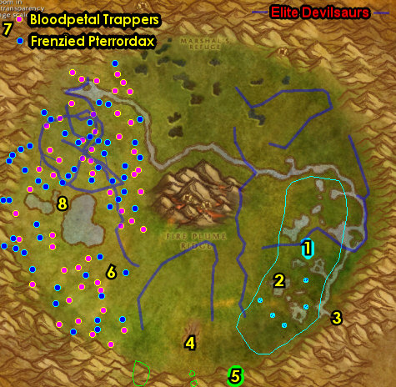

01) Do "Volcanic Activity" along with "Finding the Source". First go to the north entrance at Fire Plume Ridge (spiky bridge entrance at 53.43). Follow the path upwards to the top and use Krakle's Thermometer quest item at the Fire Plume Ridge Hot Spot (the one at 50.46). Watch out for the lvl 56 Elite mob in the cave at the top of the Ridge. Also kill/loot the fire elementals around Fire Plume Ridge for the 9 Un'Goro Ash and to start collecting Core of Elements for a future quest (I recommend at least getting about 10 for now).
02) Make sure all the quests above are done, including obtaining 7 crystals of each color (red, blue, green, and yellow), then go to the small cave at the eastern side of Fire Plume Ridge and turn in "Lost!" 52.50.
03) Accept and do the escort "A Little Help From My Friends": escort Ringo /target back to Marshal's Refuge 44.9. You will need to use the quest item Spraggle's Canteen on Ringo to wake him up if he faints.
04) Turn in ALL quests at Marshal's Refuge and accept new ones: Turn in "Shizzle's Flyer" (on top of hill 44.12).
05) turn in "A Little Help From My Friends" and "Beware of Pterrordax" 44.9.
06) Make sure you are repaired/resupplied 43.8.
07) Next to you turn in "Roll the Bones"43.7.
08) Next to you 44.7 turn in "Alien Ecology", "Expedition Salvation" and (if you haven't yet) accept and turn in "Williden's Journal" from the item A Mangled Journal (this item/quest is obtained while killing any mob in Un'Goro Crater that should be in your inventory by now).
09) Enter the cave at Marshal's Refuge entrance 43.6 and at the very end of the cave accept and turn in "Crystals of Power" 42.3. Then accept the 3 Pylon quests: "The Northern Pylon", "The Eastern Pylon" and "The Western Pylon". You can destroy any remaining crystals in your inventory (to free bag space).
10) Open and loot A Small Pack in your inventory and then go to Linken (in the middle of Marshal's Refuge behind some trees 45.8) and turn in "It's a Secret to Everybody", accept the next part. NOTE: The Faded Photograph is not needed and will remain in your inventory forever unless you destroy or bank it.
11) At the eastern side of Marshal's Refuge behind the hill, turn in "Larion and Muigin" 46.9, accept "Marvon's Workshop".
#14
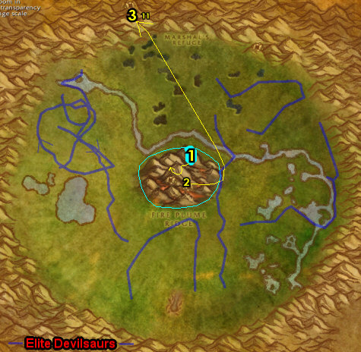

01) Go east up on the ledges and do "The Northern Pylon": click on the Northern Crystal Pylon 57.13.
02) Go east to Fungal Rock and do "The Mighty U'cha": enter the cave entrance 65.16, then keep left in the cave until you get to U'cha (lvl 55 red colored ape) and kill/loot him.
03) On the eastern side of Un'Goro Crater, go up on the ledges and do "The Eastern Pylon": click on the Eastern Crystal Pylon 77.50.
04) Just to the east of you on the mountain ledges there, do "The Bait for Lar'korwi": at the old dinosaur bones, there is a gray flat rock on the ground at 80.50. At this spot open your Torwa's Pouch quest item and first use the Preserved Threshadon Meat quest item, then use the Preserved Pheromone Mixture at this spot, then kill/loot Lar'korwi that spawns in (See Video).
05) Go south to Torwa Pathfinder on top of the hill by the waterfall 72.76 and turn in "The Bait for Lar'korwi" and "The Mighty U'cha".
06) Go west (kill/looting oozes along the way if you still need to get the 15 Slime samples) and up on the mountain ledges do "The Western Pylon": click on the Western Crystal Pylon 24.59.
07) Go NE to Golakka Hot Springs (below the hotspring mountain) and turn in "Finding the Source" 31.50, accept "The New Springs".
08) Grind your way back north to Marshal's Refuge entrance 46.13. Make sure you get all 15 Un'goro Slime Samples along the way by kill/looting oozes (slimes). Also at this time see if you can obtain 30 Savage Fronds from the Bloodpetel mobs (plants all around Un'Goro), 30 of these can be used for a later quest at lvl 59. If you are still far behind on that then don't worry about it, you may find more in the AH (or just skip it).
09) Enter the cave at Marshal's Refuge entrance 43.6 and work your way to the end of the cave and turn in "The Northern Pylon", "The Eastern Pylon" and "The Western Pylon". Then accept and turn in "Making Sense of It". NOTE: The Crystal Pylon User's Manual can be destroyed or saved in your bank for later reference and you can always get a new one from this NPC in the cave.
10) Leave the cave, make sure you are repaired/resupplied 43.8.
11) Go up on the eastern side of Marshal's Refuge, to the Flight Master 45.6 and fly to Gadgetzan, Tanaris.
#15
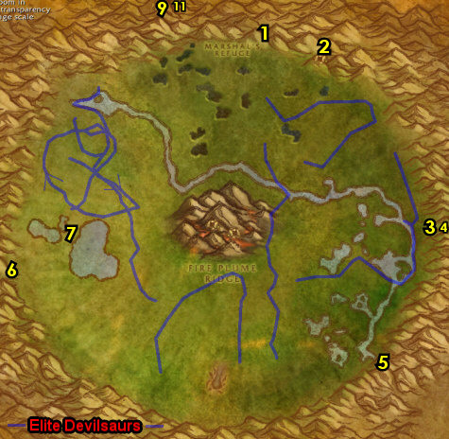

01) As you enter Gadgetzan (next to the crane) turn in "Super Sticky" 52.27.
02) In the NW hut, turn in "Bungle in the Jungle" 51.27.
03) Go to the Wind Rider Master 52.25 (north of Gadgetzan) and fly to Thunder Bluff, Mulgore.
04) Go to Elder Rise and from Arch Druid Hamuul Runetotem, accept "Un'goro Soil" 79.29.
05) On the north side of Elder Rise, turn in "Un'goro Soil" 77.22.
06) Go back to Arch Druid Hamuul Runetotem and accept "Morrowgrain Research" (79.29, #4 on map).
07) Go to Bashana Runetotem at Elder Rise in the hut by the bridge and turn in "Morrowgrain Research" 71.34, SKIP the next part.
WOTLK, 8b) If you need to, you can upgrade First Aid from the First Aid Trainer 30.21 on The Spirit Rise. NOTE: Heavy Mageweave Bandage requires skill 240, Runecloth Bandage skill 260 and Heavy Runecloth Bandage skill 290.
09) Hearth to Ratchet.
10) In Liv Rizzlefix's hut 62.39, turn in "Marvon's Workshop", SKIP "Zapper Fuel" (Dungeon quest). Also turn in "Volcanic Activity".
11) NOTE: IF the boat is already at the docks then do this step at BB's Bank instead: At the Ratchet Bank 63.37 get the following items out: stack of Pupellyverbos Port, Black Dragonflight Molt and your stack of Dark Iron Scraps. And put the following items in the bank: stack of Un'Goro soil, Un'goro Slime Samples, stack of Savage Fronds, Linken's Training Sword, 8 White Ravasaur Claws and any Core of Elements in there (to free up bag space).
12) Go to the end of the docks at Ratchet 64.39 to get on the boat to go to BB.
13) Once at BB, go in the Inn and turn in (if you haven't yet) "Whiskey Slim's Lost Grog" 27.77.
13a) Go up in the Inn to the roof at the Wind Rider Master 27.77 and fly to Kargath, Badlands.
14) At Kargath, just outside of the Inn by the Bonfire, turn in "Vivian Lagrave" 3.48, SKIP "Lost Thunderbrew Recipe" (Dungeon).
15) Next to you, accept "The Rise of the Machines".
16) Find Thal'trak Proudtusk /target, he patrols south and east of Kargath (or could be chillin by the Bonfire). From him accept "Dreadmaul Rock". NOTE: Sometimes you must wait until he stops patrolling and then stands by the Bonfire 3.48 in order to accept this.
17) Go to the Wind Rider Master 4.45 and fly to Flame Crest, Burning Steppes.
#16
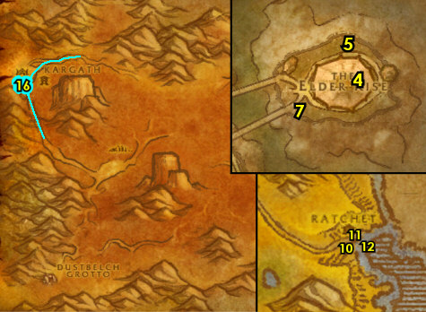

53-53 Burning Steppes (log)
01) Once at Flame Crest, under the red tent 65.24, accept: "Broodling Essence" and "Tablet of the Seven".
02) Go in the small cave and turn in "Yuka Screwspigot" 66.22, SKIP "Ribbly Screwspigot" (Dungeon).
03) Go east around 80.29 and do "Broodling Essence": use the Draco-Incarcinatrix 900 quest item on Broodlings (dragon whelps), then kill them and loot the Broodling Essence crystal that drops. Also throughout questing in Burning Steppes, kill any dragon whelps you see, they are squishy mobs that die real fast. Keep the next step in mind:
04) With the Black Dragonflight Molt with you, work your way east to the small cave 95.32 then accept and turn in "A Taste of Flame" (you will need to talk to him first after getting the quest), SKIP the next part (Dungeon quest).
05) Go up to the top of Dreadmaul Rock (bridge entrance at 76.38). Once at the top do "Dreadmaul Rock": click on Sha'ni Proudtusk's Remains 80.46 (laying on the table between four pillars). Then from the ghost of Sha'ni Proudtusk that spawns, turn in "Dreadmaul Rock", accept "Krom'Grul".
06) Do "Krom'Grul": find Krom'Grul /target inside one of the three caves at Dreadmaul Rock and kill/loot him. First check the small cave next to you at the top of Dreadmaul Rock 82.44. If he is not there, then check the other 2 caves SW entrance 77.47. For the cave on the eastern side NE entrance 82.39, keep making right turns until you get to him. ALSO: Make sure you collect a total of 30 Dark Iron Scraps, this will be used for a later quest. All the Ogres in Burning Steppes can drop them.
07) Go west to Ruins of Thaurissan around 67.38 and do "The Rise of the Machines": kill/loot War Reavers. Keep the next step in mind:
08) Do "Tablet of the Seven": loot the Tablet of the Seven 54.41 next to the dwarf statue.
09) Go to Flame Crest and under the red tent 65.24, turn in "Broodling Essence", accept "Felnok Steelspring". Also turn in "Tablet of the Seven".
10) Go to the Wind Rider Master at Flame Crest 66.24 and fly to Kargath, Badlands.
#17
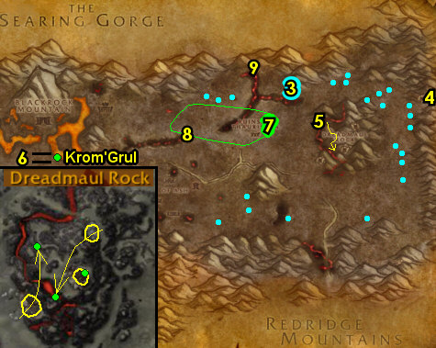

01) At Kargath, just outside of the Inn, turn in "The Rise of the Machines" 3.48, accept the next part. Find Thal'trak Proudtusk /target, he patrols south and east of Kargath (or could be chillin by the Bonfire). From him, turn in "Krom'Grul". Make sure you are repaired/resupplied.
02) Go east to The Dustbowl at the gnome and turn in "The Rise of the Machines" 26.45, SKIP the next part (Dungeon quest).
03) Hearth to Ratchet.
04) Go to the Ratchet Bank 63.37 and put the following items into it: 30+ Dark Iron Scraps, and any Core of Elements. And get the following items out: 8 White Ravasaur Claws, Tinkee's Letter and Linken's Training Sword. Also get out (if you have it) 60 Runecloth for cloth donation to the Orc faction coming up at Orgrimmar.
05) Go to the Flight Master 63.37 at Ratchet and fly to Orgrimmar, Durotar.
06) Go in the Inn at Orgrimmar and make it your new home 54.68.
#18
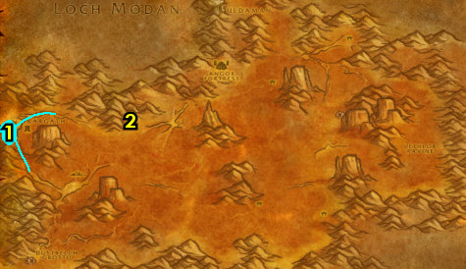

PLEASE READ: With all the faster leveling changes, by the time you get to this section you already be level 54 (or really close to it). Because of this when following my guide, you should skip this entire section and go right into the section right before 54-54 Felwood below. I will leave this section for reference purposes only. However if for some reason you are early into level 53 you can consider doing this section. If you are NOT doing this section then abandon (if you have it) "Betrayed".
53-54 Azshara
00) Go up to the Wind Rider Master 45.64 and fly to Valormok, Azshara.
01) Once at Valormok, accept "Betrayed" 22.51.
02) Go NE to the hill entrance 53.20...
03) Go up to the top of the hill and accept "Kim'jael Indeed!" 53.22.
04) Go south to Thalassian Base Camp and do "Kim'jael Indeed!" along with "Betrayed": kill the needed Blood Elves, loot Kim'jael's Equipment boxes on the ground and to Find Magus Rimtori's camp (go to 60.31).
05) At the same coordinates as previous step (60.31, #4 on map), from the Kaldorei Tome of Summoning (book on pedestal), turn in "Betrayed", accept the next part.
06) At that same spot, do the next part of "Betrayed": click on an Arcane Focusing Crystal to summon Magus Rimtori and kill/loot her. You may need to face some guards first so be prepared.
07) Go north to the hill entrance (53.20, #2 on map)...
08) Go up to the top of the hill and turn in "Kim'jael Indeed!" 53.22. Accept "Kim'jael's "Missing" Equipment".
#19
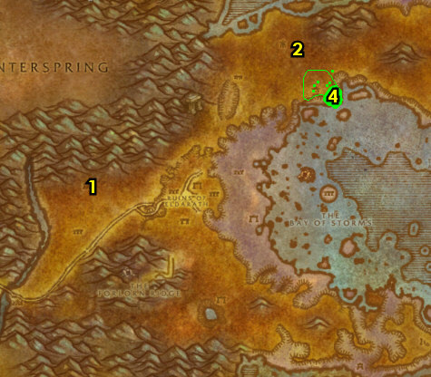

01) Drop down to The Shattered Strand 51.36 (be careful, its a long drop), then do "Kim'jael's "Missing" Equipment": kill/loot Spitelash naga until Some Rune drops (low drop rate).
02) Leave The Shattered Strand, (an exit is at 46.38, see map for more exits)..
03) Go to Valormok and turn in "Betrayed" 22.51, accept the next part. Make sure you are repaired/resupplied.
04) Head east to the hill entrance 53.20...
05) Go up to the top of the hill and turn in "Kim'jael's "Missing" Equipment" 53.22.
06) At this point you should almost be lvl 54. Grind the rest of the way to level 54.5 (10 bars into 54) on Blood Elves around Thalassian Base Camp around 58.28. NOTES: Blood Elves are squishy mobs (mobs that have 30% fewer health/armor, than the average mob that level), so they die relatively fast and yield good XP/hour. They also are a good farm spot for Runecloth, which you will need for cloth donations and First Aid. OPTIONAL: Instead of the grinding, you could go do BRD instance instead.
07) Hearth to Orgrimmar.
#20
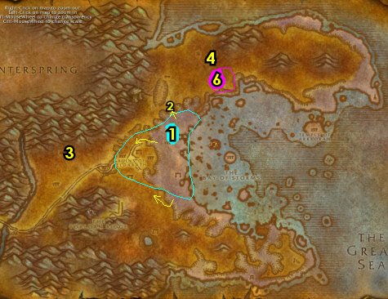

54-54 Felwood
02) N/A
03) Go NE to Magar's Cloth Goods and turn in the 60 Runecloth to the Orc's Horde Cloth Quartermaster 64.51.
04) Go north to The Drag (up in Yelmak's Alchemy and Potions) and turn in "Bone-Bladed Weapons" 56.34.
05) N/A
06) If you need to, get new spells/abilities. Make sure you are repaired/resupplied.
07) Go SW and up to the Wind Rider Master 45.64 and fly to Splintertree Post, Ashenvale.
08) Head north to Felwood (entrance at 56.28 in Ashenvale)..
#21
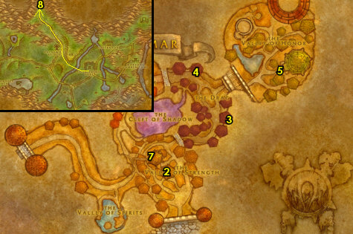

(log)
00) Go north a bit into Felwood to Emerald Sanctuary and get the FP from the Flight Master 52.82 (#1 on map).
01) Accept "Forces of Jaedenar" 51.82. And next to you in the tent, accept "Verifying the Corruption" 51.82.
02) To the west just off of the main path at Maybess Riverbreeze 47.83, accept "Cleansing Felwood".
03) Start working on "A Sample of Slime...": clear the Cursed Ooze mobs (slimes) at the two green pools (one at around 41.72, and another one at around 42.68). Eventually get 15 Felwood Slime Samples (once again, 15 is the max you can hold for WOTLK). You don't need to get all of them now.
04) Go north a bit to Jaedenar entrance 40.58 and do "Forces of Jaedenar": kill the required amount of Jaedenar mobs in the area.
05) Go north a bit around 40.56 and continue working on "A Sample of Slime...": kill/loot Tainted Oozes for getting at least 15 Felwood Slime Samples eventually. You don't need to get all of them now.
06) Follow Bloodvenom River in the middle of Felwood west to Bloodvenom Post 34.52 and accept "Well of Corruption". Then at 35.53 "Wild Guardians" and "A Husband's Last Battle".
07) Go up to the Wind Rider Master and get the FP there 34.54. Make sure you are repaired/resupplied.
08) Go east and finish up collecting at least 15 Felwood Slime Samples for "A Sample of Slime..." by kill/looting the Tainted Oozes, around Bloodvenom Falls around 41.45 (#5 on map).
#22
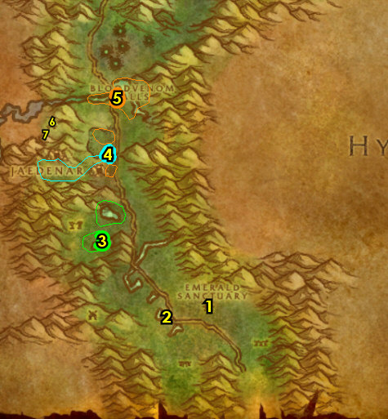

01) Go up north a bit on the east side of the path to Shatter Scar Vale around 41.42 and do "Verifying the Corruption": walk across one of the craters in the Vale to get it explored, and kill the required amount of Entropic fire elementals.
02) Follow the main path NE to Irontree Woods and do "Cleansing Felwood": kill/loot the Warpwood elementals. There is more mobs in the Irontree Cavern entrance 56.17.
03) N/A
04) Follow the main path NE (right before the Timbermaw Hold entrance) and accept "Deadwood of the North" 65.8.
05) Drop down west to Felpaw Village around 63.9 and do "Deadwood of the North": kill the needed Deadwood furbolgs.
06) Go back up to Nafien by the Timbermaw Hold entrance (65.8, #4 on map) and turn in "Deadwood of the North". Accept "Speak to Salfa". Also turn in any feathers you may have (repeatable quest to increase rep). NOTE: Becoming friendlier with Timbermaw Hold will allow you to enter their cave without them attacking you and allowing you to get additional quests and items from them.
07) Enter Timbermaw Hold next to you entrance 65.7 and go through the cave, make a right in the middle after the bridge to enter Moonglade up north.
08) Once in Moonglade, make a left and get the FP from the Wind Rider Master 32.67.
09) Exit Moonglade back to Timbermaw Hold (entrance 35.75 in Moonglade).
10) In Timbermaw Hold, make a right after the stairs to go into Winterspring..
#23
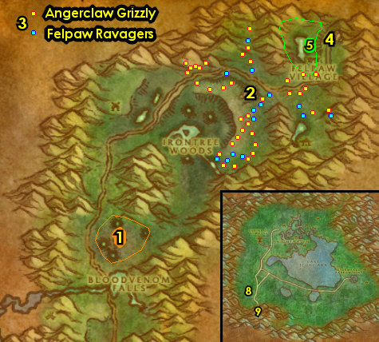

54-55 Winterspring (log)
01) Right outside of the cave, accept "Winterfall Activity" (28.35 in Winterspring). Also turn in "Speak to Salfa".
02) Follow the main path south to Donova Snowden 31.45 and accept "Threat of the Winterfall". Turn in "The New Springs", accept "Strange Sources". Also turn in "It's a Secret to Everybody", SKIP "The Videre Elixir". NOTE: You do not have to wait for the NPC, just leave..
03) Follow the main path east and just to your left as you enter Everlook accept "Are We There, Yeti?" 61.38.
04) From Felnok Steelspring under the blue tent 62.39, turn in "Felnok Steelspring", SKIP "Chillwind Horns" (for now).
TBC, 4b) Back in Everlook by the cage 62.38, accept "Ursius of the Shardtooth".
05) South in Everlook, go in the Inn and make Everlook your new home from the Innkeeper 61.39. Make sure you are repaired/resupplied.
06) Also in the Inn accept "The Everlook Report", "Duke Nicholas Zverenhoff" and "Sister Pamela".
07) Go to Everlook's Bank 61.37 and put the following items in there: 15 Blood Amber, Felwood Slime Samples, Everlook Report, Studies in Spirit Speaking any Core of Elements and (if you have it) Deadwood Ritual Totem.
08) Follow the main path south to discover Darkwhisper Gorge at 60.74 for the quest "Strange Sources".
09) Hearth to Everlook.
TBC, 9b) As you go questing, keep an eye out for a bear named Ursius /target (he looks just like all other other ones), if so, kill him for "Ursius of the Shardtooth", but don't intentionally try to find him now:
10) Exit Everlook to the right, then go east to Winterfall Village around 67.35 and do"Winterfall Activity": kill the required amount of Winterfall furbolgs. NOTE: This place is usually busy with lvl 60+ players farming Winterfall Firewater here. If that's the case then this quest can be skipped (there is no follow up). You can also skip this if you are only level 53 right now as it is kind of a higher level quest.
11) Just north of Everlook (around the mountains 61.33) do part of "Wild Guardians": kill 15 Raging Owlbeasts /target. Also start working on "Are We There, Yeti?" by kill/looting Ice Thistle Yeti. Also try to finish "Ursius of the Shardtooth" by finding and killing Ursius /target (white bear), he patrols around on the mountains.
#24
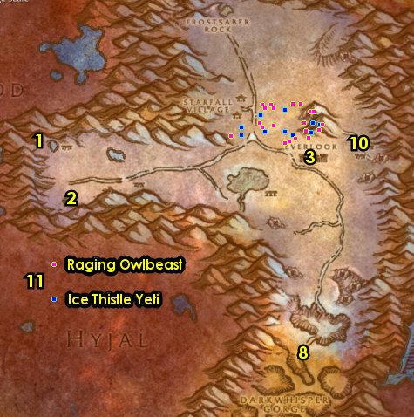

01) Go west starting around 54.37 and finish "Wild Guardians" (kill 15 Ragged Owlbeasts /target) and continue working on "Are We There, Yeti?" (kill/loot Rogue Ice Thistle yeti). Also work on the next step as well:
02) Do "Threat of the Winterfall": kill the required amount of Winterfall furbolgs. There are two camps of these mobs (one at around 42.43 and one at around 32.37). While doing this quest you should find an item, which starts "Winterfall Firewater" (accept it).
03) Go SW to Donova Snowden 31.45 and turn in "Strange Sources", "Threat of the Winterfall" and "Winterfall Firewater", accept "Falling to Corruption".
04) Hearth (or go back) to Everlook. Make sure you are repaired/resupplied.
TBC, 4b) IF YOU DID IT: Back in Everlook by the cage 62.38, turn in "Ursius of the Shardtooth".
05) Go SE a bit to Ice Thistle Hills around 66.42 (#7 on map) and finish "Are We There, Yeti?": kill/loot Yeti for the Thick Yeti Fur.
06) Hearth (or go back) to Everlook and near the entrance next to the hut, turn in "Are We There, Yeti?" 61.38, accept the next part.
07) Go SE a bit back to Ice Thistle Hills around 66.42 and do "Are We There, Yeti?": kill/loot Ice Thistle Matriarchs and Ice Thistle Patriarchs for the 2 horns (low drop rate). There is a higher concentration of these mobs in the cave entrance up at 68.42.
08) Hearth (or go back) to Everlook and turn in "Are We There, Yeti?" 61.38, accept the next part. NOTE: If you are deep in the cave you can just die on purpose and res at spirit to get back to Everlook.
09) Do part of "Are We There, Yeti?": at Legacki 62.39 /target (next to the Inn), use Umi's Mechanical Yeti quest item to scare her.
10) Make sure you are repaired/resupplied.
11) Go to Everlook's Bank 61.37 and put the following items into it: Umi's Mechanical Yeti and (if you have it) Winterfall Ritual Totem. Get out of the Bank: 15 Blood Amber.
12) Exit Everlook to your right and go to the Wind Rider Master 60.36 to fly to Bloodvenom Post, Felwood.
#25
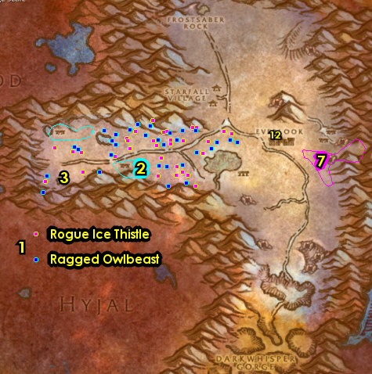

55-56 Felwood (log)
01) Once at Bloodvenom Post, turn in "Wild Guardians" 35.53, SKIP the next part (for now).
TBC, 1a) At the Wind Rider Master 34.54 fly to Emerald Sanctuary.
02) At Emerald Sanctuary turn in "Forces of Jaedenar" 51.82, accept "Collection of the Corrupt Water". And next to you in the tent, turn in "Verifying the Corruption" 51.82.
03) Go west to Maybess Riverbreeze and turn in "Cleansing Felwood" 47.83. Then click the NPC again and talk to her to get a Cenarion Beacon.
04) Just south a bit next to the main path, from Grazle (furblog 51.85), accept "Timbermaw Ally" (no exclamation mark).
05) Go south to Deadwood Village and do "Timbermaw Ally" along with "A Husband's Last Battle": kill the required amount of Deadwood furbolgs and also kill/loot Overlord Ror (gray colored furbolg 48.94).
06) Go north a bit along the main path to Grazle /target (51.85, #4 on map) and turn in "Timbermaw Ally". Accept "Speak to Nafien".
07) Go up NW in Ruins of Constellas and do "Well of Corruption": use your Hardened Flasket quest item in the green moonwell there 32.67.
08) Follow the main path north to enter Jaedenar entrance 41.58..
09) Go west in Jaedenar and do "Collection of the Corrupt Water": use your Empty Canteen quest item in the green moonwell 35.60.
10) Go north to Bloodvenom Post and turn in "Well of Corruption" (34.52, #1 on map). Wait a few seconds (do next step while waiting), then accept "Corrupted Sabers".
11) Also at Bloodvenom Post, turn in "A Husband's Last Battle" 35.53. NOTE: Do not sell your Corrupted Soul Shards to a vendor. Make sure you are repaired/resupplied.
TBC, 12) At Bloodvenom Post, go to the Wind Rider Master 34.54 and fly to Emerald Sanctuary.
#26
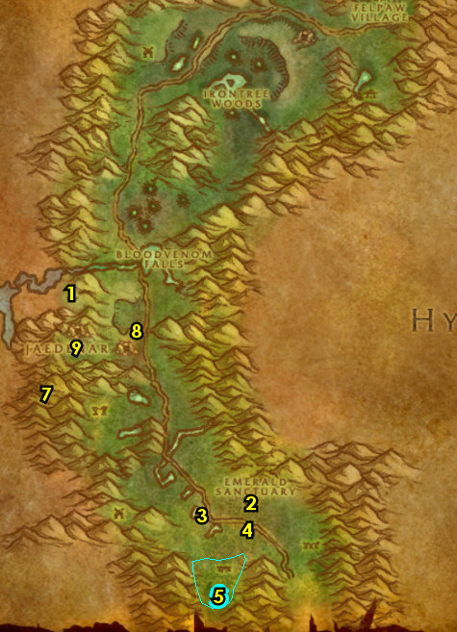

01) At Emerald Sanctuary turn in "Collection of the Corrupt Water" 51.82, SKIP "Seeking Spiritual Aid".
02) Go west to Maybess Riverbreeze and turn in "Salve Via Hunting" 47.83. NOTES: If for some reason you do not have the 6 Corrupted Soul Shards, grind on any mob in Felwood until you get them. The quest is repeatable, but doesn't yield additional XP. The reward item Cenarion Plant Salve is used to cleanse the various corrupted plants around Felwood and the reward you get from them is decent (but no XP).
03) Go NW in Ruins of Constellas and do "Corrupted Sabers": use your Winna's Kitten Carrier quest item at the green moonwell there 32.67.
04) Go north to Bloodvenom Post and once you get there talk to the Corrupted Saber that is following you, then turn in "Corrupted Sabers" 34.52. Make sure you are repaired/resupplied.
05) Follow the main path NE to Felpaw Village and clear the mobs around the Deadwood Cauldron at 60.6, or distract the mobs some how (See Video), then click on the Cauldron to turn in "Falling to Corruption", accept "Mystery Goo".
06) Go NE, right before the Timbermaw Hold entrance and turn in "Speak to Nafien" 65.8. Also turn in any feathers you may have (repeatable quest to increase rep).
07) Go through the cave to get to Winterspring and right outside of the cave, turn in "Winterfall Activity" (28.34 in Winterspring).
08) Follow the main path south to Donova Snowden 31.45 and turn in "Mystery Goo", accept "Toxic Horrors". Then if you are not level 56, grind on any mob until you are.
09) Hearth to Everlook.
10) Exit Everlook to your right and go to the Wind Rider Master 60.36 to fly to Orgrimmar, Durotar.
11) Once at Orgrimmar, get your level 56 spells/abilities.
#27
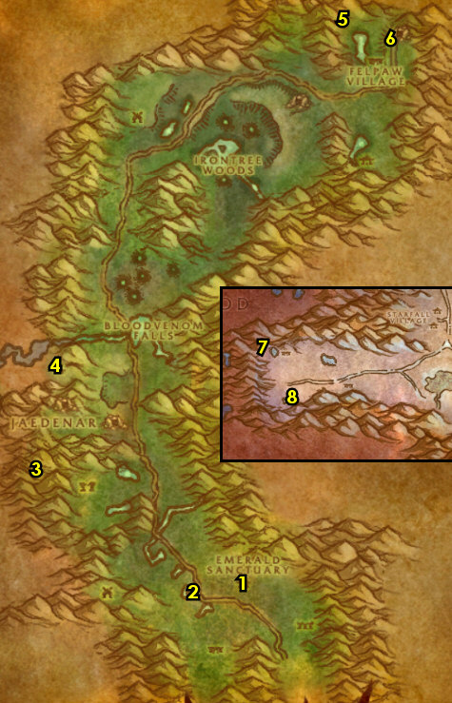

01) Leave Orgrimmar south and get on the zeppelin (51.14 in Durotar) to go to The Undercity.
02) At the UC go to the Innkeeper and make it your new home 68.38. Make sure you are repaired/resupplied.
03) Go to the Bank in the middle of the UC 66.44 and get the following items out: Felwood Slime Samples, Un'goro Slime Samples, Everlook Report and Studies in Spirit Speaking. And if you have 60 extra Runecloth (for cloth donation) get that out as well. Put the following items in your bank: Cenarion Beacon, any Corrupted Soul Shards and any Cenarion Plant Salves.
04) Find Harbinger Balthazad /target, he patrols around the bank (wearing a white shirt with a lantern), once you find him, accept "A Call to Arms: The Plaguelands!".
05) If you have the 60 extra Runecloth, go to the Magic Quarter and turn in "A Donation of Runecloth" 72.29, for undead faction.
WOTLK, 5b) If you need to, you can upgrade First Aid from the First Aid Trainer 73.55 at Rogues' Quarter. NOTE: Runecloth Bandage requires skill 260 and Heavy Runecloth Bandage skill 290.
06) Go SW to The Apothecarium and next to Chemist Fuely 48.73 use the two Testing Equipments (both red and green) to turn your Slime Samples into the quest items you need. Then turn in "A Sample of Slime..." and "... and a Batch of Ooze". Accept "Melding of Influences". NOTE: You can destroy any remaining Slime Samples to free bag space.
07) Go to the Bank in the middle of the UC (66.44, #3 on map) and put the following items into it: Encased Corrupt Ooze. Get out of the bank: Swim Speed Potions, (if you have all of them) 30+ Dark Iron Scraps and 30+ Savage Fronds. And there is a quest in Eastern Plaguelands that wants these items: 2 Thorium Bar, Golden Rod, 8 Hi-Explosive Bomb, 8 Unstable Trigger (get these out, either from the AH or bank if you can get all of them). You can then mail these items (including the 30+ Dark Iron Scraps and 30+ Savage Fronds) to yourself and retrieve them from the mailbox at Light's Hope in EPL later.
08) Leave The Undercity and go east in Tirisfal Glades to the The Bulwark (83.69 in Tirisfal Glades)..
#28
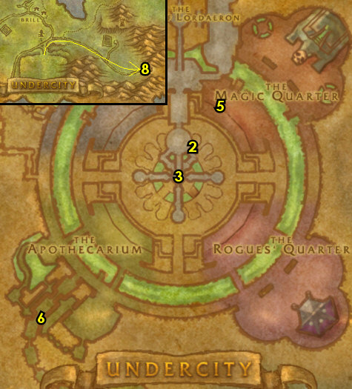

56-56 Western Plaguelands (log)
01) Make a left on the main path as you enter The Bulwark and turn in "A Call To Arms: The Plaguelands!" (83.69 in Tirisfal Glades), accept "Scarlet Diversions". Then next to you loot the Box of Incendiaries to obtain a Flame in a Bottle.
02) Next to you, turn in "The Everlook Report" 83.68. From this same NPC, complete "Argent Dawn Commission". NOTE: The trinket received called Argent Dawn Commission will allow you to collect Scourgestones from undead mobs in the Plaguelands (both eastern and western). Right-click it in your inventory to wear it. As long as you have it on, this will allow you to increase your rep with The Argent Dawn, which will allow you to buy items such as Enriched Manna Biscuits later.
WOTLK, 2a) Get the Flight Path from the Bat Handler 84.70.
03) Go to the other side of The Bulwark, and behind the bigger tent accept "A Plague Upon Thee" 83.72.
04) Go east into Western Plaguelands (WPL) to Felstone Field and up in the house, accept "Better Late Than Never" (38.54 in WPL).
05) Go in the barn next to the house and click on Janice's Parcel 39.55 to turn in "Better Late Than Never". Then click Janice's Parcel again to accept the next part of "Better Late Than Never".
06) Go just NE a bit to the small Scarlet camp 41.52 and do "Scarlet Diversions": clear the mobs in the area (you need to work quickly to avoid respawns) then click on the Command Tent to burn it and then use the Scourge Banner quest item at the camp. (See Video)
07) Go back to The Bulwark (make a right on the path) and turn in "Scarlet Diversions" (83.69 in Tirisfal Glades, #1 on map). Accept "The Scourge Cauldrons".
08) Make sure you are resupplied 83.70. NOTE: Make sure you save all Bone Fragments you find, you will need 30 of them for a later quest.
09) Go to the other side of The Bulwark and turn in "The Scourge Cauldrons" 83.72, accept "Target: Felstone Field".
#29
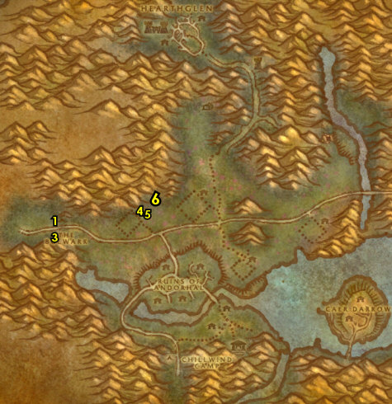

Cauldron quest chain Info: You need to kill the Cauldron Lord at each targeted farm field (listed below in the next section), grab their key and use it at the big cauldron in the middle of the farm fields. You will be going back and forth from The Bulwark to the next field. As you enter each field, the Cauldron Lord spawns near the Scourge Cauldron in the middle of each field, if the Cauldron Lord is not there, leave the field and come back. The last few Cauldrons can be tough to solo so you may want to start finding a group for them, but you should be able to solo them with good skill.
#30
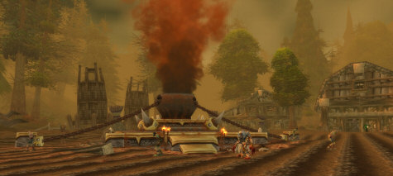

01) At Felstone Field, do "Target: Felstone Field": kill/loot Cauldron Lord Bilemaw /target 37.57. Then click on the Scourge Cauldron to turn in "Target: Felstone Field", accept "Return to the Bulwark".
02) Go back to The Bulwark and turn in "Return to the Bulwark" (83.72 in Tirisfal Glades), accept "Target: Dalson's Tears".
03) At Dalson's Tears, do "Target: Dalson's Tears": kill/loot Cauldron Lord Malvinious /target 46.52. Then click on the Scourge Cauldron to turn in "Target: Dalson's Tears", accept "Return to the Bulwark".
04) There is a small quest chain here at this farm that yields good XP: Go in the Barn at Dalson's Tears and click on Mrs. Dalson's Diary 48.51 laying on the ground to complete "Mrs. Dalson's Diary".
05) Find and kill/loot the Wandering Skeleton /target. This one skeleton wanders around the NE side of Dalson's Tears. He circles around the barn as well.
06) Click on the Outhouse 48.50 behind the barn to complete "Locked Away". Then Farmer Dalson will spawn next to the Outhouse, kill/loot this zombie.
07) Go up in the house (next to the barn) and click on the Locked Cabinet 47.50 to turn in "Locked Away". Quest chain complete.
08) Go back to The Bulwark and turn in "Return to the Bulwark" (83.72 in Tirisfal Glades, #2 on map), accept "Target: Writhing Haunt".
09) At The Writhing Haunt, do "Target: Writhing Haunt": kill/loot Cauldron Lord Razarch /target 53.66. Then click on the Scourge Cauldron to turn in "Target: Writhing Haunt", accept "Return to the Bulwark".
10) Go in the small house at The Writhing Haunt and accept "The Wildlife Suffers Too" 54.65.
11) Go back to The Bulwark and turn in "Return to the Bulwark" (83.72 in Tirisfal Glades, #2 on map), accept "Target: Gahrron's Withering". Make sure you are resupplied.
12) At Gahrron's Withering, do "Target: Gahrron's Withering": kill/loot Cauldron Lord Soulwrath /target 63.59. Then click on the Scourge Cauldron to turn in "Target: Gahrron's Withering", accept "Return to the Bulwark". NOTE: We will turn this in later.
13) Go east into Eastern Plaguelands (follow path on map) 5.38 in EPL..
#31
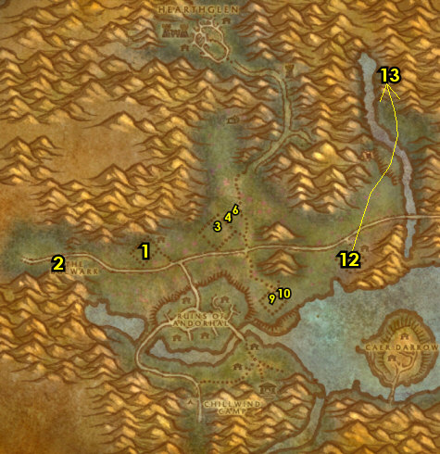

56-57 Eastern Plaguelands (log)
01) Go north along Thondoril River to Tiron Fordring 5.38 and accept "Demon Dogs", "Blood Tinged Skies" and "Carrion Grubbage".
02) Grind SE to The Marris Stead 23.68 and accept "To Kill With Purpose", "Un-Life's Little Annoyances" and "The Ranger Lord's Behest".
03) Go south to The Undercroft and down in the crypt, from the Torn Scroll 24.78 laying on the ground, accept "Hameya's Plea".
04) Grind east to Darrowshire to Pamela Redpath and turn in "Sister Pamela" 32.84, accept "Pamela's Doll".
05) At Darrowshire do "Pamela's Doll": find the 3 parts to Pamela's Doll: the head, the left side and right side. These parts have multiple spawn locations around Darrowshire in each of the 3 buildings in the area (excluding the building where Pamela is at). They look like little yellow things. Search the buildings for the 3 parts: big house 34.85, torn down house 35.85, small house 35.83, then click one of them to combine them to make Pamela's Doll. (See Video)
06) Go back to Pamela Redpath at Darrowshire and turn in "Pamela's Doll" ( 32.84, #4 on map). Accept "Auntie Marlene" and "Uncle Carlin".
07) Around southern EPL around 36.76, finish "Blood Tinged Skies": kill 30 Plaguebats. Also do part of "Demon Dogs": kill 20 Plaguehound Runts. And start working on "Carrion Grubbage": kill/loot Carrion mobs for the worm meat. All of these mobs are found in southern Eastern Plaguelands and the Carrion worm mobs are all over Eastern Plaguelands. Once you are nearing completion, work your way east to the next step:
08) Grind to Light's Hope Chapel 74.58 and accept "The Restless Souls" and "Zaeldarr the Outcast".
#32
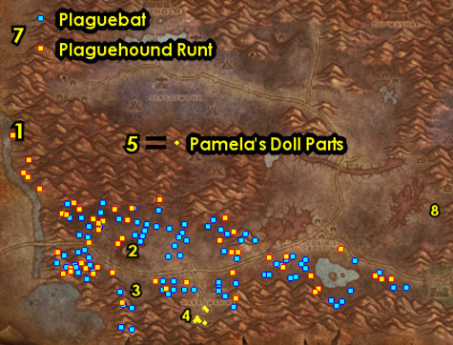

01) Go north a bit and turn in "Duke Nicholas Zverenhoff" 76.54. Also from this NPC, if you have at least 20 Minion's Scourgestones, complete a "Minion's Scourgestones" (and dont consume the item received).
02) Next to you, turn in "Uncle Carlin" 76.54. Accept "Defenders of Darrowshire".
03) Get resupplied/repaired from Craftsman Wilhelm 75.54 next to the Forge. NOTE: If for some reason you are already Friendly with The Argent Dawn, then stock up on Enriched Manna Biscuits from the female dwarf Miranda Breechlock 76.54 by the tent.
WOTLK, 3a) You should be friendly now with The Argent Dawn, if so: Right in front of the Inn's Entrance, go to Rayne 75.53 and if you have the 30 Savage Fronds (in the mailbox?) accept and turn in "Savage Fronds".
WOTLK, 3b) Also (if you are friendly with The Argent Dawn): Go in the Inn and in the back from the human with black hair 76.52 , accept and turn in "Binding the Dreadnaught" (requires the 30 Dark Iron Scraps, that could be in your mailbox).
04) At the other side of the Inn, from the human on the horse and with your one Argent Dawn Valor Token you might have, accept and turn in "They Call Me "The Rooster" 75.52. If you dont have it yet, do this when you can.
05) If you were able to obtain the items needed for "That's Asking A Lot", then turn it in (at the dwarf Smokey LaRue by the Campfire, 75.52 ), accept "When Smokey Sings, I Get Violent".
06) North in Light's Hope, get the FP there from the Bat Handler 74.51.
07) OPTIONAL: The quest "Bolstering Our Defenses" 74.52 is a PvP tower capture quest that is optional and up to you if you would like to do it or not, my guide will not cover it further. I don't recommend doing this if you are trying to level quickly.
#33
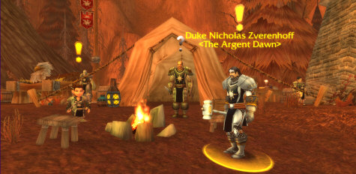

01) Go SW to Corin's Crossing around 55.62 and do "To Kill With Purpose": kill/loot the undead mobs there to obtain Living Rot (work fast they only last 10 min), then use your Mortar and Pestle quest item to combine 7 of them to make the item you need. Also start working on "Defenders of Darrowshire": kill Gibbering Ghouls and then talk to the spirit that spawns (don't need to finish this now though).
02) Just north around 56.50, do part of "Demon Dogs" and "Un-Life's Little Annoyances": kill 5 Plaguehounds /target and 20 Noxious Plaguebats. These mobs are found in the middle-eastern side of Eastern Plaguelands.
03) Grind north to Zul'Mashar (ramp entrance at 59.19 )..
04) Go up into Zul'Mashar and do "Hameya's Plea": kill/loot Infiltrator Hameya /target. This troll patrols around in front of the temple 65.13. Stay away from the dirt mounds in front of the temple as undeads will spawn near them, it's better to wait until Infiltrator Hameya patrols up front for you to take on alone. Also he hits hard so be prepared.
05) Finish up "Carrion Grubbage", "Demon Dogs" and "Un-Life's Little Annoyances": kill/loot Carrion mobs for the worm meat, kill 5 Frenzied Plaguehounds and kill 10 Monstrous Plaguebats. These mobs are found NE around the open fields of Eastern Plaguelands around 56.50. NOTE: You can find some more spirits for "Defenders of Darrowshire" around 61.35 from the Diseased Flayers, and you can find more on the later steps as well.
06) GROUP 2+ Players (or could be soloable): Go north to Quel'Lithien Lodge entrance 47.17 and try to do "The Ranger Lord's Behest": kill the needed blood elf mobs and go into the lodge, make a right, then loot the Quel'Thalas Registry (book laying on a bench 48.14 ). This quest may be hard to solo. If you are almost lvl 57, then grind to it before doing this quest. You may need to distract the mobs in the lodge, grab the book and run out some how. If you cannot solo this, or find help then it can be skipped.
07) Go west to Plaguewood (starting at 44.26 ) and do the following 3 quests together:
08) "A Plague Upon Thee": loot the Large Termite Mounds, these are spaced all around Plaguewood (see map).
09) "Defenders of Darrowshire": continue working on this by killing Cannibal Ghouls and talk to the spirits that spawn. You will have more opportunities later to finish this.
10) If you have it do "When Smokey Sings, I Get Violent": go in the various ziggurats around Plaguewood and use Smokey's Special Compound quest item inside the buildings.
#34
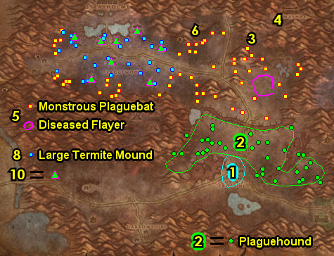

01) Go west to Terrordale and in the hut turn in "The Restless Souls" 11.29, SKIP the next part (dungeon). And next to you, accept "Augustus' Receipt Book".
02) Do "Augustus' Receipt Book": go NE a bit to the Terrordale Inn (the largest building in the area entrance 14.28 ) and go up in the Inn, make a right and between two split open barrels loot Augustus' Receipt Book 14.26 on the ground. NOTE: Kill/loot all Crypt Fiends you see to start obtaining Crypt Fiend Parts (used for a later quest).
03) Go back to the hut in Terrordale and turn in "Augustus' Receipt Book" ( 11.29 , #1 on map). NOTE: You can now get resupplied from this NPC.
04) OPTIONAL: Grind on Crypt Fiend mobs all around Terrordale to collect 30 Crypt Fiend Parts. This can be used for a later quest. There is more in the next step as well (but watch out for the Elite):
05) Go through the long cave entrance 12.25. NOTES: This cave journey is not easy. There is a lvl 60 elite spider /target (with a 1 hour respawn) that patrols back and forth to the 2 entrances of this cave. Try to sneak past it if you can. If this cave is too hard for you, then another possible quick alternative is to take the Tower Gryphon ride from the Plaguewood Tower 19.27 to the Crown Guard Tower, as long as the horde has control over the towers that is. Try to get all 30 Crypt Fiend Parts before leaving this area. If you are still far off from that, then you can skip getting the remaining ones.
06) Once you get out to the other side of the cave (or take the tower ride), north along Thondoril River at Tiron Fordring 5.38 , turn in "Demon Dogs" "Blood Tinged Skies" and "Carrion Grubbage". Accept "Redemption". Simply talk to Tiron Fordring to complete "Redemption", accept "Of Forgotten Memories".
07) Grind SE to The Marris Stead 23.68 and turn in "To Kill With Purpose", "Un-Life's Little Annoyances" and (if you did it) "The Ranger Lord's Behest". Accept "Duskwing, Oh How I Hate Thee..." and "The Corpulent One".
TBC, 7b) Do "Duskwing, Oh How I Hate Thee...": kill/loot Duskwing /target. This large lvl 60 bat patrols just north and NE of The Marris Stead around 28.63.
TBC, 7c) Go back to The Marris Stead 23.68 and turn in "Duskwing, Oh How I Hate Thee...".
08) Go south to The Undercroft, go down in the crypt and then do "Zaeldarr the Outcast": kill/loot Zaeldarr the Outcast 24.78. (See Video)
09) Behind the crypt, next to the wooden wagon, click on the Mound of Dirt 24.79 to turn in "Hameya's Plea".
10) Next to you, do "Of Forgotten Memories": click on the Loose Dirt Mound 25.80 that is next to Tirion Fordring's Grave, then kill/loot Mercutio Filthgorger (he has 3 bodyguards). IMPORTANT TIP: These mobs spawn between the two dirt mounds (from the previous step). Mercutio Filthgorger spawns in first, then his bodyguards soon after. So act fast and immediately pull Mercutio Filthgorger away from his spawn point to avoid fighting his guards too, as this fight can be really tough to do solo without this tactic.
#35
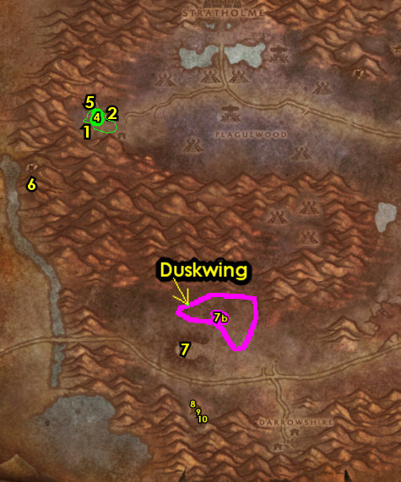

01) Go NW to Tiron Fordring 5.38 and turn in "Of Forgotten Memories", accept "Of Lost Honor".
1b) Go NE to Corin's Crossing around 54.64 and continue working on (if you still need to) "Defenders of Darrowshire": kill any Gibbering Ghouls or Diseased Flayers and then talk to the spirit that spawns! You will have another opportunity later to finish this.
02) Go to the south side of Light's Hope Chapel, then turn in "Zaeldarr the Outcast" 74.58.
03) Go north in Light's Hope Chapel and turn in (if it's finished) "Defenders of Darrowshire" 76.54.
04) Next to you at Duke Nicholas Zverenhoff /target 76.54, turn in any Scourgestones you have. If you haven't yet, save at least one Argent Dawn Valor Token for a later quest. You can consume the rest to increase rep with The Argent Dawn.
05) Get repaired/resupplied from Craftsman Wilhelm 75.54 next to the Forge.
07) In the Inn, if you have the 30 Crypt Fiend Parts, accept and turn in "Cryptstalker Armor Doesn't Make Itself..." (from Huntsman Leopold).
08) Go north a bit more in Light's Hope Chapel and turn in (if you did it) "When Smokey Sings, I Get Violent" 75.52. If you turned this in, you can then destroy Smokey's Special Compound.
09) If you still need to: Next to you at the human on the horse and with your Argent Dawn Valor Token, accept and turn in "They Call Me "The Rooster" 75.52.
10) Go NE a bit around 70.46 and finish (if you still need to) "Defenders of Darrowshire": kill any Gibbering Ghouls or Diseased Flayers and then talk to the spirit that spawns.
11) Grind north to Northdale and do "Of Lost Honor": loot the Symbol of Lost Honor 66.29 (under the lake).
TBC, 11b) Do "The Corpulent One": kill/loot Borelgore /target (lvl 60 big yellow worm, around 50.27)
12) IF YOU STILL NEED TO: Go SE to Light's Hope Chapel and turn in "Defenders of Darrowshire" (#3 on map) 76.54.
TBC, 12b) Go back to The Marris Stead 23.68 and turn in "The Corpulent One".
13) Grind all the way back west to Tiron Fordring ( 5.38 , #1 on map) and turn in "Of Lost Honor", accept "Of Love and Family".
#36
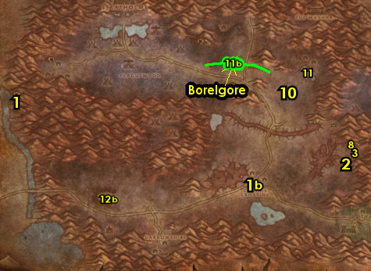

01) Go south at the island of Caer Darrow in Western Plaguelands (use a Swim Speed Potion) and turn in "Of Love and Family" 66.75 in WPL. SKIP the next part (Dungeon).
02) Hearth to UC. Make sure you are repaired/resupplied.
03) At the Bank in the middle of the UC, put the following items into it: any remaining Crypt Fiend Parts, Savage Fronds, any Core of Elements and any Insignias.
04) Drop down east to Guild Creation and turn in "Better Late Than Never" 70.43, accept "The Jeremiah Blues".
05) Underneath the bank from the Cockroach Vendor 68.44, turn in "The Jeremiah Blues", accept "Good Luck Charm".
06) Find Harbinger Balthazad /target, he patrols around the bank (wearing a white shirt with a lantern), once you find him, accept "The New Frontier".
07) Also if you still need to turn in 60 extra Runecloth (for cloth donation), go to the Magic Quarter and turn in "A Donation of Runecloth" 72.29, for undead faction.
08) Leave The Undercity and go east in Tirisfal Glades to The Bulwark (83.71 in Tirisfal Glades)..
#37
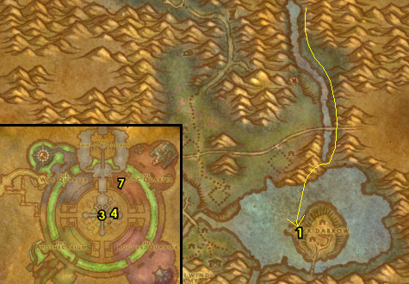

57-58 Western Plaguelands (log)
01) Make a right at The Bulwark and turn in "Return to the Bulwark" 83.72.
02) Next to you behind the tent, turn in "A Plague Upon Thee" 83.72, accept the next part. NOTE: If you have any remaining Plagueland Termites in your inventory, you can destroy them.
TBC, 2a) From the male blood elf 83.71 accept "The So-Called Mark of the Lightbringer".
03) At the other side of The Bulwark, complete "Mission Accomplished!" 83.69. Also accept "All Along the Watchtowers".
04) If you have turned Friendly with The Argent Dawn, then you can stock up on Enriched Manna Biscuits next to you from Argent Quartermaster Hasana 83.68. These biscuits will help you level faster by receiving mana faster from consuming these biscuits.
05) Go into Western Plaguelands to Felstone Field and up in the house, turn in "Good Luck Charm" 38.54, accept "Two Halves Become One".
06) Go south of Felstone Field around 37.58 and do "Two Halves Become One": kill/loot the Jabbering Ghoul /target (only one mob spawn that patrols around the farm). This mob drops Good Luck Other-Half-Charm. Right-click this item in your inventory.
07) Go back up in the house at Felstone Field and turn in "Two Halves Become One" (38.54, #5 on map).
08) Go north to Northridge Lumber Camp and do "A Plague Upon Thee": clear the mobs at the lumber camp, click on the Northridge Lumber Mill Crate 48.32 to place the termite barrel. Then click on the spawned Termite Barrel on top of the crate to turn in "A Plague Upon Thee", accept the next part. (See Video)
09) Go NE down a long slope in Northridge Lumber Camp and accept "Unfinished Business" 52.28.
10) Go south a bit and do "Unfinished Business": kill the required amount of Scarlet humans in the area. The mages and knights are around 51.41. NOTE: They share spawns with each other. See next step for the medics and hunters:
11) Go south a bit to the small Scarlet camp and kill the needed medics and hunters around 52.44.
#38
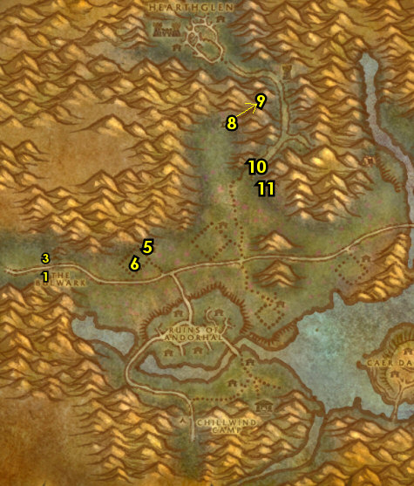

01) Go back up NE in Northridge Lumber Camp, down the long slope and turn in "Unfinished Business" 52.28, accept the next part.
02) Go east a bit and do "Unfinished Business": kill Huntsman Radley 58.36 /target. See next step for the other named mob to kill:
03) Kill Cavalier Durgen /target. He patrols around in the tower 55.24. Also go up this tower and do "The So-Called Mark of the Lightbringer" by looting the Holy Coffer.
04) Go back down in Northridge Lumber Camp and turn in "Unfinished Business" (52.28, #1 on map), accept the next part.
05) Go north to Hearthglen and do the last part of "Unfinished Business": go to the top of the watchtower 46.18 to complete the quest. Just mount up and avoid the mobs. Having a healing potion on hand helps. (Watch This Video to see a shortcut and how to do this quest).
06) Go back down in Northridge Lumber Camp and turn in "Unfinished Business" (52.28, #1 on map).
07) Make sure "The Wildlife Suffers Too" is finished: kill 8 Diseased Wolves /target. These wolves are found mostly above Dalson's Tears farm. They share spawns with the spiders in the area, so kill them if not enough wolves. Work your way to the next step:
08) Go south to the small house at The Writhing Haunt and turn in "The Wildlife Suffers Too" 54.65, accept the next part.
09) Do "The Wildlife Suffers Too" (part 2): kill 8 Diseased Grizzly /target. These bears are found north and east of The Writhing Haunt. They share spawns with the spiders, so kill spiders if not enough bears.
10) Go back to the small house at The Writhing Haunt and turn in "The Wildlife Suffers Too" (54.65, #8 on map). Accept "Glyphed Oaken Branch".
11) Go SW to Sorrow Hill and in the house (up or down in it) turn in "Auntie Marlene" 49.79, accept "A Strange Historian".
12) Do "A Strange Historian": next to the house your at, loot Joseph Redpath's Monument in the graveyard 50.77. (See Video)
13) Enter Ruins of Andorhal (bridge entrance at 49.72)..
#39
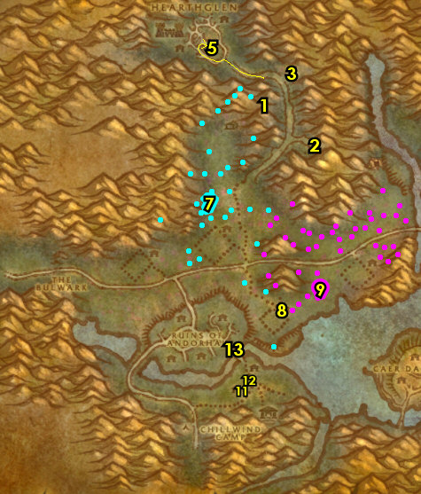

01) Make a left at the tower and do part of "All Along the Watchtowers": use the Beacon Torch quest item at Tower Four 47.71.
02) Go west and do part of "All Along the Watchtowers": use the Beacon Torch quest item at Tower One 40.72. NOTE: You must use the torch item right in the doorway of these towers in order for it to work, don't waste your charges!
03) Go north and enter the Andorhal Inn entrance 40.68, go upstairs and turn in "A Strange Historian" 39.67, accept "The Annals of Darrowshire". Also accept "A Matter of Time".
04) Enter the City Hall building in the middle of Andorhal entrance 44.69 and do "The Annals of Darrowshire": loot the Annals of Darrowshire (blue book). The actual Annals of Darrowshire book looks different from the others, it has a lighter tint on the top portion of the pages in the book, unlike the rest which has a darker tint on the top portion of the pages. (See Video)
05) Go north and do part of "All Along the Watchtowers": use the Beacon Torch quest item at Tower Two 42.66.
06) Go NE and do the last part of "All Along the Watchtowers": use the Beacon Torch quest item at Tower Three 44.63.
07) Go east a bit and do "A Matter of Time": use the Temporal Displacer quest item near the silos around 47.63 then kill the Temporal Parasites that spawn. NOTE: The quest item only works on the silos emitting blue beams of light.
08) Go west and enter the Andorhal Inn (entrance 40.68, #3 on map), go upstairs and turn in "A Matter of Time" and "The Annals of Darrowshire". Accept "Counting Out Time" and "Brother Carlin".
09) All around Ruins of Andorhal do "Counting Out Time": loot the Small Lockboxes all around the broken down houses. There is usually one at each broken down house.
10) Enter the Andorhal Inn (entrance 40.68, #3 on map), go upstairs and turn in "Counting Out Time". NOTES: This quest is repeatable, but you will not get additional XP from it. The quest reward Attuned Dampener can only be used on Araj the Summoner in the middle of Andorhal, and there will be quests later associated with killing him.
#40
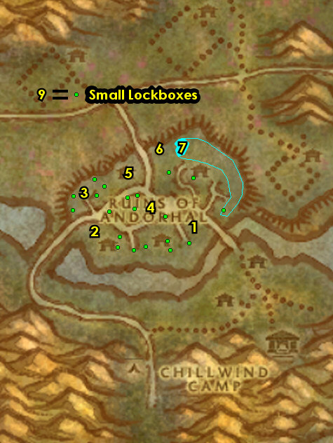

TBC, 00) Go west and make a left at The Bulwark and turn in "The So-Called Mark of the Lightbringer" (83.71 in Tirisfal Glades, #1 on map). Wait a few seconds then accept "Defiling Uther's Tomb".
01) Turn in "A Plague Upon Thee" 83.72 in Tirisfal.
02) At the other side of The Bulwark turn in "All Along the Watchtowers" 83.69. Accept "Scholomance". You can then destroy the Beacon Torch item.
03) Next to you at Argent Officer Garush 83.68, turn in any Scourgestones you may have. Then use the Argent Dawn Valor Token's received to increase your rep with The Argent Dawn.
04) Make sure you are resupplied. You can stock up on Enriched Manna Biscuits next to you from Argent Quartermaster Hasana 83.68. These biscuits will help you level faster by receiving mana faster from eating/drinking.
05) At The Bulwark turn in "Scholomance" 83.69, accept "Skeletal Fragments".
06) Go back to Ruins of Andorhal around 40.69 in WPL and do "Skeletal Fragments": kill/loot skeleton mobs for the 15 Skeletal Fragments. Also keep grinding until you have collected 30 Bone Fragments for a later quest.
TBC, 6a) Go SE to Uther's Tomb 52.84 and do "Defiling Uther's Tomb": equip the quest item Corrupted Mark of the Lightbringer, then use it at the tomb.
07) Go west and make a right at The Bulwark and turn in "Skeletal Fragments" (83.69 in Tirisfal Glades, #2 on map), SKIP "Mold Rhymes With...".
08) Next to you at Argent Officer Garush 83.68, turn in any Scourgestones you may have.
09) If you are a class that uses mana, then stock up on Enriched Manna Biscuits 83.68. NOTE: I personally buy about 600 biscuits.
TBC, 9a) At the other side of The Bulwark turn in "Defiling Uther's Tomb" 83.71.
10) Go west in Tirisfal Glades and get on the zeppelin 61.59 to go to Orgrimmar. While waiting, build up First Aid.
#41
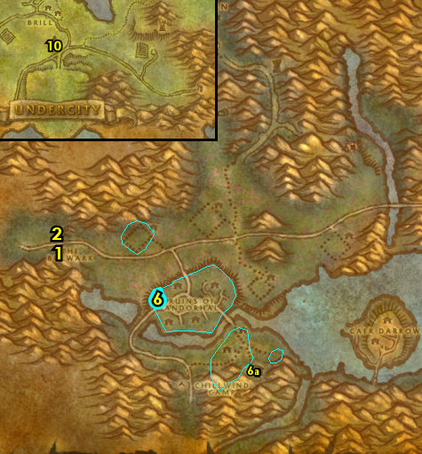

01) In Orgrimmar, go to the Inn and make Orgrimmar your new home from the Innkeeper 54.68.
02) Go to the Bank 50.69 and put your Enriched Manna Biscuits in there so that you only have about 160 left in your inventory. Also put into the bank: your stack of 30+ Bone Fragments, any extra Scourgestones, Extended Annals of Darrowshire and Attuned Dampener. And get the following items out of the bank: Umi's Mechanical Yeti, Encased Corrupt Ooze, and your current stack of Core of Elements.
03) Cloth Donations are turned in NE at Magar's Cloth Goods to the Orc's Horde Cloth Quartermaster 64.51. You may have already turned in the 60 Runecloth to them in the past.
05) Go up the spiral ramp next to you, then go get new spells/abilities.
06) Cloth Donations are also turned in at Darkbriar Lodge (Valley of Spirits) from the Troll's Horde Cloth Quartermaster 38.88. Following the guide you would still need to turn in 60 Mageweave Cloth and 60 Runecloth to them. NOTE: The "Additional Runecloth" quests do NOT yield XP (only rep).
07) Go up to the Wind Rider Master 45.64 and fly to Thunder Bluff, Mulgore.
#42
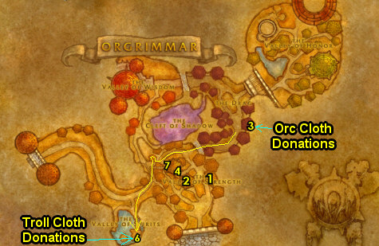

01) Once at TB, go to The Elder Rise at Nara Wildmane and turn in "Glyphed Oaken Branch" 76.32.
02) Next to you in the same room, from Arch Druid Hamuul Runetotem, turn in "The New Frontier" 79.29, accept "Rabine Saturna".
03) NOTE: If you have 60 extra Runecloth, get them out (bank is at 47.59) and turn them in for cloth donation, Tauren faction 43.43.
04) Go up to the Wind Rider Master 47.50 and fly to Moonglade (up north).
05) Once in Moonglade, go to Nighthaven and turn in "Rabine Saturna" 52.45, accept "Wasteland". Also accept "A Reliquary of Purity". NOTE: In order to accept the purity quest, you need to have been in the Dire Maul zone in Feralas before talking to Rabine Saturna in order to unlock the dialog option (which you also need to read) in order to get this quest. If you can't get it, you can just skip it and ignore any future notations of it.
06) Hearth to Orgrimmar.
06b) At Orgrimmar, down below accept "Taking Back Silithus" 48.66.
07) Go up to the Wind Rider Master 45.64 and fly to Gadgetzan, Tanaris.
09) N/A
10) NW in Gadgetzan, do part of "Are We There, Yeti?": use Umi's Mechanical Yeti quest item to scare Sprinkle /target 51.27.
11) Go to the Wind Rider Master (north of Gadgetzan, 52.25) and fly to Marshal's Refuge, Un'Goro Crater.
#43
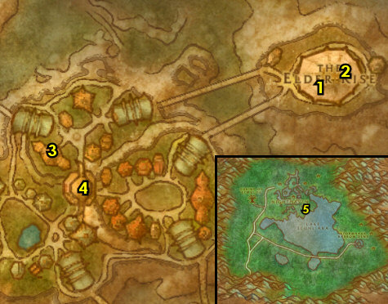

01) At Marshal's Refuge finish "Are We There, Yeti?": use Umi's Mechanical Yeti quest item to scare Quixxil /target 44.9. See Image of his location.
02) Go just west of Marshal's Refuge and do "Melding of Influences": engage a Primal Ooze /target (there is one at 39.17) and then use the Encased Corrupt Ooze quest item, then kill/loot the Gargantuan Ooze that spawns. NOTE: If there is no Primal Ooze there, then there is another one at 46.24.
03) Go into Silithus entrance 29.22..
#44
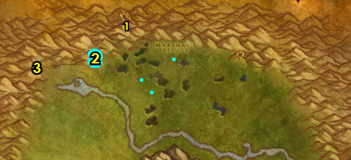

58-59 Silithus (log)
01) As you enter Silithus go to the small camp on your left (Valor's Rest) and turn in "Wasteland" 82.19, accept "The Spirits of Southwind".
02) Follow the main path west to Cenarion Hold and turn in "Taking Back Silithus" 51.38, accept "Securing the Supply Lines".
03) Next to you at the Wanted Poster: Deathclasp 51.38, accept "Wanted - Deathclasp, Terror of the Sands" (Elite).
04) Go up in the Inn next to you and accept "Deadly Desert Venom" 52.39.
05) Go up in Cenarion Hold and accept "The Twilight Mystery" 50.37.
06) Behind the moonwell, accept "Secret Communication" 49.38. And IF YOU ARE LVL 60 accept: "Abyssal Contacts", and (next to you) "Twilight Geolords".
07) Next to you, accept "Report to General Kirika" 49.37.
08) At the Wind Rider Master 49.37 in Cenarion Hold, get the FP.
09) Go in the building next to you and accept "Dearest Natalia" 49.34.
10) Go south to Southwind Village around 62.52 and do "The Spirits of Southwind" along with "A Reliquary of Purity": kill 8 Tortured Druids and 8 Tortured Sentinels around the village and work your way up in the village into the building and loot the Dusty Reliquary 63.55.
11) Grind/loot all mobs as you go NE to Valor's Rest and turn in "The Spirits of Southwind" (82.19, #1 on map), accept "Hive in the Tower".
12) Go back down SW to Southwind Village and do "Hive in the Tower": go to the top of the swarming bug tower 60.53 and click on the Hive'Ashi Pod, then kill/loot the Hive'Ashi Ambushers until you get the Encrusted Silithid Object. Also while doing Southwind Village quests you should find an item (which drops from the bugs), which starts "Brann Bronzebeard's Lost Letter", accept it. And keep grinding until you get it.
13) Grind NE to Valor's Rest and turn in "Hive in the Tower" (82.19, #1 on map), accept "Umber, Archivist".
#45
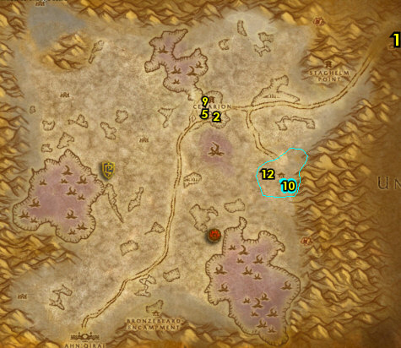

01) Go to the small camp above Staghelm Point around 66.21and do "Secret Communication": kill/loot the Twilight mobs. NOTE: IF YOU ARE LVL 60 the quest "Abyssal Contacts" can be done here and multiple times later in this zone but my guide will not cover it or the follow ups, but its worth doing. And keep the next step in mind:
02) All around NE Silithus do "Deadly Desert Venom" along with "Securing the Supply Lines": kill/loot Stonelash Scorpids (scorpids), kill/loot Sand Skitterers (spiders), and kill 15 Dredge Strikers (snakes).
03) Go to Cenarion Hold and turn in "Securing the Supply Lines" 51.38, accept "Stepping Up Security".
04) Next to you, go up in the Inn and turn in "Deadly Desert Venom" 52.39. Accept "Noggle's Last Hope". Make sure you are repaired/resupplied.
05) Go up in Cenarion Hold and behind the moonwell, turn in "Secret Communication" 49.38. NOTE: The repeatable quest "Encrypted Twilight Texts" does not yield XP, only rep with the Cenarion Circle. But save your additional Encryped Twilight Texts for a future quest.
06) Go to the NW end of Silithus around 27.15and do "The Twilight Mystery": loot the tablets on the ground. And kill/loot Dust Stormers & Whirling Invaders (wind elementals) until you get a total of 30 Core of Elements (used for a later quest), however if you are far off from the 30, you can optionally skip this.
07) All around the middle of Silithus do "Stepping Up Security": kill 20 Dredge Crushers. Also do part of "Noggle's Last Hope": kill/loot Stonelash Pincers. Work your way to the next step:
08) SE at the small horde camp, turn in "Report to General Kirika" 51.70, accept "Scouring the Desert". NOTE: For "Scouring the Desert", keep an eye out for a Silithyst Geyser which looks like a glowing red thing all around Silithuis, click on it and you will get a buff, maintain the buff while bringing it back to the PVP Horde base and stand in the teleporter looking thing, then turn the quest in for good XP!
09) Grind south to Bronzebeard Encampment and turn in "Brann Bronzebeard's Lost Letter" 41.88. Also at this same NPC, talk to him to do part of "Dearest Natalia".
10) Next to you at Frankal Stonebridge 41.89(sitting down at a tent), finish "Dearest Natalia" by talking to this NPC.
#46
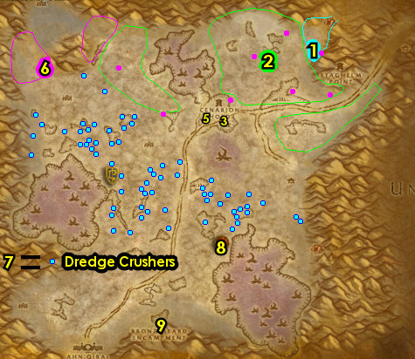
01) All around southern Silithus finish "Noggle's Last Hope": kill/loot Stonelash Flayers (scorpids) and Rock Stalker (spiders).
02) Grind north to Cenarion Hold and just outside of the Inn, turn in "Stepping Up Security" 51.38. Make sure you are repaired/resupplied.
03) Go up in the Inn next to you and turn in "Noggle's Last Hope" 52.39. Then next to you, accept "Noggle's Lost Satchel".
04) Go up in Cenarion Hold and turn in "The Twilight Mystery" 50.37, accept "The Deserter".
05) Go in the building next to you and turn in "Dearest Natalia" 49.34, SKIP "Into The Maw of Madness" (group quest).
06) Go SE to Ortell's Hideout (small cave) and turn in "The Deserter" 67.70, accept "The Twilight Lexicon".
07) Grind NW to Twilight Base Camp and do "The Twilight Lexicon": kill/loot the 3 named mobs. First one is Twilight Keeper Havunth /target. This orc patrols around the Twilight Base Camp 41.43. Also start working on (if you have the lvl 60 quest) "Twilight Geolords" by killing the Twilight Geolords (and you will see more of these mobs in the next 2 camps coming up). See next steps for the other two:
08) Grind west to Twilight Post and kill/loot Twilight Keeper Mayna /target (female human 26.37). NOTE: Feel free to grind on the Twilight mobs here to obtain Encryped Twilight Texts. You will need 10 for a future quest and you will have one more opportunity in the next step to get some more:
09) Go south to Twilight Outpost and kill/loot Twilight Keeper Exeter /target (red armored human with fiery sword 16.86). NOTES: You can avoid Hive'Zora & the Alliance camp by hugging the west side of Silithus mountains. Also keep grinding on the Twilight mobs until you get 10 Encryped Twilight Texts, this will be used for an easy turn-in quest later. And make sure "Twilight Geolords" is finished now.
10) Go right behind Bronzebeard Encampment to the mountain entrance 43.90 and try to do "Wanted - Deathclasp, Terror of the Sands" (Elite): kill/loot Deathclasp /target. This level 59 Elite scorpid is soloable but could give you some troubles. If you cannot solo it, or find a group to help you, then it can be skipped. (See Video)
11) Also at the same area of Deathclasp, do "Noggle's Lost Satchel": loot Noggle's Satchel (yellow sack on ground 45.91). (See Video)
#47
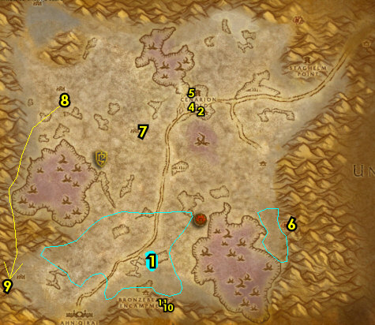
01) Grind east to Ortell's Hideout (small cave) and turn in "The Twilight Lexicon" 67.70, accept "A Terrible Purpose". Also accept, and then turn in "True Believers". Also this quest is repeatable, but no additional XP.
02) Grind back to Cenarion Hold and up in the Inn turn in "Noggle's Lost Satchel" 52.39.
03) Go up in Cenarion Hold and in the building, turn in "A Terrible Purpose" 49.34, SKIP "Into The Maw of Madness" (requires group). Also, IF YOU ARE LVL 60 turn in "Twilight Geolords" (by the moonwell), NOTE: "Vyral the Vile" is a solable quest that can be done, but wont be covered here.
04) As you exit the building, make a left and go all the way to the top of the tower and turn in (if you did it) "Wanted - Deathclasp, Terror of the Sands" 51.34.
05) Hearth (or fly) to Orgrimmar. Make sure you are repaired/resupplied.
06) In Orgrimmar, go to the Bank 50.69 and get the following items out: Extended Annals of Darrowshire and your stack of 30+ Bone Fragments. Also, (IF you still need to, and have them), get out: 30 Savage Fronds, 30 Dark Iron Scraps. NOTE: 30 Core of Elements could already be in your inventory, if not get them out too (if you have them). You can put into the bank any remaining Encrypted Twilight Text you may have.
07) Leave Orgrimmar south and get on the zeppelin (51.14 in Durotar) to go to The Undercity.
08) Once at the UC, go down in The Apothecarium and turn in "Melding of Influences" 47.73.
09) Go up to the Bat Handler 63.49 and fly to Light's Hope Chapel, Eastern Plaguelands.
10) Once at Light's Hope Chapel, go in the Inn and from the female human 76.52 sitting at the table, accept and turn in The Elemental Equation.
11) Also in the Inn from Rohan 76.53 (in purple standing near the entrance), accept and turn in "Bonescythe Digs".
ONLY do the following 3 if you still need to:
12) Back in the Inn from Korfax 76.52 (human with black hair), accept and turn in "Binding the Dreadnaught".
13) Also in the Inn from Huntsman Leopold 76.53 (balding male standing near the entrance), accept and turn in "Cryptstalker Armor Doesn't Make Itself...".
14) Just outside of the Inn on your left, accept and turn in "Savage Flora" 75.53.
#48
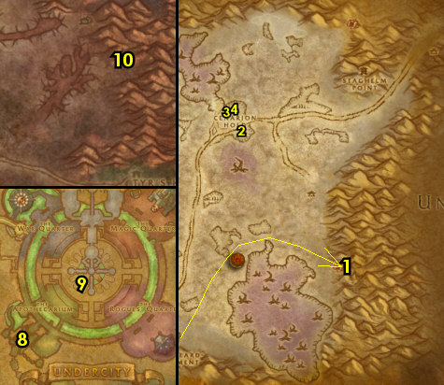

01) Outside at the campfire / tent, turn in "Brother Carlin" 76.54, accept "Villains of Darrowshire". Make sure you are repaired/resupplied. NOTE: "Heroes of Darrowshire" (and all follow up quests) is a quest chain you could do if you have a group, and it's worth doing, especially later when you get the chance.
02) Go west to Blackwood Lake and do "Villains of Darrowshire": loot Horgus' Skull under the water (look for the purple glow 47.44). See next step for the other item to loot:
03) Go south to The Infectis Scar and loot Shattered Sword of Marduk 49.60. Look for the pink glow.
04) Go back to Light's Hope Chapel at the campfire / tent and turn in "Villains of Darrowshire" ( 76.54, #1 on map).
05) Go SW to Corin's Crossing 55.62 and grind on the mobs there until your Hearthstone cooldown is up, then Hearth to Orgrimmar. Also, another decent grinding spot is The Noxious Glade 70.45. ALTERNATIVELY: If you did not do "The Ranger Lord's Behest", then you could try that now: Go north to Quel'Lithien Lodge entrance 47.17 and kill the needed blood elf mobs and go into the lodge, make a right, then loot the Quel'Thalas Registry (book laying on a bench 48.14). You may need to distract the mobs in the lodge, grab the book and run out some how. If you still cannot solo this, or find help then it can be skipped. . Also, you can do (if you still need to) "Duskwing, Oh How I Hate Thee...": kill/loot Duskwing /target. This lvl 60 bat patrols just above The Marris Stead. And: "The Corpulent One", Borelgore /target (lvl 60, around 50.27). These get accepted/turned in at The Marris Stead 23.68.
#49
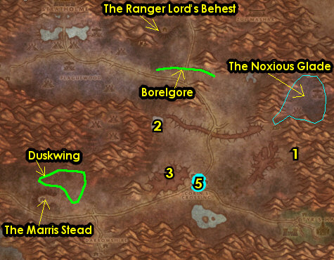
59-60 Winterspring (log)
01) After you have Hearthed to Orgrimmar, go to the Bank 50.69 and put the following items into it: any remaining Core of Elements, Bone Fragments, Savage Fronds, Dark Iron Scraps and any Insignias.
02) Go up to the Wind Rider Master 45.64 and fly to Bloodvenom Post, Felwood.
03) At Bloodvenom Post, accept "Wild Guardians" 35.53. Make sure you are repaired/resupplied.
04) Go NE to Irontree Woods (around 50.23 in Felwood) and do "Toxic Horrors": kill/loot Toxic Horrors (green water elementals).
05) Go through Timbermaw Hold entrance 65.7 and make a right in the middle after the bridge to enter Moonglade up north.
06) Once in Moonglade, go to Nighthaven and at Umber, turn in "Umber, Archivist" 45.36 or could be at 48.40, accept "Uncovering Past Secrets".
07) Go into Nighthaven and turn in "A Reliquary of Purity" 52.45, SKIP "Shards of the Felvine" (Dungeon). Also turn in "Uncovering Past Secrets".
08) Go back to Umber at Nighthaven and complete "Under the Chitin Was..." (48.40 or could be at 45.36, #6 on map).
09) Exit Moonglade at the SW path to go back to Timbermaw Hold (36.72 in Moonglade).
10) In Timbermaw Hold, make a right after the stairs (NOT the bridge) to go into Winterspring..
11) Go south to Donova Snowden (31.45 in Winterspring) and turn in "Toxic Horrors", accept "Winterfall Runners".
12) Try to do "Winterfall Runners": try to find the pack of Winterfall Runners (three lvl 57s) that patrols the main path from the Timbermaw Hold cave 28.34 to Winterfall Village 68.38 and kill/loot them for the Winterfall Crate. See map for exact patrol path. If after making one pass and you cannot find these mobs, then this can be skipped for now.
13) If (or when ever) you have completed "Winterfall Runners", go west to Donova Snowden (31.45, #11 on map) and turn it in. Accept "High Chief Winterfall" . NOTE: My guide will not cover "High Chief Winterfall".
14) Follow the main path east to Everlook.
#50
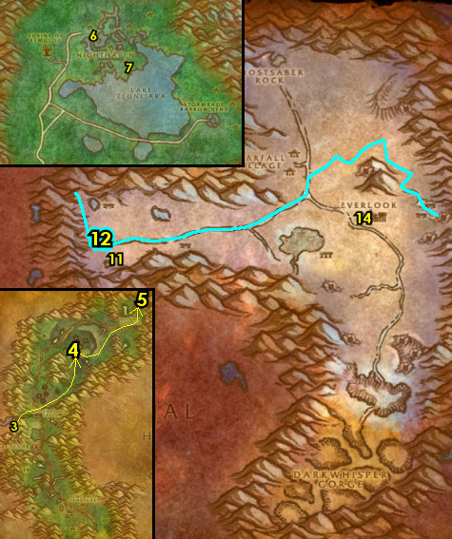
01) Just to your left as you enter Everlook (next to the hut) turn in "Are We There, Yeti?" 61.38. Then complete (if you have the engineering profession) "A Yeti of Your Own".
02) From Felnok Steelspring under the blue tent 62.39, accept "Chillwind Horns".
03) Back in Everlook by the cage 62.38, accept "Luck Be With You" (Elite) and (if you don't have it yet) "Ursius of the Shardtooth".
04) Go in the Inn and make Everlook your new home from the Innkeeper 61.39. Make sure you are repaired/resupplied.
05) Go south to Frostwhisper Gorge entrance 59.66 and start working on "Luck Be With You" (Elite): loot Frostmaul Shards. Just try to distract the giants to loot the shards. Try to sneak in and take as much as you can, you can return here later to get more.
06) Hearth to Everlook.
07) Go just north of Everlook on the mountain slopes (starting at 61.32) and do (if you still need to) "Ursius of the Shardtooth": keep grinding on mobs while working north along the mountain slopes and then kill Ursius /target (lvl 56 bear) when he shows up. See map for his patrol path.
08) Hearth (or go back to Everlook), by the cage 62.38, and turn in (if its done) "Luck Be With You", then accept and turn in "Cache of Mau'ari". Also turn in (if you still need to) "Ursius of the Shardtooth", accept "Brumeran of the Chillwind". NOTE: The Cache of Mau'ari allows you to turn in E'kos for a temporary stat boost as long as the item remains in your bags.
09) Go south (starting around 55.47) and do "Brumeran of the Chillwind": kill Brumeran /target (lvl 58 Chimera). See map for his patrol path.
10) If you need to, finish "Luck Be With You": go south to Frostwhisper Gorge (entrance 59.66, #5 on map) and loot Frostmaul Shards. Distract the elite giants and sneak in to loot the shards.
#52
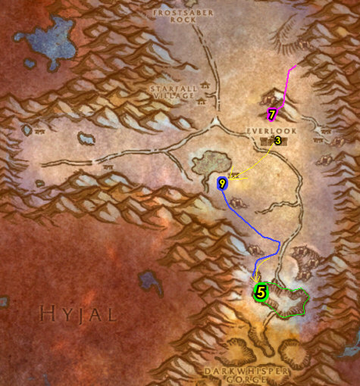

01) Go east to the Owl Wing Thicket entrance 64.59 and do "Wild Guardians": kill Moontouched Owlbeasts.
02) Once your Hearthstone cooldown is less than 5 minutes (keep grinding on owls until then), go back to Everlook (Don't Hearth) and back by the cage, turn in "Brumeran of the Chillwind", SKIP "Shy-Rotam". Also, turn in (if you still need to) "Luck Be With You".
03) Exit Everlook to your right and go to the Wind Rider Master 60.36 and fly to Bloodvenom Post, Felwood.
04) At Bloodvenom Post, turn in "Wild Guardians" 35.53, accept the next part.
05) Hearth to Everlook. Make sure you are repaired/resupplied.
06) Go north of Everlook around 65.21 and do "Wild Guardians": kill 10 Berserk Owlbeasts. While questing here you might find an called Blue-feathered Necklace, which starts "Guarding Secrets", accept it.
07) Just west of you do "Chillwind Horns": kill/loot Chillwind Ravagers. Once finished, keep grinding until your Hearthstone cooldown is less than 11 minutes.
08) Die on purpose to get back to Everlook.
09) Go to the Wind Rider Master 60.36 and fly to Bloodvenom Post, Felwood.
10) At Bloodvenom Post, turn in "Wild Guardians" 35.53. Also turn in (if you found the item) "Guarding Secrets", accept the next part.
11) At Bloodvenom Post, go to the Wind Rider Master 34.54 and fly to Thunder Bluff, Mulgore.
12) Once at TB, go to The Elder Rise to Nara Wildmane 76.32 and turn in "Guarding Secrets".
13) Hearth to Everlook. Make sure you are repaired/resupplied.
14) In Everlook, from Felnok Steelspring under the blue tent 62.39, turn in "Chillwind Horns", accept "Return to Tinkee". NOTE: You can turn this in next time you head to Burning Steppes.
15) At this point you should be very close to level 60. I usually grind the rest of the way to level 60 at the Owl Wing Thicket (entrance 64.59, #1 on map). But here is a list of other things you could do instead of the owl grinding:
#53
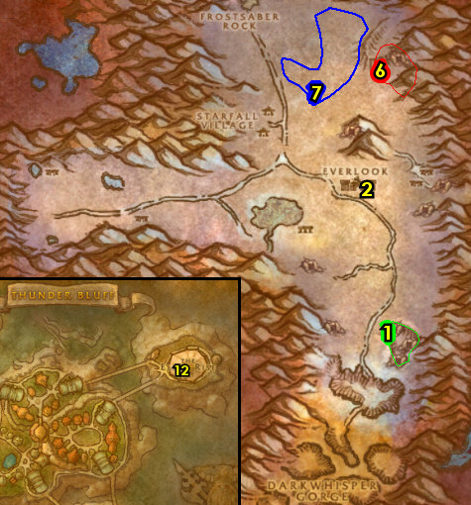

Here are the things you can do to level from 59-60:
--> You can go back into Eastern Plaguelands and do the many group quests that you couldn't solo.
--> You can grind away at mobs in Andorhal to increase your rep with The Argent Dawn.
--> You can grind away at Deadwood furbolgs up north in Felwood to gain rep with the Timbermaw.
--> You can do Black Rock Depths Instance and all the quests associated with it.
--> You can also do Stratholme Instance and all the quests associated with that.
--> You can simply grind on any mob you like until you hit 60.

