Angelo Barcelona

SDEV 300

Lab8

8 Aug 2023

DESIGN: Python Flask based web application to display RnK website. Flask used for interacting with the web application. Local storage used for storing data. 2 Text files provided one to store common passwords, the other to store user data. Language used: Python, HTML 5, and CSS

PYLINT: My pylint score is 9.31/10. Points removed for import errors and for catching to general exceptions.

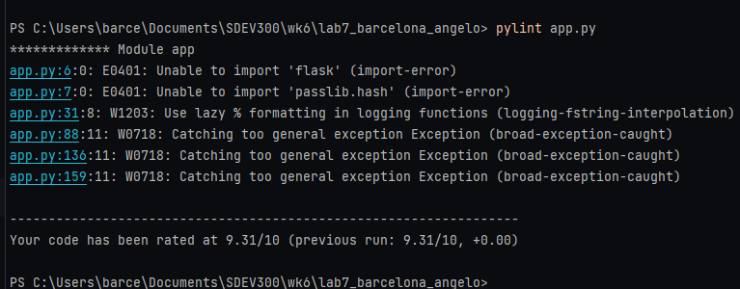

CaseFile Table

|  |  |  |  |  |
| --- | --- | --- | --- | --- |
| CASE FILE # | INPUT | PREDICTED OUT | ACTUAL OUT | PASS/FAIL |
| #1 PASSWORD FORM ALLOWS USER TO UPDATE THEIR PASSWORD AFTER LOGGING IN | PROFILE BUTTON ADDED TO ALL PAGES TO ACCESS UPDATE PASSWORD FORM | SCREENSHOT – RESET PASSWORD FORM DISPLAYED WITH USER NAME | SAME AS PREDICTED | PASS |
| #2 COMPARE PROSPECTIVE SECRETS AGAINST COMMON PASSWORD LIST | Password | SCREEN SHOT SHOWING FLASH MESSAGE THAT THE PASSWORD IS TOO COMMON | SAME AS PREDICTED | PASS |
| #3 LOGGER ADDED | SCREENSHOT | SCREENSHOT OF THE LOGGER SHOWING DATE, TIME, USER AND USER IP | SAME AS PREDICTED | PASS |
| #4 LOGS DATE, TIME, AND IP ADDRESS | SCREENSHOT | SAME AS CASEFILE 3 SHOWING DATE, TIME, AND IP ADDRESS | SAME AS PREDICTED | PASS |
| #5 UPDATE PASSWORD TOO SHORT | Kei3# | SCREENSHOT SHOWING FLASH MESSAGE PW TOO SHORT | SAME AS PREDICTED | PASS |
| #6 UPDATE PASSWORD EMPTY | “” | SCREENSHOT OF EMPTY SCREEN SAYING PW TOO SHORT | SAME AS PREDICTED | PASS |
| #7 UPDATE PASSWORD WRITTEN TO USERDATA.TXT | FROM:  1qaz2wsx!QAZ@WSX  TO:  1234qwer!@#$QWER | SCREENSHOT OF THE HASHED PASSWORDS CHANGED AND WRITTEN TO THE USERDATA.TXT | SAME AS PREDICTED | PASS |

CASEFILE #1

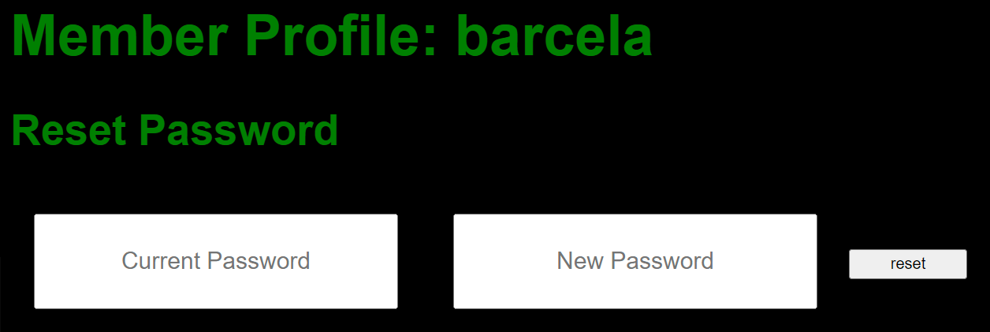

CASEFILE #2

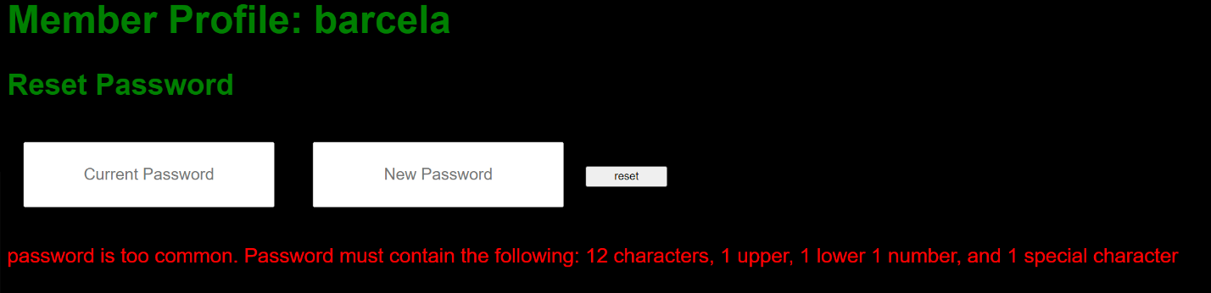

CASEFILE #3

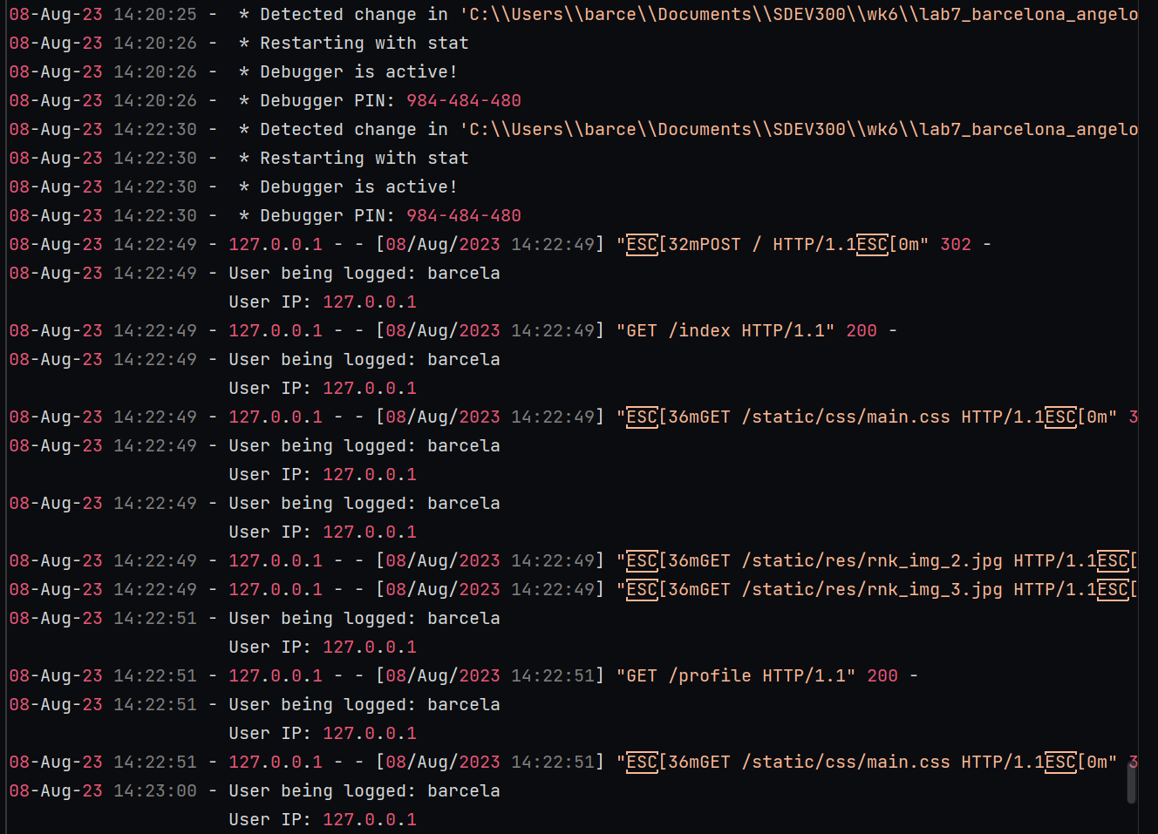

CASEFILE #5

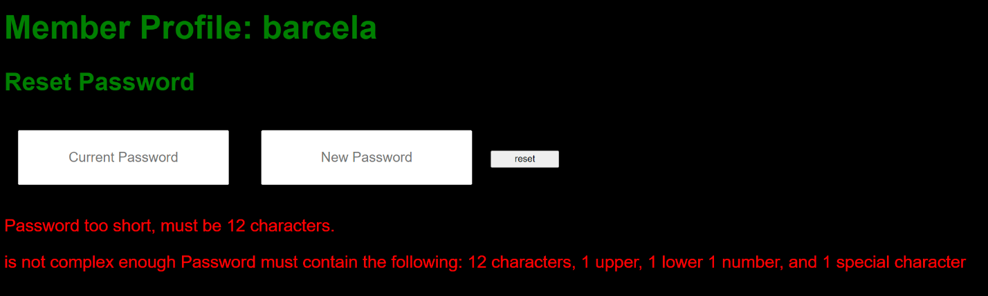

CASEFILE #6



CASEFILE #7

OLD PASSWORD



NEW PASSWORD



CIPHERS:

A.

- .... .. ... / ... -.. . ...- / ...-- ----- ----- / -.-. .-.. .- ... ... / .... .- ... / ... --- -- . / ... - .-. .- -. --. . / .-. . --.- ..- . ... - ... .-.-.-

RESULTS: GRONSFELD CIPHER:

that will be a hard climb said the scarecrow but we must get over the hill nevertheless so he led the way and the others followed

B. U28gdGhpcyBpcyBiYXNlNjQuIE5vdyBJIGtub3cu

RESULTS: BASE64

So this is base64. Now I know.

C.

--- Psuwb Ysm ----

W oa gc qzsjsf. Bc cbs qcizr dcggwpzm twuifs hvwg cih.

--- Sbr Ysm ---

RESULTS: CAESAR CIPHER N: 14

--- Begin Key ---- I am so clever. No one could possibly figure this out. --- End Key ---