Angelo Barcelona

SDEV 300

24 July 2023

Lab 6

DESIGN: This is a python web application designed using the language python, Flask Framework, HTML 5, and CSS. This application displays information about Rooks and Kings an EVE Online space ship video game alliance. This application has 3 page, 3 external links, comments, an ordered list, an unordered list, and 3 different headers. The use of render_templates was used with app.route to comprise the website.

PYLINT: Pylint score is 7.5/10 due to Pylint not recognizing that flask is imported just fine. It states that it is unable to be imported.

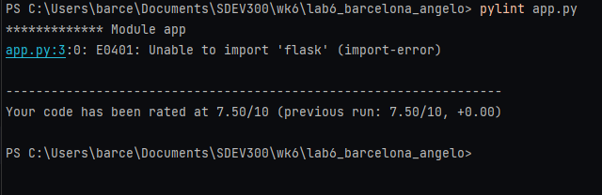

|  |  |  |  |  |
| --- | --- | --- | --- | --- |
| Test Case # | Input | Predicted Output | Actual output | Pass/Fail |
| #1 – Date and time is included in one of the web pages | Date_Time variable passed to index.html render template | Date: Today’s date  Time: Current time in Hour/Minute. Screen shot to show. | Same as predicted | Pass |
| #2 Application uses Flask render_template() to display 3 pages | Screen shots of all 3 render_template() methods and html pages that match | 3 pages screenshotted and 3 methods | Same as predicted | Pass |
| #3 Ordered List | Screen shot of the ordered list on the site and the html | Ordered list shown and html | Same as predicted | Pass |
| #4 Unordered list | Screen shot of unordered list, and python list code, and of the unordered list html | Screen shot shows the input and website output | Same as predicted | Pass |
| #5 3 external links | Screen shot of 3 external links on the website, and html code | Screenshot shows the 3 external site links | Same as predicted | Pass |
| #6 3 headers used | Screen shot of 3 headers used | Same screenshot as test case# 2 page 1 shows all 3 h1, h2, and h3 used. H1 is colored green. | Same as predicted | Pass |
| #7 Paragraph tag used | Screenshot of paragraph tag | Screen shot shows paragraph tag Same screen shot as Test case #5 | Same as predicted | Pass |
| #8 comment used | <!-- -- > | Text in the comment section commented out | Same as predicted | Pass |

Test Case #1:

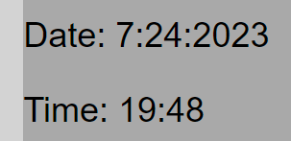

Test Case#2

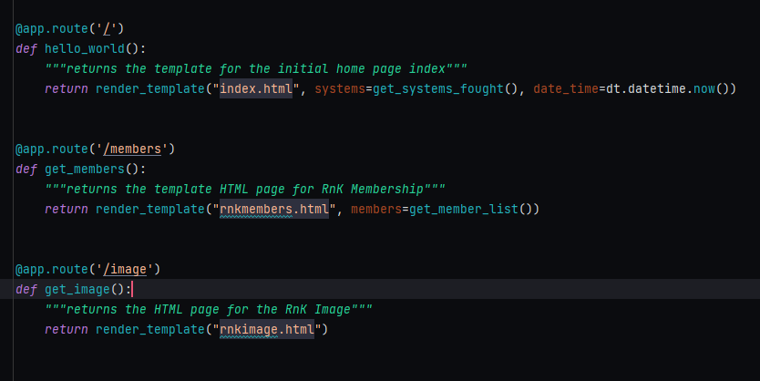

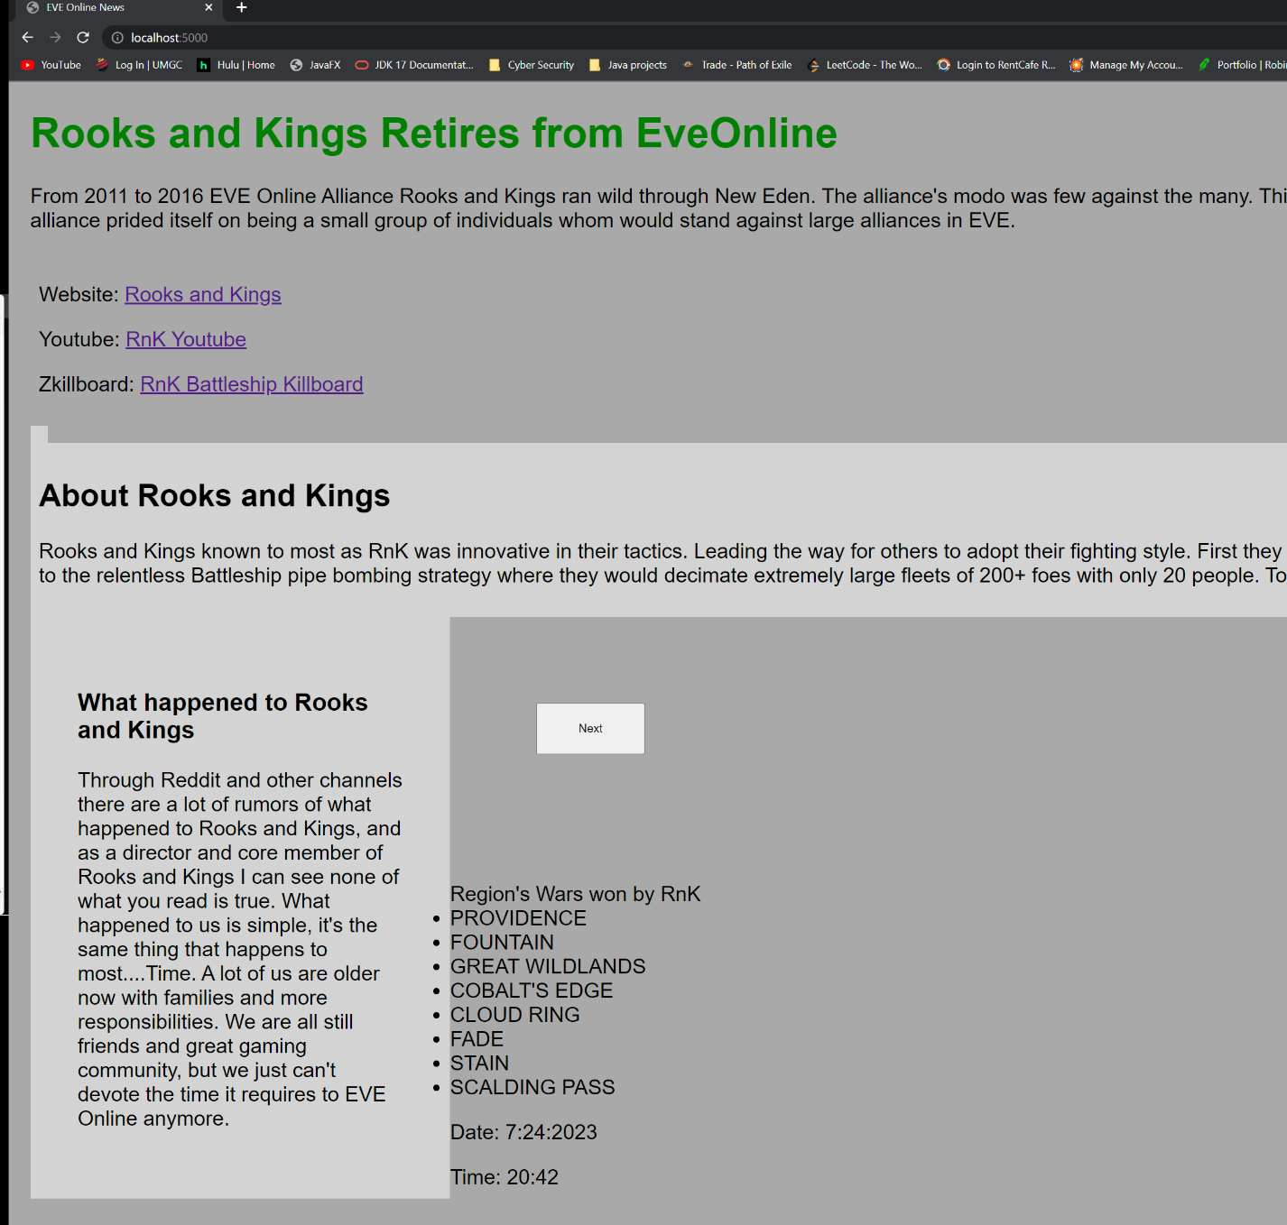

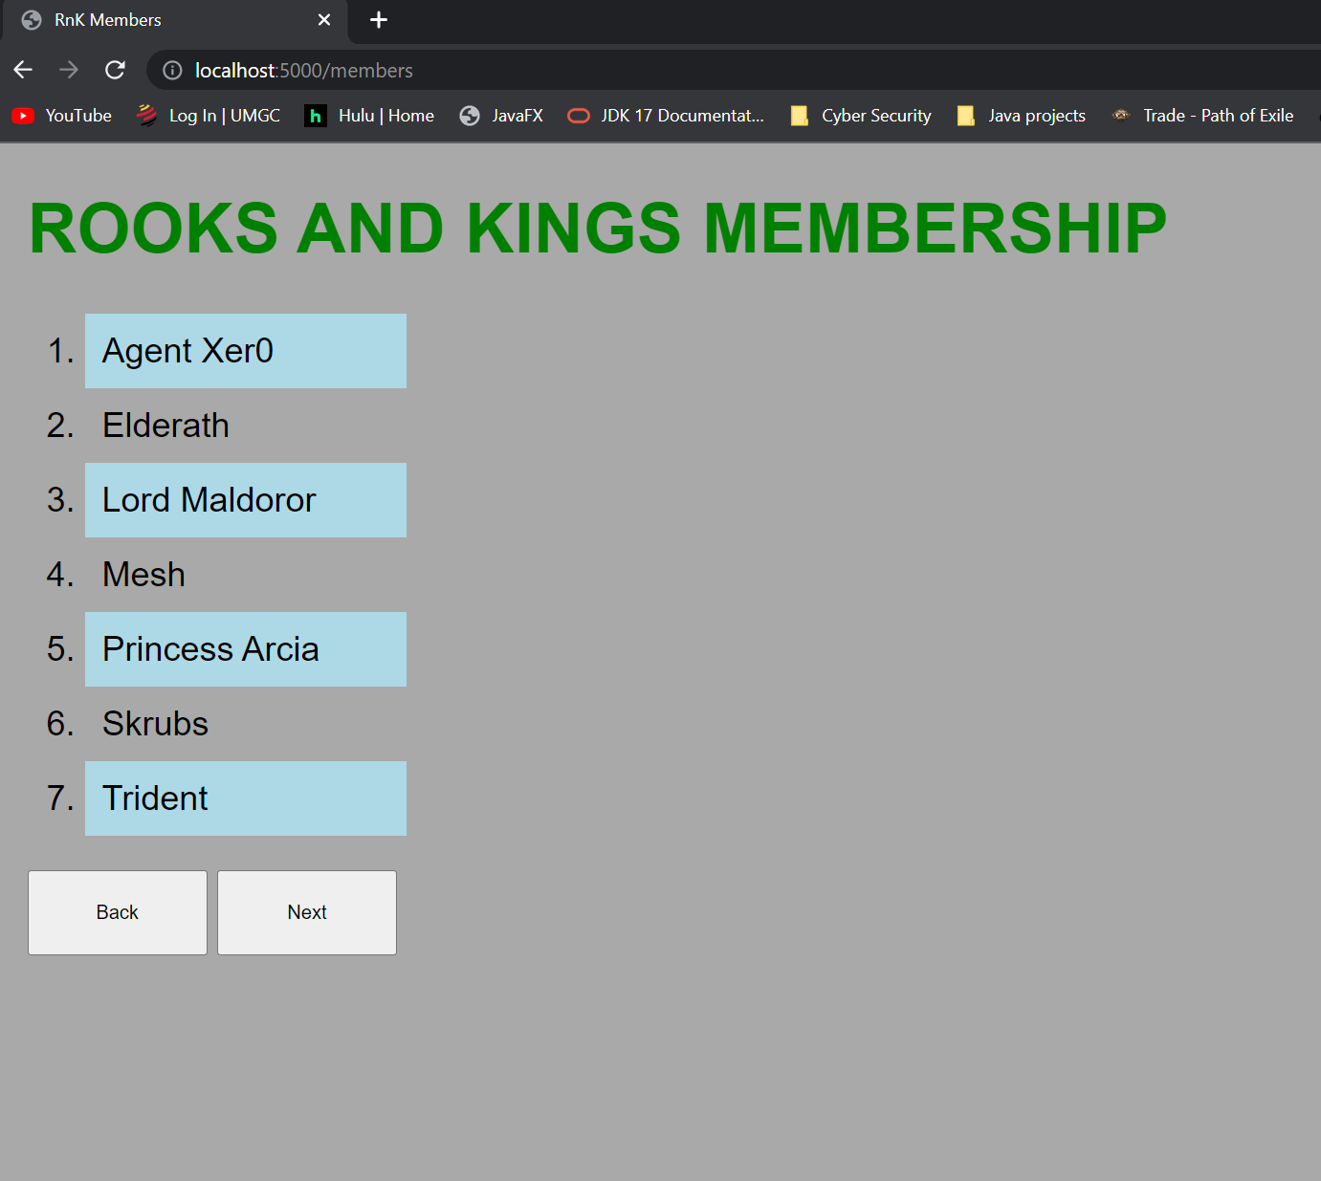

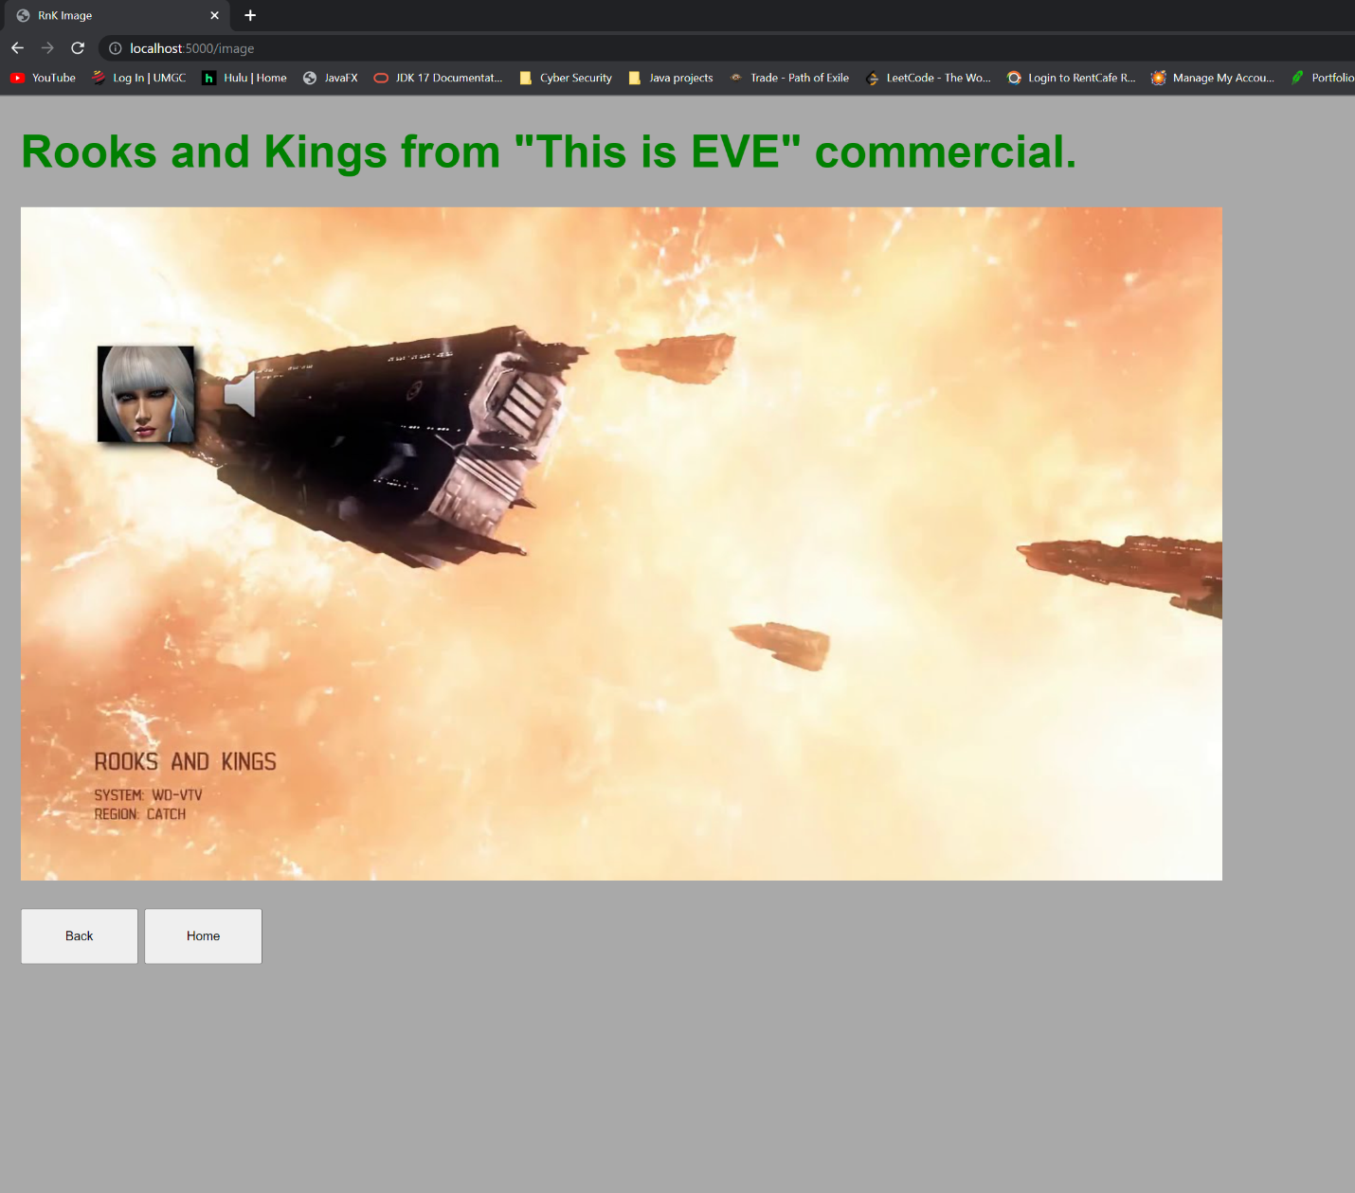

Testcase #3

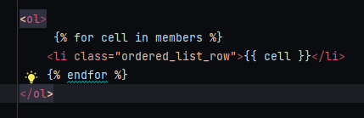

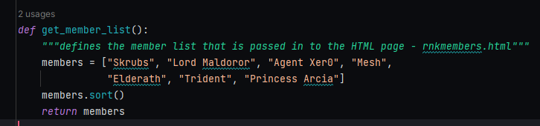

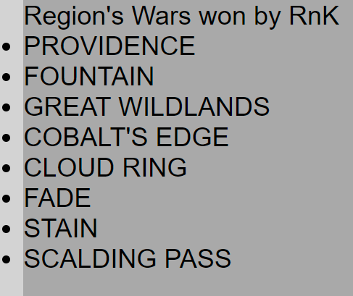

TestCase#4

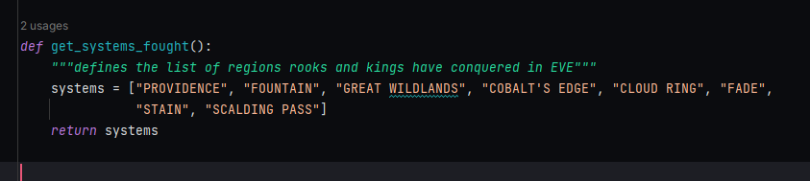

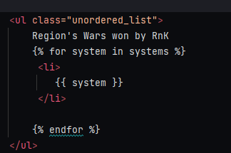

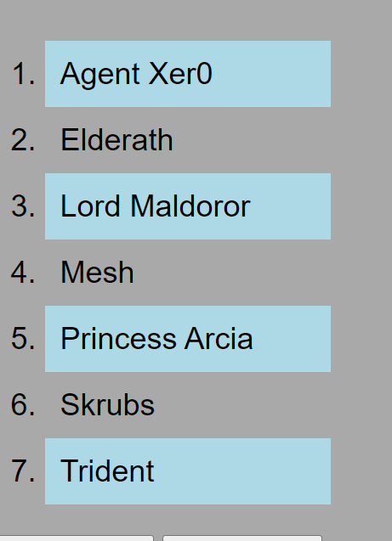

TestCase#5

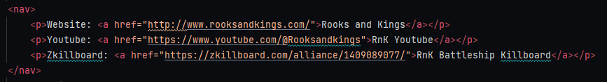

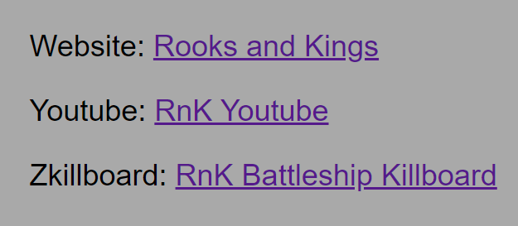

Test Case#6 – see screenshot Testcase #2

Test Case#7 – screenshot of testcase #5 showing the use of <p></p> tags

Test Case#8

