About the Product
Shared candidate brief - use this as the source of all information required for your task.
What you are designing/marketing
A smart 7.5-inch workspace display for desks, offices or walls. It is managed through a companion mobile/desktop application and is designed to keep chosen information visible in the physical workspace.

Physical Product Reference to be used
The image below shows the current physical product prototype. Use it to understand the product's overall form, proportions, frame, depth and desk-standing configuration.
PHYSICAL PRODUCT CONSTRAINT
The physical product is fixed. For this task, assume the product is the current 7.5-inch version. Do not change its physical dimensions, proportions, screen size, frame or overall form. Design around the existing hardware.
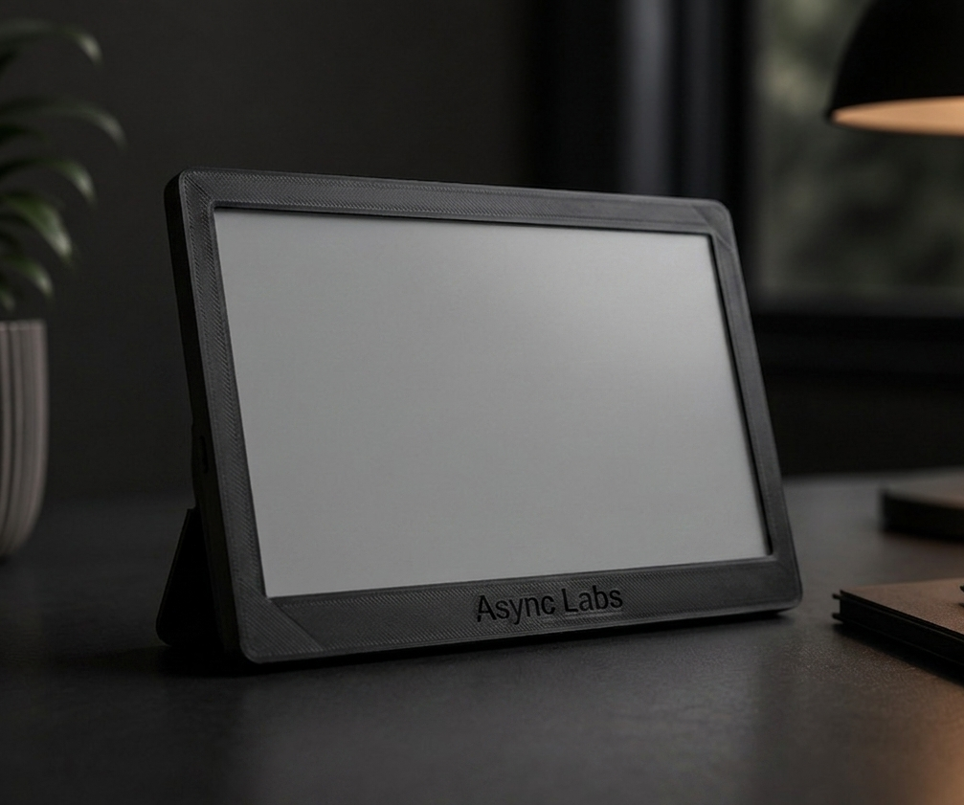
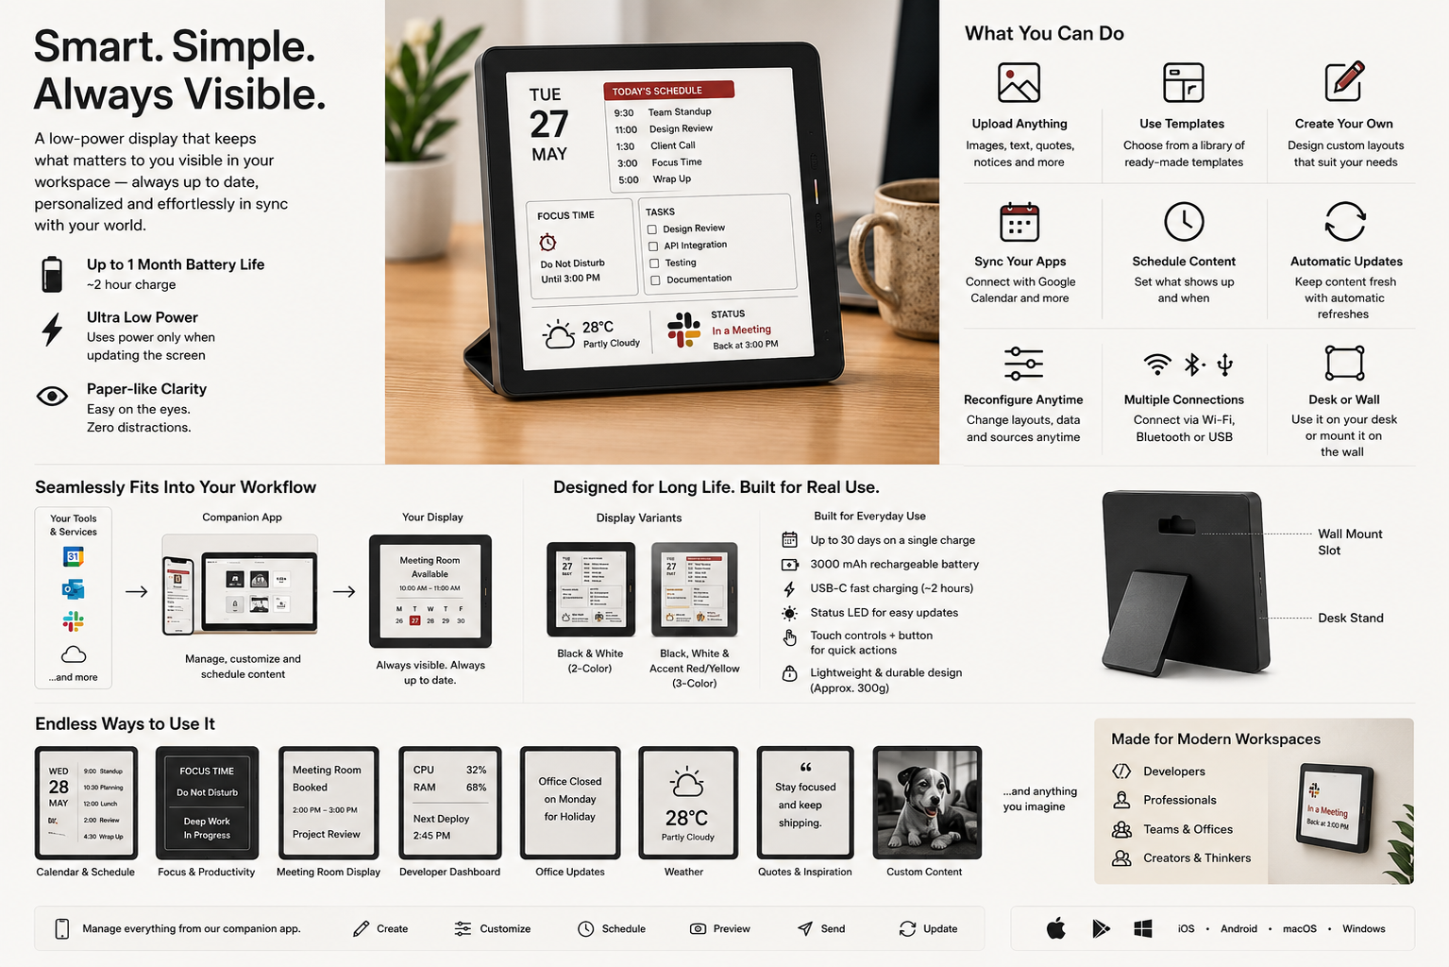
Reference image: use this only as visual context. You are free to imagine different content, applications and marketing directions.

What the product does
- Manage through a companion app: mobile and desktop controls allow users to manage what appears on the display.
- Upload and create content: images, text, calendars, task lists, dashboards and other custom content can be shown.
- Use ready-made templates: users can start from prebuilt layouts instead of creating everything from scratch.
- Create custom layouts: users can continuously reconfigure what is shown and how information is arranged.
- Connect existing applications: the display can sync with services such as Google Calendar, Outlook Calendar and Slack/Teams status.
- Schedule and automate: content can be scheduled and refreshed automatically through cloud APIs or local services.
- Place it where it is useful: use it on a desk or mount it on a wall.
- Choose the display variant: black-and-white or tri-color with an accent color.
- Keep it running for long periods: low-power operation enables up to approximately 30 days of battery life on a single charge.

Product capabilities vs. product benefits
Capability | Why it can matter
Custom content and layouts | Users can make the display relevant to their own workflows and preferences.
Templates | Users can get value quickly without designing from scratch.
Integrations | Useful information can appear without requiring a separate manual workflow.
Scheduling and automatic updates | Information can stay current without repeated manual intervention.
Always-visible surface | Important information can remain visible without occupying the main computer screen.
Low-power, long battery life | It can stay in the workspace for long periods with minimal charging attention.
Desk or wall placement | The same product can fit personal desks, shared spaces and physical signage contexts.

Example applications
- Weekly or daily calendars and schedules
- To-do lists, tasks and reminders
- Focus modes, timers and status indicators
- Meeting or room availability
- Menus at restaurants
- Developer or system metrics
- Quotes, images or custom artwork
- Office announcements and corporate signage
- Weather or other live information
- Dashboards connected to existing workflows
- Personal or professional content created by the user
Important: these are examples, not limitations
These are examples of product capabilities and applications, not strict requirements. You are encouraged to explore other applications, audiences and unconventional use cases that you believe would make the product valuable.

How to think about the product
- Think in terms of the information a person wants visible, not just the physical device.
- Think about the moment of use: what does someone need to know in one glance?
- Think about different environments: personal desk, executive office, shared room, reception, studio, home workspace, or another setting you can justify.
- Think beyond the examples above. A strong screening submission may identify an application, audience or marketing angle we have not explicitly listed.
- You are not being graded on reproducing our examples. We are interested in how you interpret the capabilities and make them valuable.

Screening principle
Show judgment. A simple, coherent idea executed well is stronger than a large collection of generic ideas.

