**Android Questions**

1. Write an application to create a splash screen.
2. Create table Student (roll no, name, address, percentage).

Create Application for performing the following operation on the table.

(Using SQLite database).

i] Insert record of 5 new student details.

ii] Show all the student details.

1. Create an application that allows the user to enter a number in the textbox. Check whether the number in the textbox is Prime or not. Print the message accordingly in the label control.
2. Java Android Program to perform all arithmetic Operations using Calculators.

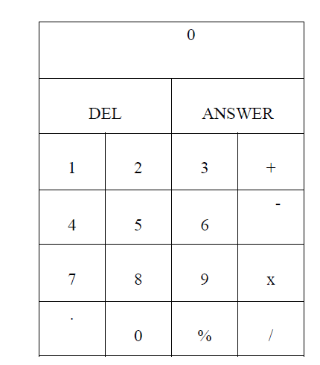

1. Construct image switcher using setFactory().
2. Create table Employee (E_id, name, address, pho_no). Create Application for performing the following operation on the table. (Using SQLite database).
3. Insert record of 5 new Employees.
4. Show all the details of Employee.
5. Create a Application which shows Life Cycle of Activity
6. Create table Customer (id, name, address, ph_no). Create Application for performing the following operation on the table. (Using SQLite database).
7. Insert new customer details (At least records).
8. Show all the customer details
9. Create an Android Application to accept two numbers to calculate it’s Power and Average. Create two buttons: Power and Average. Display the appropriate result on the next activity on Button click.
10. Create application using JSON to provide Employee Information
11. Construct an Android application to accept a number and calculate Armstrong and Perfect number of a given number.
12. Write a Java Android Program to Demonstrate List View Activity with all operations

Such as: Insert, Delete, Search

1. Create an application to demonstrate login form with validation.

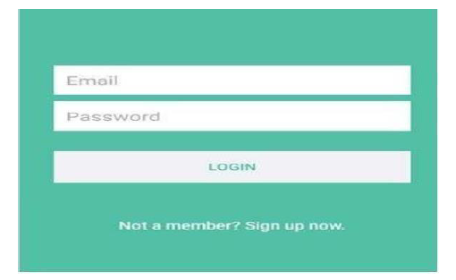

1. Create an application Which reads the person greet message from one activity and display the Greet message on another activity on click of Button (Use Intent).
2. Create an application to change Font Size, Color and Font Family of String
3. Create an application for registration form given below. Also perform appropriate validation.

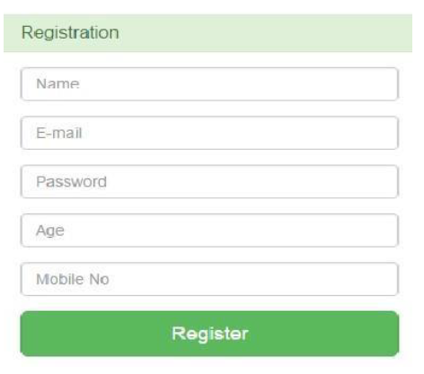

1. Create an Android Application to accept a number and display the multiplication table (Use table Layout).
2. Create table Student (id, name, address, phno). Create Application for performing the following operation on the table.

i) Insert New Student Details.

ii) Show All the Students Details.

1. Create an application that Demonstrates List View and Onclick of List Display with Toast Message.

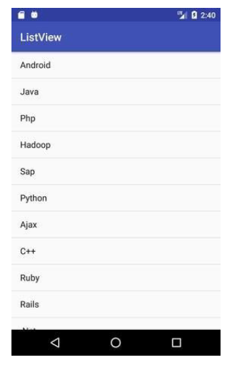

1. Create an application to send and receive messages using SMS Manager.
2. Design an application for login activity. Write android code to check login credentials with username = "mca" and password = "android". Display appropriate toast message to the user.
3. Create the simple calculator shown below also perform appropriate operation.

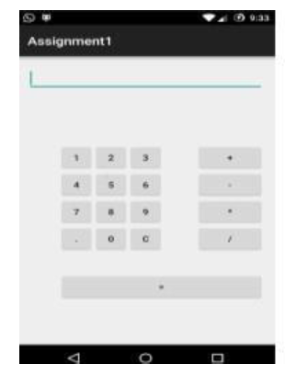

1. Create an Android Application to find the factorial of a number and Display the Result on alert box.
2. Create Table Student (Rollno, Name, Class, contact). Create an Android Application for performing the insert and display operation on the table. (Using SQLite Database).
3. Create an application to find the factorial of a number and Display the Result on alert box.
4. Construct a bank app to display different menu like withdraw, deposit etc. using ReactJS.
5. Create an application that allows the user to enter a number in the textbox. Check whether the number in the textbox is Armstrong or not. Print the message accordingly in the label control.
6. Create an application that demonstrate Options Menu, Context Menu and Popup Menu in android.
7. Create the following Vertical Scroll View Creation in Android

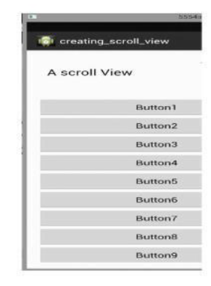

1. Create First Activity to accept information like Employee First Name, Middle Name, Last Name, Date of birth, Address, Email ID and display all information on Second Activity when user click on Submit button.
2. Create an application to accept two numbers and find power and Average. Display the result on the next activity on Button click.
3. Create an application that accept multiple items from one activity and pass to next activity and display the calculation of the first and second activity data on third.
4. Create application to send an email.
5. Construct a Login form with validation using React JS.
6. Create sample application with login module. Verify Check username and password. On successful login, pass username to next screen and if login fails, prompt the user.
7. Create Tables Employee (emp_id, emp_name, emp_desg, emp_salary) Using database perform following operation.
8. Add new record into table.
9. Accept employee name from user and display information of employee.
10. Create application to search a specific location on Google Map.
11. Create Tables Student (roll_no, name, percentage). Using database perform following operation.
12. Add new record into table.
13. Display information of students passes with first class
14. Create application to send and receive messages using SMS Manager.
15. Construct a bank app to display different menu like withdraw, deposit etc. using React JS.
16. Create a Simple Application, which reads a positive number from the user and display its factorial value in another activity.
17. Create a simple To-Do List Application using React JS.
18. Create an Android Application to accept two numbers and find power and Average. Display the result on the next activity on Button click.
19. Create an Android application to perform following operations on table Student (Sid, Sname ,phno). Use autoincrement for Sid and Perform following Operations.

i) Add Student and display its information.

ii) Delete Student

1. Create an Android Application that Demonstrate Radio Button.
2. Write a program to find the specific location of an Android device and display details of the place like Address line, city with Geocoding.
3. Create an Android Application that Demonstrate Switch and Toggle Button.
4. Create application using JSON to provide Employee information.
5. Create a custom "Contact" layout to hold multiple pieces of information, including: Photo, Name, Contact Number, E-mail id.
6. Create an application to demonstrate date and time picker.