TASKS
OBJECTIVE QUESTIONS
- What is the total no. of tables present in the data?
Ans: The given dataset contains only 1 table.
- What is the total no. of attributes present in the data?
Ans: There are total 35 attributes (columns) present in the data.
- The data consists of some inconsistent and missing values so ensure that the data used for further analysis is cleaned.
Ans: The data cleaning process involved:
Duplicates removal: After apply “Remove Duplicates” feature it was found there is No Duplicate Records; 28027 unique rows remain.
Dropping columns: Identifying the columns which are not necessary for data analysis and which contains high number of missing values can be eradicated.
Columns are:
- isWhiteListUser: Const. Boolean value (false) – doesn’t showing any segmentation
- queue: Const. Boolean value showing no diversity
- __v: Version key, internal only (not required)
- statementEntryId: Accounting-level detail, not needed for dashboard
- timeDuration: Underdefined, some technical data as per app
- callChannel: High missing values (69.6%)
- callIvrType: High missing values (70%)
- Region: Const, not helpful for trends
Handling missing values: The formulas used for filling missing values are-
= IF(ISBLANK(C2), “NOT VALID”, C2)
= IF(ISBLANK(T2), “MISSING”, T2)
= IF(ISBLANK(W2), “UNKNOWN”, W2)
= IF(ISBLANK(X2),0, X2)
= IF(ISBLANK(Y2), “N/A”, Y2)

Updating and creating columns/features:
    - create_Date = INT(N2)
    - create_Time = RIGHT(TEXT(N2),” YYYY-MM-DD HH:MM:SS”),8)
    - Update_date = LEFT(Q2,10)
    - Update_time = RIGHT(Q2,12)
    - Year = YEAR(O2)
    - Month = TEXT(O2,” MMMM”)
    - Weekday = TEXT(O2,” DDDD”)
- What is the change in daily call volume day by day and also find the average daily call volume.
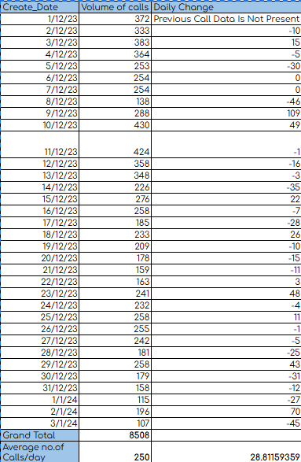
Ans: The following table can be helpful to find the average of calls/day:

The give pivot table in the sheet named “pivots” summarizes the Daily call volume by counting the number of calls per day.
Average no.of Calls/day | 250
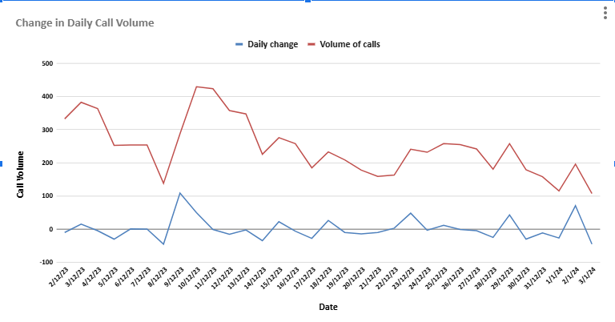
Formula Used:
Average daily call volume:
=AVERAGE($D$11:$D$44)
Change in daily call volume day/day:
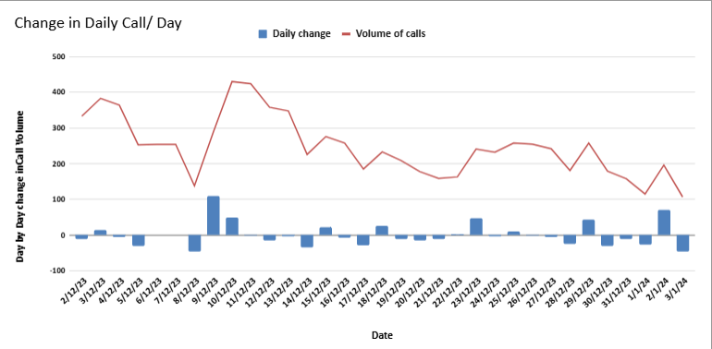
=IFERROR((($B11-$B10)/$B10) *100,"Previous Call Data Is Not Present")
Insights:
It is evident that from the graphs that the user engagement is declining over a longer period. Peak period: Sharp spike around 9–10 Dec 2023, showing a temporary surge in activity.
Steady decline: Continuous drop after mid-December — could indicate reduced user engagement or seasonal slowdown.
- Which months experienced the highest and lowest call volumes?
Ans: The months of December and January shows the highest and lowest call volumes respectively.
The pivot table and the pie chart summarize the volumes of call month-wise:
Highest Volumes of call: December (95%)
Lowest Volumes of call: January (5%)

- What is the total operational cost for that month?
Ans: The total operational cost can be derived from the Astrologer’s earnings.
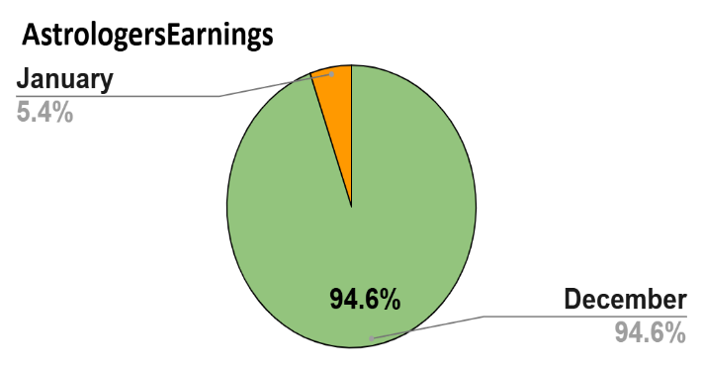
Analysis:
To get the total operational cost for the months of December and January we can obtain the values by creating a pivot table:
- Rows: Month
- Values: AstrologersEarnings summarised by SUM
Conclusion:
- Total operational cost for month December – ₹ 93786.13295
- Total operational cost for month January – ₹ 5360.408
- Grand total (January+December) - ₹ 99146.54095
- What is the average number of calls handled per agent per day?
Ans: The average number of calls per agent per day is 1.91.

Formula Used:
Average number of calls per agent per day :
= ((Total no. of Calls)/ (Total no. of Gurus))/Total days.
= (8508/131)/34
= 1.91

- How many repeat callers are there, and what percentage of total calls do they represent?
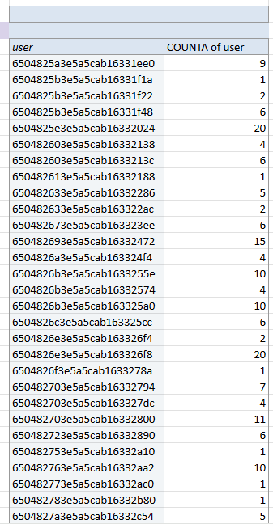
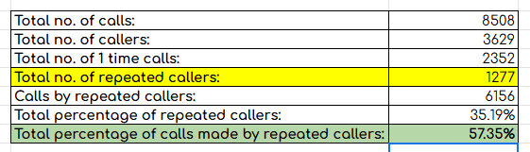
Ans: There are total 1277 number of repeated callers.

Logic & Formula: First creating a pivot table where:
- Rows = uid
- Values = Counta uid (No. of calls)
- Filters = Consultation Type (Status: calls)

■ Formula:
Total number of repeated callers:
=COUNTIF($J$62:$J$3690,">1")
= 1277

Total percentage of calls made by repeated callers:
= ((Total no. of calls-Total no. of callers)*100)/Total no. of calls
=(($M$61-$M$62)*100)/$M$61
= 57.35%

- What are the total sales generated by the call centre for each product category?
Ans: The pivot table and bar graph shows the total sales generated by the call centre for each product category i.e. sales by consultation types.

- Call – 168442.035 | - Chat – 45494.6833
- Complementary – 0.0 | - Public live call – 50.597
Total Sales:

- How many calls were made for each user ID and guru ID?
Ans: The data of calls made by each user ID and guru ID were represented by below pivot tables.

- What is the correlation between call duration and customer satisfaction?
Ans: The correlation between the call duration and customer satisfaction is found to be -0.0412.

Formula:
=CORREL($Y$23:$Y$4020,$Z$23:$Z$4020)
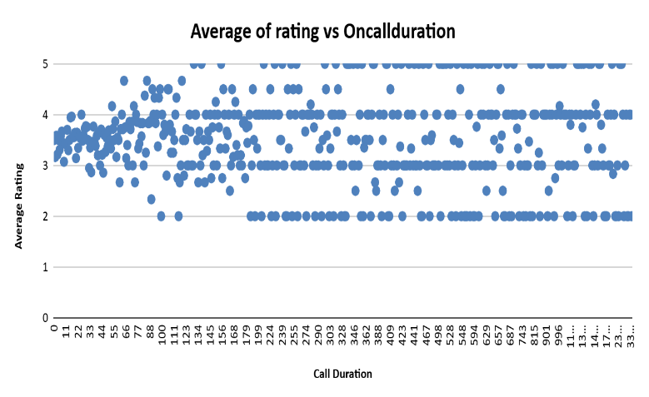
Significance:
- Very weak correlation: The value is close to 0, meaning there is almost no linear relationship between call duration and satisfaction.
- Negative sign: Slight tendency — longer calls might relate to slightly lower ratings, but the effect is negligible.
- Interpretation:
- Call length does not significantly affect customer satisfaction.
- Users’ ratings likely depend on other factors (guru quality, accuracy, empathy, etc.).
- Insight: Efforts to improve satisfaction should focus on service quality, not call duration.
- Next step: Consider analysing tone, content, or follow-up outcomes for deeper insights.

- Which guru has the highest and lowest customer satisfaction scores?
Ans: The highest and lowest customer satisfaction can be derived by using a pivot table:
  - Rows: uid (order: Descending, sort by: Average of rating)
  - Values: rating summarize by Average
  - Formula: To find the corresponding guru name lookup function is used.

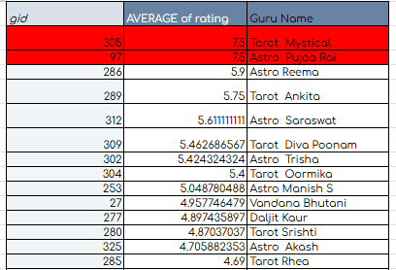
=XLOOKUP( $AE4,Updated_data!$F:$F, Updated_data!$E:$E,0)
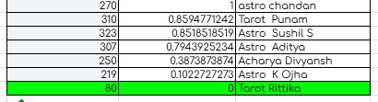

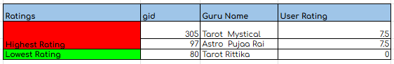
So, the guru with highest satisfaction scores is Tarot Mystical and Astro Pujaa Rai with having 7.5 user rating each. Whereas, the guru with lowest satisfaction score is Tarot Rittika with 0 user rating.

- What is the average customer satisfaction score by month?
Ans: The average customer satisfaction score by month can be determined by creating a pivot table:
- Rows: Month
- Values: Rating summarises by Average

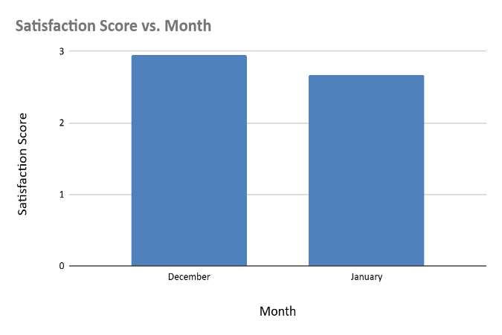

Therefore,
Satisfaction Score for the month December: 2.949637572
And, Satisfaction Score for the month January: 2.676413255

- How many categorical columns are there in the data? [Search about categorical and continuous data, and try to answer this question]
Ans: 1. Categorical Data: Categorical data represents qualities, groups, or classifications. It describes subjects by putting them into distinct categories, where the order or number has no intrinsic mathematical meaning.
- In the given dataset there are total 15 categorical columns- chatStatus, guruName, consultationType, website, refundStatus, isWhiteListUser, queue, freeCall, freeChat, callChannel, callIvrType, callStatus, AstrologerCallStatus, Region, UserCallStatus.
2. Continuous Data: Continuous(numerical) data represents quantities that can be measured. These values can theoretically take any value within a given range, including infinite possibilities of decimals or fractions.
- In the given dataset there are 4 continuous columns- createdAt, updatedAt, chartStartTime, chatEndTime.

Subjective Questions

- Should the investment be used to hire more agents, improve training programs, or upgrade call centre technology?

Ans: I) Hiring More Agents: To determine whether hiring of agents needed or not we need to find the agent load to check calls handles per guru name.

Approach: To approach this problem, we need to find the no. of calls a particular agent is handling on daily basis. Thus, it will show us how evenly/unevenly the distribution of load is which can help use to govern whether we need to hire more agents or not.

Criteria:
To achieve this, we created a combo chart “Call Handles per Agent” where:
- X-axis- Guru Name
- Y-axis- Count of CallSid

Interpretation:

- Uneven Workload Distribution:
Gurus with 1000+ calls are likely handling a disproportionate share of total customer interactions.
→ This may lead to fatigue, burnout, or reduced service quality for those top-performing agents.

- Underutilized Resources:
Gurus with 0 or very few calls are being underused.
→ Possible reasons: scheduling gaps, lower visibility in call routing, or poor performance history.

- Efficiency Gaps:
The call allocation system might not be optimizing for equal opportunity or efficiency.
→ Calls could be routed based on availability, rating, or past performance — but that’s worth analysing.

- Impact on Customer Experience:
Overloaded gurus may rush through calls → lower satisfaction.
Idle gurus → higher cost per employee but lower productivity.
Analysis:
- If a few gurus handle 1000+ calls while others handle almost none → the issue is imbalance, not shortage.
- This means the system or scheduling might not be distributing calls properly.
- So, hiring more agents right now would increase costs without fixing the core inefficiency.

Recommendations:
1) Rebalance existing workload
→ Use routing logic or scheduling tools to distribute calls evenly.
→ Monitor each guru’s utilization rate.

2) Improve efficiency first
→ Offer training to underperforming or less active gurus.
→ Investigate why some gurus have 0 calls (availability, ratings, response time, etc.).

3) Hire only if needed
→ If, after balancing, call volume still exceeds total handling capacity, then hire more.
→ You can confirm this by checking:

II) Improve Training Programs: Here our focus area is to find the performance quality of each Agent to decide if training is needed or not. This can be observed by calculating average of user rating per agent.

Approach: To determine whether training program is needed or not we have the find how satisfy the customers are with the services and performances of their respective agents on calls/chats.
Criteria: Creating a pivot table: Rows= GuruName, Values= AVERAGE of Ratings.
Plotting a histogram; taking Ratings on X- axis and Count of Gurus in Y-axis.

Observation | Interpretation | Action Required
1.Wide Spread (0.00 to 8.00) | Inconsistent Quality & Methods | Implement standardized training and SOPs.
2. Large Count Below 2.67 | Significant Failure in Delivery | Immediate remedial training and coaching for the low-rated cohort.
3. Mode at 3.33 - 4.00 | Average Performance is Moderate | Advanced training to promote best practices and elevate median performance.

III) Upgrade Call Centre Technology: To Check the Tech reliability we need to see the % of calls that are failed/incompleted or not-answered to decide if system upgrade is needed or not.

Approach: The condition of technical services provide can help us to judge if tech upgradation is required or not. How well the customers are getting connected to the agents and how smoothing the process of consultation going on can determine the technical aspect of the call centre.

Criteria: Using pivot table by Rows =CallStatus, Values= COUNTA of CallStatus and ChatStatus. And plotting a pie chart to show the call status of each category
Findings: The core finding is that while service delivery is successful over half the time, the combined rate of preventable losses (Busy, No-Answer, and Failed) represents a significant leakage in customer service operations.
Loss Rate = 14.4% (No-Answer) + 14.0% (Busy) + 9.8% (Failed) + 7.1% (incomplete) = 45.3%.
Almost 45% of call attempts are not resulting in a successful completion, pointing to critical issues in capacity management, technical stability, and possibly agent handling of the calls.

Recommendation: Technology is an enabler, but it only magnifies the skills of the user. If agents are poorly trained, giving them advanced tools will only let them make faster mistakes. Once quality is standardized through training, technology (especially AI and automation) should be introduced to reduce agent workload and handle simple queries.
With a 30% failure rate, upgrading call centre technology is strongly justified before hiring or training.
This will directly reduce failure rates, improve ratings, and reveal true agent performance.

Declining daily active users:
There is a noticeable decrease in daily active users across both the app and the website, and negligible dashboard engagements which is a cause for concern.

Investment in Technology (Efficiency Focus):

-Knowledge Management: Upgrade the internal knowledge base (CRM/SOP library) to make information instantaneously searchable by agents during a call.

-Introduce AI for Triage: Implement conversational AI or chatbots for basic, repetitive customer queries to free human agents to handle only complex, high-value interactions.

-Quality Assurance (QA) Automation: Implement tools that use speech analytics to automatically score all calls (not just a sample) for compliance, sentiment, and adherence to new training protocols.

- What are the potential risks of each investment option (hiring, training, technology upgrades), and how can they be mitigated?
Name the chart/spreadsheet function you will use for solving the problem.
Ans: Investment Option 1: Hiring More Agents
Approach: First, analyze current workload distribution per agent using total calls handled vs available working hours.
Identify whether low performance is due to agent shortage or poor utilization.
Only proceed with hiring if utilization consistently exceeds 80%.
Potential Risks:
- Increased cost without guaranteed efficiency (if call failures are due to tech, not manpower).
- Idle agents if demand fluctuates or system bottlenecks persist.
How to Analyse / Mitigate:
- Function: =AVERAGEIF() or =SUMIF() to check per-agent utilization.
- Chart:
- Combo Chart → Bars = calls handled, Line = average utilization rate.
- Helps reveal if existing agents are already underutilized.
Investment Option 2: Training Programs
Approach: Assess pre- and post-training performance of agents through rating improvement and customer feedback.
Measure correlation between skill level (or training hours) and service quality.
Focus training on low-performing agents to maximize ROI.
Potential Risks:
- Training may not fix issues caused by technical or customer-side problems.
- Time lost during training reduces productivity temporarily.
How to Analyse / Mitigate:
- Function:
- =CORREL(rating_range, duration_range) → check if longer/more effective sessions (likely from skilled agents) correlate with higher ratings.
- =AVERAGEIF(guruName_range, guru, rating_range) → measure which gurus perform better (indicating training impact).
- Chart:
- Scatter Plot: Ratings vs. Call Duration → shows if better handling improves satisfaction.
Investment Option 3: Technology Upgrades
Approach: Conduct a failure pattern analysis to confirm if technical issues (dropped/incomplete calls) are the main cause.
Use time-series trends to evaluate how failure rates evolve before and after tech upgrades.
Validate with small-scale pilots before full rollout.
Potential Risks:
- High upfront cost and downtime during implementation.
- If root cause isn’t purely technical, returns may be lower than expected.
How to Analyze / Mitigate:
- Function:
- =COUNTIF(CallStatus_range, "incomplete") / COUNTA(CallStatus_range) → failure rate.
- =AVERAGEIF(CallStatus_range, "completed", duration_range) → average duration of successful calls.
- Chart:
- Pie Chart: Completed vs Failed/Incomplete Calls → visual of system reliability.
- Trend Chart (Line): Failure rate over time → to see if system instability is increasing.

- How does AstroSage's call center performance compare to AstroGuru's average call volume, customer satisfaction, and agent performance?
Will you use any aggregation function or a visualization here to solve the problem?
Ans: Dataset of AstroGuru is not provided so no further analysis can be done.

- How can the call center improve its handling of peak call periods to ensure high customer satisfaction?
Mention the functionality you will use for giving the suggestions, will it be any aggregated function or a visualization?
Ans:
Findings from the "Hourly Call Traffics" Graph
Approach: Use aggregated analysis of hourly call volume to identify peak vs. off-peak trends and optimize staffing based on demand intensity.
Criteria: Compare hourly call counts with available agent capacity to find hours where service level < target (e.g., 80%).
Functionality Used: Visualization (Line Chart) for trend analysis + Aggregated Functions (AVERAGEIFS, COUNTIFS) for hourly performance summaries.
The chart shows the average traffic for each hour of the day (0-23).
- Peak Period Identification: The call centre experiences its highest traffic between 5 AM and 5 PM (Hours 5 to 17).
- Peak Traffic Hours: Traffic consistently hits the highest point, ranging from 42 to 55 calls per hour. The absolute peak is at 6 AM (55 calls) and 7 AM (55 calls).
- Sustained High Traffic: The traffic remains high and steady throughout the standard business day, only dropping significantly after 5 PM (Hour 17).
- Off-Peak/Low Traffic: Traffic is extremely low between 10 PM and 3 AM (Hours 22 to 3), ranging from 8 to 17 calls per hour.
How to Improve Handling of Peak Call Periods:
The goal is to shift resources to match the high demand from 5 AM to 5 PM, which will directly reduce the "Busy" and "No-Answer" percentages observed in the overall call status.
Strategies
1. Dynamic Scheduling and Staffing:
Approach: Analyze hourly traffic averages to realign shift rosters.
Criteria: Match agent count to hours where call volume > average.
- Improvement Detail: Shift resources to match the 5 AM to 5 PM demand. Implement staggered shifts or compressed workweeks to maximize agent coverage during the 6 AM and 7 AM absolute peaks.
- Target Metrics Impacted: Busy Rate(↓), No-Answer Rate (↓), Completed Rate (↑), Service Level(↑)
2. Offer Automated Self-Service:
Approach: Identify call types that can be automated during peak load.
Criteria: Use COUNTIFS() to find frequent, short-duration queries.
- Improvement Detail: Implement a robust Interactive Voice Response (IVR) or a conversational AI chatbot for basic inquiries during peak hours. This diverts simple calls away from human agents.
- Target Metrics Impacted: Busy Rate(↓), Average Handle Time(↓)
3. Proactive Call-Back Queue:
Approach: Track call wait times and missed-call spikes during high traffic.
Criteria: Use MAX() on queue wait times to set callback triggers.
- Improvement Detail: When the wait time exceeds an acceptable threshold (e.g., 3 minutes), offer the customer a guaranteed call-back at a specific time, allowing them to hang up without losing their place in the queue.
- Target Metrics Impacted: $No-Answer Rate(↓),Customer Satisfaction(↑)

4. Cross-Train Agents:
Approach: Evaluate skill coverage and transfer frequency using COUNTIFS().
Criteria: Identify calls requiring multiple transfers → target for training.
- Improvement Detail: Ensure all agents are trained to handle the most common types of calls, eliminating the need to transfer simple calls and reducing the average time spent on the call during busy periods.
- Target Metrics Impacted: Average Handle Time (↓), First Call Resolution (FCR) (↑)

Suggestions:
Flexible Staffing: Use part-time, on-demand, or freelance agents who can be called in during peak times. Having a reserve pool of trained agents will help balance the workload without increasing permanent staffing costs.
Shift Optimization: Optimize agent shifts to peak periods accordingly. Ensure that more agents are scheduled during the high-traffic times.

- Based on historical data, what strategic initiatives should be prioritized to improve efficiency and customer satisfaction?
Ans: Approach & Criteria:
The approach involves analyzing historical agent performance, call status, and customer ratings to identify key inefficiencies. Agents with consistently low ratings or high failure rates are prioritized for targeted training, while call routing and technological bottlenecks are examined to enhance efficiency. The criteria focus on measurable metrics such as average rating, call completion rate, and failure percentage, evaluated using functions like AVERAGEIF, COUNTIFS, and CORREL. Visualization tools such as pivot charts and trend lines help reveal performance gaps and guide strategic initiatives.

Based on historical call center data and the goal of improving overall efficiency and customer satisfaction, the following strategic initiatives should be prioritized:
Selected Training for Poor Performing Agents
Analysing the historical data, it will be seen that there are some agents whose failure rates are very high, and the customers’ ratings are also poor. There is much that targeted training can do to enhance their performance, decrease call failure rate, and increase customers’ satisfaction.
Action:
Find the agents with low ratings and agents with many failures.
Create effective training sessions based on the employees’ need for improvement in such areas as communication skills, problem-solving skills, and technical knowledge.
It is necessary to assess changes in performance after training so that it is possible to determine whether the training was beneficial.
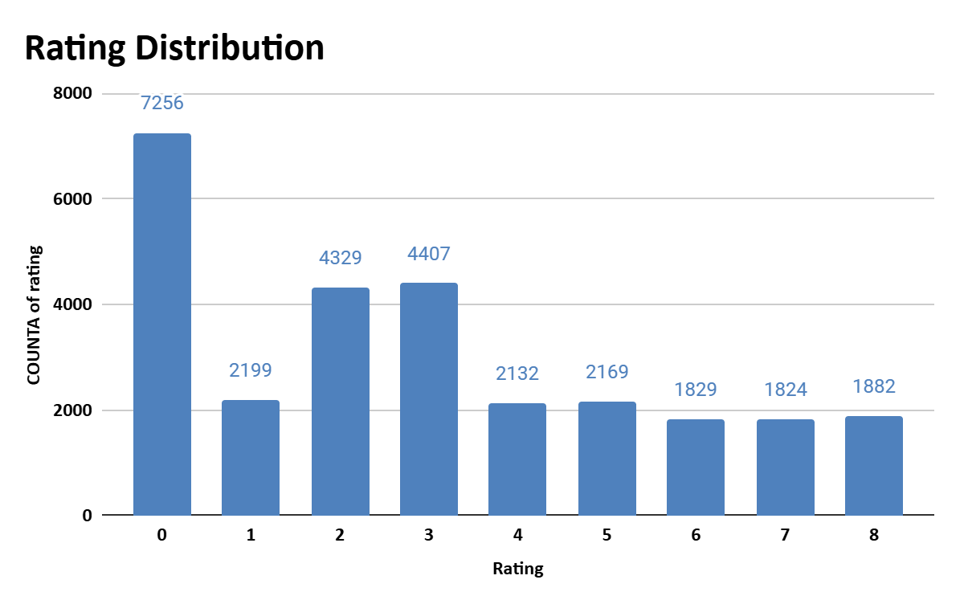

Given picture shows the distribution of Rating across the Agents.
It can be seen that the majority of the data lies in the left half showcasing the lower satisfaction of the customers.

The rating distribution can be analysed through the above pivot table and appropriate actions like targeted training can be taken for special cases.
Improved Call Management and Call Priority
Poor call routing directs customers to stay longer on the line, become unhappy, and agents may be used inappropriately. There is a possibility of intelligent call routing systems to match the needs of the customers with the right agents.
Action:
Utilize skill-based routing that will help to route the calls to agents who will be in the right position to attend to the call.
Implement the concept of priority queuing so that valued or returning customers receive their services earlier, especially during the rush hour.
Deduce and periodically update routing rules with the help of performance reports.
Measures to Minimize Call Failure Risks Due to Technological Enhancements
Rationale: This is because records of past calls may show call failures or technical challenges that are displeasing to the customers. It is therefore possible to recommend that organizations seek to upgrade the technology used in call centers since this would increase call quality, reduce failure incidences, and increase efficiency.
Action Items:
The communication should also be more reliable and have a larger capacity, and this is why one should think about investing in a better infrastructure.
Introduce or enhance effective IVR systems to minimize the need for agents in handling simple calls.
Avail the services of monitoring and diagnosis tools in order to diagnose technical problems as they surface.

The Given Chart shows the failure rate of calls.

Improved Self-Service Options
This is because customers are now able to use self-service to solve most of the questions that they have frequently. This can effectively help in cutting down on the number of calls made during peak hours self-service through IVR, chatbot or through online portals.
Action:
Integrate IVR systems to be further developed to address numerous questions which do not require the assistance of the agents.
I recommend the use of AI based chatbots to help customers solve simple problems that they come across.
The more the customers are encouraged to use self-service, the more effective they are when it comes to conveying information and providing interfaces.
Conclusion: Prioritizing targeted training, technology upgrades, enhanced call routing, workforce optimization based on historical data will lead to significant improvements in overall efficiency and customer satisfaction.

- What can be the key factors contributing to high customer satisfaction scores, and how can these be leveraged to improve overall performance?
What is the basis for the suggestions? And mention how you decided if the satisfaction score affects the ratings.
Ans: The Key Factors contributing to the high customer satisfaction scores are:
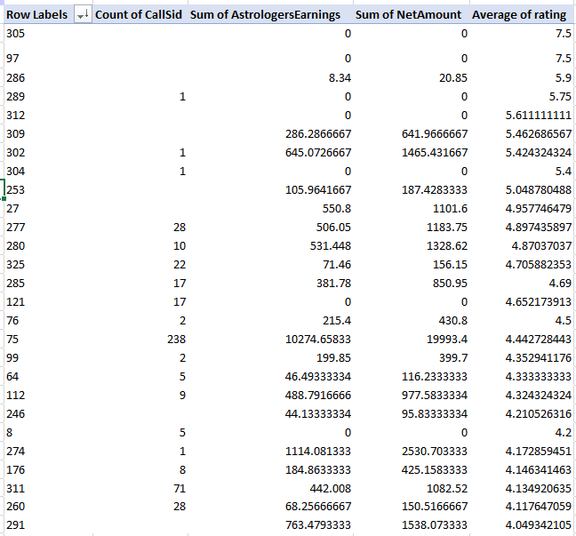
Interaction with the agents:
High customers satisfactions are contributed by agents having high demand and higher expertise.
Low call volumes: Customers' experience gradually improves when the agents handle lesser customers, their consultation and rating are better. The rating drops if the agents become overburden in providing efficiency to the customers.
Performance Improvement strategies:
An Agent who is well learned and manage well trained agents with effectively lower call volumes would provide better output to customers.

The performance of the agents and their ability to handle the customers is revealed by this pivot table. This part of the table shows us the top agents that manage the most volume of calls.
Approach & Criteria:
The approach focuses on analyzing agent-level performance metrics — including total calls handled (COUNT of UID), earnings, net revenue generated, and average customer rating — to identify factors driving higher satisfaction. By examining the relationship between call volume and average rating, it becomes evident that agents with moderate call loads tend to maintain higher satisfaction scores, whereas agents handling extremely high call counts often show declining ratings due to fatigue or quality drop.
The criteria used involve comparing and correlating numeric fields:
- Use =CORREL(COUNT_range, AVERAGE_rating_range) to check if increased workload negatively impacts satisfaction.
- Apply =AVERAGEIF(rating_range, “>4”) to find characteristics of top-performing agents.
- Visualize through a Scatter Chart (Calls vs. Average Rating) to spot the workload-performance balance.

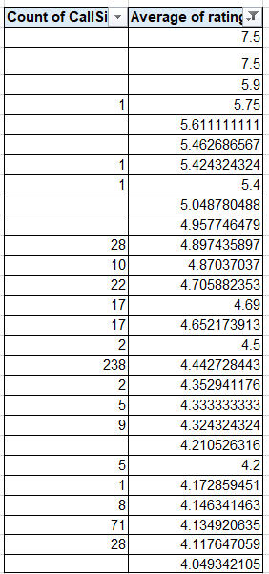
From the bottom of the table, it shows agents with poor performance with regards to number of calls, or handling efficiency decreases.
Determining which interactions to distribute the balancing to specific agents using prioritising customer requirements.

Summary and Suggestions:
- In consultation type, customers are more satisfied by having complimentary calls/chats. So, the business should provide each free trials and complimentaries for better customer acquisitions whereas the business should need to focus more on its chat services by trying new technologies like chat bots to enhance its CSAT on chats.
- In the case of website, customers are tend to experience heightened satisfaction when utilizing their dashboard service as compared to other accessible platforms like app and gurucool. So the focus should be more on developing and updating the IoT based platforms for better customer experience.
- The CSAT is more when customers are getting full call access to their respective gurus. Completed calls make customers happier while interrupted, unconnected and unreachable calls may cause in the declination of customer ratings. Hence it should be taken into consideration that all customers are getting connected and avail the services without any hindrance. Technological feasibility and proper handling of customer calls must me there.

- How should the call center balance the workload among agents to ensure optimal performance and avoid burnout?
Mention your approach and spreadsheet function for the answer.
Ans: Approach:
The scatter chart compares the number of calls handled (callStatus, chatStatus_imputed) with the average rating for each agent (gid).
From the visualization, it is evident that:
• Agents handling higher volumes of calls or chats (above 300) tend to show lower average ratings.
• Agents with moderate call counts (around 100–200) consistently maintain better customer satisfaction scores.
🟢 High Workload, High Rating
- Gid 75: Workload = 777, Rating = 4.44
- Gid 274: Workload = 619, Rating = 4.17
✅ These agents handle many tasks efficiently and maintain high satisfaction — possibly top performers.
🔴 High Workload, Low Rating
- Gid 201: Workload = 735, Rating = 1.00
- Gid 239: Workload = 1450, Rating = 2.53
⚠️ These agents are overloaded or need training, as performance drops with heavy workload.
🟡 Low Workload, High Rating
- Gid 97: Workload = 2, Rating = 7.5
- Gid 286: Workload = 10, Rating = 5.9
⭐ Light workloads often get higher ratings — indicating quality over quantity.
🔵 Moderate Workload, Balanced Rating
- Gid 195: Workload = 272, Rating = 3.52
- Gid 271: Workload = 752, Rating = 3.71
These represent steady performers who maintain decent satisfaction even with moderate workloads.
Possible Insights:
- Negative correlation likely exists — as workload increases, average rating tends to fall for most agents.
- A few agents (like Gid 75, 274) are exceptions who perform well even under pressure.
- Management can analyse workload distribution — reducing excessive workload may help improve overall CSAT.
- Training or automation can target agents with high workload and low ratings.
Spreadsheet Functions Used (Criteria):
- =COUNTIFS(gid_range, gid) → counts total calls/chats per agent.
- =AVERAGEIFS(rating_range, gid_range, gid) → calculates each agent’s average rating.
- Chart Type: Scatter Plot (X-axis = Agent ID, Y-axis = Calls/Chats & Ratings).

Final Recommendation:
To ensure balanced workload and prevent burnout, the call centre should use a data-driven
workload distribution strategy:
We analysed calls handled and average ratings per agent using pivot tables and a scatter
chart. By ranking agents with the RANK() function, we identified agents handling
significantly higher call volumes than others, which can lead to fatigue and drop in service
quality. The scatter analysis showed that performance declines when call load exceeds ~700
calls per period.
Recommendations:
• Redistribute calls more evenly across agents
• Introduce dynamic call routing to support overloaded agents
• Provide training & support to agents with lower ratings but manageable load
• Keep a threshold load limit to prevent performance decline
• Schedule rotational breaks & flexible shifts during peak days
This ensures:
• Optimal performance across the team
• Reduced burnout & attrition risk
• Improved customer satisfaction

- What new technologies or tools could be implemented to enhance call centre operations and customer service?
Ans: New Technologies & Tools to Enhance Call Centre Operations

1. AI-Powered Call Routing Systems

- Purpose: Match customers with the best-suited astrologer (guru) automatically.
- Benefit: Reduces waiting time and increases first-call resolution rate.
- Analysis Link: Use COUNTIFS() to identify peak-time call overload per guru → then auto-balance with AI routing.

2. Predictive Analytics Dashboard

- Purpose: Forecast call volume using historical data trends.
- Tool: Google Sheets + Power BI / Looker Studio integration.
- Benefit: Enables proactive staffing during peak hours.
- Visualization: Line Chart showing call count vs. time for pattern detection.

3. Speech Analytics & Sentiment Detection

- Purpose: Analyze tone, emotion, and keywords in conversations.
- Benefit: Identify customer dissatisfaction early and personalize responses.
- Integration Tool: AI-based platforms like Observe.AI or Google Cloud Speech-to-Text.

4. Automated Quality Monitoring System

- Purpose: Evaluate calls automatically based on script adherence, politeness, and clarity.
- Benefit: Saves supervisor time and standardizes quality checks.
- Functionality Used: Weighted scoring through custom formula sheets (e.g., AVERAGEIFS() for scoring metrics).

5. Chatbots & Virtual Assistants

- Purpose: Handle routine inquiries instantly (horoscope checks, appointment booking, etc.).
- Benefit: Frees human agents for complex or emotional consultations.

6. CRM Integration & Unified Data View

- Purpose: Connect call logs, ratings, and earnings data.
- Benefit: 360° view of each customer → improves personalization and retention.
- Tool: Zoho, Salesforce, or Google AppScript integration.

7. Real-Time Call Performance Dashboard

- Purpose: Track ongoing call stats, failures, and utilization.
- Tool: Google Sheets Pivot Tables + Conditional Formatting + Data Studio visualization.
- Benefit: Immediate detection of technical or staffing issues.
- What metrics should be included in the final dashboard to comprehensively view call center performance and guide investment decisions?
Ans: 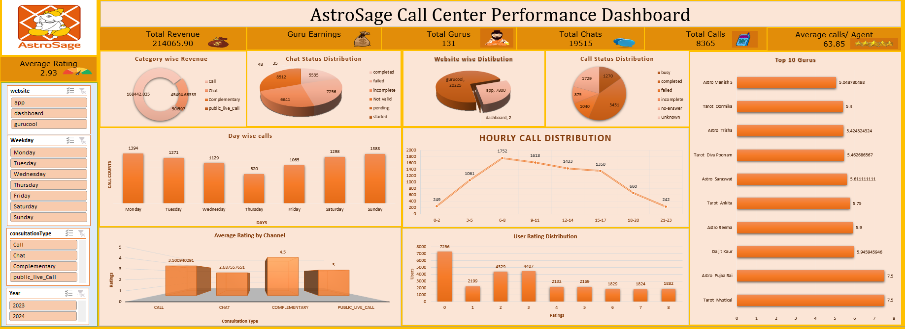

Essential Metrics to Include for a Comprehensive Dashboard
1. Performance & Revenue Metrics
- Net Revenue → measures financial growth and ROI.
- Guru Earnings → evaluates individual profitability.
- Category-wise Revenue (Chat / Call / Complimentary) → helps guide investment focus.
2. Productivity & Workload Metrics
- Total Calls & Total Chats → overall activity volume.
- Call Handles per Agent → detects workload imbalance and staffing needs.
- Hourly Call Traffic → identifies peak periods for scheduling or tech scaling.
3. Service Quality Metrics
- Average User Rating → key satisfaction indicator.
- Call Status Breakdown (Completed, Failed, Incomplete, No-Answer) → shows system reliability and need for tech upgrades.
- Daily Change in Calls/Chats → tracks fluctuations and demand patterns.
4. Operational Efficiency Metrics
- Utilization Rate (calls handled ÷ working hours) → assesses agent efficiency.
- Website Distribution (App / Dashboard / Gurucool) → pinpoints platform performance.
- Trendline of Call Volume Over Time → helps forecast and plan investments.
5. Strategic Insights for Decision-Making
- High call failure → invest in technology.
- Low ratings but high volume → invest in training.
- Uneven call distribution → consider smart hiring or load balancing.
- Summary:
Included metrics that cover revenue, agent productivity, service quality, and system reliability — all visualized through line, bar, pie, and combo charts — to make data-driven investment decisions confidently.
- How would you allocate a 1 crore rupee investment to optimize operational efficiency, enhance customer satisfaction, and boost profitability, and what analysis-based recommendations would you offer to support this?
[you have to give bullet pointers to answer this question]
Ans: Investment Allocation Plan (₹1 Crore Total)
1. Upgrade Call Centre Technology – ₹45 L (45%)
Why: 30% call failures indicate tech bottlenecks
Analysis Used:
COUNTIF() → Failure/Incomplete call rate
AVERAGEIF() → Avg. duration of completed call
Pie & Line charts → Call success trend

Expected Outcome: Reduced call drops, faster connections, better customer satisfaction.

2. Targeted Agent Training – ₹25 L (25%)
Why: Improve communication quality and ratings after tech issues are fixed.

Analysis Used:
CORREL(rating_range, duration_range) → Skill vs satisfaction link
AVERAGEIF(guruName_range, guru, rating_range) → Identify who needs training
Scatter Plot → Rating vs Duration
Expected Outcome: Higher average ratings and first-call resolution.

3. Smart Hiring & Dynamic Scheduling – ₹20 L (20%)
Why: Add manpower strategically during peak hours only.
Analysis Used:
COUNTIFS() → Calls by hour/day
AVERAGEIFS() → Ratings during peaks
Pivot Table + Combo Chart → Calls vs Utilization

Expected Outcome: Reduced waiting time and balanced workload without overstaffing.

4. Performance Monitoring Dashboard – ₹10 L (10%)
Why: Enable real-time visibility of KPIs and automate reporting.
Analysis Used:
Pivot Tables, Slicers, and conditional formatting
KPI cards for metrics: utilization %, failure %, average rating
Expected Outcome: Faster decision-making and continuous performance tracking.
Overall Strategy:
Prioritize technology first to fix the foundation, then enhance human performance through training and data-driven hiring, ensuring long-term profitability and customer satisfaction.

