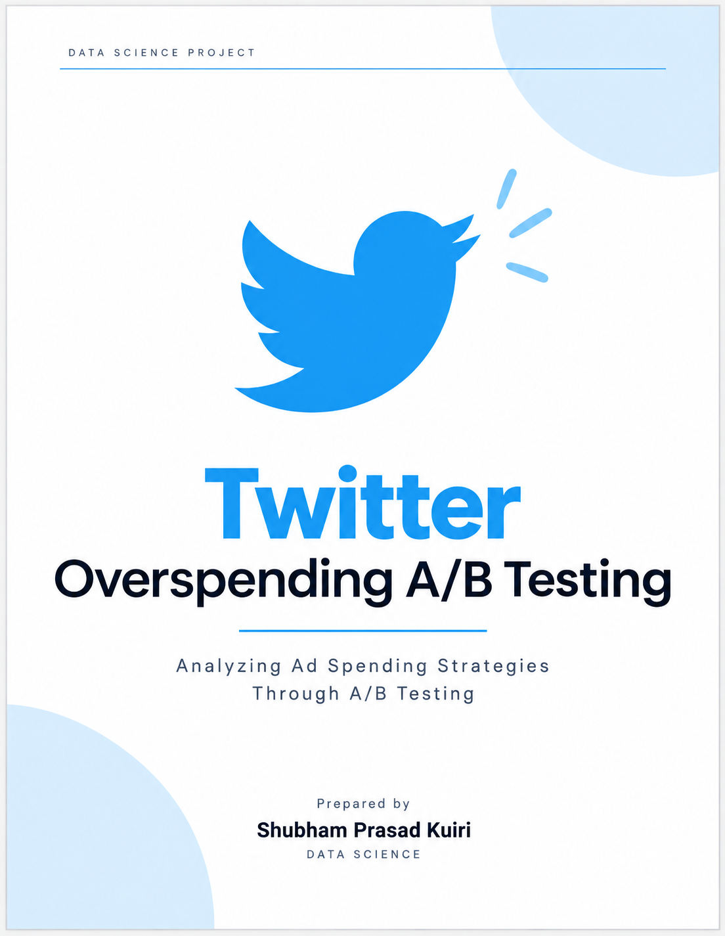

Table of Contents
A. Executive Summary
B. Project Aim & Objectives
C. Data Description
D. Methodology & Feature Engineering
E. Exploratory Data Analysis
Question 1 — Overspend Beyond 1% of Budget
Question 2 — Effectiveness by Company Size
Question 3 — Are Treatment Advertisers Setting Lower Budgets?
Question 4 — Average Overspend Percentage
Question 5 — Click-Through Rate Comparison
Question 6 — Demographic Factors & Overspend
Question 7 — Engagement Metrics Comparison
Question 8 — Significance of Budget-Spent Percentage
Question 9 — Company Size Impact Within Each Arm
Question 10 — Variance of Campaign Spend
F. Questions That Remain Unanswered
G. Final Recommendations & Next Steps

A. Executive Summary
Twitter ran a one-week, two-arm randomized experiment to test whether billing advertisers for ad impressions, rather than ad clicks, reduces the accidental overspend caused by reporting latency in the click-based system. This report analyses the resulting 15,474-campaign dataset and answers the ten questions posed in the task brief, using distribution-aware, outlier-robust statistical methods throughout because ad-spend data is heavily right-skewed.
The headline result: the impression-based product (Treatment) reduced overspend on every primary measure examined — the incidence of campaigns exceeding the 1%-overspend threshold, the average and median overspend percentage, and the share of budget actually spent — and the effect is statistically significant (p < 0.001). A formal treatment × company-size interaction model shows this effect is not uniform: it is strong and significant for small and large advertisers, while the interaction term for medium-sized companies is statistically significant in the opposite direction, meaning the treatment effect for medium companies is genuinely different from — and weaker than — the effect for large companies. There is also a statistically robust difference in budgets between arms, consistent with (but not proof of) the product manager's concern that treatment advertisers may be setting more conservative budgets.

BOTTOM LINE
Impression-based billing measurably curbs overspend for small and large advertisers; the medium-company segment needs more data before a claim can be made either way. Recommend a phased, segment-aware rollout with continued monitoring (see Section 7).

Findings at a Glance:

# | Question | Finding
1 | Campaigns overspending >1% of budget | Control 73.9% vs. Treatment 66.9% — significantly lower in treatment (p < 0.001)
2 | Treatment effect by company size | Yes for small & large (p < 0.001); no significant simple effect for medium — interaction model confirms a genuine size-driven difference (p = 0.023)
3 | Lower budgets in treatment? | Yes — median $38.60 (treatment) vs. $65.38 (control), p < 0.001; cannot confirm “wariness” as the cause
4 | Average overspend % by group | Control mean 25.3% / median 6.5% vs. Treatment mean 17.6% / median 4.6% (p < 0.001)
5 | CTR comparison | Not answerable — no impression/click fields in the dataset
6 | Demographic correlation | company_size significant (p < 0.001 in both arms); industry not available
7 | Engagement metrics | Not answerable — fields not present in the dataset
8 | % of budget spent | Control 125.3% vs. Treatment 117.6% average — significantly lower (p < 0.001)
9 | Company size impact within arm | Significant within both arms (Kruskal-Wallis p < 0.001)
10 | Variance of campaign spend | Nominally 6.33× higher in treatment, but Levene’s test not significant (p = 0.068)

B. Project Aim & Objectives
Twitter's advertising platform historically billed advertisers for ad clicks. Because there is a delay between an ad being served and the click being reported, advertisers could be billed for clicks that occur after their budget is exhausted — resulting in unintended overspend (e.g., a campaign with $10 remaining that generates $20 of clicks wastes $10). To reduce this billing latency, Twitter developed an impression-based pricing product and ran a randomized controlled experiment to evaluate it.

Objective:
Determine whether impression-based billing (treatment) reduces advertiser overspend relative to click-based billing (control), whether the effect varies by company size, and answer the supporting analytical questions the product team needs to make a rollout decision.

Experiment Design:
- Control (treatment = False): traditional click-based billing.
- Treatment (treatment = True): new impression-based billing.
- Randomization unit: individual advertising campaign.
- Duration: one week.
- Primary outcome: overspend — defined as campaign_spend exceeding campaign_budget.

C. Data Description
The dataset (Twitter A_B testing.csv) contains 15,474 campaigns and exactly four columns:
Field | Type | Description
treatment | Boolean | True = new impression-based product; False = old click-based product.
company_size | Categorical | small / medium / large advertiser.
campaign_budget | Float ($) | Budget set by the advertiser for the campaign.
campaign_spend | Float ($) | Actual amount spent on the campaign.

Data Quality & Randomization Checks:
print("Shape:", df.shape)
print("Missing values:\n", df.isna().sum())
print("Duplicate rows:", df.duplicated().sum())
print("Non-positive budgets:", (df["campaign_budget"] <= 0).sum())
print("Negative spend:", (df["campaign_spend"] < 0).sum())
print(df["treatment"].value_counts())
print(pd.crosstab(df["company_size"], df["group"], normalize="columns") * 100)

Insights
- No missing values, no duplicate rows, and no non-positive spend or budget values across all 15,474 rows.
- Group sizes are close to a 50/50 split — 7,733 control campaigns vs. 7,741 treatment campaigns.
- The small / medium / large company-size mix is well balanced across both arms (small: 55.6% control vs. 59.5% treatment; medium: 9.5% vs. 8.9%; large: 34.9% vs. 31.6%), with no large imbalance evident descriptively.

D. Methodology & Feature Engineering
campaign_spend and campaign_budget are both heavily right-skewed (the mean sits far above the median and the maximum values are orders of magnitude above the 75th percentile) — typical of ad-spend data, where a handful of very large advertisers spend far more than everyone else. This skew shapes every methodological choice made in this report:
- Distributions are visualized on a log scale so the bulk of (smaller) campaigns is not flattened by a few extreme outliers.
- Medians are reported alongside means, since the median better reflects the “typical” campaign's experience under heavy skew.
- Non-parametric and robust tests (Mann-Whitney U, Kruskal-Wallis, Levene's test) are used as the primary significance tests because they do not assume normality and are less distorted by outliers than a raw t-test.
- Parametric tests (Welch's t-test, two-proportion z-test) are reported alongside as a cross-check.
- A formal logistic regression with a treatment × company-size interaction term is used to test heterogeneity directly, rather than inferring it from three separate subgroup p-values.

Signed Deviation vs. Actual Overspend:
A key metric-definition choice: raw (spend − budget) / budget produces negative values for campaigns that underspent. This report distinguishes overspend_pct (the signed deviation — can be negative) from actual_overspend_pct (the same quantity clipped at zero, i.e. max(spend − budget, 0) / budget), so that averaging never lets underspending campaigns mask true overspend.
df["group"] = np.where(df["treatment"], "Treatment", "Control")
df["overspend_amount"] = df["campaign_spend"] - df["campaign_budget"]
df["overspend_pct"] = df["overspend_amount"] / df["campaign_budget"] * 100
df["actual_overspend_pct"] = df["overspend_pct"].clip(lower=0)
df["overspent_gt1pct"] = df["overspend_pct"] > 1
df["budget_spent_pct"] = df["campaign_spend"] / df["campaign_budget"] * 100
df["log_spend"] = np.log1p(df["campaign_spend"])
df["log_budget"] = np.log1p(df["campaign_budget"])

Metric | Definition | Used in
overspend_amount | campaign_spend − campaign_budget ($, can be negative) | feature base
overspend_pct (signed) | overspend_amount ÷ campaign_budget × 100 | Q2, Q4, Q6, Q9
actual_overspend_pct | max(overspend_pct, 0) — underspend clipped to 0 | Q4
overspent_gt1pct | overspend_pct > 1 | Q1, Q2
budget_spent_pct | campaign_spend ÷ campaign_budget × 100 | Q8

A significance threshold of α = 0.05 is used throughout this report, i.e. a p-value below 0.05 is treated as statistically significant evidence against the null hypothesis of “no real difference.

E. Exploratory Data Analysis
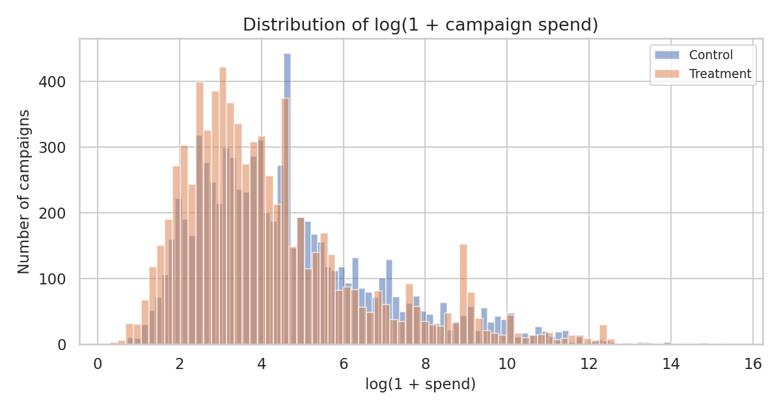
Before engineering overspend metrics, spend and overspend percentage were inspected directly, on a log / clipped scale, to confirm the skew and check whether the two arms look similar in their raw distributions.

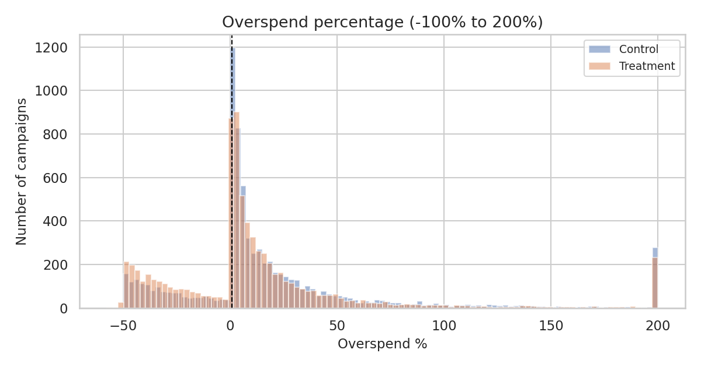
Figure 1. Distribution of log(1 + campaign spend), by group.

Figure 2. Overspend percentage distribution, clipped to −100%…200% for readability. Dashed line marks the 1% threshold used in Q1.

Insights
- Both campaign_spend and overspend_pct are strongly right-skewed in both arms — this is why the report leans on medians, log scales, and rank-based tests throughout rather than raw means alone.
- The treatment distribution is visibly shifted toward lower overspend percentages relative to control, consistent with the formal test results in Q1–Q4 below.
- Extreme observations are retained rather than removed — they represent real advertiser behaviour, not data errors (confirmed by the data-quality checks in Section 3).

Question 1 — Overspend Beyond 1% of Budget
Q1 | How many campaigns have overspent by greater than 1% of their budget in the control group? In the treatment group?

Why this question matters
This is the assignment's core headline metric and the simplest, most direct signal of whether the new product is working.
Approach
Using the engineered overspent_gt1pct flag (overspend_pct > 1), the count and rate of overspending campaigns was computed per group, then tested with a two-proportion z-test — the standard test for comparing a rate between two independent groups at this sample size.

Code
q1 = df.groupby("group")["overspent_gt1pct"].agg(campaigns="size", overspent="sum")
z_stat, p_value = proportions_ztest(count, nobs)

Result
Group | Campaigns | Overspent > 1% | Rate
Control | 7,733 | 5,716 | 73.92%
Treatment | 7,741 | 5,180 | 66.92%

Two-proportion z-test: z = −9.54, p = 1.43 × 10⁻²¹.

Visualization
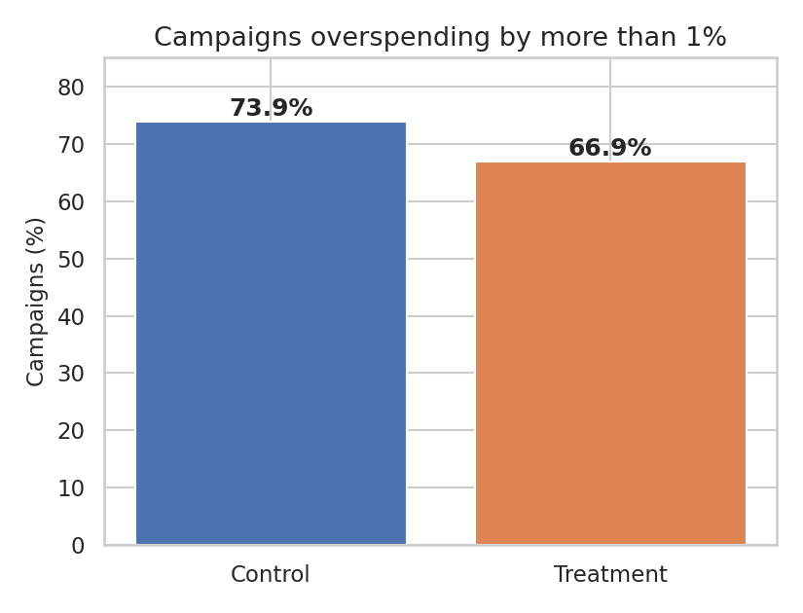

Figure 3. Share of campaigns overspending by more than 1% of budget, control vs. treatment.

Answer
5,716 control campaigns and 5,180 treatment campaigns overspent by more than 1% of their budget. The treatment group's overspend rate (66.9%) is meaningfully and statistically significantly lower than the control group's (73.9%) — a 7.0 percentage-point reduction (95% CI: 5.6 to 8.4 points) — the z-test rules out random chance at any conventional significance threshold.

Recommendation
Treat this >1%-overspend rate as a simple, executive-friendly headline metric for tracking the rollout — it is easy to explain to non-technical stakeholders and already shows a clear, statistically robust improvement.

Question 2 — Effectiveness by Company Size
Q2 | Was the new product effective at reducing overspend, and was it more or less effective depending on the company size? Put together an analysis describing how the treatment affected overspend.

Why this question matters
Twitter cares whether the product works uniformly across advertiser segments, or whether rollout should be targeted/prioritized for particular company sizes — a treatment that helps only large advertisers needs a different go-to-market plan than one that helps everyone equally.
Approach
Three complementary views are used, in increasing order of rigor: (1) separate per-size proportion tests on the >1% threshold, (2) separate per-size Mann-Whitney tests on the continuous overspend_pct, and (3) a single logistic regression with an explicit treatment × company_size interaction term — the only one of the three that formally tests whether the treatment effect itself differs across segments, rather than merely whether each segment individually shows a significant treatment-control gap.
Code
model_q2 = smf.logit(
"overspent_gt1pct ~ treatment_binary * C(company_size)",
data=df
).fit(disp=False)
Result — per-segment tests
Company size | Control rate | Treatment rate | Diff (pp) | p (proportions) | p (Mann-Whitney)
Small | 78.9% | 70.9% | −8.0 | < 0.001 | < 0.001
Medium | 61.5% | 59.8% | −1.7 | 0.519 | 0.730
Large | 69.4% | 61.5% | −7.9 | < 0.001 | < 0.001
Result — formal interaction model
Reference category: large companies, control arm. Key coefficients:
Term | Coef. | p-value | Interpretation
treatment_binary | −0.351 | < 0.001 | Treatment reduces log-odds of overspend for large companies
treatment × medium | 0.281 | 0.023 | Significant — the treatment effect for medium companies is statistically different from (weaker than) the effect for large companies
treatment × small | −0.078 | 0.311 | Not significant — no evidence the small-company effect differs from the large-company effect
Visualization
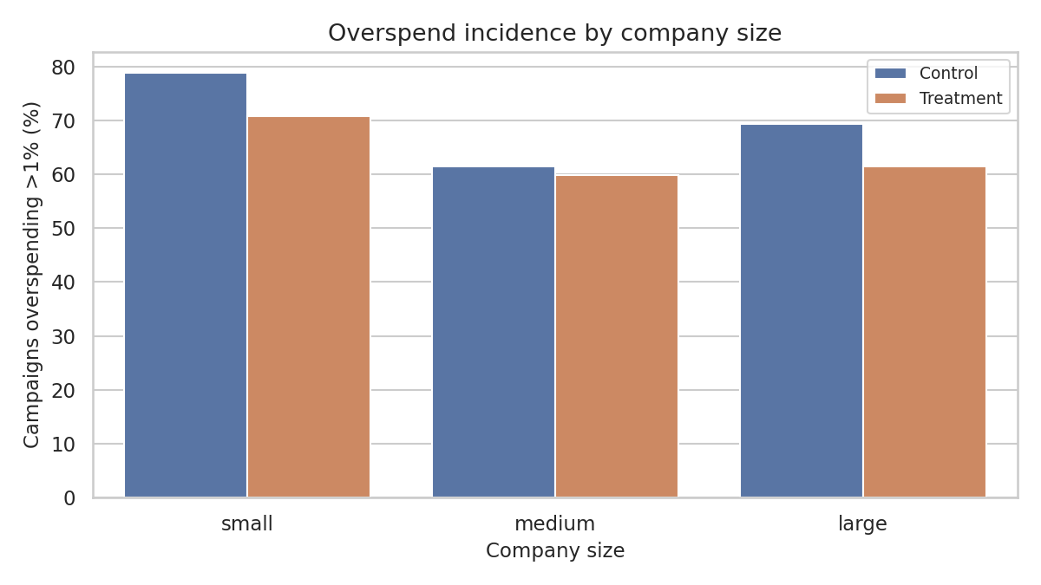

Figure 4. Overspend incidence (>1% threshold) by company size and group.

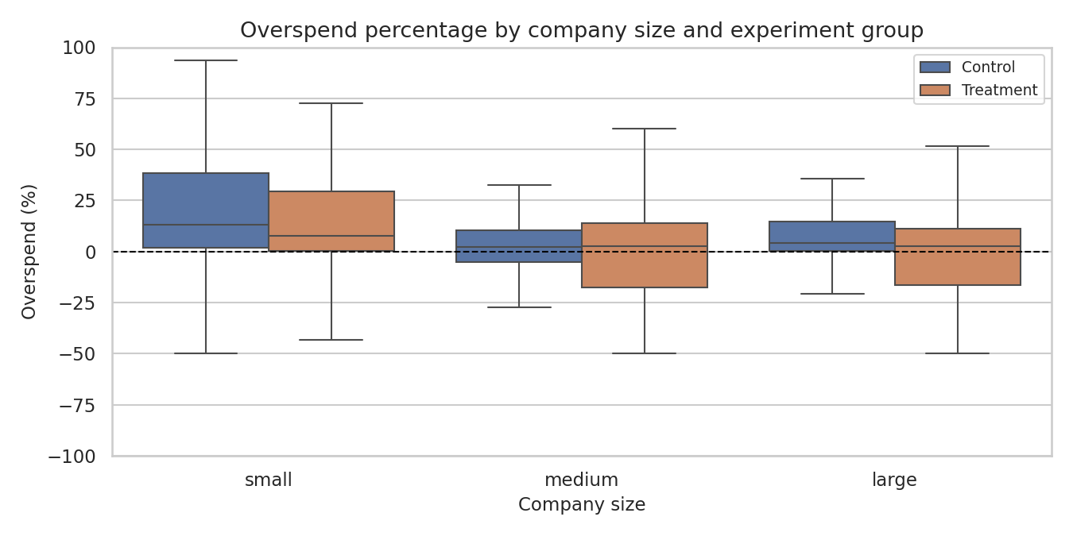

Figure 5. Distribution of overspend percentage by company size and group (outliers hidden).

Answer
Yes, the treatment reduced overspend overall, and the reduction is large and statistically significant for both small and large companies individually (both p < 0.001). For medium-sized companies, the simple treatment-control gap is not significant (p ≈ 0.52 / 0.73 depending on the test) — but critically, the formal interaction model shows this is not simply “no data either way”: the interaction term for medium companies is itself statistically significant (p ≈ 0.023), meaning the treatment effect for medium companies is genuinely, measurably different from the effect observed for large companies, not just underpowered. The interaction with small companies is not significant, so the small-company effect cannot be statistically distinguished from the large-company effect.
Recommendation
Do not present a single blended “the treatment works” headline. Report the effect as segment-specific: strong, confirmed gains for small and large advertisers; an open question for medium advertisers that the interaction model shows is a real source of heterogeneity, not a fluke of a smaller sample — worth targeted follow-up (more data or a dedicated sub-experiment) before rolling out to that segment.

Question 3 — Are Treatment Advertisers Setting Lower Budgets?
Q3 | A product manager on the team is concerned that certain advertisers in the treatment group are entering lower budgets because they are wary of the new product. Provide some evidence to support their suspicions, or show that any differences in budgets are likely due to random fluctuations.

Why this question matters
If treatment advertisers are behaving differently at the budget-setting stage, the observed overspend reduction might be partly a budgeting artifact rather than purely a billing-mechanism effect — this matters for how much credit the new product deserves.
Approach
The PM's hypothesis is causal in wording (“because they are wary”). The data can test whether budgets differ between arms; it cannot, by itself, establish advertiser motivation. Budgets are heavily skewed, so both a log-scale Welch's t-test and a raw-scale Mann-Whitney U test are used.
Code
welch_t, welch_p = stats.ttest_ind(log_treat_budget, log_control_budget, equal_var=False)
u_budget, p_budget = stats.mannwhitneyu(treat_budget, control_budget, alternative="two-sided")
Result
Group | Mean | Median | Std.
Control | $4,641.83 | $65.38 | $47,765.75
Treatment | $6,902.23 | $38.60 | $131,623.54

Welch t-test (log budget): t = −8.19, p = 2.85 × 10⁻¹⁶ | Mann-Whitney U (raw budget): p = 1.47 × 10⁻²⁶.
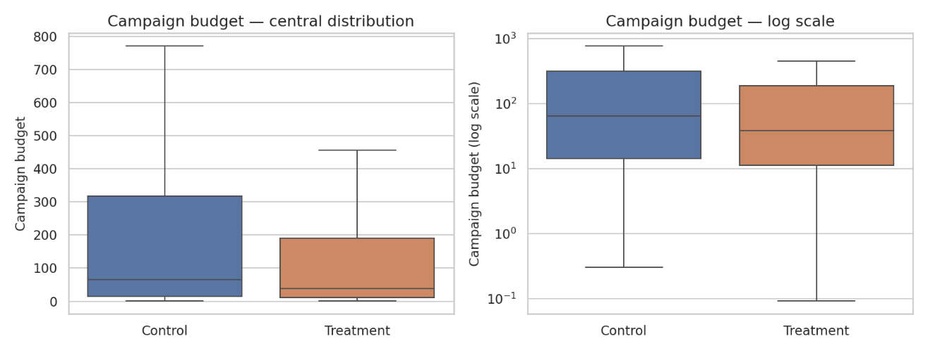
Visualization
Figure 6. Campaign budget by group: raw scale (left) and log scale (right), outliers hidden for readability.

Answer
Median budget is noticeably lower in the treatment group ($38.60) than control ($65.38), and both robust tests find this highly statistically significant (p ≪ 0.001). This is consistent with the PM's concern — budget distributions genuinely differ between arms. However, the dataset cannot establish why: it contains no advertiser survey, no pre-experiment baseline, and no direct measure of sentiment or “wariness.” The difference is real; the causal story (“because they are wary”) is a plausible interpretation, not a demonstrated fact.

Recommendation
Validate the wariness hypothesis with qualitative research (advertiser survey or interviews) or a quasi-experimental check — e.g., whether the treatment/control budget gap narrows over time as trust in the new product builds. Until then, report this as “a budget difference consistent with, but not proof of, advertiser caution.”

Question 4 — Average Overspend Percentage
Q4 | What is the average overspend percentage for campaigns in both the control and treatment groups?

Why this question matters
A single summary number is often the first thing stakeholders ask for — but naive averaging can be misleading when the underlying metric mixes underspend (negative values) with overspend, and when the distribution is heavily skewed.

Approach
The signed overspend_pct is reported first because it is the direct (spend − budget) / budget measure requested. Because underspending creates negative values and extreme campaigns can heavily distort the mean, mean and median are reported side by side, along with the non-negative actual_overspend_pct for a “true overspend only” view.

Result
Group | Mean (signed) | Median (signed) | Mean (actual) | Median (actual)
Control | 25.32% | 6.46% | 31.32% | 6.46%
Treatment | 17.61% | 4.63% | 25.93% | 4.63%

Mann-Whitney U on signed overspend_pct: p = 1.01 × 10⁻²³.

Visualization
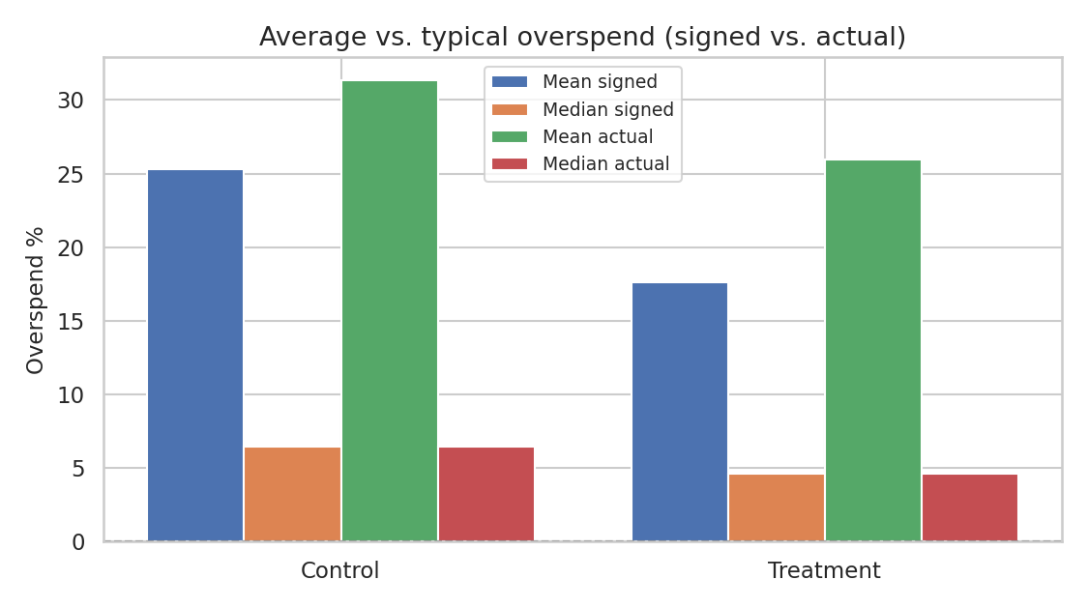

Figure 7. Mean vs. median, signed vs. actual overspend percentage, by group.

Answer
The average signed overspend percentage is 25.3% for control and 17.6% for treatment; the median tells a more moderate but consistent story (6.5% vs. 4.6%). The gap between mean and median in both groups confirms the distribution is dominated by a subset of large-overspend campaigns rather than reflecting a “typical” campaign — the median is the more representative summary for a PM audience. Both signed and actual-overspend-only views agree: treatment is meaningfully lower on average (Mann-Whitney p ≪ 0.001).

Recommendation
Report median overspend % as the primary headline number in dashboards, with mean shown alongside as a secondary figure — and flag any month where mean and median diverge sharply, since that is itself a signal of a few extreme accounts driving results.

Question 5 — Click-Through Rate Comparison
Q5 | How does the click-through rate (CTR) compare between the traditional click-based model and the impression-based model?

Approach
CTR is defined as clicks ÷ impressions. The supplied dataset contains neither clicks nor impressions — only treatment, company_size, campaign_spend, and campaign_budget.
Data availability check
NOT ANSWERABLE FROM THE SUPPLIED DATA
CTR cannot be calculated from Twitter_A_B_testing.csv. Rather than approximate it from an unrelated variable (which would risk presenting a fabricated number as if it were measured), this is flagged as a data gap. See Section 6 for what would be needed to answer it.

Question 6 — Demographic Factors & Overspend
Q6 | What demographic factors (e.g., industry, company size) correlate with higher overspending rates in both groups?

Why this question matters
Understanding which advertiser segments are most exposed to overspend helps prioritize the rollout and target support/education efforts.
Approach
The supplied dataset contains company_size but not industry, so this analysis is restricted to company_size and industry is explicitly flagged as unavailable. A Kruskal-Wallis test checks whether overspend_pct differs across size tiers within each arm.
Result
Group | Size | Campaigns | Mean overspend % | Median overspend % | >1% rate
Control | Large | 2,701 | 12.3% | 4.0% | 69.4%
Control | Medium | 735 | 4.6% | 2.2% | 61.5%
Control | Small | 4,297 | 37.1% | 13.0% | 78.9%
Treatment | Large | 2,445 | 3.3% | 2.5% | 61.5%
Treatment | Medium | 692 | 5.1% | 2.5% | 59.8%
Treatment | Small | 4,604 | 27.1% | 7.8% | 70.9%

Kruskal-Wallis — Control: H = 438.3, p = 6.60 × 10⁻⁹⁶ | Treatment: H = 270.4, p = 1.89 × 10⁻⁵⁹.
Visualization
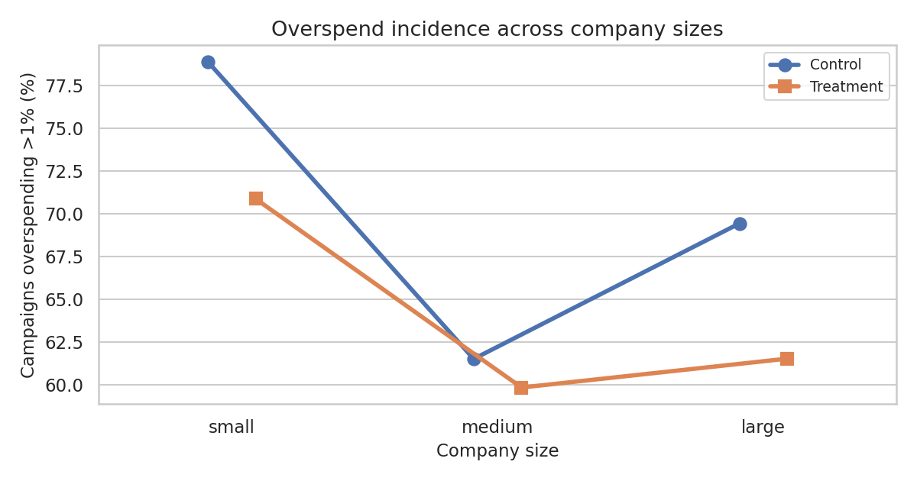

Figure 8. Overspend incidence across company sizes, by group.
Answer
Company size correlates significantly with overspend rate within both arms (Kruskal-Wallis p ≪ 0.001 for both). Small companies consistently show the highest overspend — both in incidence and in typical magnitude — followed by large, then medium, in both control and treatment. Industry cannot be assessed; it is not a column in the supplied data.

Recommendation
If industry data can be joined in from another system, re-run this analysis with industry included — company size alone may be a proxy for industry mix (e.g., certain industries skew toward small businesses) and the current result may partly reflect that confound.

Question 7 — Engagement Metrics Comparison
Q7 | How do the overall engagement metrics (likes, retweets, replies) differ between the two advertising models?

Approach
Likes, retweets, and replies are not present in Twitter_A_B_testing.csv.

Data availability check
NOT ANSWERABLE FROM THE SUPPLIED DATA
Engagement differences cannot be measured from the supplied files. This is flagged as a data limitation rather than estimated. See Section 6.

Question 8 — Significance of Budget-Spent Percentage
Q8 | Is there a statistically significant difference in the percentage of budget spent between the control and treatment groups?

Why this question matters
This is closely related to Q1/Q4 but framed as a continuous ratio rather than a threshold or a signed percentage — useful for understanding the typical “how close to (or over) budget” experience.

Approach
budget_spent_pct = campaign_spend / campaign_budget × 100. Because this ratio is highly skewed, robust descriptive statistics are reported and a Mann-Whitney comparison is used as the primary test, with a Welch test on the log-transformed ratio as a sensitivity check.

Result
Group | Mean | Median | Std. | Max
Control | 125.3% | 106.5% | 73.9 | 500%
Treatment | 117.6% | 104.6% | 69.8 | 500%

Mann-Whitney U: p = 1.01 × 10⁻²³ | Welch t-test on log(1 + ratio): p = 1.82 × 10⁻²¹.

Visualization
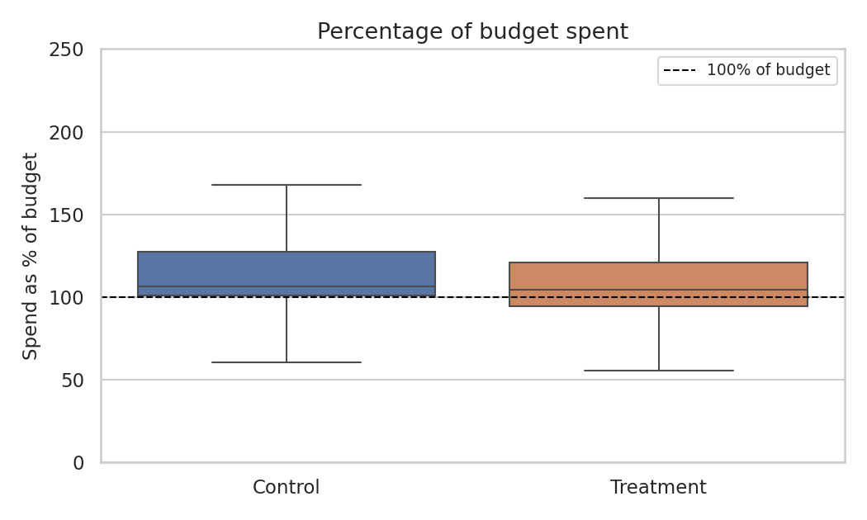

Figure 9. Percentage of budget spent, by group (outliers suppressed from the visible range).

Answer
Yes. The percentage of budget spent is significantly lower on average in the treatment group (117.6%) than control (125.3%) — both tests p ≪ 0.001 — consistent with the impression-based product curbing the billing overshoot that occurs under the click-based model's reporting lag. The median is especially informative here because a small budget can produce an extremely large spend-to-budget ratio; the business conclusion should not rest on the raw mean alone.

Recommendation
Use median % of budget spent as a secondary rollout-tracking metric alongside the >1%-overspend rate from Q1 — together they capture both incidence and typical severity.

Question 9 — Company Size Impact Within Each Arm
Q9 | Does company size have a significant impact on the overspend percentage in both control and treatment groups?

Why this question matters
This is deliberately distinct from Q2: Q9 asks whether company size is associated with overspend within each pricing model; Q2 asks whether the treatment effect itself changes by company size. Conflating the two risks a common analysis mistake.

Approach
Company-size differences were tested separately within control and treatment using Kruskal-Wallis tests, consistent with the skewed outcome variable.

Code
for group in ["Control", "Treatment"]:
values = [subset.loc[subset.company_size == s, "overspend_pct"]
for s in ["small", "medium", "large"]]
h, p = stats.kruskal(*values)

Result
Group | Kruskal-Wallis H | p-value
Control | 438.32 | 6.60 × 10⁻⁹⁶
Treatment | 270.43 | 1.89 × 10⁻⁵⁹

Visualization

Figure 10. Overspend percentage by company size and group (same view as Q2, reused here to support the within-arm comparison).

Answer
Yes — company size has a statistically significant relationship with overspend % within both arms (Kruskal-Wallis p ≪ 0.001 for both control and treatment). A significant result indicates at least one size tier's distribution differs from another within that pricing model; it does not by itself identify which pairs differ — pairwise follow-up tests would be needed if that level of detail is required.

Recommendation
Keep Q9 (within-model company-size association) and Q2 (cross-model treatment-effect heterogeneity) as separate lines in any dashboard or write-up — they answer different business questions and should not be summarized with a single p-value.

Question 10 — Variance of Campaign Spend
Q10 | Is the variance in campaign spend significantly different between the control and treatment groups?

Why this question matters
Understanding whether the new product changes the spread (not just the average) of campaign spend matters for risk and billing-infrastructure planning — a product with much higher variance could mean occasional very large billing events even if the average is well-behaved.
Approach
Levene's test (centred on the median, i.e. the Brown-Forsythe form) is used rather than a raw F-test / variance ratio, because it is robust to non-normality and far less sensitive to a handful of extreme outliers — both of which are present in this data.
Code
var_control = control_spend.var(ddof=1)
var_treatment = treatment_spend.var(ddof=1)
levene_stat, levene_p = stats.levene(control_spend, treatment_spend, center="median")
Result
Group | Variance of campaign_spend
Control | 1,157,680,892
Treatment | 7,331,319,046
Ratio (Treatment ÷ Control) | 6.33×

Brown–Forsythe / Levene statistic = 3.328, p = 0.0681 — not significant at the 5% level.
Visualization
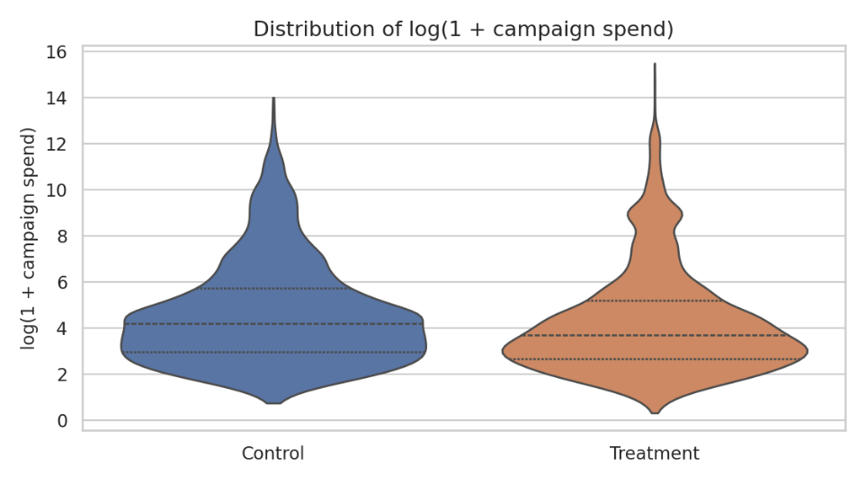

Figure 11. Campaign spend distribution and spread by group (log scale).

Answer
The raw variance of campaign_spend is nominally 6.33× higher in the treatment group, but Levene's test — the more trustworthy test given the extreme skew — puts this at p = 0.068, which does not clear the conventional 5% significance threshold (though it is close, and would be considered suggestive at a 10% threshold). A 6.3× descriptive variance gap should not be reported as a confirmed statistical effect; it is borderline and, consistent with Q3, likely driven by a small number of extreme treatment-group accounts rather than a systematic shift in the whole treatment population.

Recommendation
Do not treat the 6.3× variance ratio as a confirmed effect on its own. If spend variance is operationally important for billing-infrastructure capacity planning, re-test after separately flagging or excluding the handful of largest accounts, or after collecting more data to increase statistical power.

F. Questions That Remain Unanswered
Three parts of the task brief ask about fields that are not present in Twitter_A_B_testing.csv. Rather than approximate or fabricate figures for these, they are flagged here explicitly, together with what data would be needed to answer them properly.
Question | What's missing | What would be needed
Q5 — CTR comparison | No impression or click counts | Join in ad-serving logs with per-campaign impression and click counts
Q6 — industry (part) | No industry field | Add an industry/vertical field to the advertiser or campaign table
Q7 — Engagement metrics | No likes / retweets / replies | Join in tweet-level engagement data linked to each campaign

Note: company_size, the other demographic factor named in Question 6, is available and was analysed in full in Questions 6 and 9 above.

G. Final Recommendations & Next Steps

Overall Conclusion
The impression-based billing product meaningfully reduces advertiser overspend relative to the traditional click-based model. This holds clearly and robustly for small and large advertisers. For medium-sized advertisers, the formal interaction model shows the effect is genuinely different from the large-company effect — this is a real signal of heterogeneity, not simply an underpowered subgroup, and should not be described as “the treatment works everywhere.” There is also a statistically robust budget difference between arms, consistent with (but not proof of) the product manager's concern about advertiser caution.

Recommendations
- Proceed with a phased rollout of the impression-based product, prioritizing small and large advertisers first, where the overspend reduction is largest and most statistically robust.
- Treat medium-sized companies as a distinct open question, not a null result — the interaction model shows their treatment effect is statistically different from large companies', which argues for a dedicated follow-up (more data or a targeted sub-experiment) rather than either forcing the rollout or writing the segment off.
- Validate the budget-setting hypothesis (Q3) with an advertiser survey or interviews, and re-check whether the treatment/control budget gap narrows over time as trust in the new product builds — this affects how much credit the billing mechanism itself deserves for the overspend reduction.
- Track median, not just mean, overspend metrics in any ongoing dashboard, since a small number of extreme accounts repeatedly distort mean-based figures throughout this dataset (Q3, Q4, Q10).
- Set per-segment KPI targets rather than one blended target, since company size independently and significantly affects overspend behaviour (Q9) and the treatment effect itself is not uniform across segments (Q2).
- Close the data gaps identified in Section 6 — join in impression/click counts and engagement data, and add an industry field — so that CTR, engagement, and industry-level questions can be answered in the next iteration of this analysis.
- Re-test spend variance (Q10) after separately flagging or excluding the handful of extreme-value accounts, since the current result is borderline (p = 0.068) and sensitive to a small number of outliers.
SUGGESTED DECISION
Approve a phased, segment-aware rollout of the impression-based product, paired with the monitoring and data-collection steps above.

