ECE 311

Lab 3 System Properties

Xuanying Li

xli146

Section C

Report Item 1:

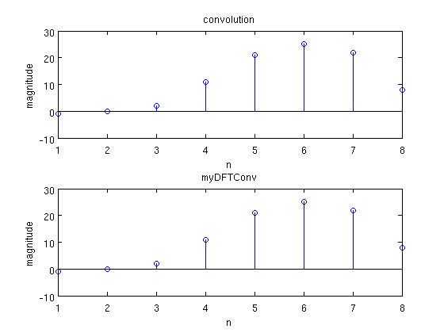

My function myDFTConv results the same as function conv. Order of complexity of myDFTConv is O(log2(n)) = 2

Report Item 1.2:

Report Item 2: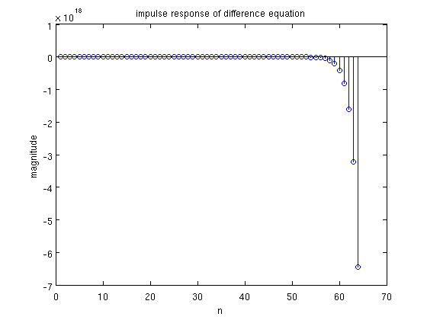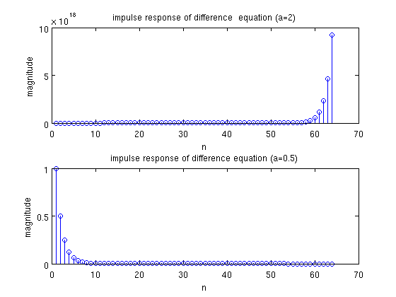

a=2: the system is causal, unstable, and non-linear.

a=0.5: the system is causal, stable, and non-linear.

Since the system is not a LSI system, I can't find the output of either system by convolving x(n) with h(n).

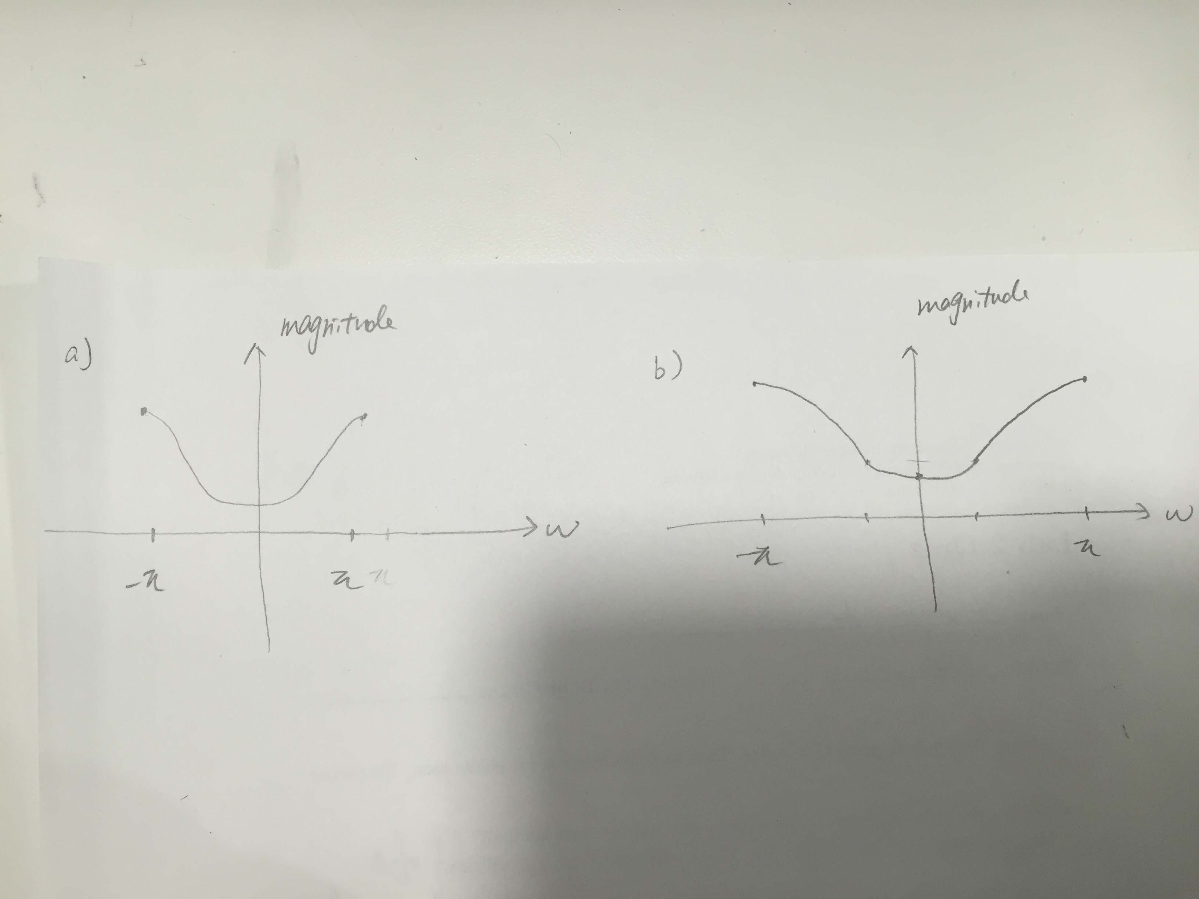

Report Item 3.1:

The minimum magnitude response is at w=0 and maximum is at w=pi.

Report Item 3.2

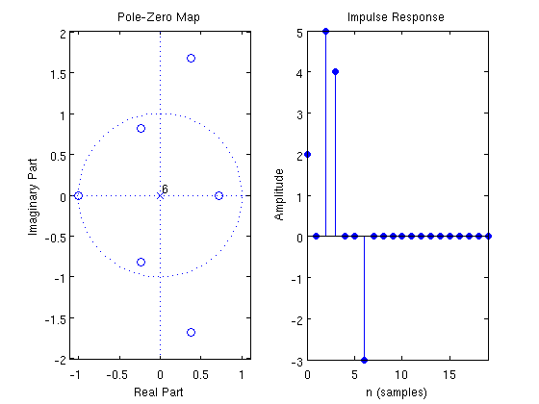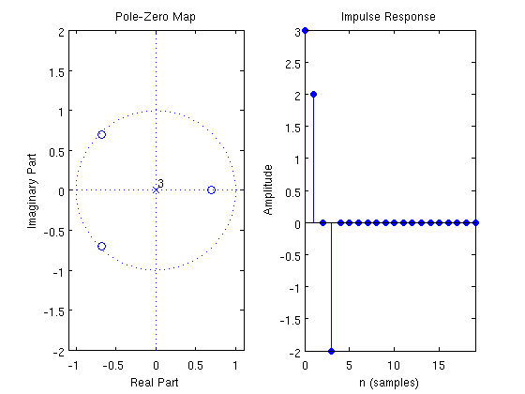

All three systems are stable, because all poles are inside of unit circle.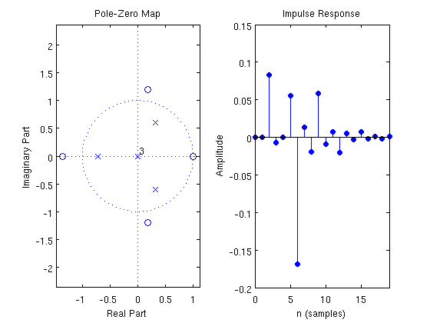

Report Item 3.3

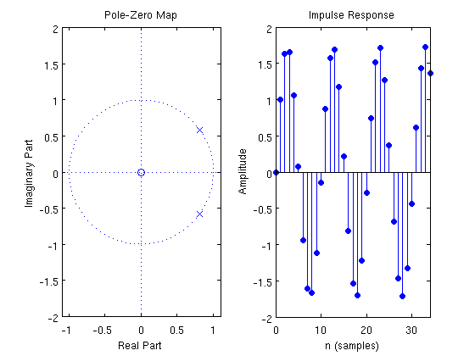The system is not BIBO stable, because amplitude of impulse response does not approaches to zero. And the poles are not inside of unit circle.