Polytechnic University of Puerto Rico

Electrical & Computer Engineering and Computer Science Department

Spring 2022

**CECS 4204-80 Software Engineering**

**Prof. Carlos M. De La Torre Ugarte**

**Software Design Descriptions**

**Version 1.0**

Latest Revision:

[10/16/2024]

For:

Prof. Carlos M. De La Torre Ugarte

Prepared By:

Taishali N. Jimenez Quinones

|  |  |  |  |
| --- | --- | --- | --- |
| **Member** | **ID#** | **Program** | **Signature** |
| Coral S. Schmidt Montilla | #148830 | Computer Science |  |
| Taishali N. Jimenez Quinones | #148017 | Computer Engineering |  |
| Eddie M. Santiago Malave | #116933 | Computer Engineering |  |
| Lennox Rivera | #140874 | Computer Engineering |  |

**REVISION HISTORY**

The purpose of the table is to record version number, version date, name of the person making the change and a short revision description.

|  |  |  |  |
| --- | --- | --- | --- |
| **Name** | **Dates** | **Version** | **Task** |
| Taishali N. Jimenez Quinones | 10/09 | 1 | Fill out the information |
| Taishali N. Jimenez Quinones | 10/11 | 1.1 | Fill out the information |
| Taishali N. Jimenez Quinones | 10/16 | 1.2 | Fill out the information |

Table of Contents

Table of Contents ii

1. Introduction 1

1.1 Purpose 1

1.2 Scope 1

1.3 Definitions, Acronyms and Abbreviations 1

2. Reference 2

[1] Software Engineering: A Practitioner’s Approach. 2

[2]Schaum's Outline of Software Engineering…………………………………………………...2

3. Decomposition Description 2

3.1 Module Decomposition 2

3.1.1 Home Page Module Decomposition 2

3.1.2 Registration Screen Decomposition 3

3.2 Concurrent Process Decomposition 4

3.2.1 User Registration and Log In 4

3.3 Data Decomposition 4

3.3.1 User Entity 4

3.3.2 Profile Entity 5

4. Dependencies Description 6

4.1 Intermodule Dependencies 6

4.2 Interprocess Dependencies 7

4.3 Data Dependencies 11

5. Interface Description 11

5.1 User Interfaces 12

5.1.1 State Diagram for User Interfaces 14

5.2 Administrator Interfaces 15

5.2.1 State Diagram for Administrator Interfaces 15

6. Detailed Design 16

6.2 Data Detailed Design 17

**List of Tables**

Table 1: Definitions 1

Table 2: Acronyms and Abbreviations 1

Table 3: Intermodule Dependencies 7

**List of Figures**

Figure 1: Home Page Module Decomposition 3

[Figure 2: Registration Screen Module Decomposition 3](#_Toc180262324)

Figure 3: User Registration and Log In 4

Figure 6: Intermodule Dependencies 6

Figure 7: Profile Dependencies 11

Figure 9: Home Page State Diagram 12

Figure 10: Main Page State Diagram 12

Figure 11: Resume Builder State diagram 13

Figure 15: Resume Builder Register Page 14

Figure 16: User Interface 14

Figure 17: Administrator Interface 15

Figure 18: State diagram of Administrator Interface 15

Figure 19: Sequence Diagram Log in User and Administrator 16

Figure 20: Sequence Diagram Main Page 17

Figure 21: Detailed Design 18

# 1. Introduction

## 1.1 Purpose

The purpose of this document is to create an outline of the design of our Resume Builder. This application will allow the user to navigate through the process of creating a resume step by step.

## 1.2 Scope

This document will cover the design of the Resume Builder website starting by discussing the module decomposition, the dependencies, and the user interface.

## 1.3 Definitions, Acronyms and Abbreviations

The following table illustrates the series of definitions, acronyms and abbreviations that are necessary to be aware of for proper understanding of this document.

|  |  |
| --- | --- |
| **Term** | **Definition** |
| Resume | Formal document that displays a person’s professional background and skills. |
| Entity | An entity is a thing, person, place or object that has an independent existence and can be uniquely identified in a database |
| Attribute | Each entity has specific attributes that provide more information about it. |
| Module | A module is an extension to a main program dedicated to a specific function. |

Table 1: Definitions

|  |  |
| --- | --- |
| **Acronym or Abbreviation** | **Term** |
| UI | User Interface |
| DB | Database |

Table 2: Acronyms and Abbreviations

# 2. Reference

The following reference are cited using the IEEE format. This reference are foe technical words in this document.

# [1] Pressman, R. (2014). *Software Engineering: A Practitioner’s Approach*. New York: McGraw Hill.

--Systems Design--Software Design Descri

[2] Gustafson, D. (2002). *Schaum's Outline of Software Engineering.* McGraw Hill Professional

# 3. Decomposition Description

The website will be divided into several modules to allow the creation of a resume easier while dividing into a step-by-step process. Each module will handle a specific task, like user registration, form submission, and allow to generate a PDF.

## 3.1 Module Decomposition

This section will describe and break down the duties and responsibilities of each module.

### 3.1.1 Home Page Module Decomposition

The home page module serves as the entry point for users to begin their resume building process. With just a click of their button, the user will be able to navigate towards the module which will begin the step-by-step process of building a resume.

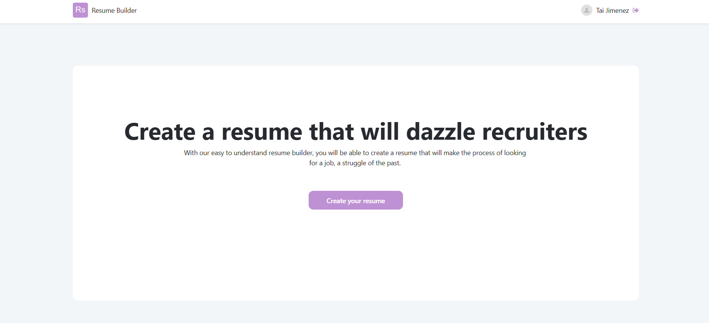

Figure 1: Home Page Module Decomposition

### 3.1.2 Registration Screen Decomposition

The registration screen module allows users to create an account by providing basic information like their username, email, and password. This will make sure the user has safe experience within our website.

*Figure 2: Registration Screen Module Decomposition*

## 3.2 Concurrent Process Decomposition

This section will outline the concurrent process that runs with this application like login information, and the user login information.

### 3.2.1 User Registration and Log In

The user registration and login module will be accessible within one module. Once the user clicks on the “Sign up here” link, the user will then go over to the registration module mentioned in figure 2.

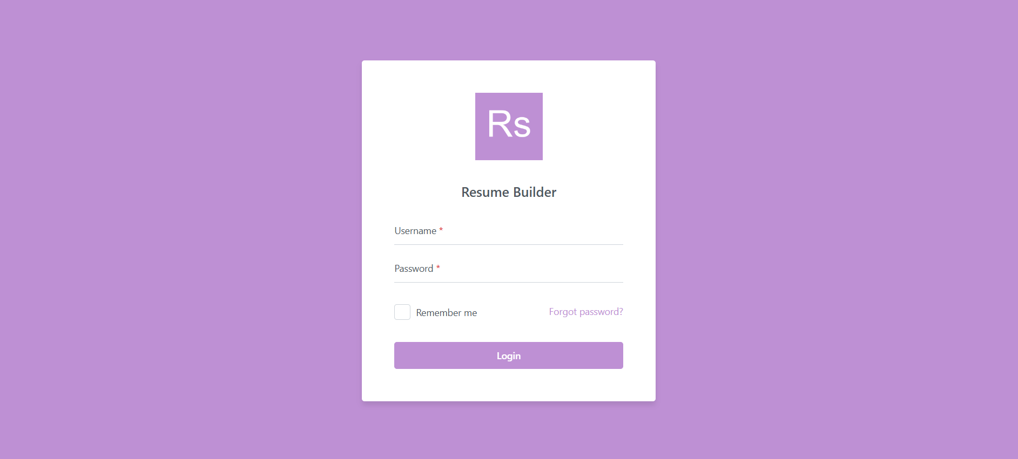

Figure 3: User Registration and Log In

## 3.3 Data Decomposition

Data decomposition is essential for breaking down of the data entities used in the resume builder application.

### 3.3.1 User Entity

The User entity will store basic information of the user and will also link to other entities such as Profile entity.

### 3.3.2 Profile Entity

The Profile entity stores information related to the user’s information like first name, last name, email, birth date, address, and LinkedIn profile link.

**3.3.3 Resume Entity**

This will have all the necessary attributes necessary to fill out when creating a resume, including all of the necessary information to fill out the form and will be linked to the user entity, the profile entity, and other related entities like the Education and Experience entities.

**3.3.4 Education Entity**

The Education entity holds the attributes related to the user’s education relevant in the process of creating a resume.

**3.3.5 Experience Entity**

This will have all of the necessary attributes regarding the experience which will be linked to the Resume entity.

**3.3.6 Responsibilities Entity**

The Responsibilities entity allows us to explain in detail the responsibilities on the experience added in ExperienceId therefore it has a foreign key for the Experience entity

**3.3.7 Skills Entity**

The Skills entity will allow the user to input any skills they might have allowed to categorize them; it will also have a foreign key linking it to the ResumeBuilder Entity.

**3.3.8 Certification Entity**

The Certification entity includes the information regarding any certification the user might have.

**3.3.9 Type Entity**

The Type entity is used to classify multiple categories relevant to the resume builder

**3.3.10 TypeRef Entity**

The TypeRef entity contains values relevant to the Type entity.

**3.3.11 Projects Entity**

The Projects entity stores the information about projects the user might want to include in the resume.

**3.3.12 ProjectDescription Entity**

The ProjectDescription entity will allow multiple descriptions for a single project therefore it has a foreign key linking it to projects.

**3.3.13 ProjectSkills Entity**

The ProjectSkills entity will serve as a connection for Projects and Skills and will allow the user to add the skills relevant to the projct mentioned.

# 4. Dependencies Description The dependencies descriptions will include all the dependencies used for the entities and how they are interrelated.

## 4.1 Intermodule Dependencies

The following table outlines the intermodule dependencies for the entities required in the process of building a resume.

Figure 6: Intermodule Dependencies

| **Intermodule** | **Dependency** |
| --- | --- |
| User ↔ Profile | one to one relationship |
| Profile ↔ ResumeBuilder | one to one relationship |
| ResumeBuilder ↔ Education | one to many relationship |
| ResumeBuilder ↔ Experience | one to many relationship |
| ResumeBuilder ↔ Skills | One to many relationship |
| ResumeBuilder ↔ Certification | One to many relationship |
| ResumeBuilder ↔ Projects | One to many relationship |
| Experience ↔ Responsibilities | One to many relationship |
| Projects ↔ ProjectDescription | One to many relationship |
| Projects ↔ ProjectSkills | Many to many relationship |
| Type ↔ TypeRef | One to many relationship |

Table 3: Intermodule Dependencies

## 4.2 Interprocess Dependencies

Interprocess dependencies refer to the relationship and interactions between various modules within the resume builder application.

|  |
| --- |
| BEGIN  EXECUTE IMMEDIATE 'DROP TABLE ProjectSkills';  EXECUTE IMMEDIATE 'DROP TABLE ProjectDescription';  EXECUTE IMMEDIATE 'DROP TABLE Projects';  EXECUTE IMMEDIATE 'DROP TABLE Responsibilities';  EXECUTE IMMEDIATE 'DROP TABLE TypeRef';  EXECUTE IMMEDIATE 'DROP TABLE Type';  EXECUTE IMMEDIATE 'DROP TABLE Certification';  EXECUTE IMMEDIATE 'DROP TABLE Skills';  EXECUTE IMMEDIATE 'DROP TABLE Experience';  EXECUTE IMMEDIATE 'DROP TABLE Education';  EXECUTE IMMEDIATE 'DROP TABLE ResumeBuilder';  EXECUTE IMMEDIATE 'DROP TABLE Profile';  EXECUTE IMMEDIATE 'DROP TABLE Users';  EXCEPTION  WHEN OTHERS THEN  NULL; -- Ignore errors if tables do not exist  END;  /  CREATE TABLE Users (  Id NUMBER PRIMARY KEY,  Name VARCHAR2(100),  Username VARCHAR2(50) UNIQUE,  Password VARCHAR2(255),  Email VARCHAR2(100) UNIQUE,  MobilePhone VARCHAR2(20),  ExternalId VARCHAR2(50),  Creation_Date DATE DEFAULT SYSDATE,  Last_Login DATE,  Is_Active NUMBER(1) DEFAULT 1  )  CREATE TABLE Profile (  Id NUMBER PRIMARY KEY,  FirstName VARCHAR2(100),  LastName VARCHAR2(100),  Email VARCHAR2(100) UNIQUE,  BirthDate DATE,  Age NUMBER,  UserId NUMBER,  FOREIGN KEY (UserId) REFERENCES Users(Id)  )  CREATE TABLE ResumeBuilder (  Id NUMBER PRIMARY KEY,  UserId NUMBER,  ProfileId NUMBER,  FOREIGN KEY (UserId) REFERENCES Users(Id),  FOREIGN KEY (ProfileId) REFERENCES Profile(Id)  )  CREATE TABLE Education (  Id NUMBER PRIMARY KEY,  ResumeBuilderId NUMBER,  InstitutionName VARCHAR2(100),  Degree VARCHAR2(100),  FieldOfStudy VARCHAR2(100),  StartDate DATE,  EndDate DATE,  YearName VARCHAR2(10),  GPA NUMBER(3, 2),  Honors VARCHAR2(100),  Location VARCHAR2(100),  FOREIGN KEY (ResumeBuilderId) REFERENCES ResumeBuilder(Id)  )  CREATE TABLE Experience (  Id NUMBER PRIMARY KEY,  ResumeBuilderId NUMBER,  CompanyName VARCHAR2(100),  JobTitle VARCHAR2(100),  StartDate DATE,  EndDate DATE,  Location VARCHAR2(100),  FOREIGN KEY (ResumeBuilderId) REFERENCES ResumeBuilder(Id)  )  CREATE TABLE Skills (  Id NUMBER PRIMARY KEY,  ResumeBuilderId NUMBER,  SkillName VARCHAR2(100),  ProficiencyLevel VARCHAR2(50),  SkillCategory VARCHAR2(50),  FOREIGN KEY (ResumeBuilderId) REFERENCES ResumeBuilder(Id)  )  CREATE TABLE Certification (  Id NUMBER PRIMARY KEY,  CertificationName VARCHAR2(100),  IssuingOrganization VARCHAR2(100),  IssueDate DATE,  ExpirationDate DATE  )  CREATE TABLE Projects (  Id NUMBER PRIMARY KEY,  ResumeBuilderId NUMBER,  ProjectName VARCHAR2(100),  Description VARCHAR2(4000),  IDEUsed VARCHAR2(100),  StartDate DATE,  EndDate DATE,  Location VARCHAR2(100),  FOREIGN KEY (ResumeBuilderId) REFERENCES ResumeBuilder(Id)  )  CREATE TABLE ProjectDescription (  Id NUMBER PRIMARY KEY,  ProjectId NUMBER,  Description VARCHAR2(4000),  FOREIGN KEY (ProjectId) REFERENCES Projects(Id)  )  CREATE TABLE ProjectSkills (  Id NUMBER PRIMARY KEY,  ProjectId NUMBER,  SkillId NUMBER,  FOREIGN KEY (ProjectId) REFERENCES Projects(Id),  FOREIGN KEY (SkillId) REFERENCES Skills(Id)  )  CREATE TABLE Responsibilities (  Id NUMBER PRIMARY KEY,  Description VARCHAR2(4000),  ExperienceId NUMBER,  FOREIGN KEY (ExperienceId) REFERENCES Experience(Id)  )  CREATE TABLE Type (  Id NUMBER PRIMARY KEY,  Name VARCHAR2(100),  Description VARCHAR2(255),  CreatedBy VARCHAR2(100),  CreatedOn DATE DEFAULT SYSDATE,  UpdatedBy VARCHAR2(100),  UpdatedOn DATE DEFAULT SYSDATE,  IsActive NUMBER(1) DEFAULT 1  )  CREATE TABLE TypeRef (  Id NUMBER PRIMARY KEY,  TypeId NUMBER,  Name VARCHAR2(100),  Description VARCHAR2(255),  Code VARCHAR2(50),  CreatedBy VARCHAR2(100),  CreatedOn DATE DEFAULT SYSDATE,  UpdatedBy VARCHAR2(100),  UpdatedOn DATE DEFAULT SYSDATE,  Sorting NUMBER,  IsActive NUMBER(1) DEFAULT 1,  FOREIGN KEY (TypeId) REFERENCES Type(Id)  ) |

# CTRL Intelligence Disclaimer:

#

# This script should be run to create all initial tables for the App.

#

# Note: If you run this script having already ran it before, this will drop tables

# and delete all records within does tables.

#

# This should only be ran one time when being used for Production environment.

#

# Future tables and/or changes should come from different scripts.

#

#

#

USE [xxx]db;

[DB script]

Made with Oracle Database XE 11.2

## 4.3 Data Dependencies

The Resume Builder website contains multiple entities that have profile dependencies. The Profile entity is linked to the Users entity by integrating a UserId foreign key. Consecutively, the ResumeBuilder entity depends on both the Profile entity and the Users entity to be able to create a unique resume entry to that particular user. The Education, Experience, Skill and Projects entity are linked to the ResumeBuilder entity by using the foreign key ResumeBuilderId. This will store the data for the resumes to each entry. The TypeRef entity depends on the Type entity and requires having a TypeId which will allow to have a unique value for each type.

Figure 7: Profile Dependencies

# 5. Interface Description

This section will describe the user and administrator interfaces within the resume builder application. This will be explained in detail with state diagrams for each different screen.

## 5.1 User Interfaces

The User interfaces are extremely essential components of a resume builder, since they allow the user to register, log in and build an easy to understand, step-by-step, resume. Having a user interface design will create effective communication between humans and computers.

Figure 9: Home Page State Diagram

Figure 10: Main Page State Diagram

Figure 11: Resume Builder State diagram

*Figure 13: Resume Builder Description Page*

*Figure 14: Resume Builder* *Login Page*

Figure 15: Resume Builder Register Page

### 5.1.1 State Diagram for User Interfaces

The state diagram for user interfaces will show the states in the resume builder application of the user experience.

Figure 16: User Interface

## 5.2 Administrator Interfaces

The administrator interface is designed to allow the administrator to examine and maintain monitor user activities, manage resumes, and add information for the resume format as needed.

Figure 17: Administrator Interface

### 5.2.1 State Diagram for Administrator Interfaces

The state diagram for the administrator interfaces will show the states in the resume builder application in the administrative screen.

Figure 18: State diagram of Administrator Interface

# 

# 6. Detailed Design

Theis section will include the detailed designs of modules and data. These will have a collection of figures with sequence diagrams

**6.1 Module Detailed Design**

This section will have diagrams for the module detail design involved in the resume builder website which entails the corresponding sequence diagrams.

Figure 19: Sequence Diagram Log in User and Administrator

Figure 20: Sequence Diagram Main Page

## 6.2 Data Detailed Design

This section will outline the database schema and relationship between multiple entities within the resume builder application.

Figure 21: Detailed Design