**Homework 2**

**Name: Coral S. Schmidt Montilla ID#: 148830**

***Completely answer all of the following questions.***

1. 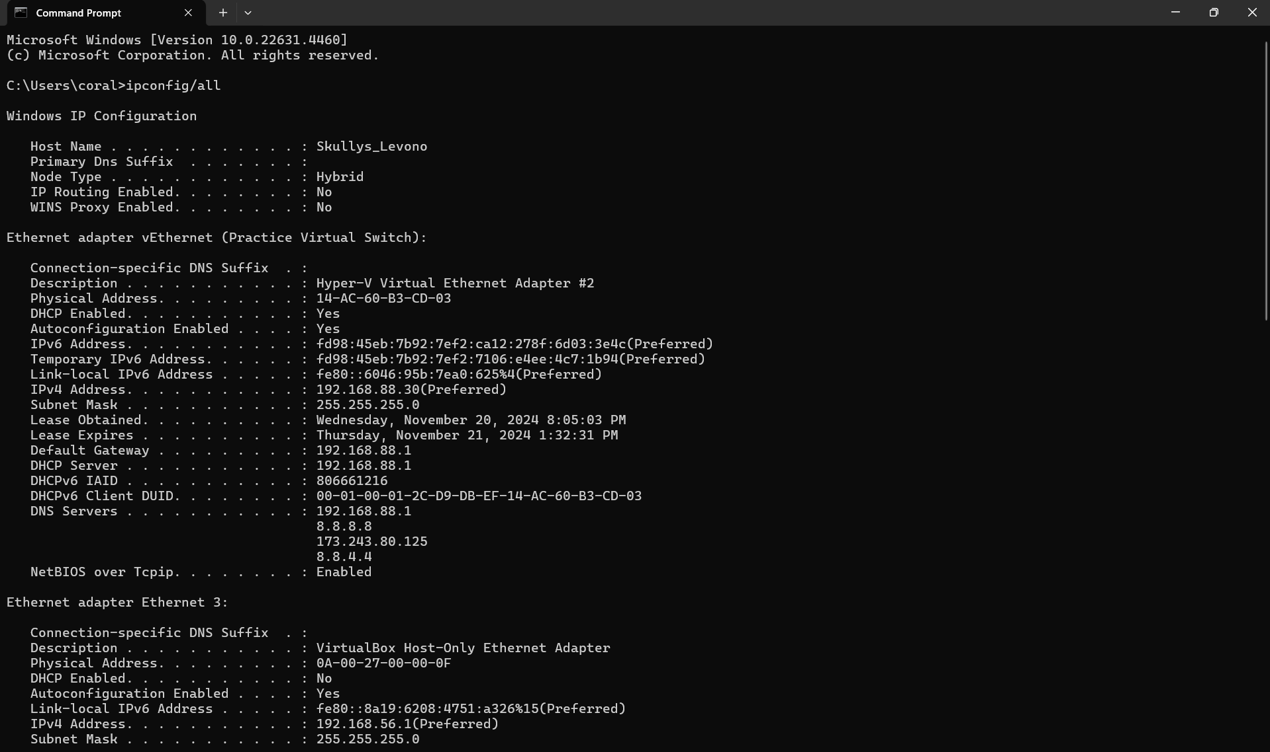Open Windows’ Command Prompt and type ipconfig /all (in Linux/Unix/Mac type ifconfig). Provide a screenshot that shows the result of executing the command for the network interface in use during the exercise. This screenshot will show your computer's IP address, default gateway, and local DNS servers. *1 point*

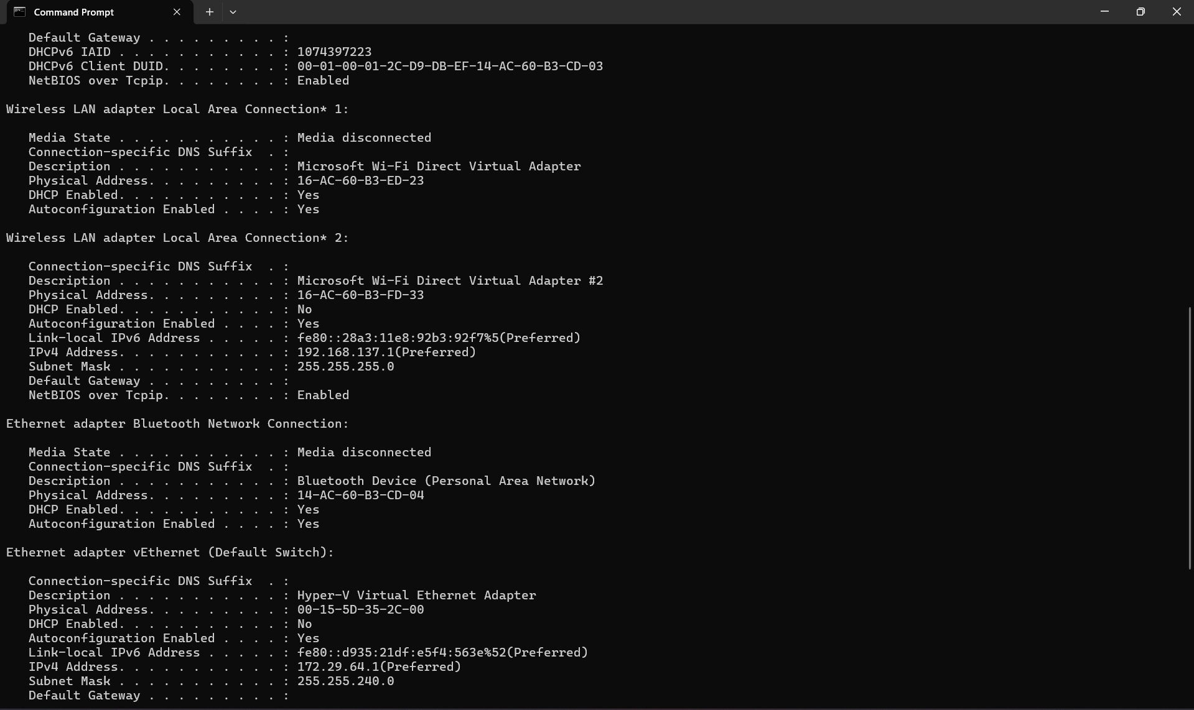

1. Is your browser running HTTP version 1.0 or 1.1? What version of HTTP is the server running? Include Wireshark screenshots to justify your answers. *2 points*

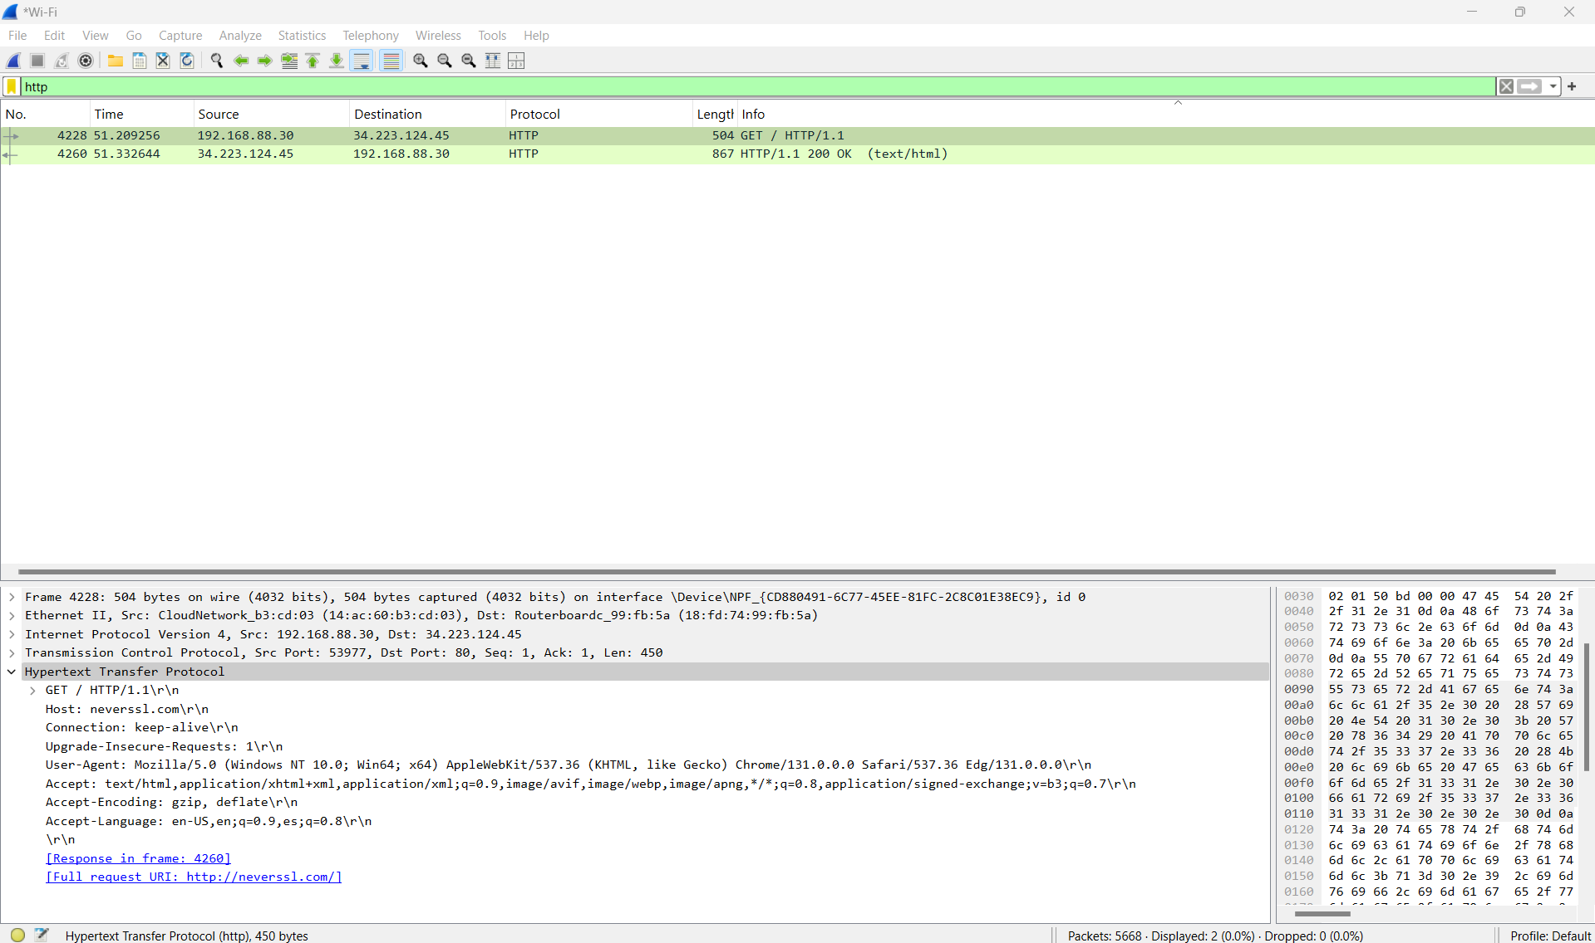As you can see from the screenshots bellow the version of HTTP ran by my browser and server is **HTTP/1.1**.

1. What is the IP address of your computer? Of the gaia.cs.umass.edu server? Include Wireshark screenshots to justify your answers. *2 points*

As shown in the screenshot bellow the IP address of my computer is **192.168.88.30** and the servers IP address is **128.119.245.12**.

1. What is the status code returned from the server to your browser? Include a Wireshark screenshot to justify your answer. *1 point*

As shown by the screenshot below the status code returned from the server to my browser is **200 OK**.

1. When was the HTML file that you are retrieving last modified at the server? Include a Wireshark screenshot to justify your answer. *1 point*

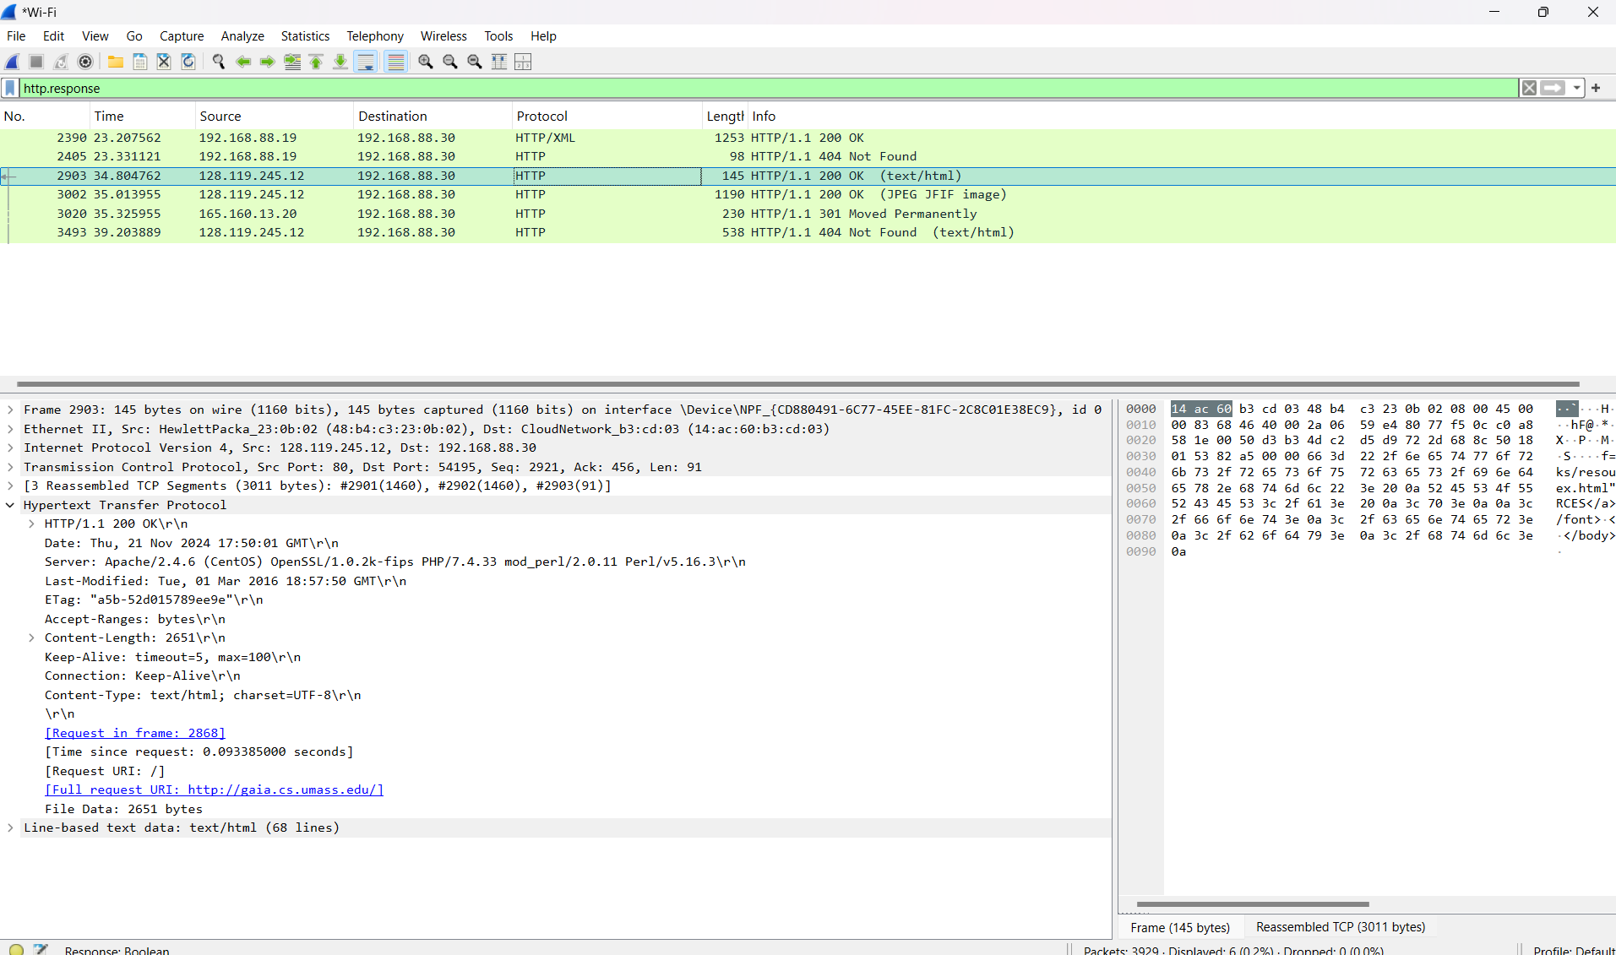As shown in the screenshot the HTML file that I am retrieving was last modified at the server on **Tue, 01 Mar 2016 18:57:50 GMT\r\n**.

1. Inspect the contents of the first HTTP GET request from your browser to the server. Do you see an “IF-MODIFIED-SINCE” line in the HTTP GET? If so, write down the field’s value. Include a Wireshark screenshot to justify your answer. *1 point*

As shown in the screenshot bellow **there is no IF-MODIFIED-SINCE** line in the HTTP GET.

1. Inspect the contents of the server response. Did the server explicitly return the contents of the file? How can you tell? Include a Wireshark screenshot to justify your answer. *1 point*

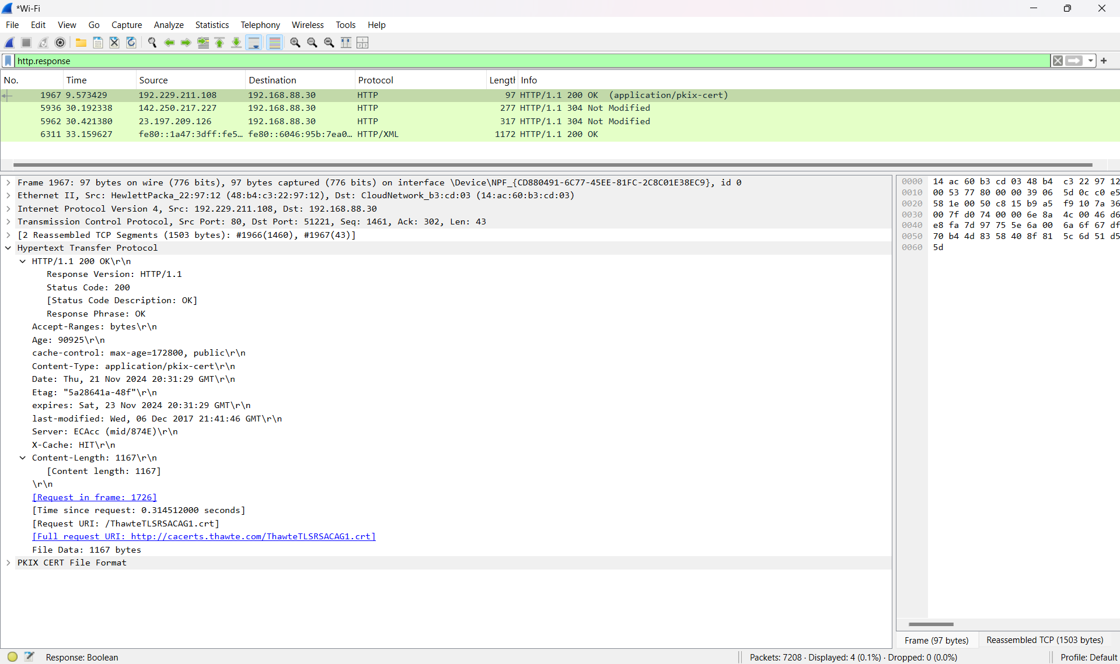As you can see from the screenshot below **the server explicitly returned the contents of the file**. This is shown by the **Response Code: 200 OK** and the **Content-Length field**, which specifies the size of the returned file. The **Content-Type field** also indicates the file type.

1. Now inspect the contents of the second HTTP GET request from your browser to the server. Do you see an “IF-MODIFIED-SINCE:” line in the HTTP GET? If so, what information follows the “IF-MODIFIED-SINCE:” header? Include a Wireshark screenshot to justify your answer. *1 point*

As you can see from the screenshot below the **If-Modified-Since line is present** in the second HTTP GET request. The date shown is **Thu, 25 Jul 2024 14:48:00 GMT\r\n**.

