**Homework 3**

**Name: Coral S. Schmidt Montilla ID#: 148830**

***Completely answer all of the following questions.***

1. Open Windows’ Command Prompt and type ipconfig /all (in Linux/Unix/Mac type ifconfig). Provide a screenshot that shows the result of executing the command for the network interface in use during the exercise. This screenshot will show your computer's IP address, default gateway, and local DNS servers. *1 point*

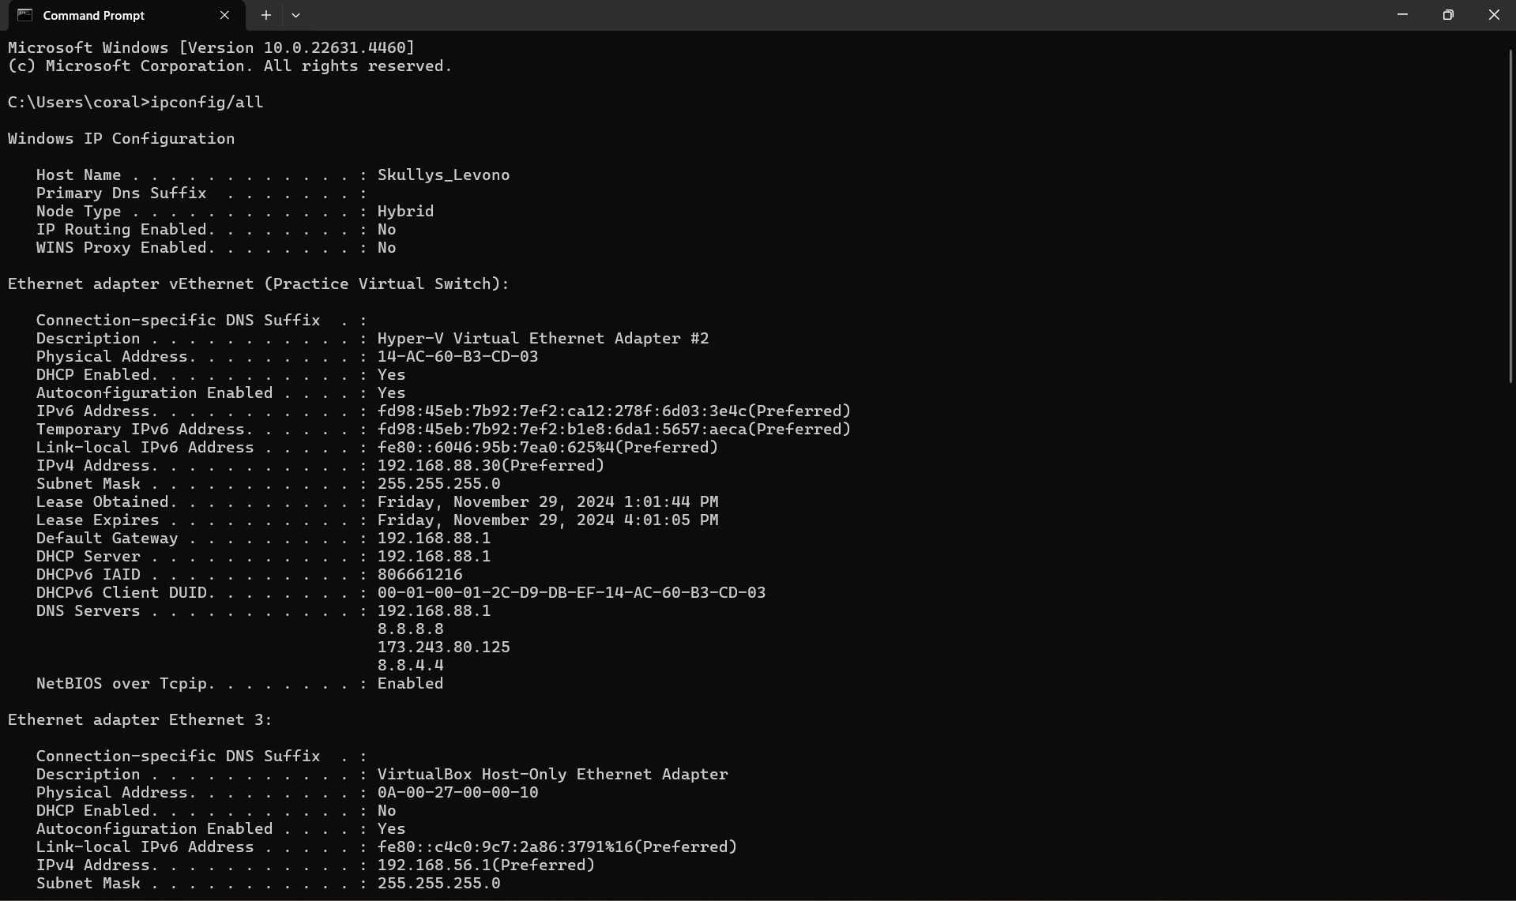

1. Run nslookup to obtain the IP address of the University’s web site, www.pupr.edu. Include a screenshot to justify your answer. *1 point*

As you can see from the screenshot below, the IP address of [www.pupr.edu](http://www.pupr.edu) is **167.172.0.84**.

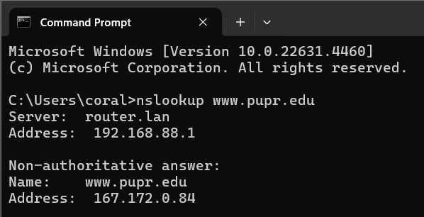

1. Run nslookup to determine the authoritative DNS servers for www.pupr.edu. Include a screenshot to justify your answer. *1 point*

As you can see from the screenshot below, the authoritative DNS servers for [www.pupr.edu](http://www.pupr.edu) are **ns1-37.azure-dns.com, ns2-37.azure-dns.net, ns3-37.azure-dns.org, and ns4-37.azure-dns.info**.

1. Run nslookup to determine the mail servers for www.pupr.edu. Include a screenshot to justify your answer. *1 point*

As you can see from the screenshot below, the mail server for [www.pupr.edu](http://www.pupr.edu) is **pupr-edu.mail.protection.outlook.com with an MX preference of 10**.

Complete the lab’s Part 3 before answering the following questions.

1. What is the IP address of your computer? Include a screenshot to justify your answer. *1 point*

As you can see from the screenshot bellow, the IP address of my computer is **192.168.88.30**.

1. Locate the DNS query and response messages. Are then sent over UDP or TCP? Include a Wireshark screenshot to justify your answer. *1 point*

As you can see from the screenshot below, the DNS query and response messages are sent over **UDP**. This can be observed in the packet details section, where the User Datagram **Protocol (UDP)** is specified as the transport protocol.

1. What is the destination port for the DNS query message? Include a Wireshark screenshot to justify your answer. *1 point*

As you can see from the screenshot below, the destination port for the DNS query message is **53**.

1. Examine the DNS query message. What “Type” of DNS query is it? Include a Wireshark screenshot to justify your answer. *1 point*

As you can see from the screenshot below, the DNS query message is of **Type A (Host Address)**.

1. Examine the DNS response message. How many “answers” are provided? What do each of these answers contain? Include a Wireshark screenshot to justify your answer. *2 points*

As you can see from the screenshot below, the DNS response message provides **4 answers**. Each answer contains the following:

1. **catalog.gamepass.com**: CNAME, alias for catalog.gamepass.com.edgesuite.net.
2. **catalog.gamepass.com.edgesuite.net**: CNAME, alias for a1992.dscd.akamai.net.
3. **a1992.dscd.akamai.net**: Type A, IPv4 address **23.39.210.17**.
4. **a1992.dscd.akamai.net**: Type A, IPv4 address **23.39.210.18**.

These records represent a chain of aliases (CNAME) and two IPv4 addresses (A records) that resolve to the requested hostname.

