**Homework 4**

**Name: Coral S. Schmidt Montilla ID#: 148830**

***Completely answer all of the following questions.***

1. Open Windows’ Command Prompt and type ipconfig /all (in Linux/Unix/Mac type ifconfig). Provide a screenshot that shows the result of executing the command for the network interface in use during the exercise. This screenshot will show your computer's IP address, default gateway, and local DNS servers.

1. What is the IP address and TCP port number used by your client computer (source) to transfer the file to gaia.cs.umass.edu? Include a Wireshark screenshot to justify your answers. *2 points*

As shown in the Wireshark screenshot below, the IP address of my client computer is **192.168.88.30**, and the TCP port number used is **60675**. These values are found in the packet details under the **Internet Protocol Version 4** section (Source field) and the **Transmission Control Protocol** section (Source Port field). The server’s IP address is **128.119.245.12**, and it is communicating on port **80** (Destination Port).

1. What is the real sequence number, in hex, of the TCP SYN segment that is used to initiate the TCP connection between the client computer and gaia.cs.umass.edu? What is it in the segment that identifies the segment as a SYN segment? Include a Wireshark screenshot to justify your answers. *2 points*

As shown in the Wireshark screenshot below, the real sequence number of the TCP SYN segment used to initiate the connection is **0x415028083**. This value is found in the "Sequence Number (raw)" field under the **Transmission Control Protocol** section in the packet details.

The SYN segment is identified by the Flags field, where the SYN flag is set to **1**. This is further indicated by the "Flags: 0x002 (SYN)" field in the packet details.

1. What is the real sequence number, in hex, of the SYNACK segment sent by gaia.cs.umass.edu to the client computer in reply to the SYN? What is the real value, in hex, of the Acknowledgement field in the SYNACK segment? How did gaia.cs.umass.edu determine that value? What is it in the segment that identifies the segment as a SYNACK segment? Include Wireshark screenshot(s) to justify your answers. *4 points*

As shown in the Wireshark screenshot below, the real sequence number of the SYN-ACK segment sent by the server is **0xc43216b2**. The real value of the Acknowledgment field is **0x415028084**, which is calculated as the client’s initial sequence number (**0x415028083**) plus 1.

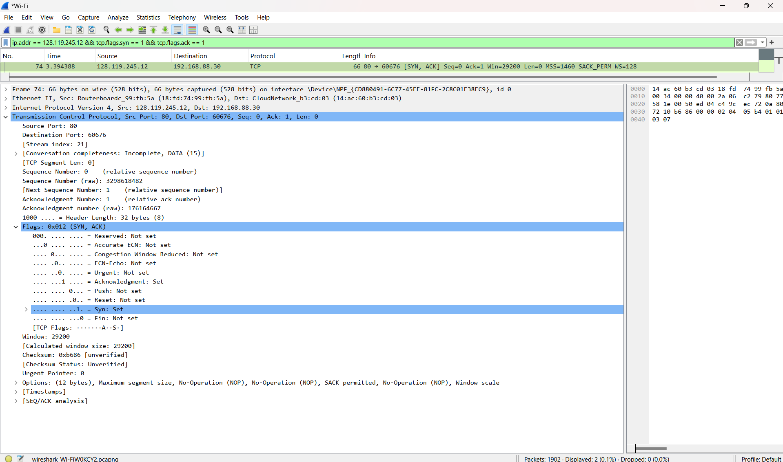The SYN-ACK segment is identified by the **Flags** field, where both SYN and ACK flags are set (0x012). These values are highlighted in the Wireshark screenshot below.

1. What is the real sequence number, in hex, of the TCP segment containing the HTTP POST command? Note that in order to find the POST command, you’ll need to dig into the packet content field at the bottom of the Wireshark window, looking for a segment with a “POST” within its DATA field. Include Wireshark screenshot(s) to justify your answers. *1 point*

As shown in the Wireshark screenshot below, the real sequence number of the TCP segment containing the HTTP POST command is **0x253f3**. This value is found in the **Sequence Number (raw)** field under the **Transmission Control Protocol** section.

The content of the packet is verified in the **Packet Bytes** pane, where the ASCII representation includes the "POST" command. These details confirm that this segment contains the HTTP POST command.

1. What is the length, in bytes, of the TCP segment containing the HTTP POST command? Include Wireshark screenshot(s) to justify your answers. *1 point*

As shown in the Wireshark screenshot below, the length of the TCP segment containing the HTTP POST command is **481 bytes**. This value is found in the **TCP payload (481 bytes)** field under the **Transmission Control Protocol** section.

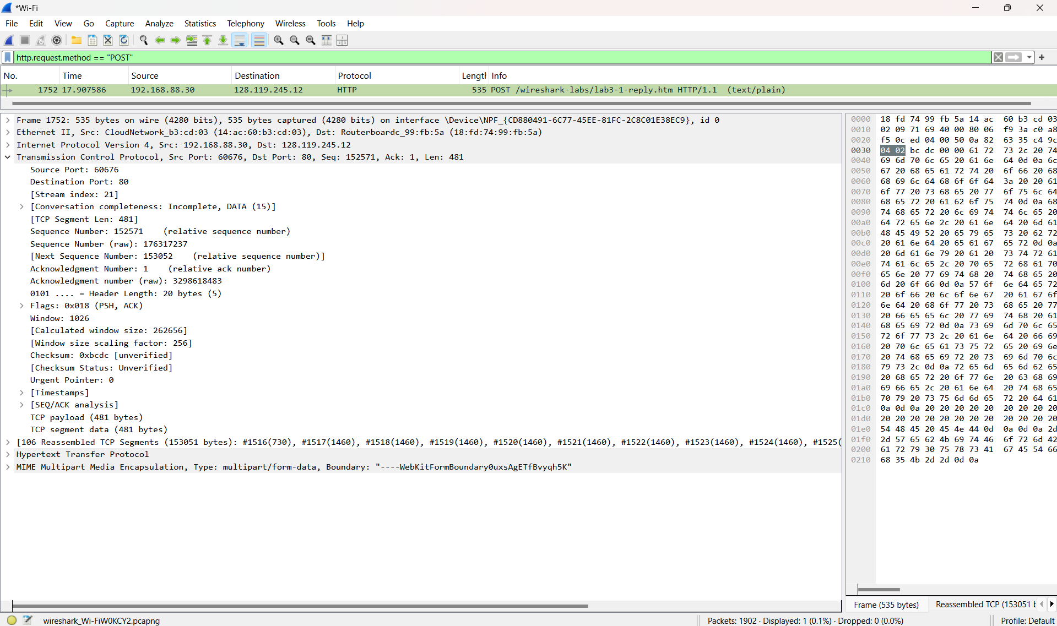The length is also confirmed by the raw data displayed in the **Packet Bytes** pane, which corresponds to the payload size. These details highlight the size of the TCP segment carrying the HTTP POST command.