**Homework 5**

**Name: Coral S. Schmidt Montilla ID#: 148830**

***Completely answer all of the following questions.***

1. Open Windows’ Command Prompt and type ipconfig /all (in Linux/Unix/Mac type ifconfig). Provide a screenshot that shows the result of executing the command for the network interface in use during the exercise. This screenshot will show your computer's IP address, default gateway, and local DNS servers.

1. Select the first ICMP Echo Request message sent by your computer and expand the Internet Protocol part of the packet in the packet details window. What is the IP address of your computer? Include a Wireshark screenshot to justify your answers. *2 points*

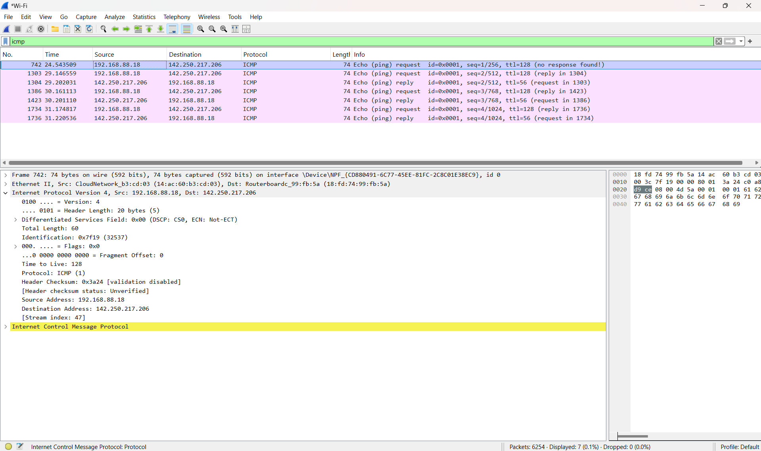The **IP address of my computer** shown in the Wireshark screenshot below is **192.168.88.18**.

1. Within the IP packet header, what is the value in the upper layer protocol field? Include a Wireshark screenshot to justify your answers. *2 points*

The **upper layer protocol field’s value** in the Wireshark screenshot below is **1**.

1. How many bytes are in the IP header? How many bytes are in the payload of the IP datagram? Explain how you determined the number of payload bytes. Include Wireshark screenshot(s) to justify your answers. *4 points*

**The IP header size** is **20 bytes**, as indicated by the Header Length field in the Wireshark screenshot. The **payload size** is **40 bytes**, which was determined by subtracting the IP header size from the total length of the IP datagram.**.**

1. Has this IP datagram been fragmented? Explain how you determined whether or not the datagram has been fragmented. Include Wireshark screenshot(s) to justify your answers. *2 points*

**This IP datagram has not been fragmented**. I determined this by examining the Flags and Fragment Offset fields in the Wireshark screenshot.

* 1. The **Flags field** is set to **0x00**, indicating that the MF (More Fragments) bit is 0, meaning this is not a fragmented datagram.
  2. A screenshot of a computer

     Description automatically generatedThe **Fragment Offset** is **0**, confirming that this is the first or only fragment of the datagram.