**Homework 6**

**Name: Coral S. Schmidt Montilla ID#: 148830**

***Completely answer the following question.***

1. Consider the network shown in the figure below. With the indicated link costs, use Dijkstra’s shortest-path algorithm to compute the shortest path from **node v** to all network nodes. Show how the algorithm works by presenting your results in the table provided. (*10 points*)

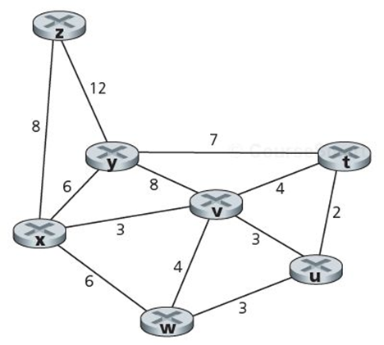

|  |  |  |  |  |  |  |  |
| --- | --- | --- | --- | --- | --- | --- | --- |
| ***Step*** | **N’** | **D(*u*), p(*u*)** | **D(*v*), p(*v*)** | **D(*w*), p(*w*)** | **D(*x*), p(*x*)** | **D(*y*), p(*y*)** | **D(*z*), p(*z*)** |
| *0* | ***v*** | ∞ | 0 | ∞ | ∞ | ∞ | ∞ |
| *1* | v, w | 4, v | 0 | 3, v | ∞ | 8, v | ∞ |
| *2* | v, w, u | 4, v | 0 | 3, v | 7, w | 8, v | ∞ |
| *3* | v, w, u, x | 4, v | 0 | 3, v | 7, w | 6, u | ∞ |
| *4* | v, w, u, x, y | 4, v | 0 | 3, v | 7, w | 6, u | ∞ |
| *5* | v, w, u, x, y, z | 4, v | 0 | 3, v | 7, w | 6, u | 14, y |
| *6* | v, w, u, x, y, z | 4, v | 0 | 3, v | 7, w | 6, u | 14, y |