Computer Science

Coral S. Schmidt Montilla

#148830

Numerical analysis for computer science mayors

FA 2024 CS3010-80

Assignment Problems

1. 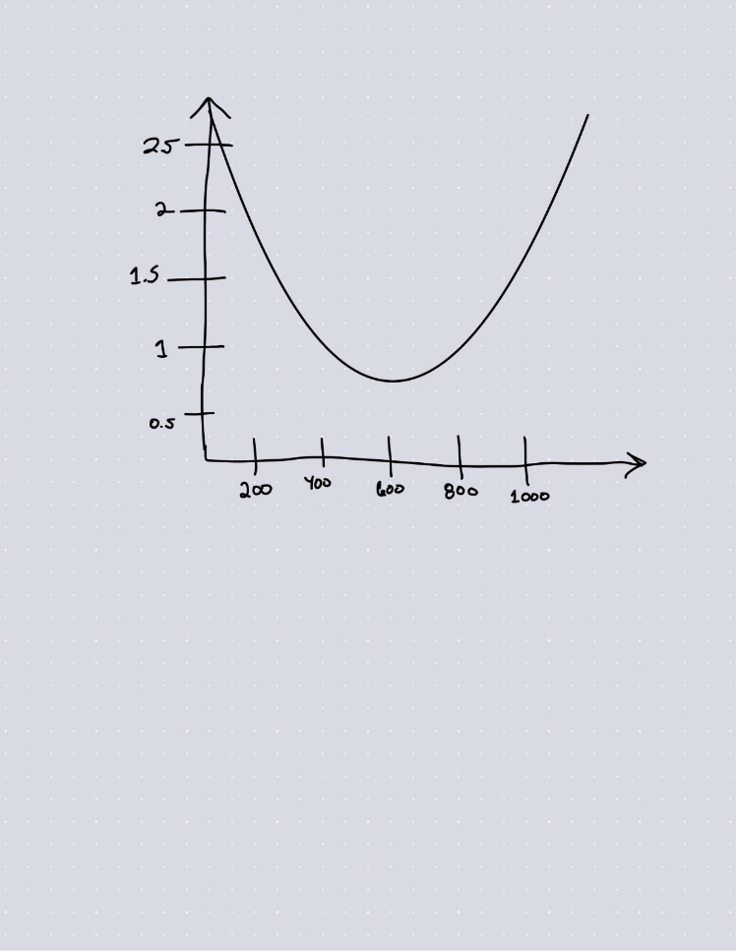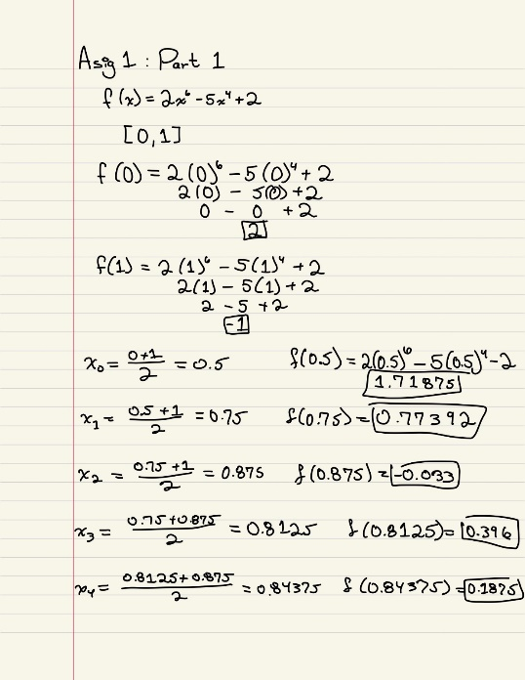Use the bisection method to solve the following nonlinear equation  . Starting with the initial interval [0,1]. Approximate the solution with an absolute error of less than or equal to 10-3. Show the corresponding solution and the minimum amount of iterations required. Draw the graph of the function.
2. 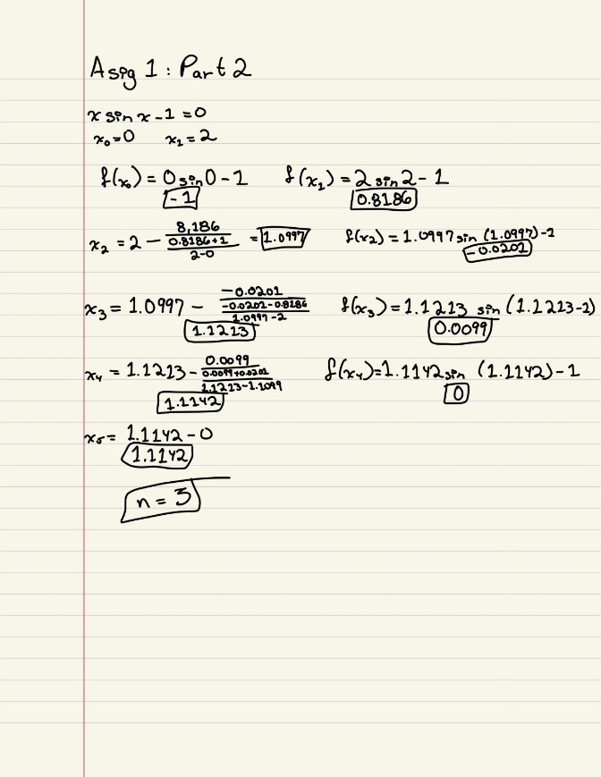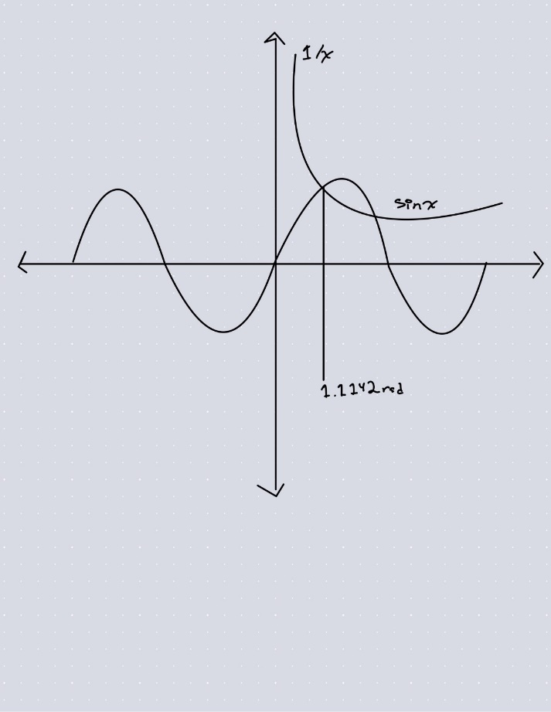Use the secant method to solve the nonlinear equation , where x is in radians, starting with the initial interval of [0,2]. Show the corresponding solution and the minimum amount of iterations required. Draw the graph of the function.

1. 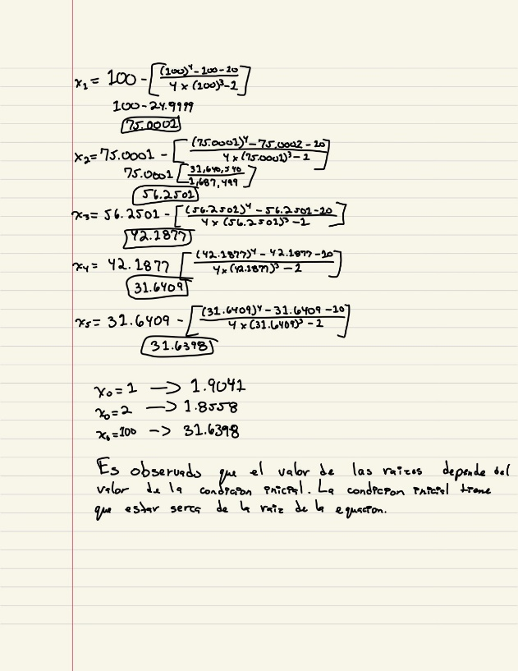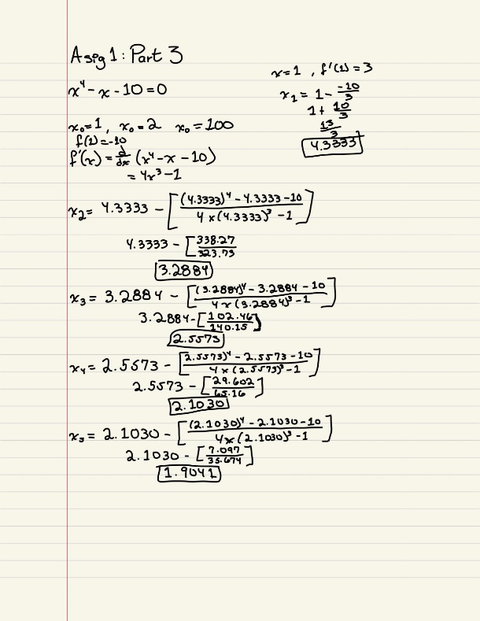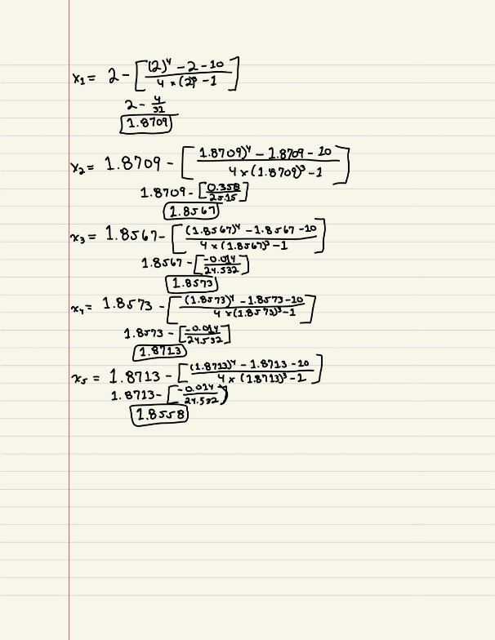Apply the Newton-Raphson method to approximate the root of the nonlinear equation       Compute and presets the results of five iterates for each of the initial guesses x0=1, x0=2, x0=100. What are the observations?
2. Corroborate your previous problems solution using MATLAB fzero function,  <https://www.mathworks.com/help/matlab/ref/fzero.html>.  Add to the pdf file the MATLAB output for each of the problems.

No entrego los resultados de MatLab porque no e tenido ninguna otra clase que me ayude a entender como utilizarlo. Hice mi mejor esfuerzo en tratar de entender cómo utilizarlo, pero tengo muchas otras clases que me consumen bastante tiempo. Espero para el próximo modulo poder entregarle la asignación con la corroboración de MatLab.