Computer Science

Coral S. Schmidt Montilla

#148830

Numerical analysis for computer science mayors

FA 2024 CS3010-80

**Assignment Problems**

1. The voltage E = E(t) in an electrical circuit obeys the equation

where R is resistance and L is inductance. Use L = 0.05 and R= 2 and values for I(t) in the table following.

|  |  |  |  |  |  |
| --- | --- | --- | --- | --- | --- |
| **t** | **1** | **1.1** | **1.2** | **1.3** | **1.4** |
| **I(t)** | 8.227 7 | 7.242 8 | 5.990 8 | 4.526 0 | 2.912 2 |

Find dI(t)/dt (1.2) using

* 1. Forward difference formula,
  2. Backward Difference
  3. Central Difference

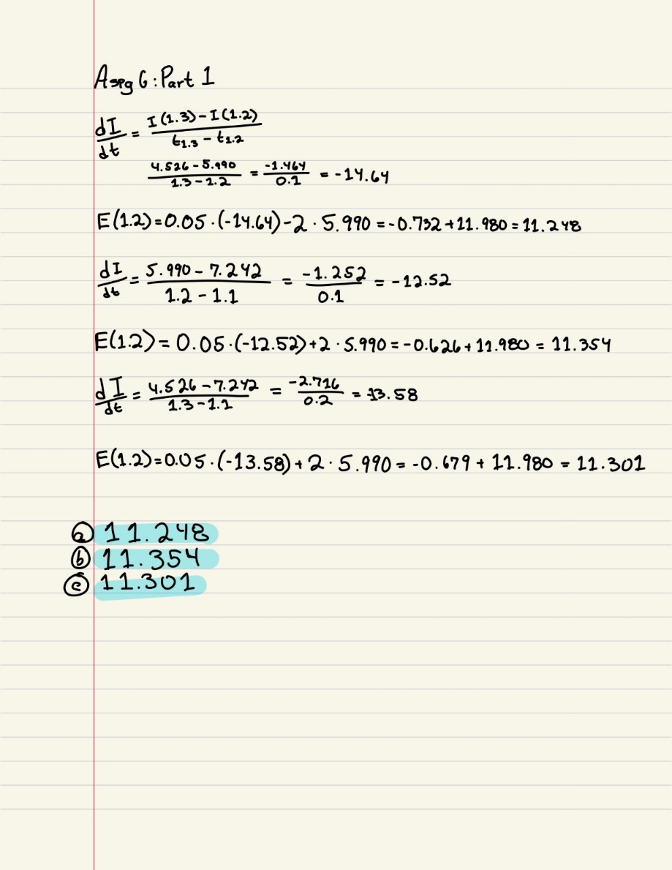and compute E (1.2) for each case. Compare your answer against I(t) = 10e-t/10sin(2t)

1. 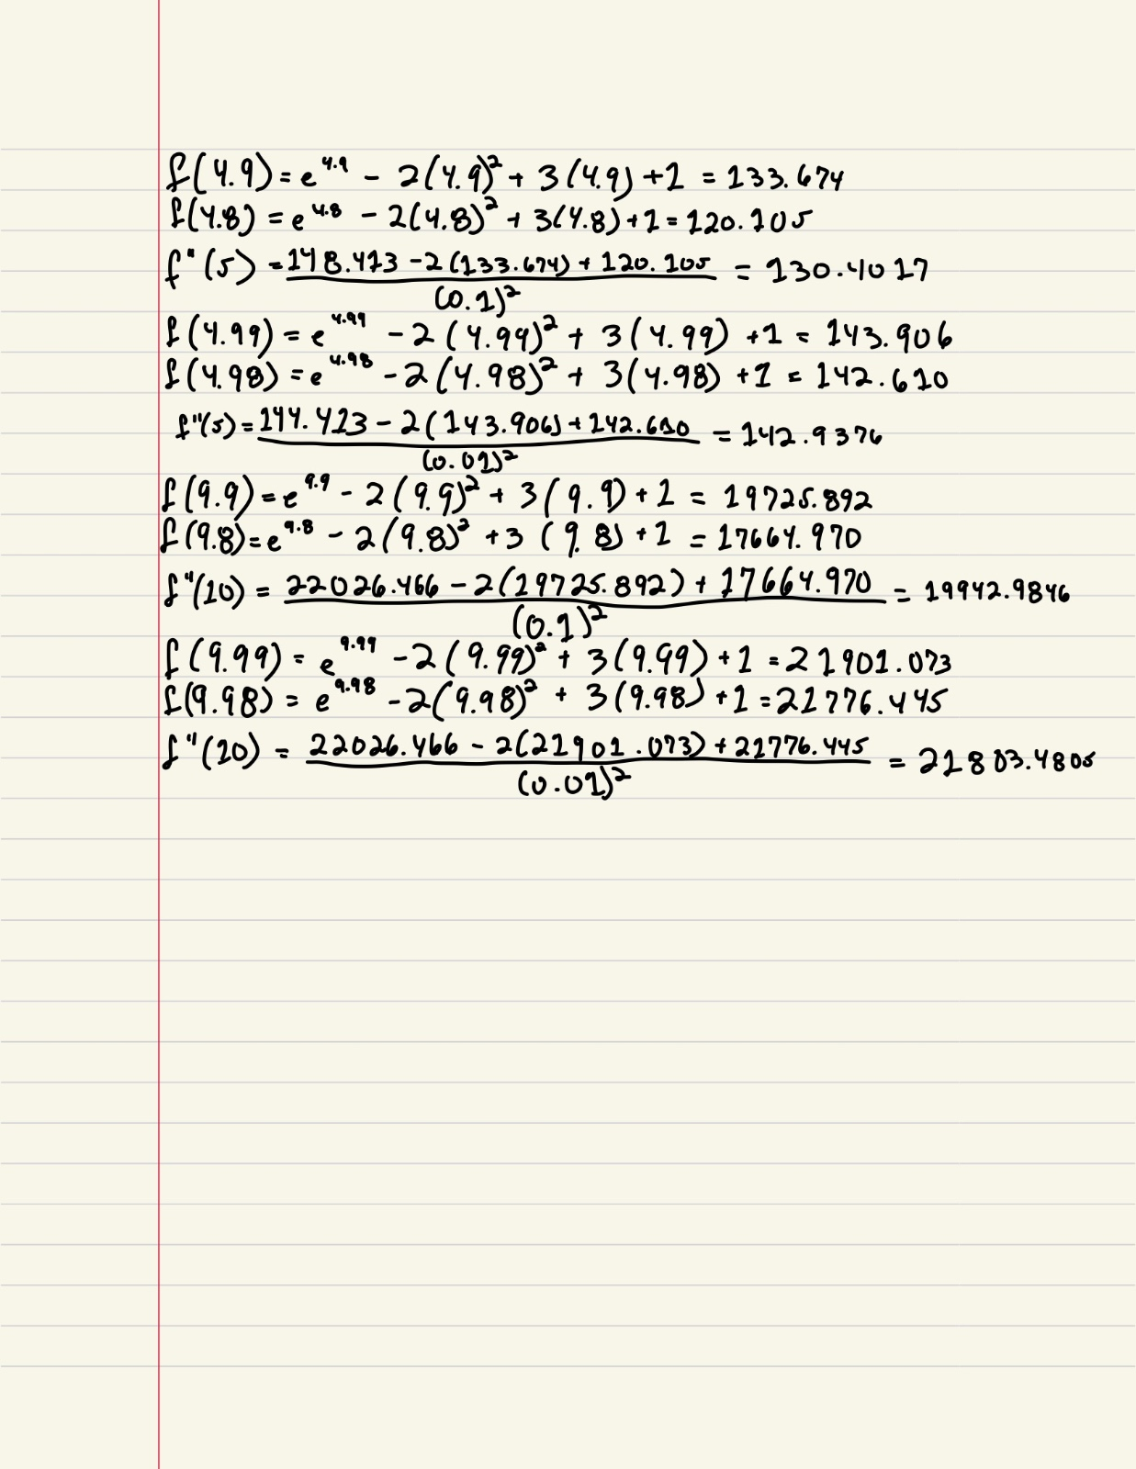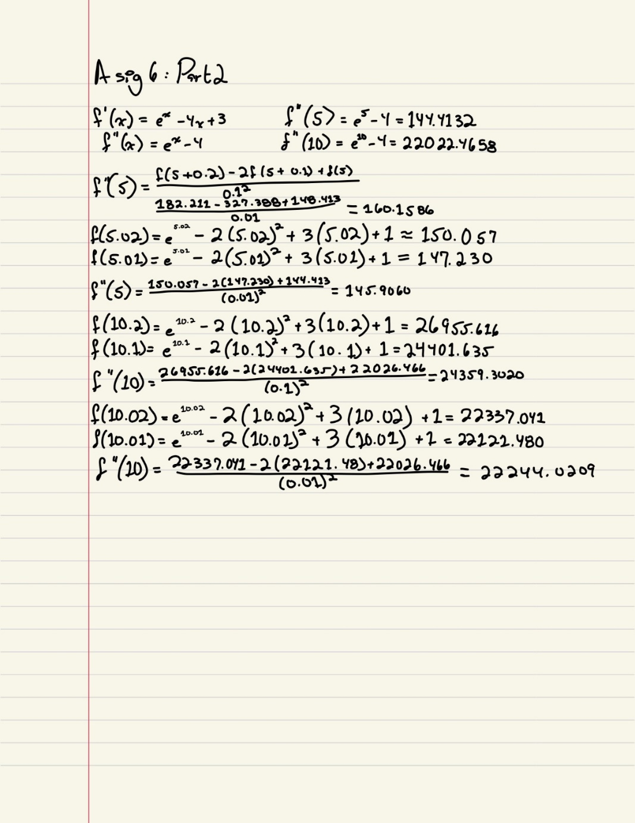Compute the second derivative using forward, backward, central difference and Taylor for the following function, 𝑓(𝑥) = 𝑒𝑥 − 2𝑥2 + 3𝑥 + 1. approximate f’’(5) and f’’(10) using h=0.1 and h=0.01 for both cases and compare your answers against the analytical solution.

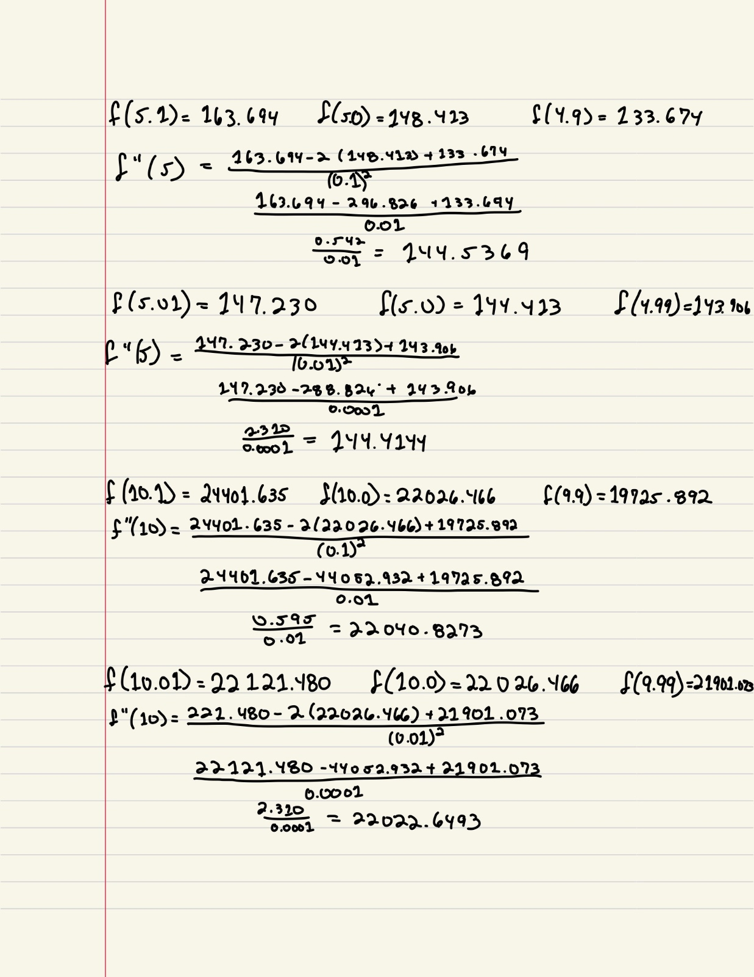

1. A function f has the values shown below:

|  |  |  |  |  |  |
| --- | --- | --- | --- | --- | --- |
| **x** | 1 | 1.25 | 1.5 | 1.75 | 2 |
| **f(x)** | 10 | 8 | 7 | 6 | 5 |

* 1. Use Midpoint rule to approximate A black background with a black square

     Description automatically generated with medium confidence𝑑𝑥
  2. Use Simpson’s rule to approximate A black background with a black square

     Description automatically generated with medium confidence𝑑𝑥

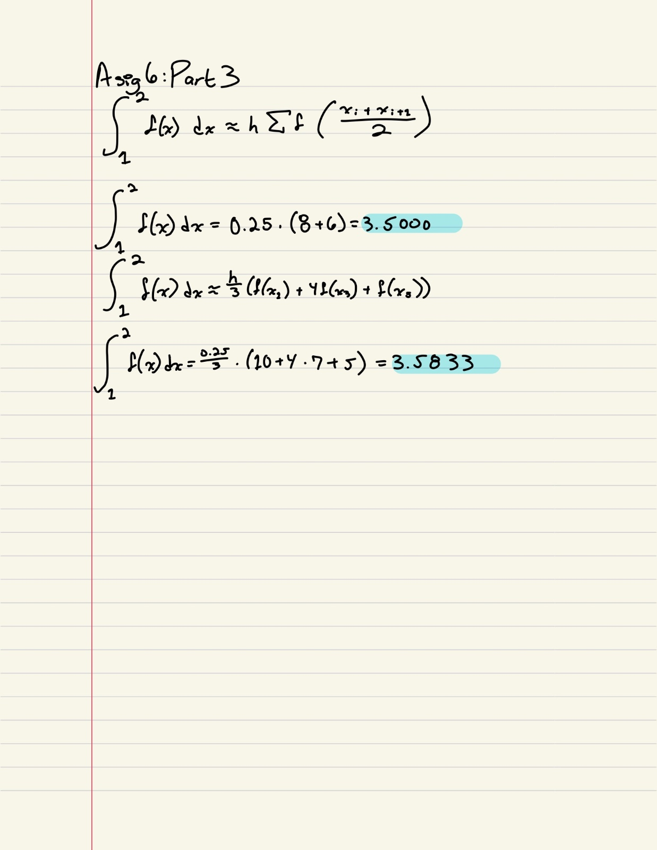

1. Approximate the solution of A black background with a black square

   Description automatically generated with medium confidence(𝑒𝑥𝑎𝑐𝑡 𝑣𝑎𝑙𝑢𝑒 ≈ 0.7468) by using,
   1. Trapezoidal with h=0.2,
   2. 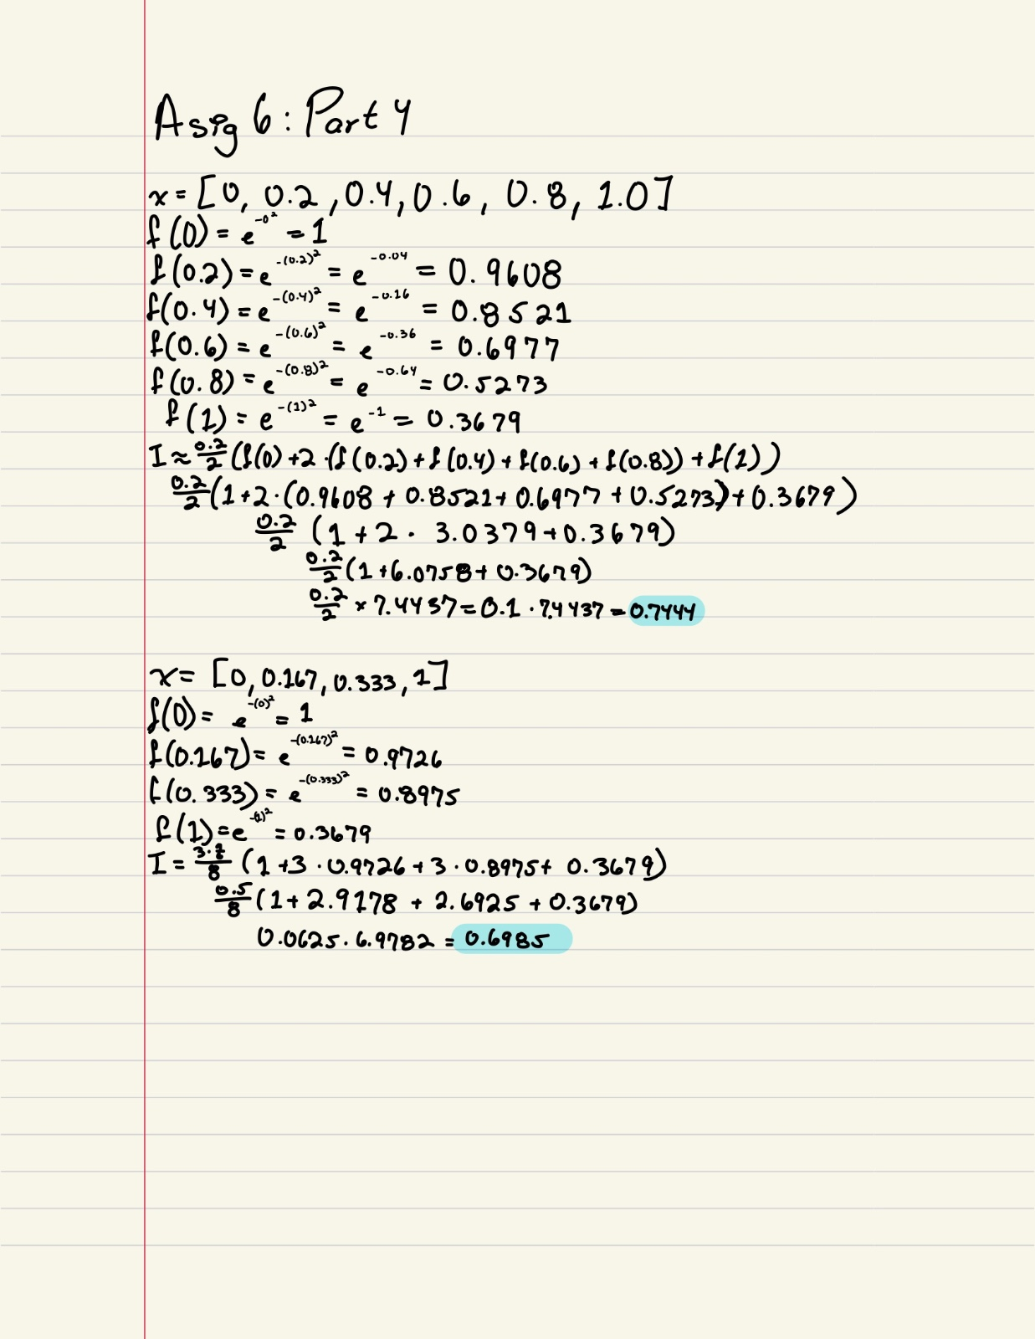3/8 Simpson methods with h=1/6
2. Validate previous problems results using MATLAB.

Problem 1:

Problem 2:

Problem 3:

Problem 4: