**Software Test Document**

Prepared By:

|  |  |  |  |
| --- | --- | --- | --- |
| **Member** | **ID#** | **Program** | **Signature** |
| Coral S. Schmidt Montilla | #148830 | Computer Science |  |
| Jaime J. Cuebas Ruiz | #121703 | Computer  Engineering |  |
| Christopher Ortiz | #130607 | Computer Science |  |
| Christian Brito | #9734 | Computer Science |  |
| Taishali N. Jimenez Quinones | #148017 | Computer Engineering |  |

**Version Log 1.0**

This section includes the changes made in each version with its description, author, and the date that the changes were made.

|  |  |  |  |
| --- | --- | --- | --- |
| **Version** | **Description** | **Modified by** | **Date** |
| 1.1 | Fixed formating, filled in the references and pointed out information that should be elaborated on. | Coral S. Schmidt Montilla | 23/10/2024 |
| 1.2 | Updated logo | Coral S. Schmidt Montilla | 5/4/2025 |
| 1.3 | Updating info | Christian Brito | 5/06/2025 |
| 1.4 | Finalizing Info | Christian Brito | 5/8/2025 |
|  |  |  |  |
|  |  |  |  |
|  |  |  |  |
|  |  |  |  |
|  |  |  |  |

**Table of Contents Page**

1. Introduction 4

1.1 Purpose 4

1.2 Scope 4

2. References 5

3. Definition 7

4. Test Plan 9

4.1 Outline 9

4.2 Test plan identifier 9

4.3 Introduction 10

4.4 Test items 11

4.5 Features to be tested 11

4.6 Feature not to be tested 12

4.7 Approach 13

4.8 Item Pass/fail 13

4.9 Suspension Criteria and Resumption Requirements 15

4.10 Testing Task 17

4.11 Environmental Needs 18

4.12 Responsibilities 18

4.14 Schedule 19

4.15 Risks and contingencies 20

4.16 Approvals 21

5. Test Design Specification 21

5.1 Purpose 22

5.2 Outline 22

5.2.1 Test Design Specification Identifier 22

5.3 Featured to be tested 22

6. Test Case Specification 23

6.1 Test Case Specification Identifier 23

6.2 Test Items 23

6.3 Input Specifications 24

6.4 Output Specifications 24

6.5 Environmental Needs 24

6.6 Special Procedural Requirements 25

6.7 Intercase Dependencies 25

7. Test Procedure Specification 25

8. Test Log 26

8.1 Purpose 26

8.2 Outline 26

8.3 Test Log: details 27

9. Test Incident Report 28

9.1 Purpose 28

9.2 Outline 28

9.4 Summary 28

9.5 Incident Description 29

9.6 Impact 29

10.Test Summary Report 29

10.1 Purpose 30

10.2 Outline 30

10.2.1 Test Summary Report Identifier 30

10.2.2. Summary 30

10.2.3. Variances 30

10.2.4. Comprehensive assessment 30

10.2.5. Summary of results 30

10.2.6. Evaluation 31

10.2.7. Summary of activities 31

11. Tests performed 33

11.1. Test results 33

**List of Tables**

Table 1: Term Definitions 2

Table 2: Acronyms and their terms 3

Table 3: Abbreviations and their terms 3

Table 4: Test Items Table 4

Table 5: Tested Features 5

Table 6: Approach taken towards features test. 6

Table 7: Test Cases with Pass and Fail Criteria 6

Table 8: Suspension and Criteria 7

Table 9: Tester Position and Task 7

Table 10: Responsibilities and Descriptions 8

Table 11:Staffing and Training Needs 8

Table 12:Schedule 9

Table 13:Risks and Contingency Plan 9

Table 14: Approval signature and supervisors 10

Table 15: Test Cases with their Feature, Type, Pass & Fail Criteria 11

Table 16: Software Test Case Specification Identifier 11

Table 17: Software Test Items 12

Table 18: Hardware and Software needed for Test Cases 13

Table 19: Test Procedure Specification 13

Table 20: Test Log 14

Table 21: Table of Performed Test 17

**List of Figures**

Figure 1: Test Item Transmittal Report Template 14

Figure 2: Test Incident Report Template 15

Figure 3: Test Item Summary Report 17

Figure 4: Test Result for test S1 18

Figure 5: Test Result for test S2 18

Figure 6: Test Result for test S3 18

# 1. Introduction

## 1.1 Purpose

The purpose of this document is to include everything that is being added and tested in the Resume Builder. It is a summary of the testing being done, the test approach and management, and its expected execution.

## 1.2 Scope

This document will cover the Resume Builder, and everything done with it “behind the scenes” to make it work.

# 2. References

[1]

“What is a Test Plan: Importance, Components, How to create Test Plan,” *BrowserStack*, Sep. 28, 2024. Available: https://www.browserstack.com/test-management/features/test-run-management/what-is-test-plan. [Accessed: Oct. 23, 2024]

‌[2]

“What is a Test Plan? Complete Guide With Examples | PractiTest,” *PractiTest*, Sep. 22, 2024. Available: https://www.practitest.com/resource-center/article/write-a-test-plan/. [Accessed: Oct. 23, 2024]

‌[3]

Test, “IEEE 829 Test Plan Example,” *Google Docs*, 2019. Available: https://docs.google.com/document/d/1F1TUX5BkviRbw8auI2Xq2K2wyGTS-Ag14DRymiELmzc/edit?pli=1&tab=t.0#heading=h.jd6vjs4lpb4w. [Accessed: Oct. 23, 2024]

‌[4]

“software test document test categories - Google Search,” *Google.com*, 2024. Available: https://www.google.com/search?q=software+test+document+test+categories&rlz=1C1ALOY_esPR981PR981&oq=&gs_lcrp=EgZjaHJvbWUqCQgBECMYJxjqAjIJCAAQIxgnGOoCMgkIARAjGCcY6gIyCQgCECMYJxjqAjIJCAMQIxgnGOoCMgkIBBAjGCcY6gIyCQgFECMYJxjqAjIJCAYQIxgnGOoCMgkIBxAjGCcY6gLSAQo4MDU2MjBqMWo3qAIIsAIB&sourceid=chrome&ie=UTF-8. [Accessed: Oct. 23, 2024]

[5]

Atlassian, “The different types of testing in software | Atlassian,” *Atlassian*, 2024. Available: https://www.atlassian.com/continuous-delivery/software-testing/types-of-software-testing. [Accessed: Oct. 23, 2024]

[6]

Q. Team, “Roles and Responsibilities in a High-Performing Software Testing Team | Qodo,” *Qodo*, Apr. 10, 2024. Available: https://www.qodo.ai/blog/roles-and-responsibilities-in-a-high-performing-software-testing-team/. [Accessed: Oct. 23, 2024]

‌

[7]

“Software Testing Certifications - Starting Only $49 - Affordable Certifications, Free Books! 50% Off Until Early Next Week!,” *International Software Test Institute*, 2024. Available: https://www.test-institute.org/What_Is_Software_Risk_And_Software_Risk_Management.php. [Accessed: Oct. 23, 2024]

‌

[8]

“Test Design Specification |Professionalqa.com,” *Professionalqa.com*, 2020. Available: https://www.professionalqa.com/test-design-specification. [Accessed: Oct. 23, 2024]

‌

[9]

“IEEE 829-1998 |Professionalqa.com,” *Professionalqa.com*, 2018. Available: https://www.professionalqa.com/ieee-standard-829-1998. [Accessed: Oct. 23, 2024]

‌

[10]

“Approval Testing: Agile Testing that Scales,” *Methodsandtools.com*, 2018. Available: https://www.methodsandtools.com/archive/approvaltest.php. [Accessed: Oct. 23, 2024]

‌

[11]

L. Sharma, “What is Test Case Specification in Software Testing Test Plan,” *TOOLSQA*, Oct. 19, 2021. Available: https://toolsqa.com/software-testing/test-case-specification/. [Accessed: Oct. 23, 2024]

‌

# 3. Definition

This section contains a table of terms mentioned in this document with their definition. It also includes tables with Abbreviations and Acronyms that are used within the document.

| **Term** | **Definition** |
| --- | --- |
| Application | A program or software designed to fulfill a particular purpose for the user, often accessed through a web or mobile interface. |
| User Interface | The visual part of the app that users interact with to input information or control the program. |
| Resume | A formal document listing a person’s professional and educational track record and achievements. |
| Application Programming Interface | A set of functions that allow the app to communicate with external services. |
| Portable Document Format | A file format that ensures documents maintain consistent formatting for easy sharing and printing. |

Table 1: Term Definitions

| **Acronym** | **Term** | **Definition** |
| --- | --- | --- |
| [xxx] | [xxx] | [xxx] |
|  |  |  |
|  |  |  |
|  |  |  |
|  |  |  |
|  |  |  |
|  |  |  |
|  |  |  |
|  |  |  |

Table 2: Acronyms and their terms

|  |  |
| --- | --- |
| **Abbreviations** | **Term** |
| Info. | Information |
| App | Application |
| INC | Incident |
| DB | Database |

# 4. Test Plan

The test plan is how the testing will be done. It includes defining test objectives, test approach, test tools, test environment, test schedules, and team responsibilities and composition.

## 4.1 Outline

This part will include everything from the Resume Builder: its features and what needs to be tested or not, the expectations of execution of each part, its needs in test tools and team responsibilities, and its expected schedule.

## 4.2 Test plan identifier

To ensure efficiency and a thorough testing process, the test plans are organized in a series of steps which are in the following order:

1. **Introduction**
2. **Test items**
3. **Features to be tested**
4. **Feature not to be tested**
5. **Approach**
6. **Item Pass/fail**
7. **Suspension criteria and resumption requirements**
8. **Test deliverables**
9. **Testing tasks**
10. **Environmental needs**
11. **Responsibilities**
12. **Staffing and training needs**
13. **Schedule**
14. **Risks and contingencies**
15. **Approvals**

## 4.3 Introduction

The Resume Builder, as the name implies, is an app to make resumes with ease. In here, we show all the testing that had been done to make sure that it works as expected and that the users can have an easy but fulfilling time while making their resumes for different kinds of work.

## 4.4 Test items

The following table demonstrates the tests that took place for the web application.

|  |  |  |  |
| --- | --- | --- | --- |
| **Tests Name** | **Test ID** | **Version** | **Author** |
| Connections | Con_1 | 0.1 | Christian Brito |
| Resume | Res_1 | 0.1 | Christian Brito |
| Visuals | Vis_1 | 0.2 | Christian Brito |
| Options | Opt_1 | 0.2 | Christian Brito |
| Resume | Res_2 | 0.2 | Christian Brito |
| User | Use_1 | 0.3 | Christian Brito |
| Errors | Err_1 | 0.3 | Christian Brito |
| Connection | Con_2 | 0.3 | Christian Brito |
| Resume | Res_3 | 0.3 | Christian Brito |

Table 4: Test Items Table

## 4.5 Features to be tested

This section contains a list of the features that will be tested in Table 5.

| **Test Name** | **Feature** | **Test**  **Category** |
| --- | --- | --- |
| Database | Use a DB to save all the user’s profile info. (Even the Resume info?) | Integration |
| Builder | Be able to create resumes, change the info, and delete it | Functional and End-to-End |
| Profile | Be able to create, get, see, and use all user info (names, email, education, experience, etc.) | Functional and End-to-End |
| Suggestions | Depending on job types, suggest which resume sections to be included and filled. | Functional and End-to-End |
| Tips | A bubble showing tips on what info is expected and preferred | Functional and End-to-End |
| Format | Create resumes in different formats and change the format of your resume without changing the info | Functional |
| Preview | Get a preview of your resume at any time | Functional and End-to-End |
| Saved | Save to complete later, or be able to continue your changes even if accidental Alt+F4 | Functional |
| Download | Download the resume for either future changes or for printing | Functional and End-to-End |
| Login | A login, for the different profiles. Email and LinkedIn login for profiles added. | Integration |
| Job Suggestions | Check if the web block for LinkedIn & Indeed. | Integration |

Table 5: Tested Features

## 4.6 Feature not to be tested

This section mentions the feature that can’t be tested since it is owned by a third party in Table 6.

* + - Browser usage – how the app works in a browser
    - Mobile usage – how the app works in a mobile

## 4.7 Approach

For the approach of testing, we will have the inside and the outside. The inside is everything inside the Resume Builder, while the outside is everything that connects to the Resume Builder. If there is an error, we can identify if it’s during the merger or in either side

|  |  |
| --- | --- |
| **Feature Group** | **Approach** |
| Inside | This group will focus on everything inside the Resume Builder. |
| From Table 5: the Builder, Profile, Suggestions, Tips, Format, Preview and Save. |
| If possible, they will also be testing the visuals. |
| Outside | The group will focus on everything outside the Resume Builder. |
| Monstly connections. From Table 5: DB and Login. |
| Also tests visuals on each, and make sure it connects with other external things from the profile like email, certifications, LinkedIn profile, etc. |
| Pass additional suggestions/tips to Inside group. |

Table 6: Approach taken towards features test.

## 4.8 Item Pass/fail

This section briefly describes a test and states the pass or fail criteria for each test being conducted on the system.

| **Test Name** | **Description** | **Pass Criteria** | **Fail Criteria** |
| --- | --- | --- | --- |
| Database | Connect app and D | Successfully connects | Error at connecting |
| Create | Create a resume | Successfully create a resume | Error at creating a resume |
| Change | Change info in a resume | Successfully change the info in a resume | Error at changing, or info doesn’t change |
| Profile | Create a profile with changeable info | Successfully create a profile and change its info | Error at creating a profile or info doesn’t change |
| DataProf | Make sure the DB saved the profile info, and both get it and see it | Successfully get the info from the DB and be able to see it | Error at connecting to DB, DB has wrong info, or unable to see the info |
| Visuals | Make sure the visuals work as intended and that they are close or equal to those asked from the Fron-End Dev | Visuals work as intended and they look as asked from the Front-End Dev. Also, no visual errors after changing or selecting anything | Visuals don’t work or we have visual errors after changing or selecting anything. Also, if they don’t look as asked and can’t convince the Front-End Dev to change them |
| Suggestions | Make sure suggestions work as intended, and can be turned off | Suggestions work as intended. Preferably bubbles with an ‘x’ to close | Suggestions don’t show up, show somewhere else, or the suggestions is not for what was asked |
| Tips | Make sure tips work as intended and can be turned off | Tips work as intended. Preferable bubbles with an ‘x’ to close | Tips don’t show up, show somewhere else, or the tip is not for what was asked for |
| Format | Be able to at least create a resume in different formats | Successfully create a resume in different formats and change their info. Check visuals too | Error at creating the resume, error at changing info, have wrong format or visual errors |
| Preview | Be able to see a preview of the resume | Successfully see the preview of the resume | Preview doesn’t work, preview doesn’t show what it should, wrong info, wrong visuals. |
| Saved | Be able to save the resume, close the app, reopen the app and be able to continue with the resume where it was left off | Successfully save a resume, close the app, reopen the app, and continue with changing the resume. | Error at saving the resume, error at closing/reopening the app, resume info is wrong or gets reset, can’t change resume after reopening. |
| Download | Be able to download the resume, and make sure the download is what is expected | Successfully download a pdf of the created resume. | Error at changing the resume into a pdf, error in downloading the pdf, pdf info is wrong. |
| Login | Make sure login works as intended, so you can get the profile with saved info and resumes | Successfully login into a previously created profile | Login doesn’t work, doesn’t login even if info is correct, logs into a random profile, logs in even if info is wrong, logs in even when there is no profile to log into. |
| Delete | Delete the resume | Successfully delete the resume. | Error at deleting the resume |

Table 7: Test Cases with Pass and Fail Criteria

## 4.9 Suspension Criteria and Resumption Requirements

This section contains the criteria that determines whether an item that failed a test is suspense for further testing:

| **Test** | **Description** | **Action** |
| --- | --- | --- |
| Database | Error at connecting | Check the DB. Check if the app does connect to the DB. |
| Create | Error at creating a resume | Check all the functions in the resume builder. Potential visual error as well |
| Change | Error at changing the info | Check the data types and the functions. Potential visual error as well |
| Profile | Error at creating a profile | Make sure the field names match the names in the DB. Potential DB or DataProf error. |
| DataProf | Error with the received profile info | Potential DB connection error. Potential visual error as well |
| Visuals | Error with the visuals | Fix the visuals, but don’t overwork it, it may give an error or bug again |
| Suggestions | Suggestions not working | Not critical. Check the functions for errors. Possible visual error as well |
| Tips | Tips not working | Not critical. Check the function for errors. Possible visual error as well |
| Format | Not able to create the resume in different format | Not critical. Check the functions for errors. Possible visual error as well. |
| Preview | Unable to see a preview | Check the functions for errors. Make sure the resume has been created. Possible visual errors as well |
| Saved | Unable to save | Not critical. Check the functions for errors. Make sure there is an actual save function in the code |
| Download | Unable to download | Check the functions for errors, possible errors when changing to download pdf |
| Login | Doesn’t work | Potential errors in functions, potential DataProf error (profile saved with wrong login), potential visual error, potential error in outside check (email or LinkedIn) |
| Delete | Error at deleting a resume | Check the functions. Potential visual error as well |

Table 8: Suspension and Criteria

## 4.10 Testing Task

This section details the tasks that the individual roles will have to complete. Each feature group (Table 6) should contain:

|  |  |
| --- | --- |
| **Position** | **Task** |
| Test Manager and Test Lead | In charge of creating, sending and receiving other Software Test Documents, in charge of team’s personal testing schedule, allocates resources, implement changes were needed, and deals with the higher ups. |
| Testers | They test the software and make sure to make as many use-case tests as possible for the developers to solve as many errors as possible. They are divided into: Manual Testers, Performance Testers, and Usability Testers. |
| Developers | They create and make changes to the code, create and make changes in the visuals, fix the bugs and errors in the code, and make sure everything works as it should |
| Test Data Manager | They deal with the creation, management and handling of the test data. They make sure its relevant, accurate, and well implemented. |

Table 9: Tester Position and Task

## 4.11 Environmental Needs

This is what is needed for the program’s testing to work as it should. It includes characteristics, setup and accessibility of the testing environment, as well as showing what testing tools are needed (if any).

* + - A Windows PC with access to the DB and the code, as well as the respective programs to open and run them (like MySQL or Oracle for the DB, and Visual Studio Code or Eclipse for the code)
    - Multiple test data on the testing site.
    - Comprehensive testing cases

## 4.12 Responsibilities

In Table 11, it will display the responsibilities each role will be tasked with.

| **Name** | **Responsibilities** |
| --- | --- |
| Test Managers | They oversee the entire testing process. They develop testing strategies, allocate resources and ensure that testing aligns with project goals. They also deal with risk assessment, communication with stakeholders, and maintain testing standards. |
| Test Lead | Works with the Test Manager to coordinate and manage day-to-day testing. Assigns task to team members, monitor progress, provide guidance, and ensure testing goes according to the test strategy. |
| Software Testers | Responsible for designing and executing test cases based on requirements. They identify and document defects and conduct various types of testing. They are divided into: Manual Testers, Performance Testers, and Usability Testers. |
| Test Environment Manager | Responsible for setting up and maintaining the testing environment and minimizing discrepancies between it and production environment. |
| Test Data Managers | They deal with the creation, management and handling of the test data. They make sure its relevant, accurate, and well implemented. |

Table 10: Responsibilities and Descriptions

## 4.14 Schedule

A schedule of when it is expected to test something.

|  |  |  |
| --- | --- | --- |
| **Test** | **Due Date** | **Tester Position** |
| Database, Create, Change, Profile, and DataProf | 05/01/2025 | Manual |
| Database, Create, Change, Profile, and DataProf | 05/01/2025 | Usability |
| Visuals, Suggestions, Tips, Format, Preview, Saved, Download, and Database | 05/02/2025 | Manual |
| Visuals, Suggestions, Tips, Format, Preview, Saved, Download, and Database | 05/02/2025 | Usability |
| Login, Delete, Profile, and Database | 05/05/2025 | Manual |
| Login, Delete, Profile, and Database | 05/05/2025 | Usability |
| Final test | 05/?/2024 | Manual and Usability |

Table 12: Schedule

## 4.15 Risks and contingencies

A few big potential problems can occur during development, generally caused by lack of communication, control, or time. Here we have some potential risks and the contingency plan in case that happens.

| **Risk** | **Contingency Plan** |
| --- | --- |
| Database failure | If unsalvageable, recreate the DB from scratch |
| Elimination of big chunks of code | Try to salvage it. If impossible, recreate things. |
| Computer failure | Have a backup online ready to be edited in case the computer is unfixable. |

Table 13: Risks and Contingency Plan

## 4.16 Approvals

Many changes are just ‘potential assertions’ until they receive approval from the Test Manager or Test Lead, seeing as all changes will affect the code; some desirable, some undesirable, some subtly, some bring issues, and some can be ignored.

| **Name** | **Signature** |
| --- | --- |
| Christian Brito |  |

Table 14: Approval signature and supervisors

# 5. Test Design Specification

The Test Design Specification specifies the test conditions for a test item, the detailed test approach, and identifies the associated high level of test cases. The objective is to specify which test suites and test cases to run and which to skip.

## 5.1 Purpose

The purpose is to identify which set of features needs to be tested and identify the group of test cases that will allow them to test these features effortlessly.

## 5.2 Outline

Define the refinements of the test approach presented in the test plan

* Test Contidions
* Detailed Approach
* High Level Test Cases

### 5.2.1 Test Design Specification Identifier

Unique company generated Test ID to identify this test case specification

| **Test ID** | **Test Name** | **Feature** | **Pass Criteria** | **Fail Criteria** |
| --- | --- | --- | --- | --- |
| 01 | Builder | Create, Change, Profile, Database | Creates a resume, changes info, creates a profile, and gets its info from the DB | Fail to do any of the previously mentioned |
| 02 | Added | Visuals, Suggestions, Tips, Format, Preview, Saved, Download, and DB | Suggestions and Tips work, Format works, Preview, Saved and Download works | Fail to do any of the previously mentioned |
| 03 | Outside | Login, Delete, Profile, and Database | Login into a profile, get your profile info, and delete a resume | Fail to do any of the previously mentioned |

Table 15: Test Cases with their Feature, Type, Pass & Fail Criteria

## 5.3 Featured to be tested

Features not included in Table 15:

* Browser usage
* Mobile usage

# 6. Test Case Specification

The Test Case Specification describes a detailed summary of what test scenarios will be tested and how they will be tested

## 6.1 Test Case Specification Identifier

| **ID** | **Version** | **Date** | **Author** | **Test Item** |
| --- | --- | --- | --- | --- |
| 01 | 0.1 | 05/01/2025 | Christian Brito | Create, Change |
| 02 | 0.1 | 05/02/2025 | Christian Brito | Profile, Database |
| 03 | 0.2 | 05/05/2025 | Christian Brito | Suggestions, Tips |
| 04 | 0.2 | 05/06/2025 | Christian Brito | Format, Preview, Saved, Download |
| 05 | 0.3 | 05/06/2025 | Christian Brito | Login, Delete, Profile |

Table 16: Software Test Case Specification Identifier

## 6.2 Test Items

Individual items to be tested.

| **Item** | **Requirements** | **Design** | **Specification** |
| --- | --- | --- | --- |
| Connection | SQL Developer | DB schema & connection logic | Must connect to SQL DB and handle CRUD ops |
| Resume Builder UI | Outsystems | UI layout, form structure | Users can input/edit personal resume info |
| Visuals | Outsystems | Theme, fonts, and formatting | Consistent styling for resumes |
| Options | Outsystems | Dropdowns, toggles for templates | User-selectable styles or layouts |
| User Accounts | Outsystems | Registration, login flow | Users can register/login securely |
| Error Handling | Outsystems | Alerts, validation UI | Clear messages for invalid input/actions |
| Templates | Visual Studio & Outsystems | Pre-defined layouts | Multiple resume formats to choose from |

Table 17: Software Test Items

## 6.3 Input Specifications

Description of what is required to execute the test case (input files, values entered in a field, etc)

* + This should be in an “Action” field

## 6.4 Output Specifications

Description of what the system should look like after the test case is run

* Thus should be in an “Expected Results” field

## 6.5 Environmental Needs

The following Table 19 describes the Hardware, Software and Other needs for each test case.

|  |  |  |  |
| --- | --- | --- | --- |
| **Test Case IDs** | **Hardware** | **Software** | **Other** |
| 01 | PC | Windows, SQL Developer, Outsystems Service Studio 11 | N/A |

Table 18: Hardware and Software needed for Test Cases

## 6.6 Special Procedural Requirements

Operations done by an app in which user involvement is needed to achieve a desired result.

## 6.7 Intercase Dependencies

Dependencies between test cases

* Example: If the Database test case fails, more than likely the Profile test case will fail and the DataProf test case will surely fail.

# 7. Test Procedure Specification

Outlines the steps to be followed during the execution of a specific test.

| **Test Case** | **Set Up** | **Start** | **Proceed** | **Measure** | **Shutdown** |
| --- | --- | --- | --- | --- | --- |
| 01 | N/A | From Login page and make a resume | Standard making of the resume | Making sure everything works | When the resume is completed and downloaded |
| 02 | N/A | Signing up to make a new User | Making a new user | Making sure everything works | When User can login |
| 03 | N/A | Download and Preview the Resume | Standard making o the resume | Making sure everything works | When the resume is completed and downloaded |

Table 19: Test Procedure Specification

# 8. Test Log

In this section of the document, the details for the test log will be provided. Here will be the info about each test done for the Resume Builder application.

## 8.1 Purpose

This section keeps a record of the timestamps for the performed tests.

## 8.2 Outline

The test log will have following structure:

* + Tested Item
  + Test log identifier
  + Description
  + Activity and event entries

## 8.3 Test Log: details

This section Provides the template for the test log

|  |  |  |  |
| --- | --- | --- | --- |
| **Test Item** | **Test Log ID** | **Description** | **Activity** |
| Connection | 01 | Testing the DB connection | Passed |
| Resume | 02 | Testing to create and change a resume | Passed |
| Profile | 03 | Test to create a profile and get its info | Failed |
| Extras | 04 | Test suggestions and tips | Passed |
| Saving | 05 | Testing Format, Preview, Saved, and Download | Passed |

Table 20: Test Log

# 9. Test Incident Report

This section specifies how test incidents will be handled.

## 9.1 Purpose

To get the reason for the difference between actual and expected results, when did it failed, and supporting evidence to help in its resolution.

## 9.2 Outline

This section contains and is divided by the following subsections:

* Test Incident Report Identifier
* Summary
* Incident Description
* Impact

**9.3 Test Incident Report Identifier**

Company named identifier to know exactly to which test it is referring to

## 9.4 Summary

A small piece of info about the incident, usually by the program itself, showing where it failed

## 9.5 Incident Description

Provides additional info about the incident, along with supporting evidence of the defects.

## 9.6 Impact

The team provides an overview of the incident. Includes all the necessary info and details, focusing on how, when and where the incident occurred and how the team discovered it.

**9.7 Test Incident Report**

This section provides a template for the test incident report.

|  |  |  |  |
| --- | --- | --- | --- |
| **Test Incident Report ID** | **Summary** | **Incident Description** | **Impact** |
| INCt#1 | Can make new Users | OutSystems imposes a cap on the number of users that can be created. | New users can't be made |
| INC#2 | Multiple formats aren't working | We haven't figured out how to select the other formats | Users can't use other formats. |

Figure 2: Test Incident Report Template

# 10.Test Summary Report

This section details the summary reports for the performed tests.

## 10.1 Purpose

To provide comprehensive documentation of the testing activities done through the development of the app.

## 10.2 Outline

A test summary report shall have the following structure:

a) Test summary report identifier.

b) Summary.

c) Variances.

d) Comprehensive assessment.

e) Summary of results.

f) Evaluation.

g) Summary of activities.

h) Approval.

### 10.2.1 Test Summary Report Identifier

Company named identifier to know exactly to which test it is referring to

### 10.2.2. Summary

Contains all the details of the testing process, what was tested, when was it tested, how it was tested, and the environments where it was tested.

### 10.2.3. Variances

The variances between what was planned for testing and what was tested.

### 10.2.4. Comprehensive assessment

A comprehensive report or documentation of all the testing activities that were done. Basically, what the summary is based on.

### 10.2.5. Summary of results

Shows only the relevant results, which are usually at the end when all the test cases have passed

### 10.2.6. Evaluation

The examining and validating the items and such that were tested to ensure everything meets specified requirements and performs as intended.

### 10.2.7. Summary of activities

Shows a small amount of all the activities that were included in the Comprehensive Assessment, usually only the important ones.

**10.2.8 Test Summary Report: Report**

This section provides the template for the Test Summary Report

|  |  |  |  |  |  |  |
| --- | --- | --- | --- | --- | --- | --- |
| **Test Summary Report Identifier** | **Summary** | **Variances** | **Summary of results** | **Evaluation** | **Summary of activities** | **Approval** |
| INC#1 | App was Tested to see if it was able to sign up new users | Planned to be tested was the ability to sign up new users | OutSystems imposes a cap on the number of users that can be created. | The user registration feature was tested and partially meets requirements. | Testing Sign up feature |  |
| INC#2 | App was tested to see if multiple formats were able to be used | Planned to be tested was the ability to use multiple formats | Having trouble getting the logic to work to use mutliple formats | The multiple-format logic does not currently meet functional requirements. | Testing the multiple format features |  |

Figure 3: Test Item Summary Report

# 11. Tests performed

This section provides the tests that have been performed

| **Test ID** | **Test Name** | **Feature** | **Pass** | **Fail** | **Y/N** |
| --- | --- | --- | --- | --- | --- |
| S1 | Create | Create a resume | If a resume is created | If an error occurs | Y |
| S2 | Profile | Create a profile | If a profile is created and saved in the DB | If an error occurs | N |
| S3 | Preview | Get the preview of the resume | If we get the preview of the resume as it should | If an error occurs | Y |
| S4 | Format | Changing the format of the resume | If the resume you get are the different | If an error occurs | N |

Table 21: Table of Performed Test

## 11.1. Test results

The results of the tests that have been performed.

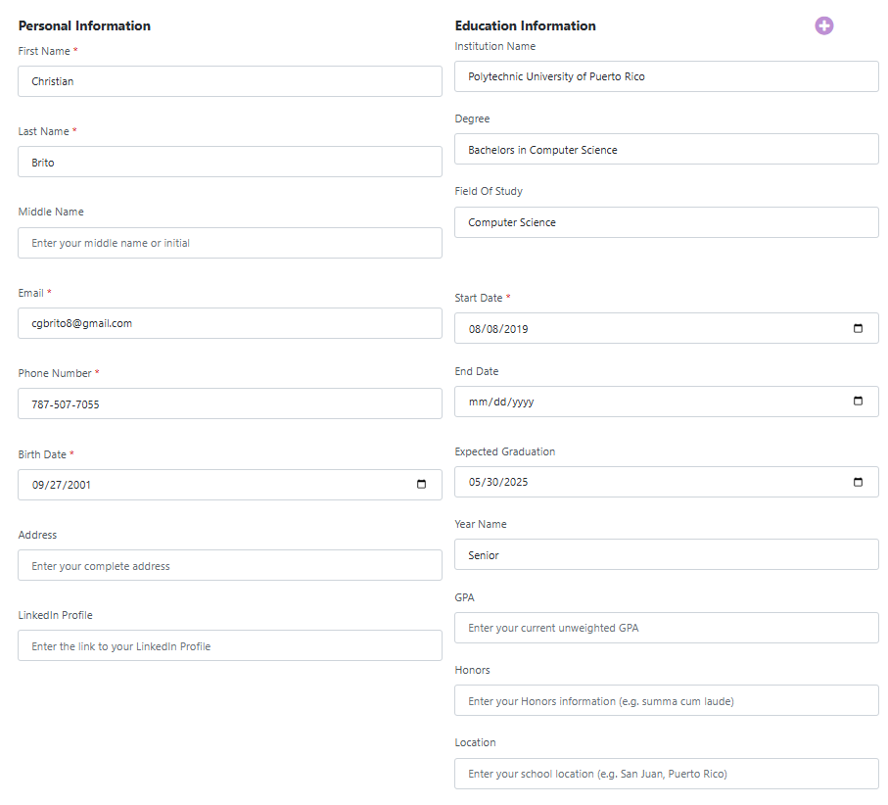

Figure 4: Test Result for test S1

Due to current limitations in the OutSystems platform, we are unable to create new users currently. OutSystems imposes a cap on the number of users that can be created. Until the restriction is lifted or additional user capacity is made available, no new user accounts can be added.

Figure 5: Test Result for test S2

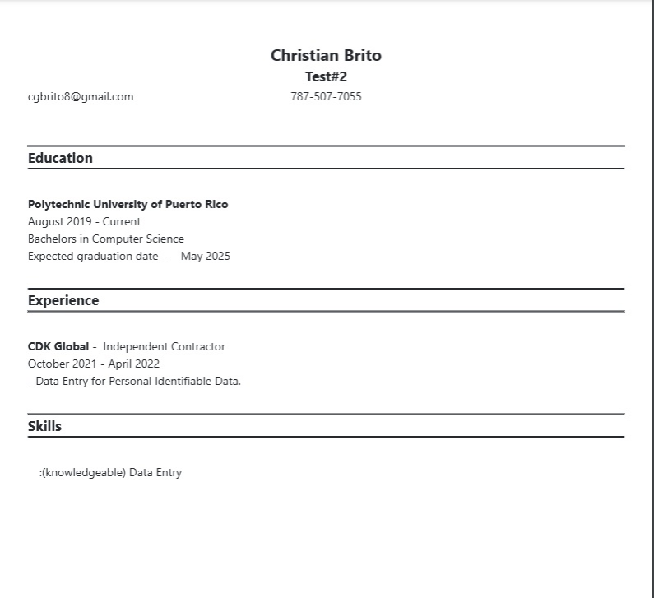

Figure 6: Test Result for test S3

Currently, we have one format working, which is functioning as expected. However, due to the current constraints within the system and resource limitations, we are focusing on stabilizing and optimizing this existing format before introducing additional ones. This approach ensures consistent performance and allows us to address any issues effectively before expanding further.

Figure 7: Test Result for test S4