Coral S. Schmidt #148830

To conduct the hypothesis test and construct the confidence interval for the weight of Gain detergent boxes, let us assume the following:

- Labeled weight of Gain detergent boxes: 500 grams

- Sample of 8 Gain detergent boxes:

- Sample weights (in grams): 498, 502, 503, 495, 499, 501, 497, 500

Calculate the sample mean and sample standard deviation:

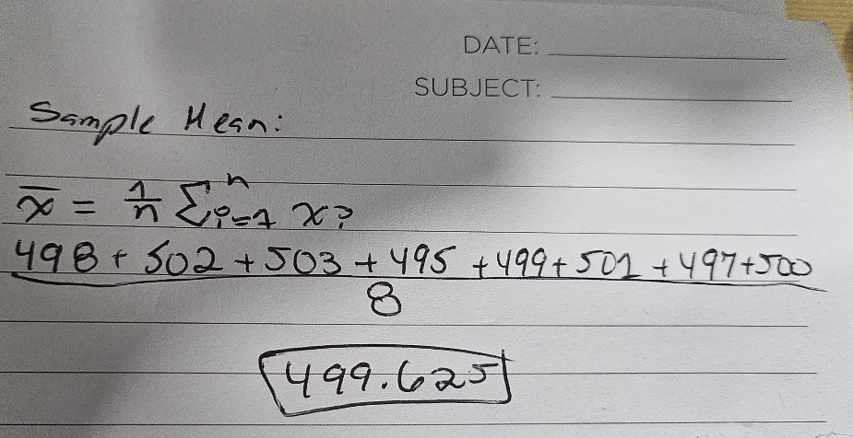Sample Mean (x̄):

Sample Standard Deviation (s):

The hypothesis test:

- Null Hypothesis (H0): The mean weight of Gain detergent boxes equals 500 grams.

- Alternative Hypothesis (H1): The mean weight of Gain detergent boxes is not equal to 500 grams.

- Significance Level (α): 0.01

Calculate the test statistic and p-value for the hypothesis test using the sample mean, standard deviation, and significance level. We then compare the p-value to the significance level to determine whether to reject the null hypothesis.

Additionally, we can construct a confidence interval using the sample mean and standard deviation to estimate the accurate mean weight of Gain detergent boxes with a certain level of confidence. Let us proceed with these calculations.

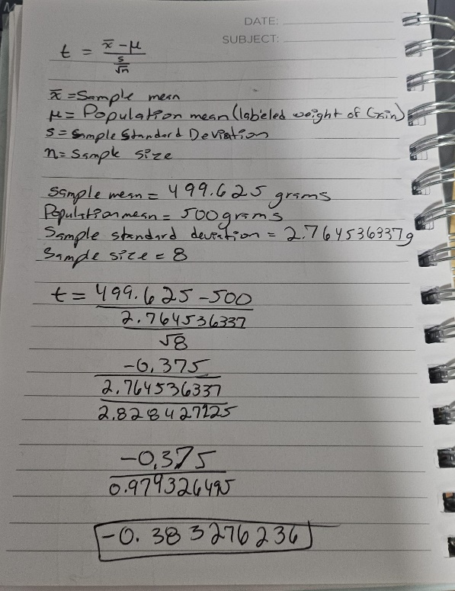First, let us calculate the test statistic (t-statistic) for the hypothesis test:

Next, we need to find the degrees of freedom (\( df \)) for the t-distribution, which is \( n - 1 = 8 - 1 = 7 \).

Using a t-table or statistical software, we can find the critical t-value for a two-tailed test with a significance level (\( α \)) of 0.01 and \( df = 7 \).

The critical t-value is approximately ±2.997 for a significance level of 0.01 and 7 degrees of freedom.

Now, we can calculate the p-value associated with the test statistic. We find the area under the t-distribution curve beyond the absolute value of the test statistic (0.383276236) with 7 degrees of freedom.

Once we have the p-value, we compare it to the significance level (0.01) to decide whether to accept the null hypothesis.

Additionally, we can construct a confidence interval to estimate the true mean weight of Gain detergent boxes with a certain level of confidence, using the sample mean and standard deviation. We can calculate the margin of error and then determine the confidence interval using the formula:

Confidence Interval = (*X - M*argin of Error, x +Margin of Error)

Let us proceed with these calculations.

Given the t-statistic of approximately -0.383 and the critical t-value of ±2.997 for a significance level of 0.01 and 7 degrees of freedom, we compare the absolute value of the t-statistic to the critical t-value to determine the p-value.

Since the absolute value of the t-statistic (0.383) is less than the critical t-value (2.997), the corresponding p-value is more significant than the significance level of 0.01. Therefore, we fail to reject the null hypothesis.

Consequently, there is insufficient evidence to conclude that the mean weight of Gain detergent boxes differs from 500 grams.

For the construction of a 99% confidence interval, first calculate the margin of error using the formula:

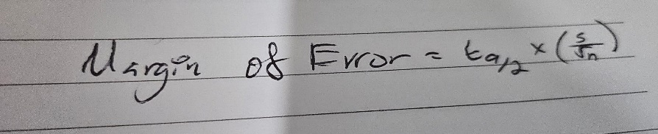

Compute the margin of error using the critical t-value for a 99% confidence level (approximately ±2.997), the sample standard deviation, and the sample size.

Then, construct the confidence interval using the sample mean and the margin of error. This interval estimates the range within which we expect the accurate mean weight of Gain detergent boxes to lie with 99% confidence.

The margin of error and constructing the confidence interval.

To compute the margin of error for a 99% confidence interval, we use the formula:

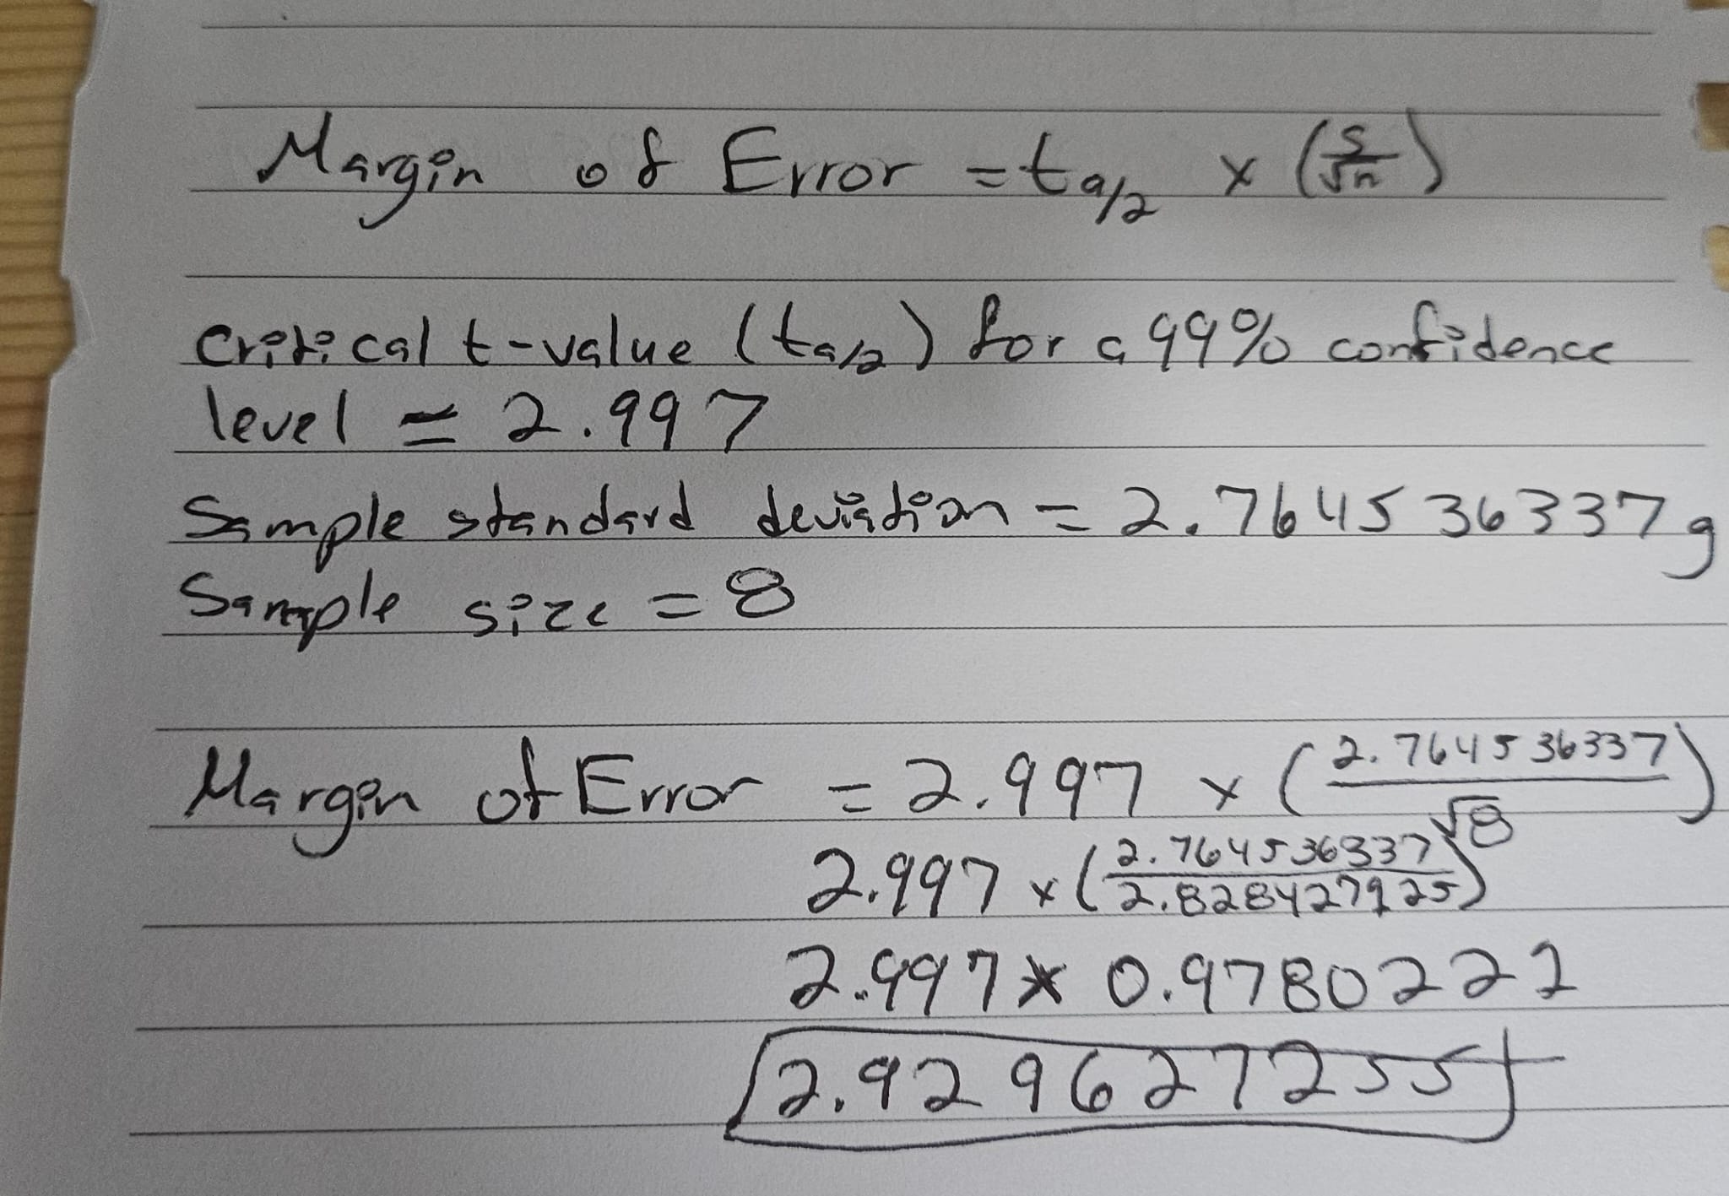

The 99% confidence interval using the sample mean and the margin of error:

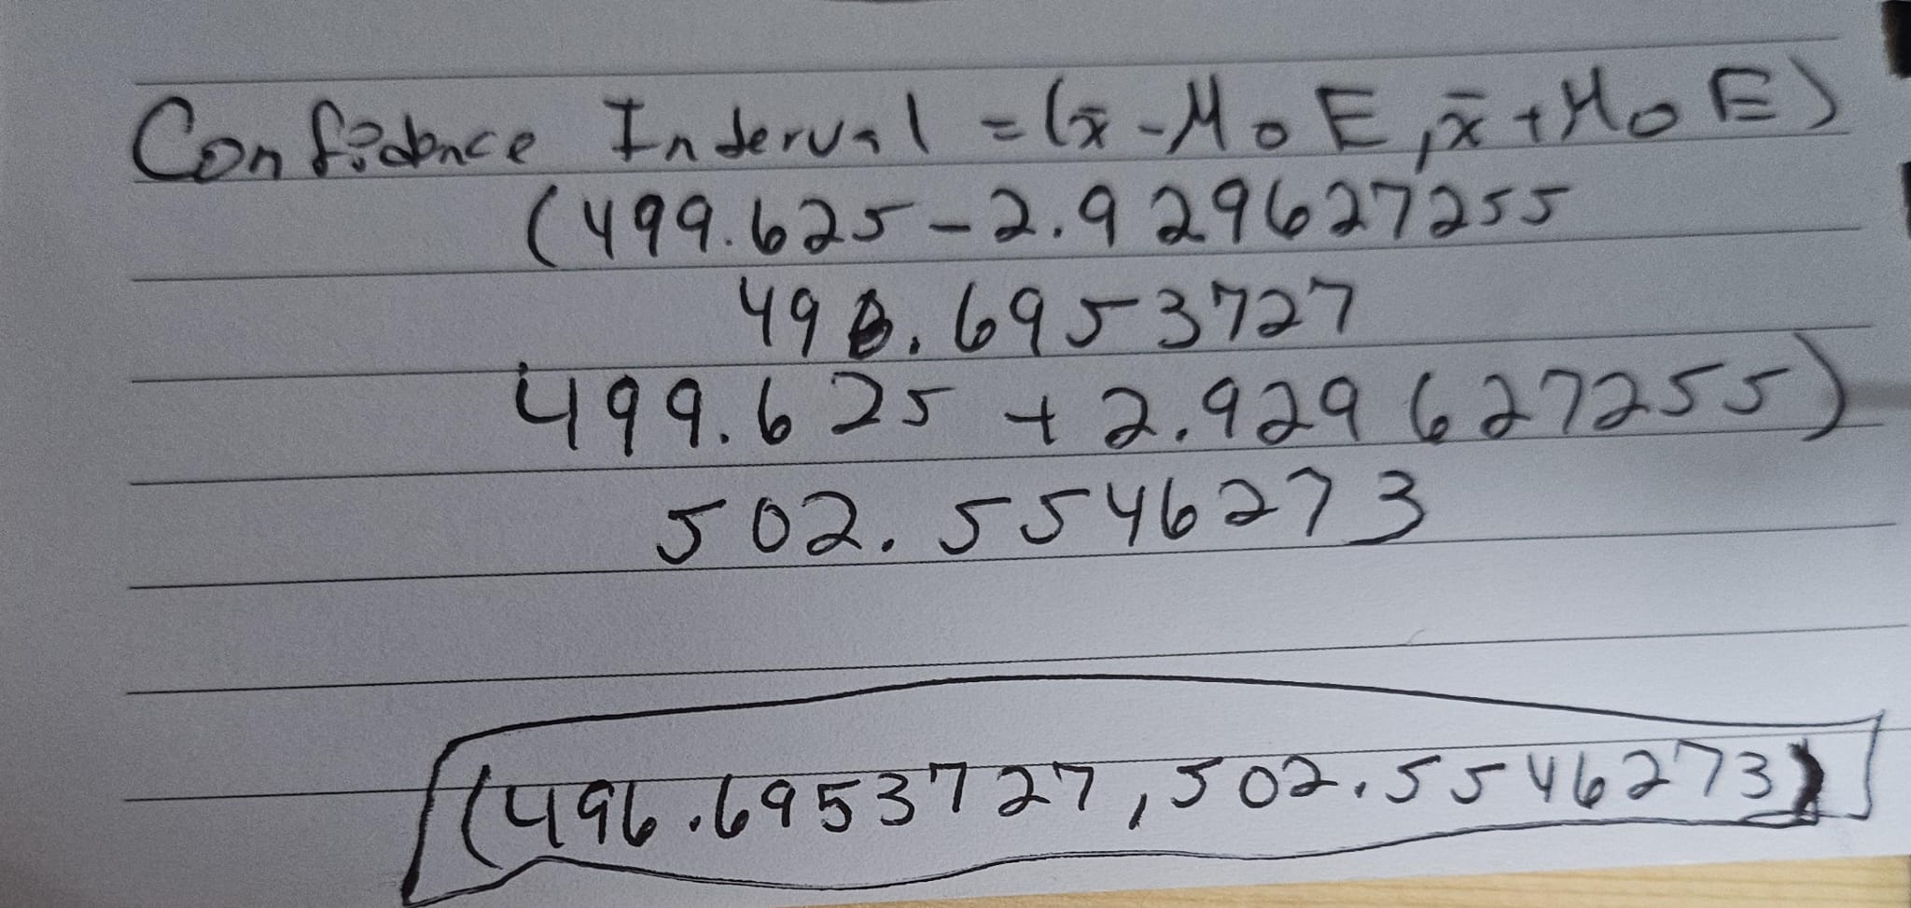Therefore, I can be 99% confident that the actual mean weight of Gain detergent boxes lies within the interval of approximately 496.70 grams to 502.55 grams.