Coral S. Schmidt Montilla #148830

To apply the test of hypothesis and to compute the confidence level, P – value, and the sample size lets vary the confidence level and the accuracy of the textbook example of the mean bonding strength of a lithium aluminum alloy (example 8 - 5, page 264)

Remember that in the textbook example the:

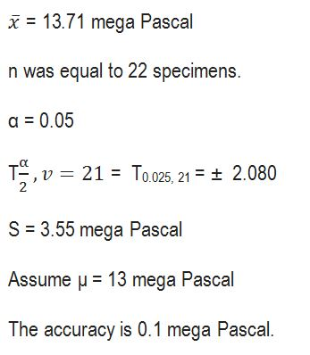  
Questions:

If you change the alpha from 0.05 to an alpha of 0.01 the critical T use in the hypothesis testing (from the table) is +2.831?

a. True



b. False

The experimental T in the test of hypothesis is 0.938?

a. True



b. False

The null hypothesis is rejected?

a. True

b. False

