Coral Schmidt Montilla #148830

This problem is about the mathematical achievement test scores and final calculus grades for engineering students. The Mathematics Achievement test was taken before the Calculus course.

The data supplied in the problem is:

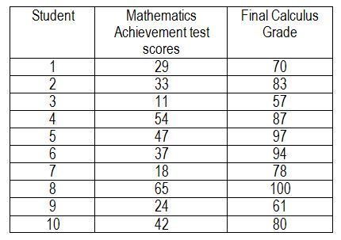

Questions:

The independent and dependent variables are mathematics achievement test scores and final calculus grade respectively?

True



False

The Simple Linear Regression Line is = 0.73X -39.48?



True

False



The Correlation Coefficient and the Coefficient of Determination is respectively 0.83 and 0.68?

True

False



|  |  |  |  |  |
| --- | --- | --- | --- | --- |
| Regression Statistics | | | | |
| Multiple R | | | 0.82651 | |
| R Square | | | 0.683104 | |
| Adjusted R Square | | | 0.643492 | |
| Standard Error | | | 8.748387 | |
| Observations | | | 10 | |
| Regression Statistics | | | | | | | |
|  | df | SS | | MS | | F | Significance F |
| Regression | 1 | 1319.826 | | 1319.826 | | 17.2449 | 0.003197 |
| Residual | 8 | 612.2742 | | 76.53428 | |  |  |
| Total | 9 | 1932.1 | |  | |  |  |

