Coral S. Schmidt Montilla #148830

To demonstrate the Central Limit Theorem, throw 5 times a dice and compute the average of the 5 results. Repeat this procedure 100 times, always recording the result obtained. Note that some results will have decimal numbers. Construct a histogram with these 100 results. See Module 3, lesson 4 to construct a Histogram.

Dice used D10:

Histogram:   
 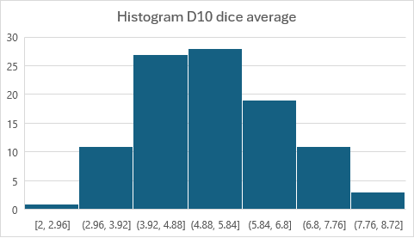

1. Does the shape of the constructed histogram resemble the uniform distribution or the normal distribution?

The histogram resembles normal distribution.

1. Why does this exercise demonstrate the Central Limit Theorem?

This exercise serves as a practical demonstration of the Central Limit Theorem. It shows that the distribution of sample means, which are calculated from the averages of multiple trials (each consisting of five dice throws), tends to approximate a normal distribution, regardless of the shape of the original distribution of the individual trials. The Central Limit Theorem, in essence, states that as the sample size increases, the distribution of sample means approaches a normal distribution, even if the population distribution is not normal. To put it simply, each trial in this exercise follows a discrete uniform distribution (since it is a fair d10). However, as we take more and more samples and calculate their averages, the resulting distribution of these averages becomes approximately normal, illustrating the step-by-step process of how the Central Limit Theorem works.