Introduction

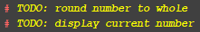
The aim of this assignment was for a two-person team to co-create an application that was capable of working as a ‘To-do’ list manager. This application had many requirements for its function. These included being able to create the list, add to it, modify its contents whenever necessary, and delete any unneeded items from this list. These basic functions are necessary for the application to function by our requirements. Similarly, there are additional, ease of use and organisational features to be added to the system. These involve giving the details of the reminder such as a start date, a due date, a priority count and a reminder status to allow users to keep active track of how longs left before they have to be completed and how far they have got with it.

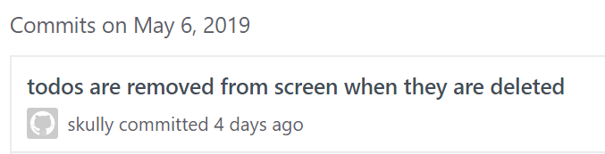
This application had to be built using python so we used GitHub as a way to allow us both to work on the same code in an organised manner, meaning we could upload and keep track of our changes as we went and rollback to a prior version if desperately required. Similarly, by doing this we could leave each other our own in-build todo notes to allow us both to keep track of what had been done and what needed to be done.

As you can see from the screenshots, we also left notes in the GitHub to show when changes were added and what was edited in each change. This allowed us further insight into what was being done at what time and what was left for us to do as we could see what either person had finished when they last opened up the code.

The code
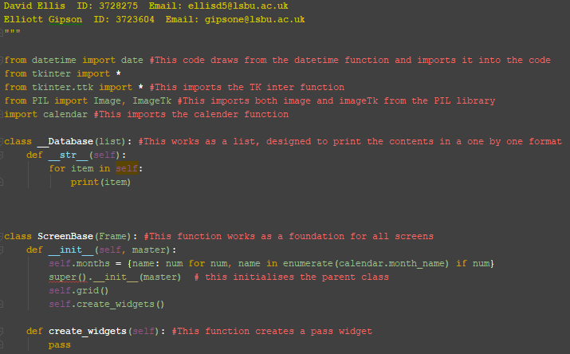
This is the beginning of the code. It is where importable functions are called upon to bring all the necessary libraries into the code structure. By calling these in it allows us to amplify what would normally be done in code and lets us use further functions without code. For this project, we used the calendar function and the Tkinter function so that we can use dates and develop a suitable graphical user interface (GUI) for our project.

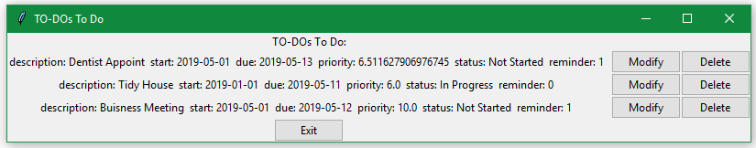
Next, we created 2 classes, Screen base, and database. These classes are used to define segments of our code and allow us to call upon them further down without having to redefine them uniquely every time we required them. By doing this, it makes our code far more efficient and keeps the overall project more organised and structured. ScreenBase is for setting the stage of the GUI and allowing a platform to be made in python where further code can then build itself onto this to give us a visual representation. This function creates a grid structure for us to then use later on to help properly position our different segments of code & properly align widgets such as buttons and text. This then calls the create_widget function to create them. Database is where all the ToDo objects are held while the program is running. The create widget function does nothing at this stage as it is intended to be overwritten by child classes
.
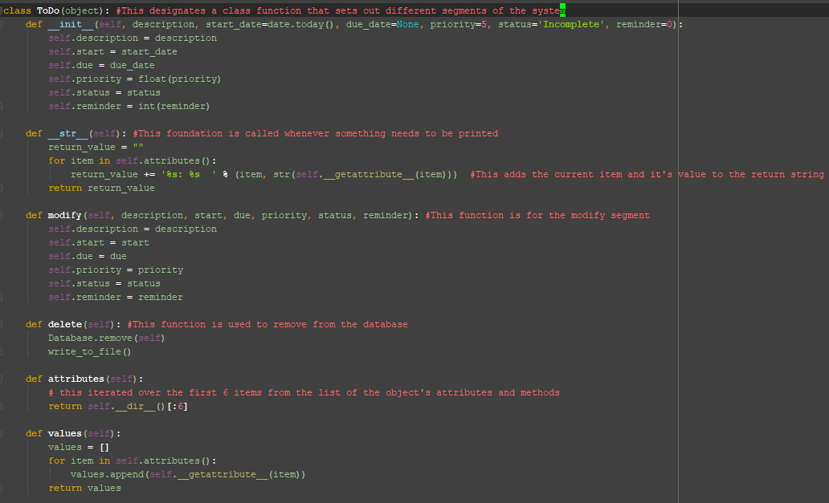
The ToDo class is used to represent each todo that is made. This holds all the attributes of a todo with methods to carry out tasks directly related to an instance of ToDo. The __init__ method is used to initialise the object and will be called when the class is called.

Def modify is used to define the parameter for a modify function. It lays out the different segments that can be added to or modified within the code and in our GUI. Def delete is similar in that it is called to allow us to remove from the database our specified item before rewriting this change to the database to save our changes. Def attributes is used to iterate over the first 6 items in a list to show all attributes connected to an object. Def values is used to create a list known as values, which is then used to search the above attributes function and append and return specified attributes.
This segment of the code is used for the main menu screen of the program. This class is where the menu segment of the GUI is held and this class is called upon when the code is launched. By doing this we instantly have the main menu in the display for the user to search through and then route their way to further functions held within the code. The __init__ function is used to get the content from the core file & if no content is found, it will continue to the next code.

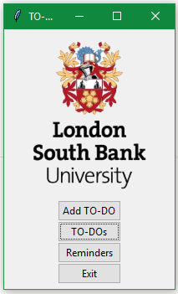
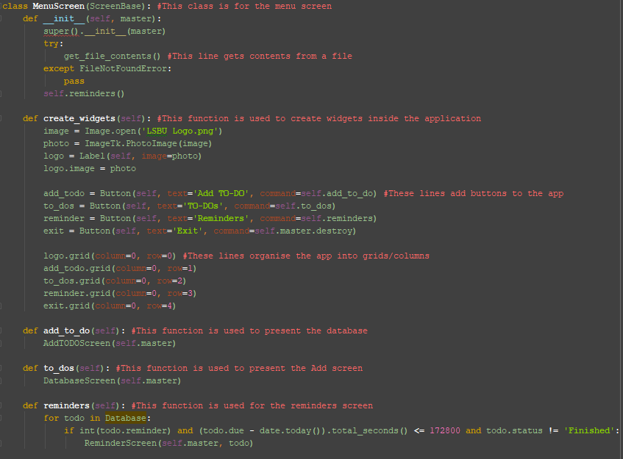
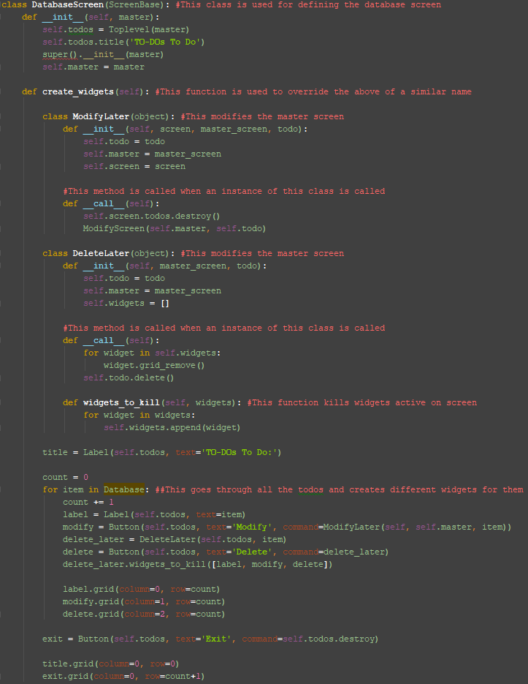
Unlike the prior class, create_widgets has a few functions here. It is used to open a LSBU logo, and present it in the GUI as well as a label this logo and then begins to create buttons for the user to interface with. These buttons are; Add to-do, to-dos, and an exit button respectively. The code then places these buttons into a grid format as created at the start of the code. This gives them designated places on our GUI. At the end of this code, Def to_dos and Def add_to_do are both used to call functions that will be shown further in this document and are classes that carry out the entailed functions for the user. By defining these classes we can simply do as is done here and call the class instead of having the whole code be repeated every time we require it.

This segment of the code is used to present the database/ list on the screen. It has a created widget that overrides the prior one and is the main example for widgets. Similarly, it runs through the modify later and delete later functions before then activating the widget kill function that is used for us to delete a widget from our display.

The count segment iterates the database and finds every item before appending them as necessary, deleting or modifying them depending on the user input. Finally, there is a exit button, as well as its associated grid placement.

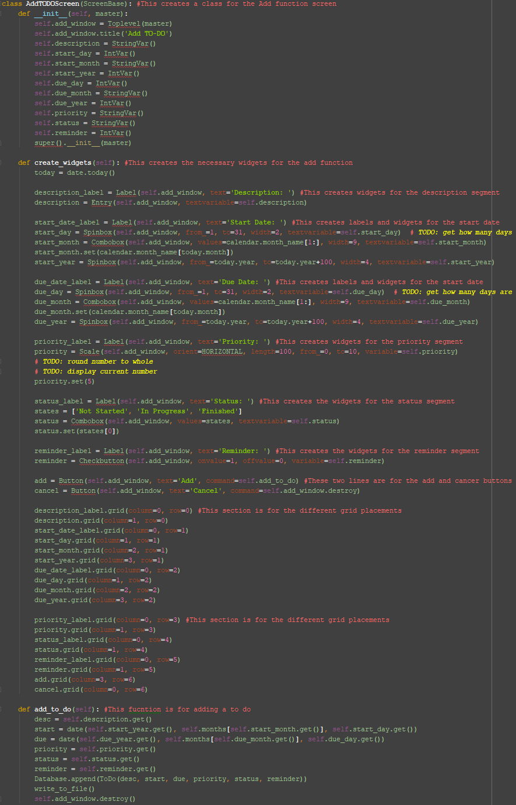
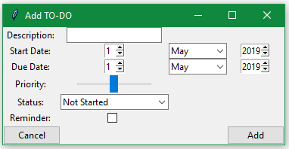

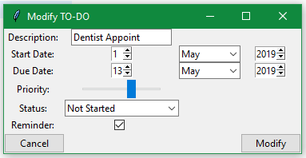

The AddToDoScreen is used for adding a todo item to the database. This segment is where users can access, describe and set parameters for new list items. They are allowed to add a start date, end date, description, current work status, as well as the priority for the item so that they know how urgent of a task it is.

Inside this area, the widgets function is used to create many widgets for this instance. These include status labels, priority labels and buttons for both add and cancel. There's are all segmented and placed onto the grid to be organised for the viewing user.

The add_to_do def is used to write the users selected inputs to the file. It does this and then destroys the window, closing the application.

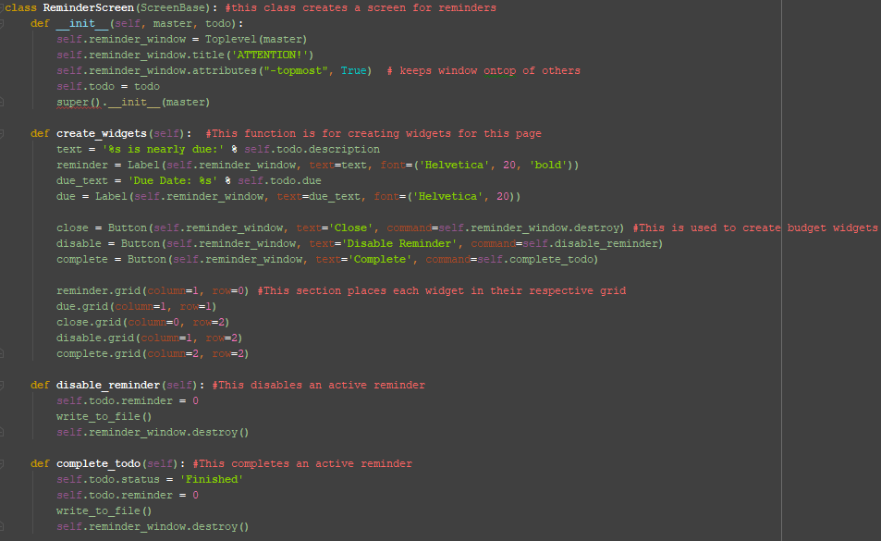
This is the reminder function, it is used to create pop-ups and notify users of deadlines for their To-do’s. You are allowed to disable a widget as well as mark them as completed to close them out and no longer see them on your active list.

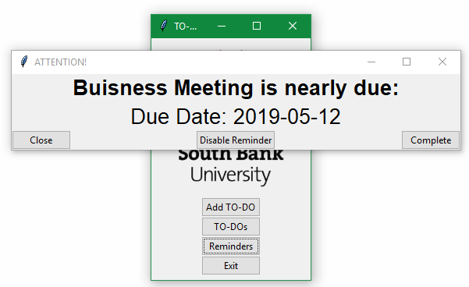
This is the ending of the code and includes a few functions used for ease of life throughout the code. These include the write function to remove the need to type it out every time.
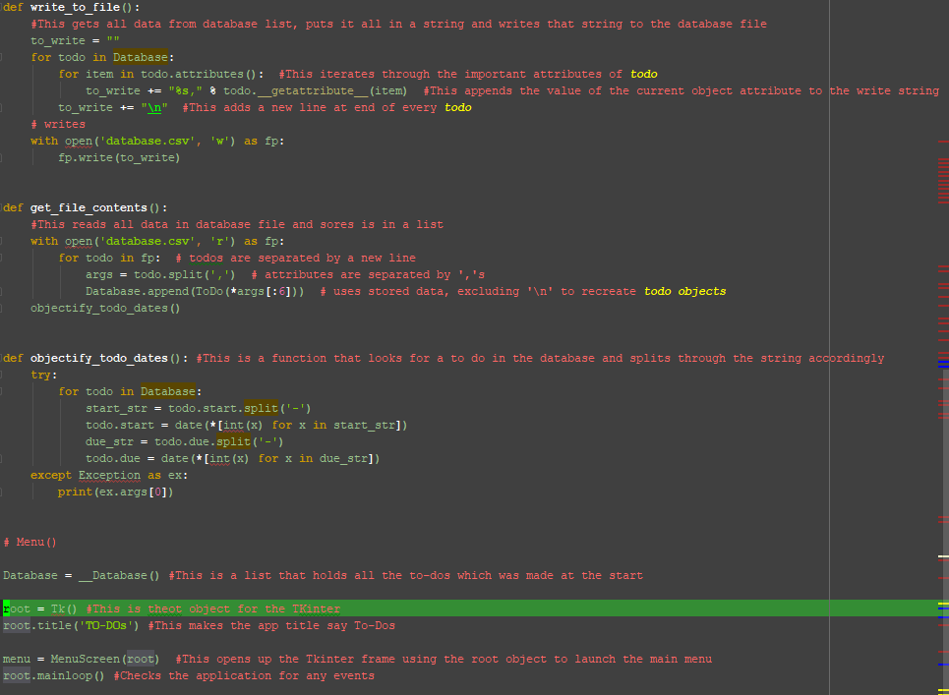
It also has a get file contents function used to quickly pull data from the selected file. The objectify function also checks the file but instead, scans and segments out the todo’s in the code.
Finally, it calls the menu and creates the original database. This then creates the objects to present a window for the app to run in.

