# ITSEC

**LAB REPORT: 2**



**BY – AMANUEL LEGESSE SOFTWARE ENG. EXT**

**ID – ATE/3628/1**

RSA Encryption and Signature Lab

Task -1 Deriving the Private Key

* I compiled the program, bn_sample.c, given in the project description. I ran “ gcc bn_sample.c -lcrypto “ to compile the program using the crypto library. The following was the result from running the program.

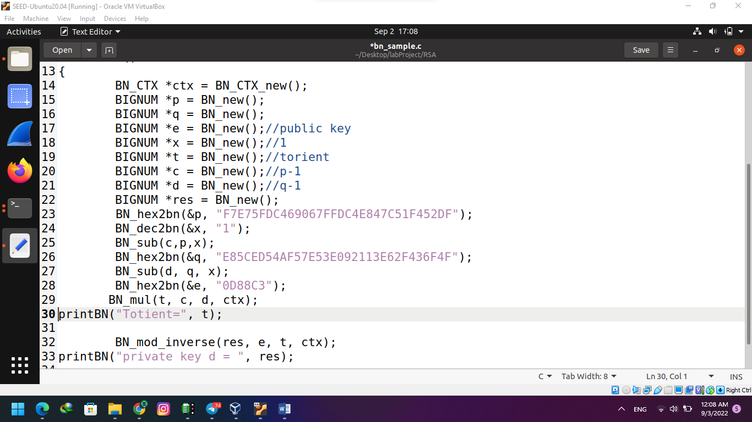

* I calculated n by multiplying p * q and To find ϕ(n) , I calculated (p – 1)*(q – 1).

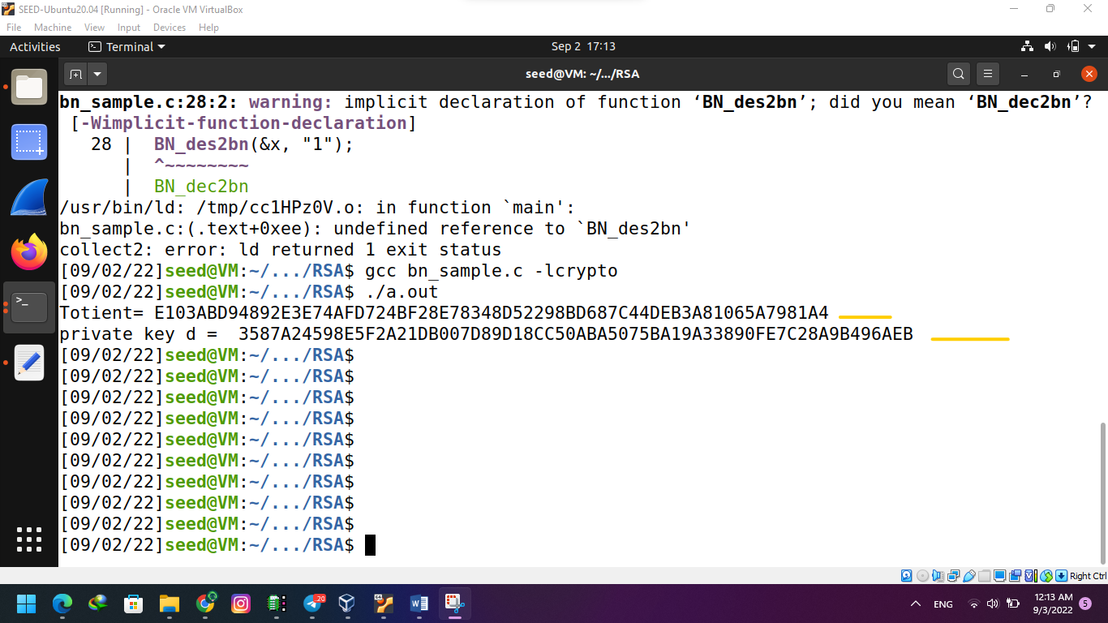

Task -2 Encrypting a Message

* In order to encrypt the message “A top secret!” first I converted it into hex string then to a BIGNUM using hex-to-bn. Using s python command

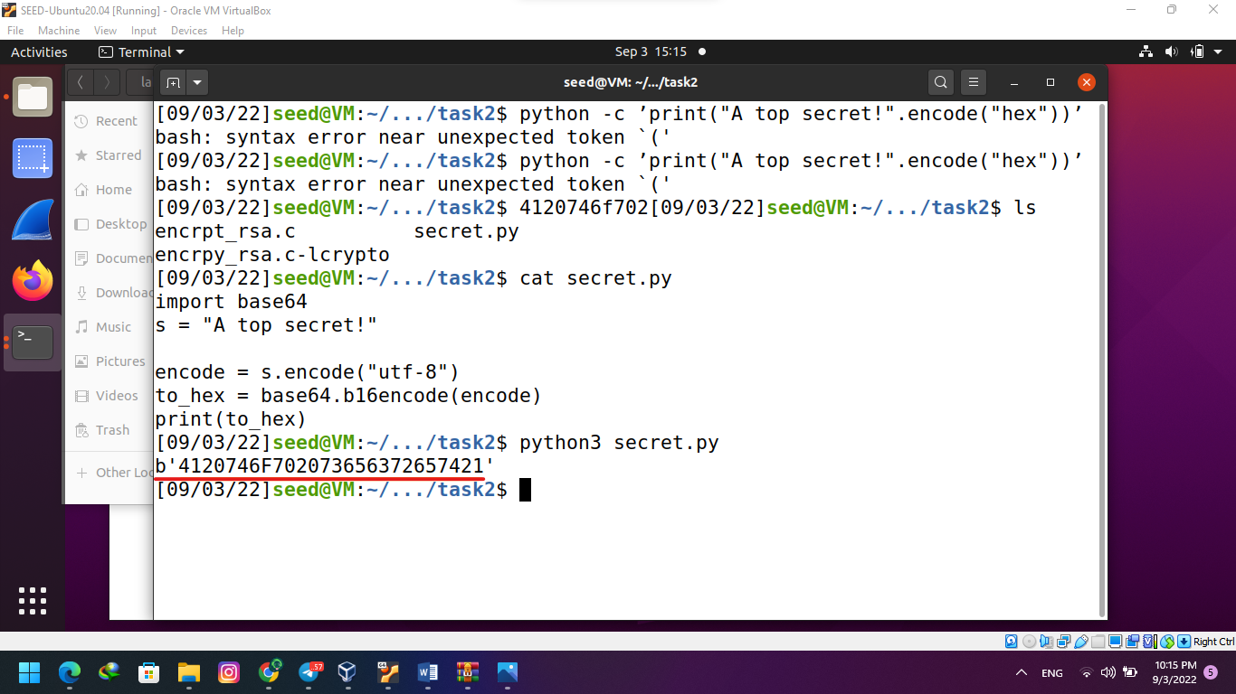

* Next I compiled the encryption to C.

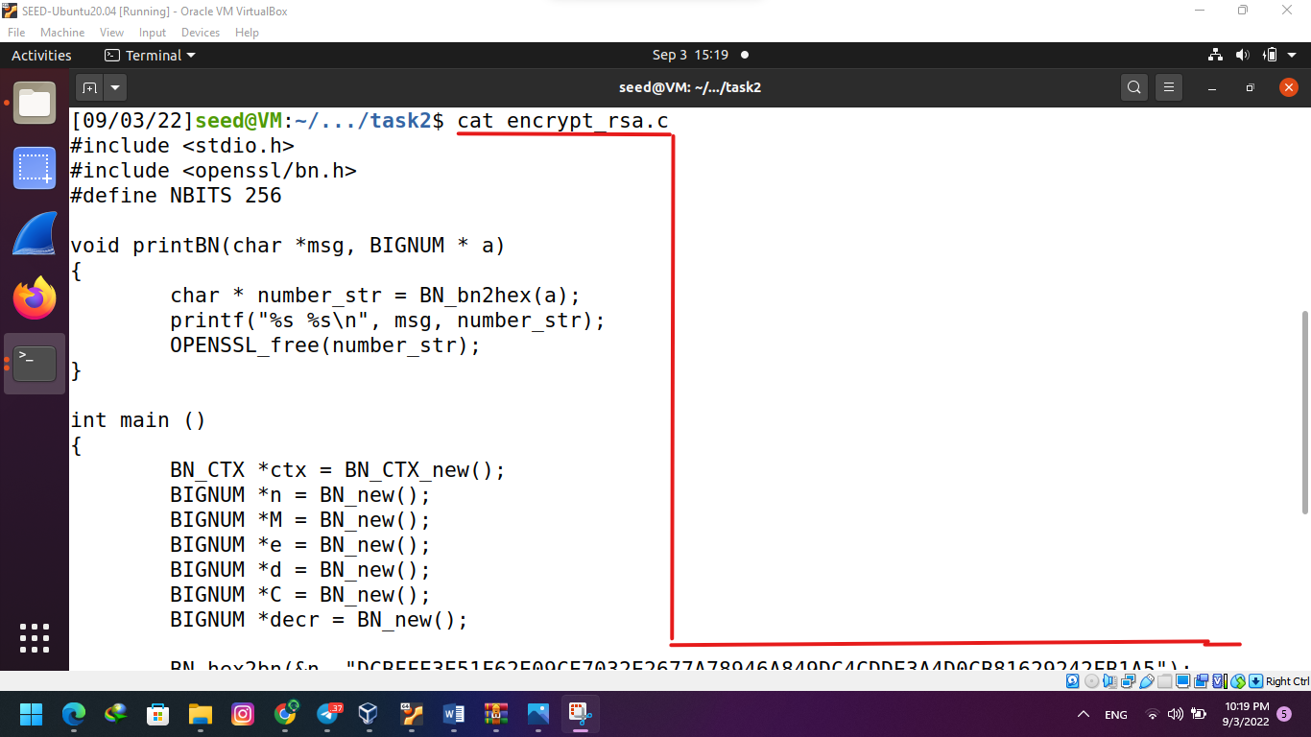

* After running the C program encrpt_rsa.c I got the encrypted and decrypted message in hexDecimal.

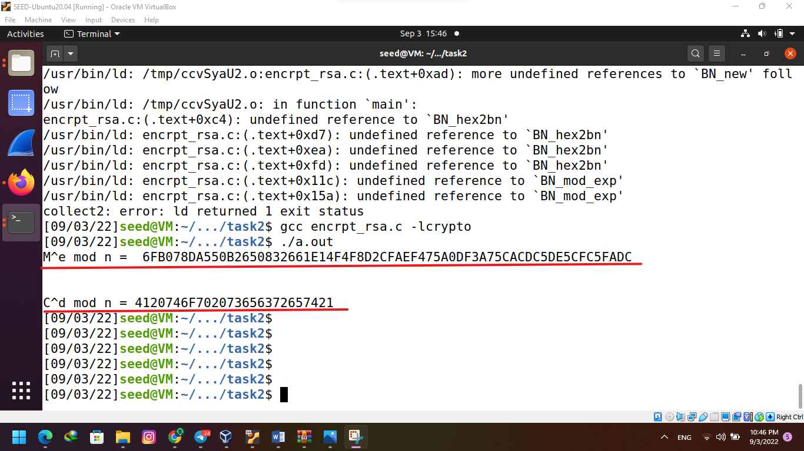

Task 3: Decrypting a Message

* Previously I already implemented the decryption equation, I used this code to decrypt the ciphertext provided by creating a decrpt_rsa.c file with an out put if the decrypted number.

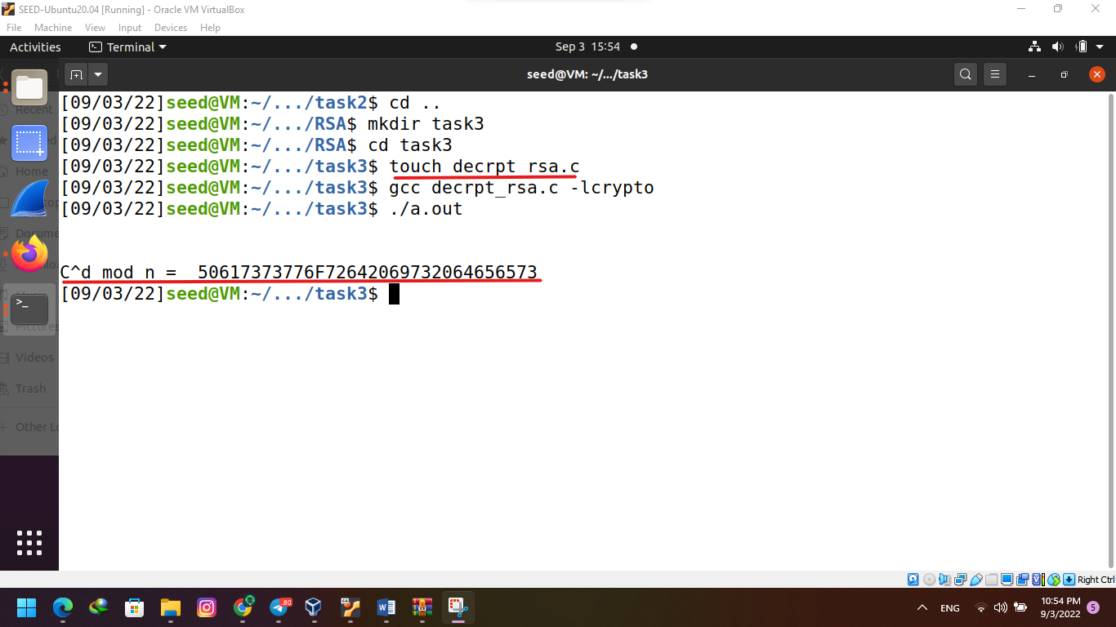

Task 4: Signing a Message

* Created 2 python scripts with “I owe you $2000” and “I owe you $3000 to sign and change it from $2000 to $300 by using a complied C program signing_rsa.c. The result is as shown below.

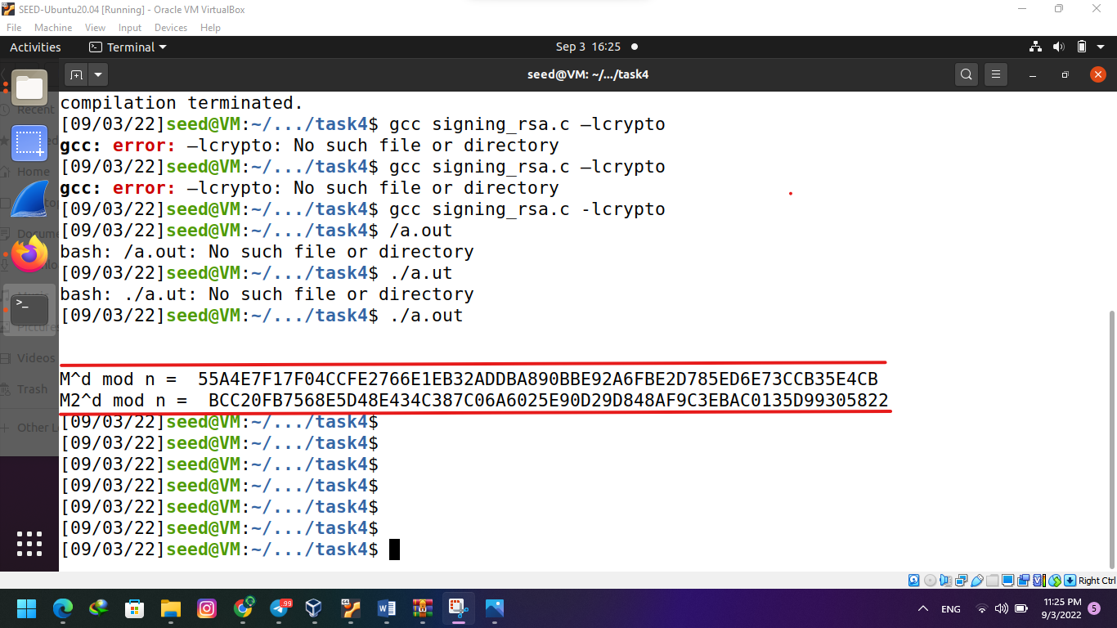

* I converted the message to hexadecimal and ran the digital signature equation on it.
* The original hexadecimal message encodings only differed by one byte but, the digital signatures of the two messages are different.

Task 5: Verifying a Signature

* To verify that a signature is the correct message, I used the following formula to get the hexadecimal representation of the message: Signature^e mod n. My program returned the hex string.

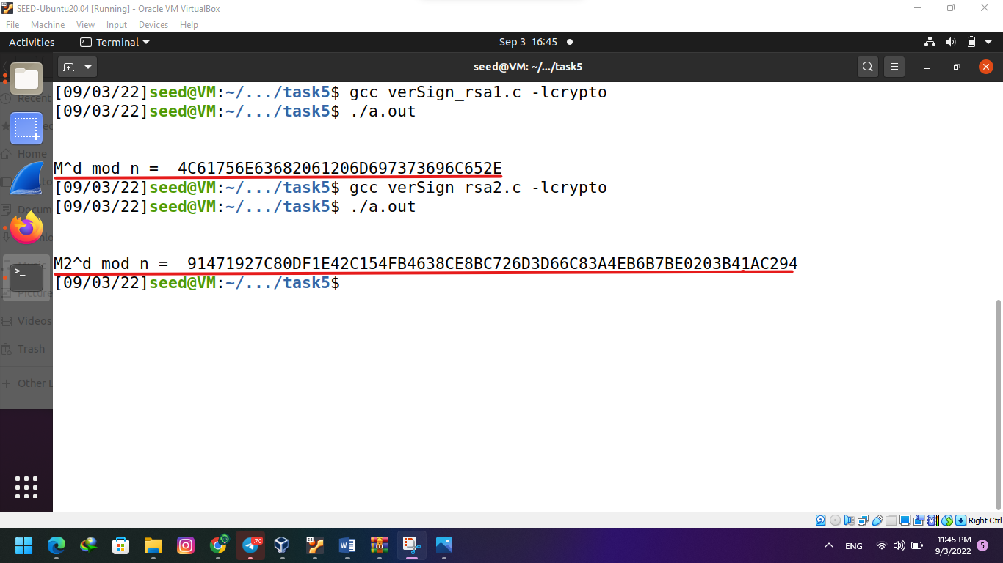

* After I compiled the C program receiving the first output I modified the signature from 2F to 3F and ran the program again. I got the second hex string displayed above.