**Fitness Calculator User Manual**

On Startup:

1. Startup Screen

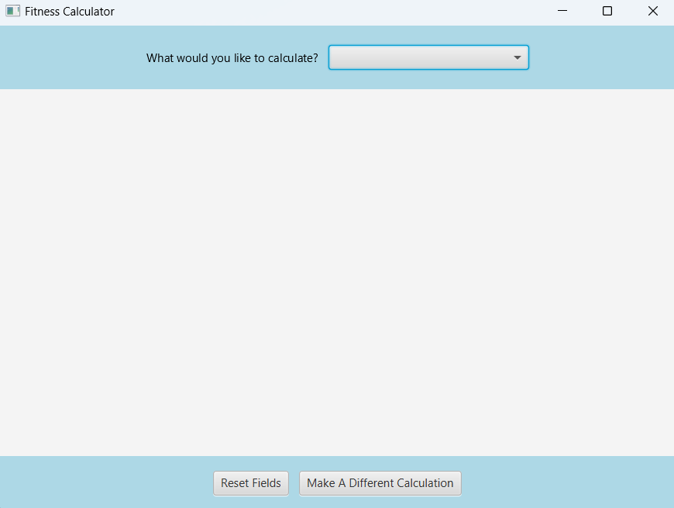

When opening the Fitness Calculator, the user will be prompted to select which variable they are looking to calculate.

There are also two buttons on the bottom of the screen: “Reset Fields” and “Make a Different Calculation”. After starting the application, the buttons do not do anything, as the user has yet to chose what variable they would like to calculate. Once a query is chosen, these buttons can be used. The function of these buttons will be discussed later.

1. Calculation Query Drop-Down Menu

The user has an option to select one of 5 different variables, as shown above.

Total Calories Burned:

1. Initial Screen

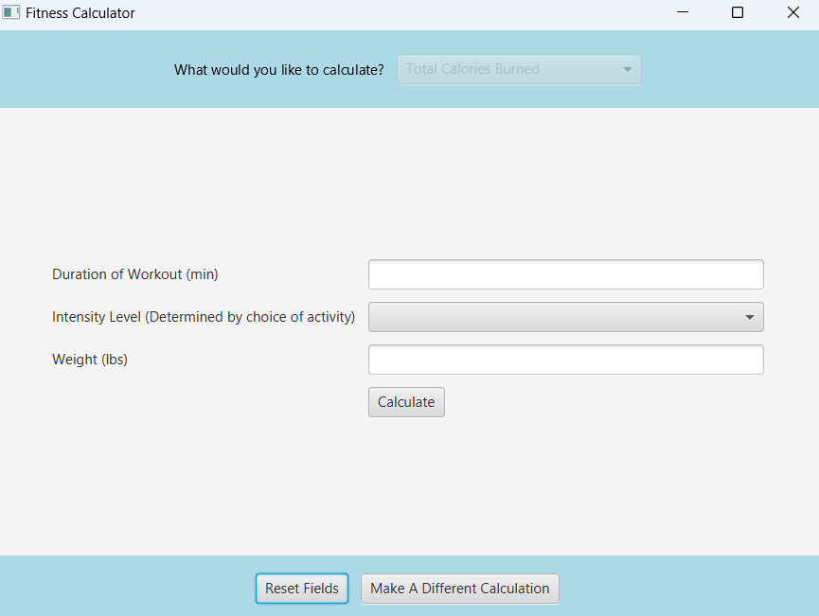

If the user selects “Total Calories Burned”, the screen will display the information needed within the calculation. In this scenario, the user needs to input the duration of the workout (min.), the intensity level of the workout, and the user’s weight (lbs.). After all fields are entered, the user can click the “Calculate” button.

1. Intensity Level Drop-Down Menu

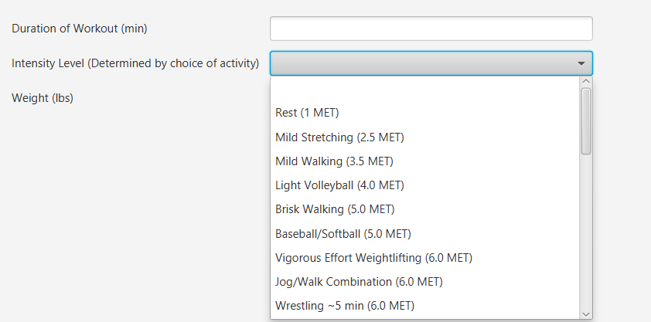

When clicking on the drop-down menu for the intensity level, the user will be met by a variety of exercises. There is a total of 31 different activities in this list. The specific exercise the user is going to complete determines the intensity, as noted by the MET value. The MET value is a numerical indication of the intensity of an activity. The list is ranked from the lowest MET value to the highest.

If the user is attempting to complete an exercise that is not on the drop-down menu, this calculation can still be completed. The user will have to select a different exercise that is similar to the intensity level of the activity the user will be completing.

**Note:** The “Intensity Level” drop-down menu is the exact same for **ALL** other calculations in which it is used.

1. Results Screen

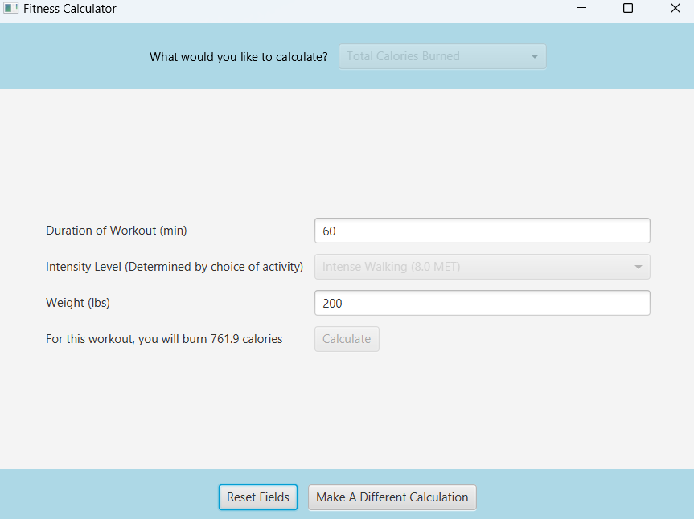

After the user inputs the required fields and clicks the “Calculate” button, the result of this calculation will be printed out.

Once this calculation is completed, the user will only be able to click one of two buttons: “Reset Fields” or “Make a Different Calculation”.

**Reset Fields:** This button will delete all user input text and remove the initial result. The user will then be able to make the same calculation with a new set of input variables.

**Make a Different Calculation:** This button will remove all variables in the center screen and allow the user to select a new calculation query at the top of the screen. The user must click this button first before choosing a new calculation query, as the calculation query drop-down menu is locked without clicking this button.

1. Error Message

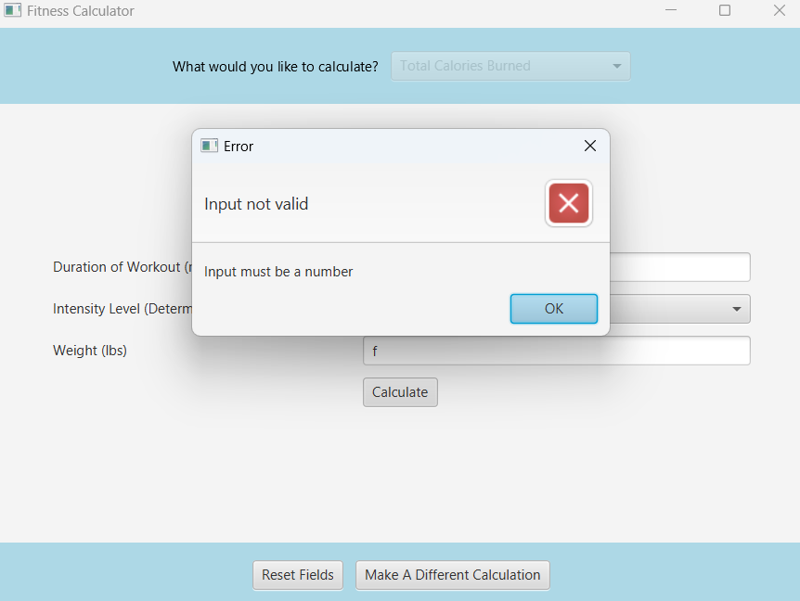

When calculating, if any non-numerical value has been entered, or if any field is left blank, an error message will appear. The user then has the option to either select “Reset Fields” or “Make a Different Calculation”.

**Note:** This error message will be displayed in **ALL** calculation queries if the entered criteria are not correct.

1. Reset Fields Example



If “Reset Fields” is clicked, then all user input text and any results will be deleted. This will allow the user to compute the same calculation with a different set of variables.

**Note:** This button works the same for **ALL** calculation queries.

1. Make a Different Calculation Example



If “Make a Different Calculation” is clicked, then all variables in the center screen will be deleted and the user will be allowed to select a different calculation query.

**Note:** This button works the same for **ALL** calculation queries.

Required Duration of Workout:

1. Initial Screen

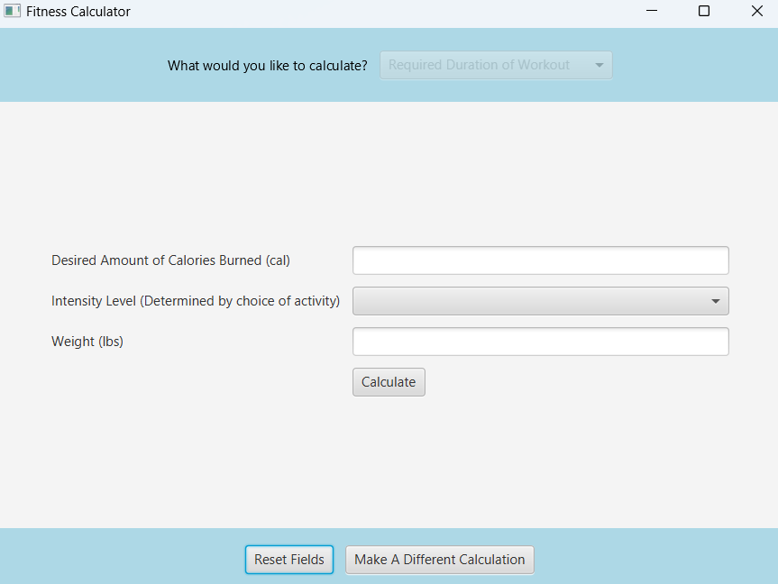

If the user selects “Required Duration of Workout”, the screen will display the information needed within the calculation. In this scenario, the user needs to input the desired number of calories burned, the intensity of the workout, and the user’s weight (lbs.). After all fields are entered, the user can click the “Calculate” button.

**Notes:** See Total Calories Burned (2) for information about the “Intensity Level” drop-down menu.

1. Results Screen

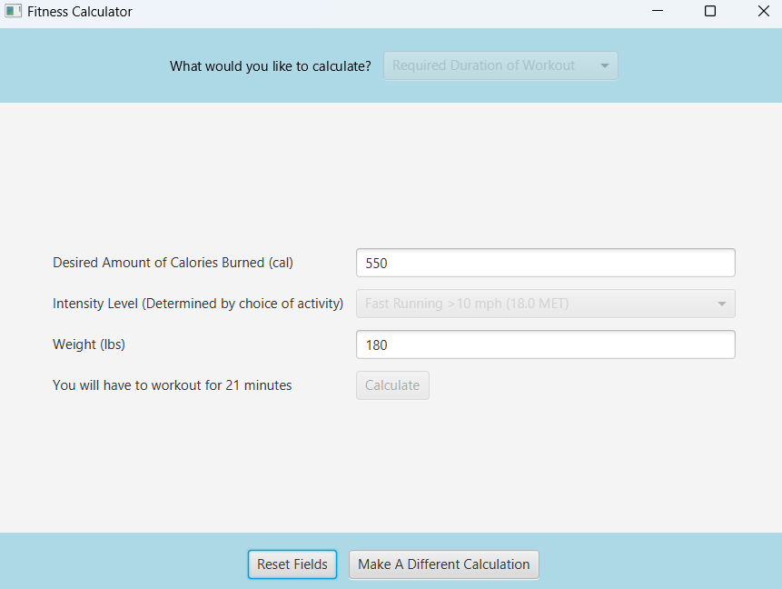

After the user inputs the required fields and clicks the “Calculate” button, the result of this calculation will be printed out.

Once this calculation is completed, the user will only be able to click one of two buttons: “Reset Fields” or “Make a Different Calculation”.

**Notes:**

* See Total Calories Burned (4) if you get an error message.
* See Total Calories Burned (5) for more information about the “Reset Fields” button.
* See Total Calories Burned (6) for more information about the “Make a Different Calculation” button.

Body Fat Percentage:

1. Initial Screen

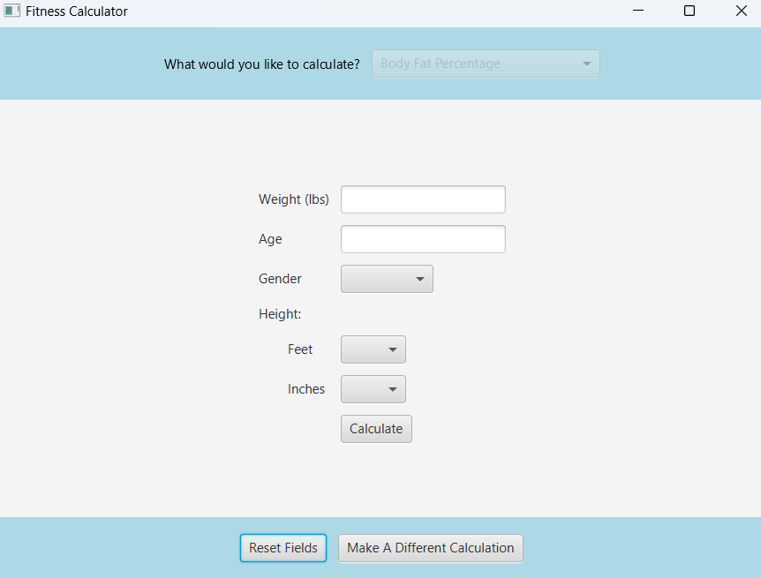

If the user selects “Body Fat Percentage”, the screen will display the information needed within the calculation. In this scenario, the user needs to input the user’s weight (lbs.), age, gender, and height (ft. and in.). After all fields are entered, the user can click the “Calculate” button.

1. 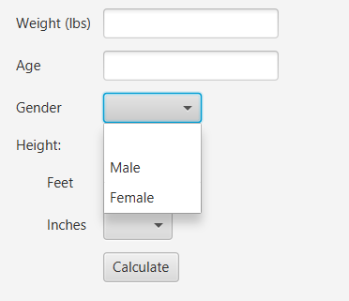Gender Drop-Down Menu

When clicking on the drop-down menu for gender, the user will be met by the two gender options. The user can select either of these options.

**Note:** The “Gender” drop-down menu is the exact same for **ALL** other calculations in which it is used.

1. 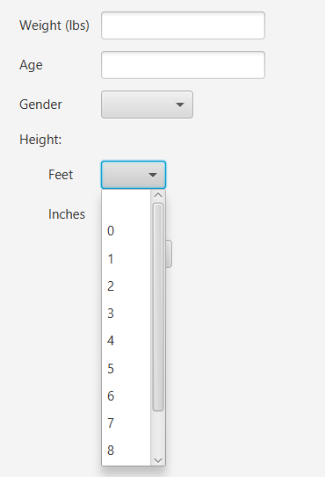Feet Drop-Down Menu

When clicking on the drop-down menu for feet, the user will be met by a list of values 0-10. The user can select whichever option resembles the value of feet in their total height.

**Note:** The “Feet” drop-down menu is the exact same for **ALL** other calculations in which it is used.

1. 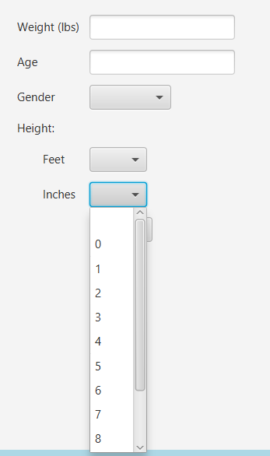Inches Drop-Down Menu

When clicking on the drop-down menu for inches, the user will be met by a list of values 0-11. The user can select whichever option more closely resembles the value of inches in their total height.

**Note:** The “Inches” drop-down menu is the exact same for **ALL** other calculations in which it is used.

1. Results Screen

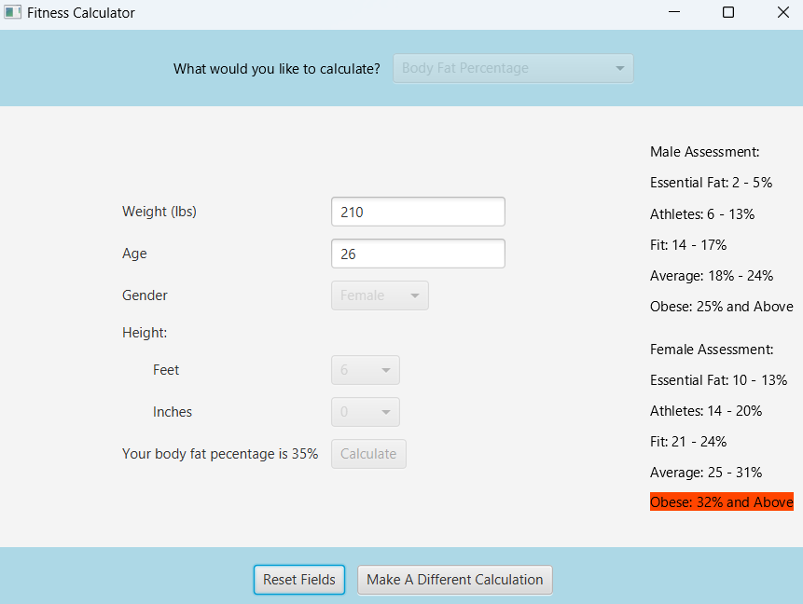

After the user inputs the required fields and clicks the “Calculate” button, the result of this calculation will be printed out. Additionally, a male and female body fat percent assessment will be printed on the right side of the screen. The category that the calculated body fat percentage falls into will automatically be highlighted. The different colors of the highlighted categories signify the following:

Green – an extremely healthy body fat percentage

Yellow – an average healthy body fat percentage

Red – a dangerously high body fat percentage

**Notes:**

* See Total Calories Burned (4) if you get an error message.
* See Total Calories Burned (5) for more information about the “Reset Fields” button.
* See Total Calories Burned (6) for more information about the “Make a Different Calculation” button.

Body Mass Index (BMI):

1. Initial Screen

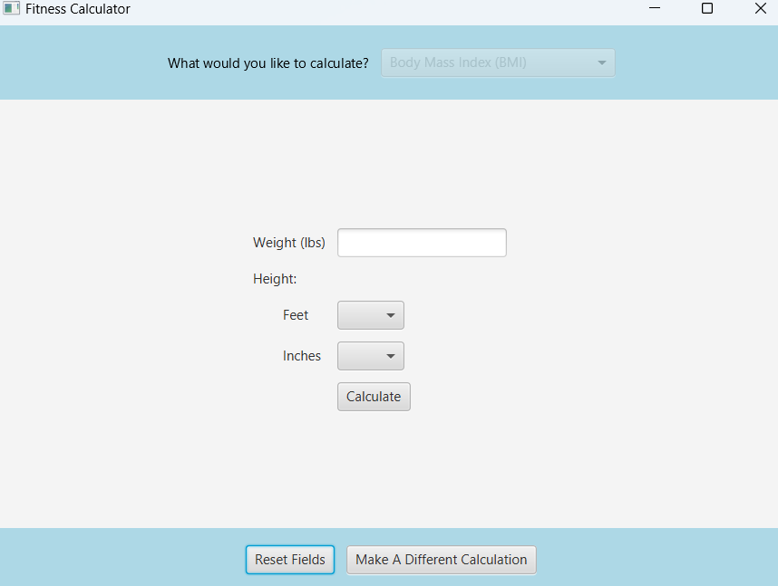

If the user selects “Body Mass Index (BMI)”, the screen will display the information needed within the calculation. In this scenario, the user needs to input the user’s weight (lbs.) and height (ft. and in.). After all fields are entered, the user can click the “Calculate” button.

**Notes:**

* See Body Fat Percentage (3) for more information about the “Feet” drop-down menu
* See Body Fat Percentage (4) for more information about the “Inches” drop-down menu

1. Results Screen

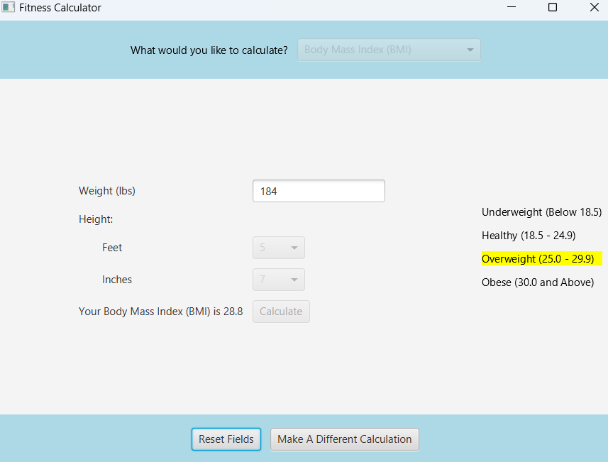

After the user inputs the required fields and clicks the “Calculate” button, the result of this calculation will be printed out. Additionally, a body mass index (BMI) assessment will be printed on the right side of the screen. The category that the calculated BMI falls into will automatically be highlighted. The different colors of the highlighted categories signify the following:

Green – a healthy BMI

Yellow – an average BMI

Red – a dangerously high or low BMI

**Notes:**

* See Total Calories Burned (4) if you get an error message.
* See Total Calories Burned (5) for more information about the “Reset Fields” button.
* See Total Calories Burned (6) for more information about the “Make a Different Calculation” button.

Basal Metabolic Rate (BMR):

1. Initial Screen

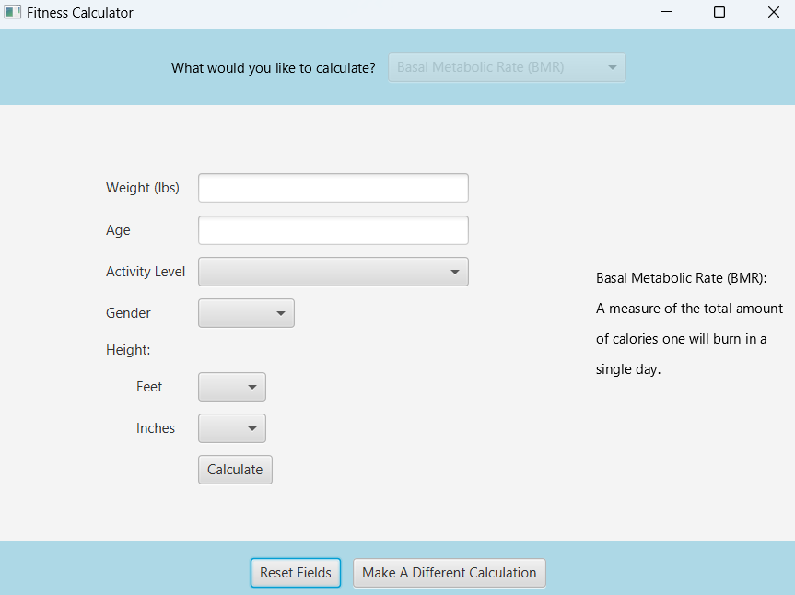

If the user selects “Basal Metabolic Rate (BMR)”, the screen will display the information needed within the calculation. In this scenario, the user needs to input the user’s weight (lbs.), age, activity level, gender, and height (ft. and in.). The definition of basal metabolic rate is also printed on the left side of the screen. After all fields are entered, the user can click the “Calculate” button.

Notes:

* See Body Fat Percentage (2) for more information about the “Gender” drop-down menu
* See Body Fat Percentage (3) for more information about the “Feet” drop-down menu
* See Body Fat Percentage (4) for more information about the “Inches” drop-down menu

1. 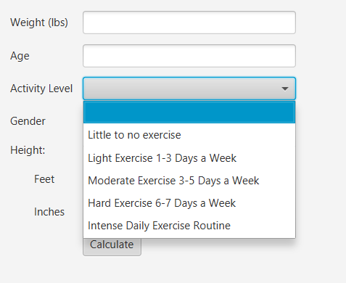Activity Level Drop-Down Menu

When clicking on the drop-down menu for activity level, the user will be met by various categories of amount of weekly exercise. The user can select whichever category relates most closely with their amount of weekly exercise.

**Note:** The “Activity Level” drop-down menu only appears in this calculation query.

1. Results Screen

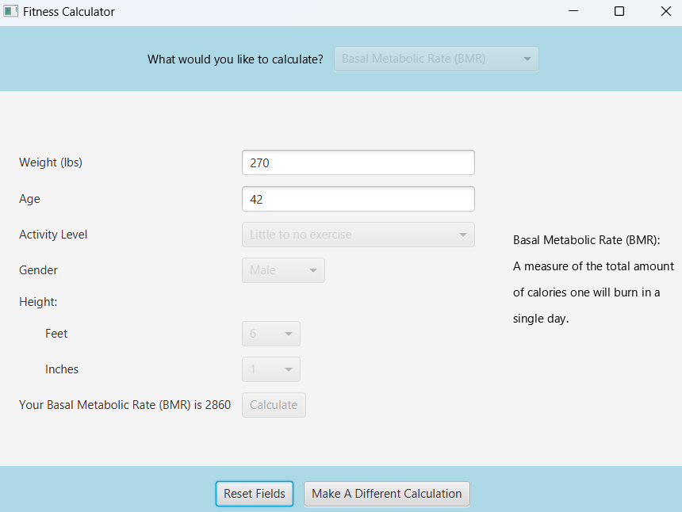

After the user inputs the required fields and clicks the “Calculate” button, the result of the calculation will be printed out. This printed value is the number of calories one will burn in a single day, as given by the definition of basal metabolic rate on the right side of the screen.

**Notes:**

* See Total Calories Burned (4) if you get an error message.
* See Total Calories Burned (5) for more information about the “Reset Fields” button.
* See Total Calories Burned (6) for more information about the “Make a Different Calculation” button.

Ending the Application:

1. How to Close the Fitness Calculator

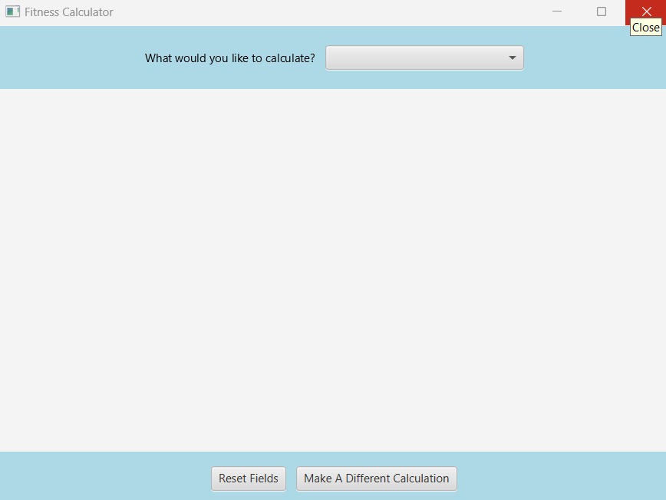

To close the Fitness Calculator, simply click on the “X” button in the top right corner of the screen. This will effectively shut down the application.