Title ddddddddfjkfjlasf

Jjfdlj水水水顶顶顶顶水水水水

Revision History
Date | Revision | Author | Description
2025-5-13 |  | 张三 | Initial draft

RESTRICTED DISTRIBUTION
The information is standard Company Confidential but due to its sensitivity it has restricted distribution and viewing within Volvo Cars.
Document Version Control
Date Issued | Version | Description | Author
2025-5-13 | V1.0 | Draft | Yang Li
2025-08-29 | V2.0 | Change | Zhong, Shengyou
Contributors
The content of this document has been authored with the combined input of the following group of key individuals.
Name | Role | Area
 | Cost Accountant | CAC
Source Documents
Title | Author | Version | Date
Document Sign-off Requirements
The following table contains the people required to sign-off and/or review this document and those that require the document for information only.
Name | Department | Responsibility
Document Classification
Classification | Company Confidential
Definition | Information is Group confidential and needs to be protected
Context | Where loss of information confidentiality would result in significant harm to the interests of the organization, financial loss, embarrassment or loss of information

Introduction
The Process Definition Document (PDD) captures the flow of a business process to be developed.
The flowchart contained within the document captures, at a high level, the business process to be automated, the target systems used within the process and any assumptions that have been taken into account.
Once agreed as the basis for the automation of the target process, the flowchart and assumptions will be used as a platform from which the automated solution will be designed.
Changes to this business process may constitute a request for change and will be subject to the agreed agility program change procedures.
Note: This document must be completed in the absence of existing process documentation that provides the level of detail required for a process to be automated. If existing process documentation is to be used instead of a new PDD the following steps should still be undertaken
- Existing process documentation reviewed to ensure it is still up to date and fully captures the current manual process
- Existing process documentation provides the same level of detail that is required for automation
- Agreed by the business as an accurate description of the manual process

Creating New work order.
- Click new work order [新建工单]
- Click Take ownership [取得所有权]
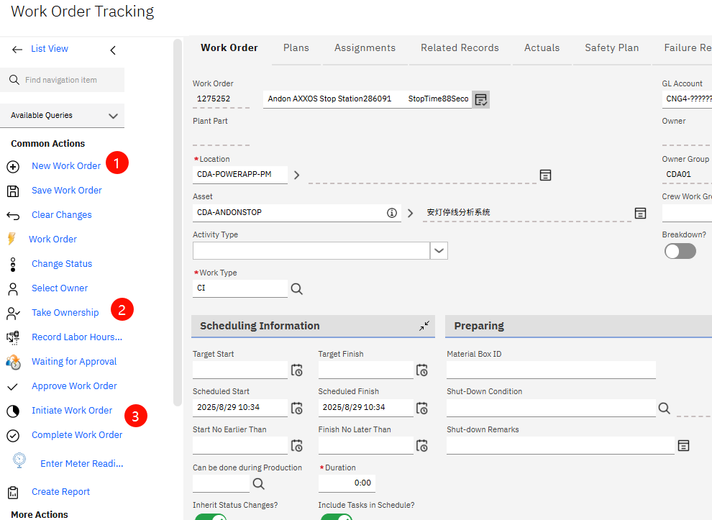
- Click Initiate order[启动工单]

Fill order information

- Work Order. Automatically generated when creating a work order.
- Fill the title of work order.
- Fill Asset code. Automatically display description after filling asset code.
- Choose the Owner group.
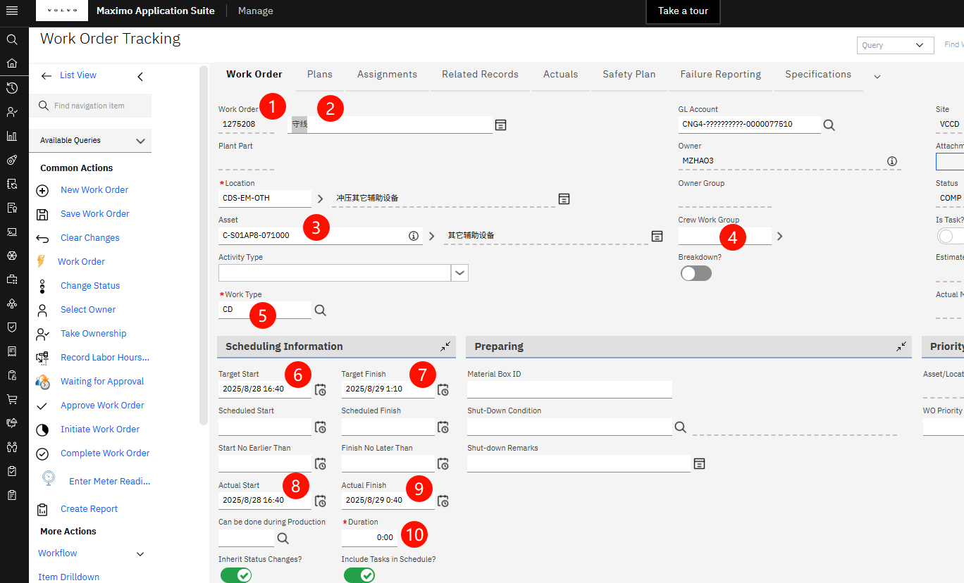
- Choose the Work Type.

End page

