VENDOR PERFORMANCE ANALYSIS

Exploratory Data Analysis Insight
Summary Statistics
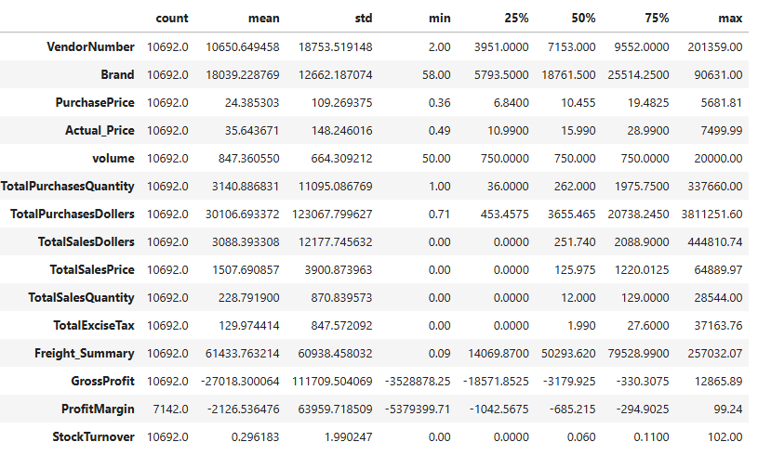

Distribution Plots for Numerical Columns

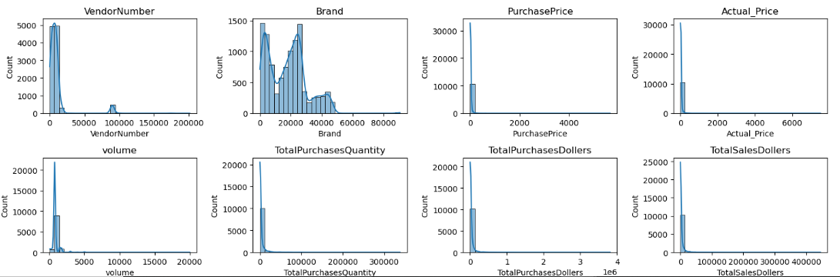

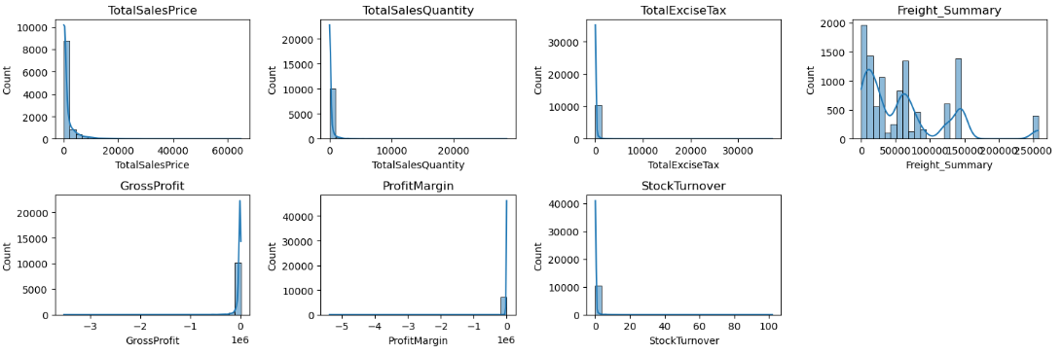

Negative & Zero Values:
1) Gross Profit: The minimum value is -3,528,878.25, indicating a significant loss. This suggests that certain products or transactions are being sold at a loss, potentially due to high procurement costs or selling prices that are lower than the purchase cost.
2) Profit Margin: The minimum value is -5,379,399.71, indicating instances where revenue is either zero or insufficient to cover costs. This suggests significant losses, potentially resulting from high operating costs, product returns, or transactions where expenses exceed generated revenue.
3) Total Sales Quantity & Sales Dollars: The minimum value is 0, indicating that some products were purchased but not sold during the analyzed period. These items may represent slow-moving, non-moving, or obsolete inventory, which could lead to increased holding costs and reduced inventory efficiency.

Outliers Indicated by High Standard Deviations:

1)Purchase & Actual Prices: The maximum values (5,681.81 and 7,499.99) are substantially higher than their respective mean values (24.39 and 35.64). This indicates a highly skewed distribution, suggesting the presence of premium or high-value products that are priced significantly above the average.

2) Freight Cost: The wide range of values, from 0.09 to 257,032.07, indicates significant variability in transaction sizes. This may reflect a combination of small individual shipments and large bulk orders, potentially highlighting variations in logistics operations or opportunities to improve shipment planning and operational efficiency.

3) Stock Turnover: The values range from 0 to 102.00, indicating substantial variation in inventory turnover. A value of 0 suggests that some products were purchased but not sold, resulting in stagnant inventory. Values greater than 1 indicate that the quantity sold exceeded the quantity purchased during the analyzed period, likely because sales were fulfilled using inventory carried over from previous stock rather than from current purchases.

Data Filtering
To enhance the reliability of the insights, we removed inconsistent data points where:
- Gross Profit ≤ 0 (to exclude transactions leading to losses).
- Profit Margin ≤ 0 (to ensure analysis focuses on profitable transactions).
- Total Sales Quantity = 0 (to eliminate inventory that was never sold).
Correlation Insights
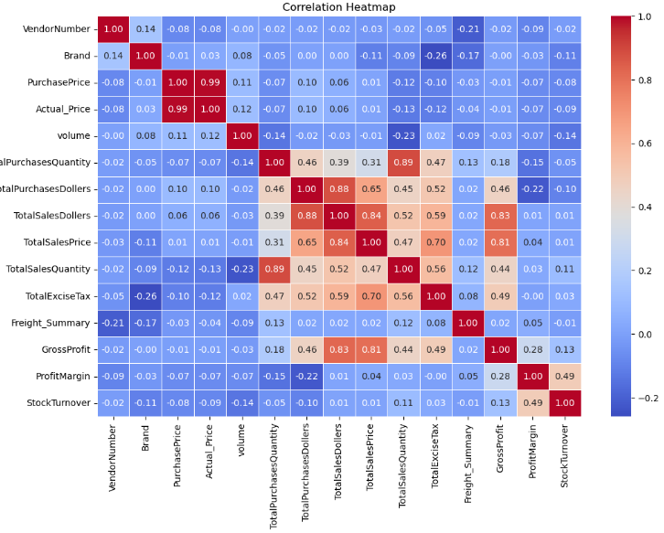
1) Purchase Price has weak correlations with TotalSales Dollars and Gross Profit, suggesting that price variations do not significantly impact sales revenue or profit.
2) Strong correlation between total purchase quantity and total sales quantity, confirming efficient inventory turnover.
3) Negative correlation between profit margin & total sales price suggests that as sales price increases, margins decrease, possibly due to competitive pricing pressures.
4) Stock Turnover has weak negative correlations with both GrossProfit and Profit Margin, indicating that faster turnover does not necessarily result in higher profitability
Research Question & Key Findings
1.Brands for Promotional or Pricing Adjustment

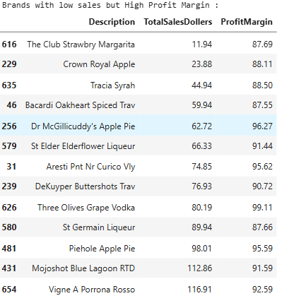

Brands exhibit lower sales but higher profit margins, which could benefit from targeted marketing, promotions, or price optimizations to increase volume without compromising profitability.
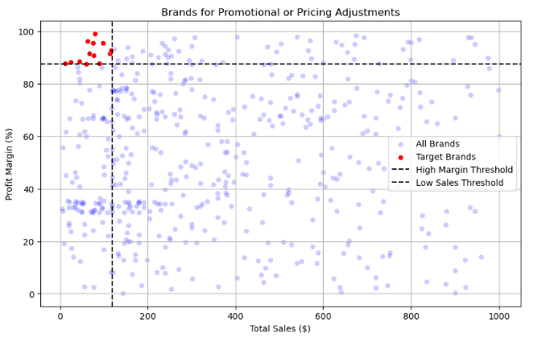

2. Top Vendors by Sales & Purchase Contribution
The top 10 vendors contribute 76.33% of total purchases, while the remaining vendors contribute only 23.67%. This over-reliance on a few vendors may introduce risks such as supply chain disruptions, indicating a need for diversification.

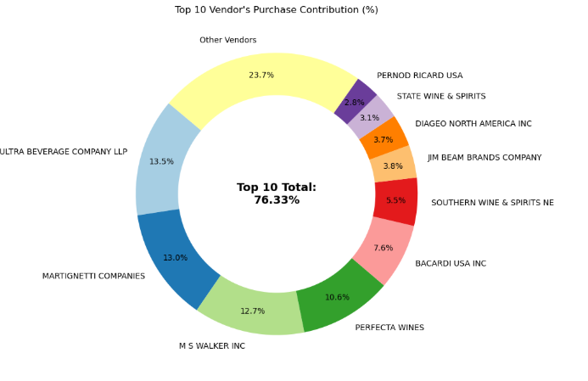

3. Impact of Bulk Purchasing on Cost Savings
Vendors buying in large quantities receive a 72% lower unit cost ($11.93 per unit vs. higher unit costs in smaller orders).
Bulk Pricing strategies encourage larger orders, increasing total sales while maintaining profitability.

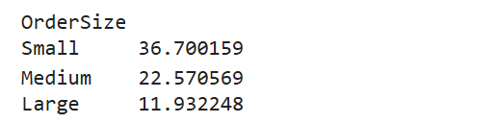

4. Profit Margin Comparison: High vs Low – Performing Vendors
Top Vendors Profit Margin (95% CI): (52.73%, 61.42%), Mean: 57.08 %
Low Vendors Profit Margin (95% CI): (46.83%, 54.49%), Mean: 50.66%
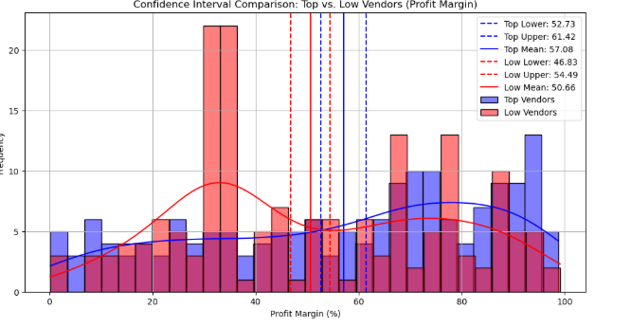
1) The estimated profit margin for top-performing vendors (95% CI: 52.73%–61.42%) appears to be higher than that of low-performing vendors (95% CI: 46.83%–54.49%). However, since the confidence intervals overlap slightly, this alone does not conclusively establish a statistically significant difference.

2) The results suggest that top-performing vendors may also achieve higher profit margins. However, a formal hypothesis test (such as an independent t-test) would be needed to determine whether the observed difference is statistically significant.

3) For High-Performing Vendors: If they aim to improve profitability, they could explore selective price adjustments, cost optimization, or bundling strategies.

4) For Low-Performing Vendors: Despite higher margins, their low sales volume might indicate a need for better marketing, competitive pricing, or improved distribution strategies.

5. Statistical Validation of Profit Margin Differences
Hypothesis Testing:
H0 (Null Hypothesis): No significant difference in profit margins between top and low-performing vendors
H1 (Alternative Hypothesis): A significant difference exists in profit margins between the two vendor groups
Result: The null hypothesis is rejected, confirming that the two groups operate under distinctly different profitability models,
Implication: High-margin vendors may benefit from better pricing strategies, while top-selling vendors could focus on cost efficiency.

Final Recommendations
- Re-evaluate pricing for low-sales, high-margin brands to boost sales volume without sacrificing profitability.
- Diversify vendor partnerships to reduce dependency on a few suppliers and mitigate supply chain risks.
- Leverage bulk purchasing advantages to maintain competitive pricing while optimizing inventory management
- Optimize slow-moving inventory by adjusting purchase quantities, launching clearance sales, or revising storage strategies.
- Enhance marketing and distribution strategies for low-performing vendors to drive higher sales volumes without compromising profit margins.
- By implementing these recommendations, the company can achieve sustainable profitability, mitigate risks, and enhance overall operational efficiency.

