Table of Contents

Document Version 2

1. Purpose 3

1.1. Intended Audience 3

1.2. Intended Use 3

1.3. Scope 3

1.4. Definitions and Acronyms 3

2. Overall System Description 4

2.1. Use Case Diagrams 4

2.2. System Architecture 5

2.3. Functional Requirements 6

2.3.1. Function xxxx 6

2.3.2. Function yyyy 7

2.3.3. Function zzzz 7

3.1. Non-Functional Requirements 8

3.1.1. Non-Functional Requirement xxxx 8

4. Software Architecture 9

4.1. Static Software Architecture 9

# Document Version

|  |  |  |  |  |
| --- | --- | --- | --- | --- |
| No | Update | Name | Date | Version |
| 1. | Initial version |  |  | 1.0 |

# Purpose

## Intended Audience

This SRS document describes the System Requirements and Software Design for an IoT Coffee maker and the target audience are System and Software Engineers working on the development of this project.

## Intended Use

The SRS defines the overall System Architecture and Requirements as well as the Software Architecture and Design. This document is also contains the definition of the System Requirements which shall be used as the input for System Test cases and Software Unit Test cases.

## Scope

## Definitions and Acronyms

|  |  |
| --- | --- |
| **Acronym** | **Description** |
| IR | Infra Red |
| LED | Light Emitting Diode |
| NFC | Near Field Communication |
| SW | Software |
| HW | Hardware |

# Overall System Description

## Use Case Diagrams

Add Use Case diagrams here ..

## System Architecture



DC Motor

Servo Motor

Heater

Water Temperature Sensor

SPI_ADC_CH01

LCD

I2C

**Raspberry Pi Development Board**

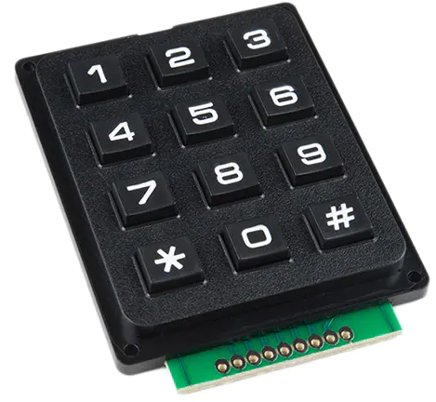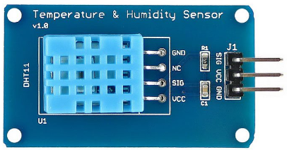

Water Temperature Sensor

## Functional Requirements

### Function Drink Selection and Payment

Add short description here …

This function is intended for the client to be able to select the drink and it allow it to be displayed correctly. After selecting the drink, the client will then use the QR to pay and the vending machine camera should be able to capture the QR correctly and dispense the drink after payment is done.

|  |  |
| --- | --- |
| **REQ_ID** | **Requirement** |
| REQ-01 | Vending machine should be able to recognise drink selected by client and display on the LCD correctly. |
| REQ-02 | When client presents QR code, vending machine camera should be able to correctly capture the QR code, deduct the balance accordingly and display a thank you message on the LCD |
| REQ-03 | After payment is done, drink should be dispensed. |

### Function Damage Detection

Add short description here …

In the event that a client attempts to pry open the door or damage any part of the vending machine,

vending machine camera must capture the image of the perpetuator and alert relevant service team.

|  |  |
| --- | --- |
| **REQ_ID** | **Requirement** |
| REQ-01 | There must be a security lock on the door that requires some sort of authentication to ensure that the door wont open easily. |
| REQ-02 | Camera must be vigilant 24/7 to be able to capture the image of the perpetuator . |
| REQ-03 | In the event that the perpetuator has been caught, the buzzer must be played immediately and an alert must be sent to the service team immediately for legal action to be taken. |

### Function Vending Machine Maintenance

1. Add short description here …

There must be maintenance done for the vending machine weekly, and for the machine to be able to recognise its own component failures which will allow it to send alerts to technicians for maintenance. Technicians must key in correct code for opening the door to prevent the buzzer from sounding.

|  |  |
| --- | --- |
| **REQ_ID** | **Requirement** |
| REQ-01 | Machine must be able to detect component failure e.g. stuck drink , storage issue or LCD display not showing correctly and report this failure to the technician. |
| REQ-02 | Technician should key in the code to the keypad correctly or else the buzzer will start sounding. |
| REQ-03 | Machine should send a weekly report on component status to see which component requires more attention. |

## Non-Functional Requirements

### Non-Functional Requirement xxxx

Add short description here …

|  |  |
| --- | --- |
| **REQ_ID** | **Requirement** |
| REQ-xx |  |
| REQ-xx |  |

# Software Architecture

## Static Software Architecture

The Software Architecture defines the various Software Components that are developed to realize the implementation of the system requirements.

**PowerMgt**

**HMI**

**Application Layer**

**Hardware Abstraction Layer (HAL)**

**ADC**

**USonic**

**NFC**

**Servo**

**RainSens**

**BlackCoffee**

**HotWater**